New Monitor and Control System for the GMRT
Rajsing Uprade¹, Naresh Sisodia¹, Charudatta Kanade^{1,}, Sachin Shrekar¹ ,Santaji Katore¹, Deepak Bhoong¹,Jitendra Kodilkar¹, S. Nayak¹, Nimisha Kanatharia¹ and Y. Gupta¹
1 NCRA-TIFR, Post Bag 3, Ganeshkhind, Pune 411007, Maharashtra, India

(rajsingh,naresh,cpk,sachin,snk,deepak,jitendra,nayak,ngk,ygupta@ncra.tifr.res.in)

The Giant Meterwave Radio Telescope (GMRT) is being upgraded to allow wide-band frequency observation in a seamless frequency coverage from about 50 to 1500 Mhz along with the modern servo systems for the antennas and feeds. To control and coordinate the newly upgraded GMRT systems for performing astronomical observations, the new GMRT Monitor and Control (M&C) system is being developed. The new M&C system has a modern hardware and software architectural features as compare to the existing GMRT control system. The high end server class machines in the Central Electronics Building (CEB) are used to run the central supervisory M&C system, which communicates to all thirty antennas spread over a radial distance about ~ 15 km using a dedicated Ethernet/Optical-Fiber link at 1 Gbps. The new Monitor and Control Modules (MCM) developed based on Rabbit RCM 4300 micro-controller are used to tune the RF signal receiver chain systems like Front-end, signal conditioning and Analog-backend. Rabbit processor support 1 GB miniSD memory card, 10/100T base Ethernet port for the communication along with a configurable 32 bit TTL control and 64 analog channels inputs to monitor. Dynamic C Intergated development environment support provided on Rabbit processor is used to develop and run the embeded control software. This software handles low level M&C functionalities like implementation of control logic, monitoring interpretation and safety of the instrument. Similarly, servo system of antenna and Feed-Positioning System plan to be controlled by PC104 embeded computer with lightweight Puppy Linux OS. The M&C system will thus coordinate and remotely control all thirty antennas, which includes total 180 sub-systems using the IP based interface.

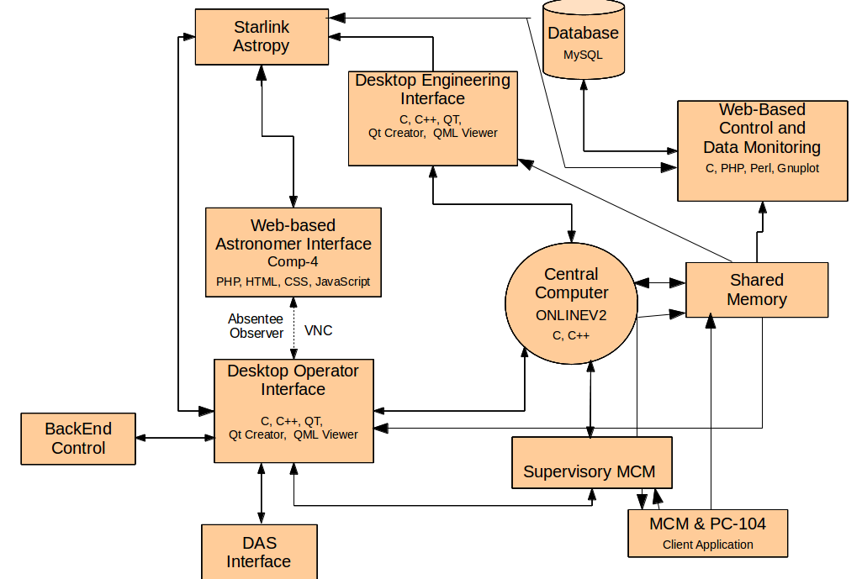

fig 1 : Block Diagram of Online V2.
A new M&C system software called ONLINE Version 2.0 (Online-V2) developed in-house by operation group member is in testing phase. Online-V2 follows a client-server software architecture and the design is based on the TCP/IP communication. The multi-threaded M&C Application server program developed in C runs under Linux operating system. The number of clients running on various sub-systems at the antenna base like Front-end, servo and Feed Positioning System connects to the M&C application server via multiple communication channels using the TCP/IP communication. The clients for each sub-system self-descover the connection automatically and send it's ID to the server. The M&C application server is capable of handling the communication channels for all thirty antennas in real-time at turn-around time of 1 to 3 sec. The M&C application software is integrated with Qt and QML (Qt Meta Language) based Graphical User Interface which provides the user interface to astronomer, telescope-operator and engineers in the CEB. The M&C system provide multiple type of interfaces like command-line for debugging, Qt based thick clients and browser interface to view the data over internet. M&C system log all event and monitoring data using MySQL database, alert the user on occurence of alarms.

Online-V2 has been tested with sub-systems of two antennas in the Lab environment. Also, long-term stability test done successfully for three month using the single antenna and sentinel system to monitor the temperature data. The new M&C system has improved performance with minimal time for configuring the telescope. facility to restore the default values after power failure hence capable to keep minimum down time during it's operation. Unlike the inherent complexity of the old M&C system due to dependencies on hardware systems like Communication Handler, Antenna Communication PC, the new M&C system will be much more easy to maintain as dependency on such hardwares is reduced. Apart from this, the new M&C system plan to have VOIP phone for voice communication and Video camera facility for the security purposes. The safety majors are taken by implementing the sentinel system (comprising smoke and temperature detectors) which can switch off the antenna electrical power before the critical alarming condition raised.
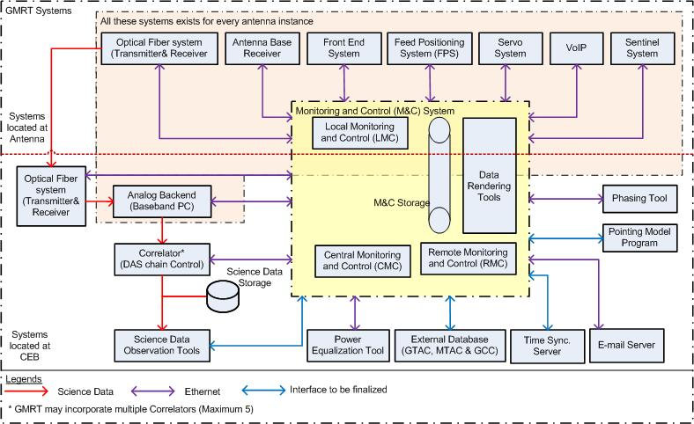

Fig 2. Shows the Upgraded GMRT M&C

As part of the upgradation process, NCRA has done feasibility study of the new GMRT M&C system in collaboration with the System Research Laboratory, TRDDC-TCS, India [2]. A prototype M&C system based on generic specifications-driven architecture called Sensor Actuator and Control Element (SACE) developed successfully to control a sub-array of three GMRT antennas. As a sub-sequent stage, User Requirements Specification (URS) and Software Requirement specification (SRS) document successfully completed in collobaroation with the TCS, India. The URS and SRS describe the functions of the system, operational & user-interface constraints and performance of the system that will govern the design and development of the M&C system software. The URS and SRS document captured all stakeholder requirements that need to be met by the new GMRT M&C system. This helps to avoid development gaps and errors at the beginning of design phase of the M&C system. Since the GMRT is a specialised facility in a specialised domain with complex astronomical observing capabilities and telescope functionality, the URS document was developed in close consultation with NCRA astronomers and engineers.
A comparitive study of various M&C system used in other observatories and open source software like EPICS has also been undertaken in collobaration with the TCS. NCRA plan to develop end-to-end M&C system software package which can execute the scheduled observing sessions and support in collecting the final astronomical data along with the meta-information and observation logs to improve the scince data quality. The long-term aim is to develop a modern M&C system that is applicable to larger telescopes like the Square Kilometre Array (SKA).

Authors will discuss the experince and learnings from the GMRT M&C system development activities like usage of modern ethernet based micro-controllers, performance issues etc. Also, apsects of specification driven architecture and requirement engineering issues will be highlighted.

References :

[1] R. Balasubramaniam et al. General Assembly and Scientific Symposim, 2011 XXXth URSI
[2] J. Kodilkar, R. Uprade et al. 2013 IOP Conf. Ser.: Mater. Sci. Eng. 44 012026

