
National Centre for Radio Astrophysics
Tata Institute of Fundamental Research,
Pune University Campus, Pune, INDIA

Technical Report
on
Online_v2 core software

Raju Uprade

GMRT – Khodad

Email : rajsingh@gmrt.ncra.tifr.res.in

Author : Raju Uprade | Date of issue :  11th December 2014 | Scope : Online_v2 core software Current status and future development
Verified by : Raju Uparade | Date of issue :  11th December 2014
Approved by : | Status/ Version : 1 | Internal Technical Report No.:
INDEX

- Abstract

- Background

- Structure

- Implementation

- Testing

- Future Scope

- Summary

Abstract

The Giant Meterwave Radio Telescope (GMRT) is being upgraded to allow wide-band frequency observation in a seamless frequency coverage from 150 to 1500 MHz along with the modern servo systems for antennas and feeds. To control and coordinate the newly upgraded GMRT systems for performing astronomical observations, the new GMRT Monitor and Control (M&C) system is being developed. The new M&C system has a modern hardware and software architectural features as compare to the existing GMRT control system. The high end server class machines in the Central Electronics Building (CEB) are used to run the central supervisory M&C system, which communicates to all thirty antennas spread over a radial distance about ~ 15 km using a dedicated Ethernet/Optical-Fiber link at 1 Gbps. The new Monitor and Control Modules (MCM) developed based on Rabbit RCM 4300 micro-controller are used to tune the RF signal receiver chain systems like Front-end, signal conditioning and Analog-backend. Rabbit processor support 1 GB miniSD memory card, 10/100T base Ethernet port for the communication along with a configurable 32 bit TTL control and 64 analog channels inputs to monitor. Dynamic C Integrated development environment support provided on Rabbit processor is used to develop and run the embedded control software. This software handles low level M&C functionalities like implementation of control logic, monitoring interpretation and safety of the instrument. Similarly, servo system of antenna and Feed-Positioning System plan to be controlled by PC104 embedded computer with lightweight Puppy Linux OS. The M&C system will thus coordinate and remotely control all thirty antennas, which includes total 180 sub-systems using the IP based interface.
Online-V2 follow client-server software architecture and design is based on the TCP/IP communication. The multi-threaded M&C Application server program developed in C runs under Linux operating system. The number of clients running on various sub-systems at the antenna base like Front-end, servo and Feed Positioning System connects to the M&C application server via multiple communication channels using the TCP/IP communication. The clients for each sub-system self-discovers the connection automatically and send it's ID to the server. The M&C application server is capable of handling the communication channels for all thirty antennas in real-time at turn-around time of 1 to 3 sec. The M&C application software is integrated with Qt and QML (Qt Meta Language) based Graphical User Interface which provides the user interface to astronomer, telescope-operator and engineers in the CEB. The M&C system provide multiple type of interfaces like command-line for debugging, Qt based client and browser interface to view the data over Internet. M&C system log all event and monitoring data using MySQL database, alert the user on occurrence of alarms.
Online-V2 has been tested with three antenna(C01,C04 & C06) two sub-systems during October-2014 maintenance period. Also, long-term stability test done successfully for three month using the single antenna and sentinel system to monitor the temperature data. The new M&C system has improved performance with minimal time for configuring the telescope. facility to restore the default values after power failure hence capable to keep minimum down time during it's operation. Unlike the inherent complexity of the old M&C system due to dependencies on hardware systems like Communication Handler, Antenna Communication PC, the new M&C system will be much more easy to maintain as dependency on such hardware is reduced. Apart from this, the new M&C system plan to have VOIP phone for voice communication and Video camera facility for the security purposes. The safety majors are taken by implementing the sentinel system (comprising smoke and temperature detectors) which can switch off the antenna electrical power before the critical alarming condition raised.
Background

Work related to Online_V2 started in October 2012. initially demonstrated the status of TELESET-ABCCOM to team members and studied various control & monitoring software-tools used in other astronomy institute like SCADA, PVSS, moniCA. For exploring ready software, Installed PVSS software on Laptop & explored various functionalities of it. After exploring various software, it was agreed that we will develop our own Online_V2 with open source technologies. Development work for Online_V2 started from January 2013.
Initially we developed a stand alone readline server which can send commands to Rabbit MCM card using our own defined structure protocol.
We have used the experience gained from working on Teleset-Abccom, 15 M NCRA disc & present Online.
Architectural block diagram of Online_v2 Control & Monitoring
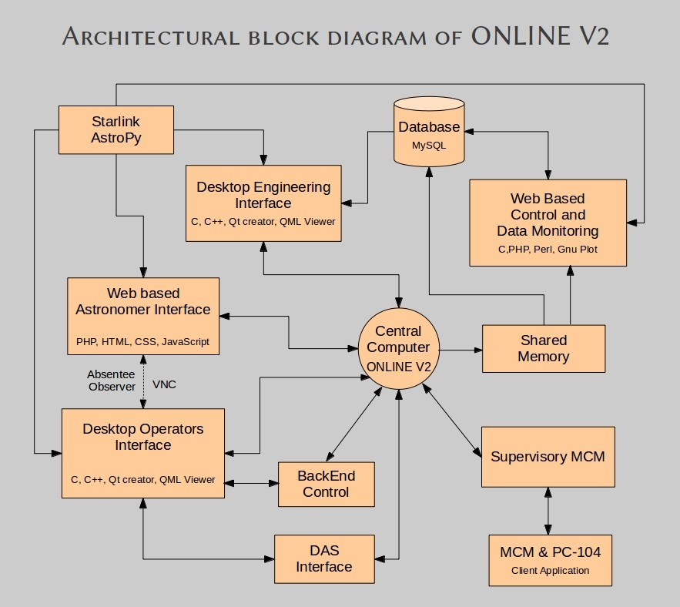
Online_v2 core : Why it is required

Online_v2 core software is the central software which is interfaced with all other antenna sub-system as well as DAS system. Online_v2 core is the master control program with a command terminal from where user can issues commands to any antenna sub-system & DAS system, write the command & response to shared memory, create user & sub array. It is the nerve center of Online_v2 control and monitoring system.

Online_v2 core : Interfacing with other system

Online_v2 has been interfaced with antenna sub-system, desktop GUI (QML/QT) and Python Environment using TCP/IP based socket, using message queue to interact with DAS server program and shared memory to write all command-response into the shared memory as well as Online_v2 core software write XML files which can be read by any web based program to display data.

Structure : why we followed particular structure

Online_v2 core directly communicates with antenna sub-system without the need of ABCCOM (ANTCOM) because we have shifted most of the intelligence and work in the low level device called as rabbit processor MCM card. It is much more powerful than currently used ANTCOM as well as during the designing of Online_v2 control and monitor system we have optimized the work to be done by rabbit processor based MCM card as well as all other component of the whole system.

Implementation :

Online_v2 core software has been implemented as a multi-threaded work queue based server with each thread assigned specific jobs to perform. Creating a multi-threaded TCP/IP protocol based server requires the capabilities to handle network communication, multi-threading and transferring data between threads.

This server opens multiple thread which runs in parallel to accomplish the task. Out of them, one thread runs Readline library enabled high user interface which accepts commands from user through terminal, one thread to accept command from Python environment and one thread fro accepting commands from desktop GUI (QML/QT) based. All other threads run in background performing 1 seconds background monitoring of every sub-system as well as take command out of the work queue whenever command is there for them to send to particular sub-system.

Python
Environment
User 0.....32
Desktop GUI
(QT/QML)

TCP/IP Socket port 7100
TCP/IP Socket port 7000

Online_v2 core
software
High user interface
Readline library
Shared memory
SHM ID 5800 5801 4999

TCP/IP Socket port 5500
TCP/IP Socket port 5000
Message Queue ID 201

DAS Server
MCM
threads
Servo
threads

Fig : Block Diagram of Online_v2 core Software

Server Structure

Producer-Consumer Model
The server is based on the producer-consumer multi threaded model where a single producer thread passes work items to 1 or more consumer threads via a work queue.
In the case of the TCP/IP server, the producer thread accepts connections then queues the connections for the consumer threads which in turn handle the connection processing as shown in this diagram.
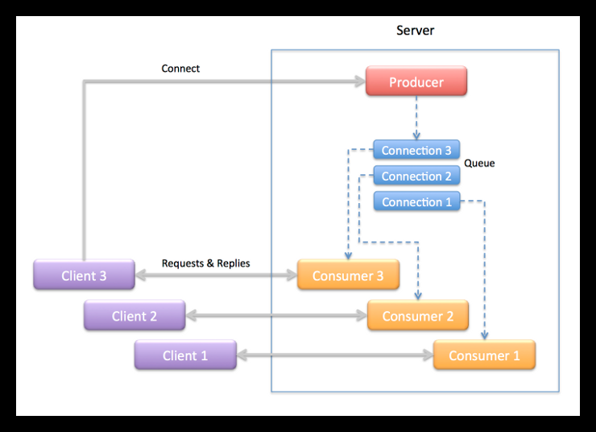

Producer Thread
The producer thread in the server is implemented in the main() function. It’s job is to create the work queue and consumer threads then accept connections from clients and pass the connections off to the consumer threads to handle. Specifically, the producer thread takes the following actions:

- Create a work queue object.
- Create the consumer threads.
- Start listening for connections from clients.
- Wait to accept a connections from a client .
- For each connection create a work item that transfers the connected socket to a consumer thread to handle the connection.
- Return to step 4.

Consumer Thread
The consumer threads are the workers that do the protocol session handling for the server. Each consumer thread handles a connection in the following manner:

- Wait for a work item to be added to the queue.
- Remove a work item from the queue.
- Extract the object from the work item.
- Wait to receive a request from the client.
- Process the request when it is received.
- Send the reply back to the client.
- Repeat steps 4 – 6 until the client closes the connection.
- Close the server end of the connection when the client closes the connection.
- Delete the work item.
- Return to step 1.

Multithreaded Work Queue
Building a multithreaded application is to devise a means to distribute tasks between threads so they can be processed concurrently.
Queues are good devices for transferring work items from one thread to another.

Producer-Consumer Model
One approach to multi threading is the producer-consumer model where one thread – the producer –places work items in a queue and one or more consumer threads waits for and removes the items to process.
Consumer
Thread 1
Work Queue
Producer
Thread

Consumer
Thread 2

When a consumer thread runs it checks the number of items on the queue. If there are one ore more work items on the queue the consumer removes one and processes it. If none are available the consumer waits for the producer to add items to the queue. These steps are repeated continually for the lifetime of the application.

Online_v2-MCM-Servo Communication Protocol :
In Online_v2 development we are using generic structure based communication protocol to communicate command & response between Online_v2 program and MCM rabbit card. Origin of this communication protocol is from 15 Meter NCRA CMS system. Where it's working without any problem for last one year. For our online_v2 development, we have trimmed and modified the structure to suit our GMRT sub-system requirement.

Connection is made using TCP/IP networking socket programming between Online_v2 and MCM program. Connection remains persistent means connections are not broken after exchanging information. Connections are broken only if MCM device is power off.

Command Structure for Online_v2-MCM communication :

typedef struct
{
int seq; // Unique Sequence
char timestamp[64]; // Timestamp of command
char system_name[16]; // System Name for which command is
char op_name[16]; // Operation to perform ( Init/Set/Mon/Reset )
short int number_param; // Number of parameter
char parameter_name[32][16]; // Parameter Name
char Argument_Ch1[32][16]; // Channel One argument
char Argument_Ch2[32][16]; // Channel Two argument
} cmd;

Response structure for MCM-Online_v2 communication :

typedef struct
{
int response_type; // Response type
int seq; // Sequence number
char timestamp[64]; // Time stamp
char system_name[16]; // System name
char Mon_raw[64][8]; // 64 channel raw data
char Mon_sum[32][64]; // Monitoring summary prepared from 64 channel raw data
short int num_resp_msg; // Number of Response Message
char response_message[32][64]; // Response message from MCM
} resp;

Structure used to send command for a particular antenna :

typedef struct
{
char antenna_name[10];
cmd CMD;
} ANT_CMD;
Structure used for creating user & sub-array :

typedef struct
{
int sub_num;
int num_in_sub;
char ant_name[32][8];
}sub;
typedef struct
{
int usernb;
sub s_a[4];
char timestamp[26];
} user;

typedef struct
{
user Tx[4];
} setdata;

Command structure for Online_v2-Servo Communication :

typedef struct
{
int seq;
char timestamp[64];
char system_name[16];
char op_name[16];
short int number_param;
char para_name[32][16];
char para_value[32][16];
} servocmd;

Response structure for Servo -Online_v2 Communication :

typedef struct
{
int seq;
char timestamp[64];
char system_name[16];
int response_code; // immediate =1 ( ACK or NAK ) event=3 & final =2 data mon = 4
int response_type; // success =1 or failure = 2
char response_msg[50]; // Accepted ,not accepted, sysntax error, irrelvant command,incomplete,unknown + Event
short int num_resp_msg;
char para_name[32][32];
char para_value[32][32];
} servoresp;
typedef struct
{
char antenna_name[10];
servocmd SRVCMD;
} SRVANT_CMD;

Size of Online_V2-MCM command structure is 1638 bytes and MCM-Online_v2 size of response structure is 4698 bytes.
Size of Online_V2-Servo command structure is 1132 bytes and Servo-Online_v2 size of response structure is 2192 bytes.

We have been using this generic communication protocol structure in C03 antenna testing & in two antenna 4 sub-system each Lab test set-up. We have not found any major problem related to communication. This generic structure based communication protocol is working very well for our Online_v2 need.

In term of reducing time interval, we are continuously working on it. With the help of powerful machines & optimization we will be able to reduce the time interval as well.

Comparison between Present Online, Teleset-Abccom & Online_v2 protocol :

Present Online do all the hex code generation and decoding in Online machine and pass it on to communication handler through PC router on a serial link @9.6 kbps. All the intelligence is in Online code.

Teleset-Abccom protocol differ in a sense that most of the intelligence has been shifted to Abccom software. Teleset only gives higher level ASCII command like English text for ex: if setnew set1.dat . Abccom will decode what it means by if setnew set1.dat, generate the corresponding hex code for that and send that to MCM 10 on serial link & get the response and form the response packet from the raw data sent by MCM 10 which can be sent to Teleset.
In Online_v2, all the bit pattern generation and decoding of response from raw data is done by MCM card so we just have to send higher level command from Online_v2 by an agreed upon communication protocol. We are following a structure based communication protocol where we are sending a command structure to a particular MCM card and we are getting a response structure.
In Online_v2 most of the intelligence is shifted in the MCM card itself.

DAS interfacing with Online

GUI
Corrsel.hdr

Online_v2

DAS SERVER

Message Queue
MSG ID is 201

Correlator system

Figure shows how Online is interfaced with Correlator system via DAS SERVER.

Das server starts reading corresel.hdr file generated by GUI. Online send commands to DAS server via message queue.

There are mainly six commands which are send by Online to the DAS server :

- initndas => DAS init
- initproj => Add project
  - strtndas => Start project
  - stpndas => Stop
  - delproj => Delete Project
  - hltndas => Finish

# initndas : [antmax] [corrsetup] [bandmask] [sub array no ] [.....]

# initprj : [antmax] [sub array] [proj title] [proj object ] [band mask selection] [prjcode]

# strtndas : [source param] [ freq param] [sub array number ]

# Antenna name mentioned during initndas & initproj should match.

sub array cmd Cmd CMD CMODE Antenna File location
Num num type mask

1. 0 0 das init 8 7FFFFFFE F /home/teleset/gsb.hdr // Init Command
2. 0 1 das addp 8 /home/teleset/proj.hdr.user0 // ADD project command

3. 4 2 das start /home/teleset/scan.hdr.user4 // DAS Start command

4. 4 3 das stop // DAS Stop command

5. 0 4 das delp 8 // Delete project command

6. 0 5 das fini 8 // Finish command

gsb.hdr => GSB config header file.

proj.hdr => generated by Online

scan.hdr => generated by Online.

Msgtag structure is declared in display.h in present Online code which is used by Online to pass DAS command DAS server :

# display.h

typedef struct
{
long type;
char buff[256];
} msgtag;

DAS Server side :

Message queue structure

typedef struct
{
long msglevel;
protocolType prot;
char buf[MsgSz];
} MsgBufType;

typedef unsigned char UNC;
typedef unsigned short UNS;
typedef short SHRT;
typedef unsigned long UNL;
typedef unsigned int UNL;

typedef struct ProtTag
{
UNC origin; /* MSG Originating station */
UNC dest; /* Destination station */
UNC type; /* The type of req, eg. Sh_com,RPC,FileIO,DAS,etc.*/
UNC cmd; /* Actual service name or shell command. */
UNC arg[4]; /*Used as a parameter of any type that can be coded in 4 bytes. */
UNC id; /* Request no, from the origin, wraps at 2^8 */
UNC flag; /* Flags of queries or replies */
UNS usrflag; /* Any short val or set of flags for user */
UNL len; /* Length of the packet that follows */
} ProtocolType;

online.h structure used in writing DAS project file & scan file :

typedef struct {
float i;
float q;
float u;
float v;
} POL_FLUX;

typedef struct {
char object[32];
POL_FLUX flux;
double mjd0;
double ra_app, dec_app, ra_date, dec_date, dra,ddec; /* rad, rad/s */
double freq[2];
double first_lo[2];
double bb_lo[2];
double rest_freq[2];
double lsrvel[2]; /* Hz, km/s */
double ch_width; /* Hz */
int id;
int net_sign[4];
int mode;
int dum1;
unsigned int antmask;
unsigned short bandmask,dum2;
short calcode, qual;
} SourceParType; // sizeof(SourceParType) to be written in scan.hdr.

typedef struct {
char code[8];
char observer[32];
char title[32];
unsigned int antmask;
unsigned short bandmask,seq;
} ProjectType; // sizeof(ProjectType) to be written in Proj.hdr.

typedef struct {
int status;
float t; /* program dependent meaning ! */
ProjectType proj;
SourceParType source;
} ScanInfoType;

typedef struct {
char datafile[80];
int das_sub_state;
int cmd_no;
ScanInfoType cntl;
} DAS_SUB_CNTL;

typedef struct {
char config_file[80];
int msg_id;
int das_state;
int das_sub_state[MAX_DAS_SUB];
DAS_SUB_CNTL sub_cntl[MAX_DAS_SUB];
} DAS_CNTL;

Command implementation :

1. Command for User & sub-array creation

1. | create | This command will create user & subarray with antenna in that particular group  user input 0 => user & sub-array will created through file input  user input 1 => user & sub-array will created through terminal input
2. | add | This command will add user,sub-array & antenna in the particular group
3. | cmd2sub | This command will send send command to the particular group of antenna
4. | delusr | This command will delete particular group user along with all information
5. | showuser | This command will display information about particular user

2. DAS command

1. | dasinit | This command will Initialize DAS system
2. | Addp | This command will add project file which will be send to DAS system
3. | delprj | This command will delete the project file
4. | startscan | This command will start scanning
5. | stopscan | This command will stop scanning
6. | finish | This command will halt DAS system

3. Antenna command

To give command to a particular antenna we have followed a particular format :
For example :

1. | C00 Sentinel init  1st string will be Antenna name  2nd string will be sub-system name  3rd string will be sub-system command

4. Sub-system commands

4.1 Sentinel system commands

No. | Command Name | Description | Argument
1. | Init | Initialize the system | -
2. | Mon | Monitor the health of the system | -
3. | set | Set the system as per the Argument | dmask Ch1 Ch2
4. | reset | Reset the system | -
4.2 Front End system commands

No. | Command Name | Description | Argument
1. | Init | Initialize the system | -
2. | Mon | Monitor the health of the system | -
3. | set | Set the system as per the Argument | band_sel Ch1 Ch2  slr_attn Ch1 Ch2  channel Ch1 Ch2  sub_band_sel Ch1 Ch2  rf Ch1 Ch2  cal_ns Ch1 Ch2
4. | reset | Reset the system | -

4.3 Fiber Optics system commands

No. | Command Name | Description | Argument
1. | Init | Initialize the system | -
2. | Mon | Monitor the health of the system | -
3. | set | Set the system as per the Argument | rf_attn Ch1 Ch2
4. | reset | Reset the system | -

4.4 GMRT Analog Backend system commands

No. | Command Name | Description | Argument
1. | Init | Initialize the system | -
2. | Mon | Monitor the health of the system | -
3. | set | Set the system as per the Argument | reflo Ch1 Ch2  lo Ch1 Ch2  attn Ch1 Ch2  filter Ch1 Ch2  lpf Ch1 Ch2  source Ch1 Ch2  signal Ch1 Ch2  path Ch1 Ch2  channel Ch1 Ch2
4. | reset | Reset the system | -

4.5 Self Test system commands

No. | Command Name | Description | Argument
1. | Init | Initialize the system | -
2. | Mon | Monitor the health of the system | -
3. | set | Set the system as per the Argument | ss Ch1 //set spectrum spreader  fdb Ch1 // set frequency doubler  fdv Ch1 //set frequency divider
4. | reset | Reset the system | -

4.6 GMRT servo system commands

No. | Command Name | Description | Argument
1. | sendsacsrc | Send source information  RA DEC to track routine | Source RA DEC
2. | goin | Inner Track | -
3. | goout | Outer Track | -
4. | trkon | Start Tracking | -
5. | trkoff | Stop Tracking | -
6. | coldstart |  | -
7. | hold | Hold Axis | Ax
8. | track | Track | Time,Ax,Ang1,Ang2
9. | position | Position Axis | Ax,Ang1,Ang2
10. | stow | Stow the antenna | Ax
11. | stow_release | Stow release | Ax
12. | stop | Stop | Ax
13. | abort | Abort tracking
14. | close | Close
15. | resethw | Reset Hardware
16. | readangles | Read angles
17. | readanavar | Read analog variables
18. | readdigvar | Read digital variables
19. | readantstatus | Read antenna status
20. | readversion | Read version
21. | readsetpara | Read set paramameters

  - GMRT servo system commands ( Yet to be Implemented )

No. | Command Name | Description | Argument
1. | TRKELOFF | track elevation offset | New track parameters
2. | TRKAZOFF | track azimuth offset | New track parameters
3. | TRKANTOFF | track azimuth, elevation offset | New track parameters
4. | TRKRAOFF | track right ascension offset | New track parameters
5. | TRKDECOFF | track declination offset | New track parameters
6. | SCANELSRC | scan src in el with derv=ipa,ptime=jpa | New track parameters
7. | SCANAZSRC | scan src in az with derv=ipa,ptime=jpa | New track parameters
8. | SCANRASRC | scan src in ra with derv=ipa,ptime=jpa | New track parameters
9. | SCANDEC | scan src in dec with derv=ipa,ptime=jpa | New track parameters

