
National Centre for Radio Astrophysics
Tata Institute of Fundamental Research,
Pune University Campus, Pune, INDIA

Technical Report
on
Online_v2 core software
& Testing done

Raju Uprade

GMRT – Khodad

Email : rajsingh@gmrt.ncra.tifr.res.in

Author : Raju Uprade | Date of issue :  11th December 2014 | Scope : Online_v2 core software Current status and future development
Verified by : Raju Uparade | Date of issue :  11th December 2014
Approved by : | Status/ Version : 1 | Internal Technical Report No.:

INDEX

- Abstract

- Background

- Structure

- Implementation

- Testing

- Summary

- References

- Appendix
- Online_v2 & DAS communication structure
- Online_v2-DAS server command and response
- Online_v2- Servo PC104 command and response at SSL Lab.
- Online_v2- Servo PC104 command and response at C01 antenna

Abstract :

The Giant Meter wave Radio Telescope (GMRT) is being upgraded to allow wide-band frequency observation in a seamless frequency coverage from 150 to 1500 MHz along with the modern servo systems for antennas and feeds. To control and coordinate the newly upgraded GMRT systems for performing astronomical observations, the new GMRT Monitor and Control (M&C) system is being developed. The new M&C system has a modern hardware and software architectural features as compare to the existing GMRT control system. The high end server class machines in the Central Electronics Building (CEB) are used to run the central supervisory M&C system, which communicates to all thirty antennas spread over a radial distance about ~ 15 km using a dedicated Ethernet/Optical-Fiber link at 1 Gbps. The new Monitor and Control Modules (MCM) developed based on Rabbit RCM 4300 micro-controller are used to tune the RF signal receiver chain systems like Front-end, signal conditioning and Analog-backend. Rabbit processor support 1 GB mini SD memory card, 10/100T base Ethernet port for the communication along with a configurable 32 bit TTL control and 64 analog channels inputs to monitor. Dynamic C Integrated development environment support provided on Rabbit processor is used to develop and run the embedded control software. This software handles low level M&C functionalities like implementation of control logic, monitoring interpretation and safety of the instrument. Similarly, servo system of antenna and Feed-Positioning System plan to be controlled by PC104 embedded computer with lightweight Puppy Linux OS. The M&C system will thus coordinate and remotely control all thirty antennas, which includes total 180 sub-systems using the IP based interface.

Online-V2 follow client-server software architecture and design is based on the TCP/IP communication. The multi-threaded M&C Application server program developed in C runs under Linux operating system. The number of clients running on various sub-systems at the antenna base like Front-end, servo and Feed Positioning System connects to the M&C application server via multiple communication channels using the TCP/IP communication. The clients for each sub-system self-discovers the connection automatically and send it's ID to the server. The M&C application server is capable of handling the communication channels for all thirty antennas in real-time at turn-around time of 1 to 3 sec. The M&C application software is integrated with Qt and QML (Qt Meta Language) based Graphical User Interface which provides the user interface to astronomer, telescope-operator and engineers in the CEB. The M&C system provide multiple type of interfaces like command-line for debugging, Qt based client and browser interface to view the data over Internet. M&C system log all event and monitoring data using MySQL database, alert the user on occurrence of alarms.

Background :

Work related to Online_V2 started in October 2012. First steps were to study the existing ONLINE software ( Software which is being in GMRT for last 15 years) and the Linux version referred to as TELESET-ABCCOM as well as we had extensive discussions in the team. As the second steps studied various control & monitoring software-tools used in other astronomy institute like SCADA, PVSS, moniCA. For exploring ready made software, Installed PVSS software on Laptop & explored various functionalities of it. After exploring various software, it was agreed that we will develop our own Online_V2 with open source technologies. Development work for Online_V2 started from January 2013.Initially we developed a stand alone readline server which can send commands to Rabbit MCM card using our own defined structure protocol. Online_v2 builds on our experience from TELESET-ABCCOM, C&M 15 M NCRA telescope in Pune & GMRT ONLINE SOFTWARE.
Architectural block diagram of Online_v2 Control & Monitoring :
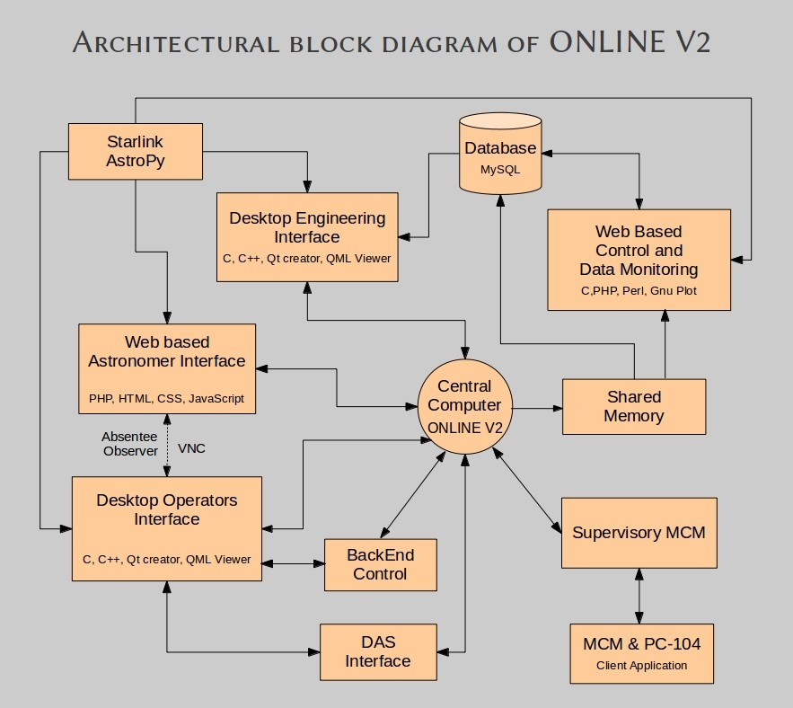
Online_v2 core : Why it is required :

Online_v2 core software is the central software which is interfaced with all other antenna sub-system as well as DAS system. Online_v2 core is the master control program with a command terminal from where user can issues commands to any antenna sub-system & DAS system, write the command & response to shared memory, create user & sub array. It is the nerve center of Online_v2 control and monitoring system.

Online_v2 core : Interfacing with other system :

Online_v2 has been interfaced with antenna sub-system, desktop GUI (QML/QT) and Python Environment using TCP/IP based socket, using message queue to interact with DAS server program and shared memory to write all command-response into the shared memory as well as Online_v2 core software write XML files which can be read by any web based program to display data.

Structure : why we followed particular structure :

Online_v2 core directly communicates with antenna sub-system without the need of ABCCOM (ANTCOM) because we have shifted most of the intelligence and work in the low level device called as rabbit processor MCM card. It is much more powerful than currently used ANTCOM as well as during the designing of Online_v2 control and monitor system we have optimized the work to be done by rabbit processor based MCM card as well as all other component of the whole system.

Implementation :

Online_v2 core software has been implemented as a multi-threaded work queue based server with each thread assigned specific jobs to perform. Creating a multi-threaded TCP/IP protocol based server requires the capabilities to handle network communication, multi-threading and transferring data between threads.

This server opens multiple thread which runs in parallel to accomplish the task. Out of them, one thread runs Readline library enabled high user interface which accepts commands from user through terminal, one thread to accept command from Python environment and one thread fro accepting commands from desktop GUI (QML/QT) based. All other threads run in background performing 1 seconds background monitoring of every sub-system as well as take command out of the work queue whenever command is there for them to send to particular sub-system.

Python
Environment
User 0.....32
Desktop GUI
(QT/QML)

TCP/IP Socket
port 7000
TCP/IP Socket
port 7100

SHM ID
5800 5801 4999
High user interface
Readline library
Shared memory
Online_v2 core
software

TCP/IP Socket
port 5000
TCP/IP Socket
port 5500
Message Queue
ID 201

DAS Server
Servo
threads
MCM
threads

Fig : Block Diagram of Online_v2 core Software

Server Structure

Producer-Consumer Model

The server is based on the producer-consumer multi threaded model where a single producer thread passes work items to 1 or more consumer threads via a work queue. In the case of the TCP/IP server, the producer thread accepts connections then queues the connections for the consumer threads which in turn handle the connection processing as shown in this diagram.
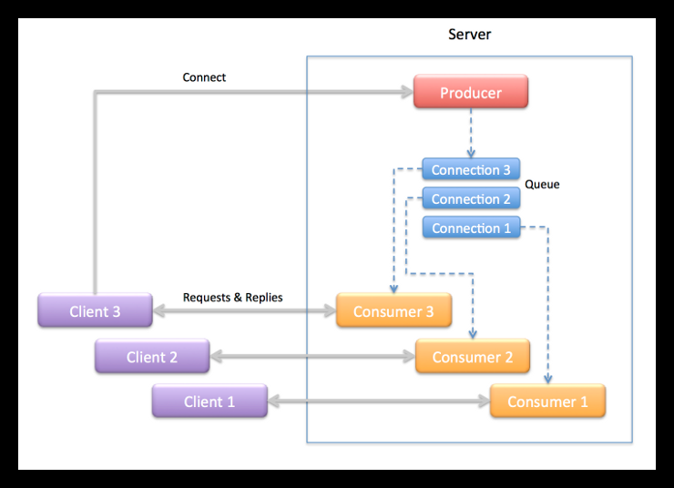

Producer Thread

The producer thread in the server is implemented in the main() function. It’s job is to create the work queue and consumer threads then accept connections from clients and pass the connections off to the consumer threads to handle. Specifically, the producer thread takes the following actions:

- Create a work queue object.
- Create the consumer threads.
- Start listening for connections from clients.
- Wait to accept a connections from a client .
- For each connection create a work item that transfers the connected socket to a consumer thread to handle the connection.
- Return to step 4.

Consumer Thread
The consumer threads are the workers that do the protocol session handling for the server. Each consumer thread handles a connection in the following manner:

- Wait for a work item to be added to the queue.
- Remove a work item from the queue.
- Extract the object from the work item.
- Wait to receive a request from the client.
- Process the request when it is received.
- Send the reply back to the client.
- Repeat steps 4 – 6 until the client closes the connection.
- Close the server end of the connection when the client closes the connection.
- Delete the work item.
- Return to step 1.
Multi-threaded Work Queue :
Building a multi-threaded application is to devise a means to distribute tasks between threads so they can be processed concurrently. Queues are good devices for transferring work items from one thread to another. One approach to multi threading is the producer-consumer model where one thread – the producer –places work items in a queue and one or more consumer threads waits for and removes the items to process.

Work Queue
Consumer
Thread 1
Producer
Thread

Consumer
Thread 2

When a consumer thread runs it checks the number of items on the queue. If there are one ore more work items on the queue the consumer removes one and processes it. If none are available the consumer waits for the producer to add items to the queue. These steps are repeated continually for the lifetime of the application.

Online_v2-MCM-Servo Communication Protocol :

In Online_v2 development we are using generic structure based communication protocol to communicate command & response between Online_v2 program and MCM rabbit card. We had developed communication protocol for the 15 Meter NCRA CMS system in the Pune campus. Amongst the important changes were trimming the command structure from 5000 bytes to 1600 bytes and response structure from 17000 to 5000 bytes. We note that communication protocol developed for 15m telescope has been working without any problem for last three year.
Connection is made using TCP/IP networking socket programming between Online_v2 and MCM program. Connection remains persistent means connections are not broken after exchanging information. Connections are broken only if MCM device is power off.

Command Structure for Online_v2-MCM communication :

typedef struct
{
int seq; // Unique Sequence
char timestamp[64]; // Timestamp of command
char system_name[16]; // System Name for which command is
char op_name[16]; // Operation to perform ( Init/Set/Mon/Reset )
short int number_param; // Number of parameter
char parameter_name[32][16]; // Parameter Name
char Argument_Ch1[32][16]; // Channel One argument
char Argument_Ch2[32][16]; // Channel Two argument
} cmd;

Response structure for MCM-Online_v2 communication :

typedef struct
{
int response_type; // Response type
int seq; // Sequence number
char timestamp[64]; // Time stamp
char system_name[16]; // System name
char Mon_raw[64][8]; // 64 channel raw data
char Mon_sum[32][64]; // Monitoring summary prepared from 64 channel raw data
short int num_resp_msg; // Number of Response Message
char response_message[32][64]; // Response message from MCM
} resp;

Structure used to send command for a particular antenna :

typedef struct
{
char antenna_name[10];
cmd CMD; // command structure is embedded in the antenna structure
} ANT_CMD;

Structure used for creating user & sub-array :

typedef struct
{
int sub_num;
int num_in_sub;
char ant_name[32][8];
}sub;
typedef struct
{
int usernb;
sub s_a[4];
char timestamp[26];
} user;

typedef struct
{
user Tx[4];
} setdata;

Command structure for Online_v2-Servo Communication :

typedef struct
{
int seq;
char timestamp[64];
char system_name[16];
char op_name[16];
short int number_param;
char para_name[32][16];
char para_value[32][16];
} servocmd;

typedef struct
{
char antenna_name[10];
servocmd SRVCMD;
} SRVANT_CMD;

Response structure for Servo -Online_v2 Communication :

typedef struct
{
int seq;
char timestamp[64];
char system_name[16];
int response_code; // immediate =1 ( ACK or NAK ) event=3 & final =2 data mon = 4
int response_type; // success =1 or failure = 2
char response_msg[50]; // Accepted ,not accepted, syntax error, irrelevant command,incomplete,unknown + Event
short int num_resp_msg;
char para_name[32][32];
char para_value[32][32];
} servoresp;

Size of Online_V2-MCM command structure is 1638 bytes and MCM-Online_v2 size of response structure is 4698 bytes.
Size of Online_V2-Servo command structure is 1132 bytes and Servo-Online_v2 size of response structure is 2192 bytes.
We have been using this generic communication protocol structure in C03 antenna testing & in two antenna 4 sub-system each Lab test set-up. We have not found any major problem related to communication. This generic structure based communication protocol is working very well for our Online_v2 need.

In term of reducing time interval, we are continuously working on it. With the help of powerful machines & optimization we will be able to reduce the time interval as well.

Comparison between Present Online, Teleset-Abccom & Online_v2 protocol :

Present Online do all the hex code generation and decoding in Online machine and pass it on to communication handler through PC router on a serial link @9.6 kbps. All the intelligence is in Online code.

Teleset-Abccom protocol differ in a sense that most of the intelligence has been shifted to Abccom software. Teleset only gives higher level ASCII command like English text for ex: if setnew set1.dat . Abccom will decode what it means by if setnew set1.dat, generate the corresponding hex code for that and send that to MCM 10 on serial link & get the response and form the response packet from the raw data sent by MCM 10 which can be sent to Teleset.
In Online_v2, all the bit pattern generation and decoding of response from raw data is done by MCM card so we just have to send higher level command from Online_v2 by an agreed upon communication protocol. We are following a structure based communication protocol where we are sending a command structure to a particular MCM card and we are getting a response structure. In Online_v2 most of the intelligence is shifted in the MCM card itself.

DAS interfacing with Online_v2 :

DAS server starts reading corresel.hdr file generated by GSB configuration GUI. Online_v2 send commands and read response to & from DAS server via message queue id 201. Command received from Online_v2 is sent on sockets to the correlator system by DAS server. Response from correlator system is received on socket by DAS server, which is then written to message queue by DAS server to be read by Online_v2.

GSB configuration GUI
Corrsel.hdr

Online_v2

DAS SERVER
Message Queue

MSG ID is 201

Correlator system

Figure : Online interfacing with Correlator system via DAS SERVER

There are mainly six commands which are send by Online to the DAS server :

- initndas => DAS init
- initproj => Add project
  - strtndas => Start project
  - stpndas => Stop
  - delproj => Delete Project
  - hltndas => Finish

# initndas : [antmax] [corrsetup] [bandmask] [sub array no ] [.....]

# initprj : [antmax] [sub array] [proj title] [proj object ] [band mask selection] [prjcode]

# strtndas : [source param] [ freq param] [sub array number ]

# Antenna name mentioned during initndas & initproj should match.

DAS Command structure :

sub array cmd Cmd CMD CMODE Antenna File location
Num num type mask

1. 0 0 das init 8 7FFFFFFE F /home/teleset/gsb.hdr // Init Command

2. 0 1 das addp 8 /home/teleset/proj.hdr.user0 // ADD project command

3. 4 2 das start /home/teleset/scan.hdr.user4 // DAS Start command

4. 4 3 das stop // DAS Stop command

5. 0 4 das delp 8 // Delete project command

6. 0 5 das fini 8 // Finish command

gsb.hdr => GSB config header file.

proj.hdr => generated by Online_v2

scan.hdr => generated by Online_v2.

Shared memory Client Program :

Online_v2 writes command-response from every thread of every antenna, user & sub-array information and DAS command-response messages from DAS server into the shared memory. Shared memory client program gets attached to the shared memory ID created by Online_v2 and reads all the information which can be displayed as per user's wish.
Any number of clients can get attached to this shared memory segments.

Information from
Online_v2

Online_v2
Shared memory

Shared
memory
Client

Command implementation :

1. Command for User & sub-array creation issued from Online_v2 terminal :

1. | create | This command will create user & subarray with antenna in that particular group  user input 0 => user & sub-array will created through file input  user input 1 => user & sub-array will created through terminal input
2. | add | This command will add user,sub-array & antenna in the particular group
3. | cmd2sub | This command will send send command to the particular group of antenna
4. | delusr | This command will delete particular group user along with all information
5. | showuser | This command will display information about particular user

2. DAS command issued from Online_v2 terminal :

1. | dasinit | This command will Initialize DAS system
2. | Addp | This command will add project file which will be send to DAS system
3. | delprj | This command will delete the project file
4. | startscan | This command will start scanning
5. | stopscan | This command will stop scanning
6. | finish | This command will halt DAS system

3. Antenna command issued from Online_v2 terminal :

To give command to a particular antenna we have followed a particular format :
For example :

1. | C00 Sentinel init  1st string will be Antenna name  2nd string will be sub-system name  3rd string will be sub-system command

4. Sub-system commands :

4.1 Sentinel system commands

No. | Command Name | Description | Argument
1. | Init | Initialize the system | -
2. | Mon | Monitor the health of the system | -
3. | set | Set the system as per the Argument | dmask Ch1 Ch2
4. | reset | Reset the system | -
4.2 Front End system commands

No. | Command Name | Description | Argument
1. | Init | Initialize the system | -
2. | Mon | Monitor the health of the system | -
3. | set | Set the system as per the Argument | band_sel Ch1 Ch2  slr_attn Ch1 Ch2  channel Ch1 Ch2  sub_band_sel Ch1 Ch2  rf Ch1 Ch2  cal_ns Ch1 Ch2
4. | reset | Reset the system | -

4.3 Fiber Optics system commands

No. | Command Name | Description | Argument
1. | Init | Initialize the system | -
2. | Mon | Monitor the health of the system | -
3. | set | Set the system as per the Argument | rf_attn Ch1 Ch2
4. | reset | Reset the system | -

4.4 GMRT Analog Backend system commands

No. | Command Name | Description | Argument
1. | Init | Initialize the system | -
2. | Mon | Monitor the health of the system | -
3. | set | Set the system as per the Argument | reflo Ch1 Ch2  lo Ch1 Ch2  attn Ch1 Ch2  filter Ch1 Ch2  lpf Ch1 Ch2  source Ch1 Ch2  signal Ch1 Ch2  path Ch1 Ch2  channel Ch1 Ch2
4. | reset | Reset the system | -

4.5 Self Test system commands

No. | Command Name | Description | Argument
1. | Init | Initialize the system | -
2. | Mon | Monitor the health of the system | -
3. | set | Set the system as per the Argument | ss Ch1 //set spectrum spreader  fdb Ch1 // set frequency doubler  fdv Ch1 //set frequency divider
4. | reset | Reset the system | -

4.6 GMRT servo system commands

No. | Command Name | Description | Argument
1. | sendsacsrc | Send source information  RA DEC to track routine | Source RA DEC
2. | goin | Inner Track | -
3. | goout | Outer Track | -
4. | trkon | Start Tracking | -
5. | trkoff | Stop Tracking | -
6. | coldstart |  | -
7. | hold | Hold Axis | Ax
8. | track | Track | Time,Ax,Ang1,Ang2
9. | position | Position Axis | Ax,Ang1,Ang2
10. | stow | Stow the antenna | Ax
11. | stow_release | Stow release | Ax
12. | stop | Stop | Ax
13. | abort | Abort tracking
14. | close | Close
15. | resethw | Reset Hardware
16. | readangles | Read angles
17. | readanavar | Read analog variables
18. | readdigvar | Read digital variables
19. | readantstatus | Read antenna status
20. | readversion | Read version
21. | readsetpara | Read set paramameters

  - GMRT servo system commands ( Yet to be Implemented )

No. | Command Name | Description | Argument
1. | TRKELOFF | track elevation offset | New track parameters
2. | TRKAZOFF | track azimuth offset | New track parameters
3. | TRKANTOFF | track azimuth, elevation offset | New track parameters
4. | TRKRAOFF | track right ascension offset | New track parameters
5. | TRKDECOFF | track declination offset | New track parameters
6. | SCANELSRC | scan src in el with derv=ipa,ptime=jpa | New track parameters
7. | SCANAZSRC | scan src in az with derv=ipa,ptime=jpa | New track parameters
8. | SCANRASRC | scan src in ra with derv=ipa,ptime=jpa | New track parameters
9. | SCANDEC | scan src in dec with derv=ipa,ptime=jpa | New track parameters

4.8 GMRT Feed positioning system commands

No. | Command Name | Description | Argument
1. | mvpos | move to the feed position | feed 610/150/1420/325
2. | loadparam | load parameters from fps.dat file | File name
3. | fpsinit | Initialize FPS system | -
4. | fpsnull | FPS NULL command | -
5. | set_tpoint | turning point position | Encoder count
6. | set_rampdcnt | Set ramp down count | Nb timer ticks
7. | set_low_rpm | Set lower RPM limit | Nb timer ticks
8. | set_brake_dd | Set break down diff | Nb enc. pulses
9. | set_rampupcnt | Set ramp up count | Nb timer ticks
10. | set_stoptimecnt | Set stop time count | Nb timer ticks
11. | set_max_pwm_cnt | Set Max PWM count | PWM count
12. | set_max_angle | Set MAX angle | Angle
13. | set_min_angle | Set MIN angle | Angle
14. | read_tpoint | Read turning point
15. | read_rampdcnt | Read ramp down count
16. | read_low_rpm | Read lower RPM limit
17. | read_brake_dd | Read break down diff
18. | read_rampupcnt | Read ramp up count
19. | read_stoptimecnt | Read stop time count
20. | read_max_pwm_cnt | Read stop time count
21. | read_max_angle | Read MAX angle
22. | read_min_angle | Read MIN angle
23. | read_version | Read version
24. | run_to_cal | Run to calibrate
25. | free_run_tow | Free run towards | 270/-10 deg
26. | run_to_preset | Run to preset | Target pos
27. | run_fine_tune | Run to fine tune | Target pos, PWM count
28. | password_run | Password run
29. | reboot | reboot
30. | fpsstop | stop

Online_v2 Source files details :

No. | File Name | Description
1. | main.c | Opens multiple threads for high user,mcm,python env,servo & GUI
2. | highuser.c , highuer.h | High user thread which accept user command through readline
3. | common.c | Common file for mostly used functions like timestamp etc.
4. | das.c , das.h | Source file to read,write to the das server using Message queue
5. | pyenv.c ,pyenv.h | Python environment thread to accept command from Python env
6. | server.h | Header file contain mostly used functions & communication structure.
7. | servo.h | Header file containing servo communication structure & functions declarations.
8. | servo.c | Source file for filling servo command structure
9. | shm.h | Header file for shared memory function declarations.
10. | shmed_mem.c | server which writes command & response to shared memory.
11. | shm_client.c | Client which read command & response from shared memory.
12. | system.c, system.h | Source file for filling MCM command structure (FE,Sentinel,GAB,OF & self test).
13. | fps.h, fps.c | Feed positioning system header & Source file for filling FPS command structure
14. | gui.c , gui.h | GUI thread to accept command from Desktop GUI (QT/QML)
15. | mcm.c , mcm.h | File for accepting client connection from various sub-system
16. | mcm_thread.c, mcm_thread.h | File for various MCM sub-system threads
17. | queue.c, queue.h | File for queue related function declarations & definition. .
18. | servo_queue.h, servo_queue.c | Servo queue related function declarations & definition.
19. | socket.c, socket.h | Socket related function declarations & definition.
20. | ssclink.h, ssclink.c | Servo communication function declarations & definition.
21. | trackservo.c, trackservo.h, | Source file containing algorithm for source tracking  ( Taken from ABCCOM servo tracking algorithm )
22. | user1.h | Header file for user input
23. | user_info.c | Source file for taking user input related to user & sub array creation.
24. | xml.c, xml.h | File for writing XML file of command & response.

Testing of Online_v2 Core software :

Lab testing :

- Eight MCM cards along with L3 network switch have been put in Lab set up for Online_V2. Online_V2 has been tested successfully by configuring eight MCM cards as two antenna four sub-system each & eight antenna one sub-system each. (Front End, Fiber optics, GAB, Sentinel)
- All basic servo commands have been implemented in Online_v2 which has been tested with actual hardware set up in servo lab. As well as one antenna tracking routine has been implemented in Online_V2, which has been tested with a prototype servo client program running on PC104 card.
- We have done several test to measure the round trip time taken by command & response packet. Initially we get into the problem with two successive monitoring packet response time. It was working properly for 2 seconds and we were trying to achieve 1 second monitoring time. We tried increasing TCP MTU as well as tried various options in socket programming but it didn't solved our problem. After various trail & error we changed the sub-net i.e. we isolated our lab setup by putting a new L3 CISCO switch & IP of server machine from rest of the network. It improved our command-response round trip time significantly and we achieved 1 seconds as well 0.5 second round trip monitoring time.
- Online_v2 software has been tested with Feed positioning system MCM card ( NULL command) in telemetry Lab where Rabbit MCM card takes command from Online_v2 software over Ethernet & send it to the FPS MCM card over serial link and get back the response, compose Ethernet response packet and send it back to online_v2 software.

Plots of round trip time:
Plots below shows the round trip time when Online_v2 was connected with eight antenna set up in lab using a small unmanageable switch. Plots shows undesirable high dropout of packets.
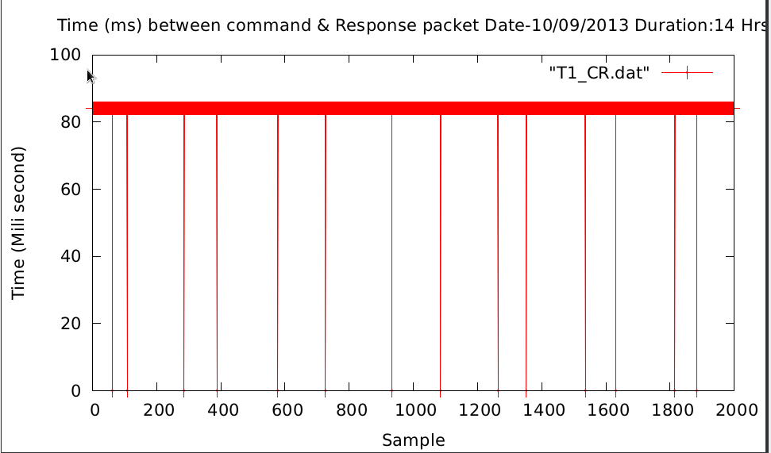
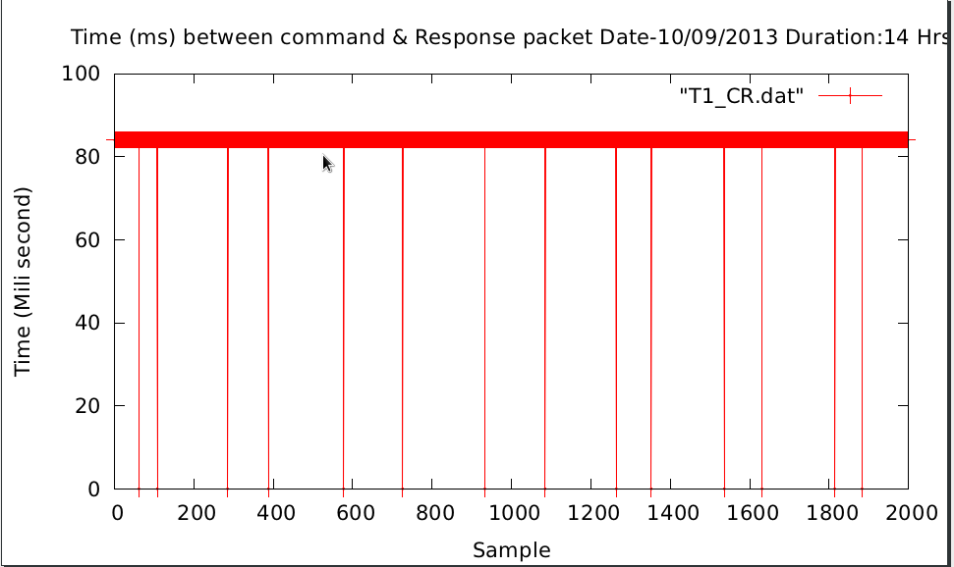
Fig(1): Time between command & response when interval is 2 seconds
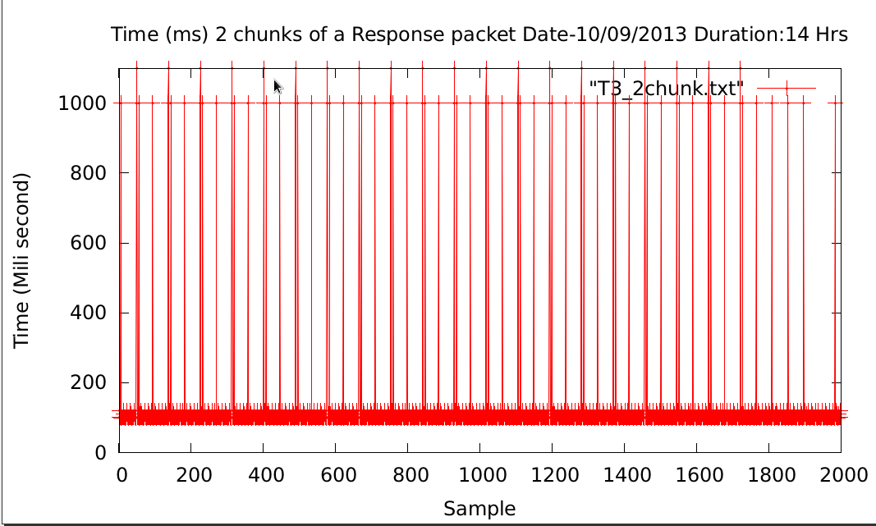
Fig(2) : Time between two chunks of a response packets in 2 second interval
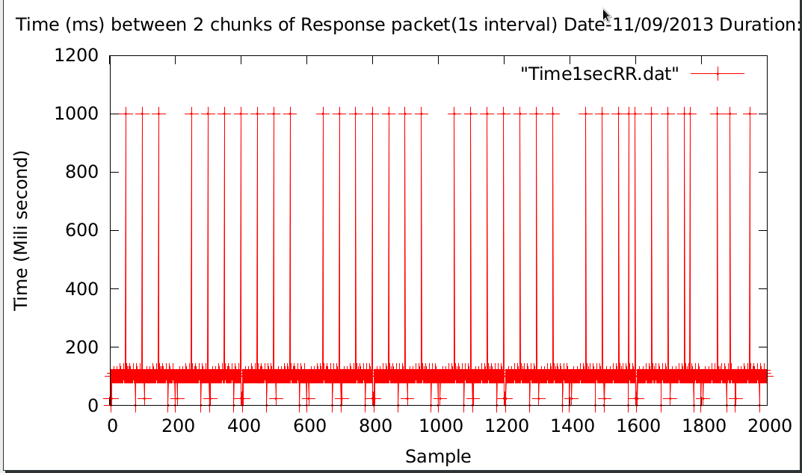
Fig(3) : Time between two chunks of a response packets in 1 second interval

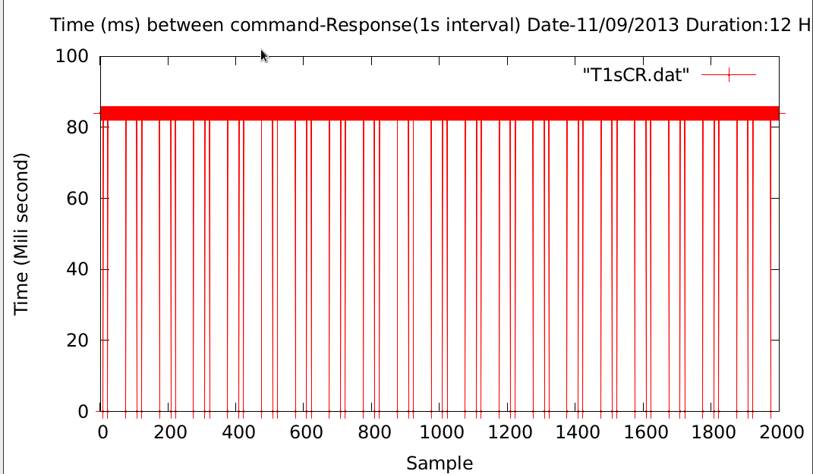
Fig(4) : Time between command & response in 1 second interval

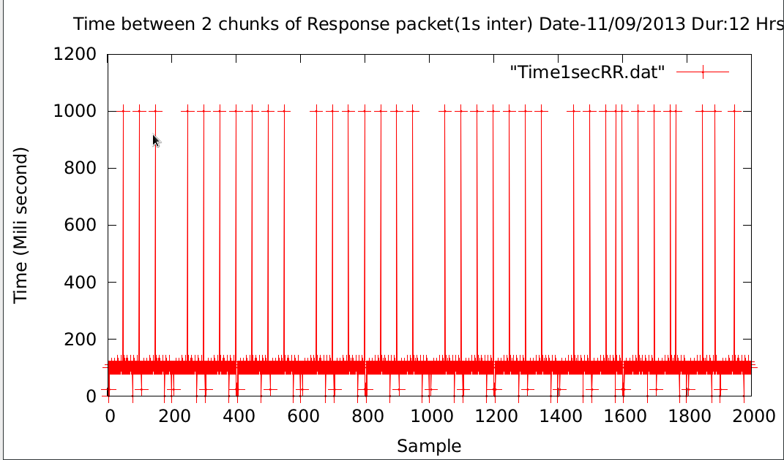
Fig(5) : Time between command & response in 1 second interval

Plots after changing the IP of server machine & sub-net :

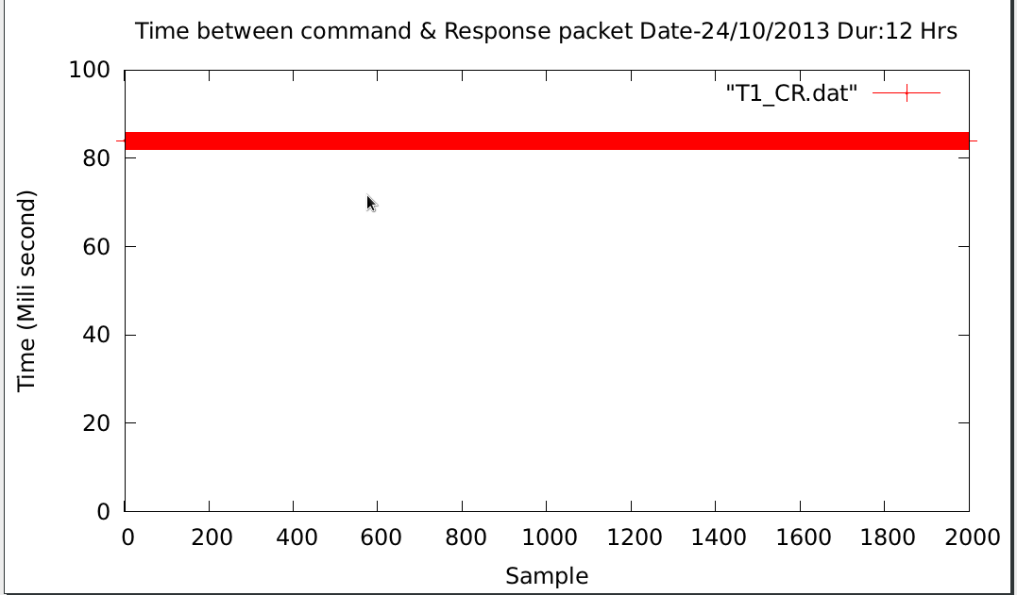
Fig( 6) : Time between command-Response after changing IP & sub-net.
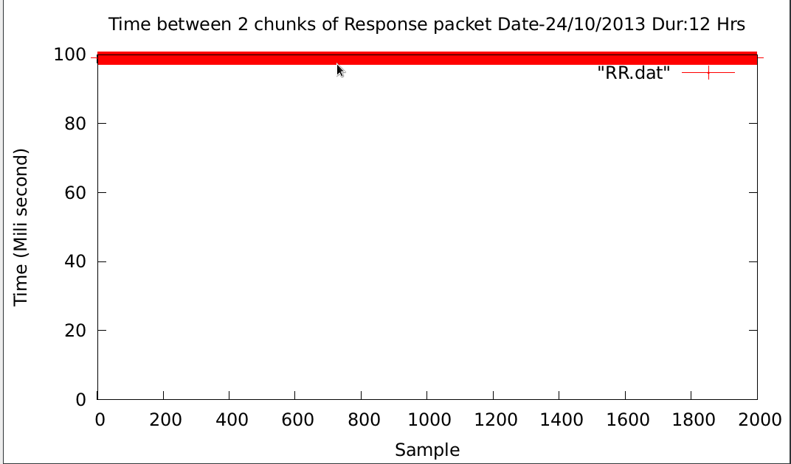
Fig(7) : Time between Two response packets after changing IP & sub-net.

Plots of round trip time when two sub-system configured in one MCM card :

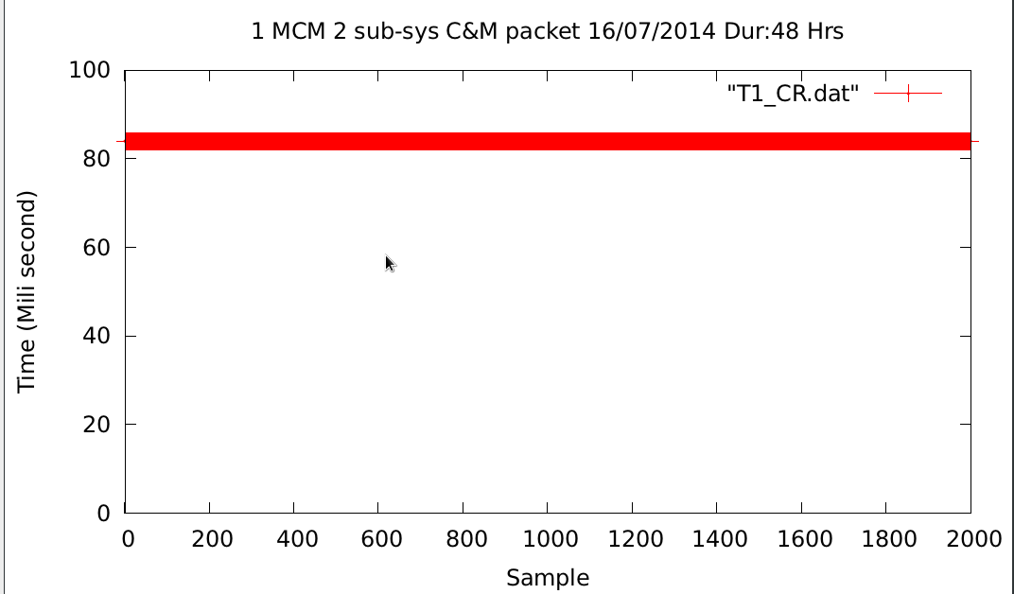
Fig(8) : Time between C & R when two sub-system configured in one MCM card
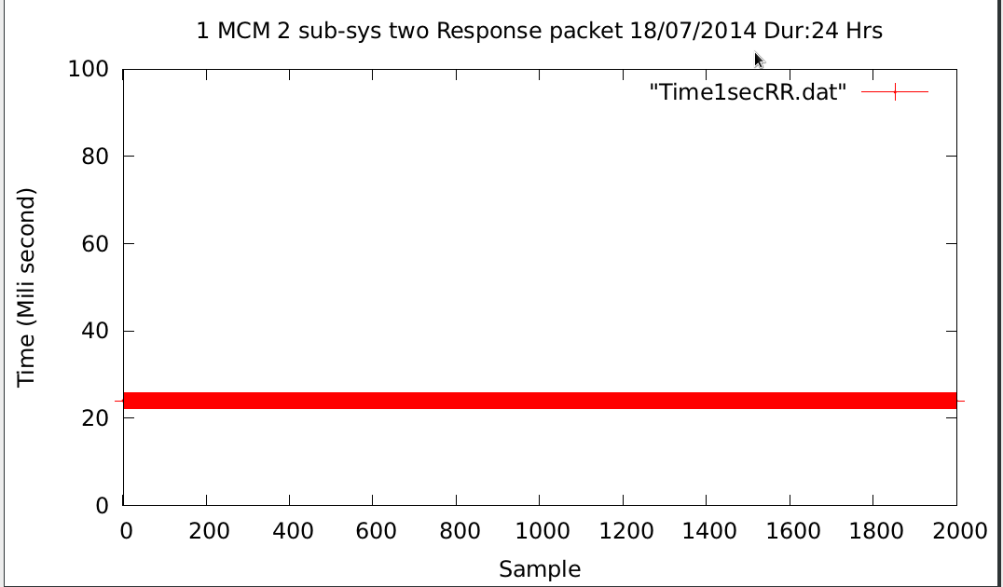
Fig(9): Time between 2 Response when two sub-system configured in one MCM card

Plots above shows that when we were connecting Online_v2 with 8 antenna Mcm cards using small 8 port unmanageable switch, Online_v2 had seen major drop out of response packets. Once we shifted our lab set up to a L3 network switch isolating MCM system sub-net with rest of GMRT sub-net, we observed zero drop out of response packets.

Antenna Testing of Online_v2 software :

- Four MCM cards were installed at C03,C06,S04 & S02. They were communicating very well with Online_v2, sending monitoring response every 1 second time interval.

- C03 rabbit MCM card was connected with a temperature sensor which was sending Antenna shell temperature every 1 second.

- We then moved all MCM cards to central square antenna for out testing. We installed MCM cards at C01,C03,C04,C06 and C09. All MCM were working fine, communicating with Online_v2 without any problem.

- After testing Online_v2 software with individual MCM cards, we tested Online_v2 core software during April-2014 & October-2014 maintenance period.

- Successfully tested two antenna sub-system at C06 antenna during April-2014 :

Date of Testing : 4th April 2014
Date of closed loop testing : 7th April 2014

During April-2014 MTAC period, we have successfully tested two antenna sub-systems at C06 antenna. We have installed HP make L2 Ethernet switch and two Rabbit MCM cards at C06 for control and monitor of Broadband OF system and Sentinel system.
1. Broadband OF system testing:
The first level control and monitoring of Broadband OF system has been tested by interfacing Rabbit MCM with OF system hardware. The command for RF attenuation was send from all three paths,
1.1. Python environment - ONLINE-V2 - Rabbit MCM - OF hardware.
1.2. GUI environment - ONLINE-V2 - Rabbit MCM - OF hardware.
1.3. Terminal environment - ONLINE-V2 - Rabbit MCM - OF hardware.
The attenuation value was set by sending command to Rabbit MCM card in range of 0 to 31 dB, in step size of 1 dB. The RF power was going down by 2dB for entire range of attenuation values. This test was done in telemetry lab as well as C06 antenna shell. The changes in attenuation were reflecting in RF power at antenna base (OF Tx output port) and receiver room OF system (OF Rx Mon port) on spectrum analyzer.
2. Sentinel System Testing:
The control port of Rabbit MCM for sentinel system was tested by connecting 32 bit LED test jig. The digital mask was send to Rabbit MCM by three paths mentioned above. The shell temperature was monitored by connecting temperature sensor to channel 1 of MCM monitoring port. The temperature reading was displayed on ONLINE-V2 shared memory.
The OF system group was involved in setting up OF system and successful completion of testing.
- Successfully tested 3 antenna 2 sub-system at C01, C04 & C06 antenna

Date of Testing : 8th October 2014 – 11th October 2014- Online_v2 Team members

During October-2014 MTAC period, we have successfully tested three antenna two sub-systems at C01,C04 and C06 antenna. We have installed CISCO & HP make L2 Ethernet switch and two Rabbit MCM cards at C01,C04 & C06 for control and monitor of Broadband OF system and Sentinel system.

1. Broadband OF system testing:
The first level control and monitoring of Broadband OF system has been tested by interfacing Rabbit MCM with OF system hardware. The command for RF attenuation was send from all three paths,
1.1. Python environment - ONLINE-V2 - Rabbit MCM - OF hardware.
1.2. GUI environment - ONLINE-V2 - Rabbit MCM - OF hardware.
1.3. Terminal environment - ONLINE-V2 - Rabbit MCM - OF hardware.
The attenuation value was set by sending command to Rabbit MCM card in range of 0 to 31 dB, in step size of 1 dB. The RF power was going down by 2dB for entire range of attenuation values. This test was done in telemetry lab as well as C06 antenna shell. The changes in attenuation were reflecting in RF power at antenna base (OF Tx output port) and receiver room OF system (OF Rx Mon port) on spectrum analyzer.
2. Sentinel System Testing:
The control port of Rabbit MCM for sentinel system was tested by connecting 32 bit LED test jig. The digital mask was send to Rabbit MCM by three paths mentioned above. The shell temperature was monitored by connecting temperature sensor to channel 1 of MCM monitoring port. The temperature reading was displayed on ONLINE-V2 shared memory.
The OF system group was involved in setting up OF system and successful completion of testing.

Snapshot of the Online_v2-Python_Environment-MCM testing :
Python Environment user 2 :
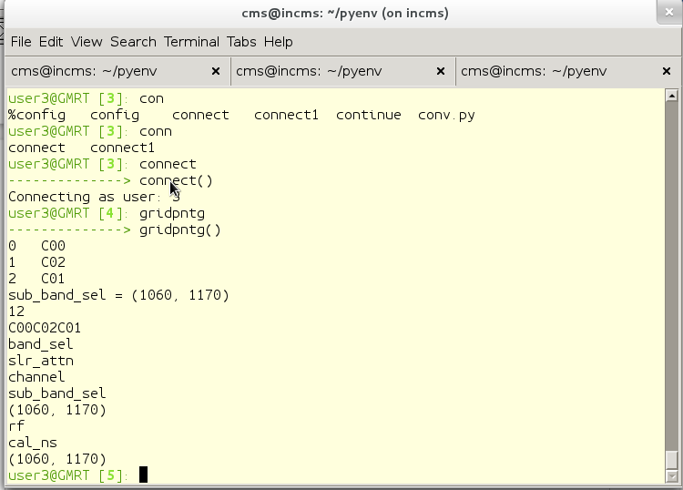
Output of Online_V2 screen :
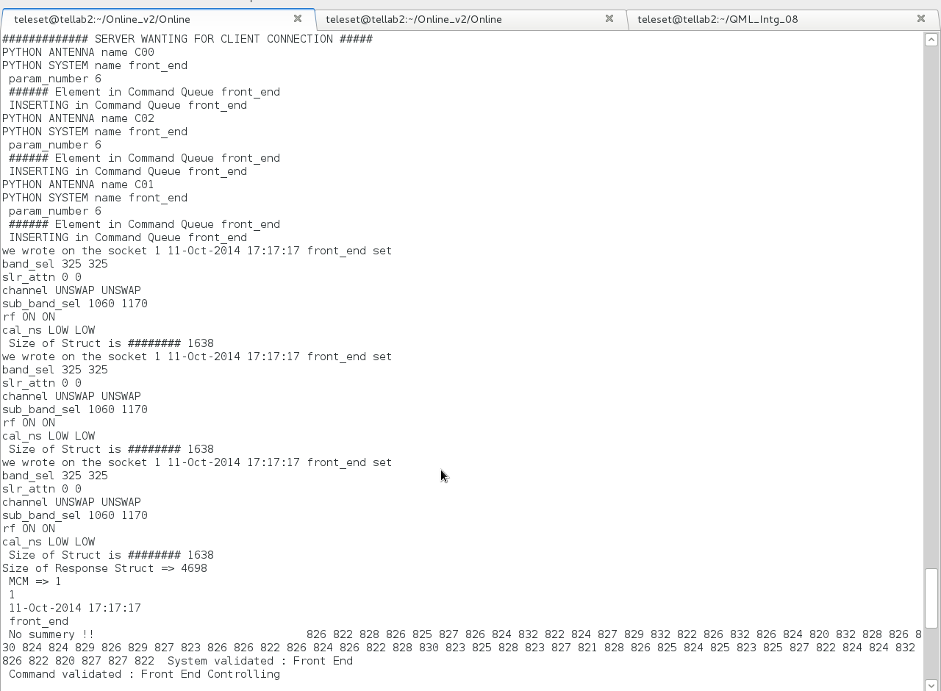
Python Environment user 3 : Procedure from User3
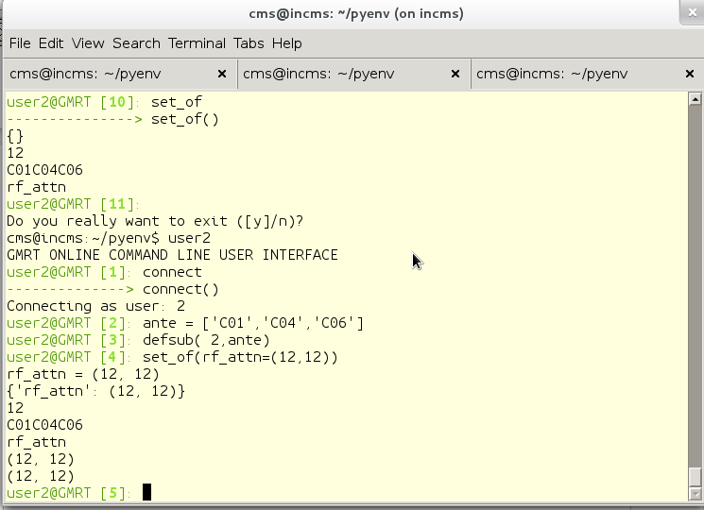
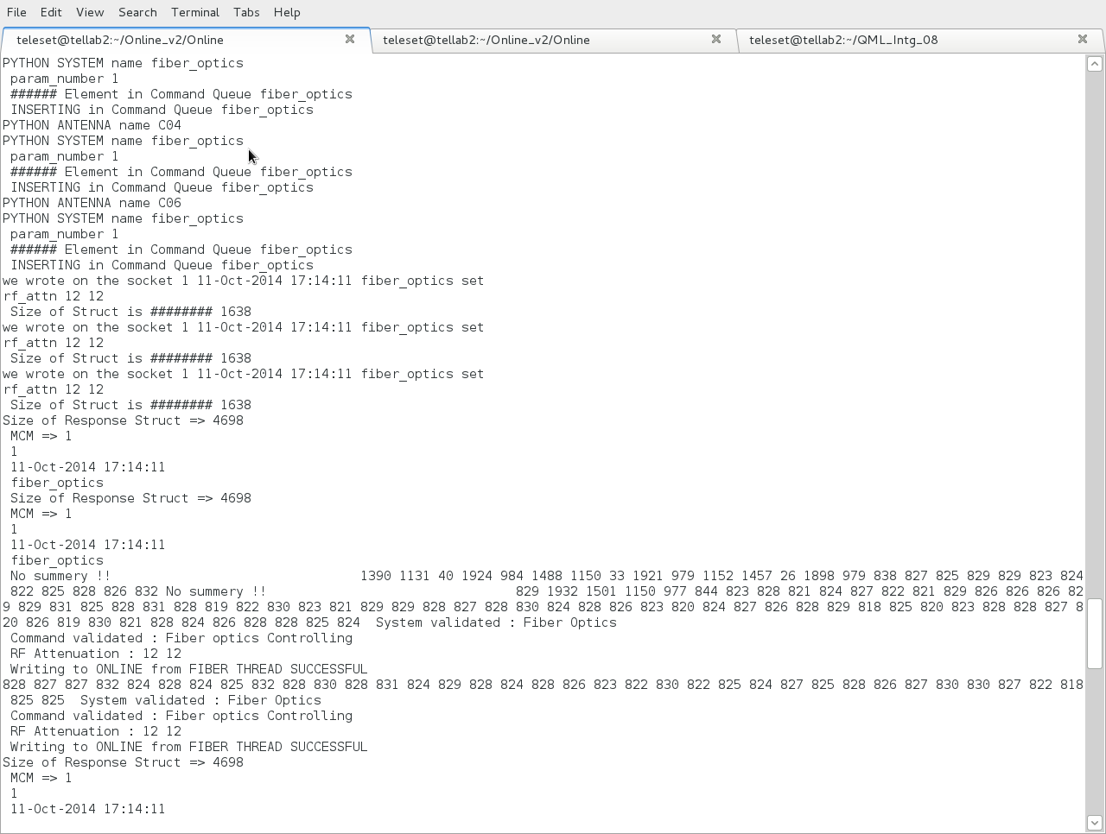
Online_V2 output Screen :

TOP Output :
With around 15 antenna sub-system connected to Online_v2, TOP output shows that Online_V2 program uses only 0.3% of CPU and 0.9% of Memory.
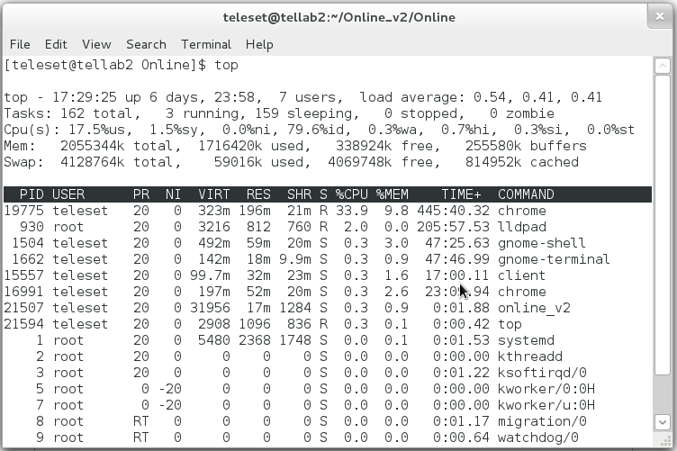
=> We also tested the stability and robustness of Online_v2 and Python environment by giving commands from user2 and user3 at a interval of 0.1 and 0.5 seconds. Both programs were able to executed commands without any problem.

Successfully tested GAB and Front end system in Lab :

Date of Testing : 5th September 2014 to 23rd September 2014

During September month, we have successfully tested GAB & FE sub-systems in respective Labs. The command for FE & GAB setting was sent from :

- GUI environment – ONLINE_V2 – Rabbit MCM – FE / GAB hardware.

- Terminal environment – ONLINE_V2 – Rabbit MCM – FE / GAB hardware.

- Front End system testing : The first level control of Front end system has been tested by interfacing Rabbit MCM with front end system hardware in FE lab. The control setting values were set by sending command to Rabbit MCM card. All changes were reflected on spectrum analyzer.

Commands tested for Front end system :

1. Frequency band 50-1420 MHZ 50-1420 MHZ
2. Solar attenuation 0 db- terminate 0 db-terminate
3. Channel swap/unswap swap/unswap
4. Sub band selection subband1-subband4 subband1-subband4
5. RF On/Off On/Off
6. calibrator noise Low/High/Med/ExHigh Low/High/Med/ExHigh

- GAB System Testing : The first level control GAB system has been tested by interfacing Rabbit MCM with GAB system hardware in ABR lab. The control setting values were set by sending command to Rabbit MCM card. All changes were reflected on spectrum analyzer. The FE and GAB system group was involved in setting up GAB & FE system and successful completion of testing.
Commands tested for GAB system :

1. Reference LO 10-105 MHZ 10-105 MHZ
2. LO 600-17000 KHZ 600-17000 KHZ
3. Attenuation 10 db 10 db
4. Filter 8 8
5. LPF 0 0
6. Source Siggen Synthesizer
7. Signal Antenna Noise
8. Path Direct Mixer
9. Channel 1 2

Online_V2 interfacing with GWB correlator via GPU DAS server :

Test done on 23/04/2014 Time : 10 AM to 11 AM

Online_V2 & GPU Dasserver executed on oper2 (IP 192.168.1.14 machine ).

************ Online_V2 Terminal display ****************

[observer@oper2 Online]$ ./online_v2

msgget: Calling msgget(0xc9,01600)
msgget: msgget succeeded: msqid = 0
Successfully Created MESSAGE QUEUE ID=0
############# SERVER WANTING FOR CLIENT CONNECTION #####
==> SERVO SERVER WANTING FOR CLIENT CONNECTION ===>### SERVER WANTING FOR GUI CLIENT TO CONNECT #####
$$$ SERVER WANTING FOR PYTHON ENVIRONMENT CLIENT TO CONNECT $$$$

>> dasinit

CMD[0] => dasinit
DAS INIT
Message Sent=>0 0 das init 1 7FFFFFFE F /home/observer/Online_v2/gpu.hdr
waiting for ack id 2
ACK Got from DASSERVER : ack
SUCCEDED

Online_v2–Servo test with actual hardware in SSL lab :
Date : 22/12/2014 Time : 11.40 AM to 12.30 PM

Test done by : Mr. Thiyagu & Mr. Raju

PC104 Card with servo program kept in SSL lab with actual hardware connected.

PC104 card IP : 192.168.8.42

Online_v2 server IP : 192.168.8.45

############# SERVER WANTING FOR CLIENT CONNECTION #####
ACCEPTED CONNECTION C00 Servo System 192.168.8.42
SERVO thread opened succesfully=> 0

C00 servo hold // commands issued from Online_v2 terminal

CMD[0] => C00
CMD[1] => servo
CMD[2] => hold
Command for C00 ANTENNA
ANTENNA C00 C00
System servo
OP NAME hold
********** hold
###### Element in Command Queue servo
we wrote on the socket 12 servo hold
ax B
Size of Struct is ######## 1126
INSERTING in Command Queue servo

>> we wrote on the socket 12 22-Dec-2014 12:03:03 servo hold
ax B
Size of Struct is ######## 1126
Size of Response Struct is ######## 2192
SEQ number is 12
Timestamp is 22-Dec-2014 12:03:03
System name is servo
Response code is 1
Response type is 1
Command Received
Command Received
Writing IMMEDIATE to ONLINE from SERVO THREAD SUCCESSFUL
Size of Response Struct is ######## 2192
SEQ number is 12
Timestamp is 22-Dec-2014 12:03:03
System name is servo
Response code is 2
Response type is 1
Servo Final Resp: Command SUCCESS
Servo Final Resp: Command SUCCESS
Writing FINAL RESPONSE to ONLINE from SERVO THREAD SUCCESSFUL

Servo-Online_V2 successful interface testing at C01 antenna

Date : 29/12/2014
Time : 14.00 PM to 15.00 PM
Persons : Mr. Thiyagu & Mr.Raju

[raju@localhost Online]$ ./online_v2
HIGHUSER thread CREATED=> 0
SERVO thread CREATED=> 0
GUI INTERFACE thread CREATED=> 0
PYTHON INTERFACE thread CREATED=> 0
### SERVER WANTING FOR GUI CLIENT TO CONNECT #####
==> SERVO SERVER WANTING FOR CLIENT CONNECTION ===>$$$ SERVER WANTING FOR PYTHON ENVIRONMENT CLIENT TO CONNECT $$$$
MCM SYSTEM thread CREATED=> 0

msgget: Calling msgget(0xc9,01600)
msgget: msgget succeeded: msqid = 0
Sucessfully Created MESSAGE QUEUE ID=0
############# SERVER WANTING FOR CLIENT CONNECTION #####

>> ACCEPTED CONNECTION C01 Servo System 192.168.4.3
SERVO thread opened succesfully=>
C01 servo track // commands issued from Online_v2 terminal

CMD[0] => C01
CMD[1] => servo
CMD[2] => track
Command for C01 ANTENNA
ANTENNA C01 C01
System servo
OP NAME track
********** track
###### Element in Command Queue servo

>> we wrote on the socket 11 29-Dec-2014 14:35:20 servo track
ax B
time 16:00:00
ang1 115:00:00
ang2 90:00:00
Size of Struct is ######## 1126
Size of Response Struct is ######## 2192
SEQ number is 11
Timestamp is 29-Dec-2014 14:35:20
System name is servo
Response code is 1
Response type is 1
Command Received
Command Received
Writing IMMEDIATE to ONLINE from SERVO THREAD SUCCESSFUL
Size of Response Struct is ######## 2192
SEQ number is 11
Timestamp is 29-Dec-2014 14:35:20
System name is servo
Response code is 2
Response type is 1
Servo Final Resp: Command SUCCESS
Servo Final Resp: Command SUCCESS
Writing FINAL RESPONSE to ONLINE from SERVO THREAD SUCCESSFUL

Summary :
- Online_v2 core software has been successfully tested with multiple sub-system, it has the potential to grow as a replacement for current online system.
- Online_v2 has been interfaced with Python environment, QML/QT GUI and readline based terminal, which makes Online_v2 suitable for automated operation of GMRT telescope.
- Online_v2 has been thoroughly tested in Telemetry Lab for past two years and it runs without any problem.
- Online_v2 has been installed in GMRT correlator Lab where Mr. Harshwardhan Reddy is using it for his GWB correlator Lab testing, He has found Online_v2 very easy to use.
- Online_v2 has been successfully tested with Servo system PC104 over Ethernet communication at Servo Lab as well as C01 antenna.
- Online_v2 has been developed In house, so it will be very easy to change, maintain & upgrade the Online_v2 software.

References :
1. http://vichargrave.com
2. Online_V2 - An Upgraded Control-Monitor Software for GMRT MwSky Poster.
3. TELESET-ABCCOM software Technical report by Laurent Pommier .

Appendix :
Structure used for Online_v2 -DAS server interfacing :
Msgtag structure is declared in display.h in present Online code which is used by Online to pass DAS command DAS server :

# display.h

typedef struct
{
long type;
char buff[256];
} msgtag;

DAS Server side :

Message queue structure

typedef struct
{
long msglevel;
protocolType prot;
char buf[MsgSz];
} MsgBufType;
typedef unsigned char UNC;
typedef unsigned short UNS;
typedef short SHRT;
typedef unsigned long UNL;
typedef unsigned int UNL;

typedef struct ProtTag
{
UNC origin; /* MSG Originating station */
UNC dest; /* Destination station */
UNC type; /* The type of req, eg. Sh_com,RPC,FileIO,DAS,etc.*/
UNC cmd; /* Actual service name or shell command. */
UNC arg[4]; /*Used as a parameter of any type that can be coded in 4 bytes. */
UNC id; /* Request no, from the origin, wraps at 2^8 */
UNC flag; /* Flags of queries or replies */
UNS usrflag; /* Any short val or set of flags for user */
UNL len; /* Length of the packet that follows */
} ProtocolType;

online.h structure used in writing DAS project file & scan file :

typedef struct {
float i;
float q;
float u;
float v;
} POL_FLUX;

typedef struct {
char object[32];
POL_FLUX flux;
double mjd0;
double ra_app, dec_app, ra_date, dec_date, dra,ddec; /* rad, rad/s */
double freq[2];
double first_lo[2];
double bb_lo[2];
double rest_freq[2];
double lsrvel[2]; /* Hz, km/s */
double ch_width; /* Hz */
int id;
int net_sign[4];
int mode;
int dum1;
unsigned int antmask;
unsigned short bandmask,dum2;
short calcode, qual;
} SourceParType; // sizeof(SourceParType) to be written in scan.hdr.

typedef struct {
char code[8];
char observer[32];
char title[32];
unsigned int antmask;
unsigned short bandmask,seq;
} ProjectType; // sizeof(ProjectType) to be written in Proj.hdr.

typedef struct {
int status;
float t; /* program dependent meaning ! */
ProjectType proj;
SourceParType source;
} ScanInfoType;

typedef struct {
char datafile[80];
int das_sub_state;
int cmd_no;
ScanInfoType cntl;
} DAS_SUB_CNTL;

typedef struct {
char config_file[80];
int msg_id;
int das_state;
int das_sub_state[MAX_DAS_SUB];
DAS_SUB_CNTL sub_cntl[MAX_DAS_SUB];
} DAS_CNTL;

Command – Response between Online_v2 & DAS server :
>> dasinit

CMD[0] => dasinit
DAS INIT
Message Sent=>0 0 das init 1 7FFFFFFE F /home/observer/Online_v2/gpu.hdr
waiting for ack id 2
ACK Got from DASSERVER : ack
SUCCEDED

>> addp

CMD[0] => addp
ADD Project
Message Sent=>4 1 das addp 1 /home/observer/Online_v2/proj.hdr
waiting for ack id 2
ACK Got from DASSERVER : ack
waiting for success is 2
waiting for success is 2
waiting for success is 2
SUCCEDED

>> startscan

CMD[0] => startscan
DAS START SCAN
Message Sent=>4 2 das start /home/observer/Online_v2/scan.hdr
waiting for ack id 2
ACK Got from DASSERVER : ack
waiting for success is 2
waiting for success is 2
waiting for success is 2
waiting for success is 2
waiting for success is 2
waiting for success is 2
SUCCEDED

>> stopscan

CMD[0] => stopscan
DAS STOP SCAN
Message Sent=>4 3 das stop
waiting for ack id 2
ACK Got from DASSERVER : ack
waiting for success is 2
waiting for success is 2
waiting for success is 2
waiting for success is 2
waiting for success is 2
SUCCEDED

>> startscan

CMD[0] => startscan
DAS START SCAN
Message Sent=>4 2 das start /home/observer/Online_v2/scan.hdr
waiting for ack id 2
ACK Got from DASSERVER : ack
waiting for success is 2
waiting for success is 2
waiting for success is 2
waiting for success is 2
waiting for success is 2
waiting for success is 2
waiting for success is 2
SUCCEDED
>> stopscan

CMD[0] => stopscan
DAS STOP SCAN
Message Sent=>4 3 das stop
waiting for ack id 2
ACK Got from DASSERVER : ack
waiting for success is 2
waiting for success is 2
waiting for success is 2
waiting for success is 2
SUCCEDED

>> startscan

CMD[0] => startscan
DAS START SCAN
Message Sent=>4 2 das start /home/observer/Online_v2/scan.hdr
waiting for ack id 2
ACK Got from DASSERVER : ack
waiting for success is 2
waiting for success is 2
waiting for success is 2
waiting for success is 2
waiting for success is 2
SUCCEDED

>> stopscan

CMD[0] => stopscan
DAS STOP SCAN
Message Sent=>4 3 das stop
waiting for ack id 2
ACK Got from DASSERVER : ack
waiting for success is 2
waiting for success is 2
waiting for success is 2
waiting for success is 2
waiting for success is 2
waiting for success is 2
waiting for success is 2
SUCCEDED

>> startscan
CMD[0] => startscan
DAS START SCAN
Message Sent=>4 2 das start /home/observer/Online_v2/scan.hdr
waiting for ack id 2
ACK Got from DASSERVER : ack
waiting for success is 2
waiting for success is 2
waiting for success is 2
waiting for success is 2
waiting for success is 2
SUCCEDED

**********GPU DASSERVER TERMINAL DISPLAY ********

[observer@oper2 dassrv-gpu]$ ./dassrv
>> Reading configuration from /home/observer/corrsel.hdr
##### INFO CorrBandMask 0[3] 1[3] 2[3] 3[3]
DPCMODE=UsbPolar Corr0Mask=3 Corr1Mask=3 Corr2Mask=3
All the stale messages cleared
Cmd Recvd: 0 0 das init 1 7FFFFFFE F /home/observer/Online_v2/gpu.hdr
During Assignment PTAB->Corr_id is 0
#### 1 7ffffffe f /home/observer/Online_v2/gpu.hdr
MAP MASK O_ANTMASK =>7ffffffe
MAP MASK D_ANTMASK =>3fffffff
got 1328 bytes from /home/observer/Online_v2/gpu.hdr
got 1328 bytes from /home/observer/Online_v2/gpu.hdr
got 1328 bytes from /home/observer/Online_v2/gpu.hdr
got 1328 bytes from /home/observer/Online_v2/gpu.hdr
To CorrA: AcqNode, CmdDest=0, CmdId=0, CmdType=DAS, Cmd=init, param=1 7FFFFFFE F /home/observer/Online_v2/gpu.hdr
CorrId=1
CorrId=1
open 1 Corr CorrA Port 6001
Waiting for CorrA to acknowledge..... OK! Got 16
13 F=16 S=8
'SUCCEDED' sent to ONLINE
Cmd Recvd: 4 1 das addp 1 /home/observer/Online_v2/proj.hdr
During Assignment PTAB->Corr_id is 0
got 80 bytes from /home/observer/Online_v2/proj.hdr
MAP MASK O_ANTMASK =>7ffffffe
MAP MASK D_ANTMASK =>3fffffff
CorrA :AddProjReq for TEST 3fffffff 3 3
IN ADDPROJECT PTAB->Corr_id is 0
To CorrA: AcqNode, CmdDest=1, CmdId=0, CmdType=DAS, Cmd=addp, param=1 /home/observer/Online_v2/proj.hdr
CorrId=1
13 F=16 S=8
'SUCCEDED' sent to ONLINE
IN Main ADDPROJECT PTAB->Corr_id is 1
Cmd Recvd: 4 2 das start /home/observer/Online_v2/scan.hdr
During Assignment PTAB->Corr_id is 1
got 232 bytes from /home/observer/Online_v2/scan.hdr
MAP MASK O_ANTMASK =>7ffffffe
MAP MASK D_ANTMASK =>3fffffff
====> Source Antmask is 7ffffffe ====>d_antmask is 3fffffff
====> Source Antmask is 3fffffff ====>d_antmask is 3fffffff
CorrA : StartReq for Code TEST AntMask 3fffffff BandMask 3
To CorrA: AcqNode, CmdDest=2, CmdId=0, CmdType=DAS, Cmd=start, param=/home/observer/Online_v2/scan.hdr
CorrId=1
13 F=16 S=8
'SUCCEDED' sent to ONLINE
Cmd Recvd: 4 3 das stop
During Assignment PTAB->Corr_id is 1
CorrA : StopReq for Project TEST
To CorrA: AcqNode, CmdDest=3, CmdId=0, CmdType=DAS, Cmd=stop, param=
CorrId=1
13 F=16 S=8
'SUCCEDED' sent to ONLINE

Cmd Recvd: 0 4 das delp 1
During Assignment PTAB->Corr_id is 0
SubArray 0: No Project or Bad CorrId
Error Number -1
'FAILED' sent to ONLINE
Cmd Recvd: 0 5 das fini 1
During Assignment PTAB->Corr_id is 0
To CorrA: AcqNode, CmdDest=5, CmdId=0, CmdType=DAS, Cmd=fini, param=1
CorrId=1
13 F=16 S=8
'SUCCEDED' sent to ONLINE
Command – Response between Online_v2 & PC04 servo system at Jogshed Lab :
C00 servo track // commands issued from Online_v2 terminal

CMD[0] => C00
CMD[1] => servo
CMD[2] => track
Command for C00 ANTENNA
ANTENNA C00 C00
System servo
OP NAME track
********** track
###### Element in Command Queue servo
we wrote on the socket 11 servo track
ax B
time 15:30:00
ang1 180:00:00
ang2 19:00:00
Size of Struct is ######## 1126
INSERTING in Command Queue servo

>> we wrote on the socket 11 22-Dec-2014 12:03:12 servo track
ax B
time 15:30:00
ang1 180:00:00
ang2 19:00:00
Size of Struct is ######## 1126
Size of Response Struct is ######## 2192
SEQ number is 11
Timestamp is 22-Dec-2014 12:03:12
System name is servo
Response code is 1
Response type is 1
Command Received
Command Received
Writing IMMEDIATE to ONLINE from SERVO THREAD SUCCESSFUL
Size of Response Struct is ######## 2192
SEQ number is 11
Timestamp is 22-Dec-2014 12:03:12
System name is servo
Response code is 2
Response type is 2
Servo Final Resp: Command IRREVELENT // As elevation axis was not there
Servo Final Resp: Command IRREVELENT
Writing FINAL RESPONSE to ONLINE from SERVO THREAD SUCCESSFUL

C00 servo readanavar // commands issued from Online_v2 terminal

CMD[0] => C00
CMD[1] => servo
CMD[2] => readanavar
Command for C00 ANTENNA
ANTENNA C00 C00
System servo
OP NAME readanavar
readanavar
###### Element in Command Queue servo
we wrote on the socket 21 servo readanavar
Size of Struct is ######## 1126
INSERTING in Command Queue servo

>> we wrote on the socket 21 22-Dec-2014 12:03:41 servo readanavar
Size of Struct is ######## 1126
Size of Response Struct is ######## 2192
SEQ number is 21
Timestamp is 22-Dec-2014 12:03:41
System name is servo
Response code is 1
Response type is 1
Command Received
Command Received
Writing IMMEDIATE to ONLINE from SERVO THREAD SUCCESSFUL
Size of Response Struct is ######## 2192
SEQ number is 21
Timestamp is 22-Dec-2014 12:03:41
System name is servo
Response code is 4
Response type is 1
Servo Analog Data
time
14:59:00
az_motor1_current
+0001.2695
az_motor2_current
+0001.2695
az_tacho1
+0001.1484
az_tacho2
+0001.1484
el_motor1_current
+0001.2695
el_motor2_current
+0001.2695
el_tacho1
+0001.1484
el_tacho2
+0001.1484
Writing FINAL RESPONSE to ONLINE from SERVO THREAD SUCCESSFUL

C00 servo readdigvar // commands issued from Online_v2 terminal

CMD[0] => C00
CMD[1] => servo
CMD[2] => readdigvar
Command for C00 ANTENNA
ANTENNA C00 C00
System servo
OP NAME readdigvar
readdigvar
###### Element in Command Queue servo
we wrote on the socket 22 servo readdigvar
Size of Struct is ######## 1126
INSERTING in Command Queue servo

>> we wrote on the socket 22 22-Dec-2014 12:04:46 servo readdigvar
Size of Struct is ######## 1126
Size of Response Struct is ######## 2192
SEQ number is 22
Timestamp is 22-Dec-2014 12:04:46
System name is servo
Response code is 1
Response type is 1
Command Received
Command Received
Writing IMMEDIATE to ONLINE from SERVO THREAD SUCCESSFUL
Size of Response Struct is ######## 2192
SEQ number is 22
Timestamp is 22-Dec-2014 12:04:46
System name is servo
Response code is 4
Response type is 1
Servo Digital Status
time
15:00:05
az_run
1
az_aol
0
az_brk
0
az_ccp
0
az_ccf
0
az_cpl
0
az_cfl
0
az_cwr
1
az_enc
0
az_ac
1
el_run
1
el_aol
0
el_brk
0
el_dnp
1
el_dnf
1
el_upp
0
el_upf
0
el_std
0
el_str
1
el_stp
0
el_enc
0
el_ac
1
mode
REMOTE
w50
0
w80
0
pos

trk
TRACKING
slw

ssc
1
dc
0
Writing FINAL RESPONSE to ONLINE from SERVO THREAD SUCCESSFUL

C00 servo abort // commands issued from Online_v2 terminal

CMD[0] => C00
CMD[1] => servo
CMD[2] => abort
Command for C00 ANTENNA
ANTENNA C00 C00
System servo
OP NAME abort
abort
###### Element in Command Queue servo
we wrote on the socket 18 servo abort
Size of Struct is ######## 1126
INSERTING in Command Queue servo

>> we wrote on the socket 18 22-Dec-2014 12:05:40 servo abort
Size of Struct is ######## 1126
Size of Response Struct is ######## 2192
SEQ number is 18
Timestamp is 22-Dec-2014 12:05:40
System name is servo
Response code is 1
Response type is 1
Command Received
Command Received
Writing IMMEDIATE to ONLINE from SERVO THREAD SUCCESSFUL
Size of Response Struct is ######## 2192
SEQ number is 18
Timestamp is 22-Dec-2014 12:05:40
System name is servo
Response code is 2
Response type is 2
Servo Final Resp: Command IRREVELENT
Servo Final Resp: Command IRREVELENT
Writing FINAL RESPONSE to ONLINE from SERVO THREAD SUCCESSFUL

C00 servo position // commands issued from Online_v2 terminal

CMD[0] => C00
CMD[1] => servo
CMD[2] => position
Command for C00 ANTENNA
ANTENNA C00 C00
System servo
OP NAME position
********** position
###### Element in Command Queue servo
we wrote on the socket 13 servo position
ax B
ang1 90:00:00
ang2 45:00:00
Size of Struct is ######## 1126
INSERTING in Command Queue servo

>> we wrote on the socket 13 22-Dec-2014 12:06:06 servo position
ax B
ang1 90:00:00
ang2 45:00:00
Size of Struct is ######## 1126
Size of Response Struct is ######## 2192
SEQ number is 13
Timestamp is 22-Dec-2014 12:06:06
System name is servo
Response code is 1
Response type is 1
Command Received
Command Received
Writing IMMEDIATE to ONLINE from SERVO THREAD SUCCESSFUL
Size of Response Struct is ######## 2192
SEQ number is 13
Timestamp is 22-Dec-2014 12:06:06
System name is servo
Response code is 2
Response type is 2
Servo Final Resp: Command IRREVELENT
Servo Final Resp: Command IRREVELENT
Writing FINAL RESPONSE to ONLINE from SERVO THREAD SUCCESSFUL

C00 servo readangles // commands issued from Online_v2 terminal

CMD[0] => C00
CMD[1] => servo
CMD[2] => readangles
Command for C00 ANTENNA
ANTENNA C00 C00
System servo
OP NAME readangles
readangles
###### Element in Command Queue servo
we wrote on the socket 20 servo readangles
Size of Struct is ######## 1126
INSERTING in Command Queue servo

>> we wrote on the socket 20 22-Dec-2014 12:07:11 servo readangles
Size of Struct is ######## 1126
Size of Response Struct is ######## 2192
SEQ number is 20
Timestamp is 22-Dec-2014 12:07:11
System name is servo
Response code is 1
Response type is 1
Command Received
Command Received
Writing IMMEDIATE to ONLINE from SERVO THREAD SUCCESSFUL
Size of Response Struct is ######## 2192
SEQ number is 20
Timestamp is 22-Dec-2014 12:07:11
System name is servo
Response code is 4
Response type is 1
Servo Angles Data
time
15:02:30
az_cp
+001:58:40
az_tp
+090:00:00
el_cp
-001:58:40
el_tp
-001:58:40
Writing FINAL RESPONSE to ONLINE from SERVO THREAD SUCCESSFUL

C00 servo stop // commands issued from Online_v2 terminal

CMD[0] => C00
CMD[1] => servo
CMD[2] => stop
Command for C00 ANTENNA
ANTENNA C00 C00
System servo
OP NAME stop
********** stop
###### Element in Command Queue servo
we wrote on the socket 14 servo stop
ax B
Size of Struct is ######## 1126
INSERTING in Command Queue servo

>> we wrote on the socket 14 22-Dec-2014 12:08:00 servo stop
ax B
Size of Struct is ######## 1126
Size of Response Struct is ######## 2192
SEQ number is 14
Timestamp is 22-Dec-2014 12:08:00
System name is servo
Response code is 1
Response type is 1
Command Received
Command Received
Writing IMMEDIATE to ONLINE from SERVO THREAD SUCCESSFUL
Size of Response Struct is ######## 2192
SEQ number is 14
Timestamp is 22-Dec-2014 12:08:00
System name is servo
Response code is 2
Response type is 2
Servo Final Resp: Command IRREVELENT
Servo Final Resp: Command IRREVELENT
Writing FINAL RESPONSE to ONLINE from SERVO THREAD SUCCESSFUL

C00 servo readantstatus // commands issued from Online_v2 terminal

CMD[0] => C00
CMD[1] => servo
CMD[2] => readantstatus
Command for C00 ANTENNA
ANTENNA C00 C00
System servo
OP NAME readantstatus
readantstatus
###### Element in Command Queue servo
we wrote on the socket 24 servo readantstatus
Size of Struct is ######## 1126
INSERTING in Command Queue servo

>> we wrote on the socket 24 22-Dec-2014 12:08:29 servo readantstatus
Size of Struct is ######## 1126
Size of Response Struct is ######## 2192
SEQ number is 24
Timestamp is 22-Dec-2014 12:08:29
System name is servo
Response code is 1
Response type is 1
Command Received
Command Received
Writing IMMEDIATE to ONLINE from SERVO THREAD SUCCESSFUL
Size of Response Struct is ######## 2192
SEQ number is 24
Timestamp is 22-Dec-2014 12:08:29
System name is servo
Response code is 4
Response type is 1
Servo Anatenna State
time
15:03:48
az_state
StwRlsBkd
el_state
StwRlsBkd
Writing FINAL RESPONSE to ONLINE from SERVO THREAD SUCCESSFUL

C00 servo readversion // commands issued from Online_v2 terminal

CMD[0] => C00
CMD[1] => servo
CMD[2] => readversion
Command for C00 ANTENNA
ANTENNA C00 C00
System servo
OP NAME readversion
readversion
###### Element in Command Queue servo
we wrote on the socket 25 servo readversion
Size of Struct is ######## 1126
INSERTING in Command Queue servo

>> we wrote on the socket 25 22-Dec-2014 12:09:54 servo readversion
Size of Struct is ######## 1126
Size of Response Struct is ######## 2192
SEQ number is 25
Timestamp is 22-Dec-2014 12:09:54
System name is servo
Response code is 1
Response type is 1
Command Received
Command Received
Writing IMMEDIATE to ONLINE from SERVO THREAD SUCCESSFUL
Size of Response Struct is ######## 2192
SEQ number is 25
Timestamp is 22-Dec-2014 12:09:54
System name is servo
Response code is 4
Response type is 1
Servo Software Version
time
15:05:13
Version
2.6
Station Number
C10
Writing FINAL RESPONSE to ONLINE from SERVO THREAD SUCCESSFUL
Command – Response between Online_v2 & PC04 servo system at C01 :

C01 servo hold // commands issued from Online_v2 terminal

CMD[0] => C01
CMD[1] => servo
CMD[2] => hold
Command for C01 ANTENNA
ANTENNA C01 C01
System servo
OP NAME hold
********** hold
###### Element in Command Queue servo
we wrote on the socket 12 servo hold
ax B
Size of Struct is ######## 1126
INSERTING in Command Queue servo

>> we wrote on the socket 12 29-Dec-2014 14:31:26 servo hold
ax B
Size of Struct is ######## 1126
Size of Response Struct is ######## 2192
SEQ number is 12
Timestamp is 29-Dec-2014 14:31:26
System name is servo
Response code is 1
Response type is 1
Command Received
Command Received
Writing IMMEDIATE to ONLINE from SERVO THREAD SUCCESSFUL
Size of Response Struct is ######## 2192
SEQ number is 12
Timestamp is 29-Dec-2014 14:31:26
System name is servo
Response code is 2
Response type is 1
Servo Final Resp: Command SUCCESS
Servo Final Resp: Command SUCCESS
Writing FINAL RESPONSE to ONLINE from SERVO THREAD SUCCESSFUL

C01 servo position // commands issued from Online_v2 terminal

CMD[0] => C01
CMD[1] => servo
CMD[2] => position
Command for C01 ANTENNA
ANTENNA C01 C01
System servo
OP NAME position
###### Element in Command Queue servo
we wrote on the socket 13 servo position
ax B
ang1 100:00:00
ang2 45:00:00
Size of Struct is ######## 1126
INSERTING in Command Queue servo

>> we wrote on the socket 13 29-Dec-2014 14:32:04 servo position
ax B
ang1 100:00:00
ang2 45:00:00
Size of Struct is ######## 1126
Size of Response Struct is ######## 2192
SEQ number is 13
Timestamp is 29-Dec-2014 14:32:04
System name is servo
Response code is 1
Response type is 1
Command Received
Command Received
Writing IMMEDIATE to ONLINE from SERVO THREAD SUCCESSFUL
Size of Response Struct is ######## 2192
SEQ number is 13
Timestamp is 29-Dec-2014 14:32:04
System name is servo
Response code is 2
Response type is 1
Servo Final Resp: Command SUCCESS
Servo Final Resp: Command SUCCESS
Writing FINAL RESPONSE to ONLINE from SERVO THREAD SUCCESSFUL

>> C01 servo readangles // commands issued from Online_v2 terminal

CMD[0] => C01
CMD[1] => servo
CMD[2] => readangles
Command for C01 ANTENNA
ANTENNA C01 C01
System servo
OP NAME readangles
readangles
###### Element in Command Queue servo
we wrote on the socket 20 servo readangles
Size of Struct is ######## 1126
INSERTING in Command Queue servo

>> we wrote on the socket 20 29-Dec-2014 14:33:58 servo readangles
Size of Struct is ######## 1126
Size of Response Struct is ######## 2192
SEQ number is 20
Timestamp is 29-Dec-2014 14:33:58
System name is servo
Response code is 1
Response type is 1
Command Received
Command Received
Writing IMMEDIATE to ONLINE from SERVO THREAD SUCCESSFUL
Size of Response Struct is ######## 2192
SEQ number is 20
Timestamp is 29-Dec-2014 14:33:58
System name is servo
Response code is 4
Response type is 1
Servo Angles Data
time
14:40:45
az_cp
+114:26:20
az_tp
+100:00:00
el_cp
+044:59:50
el_tp
+045:00:00
Writing FINAL RESPONSE to ONLINE from SERVO THREAD SUCCESSFUL

C01 servo readangles // commands issued from Online_v2 terminal

CMD[0] => C01
CMD[1] => servo
CMD[2] => readangles
Command for C01 ANTENNA
ANTENNA C01 C01
System servo
OP NAME readangles
readangles
###### Element in Command Queue servo
we wrote on the socket 20 servo readangles
Size of Struct is ######## 1126
INSERTING in Command Queue servo

>> we wrote on the socket 20 29-Dec-2014 14:34:41 servo readangles
Size of Struct is ######## 1126
Size of Response Struct is ######## 2192
SEQ number is 20
Timestamp is 29-Dec-2014 14:34:41
System name is servo
Response code is 1
Response type is 1
Command Received
Command Received
Writing IMMEDIATE to ONLINE from SERVO THREAD SUCCESSFUL
Size of Response Struct is ######## 2192
SEQ number is 20
Timestamp is 29-Dec-2014 14:34:41
System name is servo
Response code is 4
Response type is 1
Servo Angles Data
time
14:41:29
az_cp
+100:08:10
az_tp
+100:00:00
el_cp
+045:00:00
el_tp
+045:00:00
Writing FINAL RESPONSE to ONLINE from SERVO THREAD SUCCESSFUL

C01 servo track // commands issued from Online_v2 terminal

CMD[0] => C01
CMD[1] => servo
CMD[2] => track
Command for C01 ANTENNA
ANTENNA C01 C01
System servo
OP NAME track
********** track
###### Element in Command Queue servo
we wrote on the socket 11 servo track
ax B
time 16:00:00
ang1 115:00:00
ang2 90:00:00
Size of Struct is ######## 1126
INSERTING in Command Queue servo

>> we wrote on the socket 11 29-Dec-2014 14:35:20 servo track
ax B
time 16:00:00
ang1 115:00:00
ang2 90:00:00
Size of Struct is ######## 1126
Size of Response Struct is ######## 2192
SEQ number is 11
Timestamp is 29-Dec-2014 14:35:20
System name is servo
Response code is 1
Response type is 1
Command Received
Command Received
Writing IMMEDIATE to ONLINE from SERVO THREAD SUCCESSFUL
Size of Response Struct is ######## 2192
SEQ number is 11
Timestamp is 29-Dec-2014 14:35:20
System name is servo
Response code is 2
Response type is 1
Servo Final Resp: Command SUCCESS
Servo Final Resp: Command SUCCESS
Writing FINAL RESPONSE to ONLINE from SERVO THREAD SUCCESSFUL

C01 servo readanavar // commands issued from Online_v2 terminal

CMD[0] => C01
CMD[1] => servo
CMD[2] => readanavar
Command for C01 ANTENNA
ANTENNA C01 C01
System servo
OP NAME readanavar
readanavar
###### Element in Command Queue servo
we wrote on the socket 21 servo readanavar
Size of Struct is ######## 1126
INSERTING in Command Queue servo

>> we wrote on the socket 21 29-Dec-2014 14:35:41 servo readanavar
Size of Struct is ######## 1126
Size of Response Struct is ######## 2192
SEQ number is 21
Timestamp is 29-Dec-2014 14:35:41
System name is servo
Response code is 1
Response type is 1
Command Received
Command Received
Writing IMMEDIATE to ONLINE from SERVO THREAD SUCCESSFUL
Size of Response Struct is ######## 2192
SEQ number is 21
Timestamp is 29-Dec-2014 14:35:41
System name is servo
Response code is 4
Response type is 1
Servo Analog Data
time
14:42:29
az_motor1_current
+0001.2695
az_motor2_current
+0002.2460
az_tacho1
+0004.8808
az_tacho2
+0002.5839
el_motor1_current
+0000.2929
el_motor2_current
-0002.9296
el_tacho1
+0012.6328
el_tacho2
-0007.1777
Writing FINAL RESPONSE to ONLINE from SERVO THREAD SUCCESSFUL

C01 servo readdigvar // commands issued from Online_v2 terminal

CMD[0] => C01
CMD[1] => servo
CMD[2] => readdigvar
Command for C01 ANTENNA
ANTENNA C01 C01
System servo
OP NAME readdigvar
readdigvar
###### Element in Command Queue servo
we wrote on the socket 22 servo readdigvar
Size of Struct is ######## 1126
INSERTING in Command Queue servo

>> we wrote on the socket 22 29-Dec-2014 14:36:42 servo readdigvar
Size of Struct is ######## 1126
Size of Response Struct is ######## 2192
SEQ number is 22
Timestamp is 29-Dec-2014 14:36:42
System name is servo
Response code is 1
Response type is 1
Command Received
Command Received
Writing IMMEDIATE to ONLINE from SERVO THREAD SUCCESSFUL
Size of Response Struct is ######## 2192
SEQ number is 22
Timestamp is 29-Dec-2014 14:36:42
System name is servo
Response code is 4
Response type is 1
Servo Digital Status
time
14:43:29
az_run
1
az_aol
0
az_brk
0
az_ccp
0
az_ccf
0
az_cpl
0
az_cfl
0
az_cwr
1
az_enc
0
az_ac
1
el_run
1
el_aol
0
el_brk
0
el_dnp
0
el_dnf
0
el_upp
0
el_upf
0
el_std
0
el_str
1
el_stp
0
el_enc
0
el_ac
1
mode
REMOTE
w50
0
w80
0
pos

trk
TRACKING
slw

ssc
1
dc
0
Writing FINAL RESPONSE to ONLINE from SERVO THREAD SUCCESSFUL

>> C01 servo readantstatus // commands issued from Online_v2 terminal

CMD[0] => C01
CMD[1] => servo
CMD[2] => readantstatus
Command for C01 ANTENNA
ANTENNA C01 C01
System servo
OP NAME readantstatus
readantstatus
###### Element in Command Queue servo
we wrote on the socket 24 servo readantstatus
Size of Struct is ######## 1126
INSERTING in Command Queue servo

>> we wrote on the socket 24 29-Dec-2014 14:39:21 servo readantstatus
Size of Struct is ######## 1126
Size of Response Struct is ######## 2192
SEQ number is 24
Timestamp is 29-Dec-2014 14:39:21
System name is servo
Response code is 1
Response type is 1
Command Received
Command Received
Writing IMMEDIATE to ONLINE from SERVO THREAD SUCCESSFUL
Size of Response Struct is ######## 2192
SEQ number is 24
Timestamp is 29-Dec-2014 14:39:21
System name is servo
Response code is 4
Response type is 1
Servo Anatenna State
time
14:46:08
az_state
Tracking
el_state
Tracking
Writing FINAL RESPONSE to ONLINE from SERVO THREAD SUCCESSFUL

C01 servo abort // commands issued from Online_v2 terminal

CMD[0] => C01
CMD[1] => servo
CMD[2] => abort
Command for C01 ANTENNA
ANTENNA C01 C01
System servo
OP NAME abort
abort
###### Element in Command Queue servo
we wrote on the socket 18 servo abort
Size of Struct is ######## 1126
INSERTING in Command Queue servo

>> we wrote on the socket 18 29-Dec-2014 14:40:17 servo abort
Size of Struct is ######## 1126
Size of Response Struct is ######## 2192
SEQ number is 18
Timestamp is 29-Dec-2014 14:40:17
System name is servo
Response code is 1
Response type is 1
Command Received
Command Received
Writing IMMEDIATE to ONLINE from SERVO THREAD SUCCESSFUL
Size of Response Struct is ######## 2192
SEQ number is 18
Timestamp is 29-Dec-2014 14:40:17
System name is servo
Response code is 2
Response type is 1
Servo Final Resp: Command SUCCESS
Servo Final Resp: Command SUCCESS
Writing FINAL RESPONSE to ONLINE from SERVO THREAD SUCCESSFUL

C01 servo readantstatus // commands issued from Online_v2 terminal

CMD[0] => C01
CMD[1] => servo
CMD[2] => readantstatus
Command for C01 ANTENNA
ANTENNA C01 C01
System servo
OP NAME readantstatus
readantstatus
###### Element in Command Queue servo
we wrote on the socket 24 servo readantstatus
Size of Struct is ######## 1126
INSERTING in Command Queue servo

>> we wrote on the socket 24 29-Dec-2014 14:40:35 servo readantstatus
Size of Struct is ######## 1126
Size of Response Struct is ######## 2192
SEQ number is 24
Timestamp is 29-Dec-2014 14:40:35
System name is servo
Response code is 1
Response type is 1
Command Received
Command Received
Writing IMMEDIATE to ONLINE from SERVO THREAD SUCCESSFUL
Size of Response Struct is ######## 2192
SEQ number is 24
Timestamp is 29-Dec-2014 14:40:35
System name is servo
Response code is 4
Response type is 1
Servo Anatenna State
time
14:47:23
az_state
Positiong
el_state
Positiong
Writing FINAL RESPONSE to ONLINE from SERVO THREAD SUCCESSFUL

C01 servo stop // commands issued from Online_v2 terminal

CMD[0] => C01
CMD[1] => servo
CMD[2] => stop
Command for C01 ANTENNA
ANTENNA C01 C01
System servo
OP NAME stop
********** stop
###### Element in Command Queue servo
we wrote on the socket 14 servo stop
ax B
Size of Struct is ######## 1126
INSERTING in Command Queue servo

>> we wrote on the socket 14 29-Dec-2014 14:40:58 servo stop
ax B
Size of Struct is ######## 1126
Size of Response Struct is ######## 2192
SEQ number is 14
Timestamp is 29-Dec-2014 14:40:58
System name is servo
Response code is 1
Response type is 1
Command Received
Command Received
Writing IMMEDIATE to ONLINE from SERVO THREAD SUCCESSFUL
Size of Response Struct is ######## 2192
SEQ number is 14
Timestamp is 29-Dec-2014 14:40:58
System name is servo
Response code is 2
Response type is 1
Servo Final Resp: Command SUCCESS
Servo Final Resp: Command SUCCESS
Writing FINAL RESPONSE to ONLINE from SERVO THREAD SUCCESSFUL

C01 servo readdigvar // commands issued from Online_v2 terminal

CMD[0] => C01
CMD[1] => servo
CMD[2] => readdigvar
Command for C01 ANTENNA
ANTENNA C01 C01
System servo
OP NAME readdigvar
readdigvar
###### Element in Command Queue servo
we wrote on the socket 22 servo readdigvar
Size of Struct is ######## 1126
INSERTING in Command Queue servo

>> we wrote on the socket 22 29-Dec-2014 14:41:16 servo readdigvar
Size of Struct is ######## 1126
Size of Response Struct is ######## 2192
SEQ number is 22
Timestamp is 29-Dec-2014 14:41:16
System name is servo
Response code is 1
Response type is 1
Command Received
Command Received
Writing IMMEDIATE to ONLINE from SERVO THREAD SUCCESSFUL
Size of Response Struct is ######## 2192
SEQ number is 22
Timestamp is 29-Dec-2014 14:41:16
System name is servo
Response code is 4
Response type is 1
Servo Digital Status
time
14:48:04
az_run
0
az_aol
0
az_brk
1
az_ccp
0
az_ccf
0
az_cpl
0
az_cfl
0
az_cwr
1
az_enc
0
az_ac
1
el_run
0
el_aol
0
el_brk
1
el_dnp
0
el_dnf
0
el_upp
0
el_upf
0
el_std
0
el_str
1
el_stp
0
el_enc
0
el_ac
1
mode
REMOTE
w50
0
w80
0
pos

trk

slw

ssc
1
dc
0
Writing FINAL RESPONSE to ONLINE from SERVO THREAD SUCCESSFUL

