Monitoring Tools and Observing Help
For GTAC Users and Engineers

Part 1. Monitoring tools (Online V2)
Part 2. Monitoring tools (existing online)
Part 3. Observing help (existing online)

Part 1. Monitoring tools (Online V2)

Online V2 design plan:

As per the design plan, the online v2 central server sitting inside the central building will communicate with clients. There are three types of clients. First one are the User Interface clients which are the control terminals sitting inside the control room i.e. user terminals. The second one are the System Control clients which are the MCM cards sitting at the antenna base, inside the central building which controls the various antenna systems and the PCs sitting inside the central building which controls the digital back end system. The third client is the data monitoring server sitting inside the central building which collects the monitoring data form the central server and acts as a web server. Control room staff will issue the commands through the user terminals to control the telescope systems. These commands will be received by the online v2 central server and then sent to system control clients or computers for execution. After the command execution, the return response from the various systems received by the system control clients will be sent back to the central server. This response finally will be sent back to user terminal inside the control room as acknowledgment message. This communication between the clients through the central server and the process status will be written in to the shared memory all the time. The data monitoring server will collect updated shared memory data. Users will accesses this data through internet or intranet.
Radio Waves
Online V2 block diagram

30 dishes
Antenna
(RF,LO,IF,
SRV,SNT,FPS,
OFC,ABC)
N
E
T
W
O
R
K

S
W
I
T
C
H

ONLINE
V2
MONITORING
DATABASE
SERVER

Web based
Monitoring

IF
30
O
F
C
RF
30
O
F
C

30
Antenna
Analog
Backend
GAB-old
30
Antenna
Analog
Backend
GAB-new
30-1
30-1

ONLINE
V2
CENTRAL
SERVER

1
Shared
Memory

2
Communication
Handler

3
Sub Array
Controller

4
Tracking
Algorithm

Control
&
Monitor

Terminal 1

30
Antenna
Old Digital
Backend
(GSB)
INT,IA,PA
VOLTAGE
RAW
30
Antenna
New Digital
Backend
(GWB)
INT,IA,PA
VOLTAGE
RAW
Control
&
Monitor

Terminal 2

Control
&
Monitor

Terminal 3

Recording

old
DISK
Real Time
GMRT
DATA

Recording

new
DISK
Real Time
GMRT
DATA

User Interface Clients:

Desktop User interface (command line and GUI)
These are the User Interface terminals (command line) developed in the Python environment for telescope operations. Along with command line interface there is GUI interface which is developed in Qt Library. These clients connects to the central server through the computers inside the control room. Two to four such computers are kept inside the control room for the smooth telescope operations.

System Control Clients:

a)Antenna base clients (rabbit MCM and PC104)
Each antenna has subsystems like FE, LO, IF, OFC, FPS, SNT etc. For each subsystem a separate MCM card is provided at the antenna base. For SRV system a PC104 card is provided. All these cards (clients) from each antenna directly communicate with the central server via ether-net link.

b)Central building clients (rabbit MCM & back end control PCs)
For each antenna a MCM is provided to control the analog backed system. This card is sitting inside the central building (receiver room). To control the digital backed system is dedicated computer called backed end control PC is provided inside the back end lab. All these cards and PC (clients) from central building directly communicate with the central server via ether-net link.

Data Monitoring Client (web server):

Web server (collect and serve the monitoring data)
This is server machine sitting inside the central building which acts as client for central server and also acts as web server for web users. One can call it as data monitoring web server. It stores communication, monitoring and task data in to the MySQL database. Apache server is hosted as web server.
Central Server:

The main central server which performs the entire activities is sitting in the server room at central building. All the clients communicates with this central server via TCPIP protocol. The important functions of the central server are as follows.

1) handles all the communication between various clients.
2) handles the tasks and sub-tasks ( sub array controller).
3) handles the tracking process of all individual antennas.
4) handles shared memory for tasks and communication.

Data Monitoring :

All the data from each user interface client and system control client is written in to the shared memory of central server. All these data parameters are listed here.

a) System parameters X 30 antennas
System wise parameters for each antenna, command, response, asynchronous messages, MCM data etc. The systems are FE, IF, LO, FPS, SNT, SEV, OFC, analog back end and digital back end. The few important parameters are wind speed, temperature, encoder readings, feed position, tracking status, LO frequency lock, digital back end status and setup, 30 to 1 status etc.

b) Task Status X n sub arrays/projects
Here task is the process running on the central server and it is handled by the task handler or sub array controller. Task may be complicated GTAC observation or may be simple test like to park the antenna. Few important task parameters are Task ID, user name, project title, project code, source name, source ordinates, command file, source list, setup file, back end status, record (lta ) files, disk space, running schedule, command ques, scan status, antenna tracking status etc.
c) Astronomical data monitoring (back end data)
It is huge amount of data and normally monitored on back end machine itself. But as a remote user one should be able to accesses this astronomical data on the web along with the task status. Hence we plan to collect small amount of this data on the data monitoring serer so that user can monitor it on the web during his/her observations. Few important data sets are cross correlation matrix, self power plots, time series plots of cross amplitudes and cross phases etc.

d) System health monitoring (test results)
To maintain various systems routine tests has to be conduced over the regular intervals. The results from these tests are used for calibration or system debug purpose. We store this test results for long term study of various help parameters which helps to improve the sensitivity and life of this instrument. Few important test are pointing test, deflection test, fringe test, swap test, polarization test, etc.

Online V2 Demo (Test) Work

a) Data collection on the data server.

A 'c' program is running on the central server which continuously reads the shared memory and sends the data to data monitoring server all the time. For every fresh update the data base is updated with the new parameter value along with time stamp. At present we use one second delay between two updates. We collect the raw data from 8 MCM cards, each card has 64 channels. It is the monitoring data, no system is connected to the input of MCM card and hence the data is junk. But for test purpose it is very useful. We recorded this data over few days, the total size of this data is around 1 GB per day per MCM card.

b) Data Display on Web:

An Apache web server is running on the monitoring server to serve the web access to the users. We have used java-script to the client side and PHP script to the server side coding. A simple web interface is developed to monitoring the raw data for testing purpose. In this tool one can select the any MCM card and monitor the real time raw data from all the channels from that MCM card. It is like a player, one go backward, forward or jump to any time stamp. The JavaScript sends Ajax call to the PHP and which executes the query on MySQL server and finally the desired data is displayed on the web page. On the server Perl script calls the gnuplot for the data plotting.

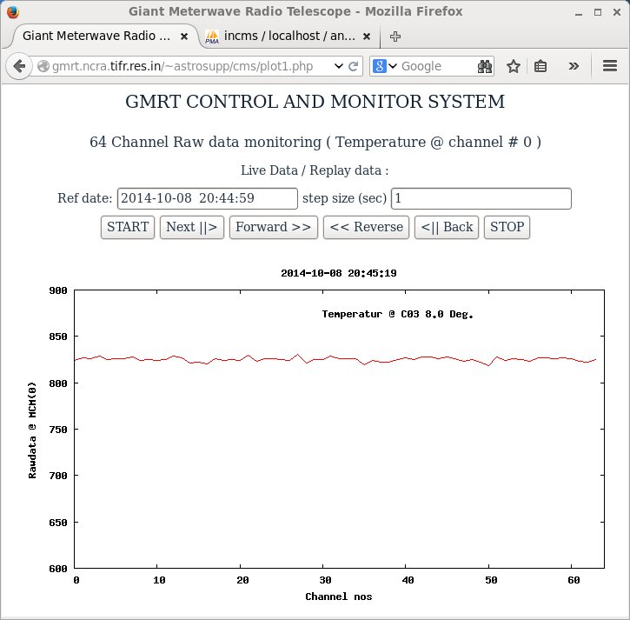
Fig. web interface for raw data monitoring
c) Temperature monitor test:

One temperature monitoring unit was connect to the MCM card at C03 antenna. The data behavior was similar like existing online with higher resolution.

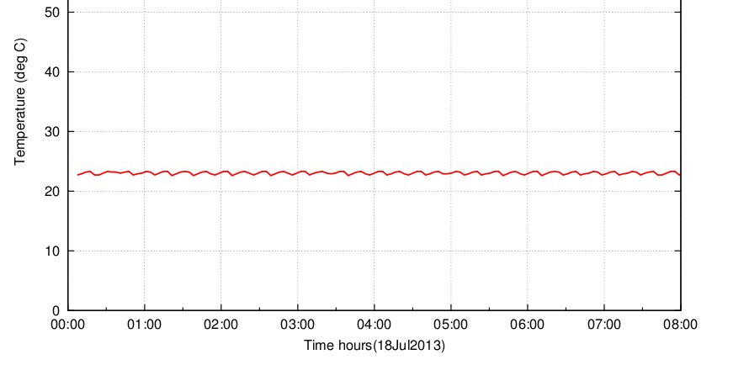
Fig. existing online temperature monitoring @ C03 antenna

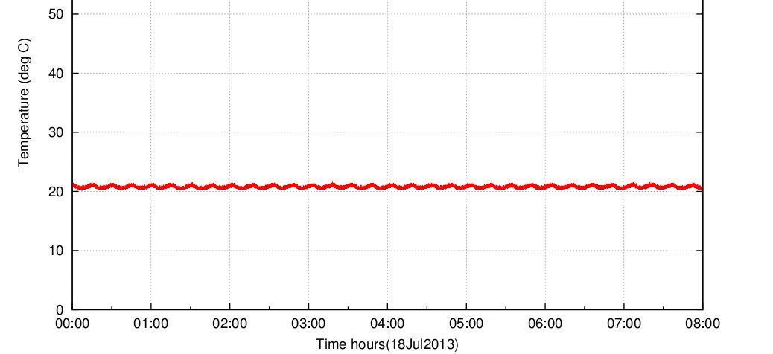

Fig. online V2 temperature monitoring @ C03 antenna

d) Raw data recording test:

Long period raw data recording test was conducted to check the stability or any dropouts. Here three different plots indicates three channels 20,40 and 60. Offsets are purposely added to avoid overlap.
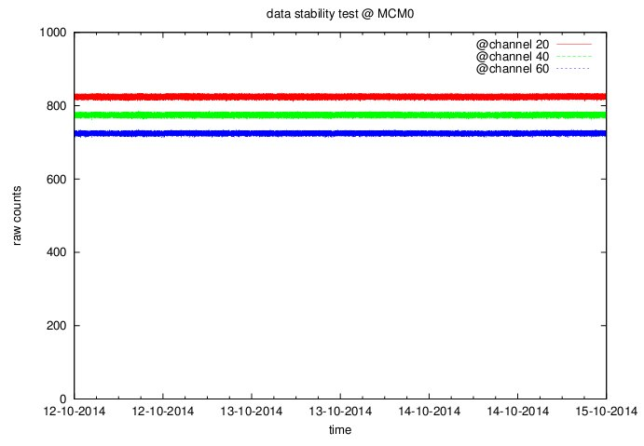

Summary:

As per the Online V2 design plan, we have successfully implemented and tested the data base for the raw data monitoring. This data can be easily assessed through the web interface. Long period recording test is successfully conducted. Temperature monitoring results are also matching with exiting online.

