HANDSМEN THREADS Salesforce-Based Clothing Management System
ABSTRACT
HandsMen Threads is a Salesforce-based clothing management system designed to manage customers, products, orders, and inventory in a centralized platform. The project uses Salesforce Flows, Apex Triggers, Batch Apex, Scheduled Apex, and Email Alerts to automate key business processes. It provides automated customer loyalty management, order validation, low-stock notifications, and inventory processing, reducing manual effort and improving the efficiency and accuracy of business operations.
1. HandsMen Threads Salesforce Application
1.1 Application Overview
The HandsMen Threads application is a Salesforce-based management system developed to manage the major operations of a clothing business. The application provides a centralized platform for managing customers, orders, products, and inventory. Salesforce automation features such as Flows, Apex Trigger, Batch Apex, Scheduled Apex, and Email Alerts are integrated into the application to automate business processes and reduce manual effort.
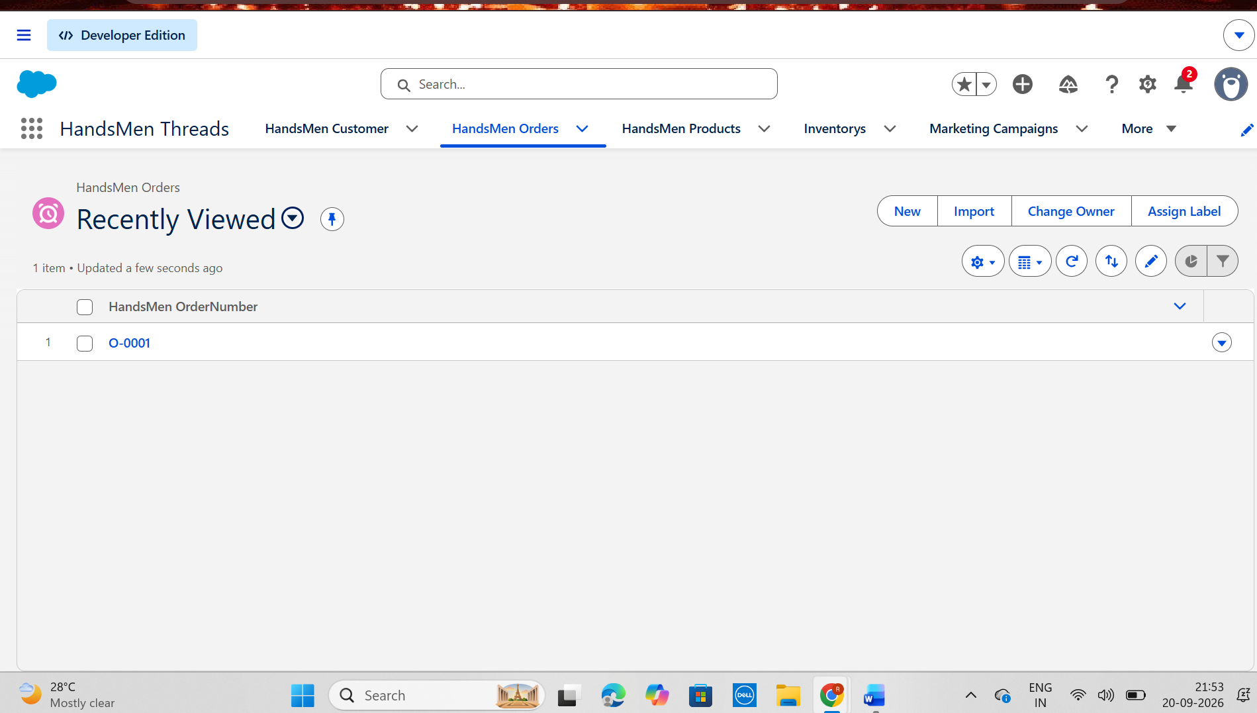
Figure 1.1: HandsMen Threads Salesforce Application
2. Customer Management
2.1 Customer Record Management
The HandsMen Customer object is used to store and manage customer information. It maintains important details such as customer name, phone number, total purchases, and loyalty status. The customer information is also used by the loyalty automation to determine the appropriate loyalty level.
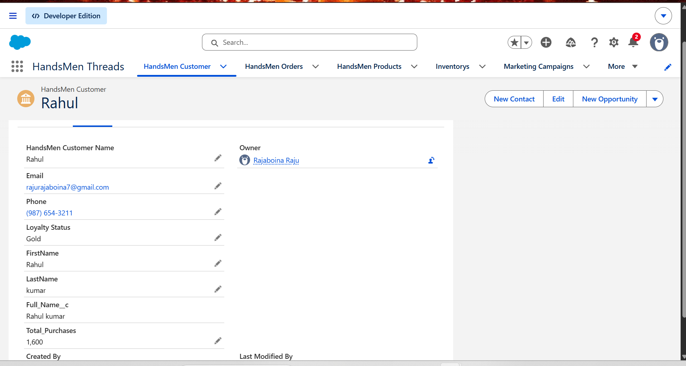
Figure 1.1: HandsMen Threads Salesforce Application
3. Loyalty Management
3.1 Automated Loyalty Status Management
The project implements an automated loyalty management system using a Scheduled-Triggered Flow. The Flow evaluates the total purchases of each customer and automatically assigns the appropriate loyalty status.
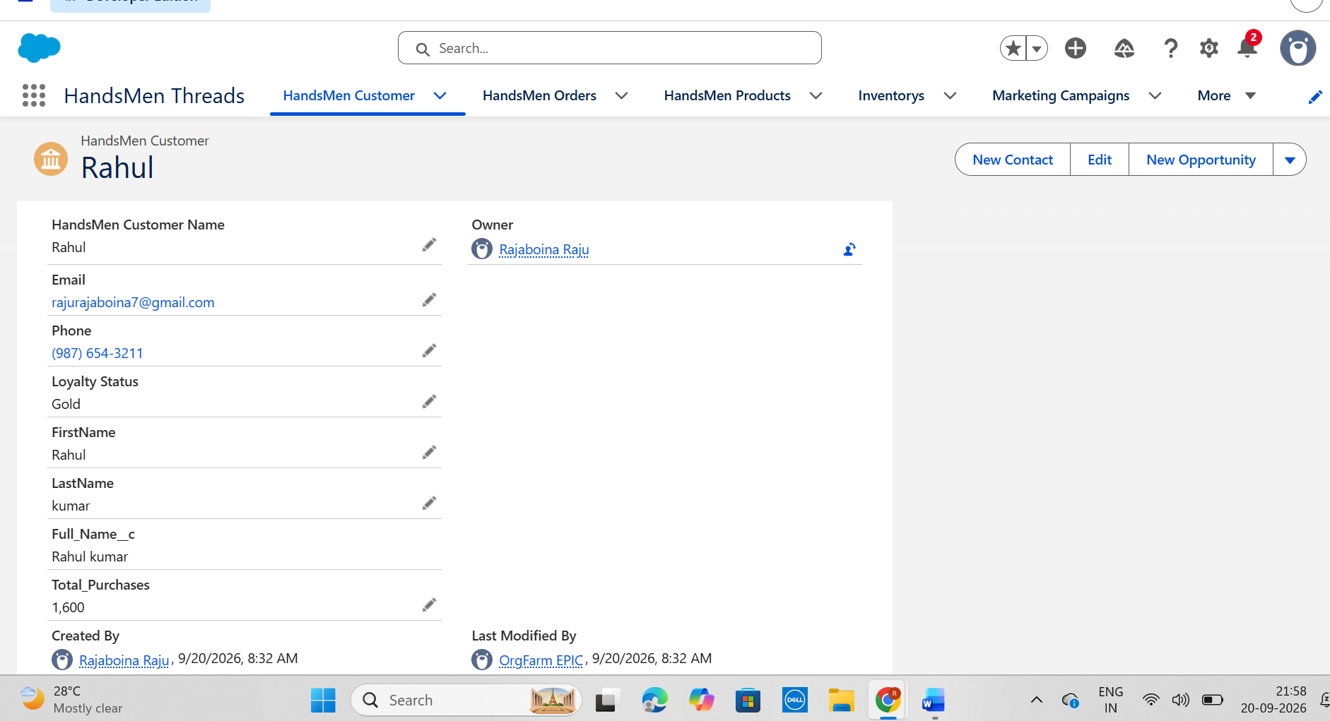
Figure 3.1: Customer Loyalty Status
3.2 Loyalty Status Update Flow
The Loyalty Status Update Flow retrieves customer records, processes them using a loop, evaluates the purchase amount through a Decision element, and updates the corresponding loyalty status.
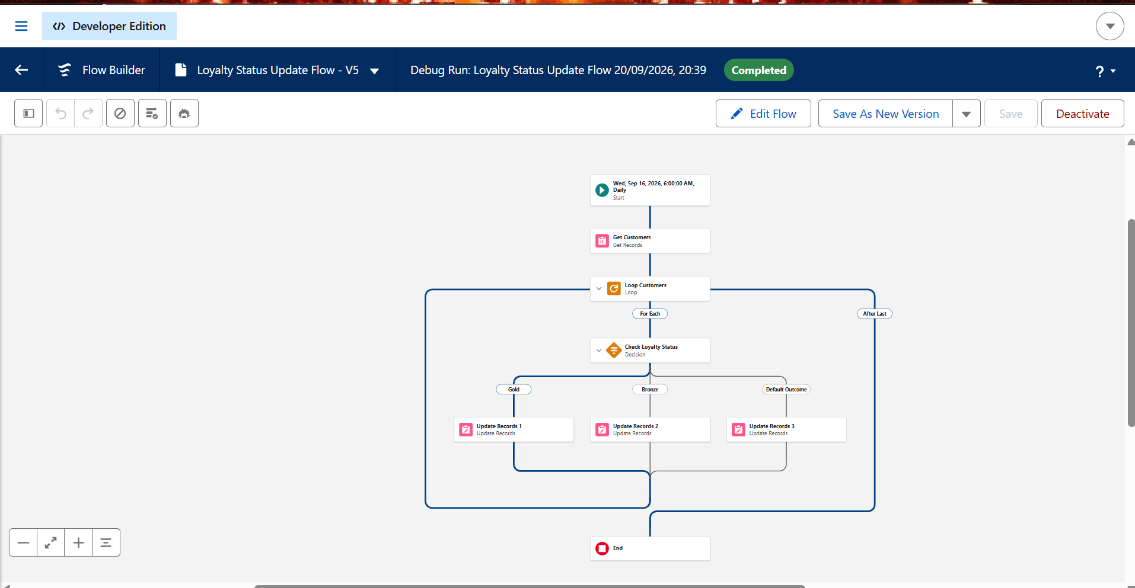
Figure 3.2: Loyalty Status Update Flow
4. Order Management
4.1 Order Management
The HandsMen Order object is used to maintain customer order information. Important details include the associated customer, order quantity, order status, and total amount.
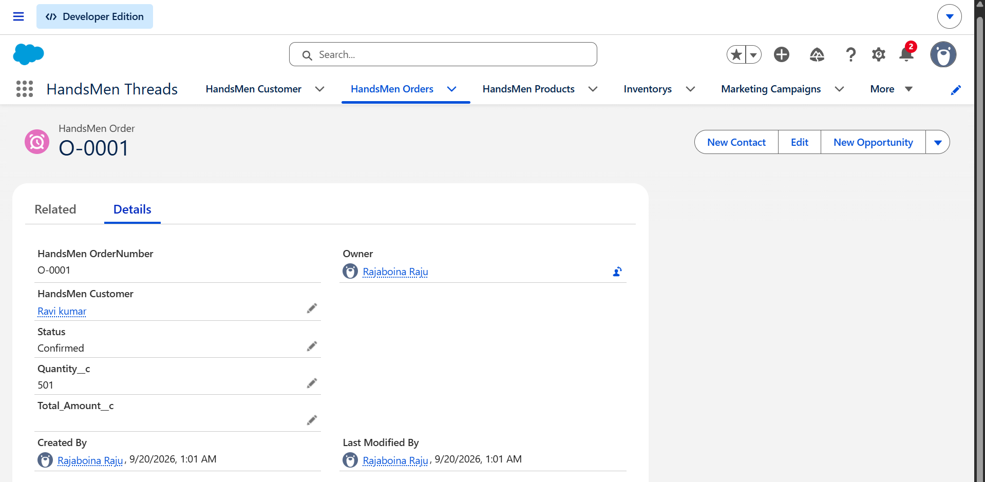
Figure 4.1: HandsMen Order Record
5. Order Validation Using Apex
5.1 Order Validation Trigger
An Apex Trigger is implemented to validate order quantities according to the order status. The trigger executes before insertion and before updating an order record.
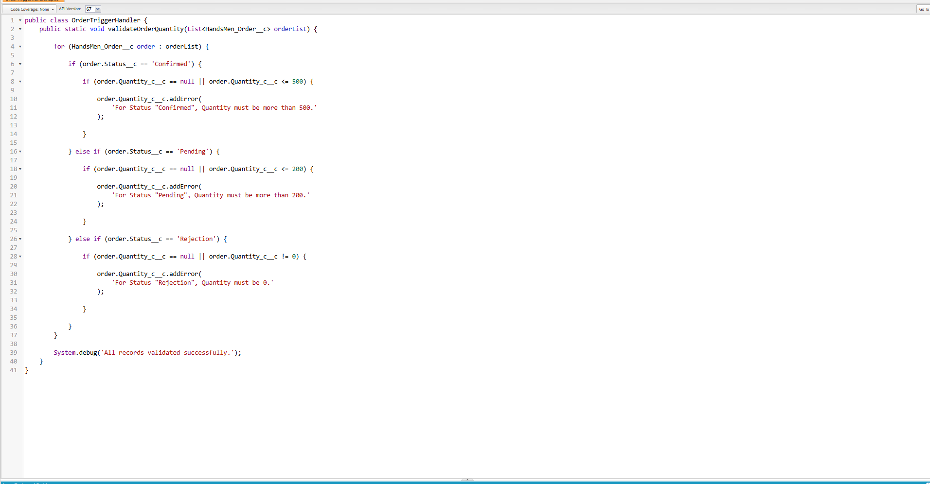
Figure 5.1: Order Trigger Implementation

6. Product Management
6.1 Product Management
The HandsMen Product object stores product-related information such as product name, SKU, price, and stock quantity. Products can be associated with orders and inventory records.
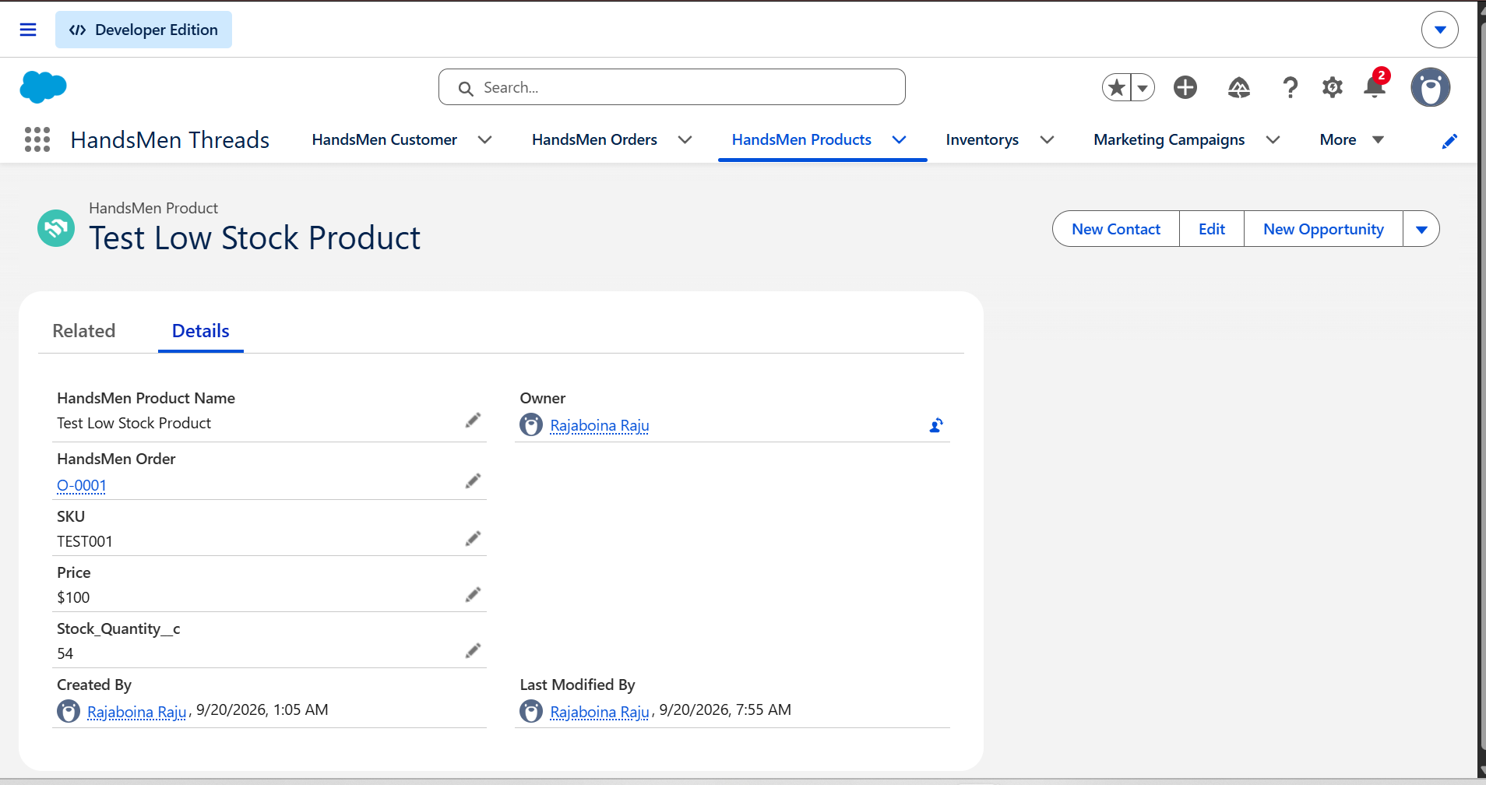
Figure 6.1: HandsMen Product Record
7. Inventory Management
7.1 Inventory Management
The Inventory object is used to maintain stock information for products. It contains the associated product, warehouse information, and current stock quantity.
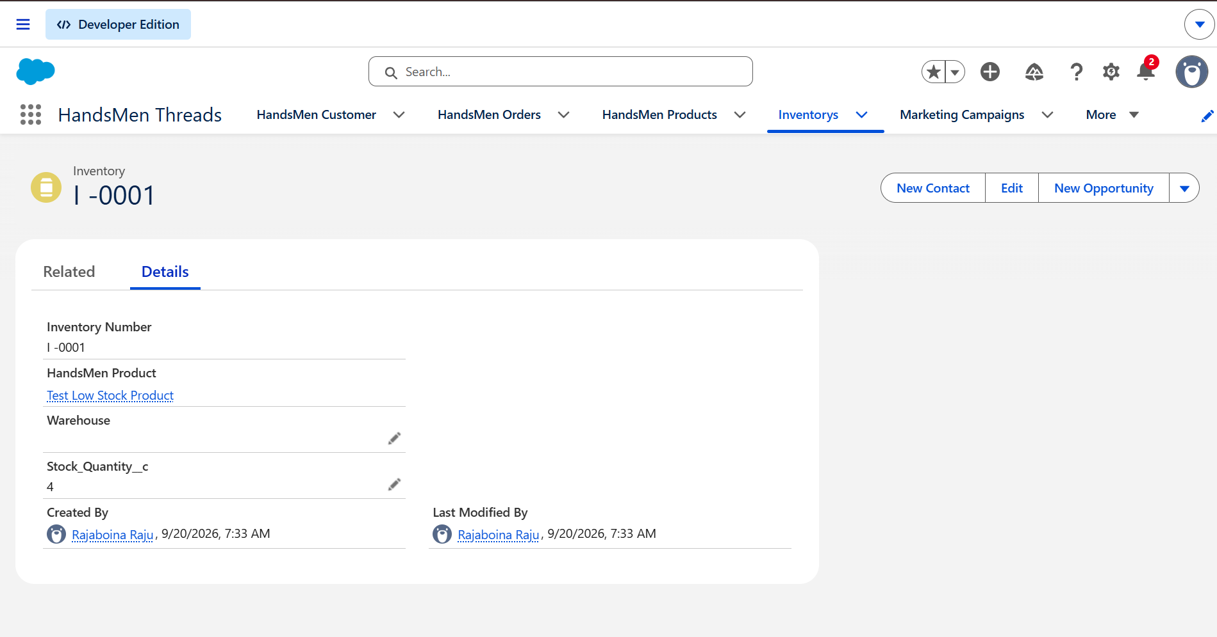
Figure 7.1: Inventory Record
8. Low Stock Alert Automation
8.1 Low Stock Detection
A Record-Triggered Flow is implemented on the Inventory object to detect low-stock conditions. The Flow executes when an inventory record is created or updated.When the stock quantity falls below 5, the Flow triggers the configured Low Stock Email Alert.
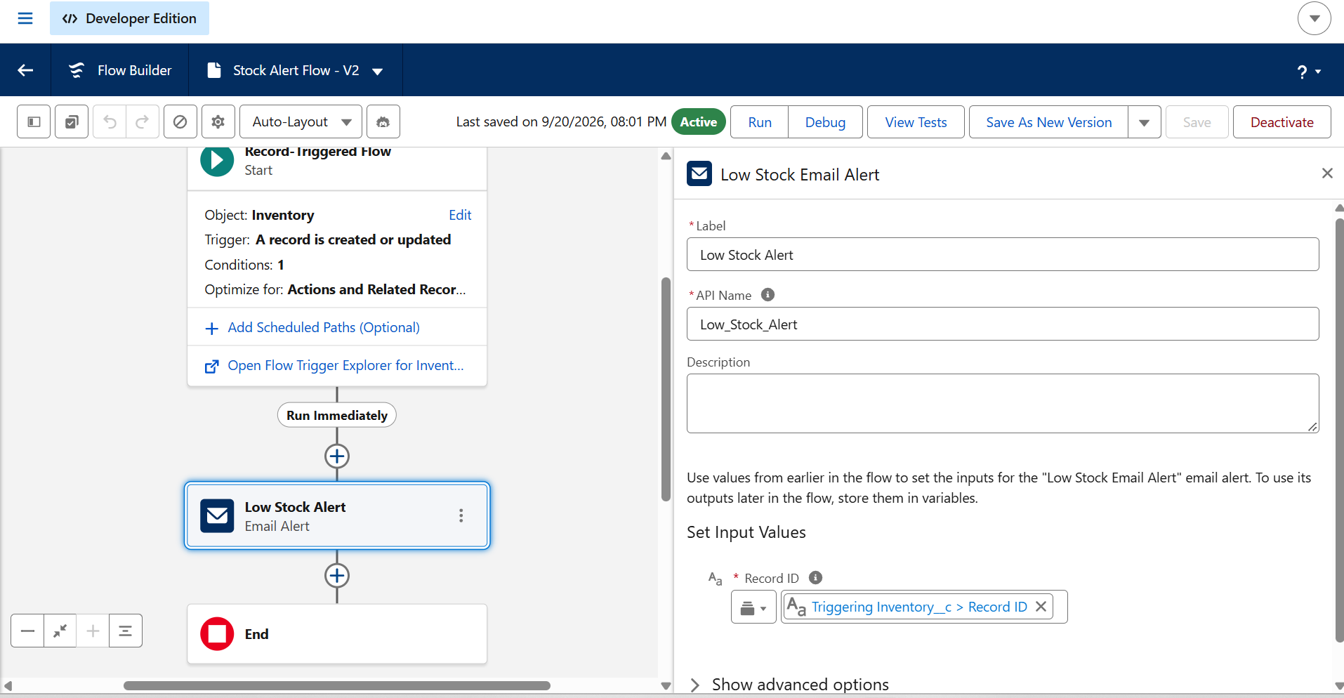
Figure 8.1: Low Stock Alert Flow
9. Low Stock Email Alert
9.1 Email Notification
An Email Alert is configured for the Inventory object using the Low Stock Alert email template. When the low-stock condition is satisfied, the notification is automatically sent to the configured recipient.
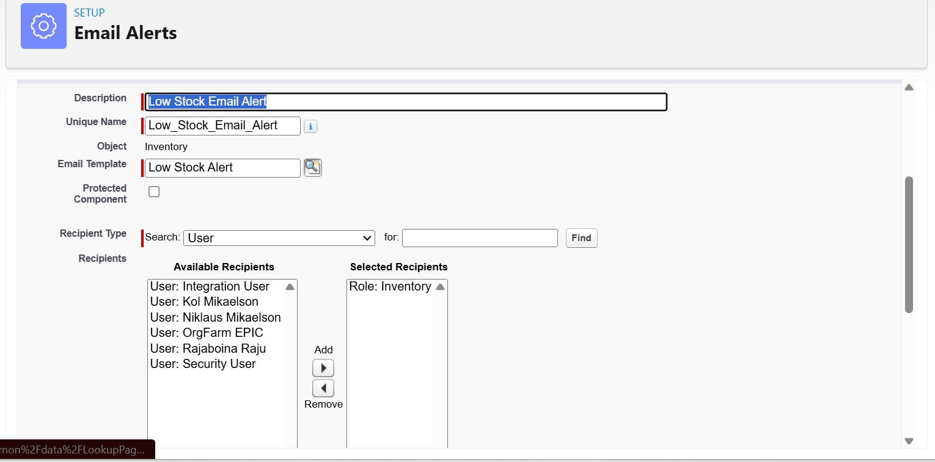
Figure 9.1: Low Stock Email Alert Configuration
9.2 Generated Email
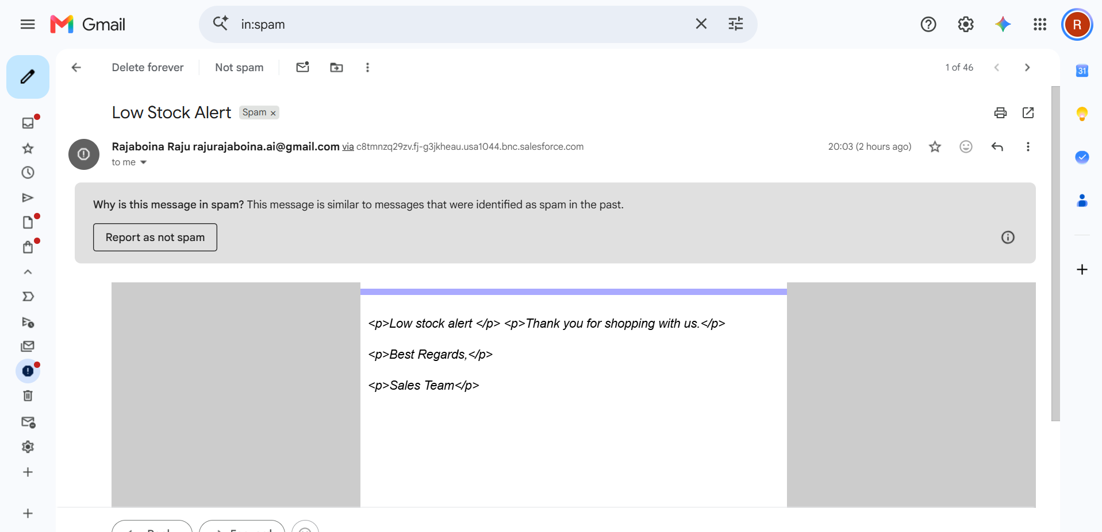
Figure 9.2: Low Stock Email Notification
10. Inventory Batch Processing
10.1 Batch Apex Implementation
The project uses Batch Apex to process low-stock products in batches. The InventoryBatchJob class implements the Batchable interface and performs the required inventory processing.
Batch Apex provides a scalable way to process a large number of Salesforce records while respecting platform governor limits.
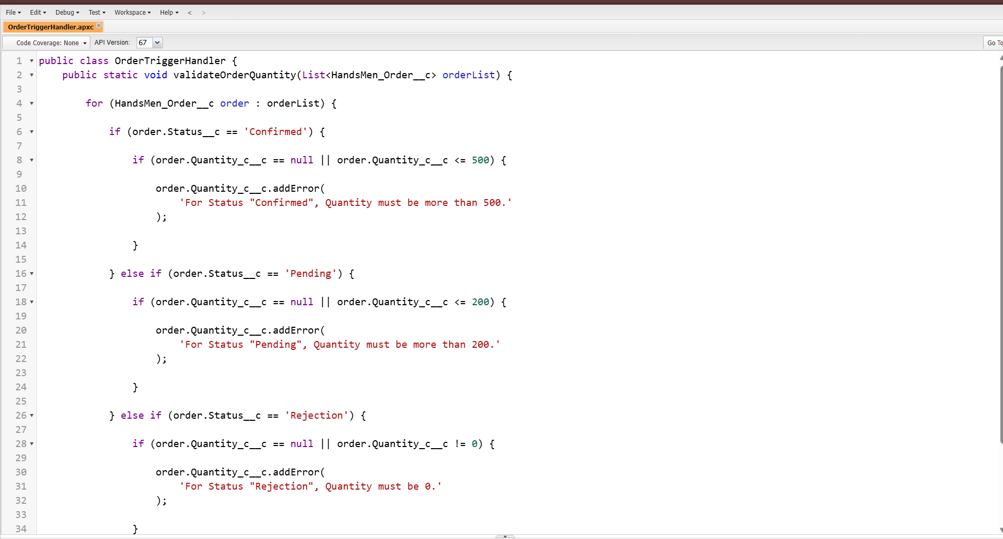
Figure 10.1: Inventory Batch Apex Implementation
11. Scheduled Inventory Processing
11.1 Scheduled Apex
The Inventory Batch Job is also implemented as a Schedulable Apex class. This allows the inventory processing operation to be executed automatically according to a configured schedule.
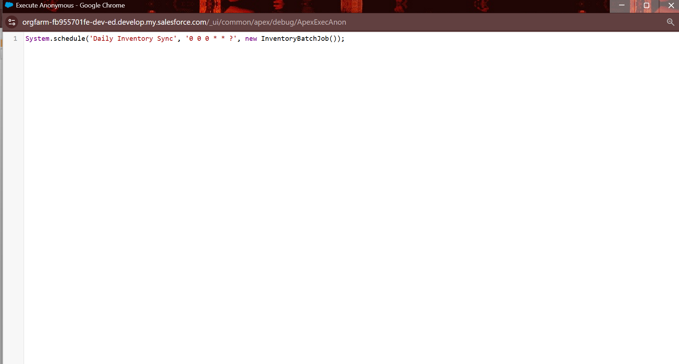
Figure 11.1: Inventory Batch Scheduler
12. Email Templates
12.1 Classic Email Templates
Two Classic Email Templates were created as part of the project:
- Low Stock Alert
- Loyalty Program Email
These templates are used to support automated communication within the system.
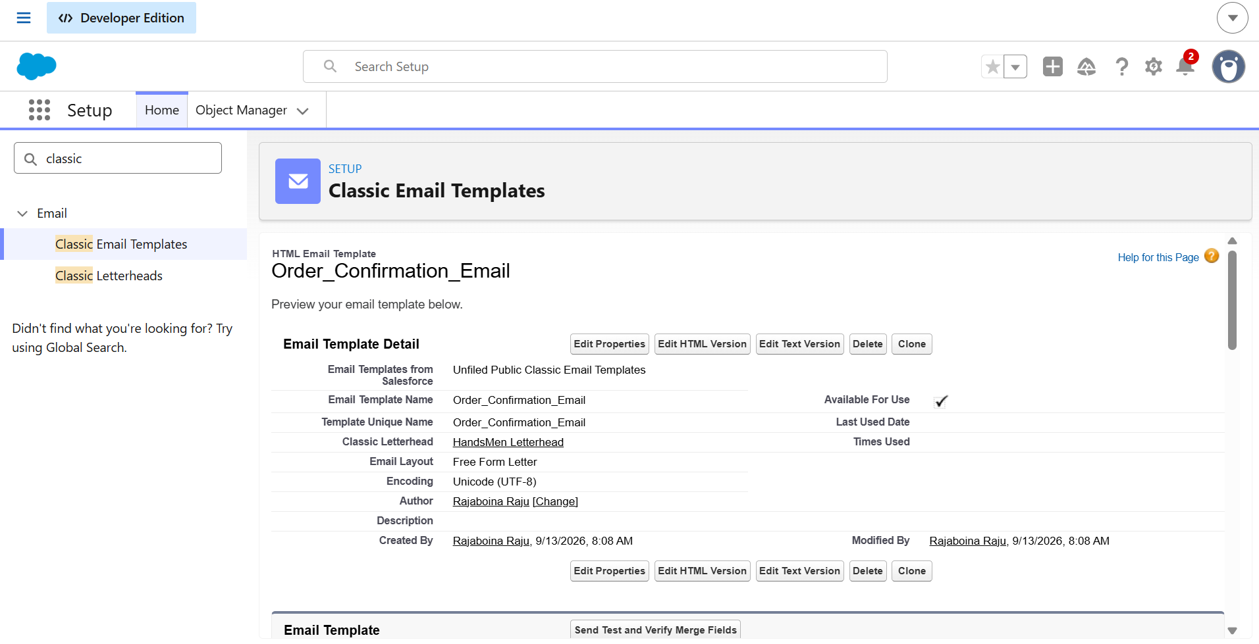
Figure 12.1: HandsMen Threads Email Templates
14. Conclusion
The HandsMen Threads Salesforce application successfully integrates Salesforce objects, automation, and Apex programming to manage clothing-business operations. The system provides centralized customer, product, order, and inventory management while automating loyalty status updates, order validation, low-stock notifications, and inventory processing.
The project demonstrates the practical use of Salesforce Flows, Email Alerts, Apex Trigger, Batch Apex, and Scheduled Apex to implement real-world business requirements.

