Javascript: Array are object

[Hrishikesh Rajurkar](https://medium.com/@rajurkarhrishikesh?source=post_page-----bf790df5be03----------------------)

[Hrishikesh Rajurkar](https://medium.com/@rajurkarhrishikesh?source=post_page-----bf790df5be03----------------------)

[Aug 13](https://medium.com/@rajurkarhrishikesh/javascript-array-are-object-bf790df5be03?source=post_page-----bf790df5be03----------------------) · 2 min read

The JavaScript array; which are high-level, list-like objects. If you are still in doubt lets compare the object properties with array



* Property Creation: Objects have key value pair where key is a string also know as “property name”

Following example show you can create property/key on array just in a same manner as object.

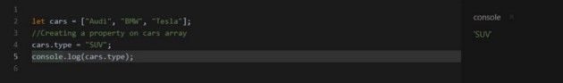

Property on array

* Methods supported by object are also supported by array

Object keys return all the object property as array. If we try this operation on cars array it returns four property.

https://miro.medium.com/max/27/1*YOtXYEddG2XGHvUomS0o2g.jpeg?q=20

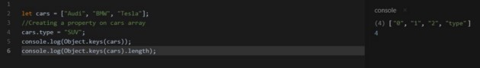

Object keys on array

* Object does not have length property

Object do not have length property. If we do want to check that object is empty we use Object.key(objectName).length, this returns count of keys of object. However arrays have length property.

It doesn’t actually return the number of items in the array. It returns the largest index plus one in the array.

https://miro.medium.com/max/27/1*olvRUZeYWXZn1BIRwbQ40w.jpeg?q=20

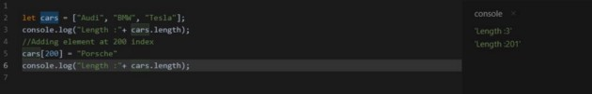

Length on array

Note: If we set the cars.length = 0, this truncates the element form array

* Object support delete operation on property/key

Object support delete operation on property. Which removes the property from object. In case of array we have pop and shift method to remove element from last and first index respectively. These method have one more job to align the index with number of elements in array.

We can delete element of array, but this gives undesirable results. Element is deleted from array but the index of array does not change.

https://miro.medium.com/max/27/1*ypLG-sLHqbYPQxzi10EazA.jpeg?q=20

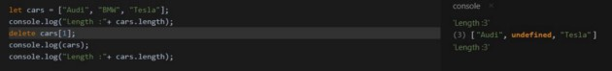

Delete on array

So to conclusion which we can draw from this is, Array is a special kind of object. Suited to storing and managing ordered data items.