 

**EFFICIENT ELECTION RESULTS PREDICTION FROM SOCIAL MEDIA**

**A PROJECT REPORT**

# Submitted by

**BADVELI MONISH (111420104009)**

**BODAVULA VEERESH (111420104012)**

**KODIPUNJULA YUVARAJ (111420104048)**

***in partial fulfilment for the award of the degree***

***of***

**BACHELOR OF ENGINEERING**

# in

**COMPUTER SCIENCE AND ENGINEERING**

**PRATHYUSHA ENGINEERING COLLEGE**

**THIRUVALLUR-602 025**

**ANNA UNIVERSITY :: CHENNAI 600 025**

**APRIL 2024**

**ANNA UNIVERSITY :: CHENNAI 600 025**

**BONAFIDE CERTIFICATE**

Certified that this project report **“Efficient Election Results Prediction From Social Media”** is the bonafide work of the **“ BADVELI MONISH(111420104009) , BODAVULA VEERESH(111420104012), KODIPUNJULA YUVARAJ(11142010 4048).”**Who carried out the project work under my supervision.

|  |  |
| --- | --- |
| **SIGNATURE** | **SIGNATURE** |
| **Dr.W.THAMBA MESHACH,** | **Ms. ANITHALAKSHMI V,** |
| **ASSOCIATE PROFESSOR,** | **ASSISTANT PROFESSOR,** |
| **HEAD OF THE DEPARTMENT,** | **SUPERVISOR,** |
| Department of CSE, | Department of CSE, |
| Prathyusha Engineering college, | Prathyusha Engineering college, |
| Thiruvallur- 602 025. | Thiruvallur- 602 025. |

**Place:** Thiruvallur **Date:**

Submitted for the Project Viva-Voce held on .... ..................................... at

Prathyusha Engineering College, Thiruvallur- 602 025.

**INTERNAL EXAMINER EXTERNAL EXAMINER**

**ACKNOWLEDGEMENT**

Our sincere thanks to **Shri. P. RAJARAO,** Chairman, Prathyusha Engineering College for facilitating us to do this project.

We are grateful to our CEO, **Smt. P. PRATHYUSHA,** for being a source of Inspiration.

We are sincerely thanking **Dr.B.R.RAMESH BAPU,** Principal, Prathyusha Engineering College for encouraging our endeavours for this project.

We are sincerely thanking **Dr.W.THAMBA MESHACH,**Associate

Professor, Head of Department,for supporting us in all stages of project conduction.

We are grateful to our project coordinator **Mr.S.CRISTAL ANAND,** Assistant professor **AND Ms.GUNASUNDARI,** Assistant professor, for her valuable suggestions and guidance.

We are grateful to our internal guide **Ms.** **ANITHALAKSHMI V,** Assistant Professor for his valuable suggestions and guidance for the successful completion of this project.

We also wish to extend our sincere thanks to all the committee members for their constant support throughout the review.

We wish to express our sincere gratitude to **PARENTS AND FRIENDS** for valuable help, co-operation and encouragement during this project work.

Last but not least, we wish to express our sincere thanks to the entire teaching faculty and non-teaching staff for their support.

**ABSTRACT**

Over the past decade, the use of social media has fundamentally altered the landscape of communication, providing a virtual space for individuals to express opinions, intentions, and engage with others. This shift has garnered significant interest from organizations and researchers, particularly in the realm of politics, where social media's influence on electoral predictions and campaign strategies has become increasingly apparent.

This study offers a comprehensive overview of the methodologies employed for predicting electoral outcomes using social media data. It examines the diverse approaches utilized, ranging from sentiment analysis to volumetric analysis, and evaluates their efficacy in accurately forecasting election results. Additionally, the study investigates the data collection methods employed, shedding light on the various sources utilized in electoral prediction research. By synthesizing existing literature, this study serves as a valuable guide for researchers seeking to navigate the complexities of electoral prediction using social media data.

**Keywords**: Election Prediction, Social Media Data, Sentiment Analysis, Politics, Twitter, Facebook

**TABLE OF CONTENTS**

**CHAPTER TITLE PAGE**

**NO NO**

ABSTRACT 1

LIST OF FIGURES 5

LIST OF SYMBOLS 6

1. **INTRODUCTION**

* 1. OVERVIEW 10

* 1. OBJECTIVE 11

* 1. LITERATURE SURVEY 11

1. **SYSTEM ANALYSIS**

* 1. EXISTING SYSTEM 15

* + 1. DISADVANTAGES 15

* 1. PROPOSED SYSTEM 15

* + 1. ADVANTAGES 16

**CHAPTER TITLE PAGE**

**NO**  **NO**

1. **SYSTEM REQUIREMENTS**

* + - 1. INTRODUCTION 18

* 1. HARDWARE REQUIREMENTS 19

* 1. SOFTWARE REQUIREMENTS 19

* 1. SOFTWARE DESCRIPTION 20

* + 1. PYTHON 20

1. **SYSTEM DESIGN**

* 1. SYSTEM ARCHITECTURE 23

* 1. UML DIAGRAM 25

* + 1. USE CASE DIAGRAM 26

* + 1. CLASS DIAGRAM 28

* + 1. ACTIVITY DIAGRAM 29

* + 1. SEQUENCE DIAGRAM 30

1. **SYSTEM IMPLEMENTATION**

* 1. LIST OF MODULES 32

* 1. MODULE DESCRIPTION 32

* + 1. SYSTEM 32

* + - 1. URL ANALYSIS 32

* + - 1. PAGE CONTENT ANALYSIS 32

* + - 1. VISUAL SIMILARITY

DETECTION 33

* + - 1. PHISHING KIT DETECTION 33

1. **TESTING**

* 1. UNIT TESTING 35

* 1. INTEGRATION TESTING 36

* 1. TESTING OF ASD SYSTEM 36

1. **RESULT AND DISCUSSION**

* 1. RESULTS 38

* 1. DISCUSSION 39

1. **CONCLUSION AND FUTURE**

**ENHANCEMENT**

* 1. CONCLUSION 41

* 1. FUTURE ENHANCEMENT 41

**ANNEXURE**

SOURCE CODE 43

**LIST OF FIGURES**

|  |  |
| --- | --- |
| **FIGURE.NO FIGURE NAME** | **PAGE NO.** |
| 4.1 System Architecture for ASD | 14 |
| 4.2 Use case Diagram for ASD | 15 |
| 4.2.2 Class Diagram for ASD | 16 |
| 4.2.3 Activity Diagram for ASD | 17 |
| 4.2.4 Sequence Diagram for ASD | 18 |

**LIST OF SYMBOLS**

|  |  |  |  |
| --- | --- | --- | --- |
| **S.NO** | **NOTATION**  **NAME** | **NOTATION** | **DESCRIPTION** |

|  |  |  |
| --- | --- | --- |
| 2. Association | NAME | Associations represent static relationships between classes.  Roles represent the way |

Represents a collection of



together.

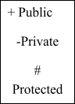

similar entities grouped

1. Class

ROLE

the two classes see each other.



1. Actor Specifies a role played by

a user that interacts with the subject.

**S.N NOTATION NOTATION DESCRIPTION O NAME**

1. Communicatio n Communication between various use cases.

1. Initial State   Initial state of the object

1. Final state Final state of the object



1. Control flow Represents various



control flow between the states.



1. Decision box Represents decision

making process from a constraint.

**S.N NOTATION NOTATION DESCRIPTION O NAME**

1. Use case Interaction between the

system and external environment.

1. External entity  Represents external

entities such as keyboard, sensors, etc.

1. Transition  Represents

communication that occurs between Processes.

1. Object Lifeline Represents the vertical



dimensions that the object communications.

1. Message Message Represents the message



exchanged.

**CHAPTER 1**

**INTRODUCTION**

**CHAPTER 1**

**INTRODUCTION**

* 1. **OVERVIEW**

In recent years, the pervasive influence of social media has reshaped the landscape of electoral prediction, attracting significant attention from researchers and organizations alike. This study embarks on a comprehensive exploration of the methodologies, data sources, challenges, and insights pertinent to predicting electoral outcomes using social media data.

**Methodological Exploration**: The study delves into the diverse array of methodologies employed in electoral prediction, ranging from sentiment analysis to volumetric analysis and social network analysis. By dissecting the intricacies of these approaches, researchers aim to uncover the underlying mechanisms driving electoral predictions and assess their effectiveness in capturing the nuances of public opinion.

**Data Sources Analysis:** Central to electoral prediction research is the utilization of data from social media platforms such as Twitter and Facebook. This study scrutinizes the methodologies used for data collection, shedding light on the intricacies of sourcing and processing social media data for predictive purposes.

**Insights and Recommendations:** Drawing from empirical evidence and research findings, the study offers valuable insights and recommendations for future research endeavours. These include exploring alternative data sources, integrating linguistic and contextual features into predictive models, and developing strategies to mitigate existing challenges in electoral prediction using social media data.

Through a meticulous examination of methodologies, data sources, challenges, and insights, this study aims to contribute to the advancement of knowledge in the field of electoral prediction and provide a roadmap for researchers and practitioners navigating the complexities of predicting electoral outcomes using social media data.

* 1. **OBJECTIVE**

The objective of this study is to comprehensively analyse the methodologies, data sources, and challenges involved in predicting electoral outcomes using social media data. It seeks to evaluate the effectiveness of techniques such as sentiment analysis, volumetric analysis, and social network analysis in electoral prediction. Additionally, the study aims to scrutinize the collection and preprocessing methods of social media data from platforms like Twitter and Facebook, addressing issues such as language barriers and data reliability. Insights and recommendations will be derived to improve the accuracy and reliability of electoral predictions using social media data, guiding future research in this field. Ultimately, this analysis aims to contribute to the advancement of electoral prediction research and provide valuable insights for policymakers, researchers, and practitioners.

**1.2 LITERATURE SURVEY**

**[1] Ceron, A., Curini, L., Iacus, S. M., & Porro, G. (2014). Every tweet counts? How sentiment analysis of social media can improve our knowledge of citizens’ political preferences with an application to Italy and France. New Media & Society, 16(2), 340-358.**

The study employs sentiment analysis techniques to parse social media data and gain insights into the political sentiments of citizens in Italy and France. By analysing the sentiment expressed in tweets and other social media posts, the researchers aim to uncover trends and patterns that may reflect public opinion on political issues and candidates. The outcome of the study offers valuable insights into the potential of sentiment analysis in understanding and predicting political preferences in different cultural contexts.

**[2] Lovaglio, P. G., Cesarini, M., Mercorio, F., & Mezzanzanica, M. (2018). Skills in demand for ICT and statistical occupations: Evidence from web- based job vacancies. Statistical Analysis and Data Mining: The ASA Data Science Journal, 11(2), 78-91.**

Through an analysis of web-based job vacancies, this research examines the skills in demand within the ICT and statistical sectors. The outcome provides a comprehensive understanding of the specific skills and qualifications sought after by employers in these industries. By identifying key trends in job postings, the study offers valuable insights for individuals seeking employment in these sectors and policymakers looking to address skill gaps in the workforce.

**[3**] **Bilal, M., Malik, N., Khalid, M., & Lali, M. I. U. (2017). Exploring Industrial Demand Trend’s in Pakistan Software Industry Using Online Job Portal Data. University of Sindh Journal of Information and Communication Technology, 1(1), 17-24.**

This study investigates the dynamics of industrial demand trends within the Pakistan software industry using data from online job portals. By analyzing job postings and skill requirements, the research sheds light on the evolving needs of the software industry in Pakistan. The outcome highlights the importance of aligning educational and training programs with industry demands to foster growth and innovation within the sector.

**[4] Boutet, A., Kim, H., & Yoneki, E. (2012). What's in Your Tweets? I Know Who You Supported in the UK 2010 General Election. ICWSM, 12, 411-414.**

Through an analysis of Twitter data, this research seeks to uncover insights into political preferences during the UK 2010 General Election. By examining the content of tweets and the sentiments expressed, the study aims to identify trends and patterns in voter sentiment on social media platforms. The outcome provides valuable insights into the role of social media in shaping political discourse and public opinion during election campaigns

**[5] Livne, A., Simmons, M. P., Adar, E., & Adamic, L. A. (2011). The Party Is Over Here: Structure and Content in the 2010 Election. ICWSM, 11, 17-21.**

Through an analysis of Twitter data, this study examines the structure and content of political discussions during the 2010 election. By analyzing the topics and sentiments expressed in tweets, the research aims to identify patterns in political discourse on social media platforms. The outcome provides insights into the role of Twitter in shaping public opinion and political narratives during election campaigns.

**CHAPTER 2**

**SYSTEM ANALYSIS**

**CHAPTER 2**

**SYSTEM ANALYSIS**

The system study is to provide the description about the existing system, its limitations and proposed system of the project.

**2.1 EXISTING SYSTEM:**

The existing system for predicting electoral outcomes using social media data encompasses several interconnected components and processes. At its core, the system relies on the collection of data from popular social media platforms like Twitter and Facebook, where users engage in discussions, express opinions, and share information related to political topics. This data collection phase often utilizes application programming interfaces (APIs) provided by the social media platforms or employs web scraping techniques to extract relevant content. Once the data is collected, it undergoes preprocessing to clean and standardize it, removing noise such as spam and irrelevant posts while also organizing it into a format suitable for analysis. Preprocessing steps may include tokenization, stemming, and the removal of stop words to enhance the quality of the data.

**2.1.1 DISADVANTAGES:**

* Data Quality Issues.
* Limited Scope.
* Language and Cultural Biases.
* Language barriers.
* Overreliance on Sentiment Analysis

**2.2 PROPOSED SYSTEM**

The proposed system for predicting electoral outcomes using social media data aims to enhance the accuracy, efficiency, and reliability of the existing methodology. Building upon the foundation of data collection, preprocessing, analysis, and prediction employed in the existing system, the proposed system introduces several innovative enhancements and refinements.

Firstly, the proposed system seeks to improve the data collection process by incorporating advanced techniques for gathering a wider range of relevant social media data from various platforms. This may involve the integration of additional data sources beyond Twitter and Facebook, as well as the utilization of more sophisticated data collection methods, such as natural language processing and web crawling algorithms, to capture diverse perspectives and insights.

Finally, the proposed system will emphasize the importance of interpretability, transparency, and accountability in its reporting and visualization mechanisms. By providing clear and actionable insights through intuitive dashboards, interactive visualizations, and comprehensive reports, the system aims to empower stakeholders with the knowledge and understanding needed to make informed decisions and strategies.

Overall, the proposed system represents a comprehensive and innovative approach to predicting electoral outcomes using social media data, offering advanced capabilities, enhanced performance, and actionable insights for researchers, political parties, and policymakers alike.

**2.2.1 ADVANTAGES**

1. **Enhanced Data Collection Methods**:
   * Utilizing Advanced Web Scraping Techniques
   * Integration of Multiple Social Media Platforms
   * Incorporating API Data Retrieval and Streaming
2. **Refined Data Preprocessing Techniques**:
   * Noise Reduction and Data Cleansing Strategies
   * Text Normalization and Tokenization Methods
   * Entity Recognition and Named Entity Resolution
3. **Advanced Analysis Algorithms**:
   * Application of Machine Learning Models
   * Implementation of Natural Language Processing (NLP) Tools
   * Integration of Deep Learning Architectures
4. **Optimized Prediction Models**:
   * Exploration of Ensemble Learning Approaches
   * Development of Time-Series Forecasting Models
   * Utilization of Probabilistic Graphical Models

**CHAPTER 3**

**SYSTEM REQUIREMENTS**

**CHAPTER 3**

**SYSTEM REQUIREMENTS**

**3.1 INTRODUCTION**

**Functional and non-functional requirements:**

In this section, you'll introduce the system requirements and provide an overview of the functional and non-functional requirements.

**Functional Requirements**:

Functional requirements describe the specific behaviors or functions that the system must perform. For example:

* The system should be able to gather real-time data from various social media platforms, including Twitter, Facebook, and Instagram.
* It must support both API-based data retrieval and web scraping techniques to ensure comprehensive data collection.
* The system should allow users to specify search queries, filters, and time frames for data retrieval.

**Non-functional requirements**: Non-functional requirements define the qualities or attributes of the system, such as performance, usability, security, and reliability.

For example:

* **Performance**:
* Response Time: The system should respond to user queries and requests within acceptable time limits, with a maximum latency of X seconds.
* Throughput: The system should be able to handle a high volume of data processing and analysis, with a throughput of at least X requests per second.
* Scalability: The system should be scalable to accommodate increasing data loads and user traffic, with the ability to scale both vertically and horizontally.
* User Interface: The user interface should be intuitive, user-friendly, and aesthetically pleasing, with clear navigation and visual elements.

**3.2 HARDWARE REQUIREMENTS**

* System : i3 Processor
* Hard Disk : 500 GB.
* Monitor : 15’’ LED
* Input Devices : Keyboard, Mouse
* Ram : 2 GB
* Minimum 2GB RAM for optimal performance

**3.3 SOFTWARE REQUIREMENTS**

* Android OS version 5.0 (Lollipop) or later.
* Visual studio(version 1.87) for development.
* Python programming language.

**3.4SOFTWARE DESCRIPTION**

This section provides a detailed description of the software components. For example:

**1.Data Collection and Integration:**

Web Scraping Tools: Software tools like BeautifulSoup or Scrapy for scraping data from social media platforms such as Twitter and Facebook.

API Integration: Integration with social media APIs (e.g., Twitter API) to access real-time data streams.

Database Management System (DBMS): A DBMS like MySQL or MongoDB for storing and managing the collected data efficiently.

**2.Data Preprocessing and Analysis:**

Programming Language: Python or R for data preprocessing and analysis tasks.

Natural Language Processing (NLP) Libraries: NLTK (Natural Language Toolkit), SpaCy, or TextBlob for text processing and sentiment analysis.

Statistical Analysis Tools: Libraries like Pandas, NumPy, and SciPy for statistical analysis of the collected data.

Machine Learning Frameworks: Scikit-learn or TensorFlow for building and training predictive models

**3.Visualization and Reporting:**

Data Visualization Libraries: Matplotlib, Seaborn, or Plotly for visualizing insights and trends in the data.

Reporting Tools: Jupyter Notebook or RMarkdown for creating interactive reports and presentations.

**4.Development and Deployment:**

Integrated Development Environment (IDE): Tools like PyCharm, JupyterLab, or VS Code for writing and debugging code.

Version Control: Git for version control management to track changes in the project codebase.

Containerization: Docker for creating containers to deploy and run the application in different environments.

Cloud Computing Platform: Services like AWS, Google Cloud Platform, or Microsoft Azure for hosting and scaling the application.

**5.Security and Compliance:**

Access Control: Implementing role-based access control (RBAC) mechanisms to manage user permissions and access to sensitive data.

Data Privacy: Ensuring compliance with data privacy regulations (e.g., GDPR) when handling user-generated content from social media platforms.

**6.Documentation and Collaboration:**

Documentation Tools: Markdown or LaTeX for writing project documentation, including requirements specifications, user manuals, and technical documentation.

Collaboration Platforms: Tools like GitHub or GitLab for collaborative development, issue tracking, and code reviews.

**CHAPTER 4**

**SYSTEM DESIGN**

**CHAPTER 4**

**SYSTEM DESIGN**

System design is the process of planning a new system or to replace the existing system. Simply, system design is like the blueprint for building, it specifies all the features that are to be in the finished product.

**4.1 SYSTEM ARCHITECTURE**

System architecture is the conceptual model that defines the structure, behaviour and more views of a system. An architecture description is a formal description and representation of a system, organized in a way that supports reasoning about the structures and behaviors of the system.

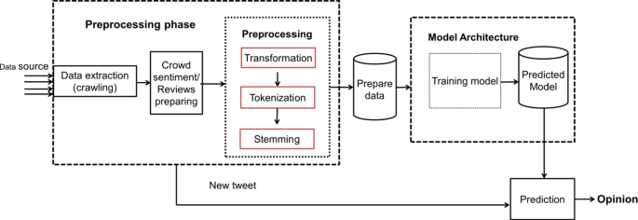

**Fig 4.1 Architecture Diagram**

**4.2 UML DIAGRAM**

UML stands for Unified Modelling Language. UML is a standardized general-purpose modelling language in the field of object-oriented software engineering. The standard is managed, and was created by, the Object Management Group.

The goal is for UML to become a common language for creating models of object-oriented computer software. In its current form UML is comprised of two major components: a Meta-model and a notation. In the future, some form of method or process may also be added to; or associated with, UML.

The Unified Modelling Language is a standard language for specifying, Visualization, Constructing and documenting the artifacts of software system, as well as for business modelling and other non-software systems.

The UML represents a collection of best engineering practices that have proven successful in the modelling of large and complex systems.

The UML is a very important part of developing objects-oriented software and the software development process.

The UML uses mostly graphical notations to express the design of software projects.

**GOALS:**

The Primary goals in the design of the UML are as follows:

1. Provide users a ready-to-use, expressive visual modelling Language so that they can develop and exchange meaningful models.
2. Provide extendibility and specialization mechanisms to extend the core concepts.
3. Be independent of particular programming languages and development process.
4. Provide a formal basis for understanding the modelling language.
5. Encourage the growth of OO tools market.
6. Support higher level development concepts such as collaborations, frameworks, patterns and components.
7. Integrate best practices.

**4.2.1 USE CASE DIAGRAM**

* + A use case diagram in the Unified Modelling Language (UML) is a type of behavioral diagram defined by and created from a Use-case analysis.
  + Its purpose is to present a graphical overview of the functionality provided by a system in terms of actors, their goals (represented as use cases), and any dependencies between those use cases.
  + The main purpose of a use case diagram is to show what system functions are performed for which actor. Roles of the actors in the system can be depicted.

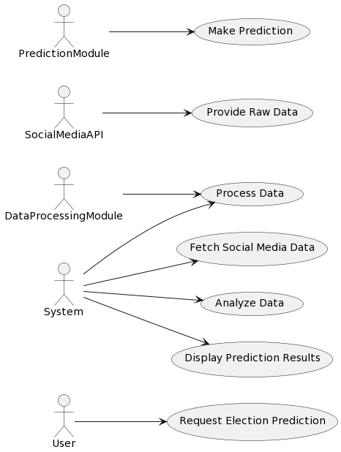

**Figure 4.2.1** Use case diagram

* + 1. **CLASS DIAGRAM**

In software engineering, a class diagram in the Unified Modeling Language (UML) is a type of static structure diagram that describes the structure of a system by showing the system's classes, their attributes, operations (or methods), and the relationships among the classes. It explains which class contains information.

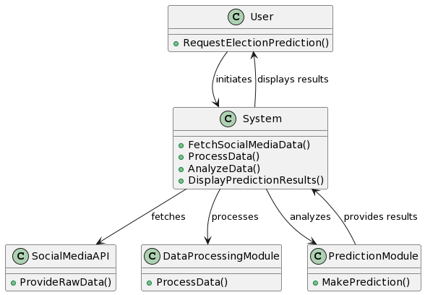

**Figure 4.2.2** class diagram

* + 1. **ACTIVITY DIAGRAM**

Activity diagrams are graphical representations of workflows of stepwise activities and actions with support for choice, iteration and concurrency. In the Unified Modeling Language, activity diagrams can be used to describe the business and operational step-by-step workflows of components in a system. An activity diagram shows the overall flow of control.

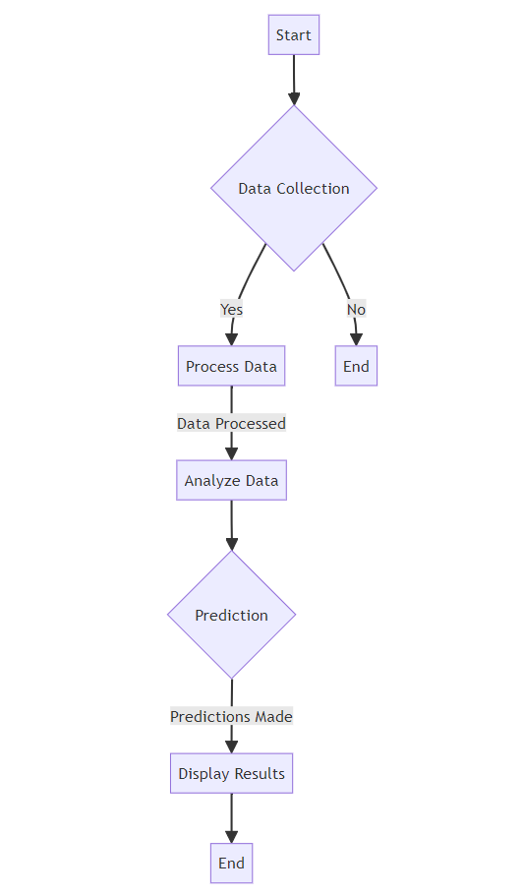

**Figure 4.2.3** Activity Diagram

* + 1. **SEQUENCE DIAGRAM**

* A sequence diagram in Unified Modelling Language (UML) is a kind of interaction diagram that shows how processes operate with one another and in what order.
* It is a construct of a Message Sequence Chart. Sequence diagrams are sometimes called event diagrams, event scenarios, and timing diagrams.

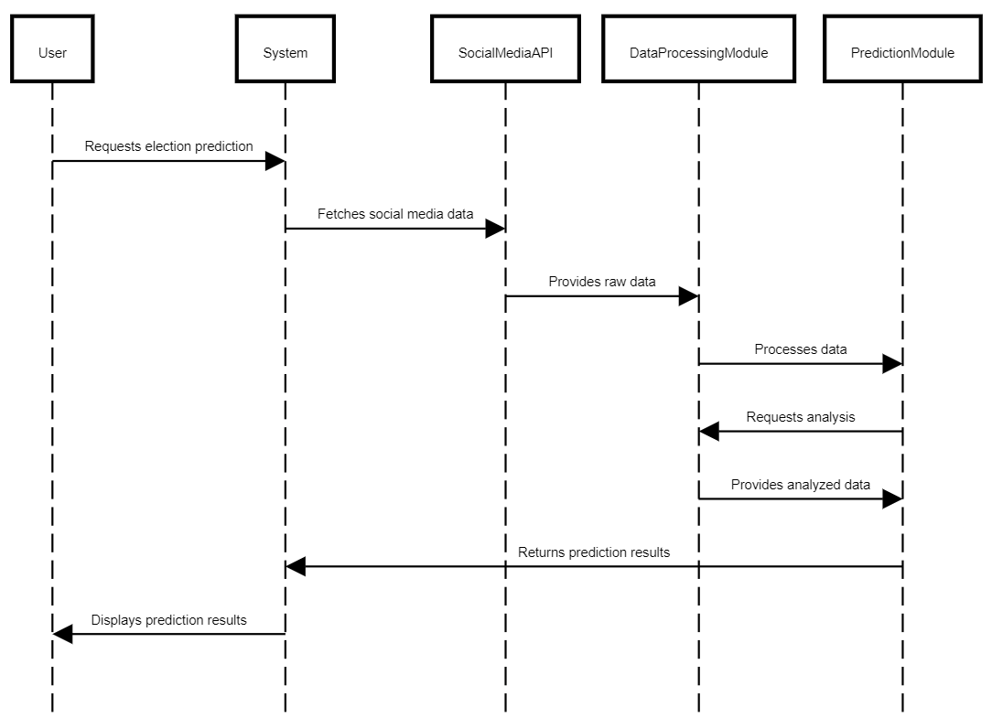

**Figure 4.2.4** Sequence Diagram

**CHAPTER 5**

**SYSTEM IMPLEMENTATION**

**CHAPTER 5**

**SYSTEM IMPLEMENTATION**

**5.1 LIST OF MODULES**

1. Data Collection Module.
2. Data Preprocessing Module.
3. Sentiment Analysis Module.
4. Statistical Analysis Module.
5. Machine Learning Module.
6. Data Visualization Module.
7. Reporting Module.

**5.2 MODULE DESCRIPTION**

**5.2.1.Data Collection Module:**

Description: This module is responsible for collecting data from social media platforms such as Twitter and Facebook. It includes functionalities for web scraping, API integration, and data retrieval from online sources.

Functions:

* Web scraping tools integration.
* Social media API integration.
* Real-time data streaming and collection.

**5.2.2.** **Data Preprocessing Module:**

Description: This module preprocesses the collected data to make it suitable for analysis. It involves cleaning, filtering, and transforming raw data into a structured format for further processing.

Functions:

* Text preprocessing (e.g., tokenization, stemming, and lemmatization).
* Data cleaning (e.g., removing duplicates, handling missing values).
* Feature extraction and engineering.

**5.2.3. Sentiment Analysis Module:**

Description: This module analyzes the sentiment of social media posts to determine the overall sentiment towards political candidates or parties. It uses natural language processing (NLP) techniques to classify texts as positive, negative, or neutral sentiments.

Functions:

* Text classification using machine learning algorithms.
* Sentiment scoring and sentiment polarity detection.
* Entity recognition and sentiment aggregation**.**

**5.2.4.Statistical Analysis Module:**

Description: This module performs statistical analysis on the preprocessed data to identify patterns, trends, and correlations related to electoral outcomes. It includes descriptive statistics, hypothesis testing, and regression analysis.

Functions:

* Descriptive statistics (e.g., mean, median, variance).
* Correlation analysis (e.g., Pearson correlation coefficient).
* Regression analysis (e.g., linear regression, logistic regression).

**5.2.5.Machine Learning Module:**

Description: This module develops and trains predictive models using machine learning algorithms to forecast electoral results based on social media data. It includes model training, evaluation, and prediction functionalities.

Functions:

* Model selection and hyperparameter tuning.
* Cross-validation and model evaluation metrics.
* Prediction of electoral outcomes using trained models.

**5.2.6.Data Visualization Module:**

Description: This module visualizes the analyzed data and model predictions to provide insights into electoral trends and public sentiments. It includes various visualization techniques such as charts, graphs, and maps.

Functions:

* Plotting and visualization of data distributions.
* Time series analysis and trend visualization.
* Geographic visualization of electoral results.

**5.2.7** **Reporting Module**

Description: This module generates reports and summaries of the analysis results for stakeholders and decision-makers. It includes functionalities for report generation, customization, and distribution.

Functions:

* Automated report generation from analysis results.
* Customizable report templates and formats.
* Exporting reports to various file formats (e.g., PDF, CSV).

**CHAPTER 6**

**TESTING CHAPTER 6**

**TESTING**

**SYSTEM TESTING AND IMPLEMENTATION**

The purpose of testing is to discover errors. Testing is the process of trying to discover every conceivable fault or weakness in a work product. It provides a way to check the functionality of components, sub-assemblies, assemblies and/or a finished product It is the process of exercising software with the intent of ensuring that the

Software system meets its requirements and user expectations and does not fail in an unacceptable manner. There are various types of test. Each test type addresses a specific testing requirement.

**6.1 UNIT TESTING**

Unit testing involves the design of test cases that validate that the internal program logic is functioning properly, and that program inputs produce valid outputs. All decision branches and internal code flow should be validated. It is the testing of individual software units of the application .it is done after the completion of an individual unit before integration. This is a structural testing, that relies on knowledge of its construction and is invasive. Unit tests perform basic tests at component level and test a specific business process, application, and/or system configuration. Unit tests ensure that each unique path of a business process performs accurately to the documented specifications and contains clearly defined inputs and expected results.

**6.2 INTEGRATION TESTING**

Integration tests are designed to test integrated software components to determine if they actually run as one program. Testing is event driven and is more concerned with the basic outcome of screens or fields. Integration tests demonstrate that although the components were individually satisfaction, as shown by successfully unit testing, the combination of components is correct and consistent. Integration testing is specifically aimed at exposing the problems that arise from the combination of components.

**6.3 TESTING OF ASD SYSTEM**

System testing ensures that the entire integrated software system meets requirements SYSTEM. It tests a configuration to ensure known and predictable results. An example of system testing is the configurationoriented system integration test. System testing is based on process descriptions and flows, emphasizing predriven process links and integration points.

**CHAPTER 7**

**RESULTS AND DISCUSSION**

**CHAPTER 7**

**RESULTS AND DISCUSSION**

**7.1 RESULTS**

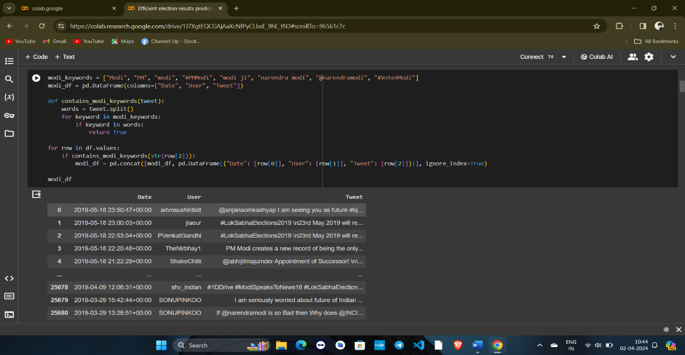

Reading the social media data

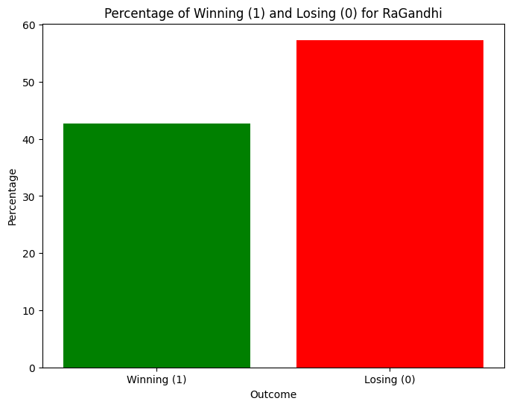

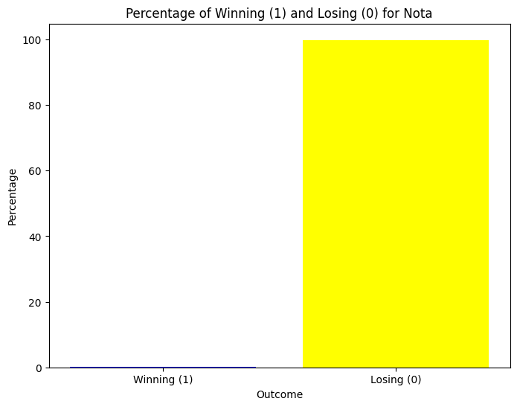

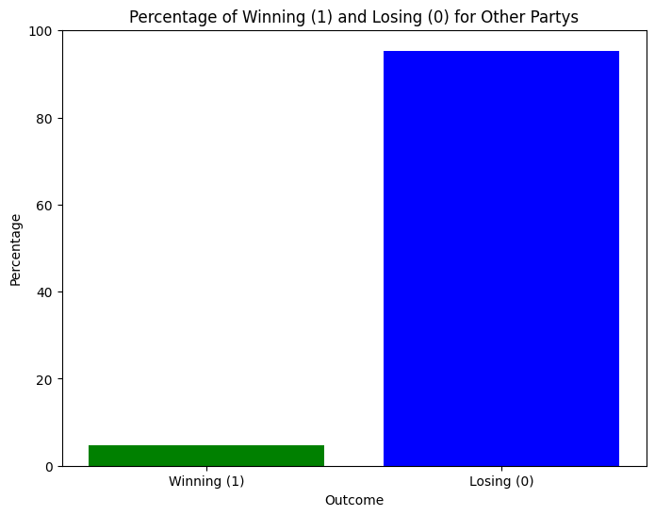

**7.2 DISCUSSION**

The project explores the utilization of social media data and techniques for predicting electoral outcomes, reflecting a growing interest among researchers and political entities in leveraging online platforms for electoral forecasting and campaign strategy planning. Through an in-depth examination of existing literature, the study provides an overview of methodologies, data sources, and outcomes associated with predicting elections using social media data. Despite the increasing popularity of social media as a tool for political communication and engagement, challenges such as language barriers, misclassification of sentiments, and data reliability persist. While many studies found social media data effective for electoral predictions, others raised concerns about its reliability and accuracy. Future research directions may involve addressing these limitations, exploring additional data sources, and enhancing analytical techniques to improve the predictive power of social media data in electoral forecasting.

**CHAPTER 8**

**CONCLUSION AND FUTURE ENHANCEMENT**

**CHAPTER 8**

**CONCLUSION AND FUTURE ENHANCEMENT**

**8.1 CONCLUSION**

The topic of predicting elections is gaining the attention of researchers as the utilization of social media data is making an important place due to its real-time nature and easy availability. Many attempts have been made by researchers to explore and validate the reliability of social media data in predicting election results. Mostly, twitter data was used by researchers in making predictions of electoral outcomes by checking the polarity of words using sentiment analysis. It is observed that very few studies utilized data collected from Facebook in making electoral predictions. Majority of studies found the social media data effective in making electoral predictions. Whereas few of the studies also discussed and reported that social media data cannot be relied upon. Similarly, sentiment analysis is the most common approach being adopted by researchers. But most of the studies also argued about the limitations attached to the approach of sentiment analysis and suggested to consider the linguistic and contextual feature as well. In the future work, the data sources other the social media will be discussed along with the comparison of data sources and approaches used.

**8.2 FUTURE ENHANCEMENT**

**Multilingual Analysis:** Addressing language barriers by developing sentiment analysis models capable of processing text in multiple languages, thereby expanding the scope of data collection and analysis beyond English-speaking regions.

Advanced Sentiment Analysis: Incorporating advanced natural language processing techniques, such as deep learning algorithms, to enhance the accuracy of sentiment classification and reduce misclassification errors in predicting electoral sentiments.

**Real-Time Monitoring:** Implementing real-time monitoring systems to continuously collect and analyze social media data during election periods, allowing for more timely predictions and adaptive campaign strategies.

Integration of Additional Data Sources: Integrating diverse data sources beyond social media, such as traditional polling data, demographic information, and economic indicators, to improve the robustness and reliability of electoral predictions.

**Predictive Analytics:** Leveraging machine learning and predictive modeling techniques to develop more sophisticated algorithms capable of identifying underlying patterns and trends in social media data, thereby enhancing the accuracy and granularity of electoral forecasts.

**User Engagement Analysis:** Expanding the analysis to include user engagement metrics, such as likes, shares, and comments, to gain insights into the effectiveness of political campaigns and candidate messaging on social media platforms.

**Visualization and Reporting:** Enhancing data visualization techniques to create intuitive and interactive dashboards for visualizing electoral predictions and trends, enabling stakeholders to interpret and act upon the insights more effectively.

**Ethical Considerations:** Implementing robust privacy and ethical frameworks to ensure responsible data collection, usage, and dissemination practices, addressing concerns related to user privacy, data bias, and algorithmic transparency.

**ANNEXURE**

**REFERENCES**

[1] Ceron, A., Curini, L., Iacus, S. M., & Porro, G. (2014). Every tweet counts? How sentiment analysis of social media can improve our knowledge of citizens’ political preferences with an application to Italy and France. New Media & Society, 16(2), 340-358.

[2] Lovaglio, P. G., Cesarini, M., Mercorio, F., & Mezzanzanica, M. (2018). Skills in demand for ICT and statistical occupations: Evidence from web- based job vacancies. Statistical Analysis and Data Mining: The ASA Data Science Journal, 11(2), 78-91.

[3] Bilal, M., Malik, N., Khalid, M., & Lali, M. I. U. (2017). Exploring Industrial Demand Trend’s in Pakistan Software Industry Using Online Job Portal Data. University of Sindh Journal of Information and Communication Technology, 1(1), 17-24.

[4] Nawaz, M. S., Bilal, M., Lali, M. I., Ul Mustafa, R., Aslam, W., & Jajja, S. (2017). Effectiveness of social media data in healthcare communication. Journal of Medical Imaging and Health Informatics,7(6), 1365-1371.

[5] Tiwana, M. S., Javeed, F., Lali, I. U., Dar, H., & Bilal, M. (2018). Comparative Analysis Of Context Based Classification Of Twitter. Fourth International Conference on Advances in Computing, Communication & Automation (ICACCA 2018), IEEE.

[6] Boutet, A., Kim, H., & Yoneki, E. (2012). What's in Your Tweets? I Know Who You Supported in the UK 2010 General Election. ICWSM, 12, 411-414.

[7] Gayo-Avello, D. (2013). A meta-analysis of state-of-the-art electoral prediction from Twitter data. Social Science Computer Review, 31(6), 649-679.

[8] Livne, A., Simmons, M. P., Adar, E., & Adamic, L. A. (2011). The Party Is Over Here: Structure and Content in the 2010 Election. ICWSM, 11, 17-21.

[9] Tumasjan, A., Sprenger, T. O., Sandner, P. G., & Welpe, I. M. (2010).Predicting elections with twitter: What 140 characters reveal about political sentiment. Icwsm, 10(1), 178-185.

[10] Fisher, S. D., Ford, R., Jennings, W., Pickup, M., & Wlezien, C. (2011). From polls to votes to seats: Forecasting the 2010 British general election. Electoral Studies, 30(2), 250-257.