Proxy Cache Pod

Table of Contents

Proxy-cache quay based pod creation 1

proxy-cache TLS issue. 1

Configure the proxy cache on the registry level. 6

hub quay configiration 6

CWL quay configuration 6

Testing pod creation using proxy-cache quay. 9

CNF image upload using pod command 12

# Proxy-cache quay based pod creation

## proxy-cache TLS issue.

1. Login in to CWL cluster and make sure mcp and nodes are looks good at this point, if any issue, need to be resolved first.

[root@ncputility ~ pancwl_rc]$ oc get nodes  
NAME STATUS ROLES AGE VERSION  
appworker0.panclypcwl01.mnc020.mcc714 Ready appworker,appworker-mcp-a,worker 38d v1.29.6+aba1e8d  
appworker1.panclypcwl01.mnc020.mcc714 Ready appworker,appworker-mcp-a,worker 38d v1.29.6+aba1e8d  
appworker10.panclypcwl01.mnc020.mcc714 Ready appworker,appworker-mcp-b,worker 37d v1.29.6+aba1e8d  
appworker11.panclypcwl01.mnc020.mcc714 Ready appworker,appworker-mcp-b,worker 37d v1.29.6+aba1e8d  
appworker12.panclypcwl01.mnc020.mcc714 Ready appworker,appworker-mcp-b,worker 37d v1.29.6+aba1e8d  
appworker13.panclypcwl01.mnc020.mcc714 Ready appworker,appworker-mcp-b,worker 37d v1.29.6+aba1e8d  
appworker14.panclypcwl01.mnc020.mcc714 Ready appworker,appworker-mcp-b,worker 37d v1.29.6+aba1e8d  
appworker15.panclypcwl01.mnc020.mcc714 Ready appworker,appworker-mcp-b,worker 37d v1.29.6+aba1e8d  
appworker16.panclypcwl01.mnc020.mcc714 Ready appworker,appworker-mcp-b,worker 37d v1.29.6+aba1e8d  
appworker17.panclypcwl01.mnc020.mcc714 Ready appworker,appworker-mcp-b,worker 37d v1.29.6+aba1e8d  
appworker19.panclypcwl01.mnc020.mcc714 Ready appworker,appworker-mcp-c,worker 37d v1.29.6+aba1e8d  
appworker2.panclypcwl01.mnc020.mcc714 Ready appworker,appworker-mcp-a,worker 30d v1.29.6+aba1e8d  
appworker20.panclypcwl01.mnc020.mcc714 Ready appworker,appworker-mcp-c,worker 37d v1.29.6+aba1e8d  
appworker21.panclypcwl01.mnc020.mcc714 Ready appworker,appworker-mcp-c,worker 37d v1.29.6+aba1e8d  
appworker22.panclypcwl01.mnc020.mcc714 Ready appworker,appworker-mcp-c,worker 37d v1.29.6+aba1e8d  
appworker23.panclypcwl01.mnc020.mcc714 Ready appworker,appworker-mcp-c,worker 37d v1.29.6+aba1e8d  
appworker24.panclypcwl01.mnc020.mcc714 Ready appworker,appworker-mcp-c,worker 37d v1.29.6+aba1e8d  
appworker25.panclypcwl01.mnc020.mcc714 Ready appworker,appworker-mcp-c,worker 37d v1.29.6+aba1e8d  
appworker26.panclypcwl01.mnc020.mcc714 Ready appworker,appworker-mcp-c,worker 37d v1.29.6+aba1e8d  
appworker27.panclypcwl01.mnc020.mcc714 Ready appworker,appworker-mcp-d,worker 37d v1.29.6+aba1e8d  
appworker28.panclypcwl01.mnc020.mcc714 Ready appworker,appworker-mcp-d,worker 37d v1.29.6+aba1e8d  
appworker29.panclypcwl01.mnc020.mcc714 Ready appworker,appworker-mcp-d,worker 37d v1.29.6+aba1e8d  
appworker3.panclypcwl01.mnc020.mcc714 Ready appworker,appworker-mcp-a,worker 38d v1.29.6+aba1e8d  
appworker30.panclypcwl01.mnc020.mcc714 Ready appworker,appworker-mcp-d,worker 37d v1.29.6+aba1e8d  
appworker31.panclypcwl01.mnc020.mcc714 Ready appworker,appworker-mcp-d,worker 37d v1.29.6+aba1e8d  
appworker32.panclypcwl01.mnc020.mcc714 Ready appworker,appworker-mcp-d,worker 37d v1.29.6+aba1e8d  
appworker33.panclypcwl01.mnc020.mcc714 Ready appworker,appworker-mcp-d,worker 37d v1.29.6+aba1e8d  
appworker34.panclypcwl01.mnc020.mcc714 Ready appworker,appworker-mcp-d,worker 37d v1.29.6+aba1e8d  
appworker4.panclypcwl01.mnc020.mcc714 Ready appworker,appworker-mcp-a,worker 38d v1.29.6+aba1e8d  
appworker5.panclypcwl01.mnc020.mcc714 Ready appworker,appworker-mcp-a,worker 38d v1.29.6+aba1e8d  
appworker6.panclypcwl01.mnc020.mcc714 Ready appworker,appworker-mcp-a,worker 38d v1.29.6+aba1e8d  
appworker7.panclypcwl01.mnc020.mcc714 Ready appworker,appworker-mcp-a,worker 37d v1.29.6+aba1e8d  
appworker9.panclypcwl01.mnc020.mcc714 Ready appworker,appworker-mcp-b,worker 37d v1.29.6+aba1e8d  
gateway1.panclypcwl01.mnc020.mcc714 Ready gateway,gateway-mcp-a,worker 38d v1.29.6+aba1e8d  
gateway2.panclypcwl01.mnc020.mcc714 Ready gateway,gateway-mcp-a,worker 38d v1.29.6+aba1e8d  
gateway3.panclypcwl01.mnc020.mcc714 Ready gateway,gateway-mcp-b,worker 38d v1.29.6+aba1e8d  
gateway4.panclypcwl01.mnc020.mcc714 Ready gateway,gateway-mcp-b,worker 38d v1.29.6+aba1e8d  
master0.panclypcwl01.mnc020.mcc714 Ready control-plane,master,monitor 38d v1.29.6+aba1e8d  
master1.panclypcwl01.mnc020.mcc714 Ready control-plane,master,monitor 38d v1.29.6+aba1e8d  
master2.panclypcwl01.mnc020.mcc714 Ready control-plane,master,monitor 38d v1.29.6+aba1e8d  
storage0.panclypcwl01.mnc020.mcc714 Ready storage,worker 38d v1.29.6+aba1e8d  
storage1.panclypcwl01.mnc020.mcc714 Ready storage,worker 38d v1.29.6+aba1e8d  
storage2.panclypcwl01.mnc020.mcc714 Ready storage,worker 38d v1.29.6+aba1e8d  
storage3.panclypcwl01.mnc020.mcc714 Ready storage,worker 38d v1.29.6+aba1e8d  
storage4.panclypcwl01.mnc020.mcc714 Ready storage,worker 38d v1.29.6+aba1e8d  
[root@ncputility ~ pancwl_rc]$ oc get mcp  
NAME CONFIG UPDATED UPDATING DEGRADED MACHINECOUNT READYMACHINECOUNT UPDATEDMACHINECOUNT DEGRADEDMACHINECOUNT AGE  
appworker-mcp-a rendered-appworker-mcp-a-0e9dd6df593dcd5016bbe7d601119bf4 True False False 8 8 8 0 37d  
appworker-mcp-b rendered-appworker-mcp-b-0e9dd6df593dcd5016bbe7d601119bf4 True False False 9 9 9 0 37d  
appworker-mcp-c rendered-appworker-mcp-c-5afb864664d3b10530b54b3153a1a61e True False False 8 8 8 0 29h  
appworker-mcp-d rendered-appworker-mcp-d-5afb864664d3b10530b54b3153a1a61e True False False 8 8 8 0 29h  
gateway-mcp-a rendered-gateway-mcp-a-c81254a16575de9053ae543c4f1ba3fb True False False 2 2 2 0 37d  
gateway-mcp-b rendered-gateway-mcp-b-3be41ecbbe09004c35ca04a4309cabf0 True False False 2 2 2 0 29h  
master rendered-master-114f60e6be691323222ea11e72de0bcf True False False 3 3 3 0 38d  
storage rendered-storage-dc2d8a34080bce1400e11bb1fb098693 True False False 5 5 5 0 37d  
worker rendered-worker-68cb1df39185f7ad80fda7915e4c5a42 True False False 0 0 0 0 38d  
[root@ncputility ~ pancwl_rc]$

1. login to hub cluster and run this command

[root@ncputility ~ pancwl_rc]$ source /root/panhubrc  
WARNING: Using insecure TLS client config. Setting this option is not supported!  
  
Login successful.  
  
You have access to 105 projects, the list has been suppressed. You can list all projects with 'oc projects'  
  
Using project "default".  
[root@ncputility ~ panhub_rc]$ oc get secret -n openshift-ingress-operator router-ca -o "jsonpath={.data['tls\.crt']}" | base64 -d  
-----BEGIN CERTIFICATE-----  
MIIDDDCCAfSgAwIBAgIBATANBgkqhkiG9w0BAQsFADAmMSQwIgYDVQQDDBtpbmdy  
ZXNzLW9wZXJhdG9yQDE3NDAwNzQ1NDQwHhcNMjUwMjIwMTgwMjIzWhcNMjcwMjIw  
MTgwMjI0WjAmMSQwIgYDVQQDDBtpbmdyZXNzLW9wZXJhdG9yQDE3NDAwNzQ1NDQw  
ggEiMA0GCSqGSIb3DQEBAQUAA4IBDwAwggEKAoIBAQDjXWFSVPshwihivZhaTrB7  
0boUOw2j3Ut/J6eSm+JA+xVl05L4XD8+C8VSst+f32Pe42Lso2hrovY1dT7IBX3g  
6S9Nnd2iRc9vC/qHcQkGQ6krIYSQ48aCH7UuahCpTqxEp+MwmhCTQngN2maTJBe3  
0E6K2IL4zXSi0Iuj08BOnH/w4pJxeWhyngXDf2SeA88EmU3juHLshHrAND84uou2  
/sOStIAhFwU+o887dSgx7iERy+6nczSDB9Qvq11cUSS4RPC82bNnxcc+BrynDwZ/  
eggs0OEaj/1cHu/svKZHX9gUKrqz80wF8YGZLLgI2oPAf2VJorvtkJAErzgttroF  
AgMBAAGjRTBDMA4GA1UdDwEB/wQEAwICpDASBgNVHRMBAf8ECDAGAQH/AgEAMB0G  
A1UdDgQWBBTZS/SzkBfiHQ5/Gy+b4g1XJOHkojANBgkqhkiG9w0BAQsFAAOCAQEA  
UwPhAbzTWZIlBsMHAL+8jvxM8qxc6HDhayAD4gbCE65vHYgSizost02vRfpOPQq1  
D6HM8JjifS3KHd6E6chdTbrHI0W8pMJJPon5akCJf/uGeGDl+2wKfmVC6UoV7hC3  
pcUzm3JKwsNJbjS5rxL8f5a8bNdIFfLQKuyRpnVX2CsNHvh+WJzynQ+PUJ6zCa7y  
x5AJxca2PTnBKRoVTAyumT1suluI9f4GRYnxTE/qIKRZRs+uT3kIl/N9VX+GbjGb  
pPszJ+p6N6Arl1BqJP1DdLin2IFGZL39pTyifm5GP+Vou2aHPuHZDVoCdxsFKup+  
gUY2KeKz0UManwubPQNnKA==  
-----END CERTIFICATE-----  
[root@ncputility ~ panhub_rc]$

1. login to workload cluster and run this command

[root@ncputility ~ pancwl_rc]$ source /root/pancwlrc  
WARNING: Using insecure TLS client config. Setting this option is not supported!  
  
Login successful.  
  
You have access to 115 projects, the list has been suppressed. You can list all projects with 'oc projects'  
  
Using project "nokia".  
[root@ncputility ~ pancwl_rc]$ oc get cm -n openshift-config user-ca-bundle -o yaml  
apiVersion: v1  
data:  
 ca-bundle.crt: |  
 -----BEGIN CERTIFICATE-----  
 MIIDDDCCAfSgAwIBAgIBATANBgkqhkiG9w0BAQsFADAmMSQwIgYDVQQDDBtpbmdy  
 ZXNzLW9wZXJhdG9yQDE3NDAwNzQ1NDQwHhcNMjUwMjIwMTgwMjIzWhcNMjcwMjIw  
 MTgwMjI0WjAmMSQwIgYDVQQDDBtpbmdyZXNzLW9wZXJhdG9yQDE3NDAwNzQ1NDQw  
 ggEiMA0GCSqGSIb3DQEBAQUAA4IBDwAwggEKAoIBAQDjXWFSVPshwihivZhaTrB7  
 0boUOw2j3Ut/J6eSm+JA+xVl05L4XD8+C8VSst+f32Pe42Lso2hrovY1dT7IBX3g  
 6S9Nnd2iRc9vC/qHcQkGQ6krIYSQ48aCH7UuahCpTqxEp+MwmhCTQngN2maTJBe3  
 0E6K2IL4zXSi0Iuj08BOnH/w4pJxeWhyngXDf2SeA88EmU3juHLshHrAND84uou2  
 /sOStIAhFwU+o887dSgx7iERy+6nczSDB9Qvq11cUSS4RPC82bNnxcc+BrynDwZ/  
 eggs0OEaj/1cHu/svKZHX9gUKrqz80wF8YGZLLgI2oPAf2VJorvtkJAErzgttroF  
 AgMBAAGjRTBDMA4GA1UdDwEB/wQEAwICpDASBgNVHRMBAf8ECDAGAQH/AgEAMB0G  
 A1UdDgQWBBTZS/SzkBfiHQ5/Gy+b4g1XJOHkojANBgkqhkiG9w0BAQsFAAOCAQEA  
 UwPhAbzTWZIlBsMHAL+8jvxM8qxc6HDhayAD4gbCE65vHYgSizost02vRfpOPQq1  
 D6HM8JjifS3KHd6E6chdTbrHI0W8pMJJPon5akCJf/uGeGDl+2wKfmVC6UoV7hC3  
 pcUzm3JKwsNJbjS5rxL8f5a8bNdIFfLQKuyRpnVX2CsNHvh+WJzynQ+PUJ6zCa7y  
 x5AJxca2PTnBKRoVTAyumT1suluI9f4GRYnxTE/qIKRZRs+uT3kIl/N9VX+GbjGb  
 pPszJ+p6N6Arl1BqJP1DdLin2IFGZL39pTyifm5GP+Vou2aHPuHZDVoCdxsFKup+  
 gUY2KeKz0UManwubPQNnKA==  
 -----END CERTIFICATE-----  
kind: ConfigMap  
metadata:  
 annotations:  
 openshift.io/owning-component: End User  
 creationTimestamp: "2025-03-03T08:56:26Z"  
 name: user-ca-bundle  
 namespace: openshift-config  
 resourceVersion: "43318895"  
 uid: 6624e5ad-93b5-418e-8c1e-7a91c724a760  
[root@ncputility ~ pancwl_rc]$ oc get proxy cluster -o yaml  
apiVersion: config.openshift.io/v1  
kind: Proxy  
metadata:  
 creationTimestamp: "2025-03-03T08:54:59Z"  
 generation: 2  
 name: cluster  
 resourceVersion: "48312416"  
 uid: ceaebe02-9bd3-4361-847e-1b880ebb85de  
spec:  
 trustedCA:  
 name: user-ca-bundle <---------------------------- this should be patched. if missing.   
status: {}  
[root@ncputility ~ pancwl_rc]$

1. login to workload cluster add tls of hub to cwl.

[root@ncputility ~ pancwl_rc]$ oc patch proxy cluster --patch '{"spec":{"trustedCA":{"name":"user-ca-bundle"}}}' --type=merge  
[root@ncputility ~ pancwl_rc]$ oc get proxy cluster -o yaml  
apiVersion: config.openshift.io/v1  
kind: Proxy  
metadata:  
 creationTimestamp: "2025-03-03T08:54:59Z"  
 generation: 2  
 name: cluster  
 resourceVersion: "48312416"  
 uid: ceaebe02-9bd3-4361-847e-1b880ebb85de  
spec:  
 trustedCA:  
 name: user-ca-bundle  
status: {}  
[root@ncputility ~ pancwl_rc]$

## Configure the proxy cache on the registry level.

### hub quay configiration

1. Open up the hub quay url

### CWL quay configuration

1. Open CWL quay login via super account and created an user called cnfowners also fix the passwd.

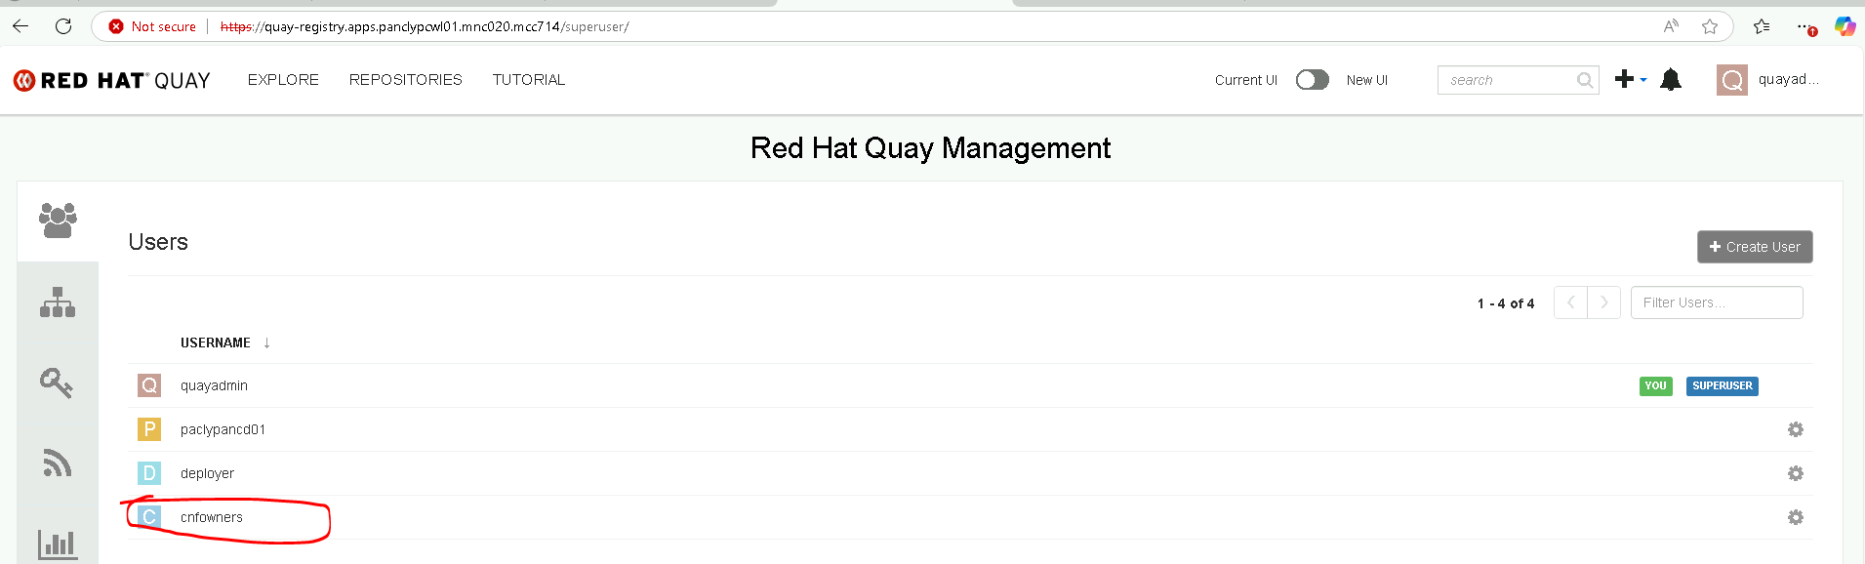 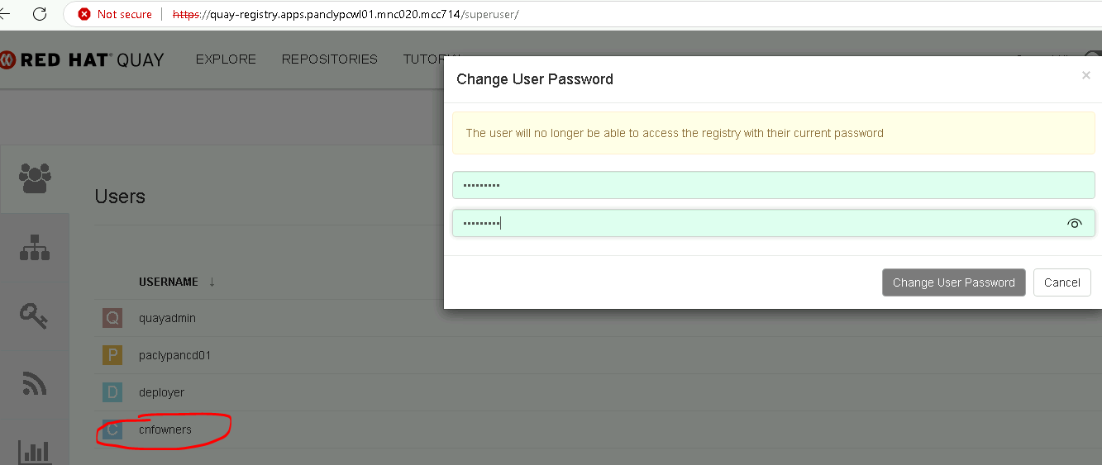

1. Create an org as same as hub quay.

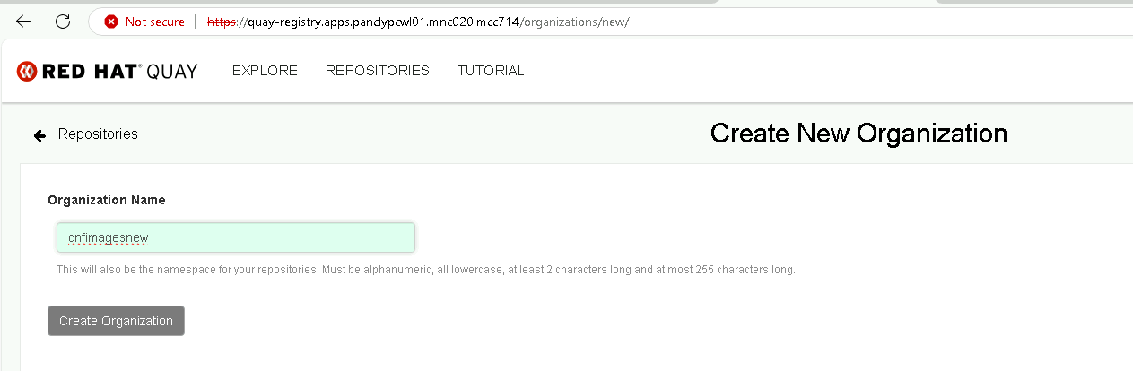

alt text

1. Set the proxy cache configuration for the organization

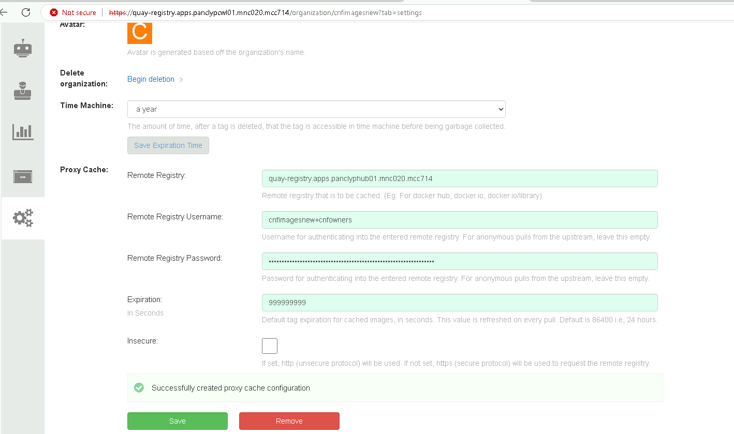

alt text

1. create robot account and default permission

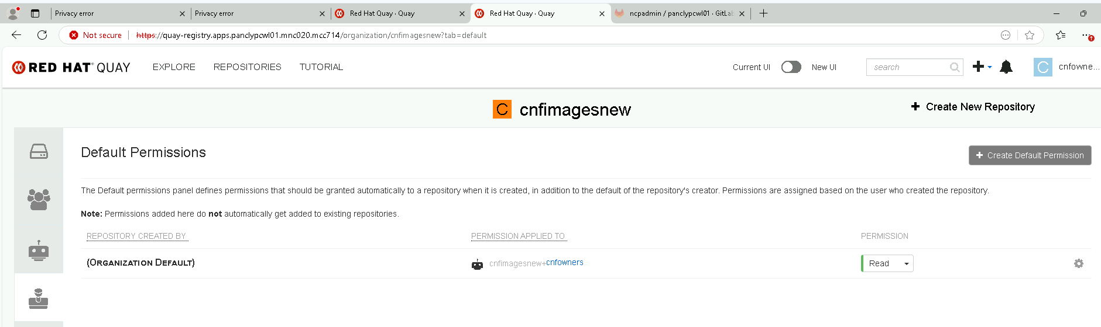

alt text

1. Create a new team for image pull user

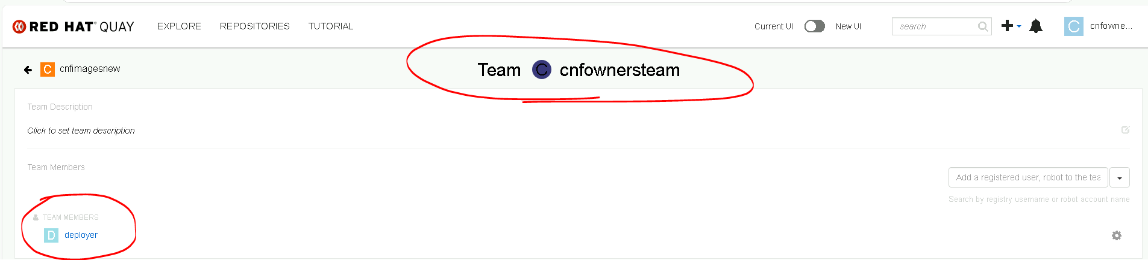

alt text

1. Set default permission for the pull user (optional)

→ Default Permissions → + Create Default Permission

1. Extend the global image pull secret

During the Managed cluster installation, the global pull secret is configured. If the 2nd Hub Quay account and the cache account are not prepared in advance, these accounts need to be added. In case of mirrored registries, only the global pull secret can be used. It is not possible to add project specific pull secrets. For more information, see chapter Image configuration resources in document Images, available in OpenShift Container Platform Product documentation.

## Testing pod creation using proxy-cache quay.

1. Login the namespace with cluster admin access to grand rights for an scc.

[root@ncputility ~ pancwl_rc]$ source /root/pancwlrc  
WARNING: Using insecure TLS client config. Setting this option is not supported!  
  
Login successful.  
  
You have access to 116 projects, the list has been suppressed. You can list all projects with 'oc projects'  
  
Using project "default".  
[root@ncputility ~ pancwl_rc]$

1. Grand admin rights to project. if missed during project creation phase.

[root@ncputility ~ pancwl_rc]$ oc policy add-role-to-user admin nokia -n nokia  
clusterrole.rbac.authorization.k8s.io/admin added: "nokia"  
[root@ncputility ~ pancwl_rc]$

1. Also grand scc role to default service account via anyuid.

[root@ncputility ~ pancwl_rc]$ oc adm policy add-scc-to-user anyuid -z default -n nokia  
clusterrole.rbac.authorization.k8s.io/system:openshift:scc:anyuid added: "default"  
[root@ncputility ~ pancwl_rc]$

1. login to cnf tenant here .

[root@ncputility ~ pancwl_rc]$ oc login -u nokia -p nokia@123  
WARNING: Using insecure TLS client config. Setting this option is not supported!  
  
Login successful.  
  
You have one project on this server: "nokia"  
  
Using project "nokia".  
[root@ncputility ~ pancwl_rc]$

1. run an pod using proxy-cache url

[root@ncputility ~ pancwl_rc]$ oc run podpingtest3 --image=ephemeral.url/cnfimages/testimage01:latest --restart=Never -- tail -f /dev/null  
pod/podpingtest3 created  
[root@ncputility ~ pancwl_rc]$ oc get pods  
NAME READY STATUS RESTARTS AGE  
podpingtest3 0/1 ContainerCreating 0 4s  
[root@ncputility ~ pancwl_rc]$ oc get pods  
NAME READY STATUS RESTARTS AGE  
podpingtest3 0/1 ContainerCreating 0 6s  
[root@ncputility ~ pancwl_rc]$ oc get pods  
NAME READY STATUS RESTARTS AGE  
podpingtest3 0/1 ContainerCreating 0 8s  
[root@ncputility ~ pancwl_rc]$ oc get pods  
NAME READY STATUS RESTARTS AGE  
podpingtest3 0/1 ContainerCreating 0 9s  
[root@ncputility ~ pancwl_rc]$ oc get pods  
NAME READY STATUS RESTARTS AGE  
podpingtest3 0/1 ContainerCreating 0 11s  
[root@ncputility ~ pancwl_rc]$ oc get pods  
NAME READY STATUS RESTARTS AGE  
podpingtest3 0/1 ContainerCreating 0 13s  
[root@ncputility ~ pancwl_rc]$

1. validate the pod status and make sure it’s getting the image via proxy-cache.

[root@ncputility ~ pancwl_rc]$ oc get pods  
NAME READY STATUS RESTARTS AGE  
podpingtest3 1/1 Running 0 5m1s  
[root@ncputility ~ pancwl_rc]$  
  
  
[root@ncputility ~ pancwl_rc]$ oc describe pod podpingtest3  
Name: podpingtest3  
Namespace: nokia  
Priority: 0  
Service Account: default  
Node: appworker9.panclypcwl01.mnc020.mcc714/10.89.96.35  
Start Time: Fri, 04 Apr 2025 08:04:47 -0500  
Labels: run=podpingtest3  
Annotations: k8s.ovn.org/pod-networks:  
 {"default":{"ip_addresses":["172.19.21.252/23"],"mac_address":"0a:58:ac:13:15:fc","gateway_ips":["172.19.20.1"],"routes":[{"dest":"172.16....  
 k8s.v1.cni.cncf.io/network-status:  
 [{  
 "name": "ovn-kubernetes",  
 "interface": "eth0",  
 "ips": [  
 "172.19.21.252"  
 ],  
 "mac": "0a:58:ac:13:15:fc",  
 "default": true,  
 "dns": {}  
 }]  
 openshift.io/scc: anyuid  
Status: Running  
IP: 172.19.21.252  
IPs:  
 IP: 172.19.21.252  
Containers:  
 podpingtest3:  
 Container ID: cri-o://749055ef608c6f30be42248c63889fd85377928389dae2e29eed50919cc2ee79  
 Image: ephemeral.url/cnfimages/testimage01:latest  
 Image ID: ephemeral.url/cnfimages/testimage01@sha256:32666e0234f88377a91de56bb78f2d4f8df45b4f99c1c2dc9ee1d134c84f4753  
 Port: <none>  
 Host Port: <none>  
 Args:  
 tail  
 -f  
 /dev/null  
 State: Running  
 Started: Fri, 04 Apr 2025 08:05:05 -0500  
 Ready: True  
 Restart Count: 0  
 Environment: <none>  
 Mounts:  
 /var/run/secrets/kubernetes.io/serviceaccount from kube-api-access-mp46w (ro)  
Conditions:  
 Type Status  
 PodReadyToStartContainers True  
 Initialized True  
 Ready True  
 ContainersReady True  
 PodScheduled True  
Volumes:  
 kube-api-access-mp46w:  
 Type: Projected (a volume that contains injected data from multiple sources)  
 TokenExpirationSeconds: 3607  
 ConfigMapName: kube-root-ca.crt  
 ConfigMapOptional: <nil>  
 DownwardAPI: true  
 ConfigMapName: openshift-service-ca.crt  
 ConfigMapOptional: <nil>  
QoS Class: BestEffort  
Node-Selectors: <none>  
Tolerations: node.kubernetes.io/not-ready:NoExecute op=Exists for 60s  
 node.kubernetes.io/unreachable:NoExecute op=Exists for 60s  
Events:  
 Type Reason Age From Message  
 ---- ------ ---- ---- -------  
 Normal Scheduled 6m5s default-scheduler Successfully assigned nokia/podpingtest3 to appworker9.panclypcwl01.mnc020.mcc714  
 Normal AddedInterface 6m4s multus Add eth0 [172.19.21.252/23] from ovn-kubernetes  
 Normal Pulling 6m4s kubelet Pulling image "ephemeral.url/cnfimages/testimage01:latest"  
 Normal Pulled 5m47s kubelet Successfully pulled image "ephemeral.url/cnfimages/testimage01:latest" in 17.521s (17.521s including waiting)  
 Normal Created 5m47s kubelet Created container podpingtest3  
 Normal Started 5m47s kubelet Started container podpingtest3  
[root@ncputility ~ pancwl_rc]$

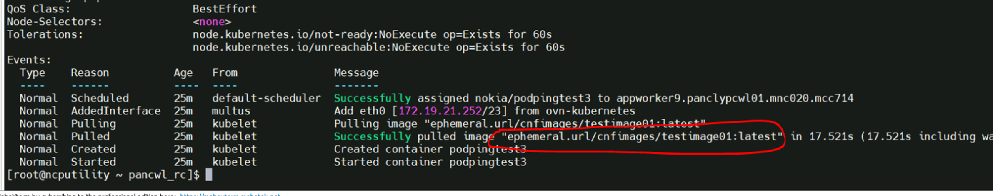

alt text

## CNF image upload using pod command

1. login to hub quay using cnfowners and org as cnfimages.

[root@ncputility ~ pancwl_rc]$ podman login quay-registry.apps.panclyphub01.mnc020.mcc714 -u cnfowners -p cnfowners  
Login Succeeded!  
[root@ncputility ~ pancwl_rc]$

1. load the container images to log registry

[root@ncputility ~ pancwl_rc]$ podman load -i <filename>.tar^C  
[root@ncputility ~ pancwl_rc]$

1. tag the image to your registry here

[root@ncputility ~ pancwl_rc]$ podman tag quay-registry.apps.panclyphub01.mnc020.mcc714/cnfimages/testimage01 quay-registry.apps.panclyphub01.mnc020.mcc714/cnfimagesnew/testimage01:latest  
[root@ncputility ~ pancwl_rc]$

1. push the image to remore registry using podman push command here .

[root@ncputility ~ pancwl_rc]$ podman push quay-registry.apps.panclyphub01.mnc020.mcc714/cnfimagesnew/testimage01:latest  
Getting image source signatures  
Copying blob 1af69dabfc93 done |  
Copying blob 53f86715cdba done |  
Copying blob b6361360b38a done |  
Copying config d39b33df22 done |  
Writing manifest to image destination  
[root@ncputility ~ pancwl_rc]$