Terraform-Adv-lab1

Steps:

Step1:
Run the git clone on the vs code terminal
$ git clone https://github.com/Vishwanathms/tf-adv-im-feb26
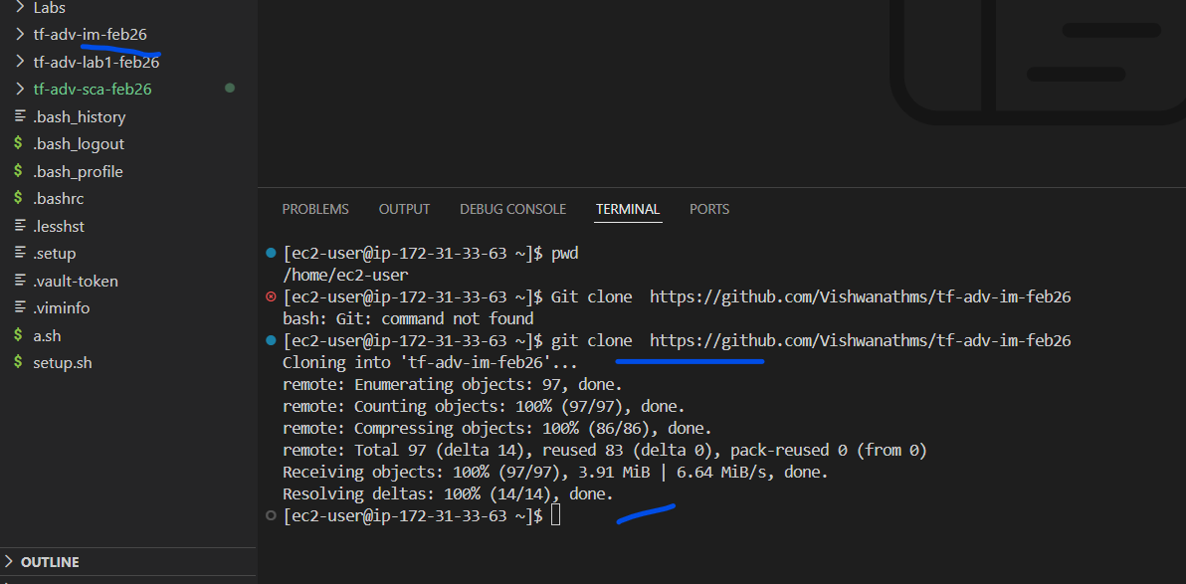
Move into the folder
[ec2-user@ip-172-31-33-63 ~]$ cd tf-adv-im-feb26/
[ec2-user@ip-172-31-33-63 tf-adv-im-feb26]$

Step2:
Go to the lab1
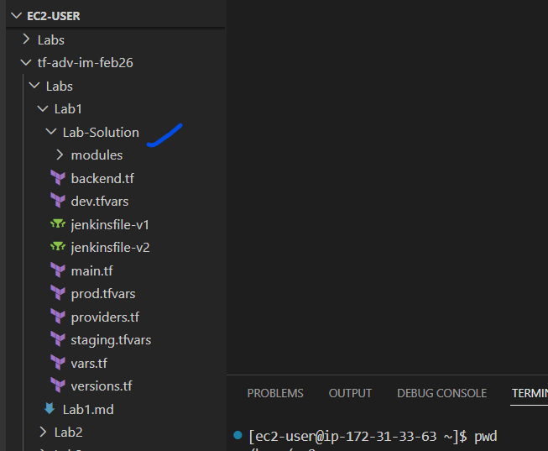

Step3:
The variables we are defining does not have default values
variable "environment" {
type = string
description = "Environment name (dev/staging/prod) supplied by Jenkins from workspace"
default = "dev"
}

variable "region" {
type = string
description = "AWS region"
default = "us-west-2"
}

variable "subnet_id" {
type = string
description = "The VPC Subnet ID to launch the EC2 instance in"
default = "subnet-04f014a664f51b81a"
}

Step4.
Create an repo for the lab1 in the github

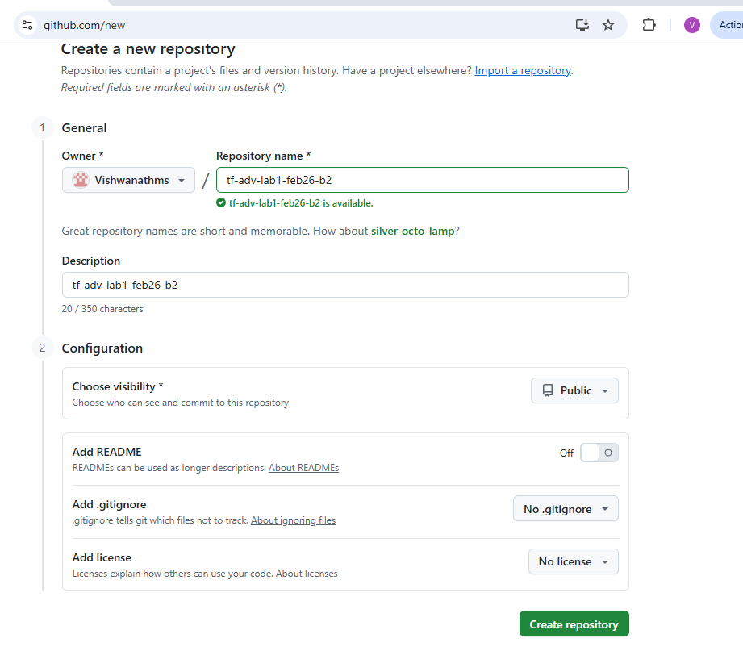

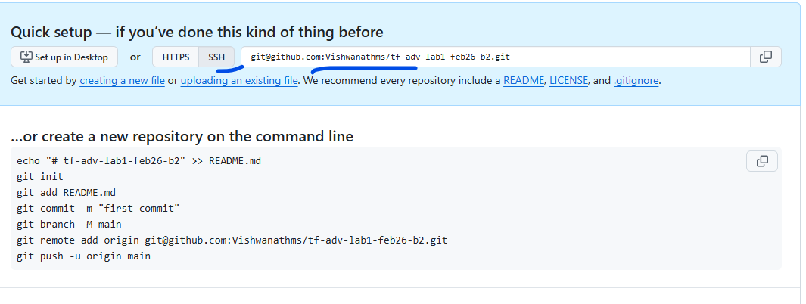
Now back on the VS code
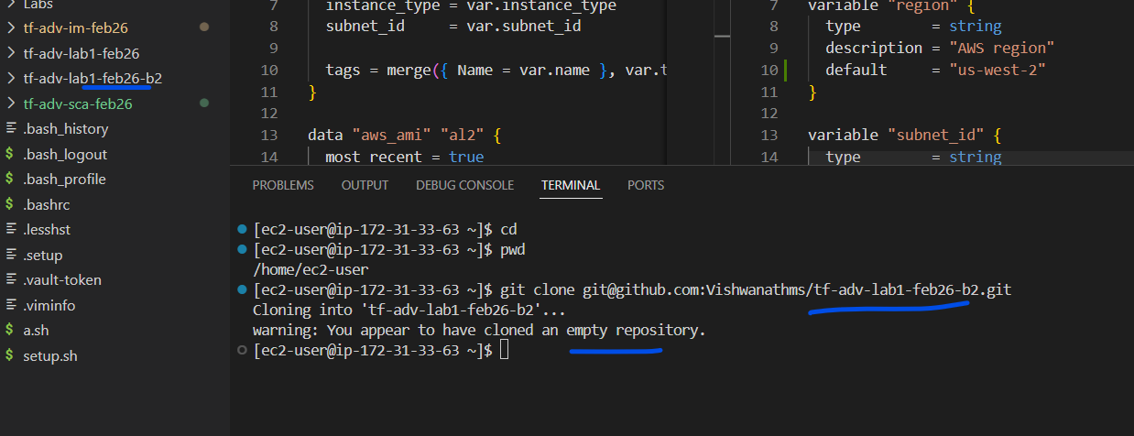

Step5:
Now w ehave to setup the key for authentication
$ ssh-keygen -t rsa
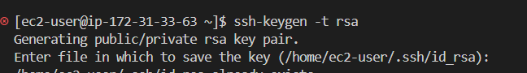
Validateing the output
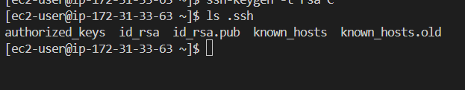
Lets use the public key
You need to be in the home directory of the user
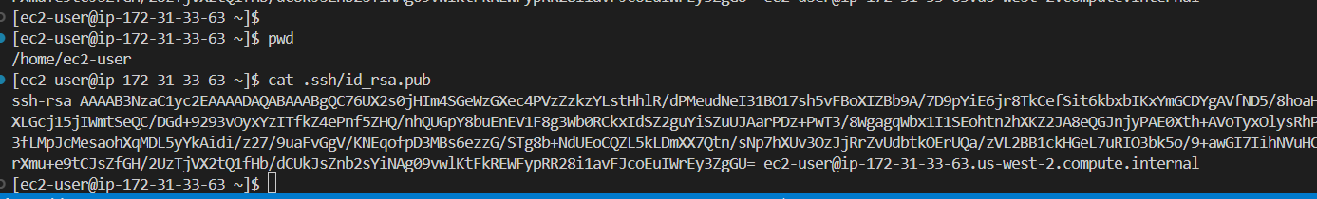
Copy the ssh public key
And paste it in the github
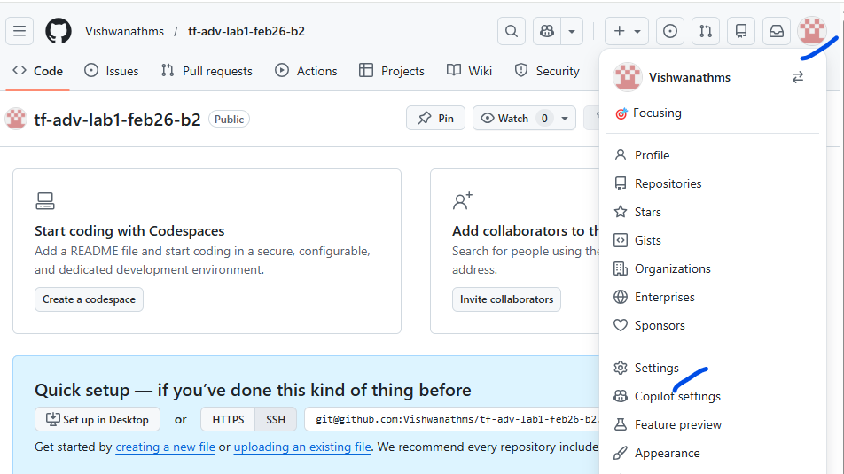
Click on Settings

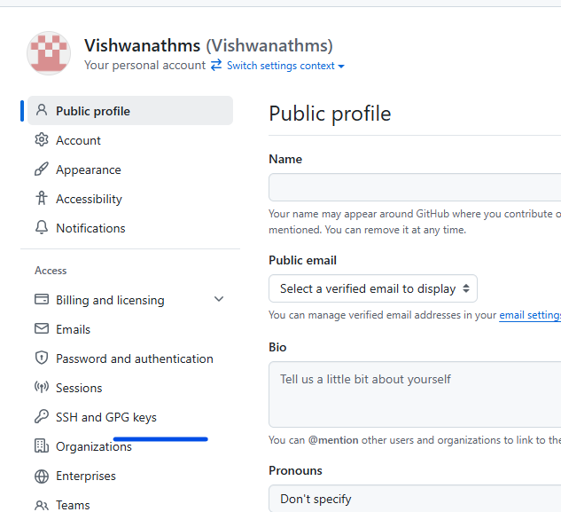
Click on “Ssh and GPG keys”
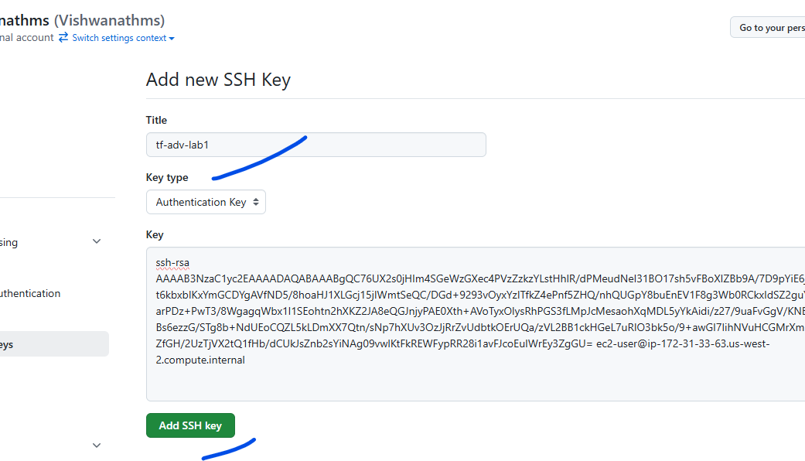
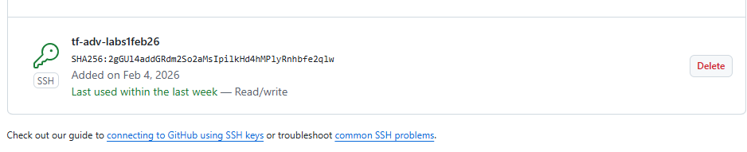

Step6:
Move to the repo folder
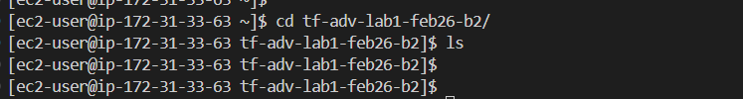
Copy the lab1 files and folders to this folder
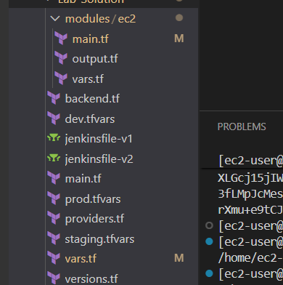
Destination is below
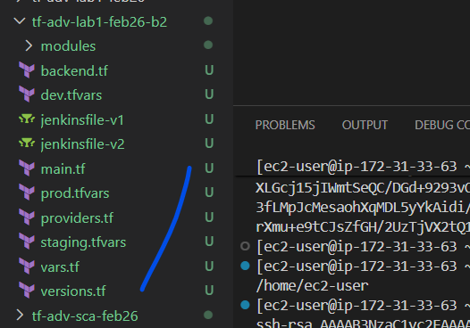
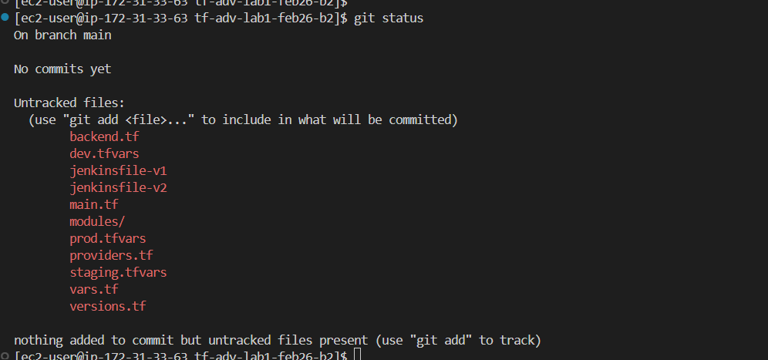

Step7:
Remove “dev.tfvars”, prod.tfvars, staging.tfvars
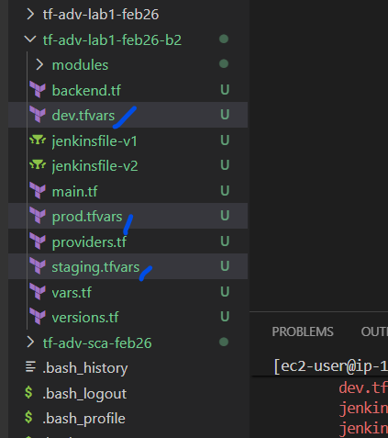

Step8:
Since we are using the backend
We will have to create the backend s3 bucket manually.
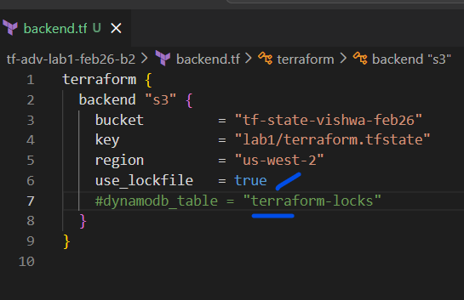
We will use the native lockfile and comment dynamodb
Create the S3 bucket with version enabled
Bucket name -- tf-state-vishwa-feb26

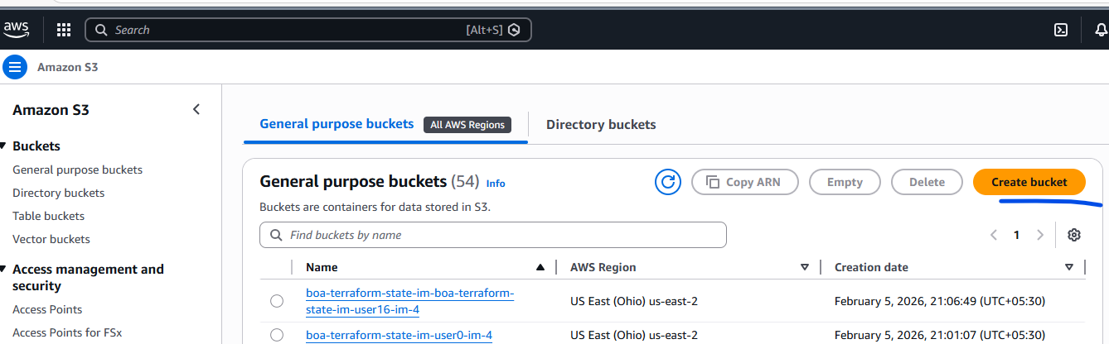
Create bucket
Note: the region is “us-west-1”
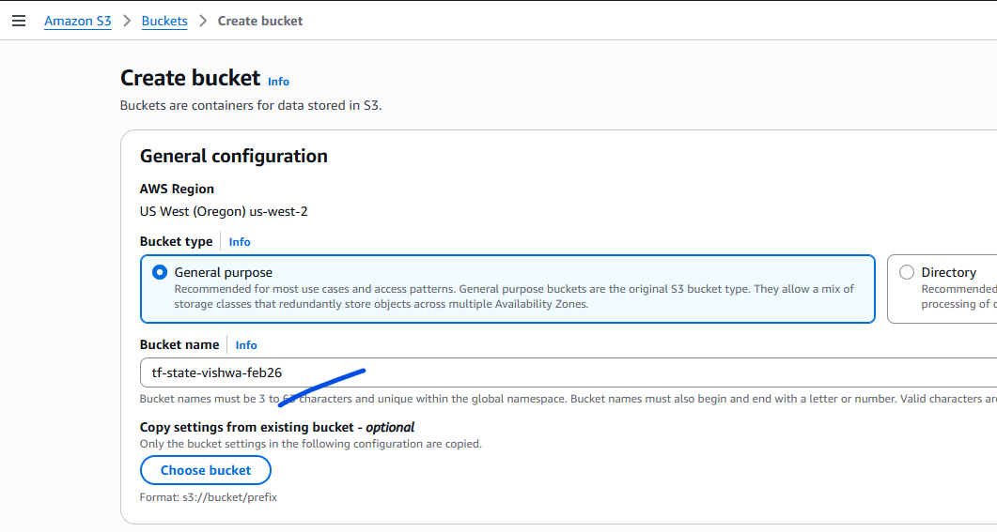
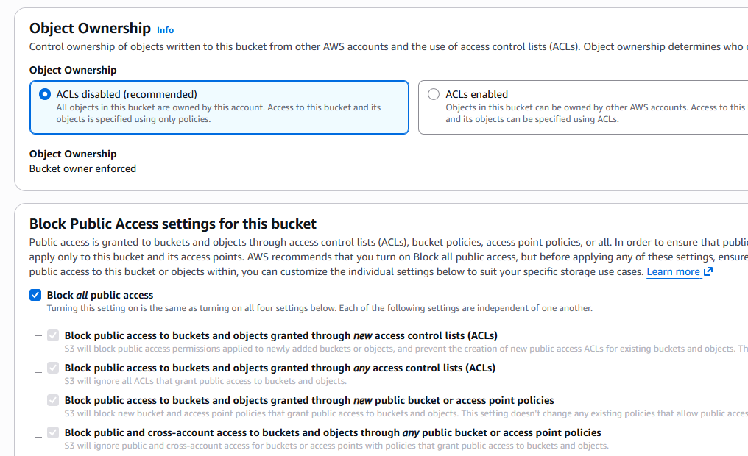

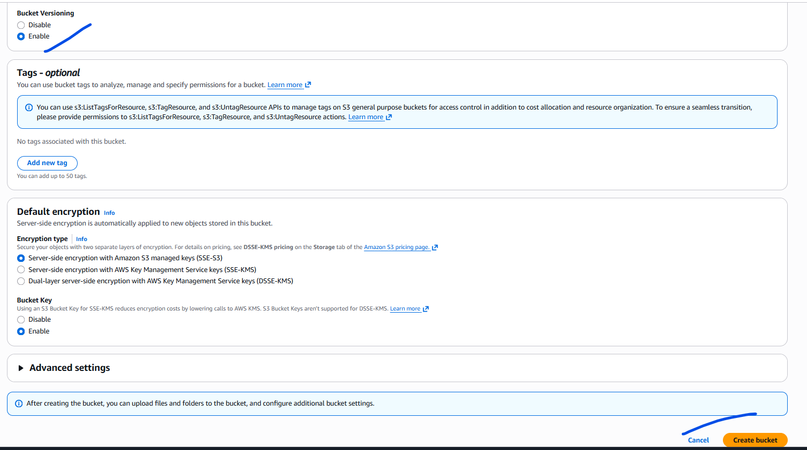

Click on “create bucket”
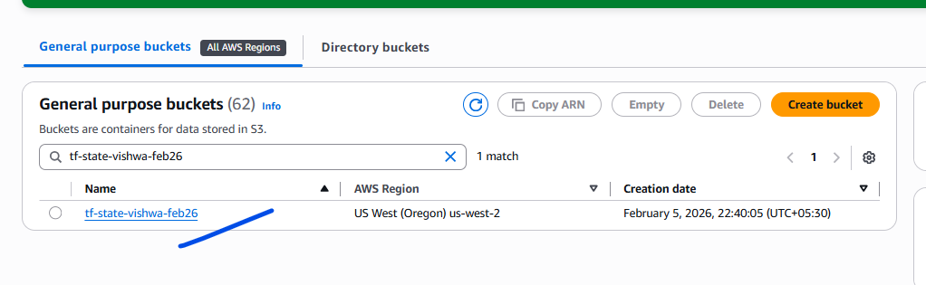
Validation

Step9:
Fine tunning the codes
In the “modules/ec2”
Comment or remove provider
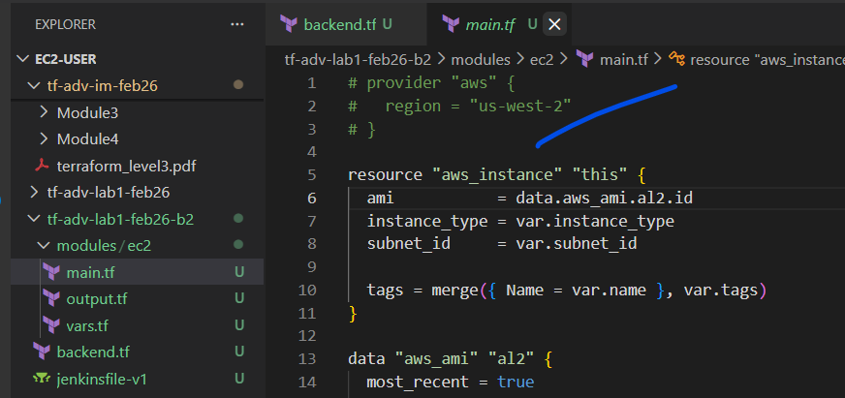

Step10:
Git commands to push to repo
git add .
git commit -m "lab1code"
git push

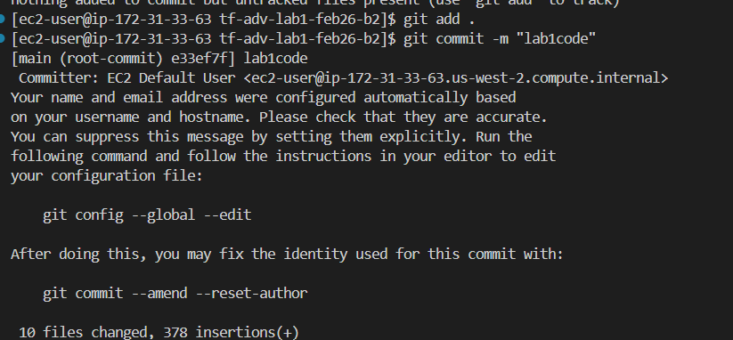
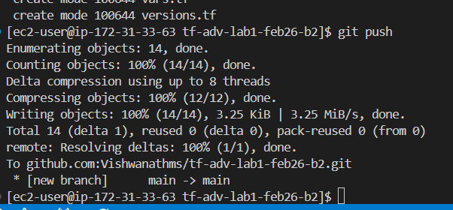
We might get an error message

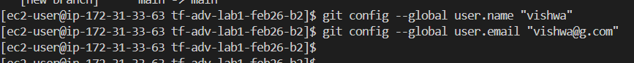

Then the git commit would work
Check in the github
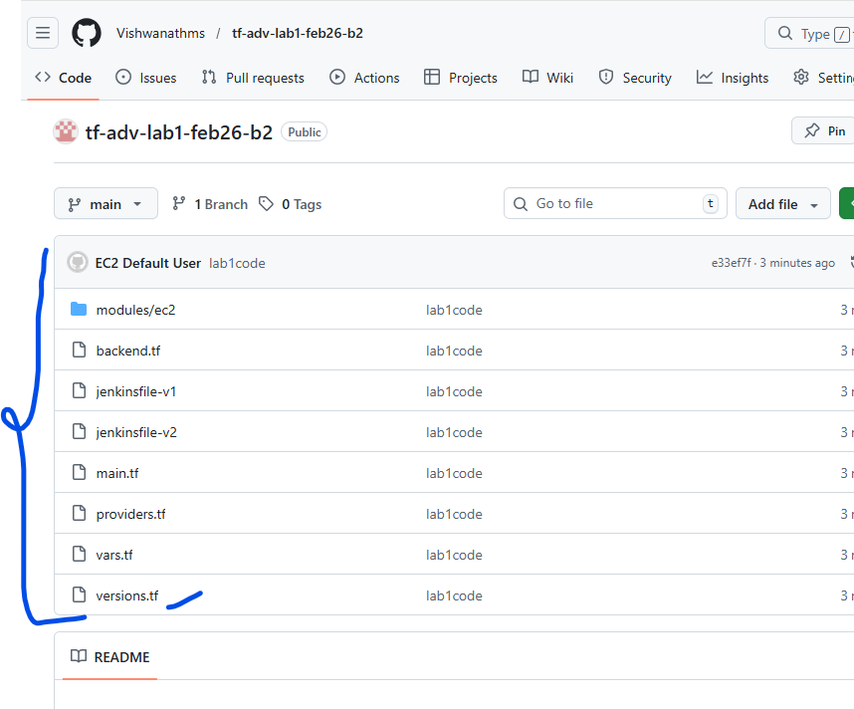

Step11:
Creating the Jenkins jobs.
It would be an multi pipeline
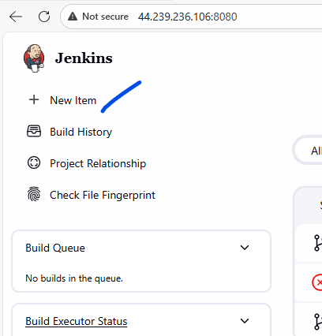
Click on the “new item”
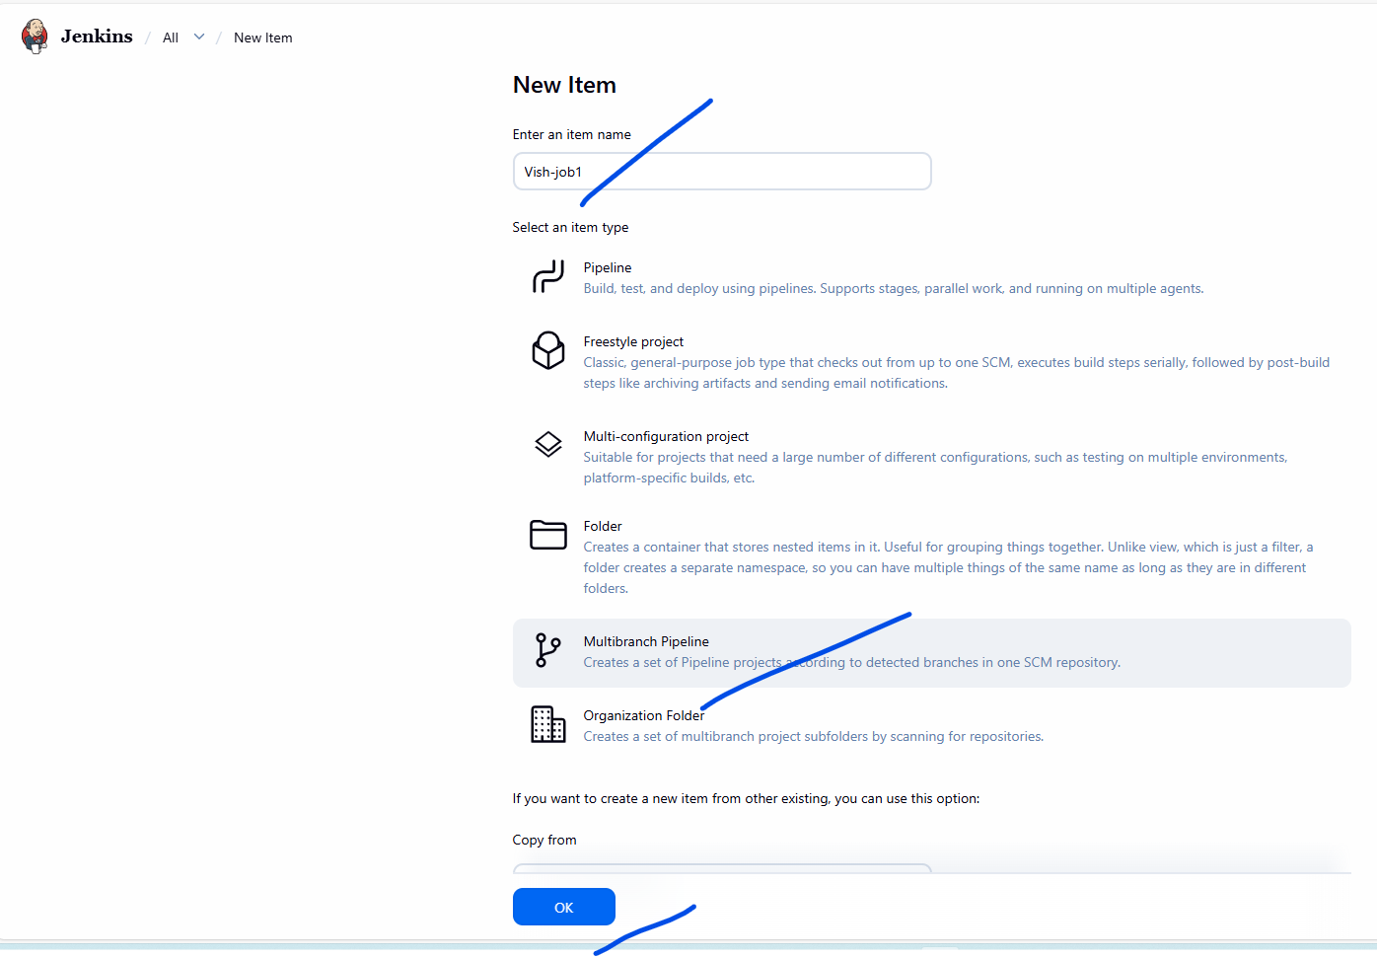
Click on “multibranch pipeline” and click “OK”
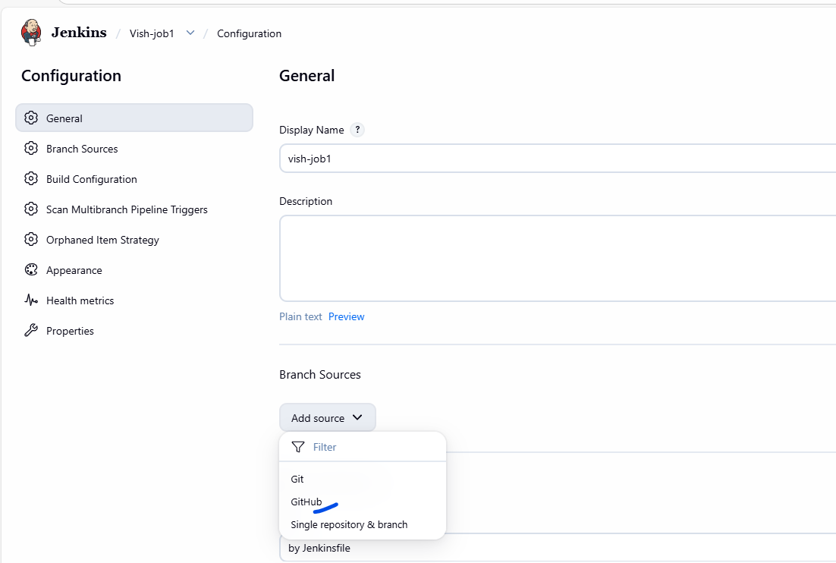
Select “github”
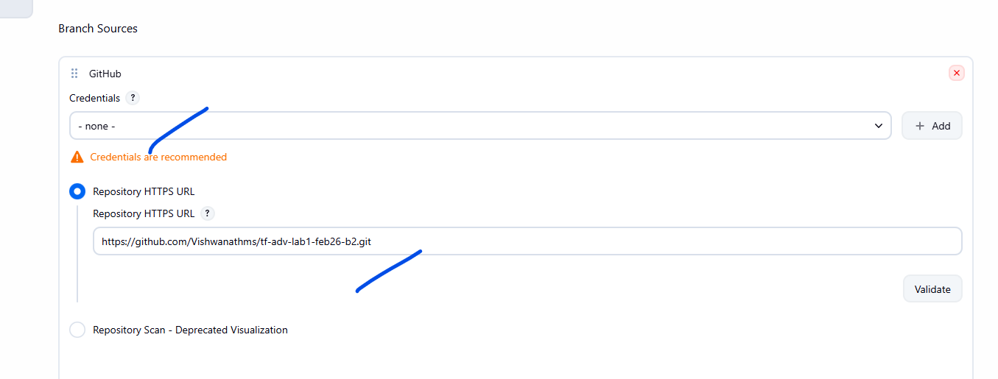
Click on validate.
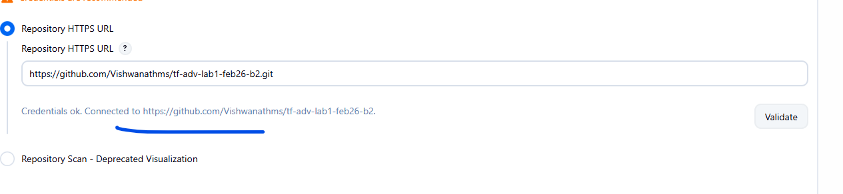

Use the https repo link from github

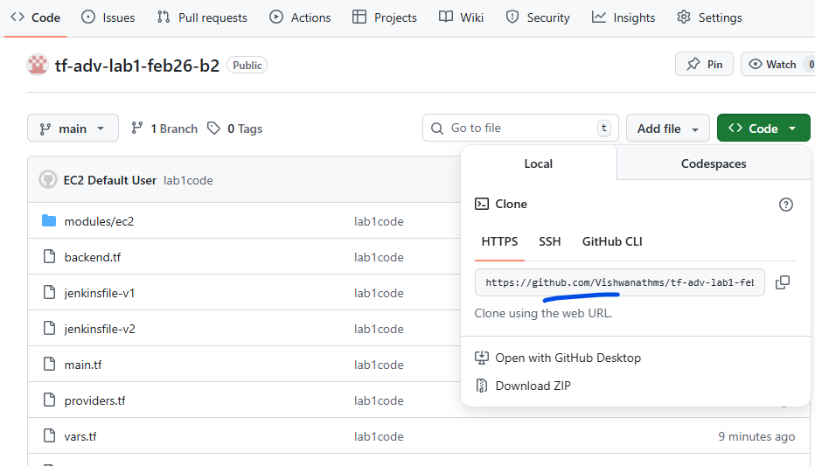

Now lets set the behaviors
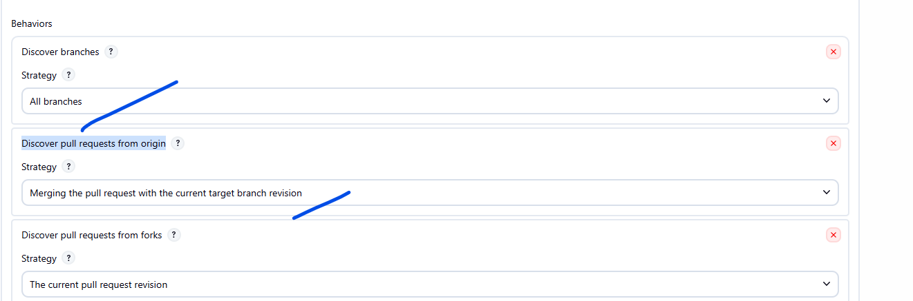
Make sure to select the right one for
“Strategy” – all branch
Dis

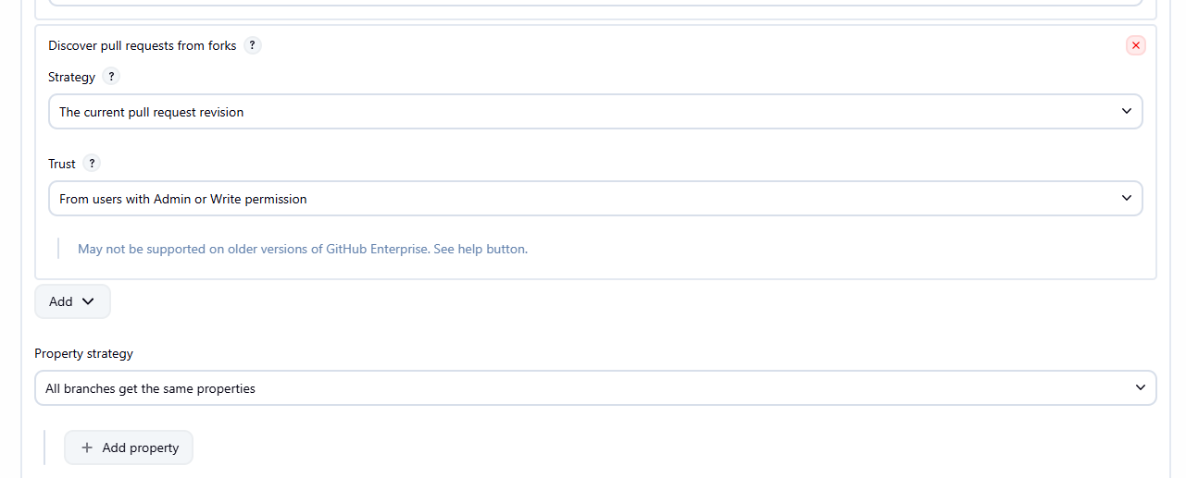
No changes here

Now make sure to match the jenkinsfile name
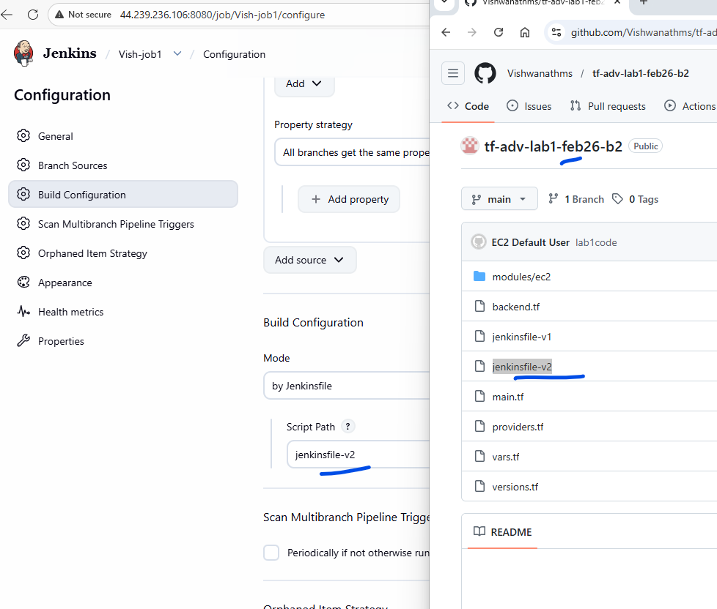

Click on Save.

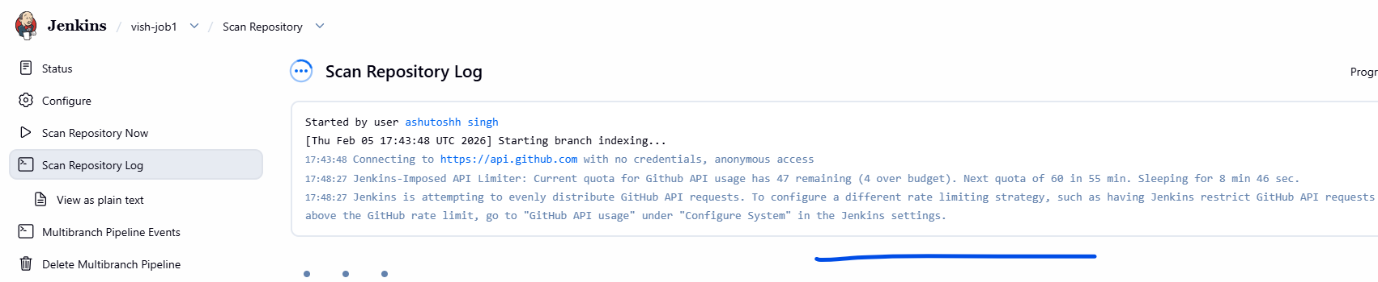
Since all the users are using the public github , there is an quota for it without creds.
To solve this problem
Lets create creds,
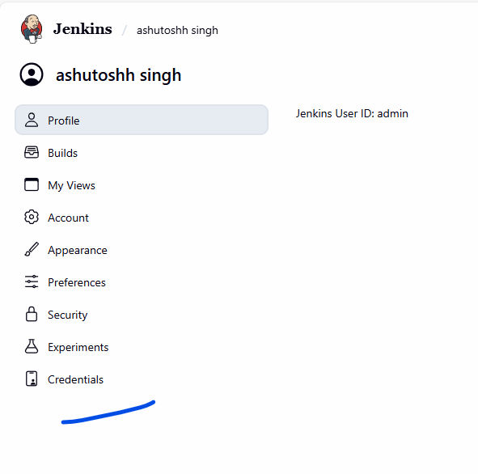
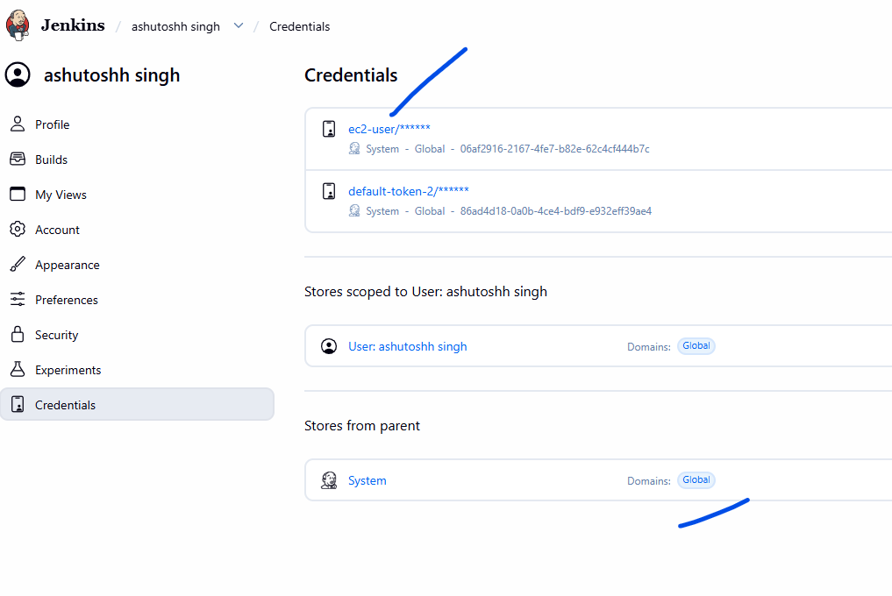
Click on “global” under the “store form parent”
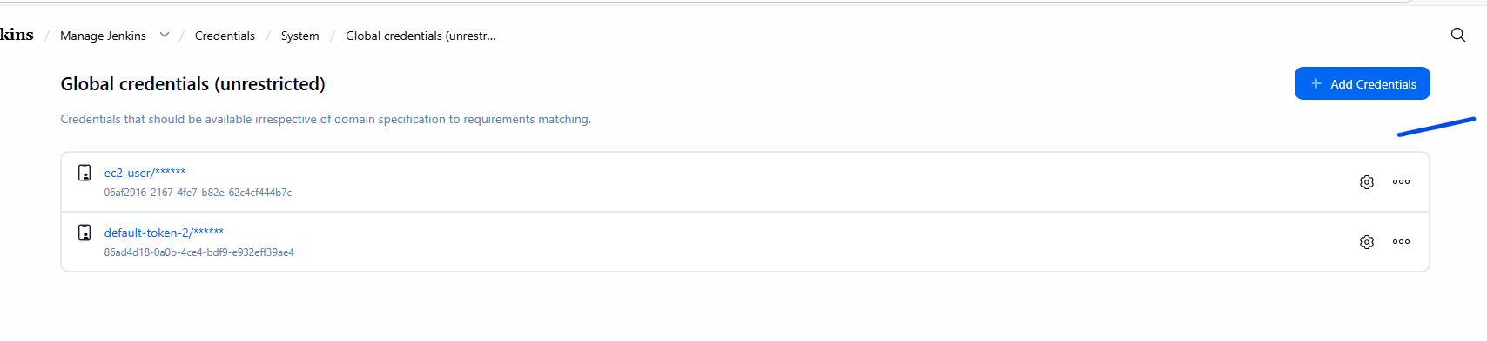
Click on “Add credentials”
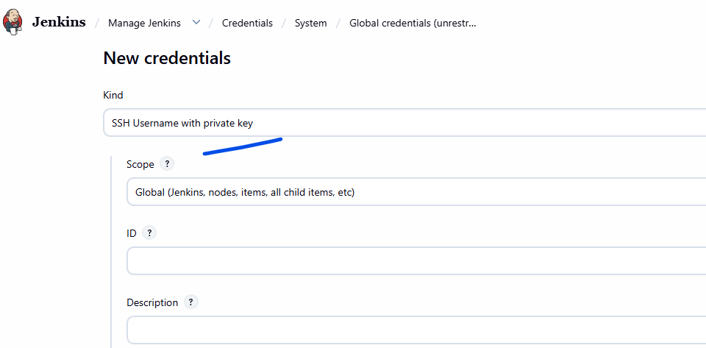
Select the “username and password”
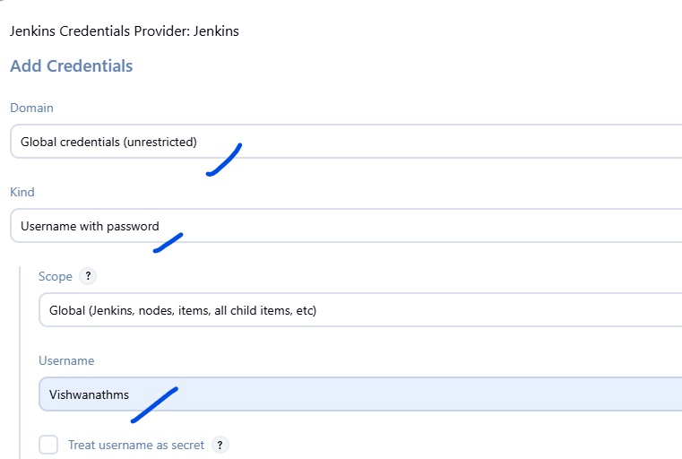
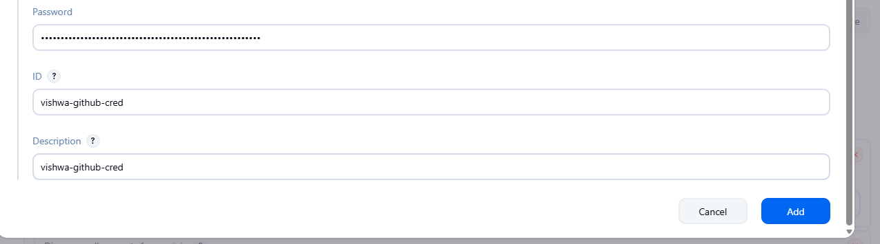
Click on “add”

Note:
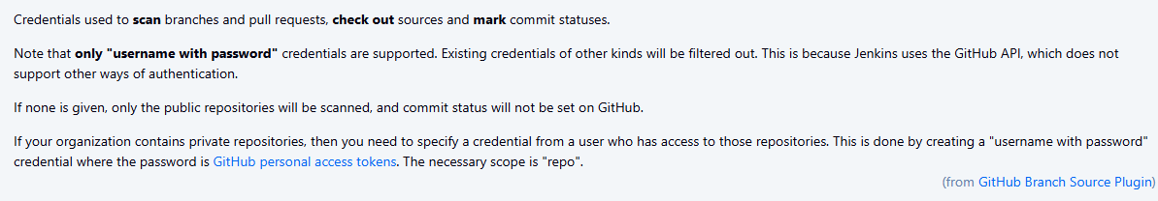
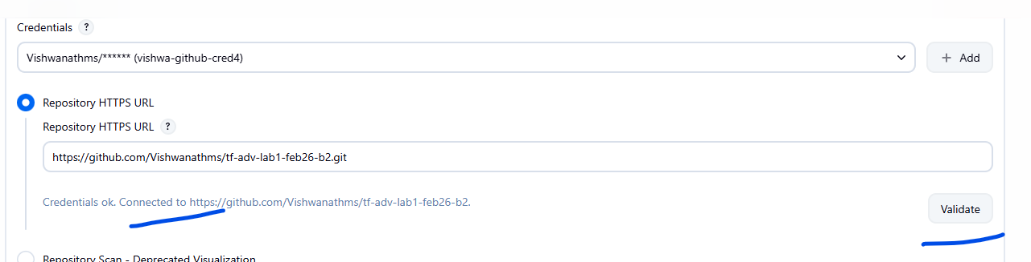
Click on validate.

Step12:
Attach the cred to the pipeline

Step13:
The output
The scan is successful
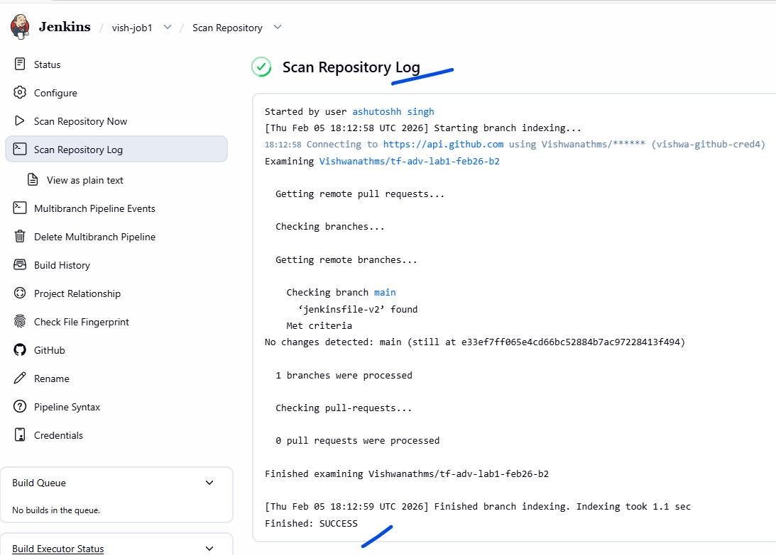

Step14:
Final touch ups
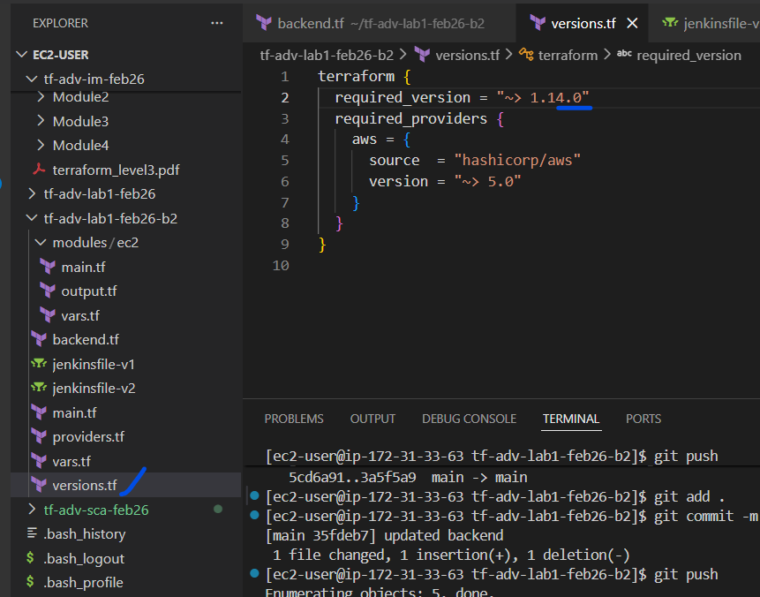
Make sure
required_version = "~> 1.14.0"
bcz the Jenkins has “1.14.4”

