Terrafrom-Adv-lab1-scenario-test

Scenario1

Create an PR

Steps
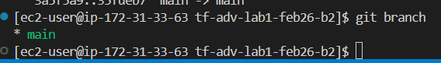
- Create an branch on the vs code
$ git checkout -b dev
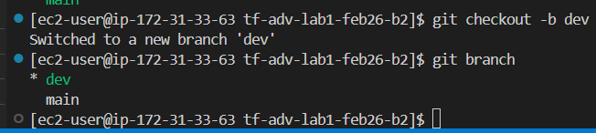

Do some changes in the local repo
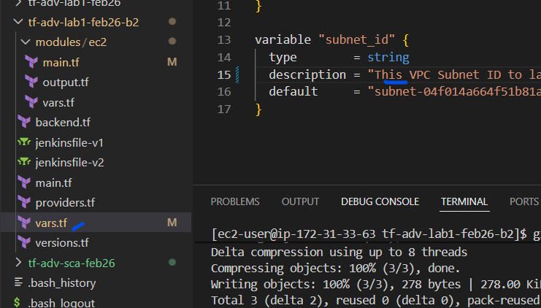
$ git add .
$ git commit -m “some changes in dev branch”
$ git push
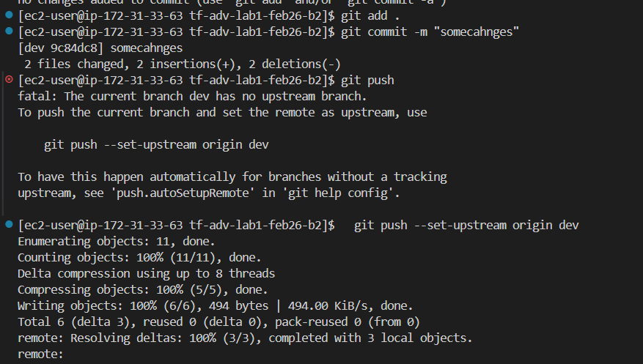

Now lets create an pull request
