Tf-adv-lab1-Steps

Steps:
- Create github repo
- Clone on the vs code
- Copy the lab2 content to the new repo folder on vs code
- Git commands to push to the github
- Create an Jenkins pipeline (normal )
- Run the Jenkins pipeline to check the output of “checkov”
- Comment the checkov and uncomment the tflint , save the file, push the code
- Run the Jenkins pipeline to check the output of “tflint”

- Create github repo
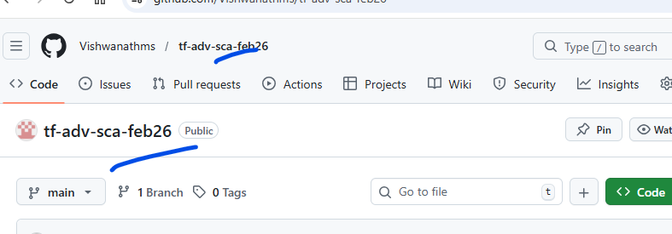

- Clone on the vs code and Copy the lab2 content to the new repo folder on vs code
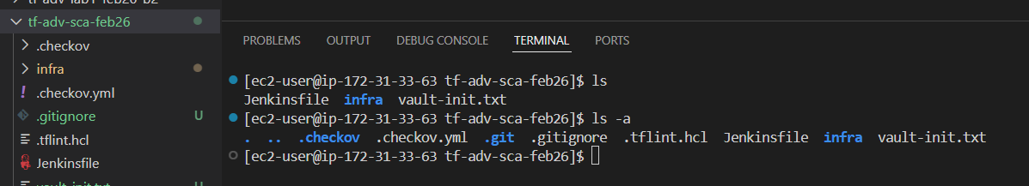
- Git commands to push to the github
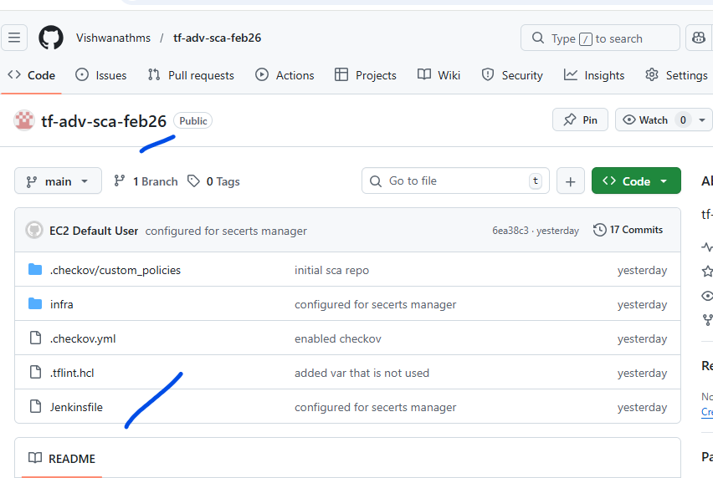
- Create an Jenkins pipeline (normal )
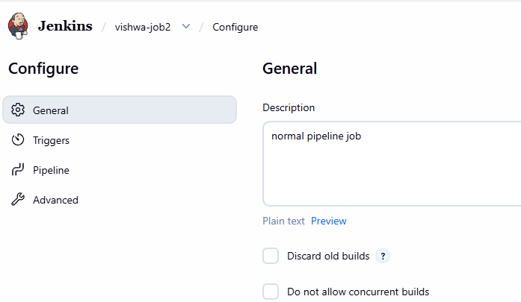
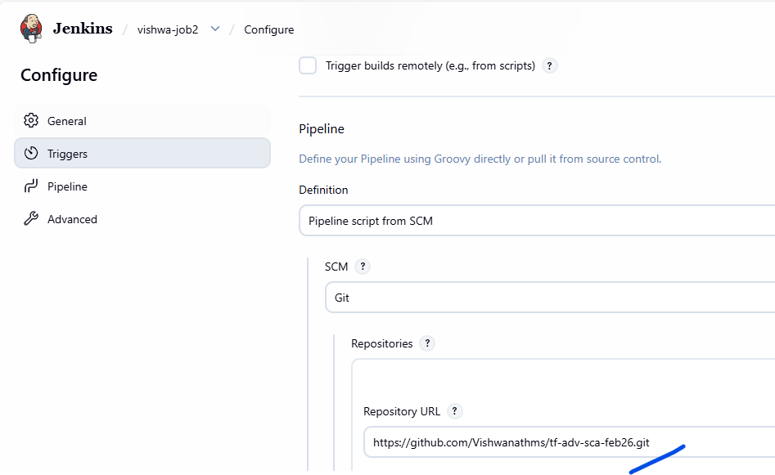
Use the https, to avoid creds
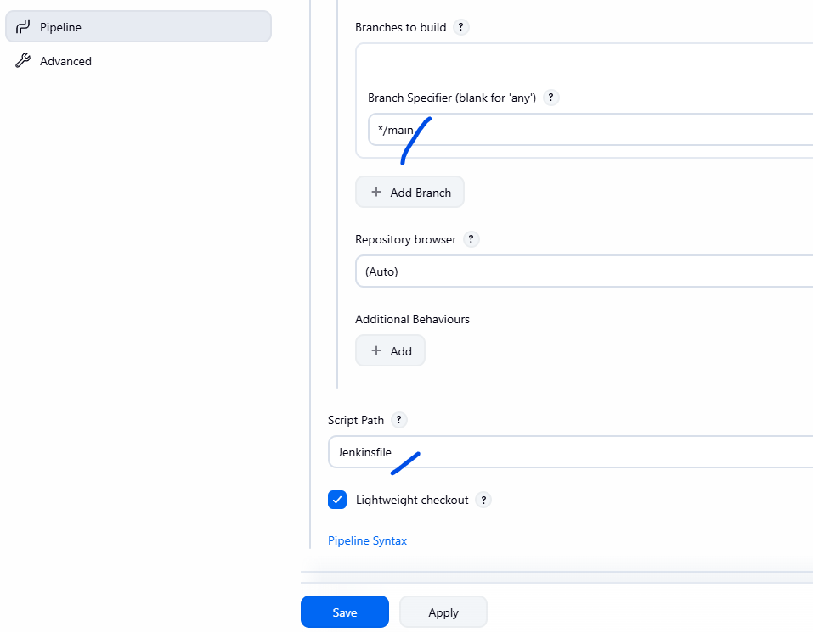
Change the branch to main and
Give the right jenkinfile
- Run the Jenkins pipeline
Note: for first time we will see the output of “Checkov”, so the tflint is commented.
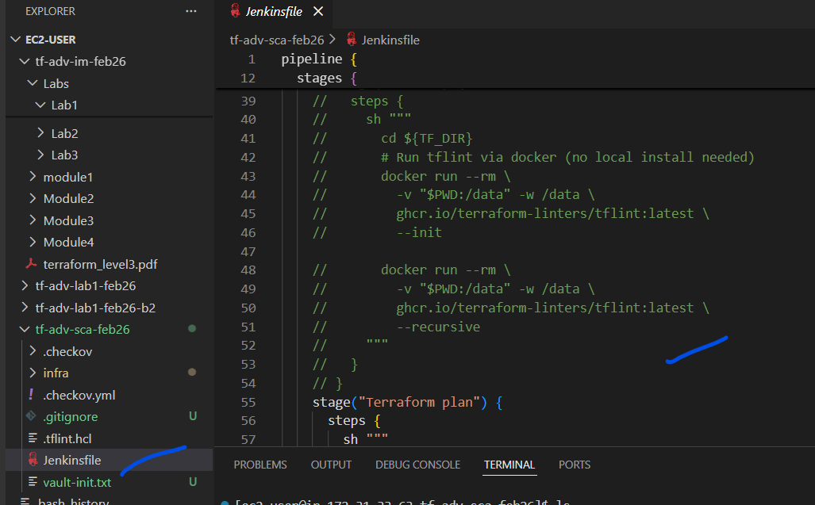

Once we run the job
