AI Orchestrator
Built an End-to-End AI Orchestration Platform — UI → Backend → Agents → ML Tools
I recently designed and implemented a production-style AI Orchestrator integrating:
🔹 Streamlit (UI)
🔹 FastAPI (Backend)
🔹 LangChain (LLM Orchestration / Agents)
🔹 Hugging Face Models (NLP)
🔹 OpenAI LLM APIs
🔹 Secure secret management via .env
The architecture focuses on clean separation of concerns, agent-based task orchestration, observability, and security best practices — similar to what real-world AI systems require.

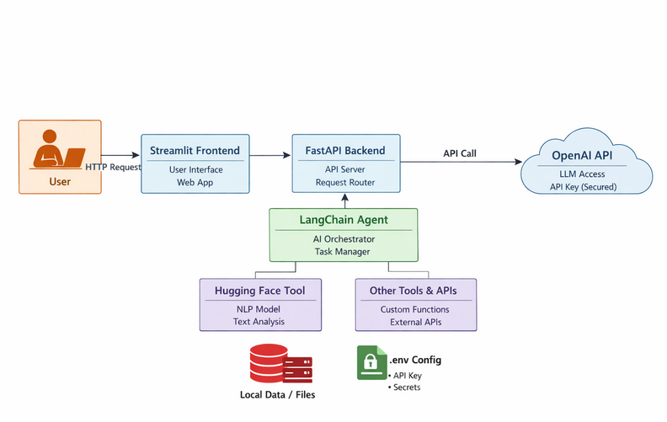

The architecture focuses on clean separation of concerns, agent-based task orchestration, observability, and security best practices — similar to what real-world AI systems require.
This project has helped me deepen my skills in:
✔ AI Architecture
✔ Agent frameworks
✔ API design & orchestration
✔ Secure key & secret handling
✔ Production-ready system design
If you’re also building AI systems or interested in production-grade GenAI — happy to connect and exchange ideas 😊
#AI #LLM #LangChain #MLOps #DevOps #Python #FastAPI #Streamlit #HuggingFace #SRE #CloudEngineering #AIArchitecture

