**Ex No:03                                          DCL Commands**

**Aim:**

To work with DCL commands.

**Procedure:**

The Data Control Language (DCL) are-

**GRAND :**

- It is used to grant a privilege to a user & allow to perform specific task.

Syntax:

GRANT [privilege_name or ALL] ON table_name TO ‘user’@’localhost’;

Example:

GRANT SELECT,UPDATE,DELETE,INSERT ON student TO ‘Raju’@’localhost’;

Output:

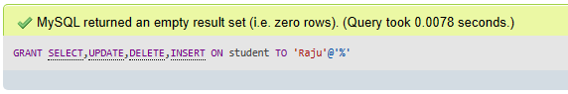

**REVOKE:**

- It is used to remove granted privilege from a user.

Syntax:

REVOKE [privilege_name or ALL] ON table_name FROM user;

Example:

REVOKE [SELECT](http://localhost/phpmyadmin/url.php?url=https://dev.mysql.com/doc/refman/5.5/en/select.html),[UPDATE](http://localhost/phpmyadmin/url.php?url=https://dev.mysql.com/doc/refman/5.5/en/update.html),[DELETE](http://localhost/phpmyadmin/url.php?url=https://dev.mysql.com/doc/refman/5.5/en/delete.html),[INSERT](http://localhost/phpmyadmin/url.php?url=https://dev.mysql.com/doc/refman/5.5/en/insert.html) ON student FROM 'Raju'@'%';

Output:

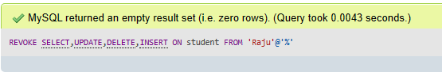

**Result:**

The queries for Triggers were successfully executed and the output is noted