**EX.NO:1 DDL COMMANDS**

**Aim:**

To work with DDL commands.

**Procedure:**

**The Data Definition Language (DDL) Commamds are-**

**CREATE:**

**-**It is used to create a new table or new database.

**i)CREATE DATABASE:**

Syntax :

CREATE DATABASE database_name;

Command :

CREATE DATABASE sfms;

Output:

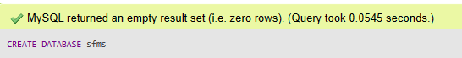

**ii) CREATE TABLE:**

Syntax:

CREATE TABLE tablename

(column_name1 datatype,

… …….,

column_name_n datatype);

Command:

CREATE TABLE `student` (

  `register` varchar(255) NOT NULL,

  `name` varchar(255) NOT NULL,

  `email` varchar(255) NOT NULL,

  `gender` varchar(100) NOT NULL,

  `updationDate` date NOT NULL,

  `password` varchar(255) NOT NULL

) ENGINE=InnoDB DEFAULT CHARSET=latin1;

Output:

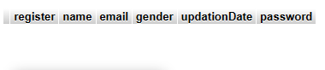

**Alter:**

-The ALTER statement is used to add, delete or modify columns in an existing table.

**i) ALTER TABLE-ADD COLUMN:**

Syntax:

ALTER TABLE table_name

ADD column_name datatype;

Example:

ALTER TABLE student

ADD mobile int(11);

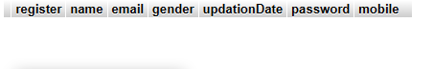Output:

**ii) ALTER TABLE-DROP COLUMN:**

Syntax:

ALTER TABLE table_name

DROP COLUMN column_name;

Example:

ALTER TABLE student

DROP COLUMN mobile;

Output:



**iii) ALTER TABLE - RENAME COLUMN:**

Syntax:

ALTER TABLE table_name

CHANGE old_name new_name DATA TYPE;

Example:

[ALTER](http://localhost/phpmyadmin/url.php?url=https://dev.mysql.com/doc/refman/5.5/en/alter-table.html) [TABLE](http://localhost/phpmyadmin/url.php?url=https://dev.mysql.com/doc/refman/5.5/en/alter-table.html)  student

CHANGE updationDate regDate  [DATE](http://localhost/phpmyadmin/url.php?url=https://dev.mysql.com/doc/refman/5.5/en/date-and-time-types.html) [NOT](http://localhost/phpmyadmin/url.php?url=https://dev.mysql.com/doc/refman/5.5/en/logical-operators.html#operator_not) NULL;

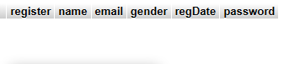Output:

**iv) ALTER TABLE-MODIFY DATATYPE:**

Syntax:

ALTER TABLE table_name

MODIFY column_name DATA TYPE;

Example:

[ALTER](http://localhost/phpmyadmin/url.php?url=https://dev.mysql.com/doc/refman/5.5/en/alter-table.html) [TABLE](http://localhost/phpmyadmin/url.php?url=https://dev.mysql.com/doc/refman/5.5/en/alter-table.html)  student

MODIFY regDate varchar(255);

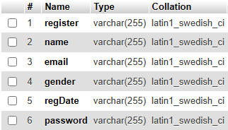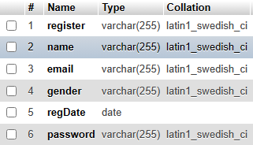Output:

**Truncate:**

-This command is used to remove all the rows from the table.

Syntax:

TRUNCATE TABLE table_name;

Example:

TRUNCATE TABLE student;

**RENAME:**

-It is used to rename the table from the database.

Syntax:

RENAME TABLE old_table_name TO new_table_name;

Example:

RENAME TABLE student TO details;

Output:

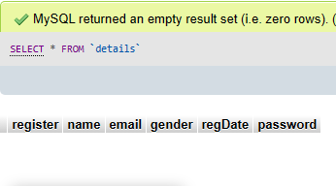

**DROP:**

-It is used to delete a table,index or view from database.

Syntax:

DROP TABLE table_name;

Example:

DROP TABLE details;

Output:

