**EX.NO:1 DDL COMMANDS**

**Aim:**

To work with DDL commands

**Procedure:**

**CREATE:**

**i)CREATE DATABASE:**

**Syntax :** CREATE DATABASE database_name;

**Command :** CREATE DATABASE sfms;

**Output:**

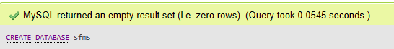

**ii) CREATE TABLE:**

**Syntax:** CREATE TABLE tablename(column_name1 datatype,…,column_name_n datatype);

**Command:**

CREATE TABLE `student` (

  `register` varchar(255) NOT NULL,

  `name` varchar(255) NOT NULL,

  `email` varchar(255) NOT NULL,

  `gender` varchar(100) NOT NULL,

  `updationDate` date NOT NULL,

  `password` varchar(255) NOT NULL

) ENGINE=InnoDB DEFAULT CHARSET=latin1;

**Output:**

