**EX.NO:5** **SQL JOINS**

**Aim:**

To work with MySQL JOINS.

**Procedure:**

A join clause is used to combine rows from two or more tables, based on a related column between them.

**INNER JOIN:**

**-**this keyword selects records that have matching values in both tables.

Syntax :

Select column name(s) from table;

Inner Join table2

ON table1.column_name= table2.column_name;

Example :

SELECT student.register,student.name,student.email,profile_log.type FROM student

INNER JOIN profile_log on

student.register=profile_log.reg_no;

Output:

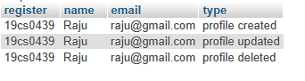

**LEFT JOIN:**

**-**returns all records from the left table and matching records(if any) from the right table.

Syntax:

SELECT column_name(s) From table1;

LEFT JOIN table2 ON table1. Column_name = table2.column_name;

Example:

SELECT student.register,student.name,student.email,profile_log.type

FROM student LEFT JOIN profile_log on

student.register=profile_log.reg_no;

Output:

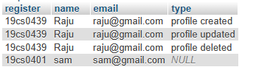

**RIGHT JOIN:**

-returns all records from the right table and matching records (if any) from the left table.

Syntax:

SELECT column_name(s) From table1;

RIGHT JOIN table2 ON table1. Column_name = table2.column_name;

Example:

SELECT student.register,student.name,student.email,profile_log.type FROM student

RIGHT JOIN profile_log on student.register=profile_log.reg_no;

Output:

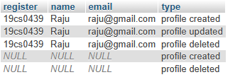

**CROSS JOIN:**

**-**returns all records from both tables.

Syntax:

Select column_name(s)

From table1.cross join table2;

Example:

SELECT student.register,student.name,student.email,profile_log.type FROM student

CROSS JOIN profile_log ;

Output:

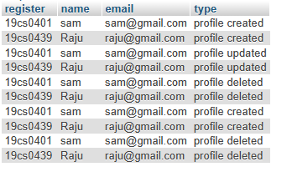

Syntax 2:

Select column_name(s)

From table1 cross join table2

Where condition;[if using where act as a inner join];

Example:

SELECT student.register,student.name,student.email,profile_log.type FROM student

CROSS JOIN profile_log on student.register=profile_log.reg_no;

Output:

