**EX.NO:4 SUB QUERY**

**Aim:**

To work with My SQL Sub Query.

**Procedure:**

Sub Query can be simply defined as a query within another query. In other words we can say that a subquery is a query that is embedded in where clause of another query.

**SELECT:**

**-**Sub Query in select statement(command) .

Syntax :

SELECT column_name FROM table_name

WHERE (SELECT column_name FROM table_name WHERE CONDITION);

Example :

SELECT * FROM student WHERE (SELECT reg_no FROM profile_log WHERE id=3);

Output:

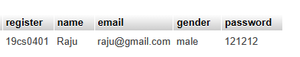

**INSERT:**

**-**Sub Query in insert command.

Syntax:

* Insert into table1 select*From table2;
* Insert into table1 select*From table2 where condition;

Example:

INSERT INTO `student` SELECT * FROM request where register='qwe123';

Output:

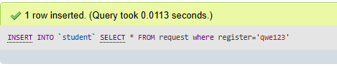

**UPDATE:**

-Sub Query in update command.

Syntax:

UPDATE table_name SET column_Name = Value

WHERE column_name IN (SELECT column_name FROM table2 WHERE CONDITION);

Example:

UPDATE student SET `password` ='abcd'

WHERE register IN (SELECT reg_no FROM profile_log WHERE id=3);

Output:

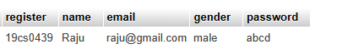

**DELETE:**

**-**Sub Query in delete command.

Syntax:

Delete from table where column_name in (select column_name from table2 where CONDITION)

Example:

DELETE FROM `student` WHERE register IN(SELECT reg_no FROM profile_log WHERE id=3);

Output:



**Result:**

The queries for Triggers were successfully executed and the output is noted