**Ex No:06                            Cursors, Procedures and Functions**

**Aim:**

To work with the Cursor, Procedure and Function in PL/SQL

**Procedure:**

Step 1: Create a necessary table for perform action .

Step 2: Then work with database using PL/SQL Block commands

**1.CURSOR:**

**Syntax:**

DECLARE cursor_name CURSOR

FOR select_statement;

OPEN cursor_name;

FETCH NEXT FROM cursor INTO variable_list;

CLOSE cursor_name;

**2.PROCEDURE:**

**Syntax:**

DECLARE

CREATE PROCEDURE procedure_name[[[IN]|OUT|INOUT]parameter_name datatype[.parameter_datatype]

AS

Declaration_section

BEGIN

Executable_section

END;

BEGIN

[procedure_name]();

END;

/

**3.FUNCTION:**

**Syntax:**

CREATE [OR REPLACE] FUNCTION function_name [parameters]

[(parameter_name [IN | OUT | IN OUT] type [, ...])]

RETURN return_datatype

{IS | AS}

BEGIN

   < function_body >

END [function_name];

**Example:**

DECLARE

n number ;

t number;

s_id student.std_id%type;

s_name student.name%type;

s_cgpa student.cgpa%type;

CURSOR s_student is --cursor

SELECT std_id, name, cgpa FROM student;

PROCEDURE pro AS --procedure

BEGIN

OPEN s_student;

LOOP

FETCH s_student into s_id, s_name, s_cgpa;

EXIT WHEN s_student%notfound;

s_cgpa:=s_cgpa*10;

dbms_output.put_line('Id:' || s_id || ' Name:' || s_name || ' Percentage:' || s_cgpa);

END LOOP;

CLOSE s_student;

END;

FUNCTION func -- function

RETURN number IS

total number(2) := 0;

BEGIN

SELECT count(*) into total

FROM student;

RETURN total;

END;

BEGIN --main program

n:=1;

case n

when 1 then

PRO();

when 2 then

t:=func();

dbms_output.put_line(t);

END case;

END;

/

**Output:**

**when n=1:**

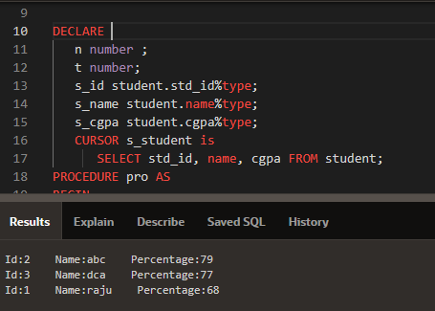

**Output:**

**when n=2**

