**Ex No:05 PL/SQL**

**Aim:**

To work with PL/SQL

**Procedure:**

* PL/SQL is a combination of SQL along with the procedural features of programming languages.
* PL/SQL is one of three key programming languages embedded in the Oracle Database, along with SQL itself and Java.
* The PL/SQL programs are divided and written in logical blocks of code. Each block consists of three sub-parts,
* Declare
* Begin
* Exception
* End

**SYNTAX:**

DECLARE

<declarations section>

BEGIN

<executable section commands>

EXCEPTION

<exception handling>

END;

**EXAMPLE:**

**1.Addition of Two Numbers:**

**Program Code:**

declare

x number(5);

y number(5);

z number(5);

begin

x:=50;

y:=20;

z:=x+y;

dbms_output.put_line('sum is'||z);

end;

/

**Output for example-1:**

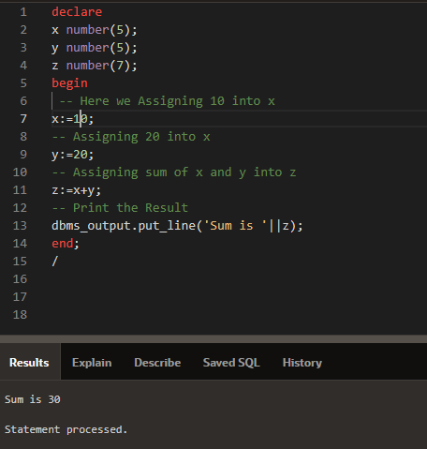

**2.Generating Series:**

**Program Code:**

declare

n number(5);

begin

n:=1;

for i in 1..10 loop

case n

when 1 then

dbms_output.put_line(i);

when 2 then

if mod(i,2)=0 then

dbms_output.put_line(i);

end if;

when 3 then

if mod(i,2)!=0 then

dbms_output.put_line(i);

end if;

end case;

end loop;

end;

/

**Output for example-2:**

