**Ex No:07                                          TRIGGERS**

**Aim:**

To work with TRIGGER in mySQL

**Procedure:**

**Syntax:**

CREATE [DEFINER = { user | CURRENT_USER }]

TRIGGER trigger_name

trigger_time trigger_event ON tbl_name

FOR EACH ROW

trigger_body

* trigger_time: { BEFORE | AFTER }
* trigger_event: { INSERT | UPDATE | DELETE }

**Example:**

1. Trigger for insert command.

**Trigger Command:**

DROP TRIGGER IF EXISTS `insert`;

CREATE DEFINER=`root`@`localhost` TRIGGER `insert`

AFTER INSERT ON `student`

FOR EACH ROW

INSERT into profile_log VALUES(null,new.register,'profile created',curdate());

**SQL command:**

INSERT INTO `student` (`register`, `name`, `email`, `gender`, `updationDate`, `password`) VALUES ('19cs0439', 'Raju', 'rajuraj@gmail.com', 'male', CURRENT_DATE(), 'Raju@1234');

**Table**:student

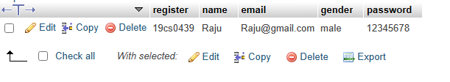

**Table:**profile_log

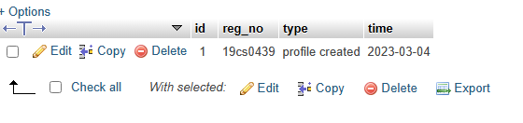

1. Trigger for update command.

**Trigger Command:**

DROP TRIGGER IF EXISTS `update`;

CREATE DEFINER=`root`@`localhost` TRIGGER `update`

AFTER UPDATE ON `student`

FOR EACH ROW

INSERT into profile_log VALUES(null,new.register,'profile updated',curdate());

**SQL command:**

UPDATE `student` SET `email`='Raju@gmail.com',`password`=12345678 WHERE register='19cs0439';

**Table**:student



**Table**:profile_log

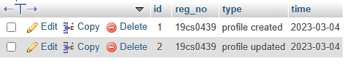

**3)** Trigger for delete command

**Trigger Command:**

DROP TRIGGER IF EXISTS `delete`;

CREATE DEFINER=`root`@`localhost` TRIGGER `delete`

BEFORE DELETE ON `student`

FOR EACH ROW

INSERT into profile_log VALUES(null,old.register,'profile deleted',curdate());

**SQL command:**

[Delete](http://localhost/phpmyadmin/url.php?url=https://dev.mysql.com/doc/refman/5.5/en/delete.html) from `student` where register='19cs0439';

**Table**:student

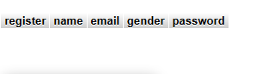

**Table**:profile_log

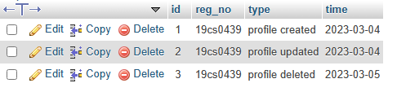

**Result:**

The queries for Triggers were successfully executed and the output is noted.