**ENTITY-RELATIONSHIP DIAGRAMS:**

An entity-relationship model (ERM) is a theoretical and conceptual way of showing data relationships in software development. ERM is a database modeling technique that generates an abstract diagram or visual representation of a system’s data that can be helpful in designing a relational database. These diagrams are known as entity-relationship diagrams, ER diagrams or ERDs.

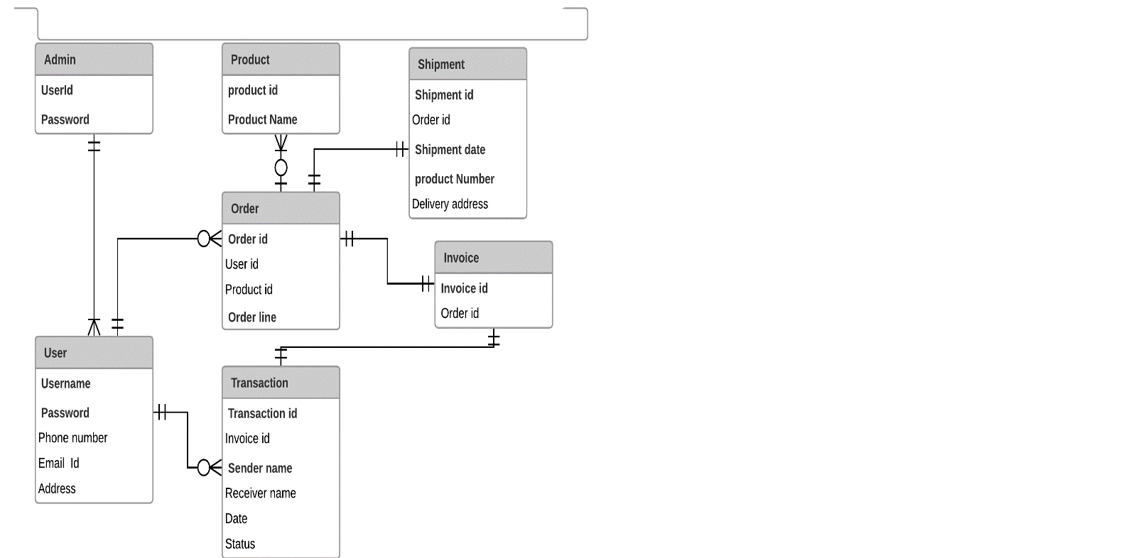

Fig 1. ER Diagrams

**USE-CASES:**

A UML use case diagram is the primary form of system/software requirements for a new software program under developed. Use cases specify the expected behavior(what), and not the exact method of making it happen (how). Use cases once specified can be denoted both textual and visual representation (such as UML). A key concept of use case modeling is that it helps us design a system from end user's perspective. It is an effective technique for communicating system behavior in the user's terms by specifying all externally visible system behavior.

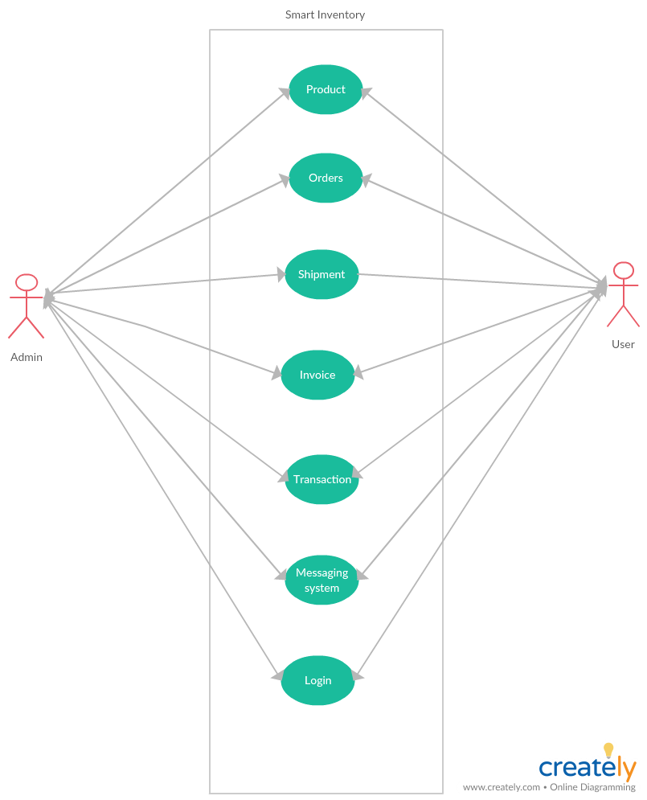

Fig 2. Use-Case Diagram

**MOCK-UP’s:**

Mockups reflect the design choices for color schemes, layouts, typography, iconography, the visuals of navigation, and the overall atmosphere of the product.

1.Welcome screen 2. Admin login screen

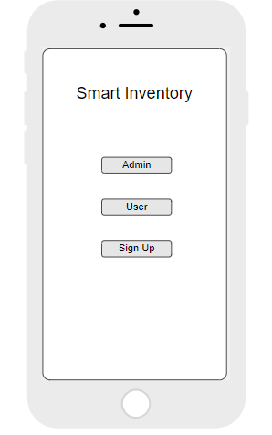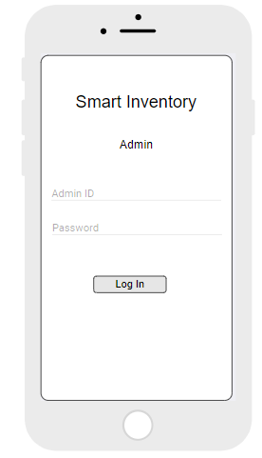

Fig 3. Welcome Screen Fig 4. Admin login screen

**3.**User login screen 4. Sign-up screen

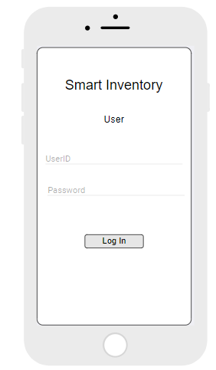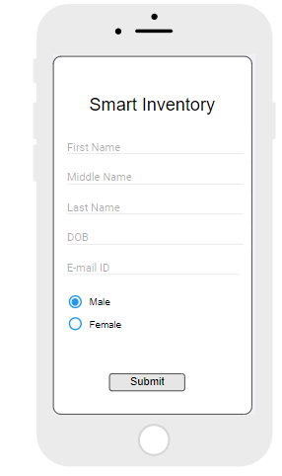

Fig 5. User Login Fig 6. Signup screen