NOTE-PAD
* Check Constraint
* Think about edge case before going to start code
* Max 1 hour per question
* Revise daily and making short note on unsolved questions with 2-3 lines

ARRAYS

1 Smallest Positive Missing Number

Brute: first 1se n tk ke element ko search karo baar baar na mile toh return that element aur sb mil jaye toh returnn+1;
Better ; arr kosort kar ke arr mein woa elementnhi hain toh retuen woah else men presnt hin to uske neighbour wale se next 1 to n wale element ko match karenge f notmatces then return that element else return previous steps;
Better ; unordered map mein saare element ko bool keform me store kar lo . for loop se 1 to n ke positve elements ko map men dhundo .sb presrnt ho toh return n+1;
oPtimal = for loop mein har element of arr ko swap kar do uske curr= valu-1 index se if curr arr ke aandar ho and arr[curr]!=arr[val](dublicate na ho nahi to infinite loop), after swap curr=arr[i]-1 ban jaega, while wali cndn chalti rahegi on the cndn of non dublicacy and curr is in arr index range

2 Number of occurrence in sorted array
Hash map se insert then calculate he no f occurrence
Bs se search the element then goleft and right anc inc cnt for dublicates as array is sorted so neighbour may be same

3) Find First and Last Position of Element in Sorted Array
i) find the element and check for left and right using while by cmp with left-1,not first decrement lsft as it produces less index if element in its neighbor not found.
ii) apply bs on left and update first occurene in equal condn, then dofor right also like:
if (nums[mid] == target) {
first = mid;
end = mid - 1; // Continue searching in the left half
4. Search Insert Position
int index = n ; // Default position if target is greater than all elements.
else if (nums[mid] < target) {
start = mid + 1;
}
else {
index = mid; // may be insert position
end = mid - 1;
}
5.) 1539. Kth Missing Positive Number
i) first mark the all elements of arrr in map then iterate over the map from 1 to till nth until we find kth missing no. k==cnt;
int cnt=0;
for(int i=1;;i++){ // no cndn find until we got;;;;;;;;;;;
if(mp[i]==0){
cnt++;
if(cnt==k) return i;
}
}
ii) generte a virutual arr of missng numbers by (arr[mid]-mid-1 then find index of k in it . then calculate the actula number by arr[indx] –(arr[indx]-indx-1-k+1)=idx+k;
if(arr[mid]-mid-1>=k){
end=mid-1;
ans=mid;
}
else{
start=mid+1;
}
}
return ans+k;

6. Count the Zeros
i) if(arr[mid]==0 &&(arr[mid-1]==1 || mid==0) ){
return n-mid;
}
ii) simply find the zero then uske right or left side cnt kar kr return cnt;

7). Search in Rotated Sorted Array:
Phle arr ke first element and mid se check it wheter it is left sorted aur right. Then check uss sorted range mein mid hain ki nhe eg . left sorted st se mid ke range then st =mid+1 if not in range the end=mid-1; and vise versa
8) Find Peak Element
i) if((i==0|| mid>left)&&((i==n-1||mid>right)) return I; o(n) mid mtlb i hi hain
ii)Bs ?:- peak mtlb inc ya dec to cnfrm hoga toh arr mujst be sorted on either left or right . so arr is in inc order ret 0; dec order ret n-1 , as the array contains multiple peaks V wale case mein we either go right or left as mid is smaller than neighbours and fails all condition under while and lead to infinite loop. Mid+1 and mid- 1 ke liye arra ko 1 se n-2 se start karenge …..
9) Special Array With X Elements Greater Than or Equal X
i) sort the array then ,0 se n tk loop chala kar har ek i ke liye bs se idx of occurrence nikal kar cnt niklalenge =n-idx if cnt==I then return i
ii) prev approach mein loop bhi bs se chalana hain, use lower_bound(begin(arr),end(arr),x)-begin(arr)-> this will give the index of occurrence of first element >=x in the arrray;
iii) array of size n+1 wala lekar element ke ocuurenc pr ++ kr dena then array pr traverse krte samay cnt +=arr[i](prefix sum) kro the at that time if cnt ==index then return index
10) Search in Rotated Sorted Array II
If mid==target if not then , decide the left of mid is sorted or right by comparing mid with first element of array .if mid>start element then left is sorted. Then check target is in range or not.uss hissab se change st and end ..
If mid==st && mid==end // dublicates occur we cant detrermin left is sorted or right then simply shrink the array by st++ and end-- ,and continue ;

11: Allocate minimum number of pages:
St =max pages and end =sum pages; is range ke beech mein check that max kitne pages dono ko individually baaat skte hain . cnt= no of student in which book is distributed. If arr mein traverse kartte sam pgs add krne pr mid se zyada aa jaye toh student++ and pages=arr[i] krte rahenge .in end if cnt<=student then end ko shift karo and mid ko as we succesfully distributed because if 2 mein distribute kar diye toh 3 mein bhi kr skte hain aiso ho mid tk pahuchne ke liye ek student ko multiple book assign kr diya ho jis wajah se cnt kam pd gaya hoo. On the other hand cnt>student mtlb individual mid se zyada pages honge book ke toh multiple students chahiye honge toh mid ko badana padenga by moving start………

(MIN)MAX: GO FOR MAXIMUM;
(MAX)MIN:GO FOR MINIMUM;
HAR QUESTION MEIN CNT KE HISAB SE SHIFTING OF START AND TAKES PLACES
START AND END DEPOND UPON THE QUESTIONS ….

12 Two Sum II - Input Array Is Sorted
i)bs ,traverse in the array set to be search =target-arrr[i] and apply bs for the second element index return i+1,mid+1 as it is 1 based indexing
ii) two pointer apprach first pointer int start and second in end then calculate sum if it is greater thantarget move end else movestart;;;
13 Pair Difference unsorted arr
Since the arr is unsorted so we cant deteremein by taking the pointers at start and end,so take it on first and second element,

For two pointer question p1 p2
Inc dec
Dec inc
// take case jisme resultoverall inc or dec ho not onlydec/inc by inc/dec thetwopointers by analysing the arr;; applicable for all operations

14 Product Pair:
we can use a hash set to store previously seen elements as we iterate through the array. This way, for each element, we can check if x / arr[i] exists in the set, which would indicate that the product of the two numbers equals x.

Using unordered map here if target/arr[i] {this would we check if arr[i] is not zero and factor of target} is found inmp return.else insert arr[i] in mpp;
15 Remove Duplicates from Sorted Arra
i)use hash map as it insert only unique elements and pop out element in ascendinf order
ii) using pointer i at 0 and j iterate from 1 to n-1; if we found arr[i]!=arr[j] then i++ karke value copy arr[i]=arr[j]. after for loop return i+1;

Kadane's Algorithm if prefix sum becomes -ve then set it to zero …..
int maxi=INT_MIN;
int prefix=0;
for(int i=0;i<arr.size();i++){
prefix+=arr[i];
maxi=max(maxi,prefix);
if(prefix<0){
prefix=0;
}
}
return maxi;
16 )Maximum Difference between Two Elements
i)two loops first iterate over all the elements till n-2 ,and stores max diff from second loop starts from i+1;
ii)use of suffix max and iterate over arrr and just update max diff of element from its suffix max element …
int maxi = INT_MIN;
int suffix = arr[n-1]; // Start with the last element in the array as suffix

for (int i = n-2; i >= 0; i--) {
maxi = max(maxi, suffix - arr[i]); // Update maximum difference
suffix = max(suffix, arr[i]); // Update suffix to be the maximum of current suffix or arr[i]
}

Equal Sums
int minDiff = INT_MAX, minDiffIndex = -1, subArray = 1, totalSum = 0, prefix = 0;
for (int i = 0; i < n; ++i) {
prefix += a[i];
int rightSum = totalSum - prefix;
int diff = abs(rightSum - prefix);
if (diff < minDiff) {
minDiff = diff;
minDiffIndex = i + 1;
if (rightSum >= prefix)
subArray = 1;
else
subArray = 2;
}
}
splits an array into two subarrays such that the difference between their sums is minimized.
- Calculate the total sum of the entire array.
- Iterate through the array, maintaining a running sum (prefix) for the left subarray.
- For each element, compute the right subarray sum as totalSum - prefix.
- Calculate the difference between the sums of the left and right subarrays.
- Track the minimum difference and update the split index and which subarray is larger.
- Return the minimum difference, the split index, and which subarray has the larger sum.

Trapping Rain Water:
i)make two arrays of suffix max prefix max to get the height from left and right then take ans= min of them . if ans-height[i]>0 water+=ans-height[i].
ii) first traverse in the arrr and find max height .then from (0-maxheigth) left to maxheight index start from left prefix-height[i]>0 then water+= prefix-height;then start from right most(n-1->maxheigthindex) leftmax is fix therefore if suffixmax-heigh[i]>0 water+= if suffixmax-heigh[i]
iii) since in approach 2 we are traversing arr tewice so we use Binary search here.
3 SUM
sort(arr,arr+n);
for(int i=0;i<n-2;i++){ then use twosum approach using two pointer j=i+1 and k=n-1;
while(j<k){
if(arr[j]+arr[k]==x-arr[i]){
return 1;
}
else if(arr[j]+arr[k]>x-arr[i]){
k--;
}

4 SUM
sort(arr,arr+n);
for(int i=0;i<n-3;i++){
for(int j=i+1;j<n-2;j++){
int start=j+1;
int end=n-1;
while(start<end){
if( arr[start]+arr[end]==x-arr[j]-arr[i]){
return 1;

Remove Element from Array
int i = 0; // Pointer to place the next non-B element
for (int j = 0; j < arr.size(); j++) {
if (arr[j] != B) {
arr[i] = arr[j]; // Move the non-B element to the front
i++;
}
}
return i; // i will represent the new length of the array

wave form printing;
if col is even then top to bottom print for(int i=0;i<n;i++) cout<<arr[i][j];
if col is odd bottom to top print - for(int i=n-1;i>=0;i--) cout<<arr[i][j];

spiral form printng
make 4 pointers left right top bottom;
while(l<=r && top<=bottom){
i)for l to r
cout<<arr[top][i];
top++;
ii)
for top->bottom
cout<<arr[i][right];
right--;
iii) if(top<bottom) // case if only single row ;
for r to l
cout<<arr[bottom][i];
bottom--;

iv) if(left<=right) // case if only single col ;
for bottom->top{
cout<<arr[i][left]
left++;

BS IN ROW WISE SORTED ARR;

1… first check range in particular row if targets comes in it range then apply bs in that clomun wise o(N+log(m*n))
if(arr[i][0]<=target && arr[i][m-1]>=target){ //check for range
// apply bs
int mid=s+(e-s)/2;
if(arr[i][mid]==target) {
return 1;
}
2…. 2d array ko as a 1 d array consider karo then O (N)
Start =0, end =(m*n)-1;
Row=mid/10;
Col =mid%10;
For particular mid claculate row and col then check that in matrix it is equql greater or less than the matrix;;;

Search in a row-column sorted Matrix
In this we start from top right i=0 and j=m-1; then check condn on arr[i][j] if it is less than target move down for greater else move left for small elements…

Missing And Repeating
for(int i=0;i<n;i++){
arr[i]--; // so that arr 0 se n-1 me aa sake tabhi %n ka use ho skta hain
}
int p,q;
for(int i=0;i<n;i++){
arr[arr[i]%n]+=n; //%n se org no. aa jayega then +n karne se repn increases
}
for(int i=0;i<n;i++){
if(arr[i]/n>1){ //repeating
p=i+1;
}
if(arr[i]/n==0){ // non repreating
q=i+1;
}
}

. Majority Element
// we just inc cnt if same element occur other wise dec cnt ;if cnt become 0 its time to assign new maj element
for(int i=0;i<nums.size();i++){
if(cnt==0){
maj=nums[i];
cnt++;
}
else{
if(maj==nums[i]){
cnt++;
}
else{
cnt--;
}
}
}

Sort Vowels in a String
string vowels ="";
for(int i=0;i<26;i++){
char ch = i+'A';
vowels+=string(upper[i],ch); // creates a string of ch upper[i] times
}

Roman to integer
If particular char ka nxt usse bada aata hain toh consider it as negative…. Otherwise take it positive and add all;
Loop 0 to s.size()-1.. define first all roman characters IVXLCDM
vector<int> arr(26);
arr['I'-'A']=1;
for(int i=0;i<s.size()-1;i++){
int x=arr[s[i]-'A'];
int y=arr[s[i+1]-'A'];
ans+=x>=y ? x:-x;
}
ans+=arr[s[s.size()-1]-'A']; // for last

int to roman
vector<int> n = {1000, 900, 500, 400, 100, 90, 50, 40, 10, 9, 5, 4, 1};
vector<string> s = {"M", "CM", "D", "CD", "C", "XC", "L", "XL", "X", "IX", "V", "IV", "I"};
while (num>0){
if (num>=n[i]){
str=str+s[i];
num-=n[i];
} else{
i++;
}
}
Factorials of large numbers
vector<int> factorial(int N){
vector<int> ans(1,1);
while(N>1){
int res, c=0, size=ans.size();
for(int i=0;i<size;i++){
res=ans[i]*N+c;
ans[i]=res%10;
c=res/10;
}
while(c){
ans.push_back(c%10);
c=c/10;
}
N--;
}
reverse(ans.begin(),ans.end());
Smallest distinct window
Firsrt we calculate the distinct characters from the string
Then two pointer I and j responsible for inc an d dec the range ;diff->kitne char chahiye
While(j<s.size())
while(diff) // inc the substring
if we encounter the first non repeating char then dec the diff by 1else inc the ocurr of repeating char and j++;
len=min(len,j-i); // calculate now here we have all distinct
While(diff!=1) // dec the substring
len=min(len,j-i); //since we are reducing range from back therfore storing the min
visited[s[i]]--;
if(visited[s[i]]==0){
cnt++;
}
i++;
dec the repeating char if its occur become zero inc the diff by 1 so that we got to abbove while loop to make the seq having all unique characters
len = j - i expression works without +1 because j is one position beyond the last valid character in the current window in most sliding window algorithms.
Longest Substring Without Repeating Characters

Two pointers I anf j=0; if arr the element is not repeated move j; if it is repeated in visted arr then move I until it prev occurrence become zero by marking visited of all element before and the cher itself,
Store the max substring by max(maxi,j-i+1)
I j
I j
ABCDE#%CZXX
0 0 0 1 1 11----
while( j<s.size()){
while(comp[s[j]]){ // char reperat ho gya
comp[s[i]]=0; //prev repeat ko htane ke liye usse and uske phle ke sbko 0 kr diya
i++;
}
comp[s[j]]=1;
maxcnt=max(maxcnt,j-i+1);
j++;
}

88. Merge Sorted Array
We start from last of num1 and insert max of numi and numj in the last position of num1 which has extra space for num2 merging .i,j is on last element of num1 an num2 while k is on last of num1.

MERGE TWO SORTED ARR
Use of gap method -shell sort
Intital gap is (n+m)/2+(N+M)%2 covers odd and even.
Reduce gap until g==1. Gap shows right will be g more awayfrom left. Then do comparison in three cases arr1,arr1 or arr1,arr2 or arr2,arr2. If left or rght >n then right or left-n, then do swap .tc is logn*n
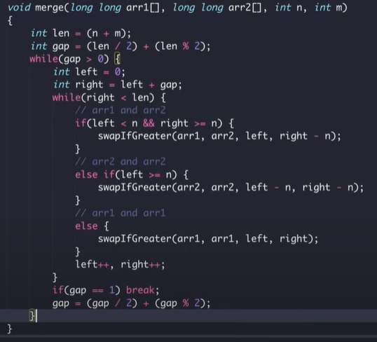
27. Remove Element
Here we took a pointer i,whenever we find an element no rqual to val we simply overwrite on arr[i] and inc i++; if element ocurr ==val we not do ANYTHING ;RETURN i for first non val elements.

14. Longest Common Prefix
First element ko as a search mankar usme loop lgakar jb tk 1 se n tk STRINGS KE element jo first loop ke index pr hain and matches with first[i] with condn koi particular string out of range na ho j<strs.size and elements are eq then j++ loop ke bahr.if j==s.size() tbhi append karenge ans mein else kisi reason ke wjh se loop break hua hoga toh ans return karenge
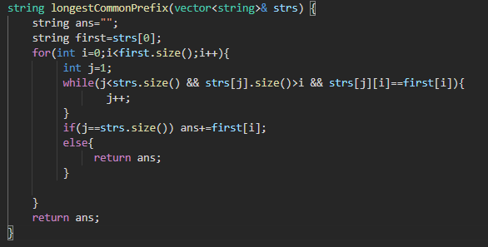
80. Remove Duplicates from Sorted Array II
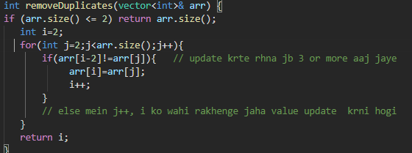
- Zigzag Conversion

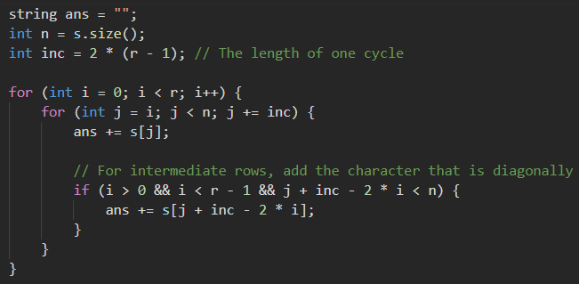 diagonal wale beech mein aayenge toh column wale ke baad add it before moving to nxt column as down ate waqt 2 lements dec by bs diagonal relation
56. Merge Intervals
Sort intervals based on the starting time .Initialize the first interval as the current one to be merged. If the current interval overlaps with the last one in result
if (ans.back()[1] >= intervals[i][0]) {
ans.back()[1] = max(ans.back()[1], intervals[i][1]);
} else {
// Otherwise, just add the interval as is
ans.push_back(intervals[i]);

STRINGS

Longest paliindrome from string
Create arr of 26 to store occurrence of each alphabets
Even char take all
Odd char take all-1;
Last add odd flag 1 if there is odd char
1859. Sorting the Sentence
First make arr 0f size 9 .while not space come temp+=arr[i] ,if dig comes ans[s[i]-‘1’]=temp then empty temp;
Isdigit() func is used to check wheter a string is digit or not

// kmpppppppppppp

LINKED LIST

Create ll from recursion inserting node at start 246810 is array and like that 10-8-6-4-2

Node*fun(arr,index,size,node*prev)
If(index==size)
Return prev;
Node*temp=new node(arr[i]);
Temp->next=prev;
Return Fun(arr,index+1,size,temp); // return finally the head address

** deletion at a particular node
Simple fun call karte jaan a hain base case pr delete ke nxt wale ko store kar ke return ka dena hain delete a prev ke nxt prr baaki cases ke liye simply wahi adress return kr dena hain….

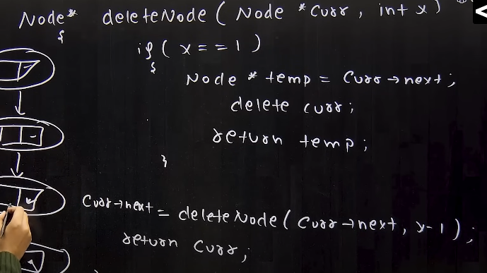

Delete without head pointer: simply given pointer ke neighbour wale ki value copy kar ke uske nxt ko point kr dena hain then neighbour ko delete maar do

Reverse a ll :
- Array mein pahle saare value store kar lo then use reverse form mein ll mein insert kra do.
- Pahle future node ka adress store then each curr node ke next pr prev ko daal dena then call fun by putting curr=future and prev=curr. Base case reach honne pr return prev; so that call se bahar aane ke last ka adress head mein aa jaye.
Middle of ll:
i)slow and fast pointer : even size fast odd size fast->next !=NULL;

Given a linked list of 0s, 1s and 2s, sort it

- Cnt 0 1 and 2 then suru se jaakar cnt—kar ke sb ko insert kr do;

- Head0 tail0 --- sarre pointers bnakar specific tail mein add kar do via tod kar.then check head1->nxt hain to usme tailo ko pt otherwise head 2 mein point kr do tail1-next =head2->next
Node *head2 = new Node(0);
Node *tail2 = head2;

while(curr){
if (curr->data == 0)
{
tail0->next = curr;
tail0 = tail0->next;
curr = curr->next;
tail0->next = NULL;
}
tail0->next=head1->next ? head1->next : head2->next; dummy ko hatane ke next se join kr rhe hain
tail1->next=head2->next; head2 na bhi ho toh null ko hi point karega which is correct
head=head0->next;
return head;

**** CIRCULAR LL IMP FOR INTERVIEWS
LOOP IN A LINKED LIST ** MOST IMP FOR INTER VIEW
- USE ARR TO STORE ADRESS OF NODE IF IT REPEATS IN IT THEN RETURN 1;
- USE SLOW AND FAST POINTER ,THEY MEET IF FAST==SLOW, NOT MEET WHEN FAST==NULL OR FAST->NEXT==NULL’
LENGTH OF LOOP – WHEN SLOW AND FAST MEETS MOVE SLOW AND CNT UNTIL SLOW WAPIS =FAST NA HO JAYE;
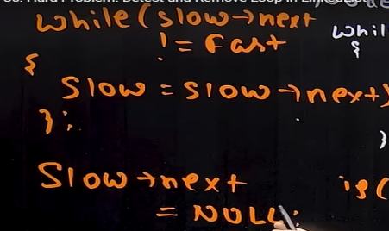
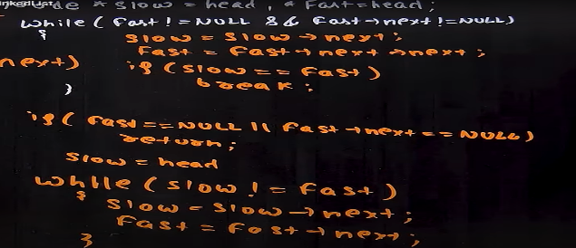
REMOVE LOOP -
I)

II)FAST WALE KO LENGTH OF LOOPS TIME AAGE RAKHNA HAAIN SLOW WALE SE THEN MOVE BOTH UNTIL THEY BECOME EQUAL. THEN SLOW WALE KO MOV EKARENGE JB TK SLOW->NEXT!=FAST

Y SHAPE LL INTERSECTION
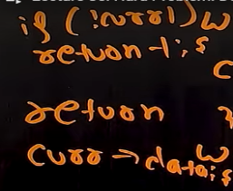
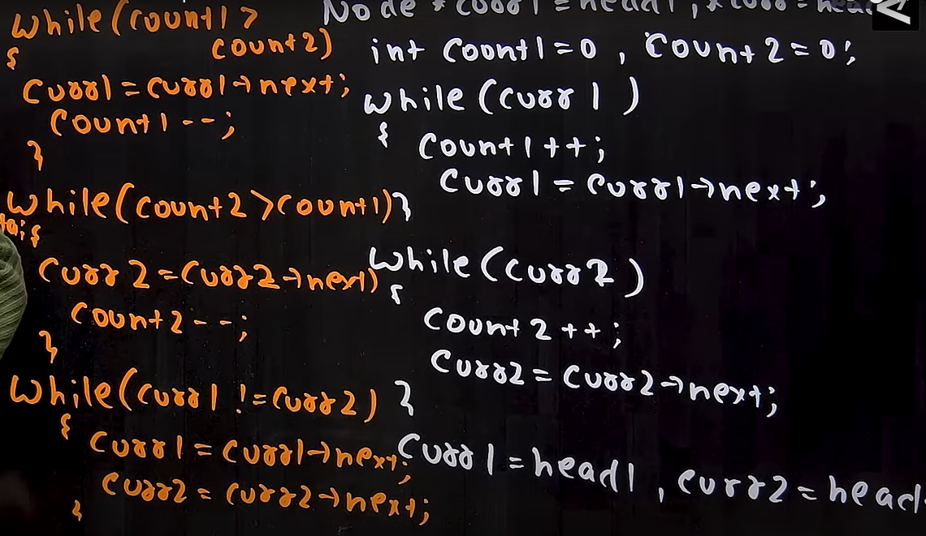

Add two numbers represented by linked lists
PHLE S1 STRING MEIN PLE LL KE ELEMENT INSERT IN REVORDER THEN SAME FOR S2; THEN APPLY ADDN OPERATION AND STORE RESULT IN OTHER STRNG FROM BEGINNING BECAUSE S1 AND ARE REVERSE ORDER TO SIMPLIFY ADDN
while (i < s1.size() || j < s2.size() || c) {
int x = i >= s1.size() ? 0 : s1[i] - '0';
int y = j >= s2.size() ? 0 : s2[j] - '0';
int ans = x + y + c;
c = ans / 10;
res.insert(res.begin(), (ans % 10) + '0');
if (i < s1.size()) i++;
if (j < s2.size()) j++;
}
Reverse a Linked List in groups of given size
CREATE DUMMY PTR first to avoid EDGE CASES AND MAKE IT HEAD then take three pointers second =first->next curr=second and prev=first for moving, jb tk first ka nxt hain . reverse the pointers till cnt—then first->next=prev and second->next =curr and now first will equal to second for nxt reversal;
while(first->next){
node*second=first->next;
node*curr=second;
node*prev=first;
while(cnt&&curr){
node*nexi=curr->next;
curr->next=prev;
prev=curr;
curr=nexi;
cnt--;
}
first->next=prev;
second->next=curr;
first=second;
cnt=k;
}
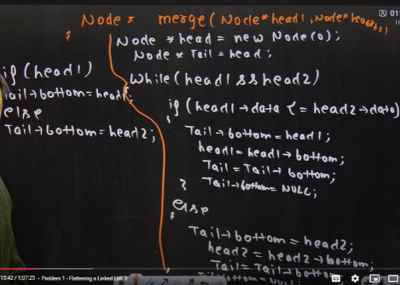
Flattening a Linked List
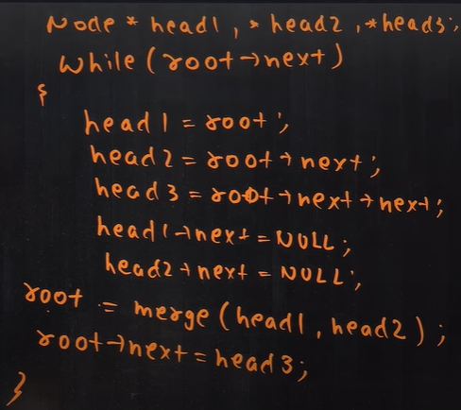
Merge K sorted linked lists

- Same as above head =arr[0]. Merge karne ke baad ans ko head mein store kara denge…
- Merge sort
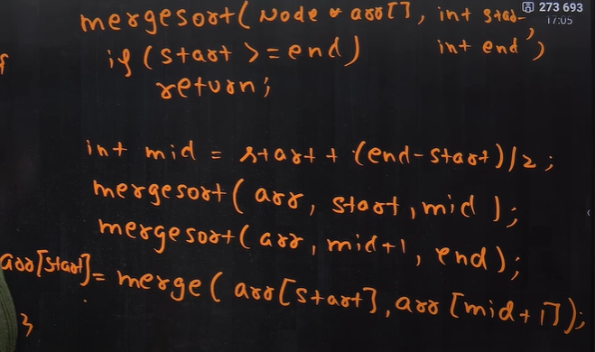

Clone a LINked List

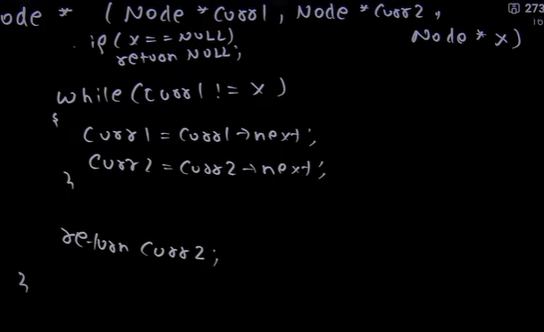
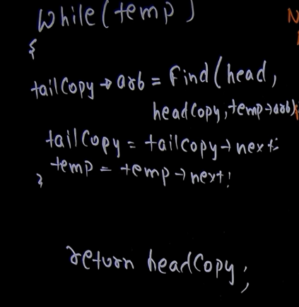
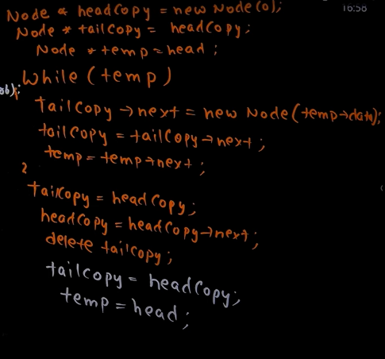
firstwe
create dummy ll using next,then with the help of fun pointing the tailcopy arbitrary by counting its step from first in org ll.

Using unordered map we store corresponding nodes adress ie org with the clone
while(temp){
mp[temp]=tailcopy; //// storing
tailcopy=tailcopy->next;
temp=temp->next;
}
temp=head;
tailcopy=headcopy;
while(temp){
tailcopy->random=mp[temp->random];
tailcopy=tailcopy->next;
temp=temp->next;
}
return headcopy;
iii)
pahle clone create kara then usse org ke beech mein insert kara then arb pointers assign kiya by org arb node ke bagal wala hi clone node ka arb hain then diconnect kiya by node apne next ke next ko point kare

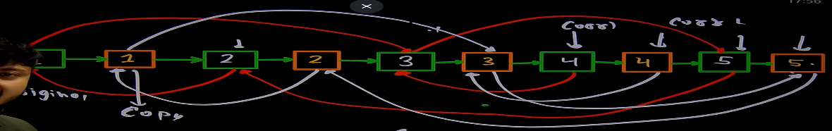

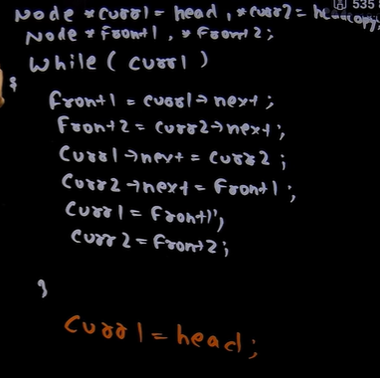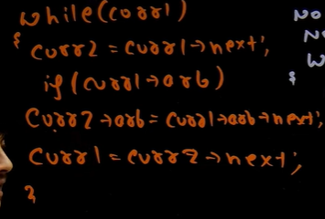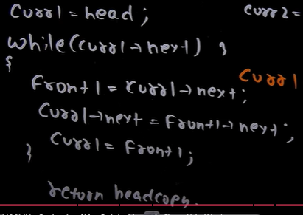

STACK
MAKE ARR BEAUTIFUL:-
IF s is empty then push arr[i] . if s top is negative and arr[i is [positive then pop else push .if s top is positve ans arr[i] is negative then pop else push
: Minimum Add to Make Parentheses Valid:
(open wale ko stack mein close milte hi pop;
If close brac pr s empty uss case mein cnt++;
If open brac st mein last tk present ho toh s.size();
Last mein cnt+s.size() for both the cases…

Print Bracket Number
for(int i=0;i<str.size();i++){
if(str[i]=='('){
cnt++;
s.push(cnt);
ans.push_back(cnt);
}
else if(str[i]==')'){
ans.push_back(s.top());
s.pop();
}
}
1: Next Greater Element
Jb tk arr ka element greater than stack ke top se jyada na aa jaye st mein push kardo index because index se pta chalega kaha pr ans mein value dalni hain . top se arr[i] jb tak greater usse ans arr mein dal kar if st!empty ho st se pop kr do and last mein arr[i] ko st mein daal do
Top and pop use karne se pahle check st not be empty ().

Largest Rectangle in Histogram:
- Next smallest left and next smallest right nikalkar dono minus karke -1 karke * height;
Nsl nikalte time start from last last mein st empty karo usme agar index write kr rhe then write -1; size kr rhe then i+1;
Nsr time jinke right na mile woah stack mein hain then empty stack by for size n-I for index just write n;start index from the 0 to n;
Arr banegi for nsl and nsr;
- Nsr find karo then index ko pop karo from stack nsl cnfrm ab st ka top hoga as ascendiing order mein jaa rahe hain then on spot calculate area by if st empty nahi hain toh height[index]*(i-st.top-1) ,if s is empty then *(i),
Last mein st mein jo bhi element jinke nsr nhi hain st empty nahi hain toh height[index]*(n-st.top-1) ,if s is empty then *(n),
Maximal Rectangle
Har column pr jakra if 0 hain toh height[j]=0 or 1 hain toh height[j]++; then call upar q wala func return max rectangle area store karate jao max ans ko for eaach column…………

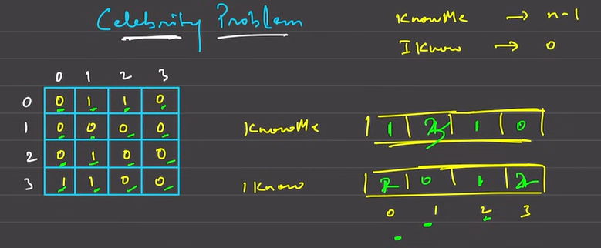
Celebrity problem
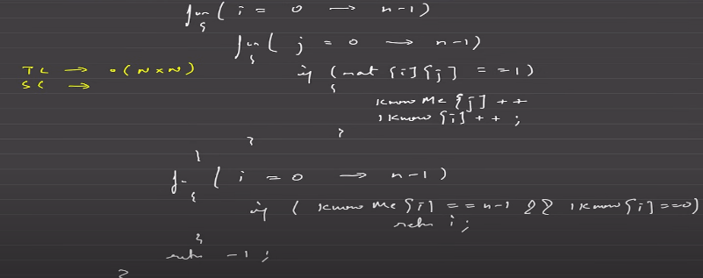
ii)
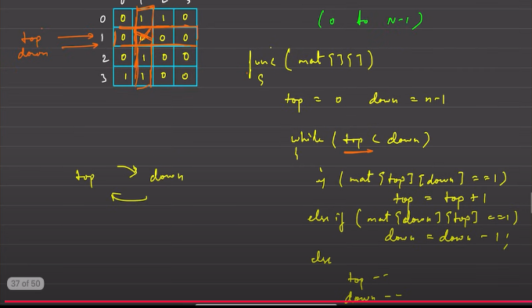
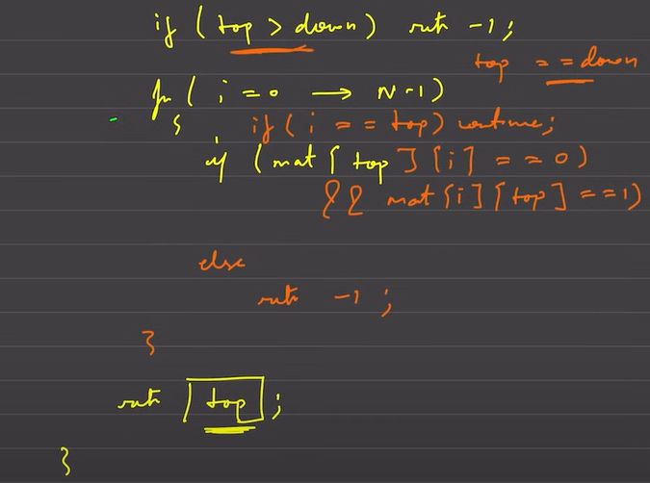

Two stack in one array:-take two pointer at st ad end insert st1from start ans insert st2 from end initially top1=-1 and top 2=n; if top1+1=top2 arr full or top2-1=top1 st 2 full,
N stack : store elements in arr but its index is store in another arr of size n which stores pointers adress like a stack,which store each stack element index at which it is stored in arr . also a stack to store the avalable indexes.
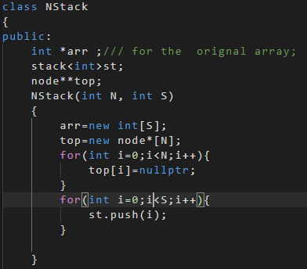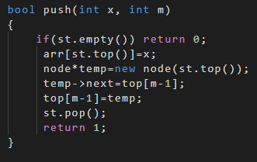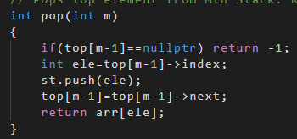

Maximum of minimum in every window
1 n^3 :=I 0 to n j 0 to n-I then k=j to j+I;
2) i=0to n j=I to n
3 First we calculate range of window size for which a particular element is maximum, range=nsr-nsl-1 change nsr and nsl according to st empty() or jinke nsr exist nhi krte hain woah stack mein hi reh gaye . we are updating only in the range-1=window size 0f range , because sb me baar update krne se tc n^2 ho jayegi .last mein n-2 se start krke pure arr mein max(arr[i],arr[i+1]) update kr denge jisse jaha bhi arr mein value nhi hogi woah fill ho jayegi because agar koi particular ndex pr hain toh apne se pichhe walo ke liye bhi max hi hoga ….
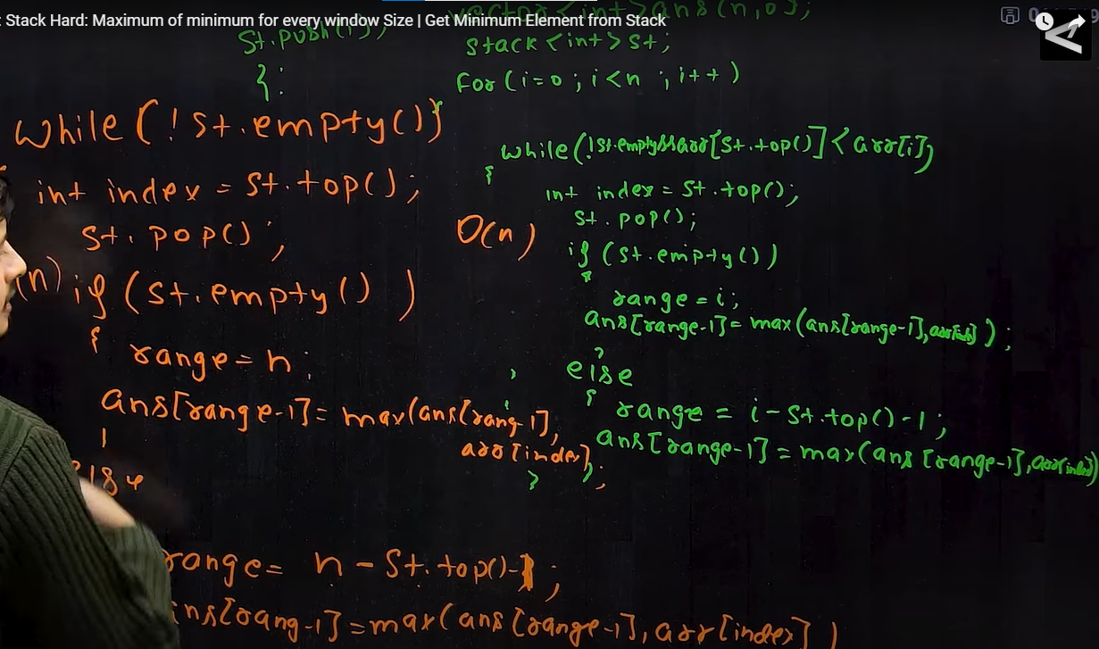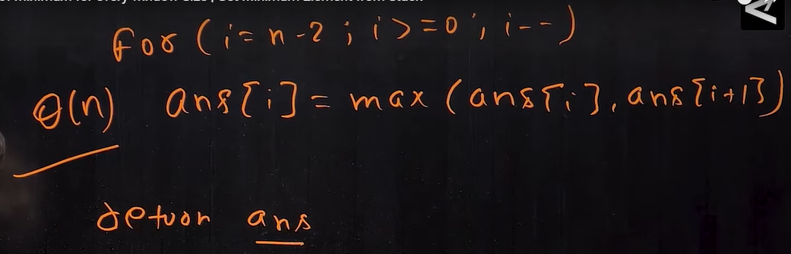

RECURSION
78. Subsets there is always two choices for every particular indexes . if you take or not take move to nxt element in the arr . if index goes out of range then push the temp arr to ans arr and return to prev call
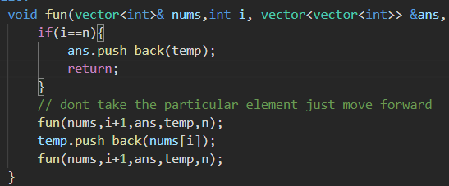
22. Generate Parentheses
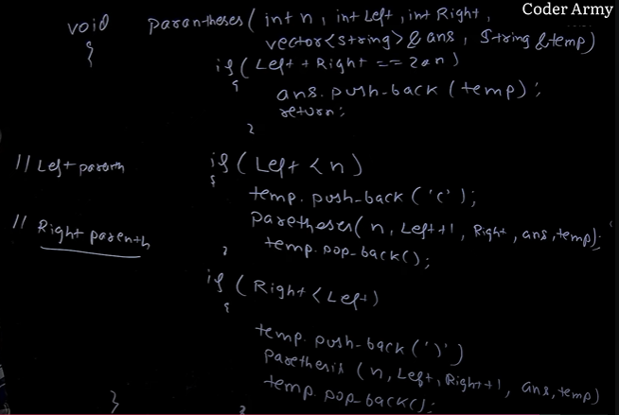
For valid right should be less than left bracket and if lieft and right boh becomne then only push in ans also left must be less than n
ALL SUBSET SUM
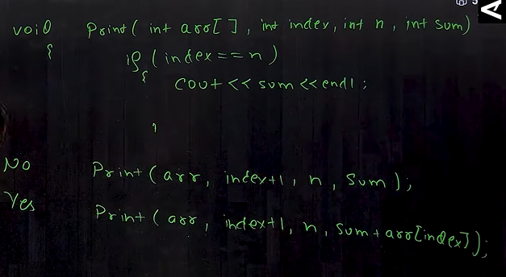
TOTAL SUM =TARGET
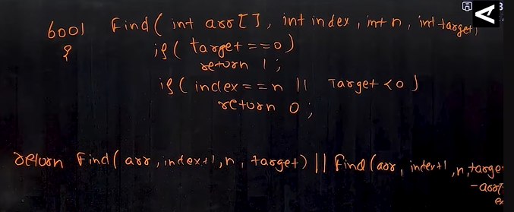 IF REPETITON ALLOWED THEN TAKEN KI CASE MEIN INDEX+1 NAHII HOGA
PERMUTATION*** M1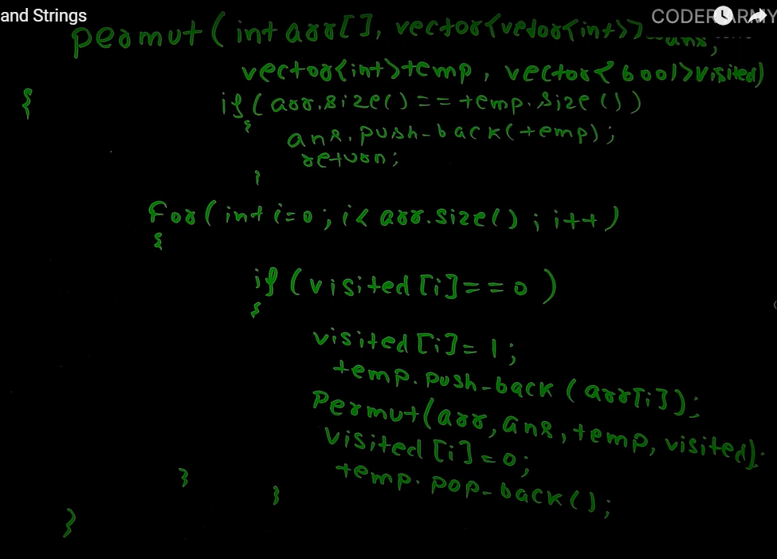
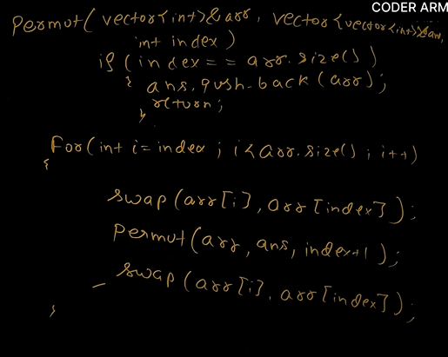
M2

PERMUTAT+REPN
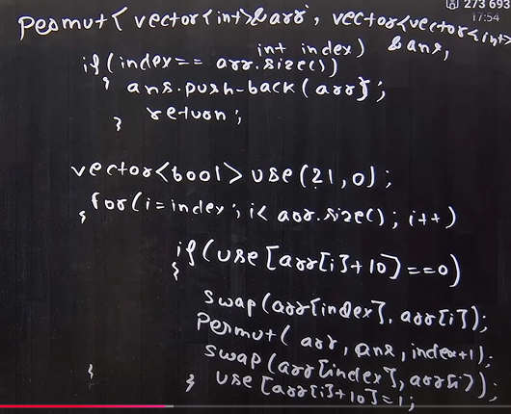

WAYS TO SUM N
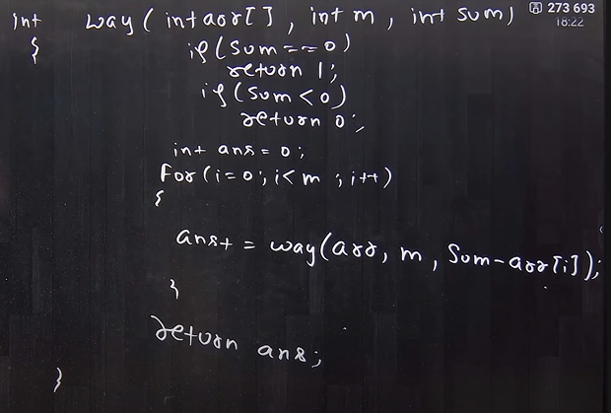
0 KE CASE MEIN INFINITE LOOP AS SUM NEVER BECOME 0 AND IINDEX NEVER INCREASES
N BIT BINARY
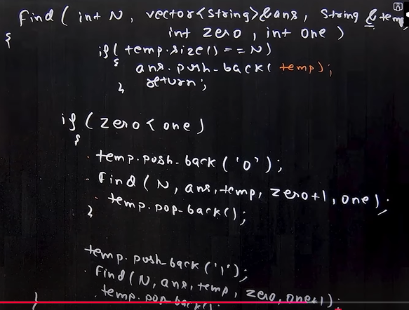

QUEUE :-
Implement queue using stack
Take two stacks one for push only other for pop. Pop karte karte s2 agar empty ho jaye toh then s1 ke saare element s2 mein push kr do then pop from s2 ,same for peek. Empty =s1&&s2 are empty;
Implement stack using queue
Jis q mein element honge usi se push pop hoga separate nhi banane . for pop n-1 element ko dusre q mein daalkar fir dusre q se element ko delete kr denge

first-negative-integer-in-every-window-of-size-k
- Pahle k-1 element ko q mein push then k se n tk loop chalakar ek element ko insert kr ke function mein q ko bhej denge to print first negative wapis aakar q.pop() kr denge.
- Q mein bs -ve element ke indexx ko push karenge then check q ka front i-k<= toh pop kr do us range mein nhi hain the print q.front if q empty hua to print k do…,
first-non-repeating-character-in-a-stream-of-character:
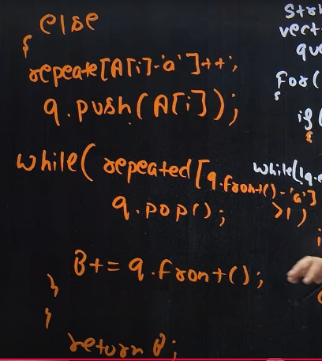
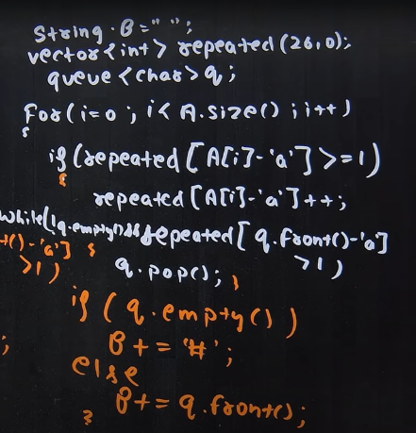

: Minimum Number of K Consecutive Bit Flips:
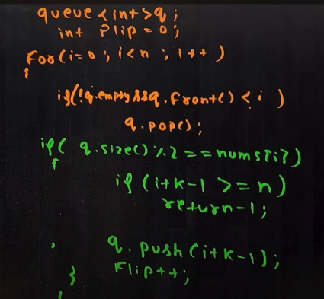
q mein wahi index ki range jayega jo 0 bn gaya hoga . return -1 tb jb element 0 ho pr window size out of range chala gaya hain. Q ke front se woah range niklega jo current index se kam ho gya hoga because curent elements us range mein hain nhi toh flip bhi nhi honge so we have to reduce flips for correct no of flips..
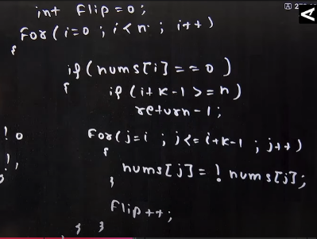
q.size tells how much times the element is flipped .

o(n^2)--------------------------->
1: Sliding Window Maximum
Deque mein index store hoga.deq mein greater element jayega jb tk arr[i] greater than deq ke top se d.pop() karte raho and front se tb pop kro jab index out of window chala gaya ho
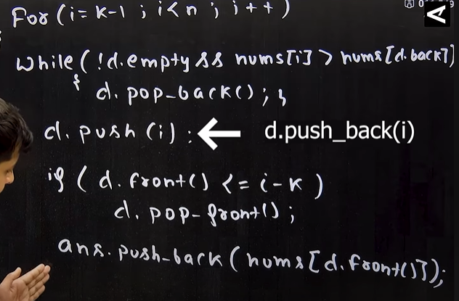
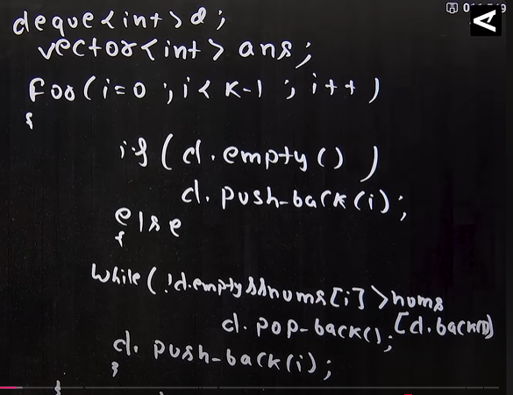

T R E E S
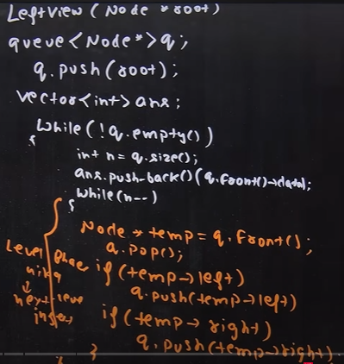
Left , right , top ,bottom in queue change the order of pushing left and right child
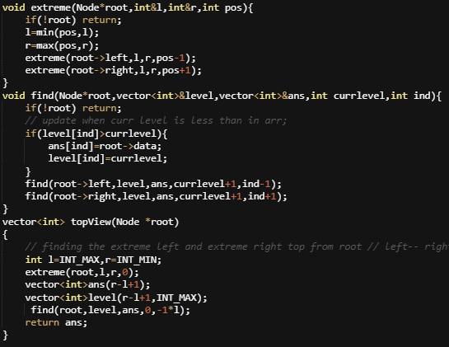
For right view push first right then left

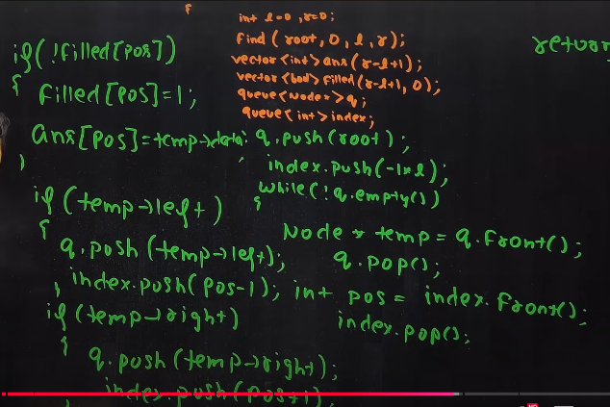top view ->iterative;;;
Symmetric
Check if two Nodes are Cousins
First with the help of q find the level of each element apply n=q.size();while(n--) then in last inc level also do check for a and b and also push child in q if hey exist
For parents we do opposite we check if they have same parent or not and return its opposite;
Level order traversal in spiral form
Takeing two stack for left to right and right to left.while moving left to right push the temp children in first left child then right child if they exists and visse versa do this until the particular stack is not get empty; then move to second stack and push root from st to ans also push its element child into in st1 in lr format. Do the whole process ntil s1 or s2 gets empty();
Iterative inorder and postorder
Make tree from inorder +pre/post

Deletion in bst
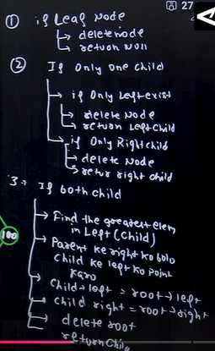
3 case mein if target and parent(left max ka parent) is same then child->rigth=root->right delete root return child

** Inorder traversal of bst is always in ascending order
CHECK FOR BST
M1) inorder traversal ko arr mein store kara kar just check prev<current;
M2) recursion ,first check left if return 0 then immediately return 0 not need t check further , then check root->data is >then prev, then right pr jaane se phle update prev=root_data then call fun for right; prev is pass as ref
Construct Binary Search Tree from Preorder Traversal
Use int min and int max for left subtree it mst be range from int min to root and for right root to int max;
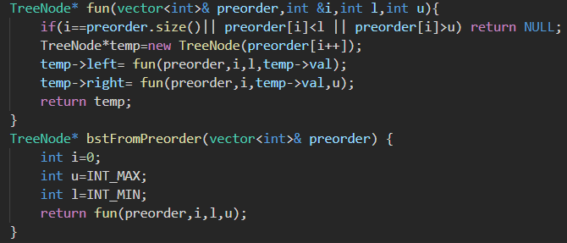
Preorder Traversal and BST
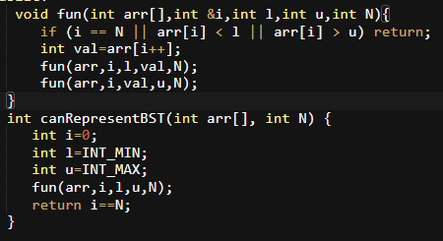
dummy value , if I ==n then the preorder given is valid . other wise kisi range pr satisfy nhi kiya toh I will not come to N;;;

DYNAMIC PROGRAMMING
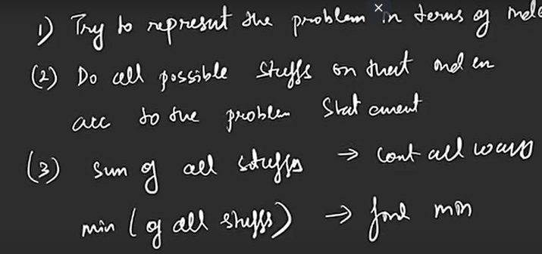
problems in which there is out of total no of ways select minof all or max of all

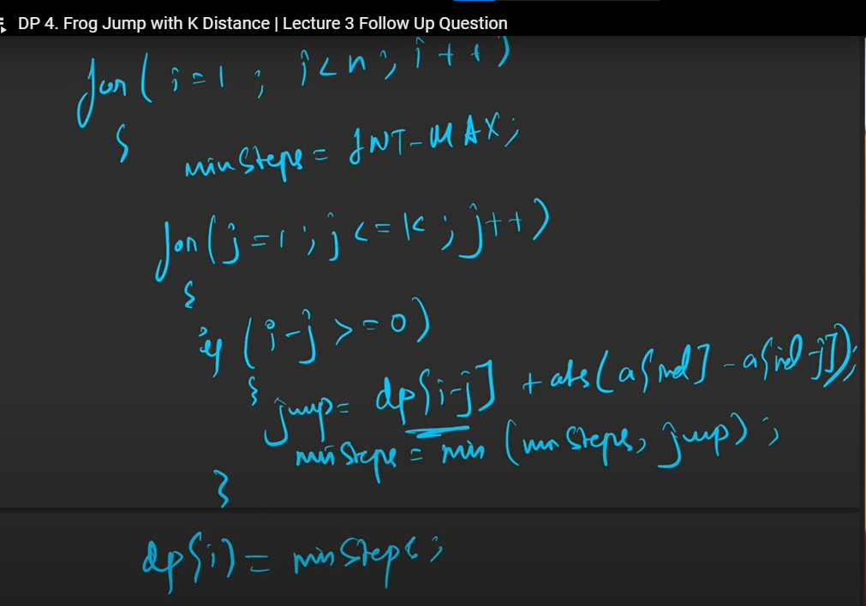

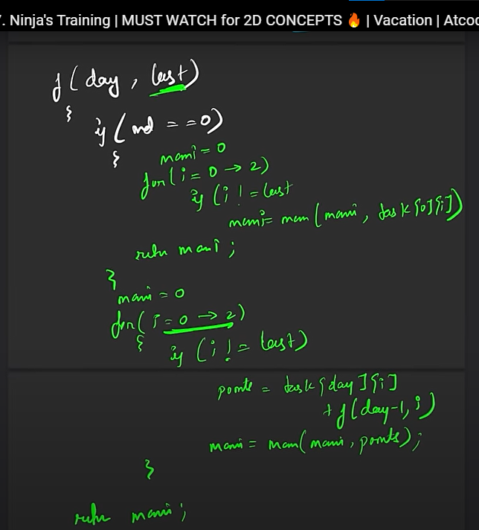
#for memeoization check for the changing parameter.parameter amx sizw would be the size of dp array
Tabulation is always opposite of recursion you write (for loop)……
If there are multiple ways to go from down to up use for loop for each element or just change the scenario start from 0,0 and at last row return any as it if base case;(traingular matrix )
If multiple startin to mutlple ending ;-> for loop either start/end and a base case check for first or lst row according to choice …..(max path sum in matrix)…..
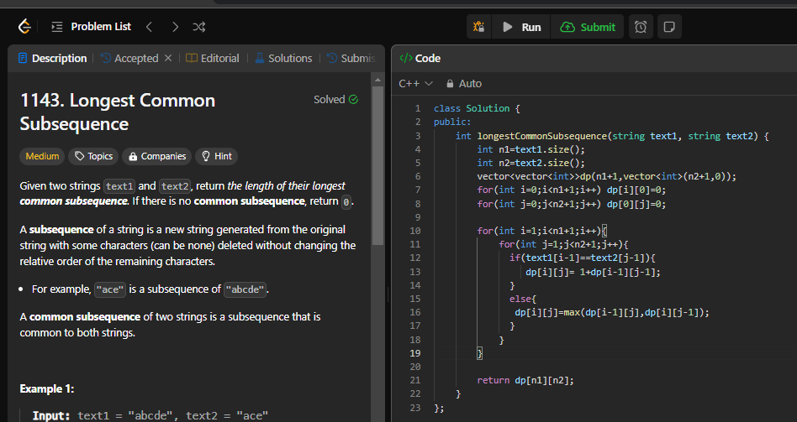
inoolves shifting of index as we cant assingna values fro i<0 or j<0 , so right shift by1 then i<0 turns to i==0;
increase dp size by1 and reduce index of strin by 1

