C P

** SUMMATION OF FIRST N NATURAL NUMBER
Long long SUM =x*1ll*(x+1)/2; by multiply 1ll answer converted to 64 bits…
1e9->32 bits
1e18->64 bits
** getline
String name,t;
Getline(cin,name); by default space is considered as deliminator;;;
String stream x (name);
While(getline(x,T, ’ ’)){ // deliminat0r is taken as space;
cout<<t<<endl;
}
MAXIMUM
To compare max among n element ->max({a,b,c,d,…..n});
** char c>=65 or >=’A’;
C=(Char)(c+32)
q) multiply 4 numbers and return last two digit
a*b*c*d=max to max 10^36 we cant store so by observation for last two digit we have to multiply only last two digit of elements; therefore a=a%100-------then ans=(a*b*c*d)%100;;
if(ans<10) print 0ans(02).
CEIL: JUST GREATER NUMBER THAN N; 3.4->4
FLOOR: JUST LESSER NUMBER THAN N 3.4->3
IF(CEIL(N)==FLOOR(N)) THEN N IS INTEGER;
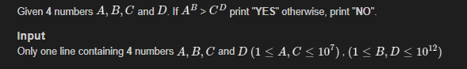
Since a^b become too large we take log on both the sides bloga<dlogc;
** set is used to store unique elements in sorted order ;
St.insert(x) , st.erase(x) ,auto it =st.find(x) fir x se aage range tk delete krne ke liye st.erase(it,it+4)

**unordered st:- unique element in any order ,constant time for all operations
## multiset :- sorted order and may have dublicates, to find cnt st.cnt(x);
For(auto it :arr) here it is the value not index and auto automatic the datatype of it.
Pq by default max ,for min conversion use syntax or *-1 while inserting and *-1 while taking out;
Binary search-
i)binary_search(arr.begin(),arr.end(),x)- returns true or false ; // for range arr.begin()+1=start index,arr.begin()+y=end+1 index (ek extra);
ii)lower_bound(a.begin(),a.end(),x)-a.begin() ->now give index……….
it gives first pointer less then or equal to x
ii)upper_bound(a.begin(),a.end(),x)-a.begin()
first pointer greater than x

- Always use long double for the decimal no as it gives high precision.. instead of float and long
- Before printing float value convert it to integer as direct printing will give s cientific notation which may not be accepted
- Always use fast i/o and /n instead of endl for tle.
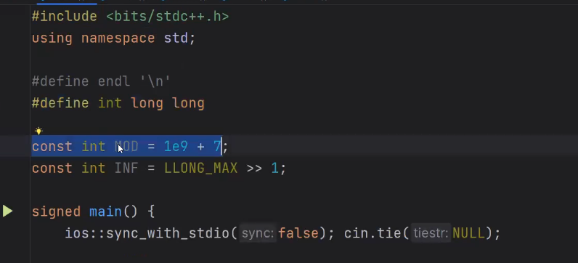
Q
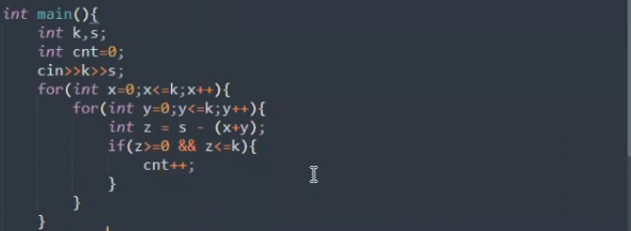
** Ceil(a,b)=(a+b-1)/b; ceil misbehave for int and mainly used for float;
Given a year number, find the minimum year number which is strictly larger than the given one and has only distinct digits.
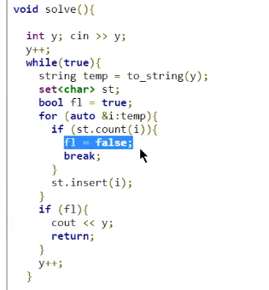
Arr has 1 unique and all duplicates
M1) hashing cnt==1 arr mein search and return index.
M2)
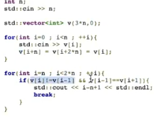
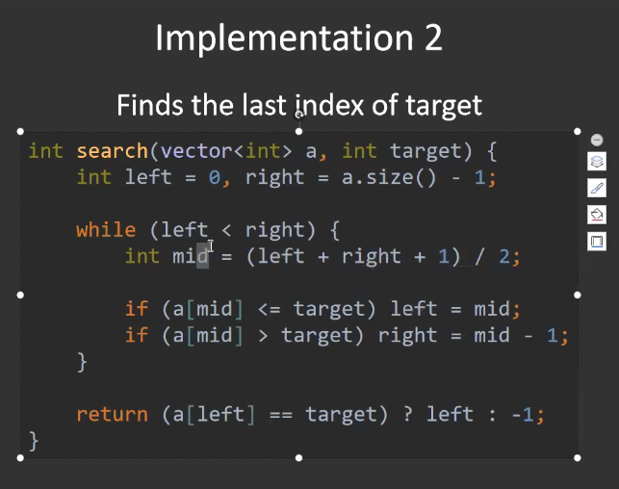
to prevent infin loop we use l<r not less than equal to beacause if l==mid ==rthen problem occur
Why use ceil in binary search?
- Ensures that mid moves towards the right side (mid = (left + right + 1) / 2) during the search.
- Useful in problems requiring finding upper bounds or the last occurrence.

New type of bs using preficate function …..
The variable l tracks the last true position where a[m] < t.
The variable r tracks the first false position where a[m] >= t. l is less than actua; range and is greater than actual last index………..
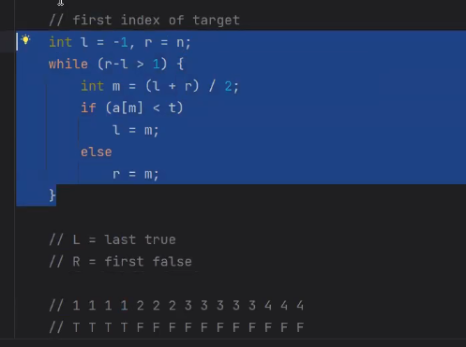
• l is the last index where a[l] < t.
r is the first index where a[r] >= t.
• Hence, r will be the first index of the target t…
Most Intereractive problem is based on binary search
Before main write query fn for interactive
