ScholarSwarm
Hackathon submission — TetraNoodle AI Hackathon 2026, “AI Scholarship Finder” challenge

ScholarSwarm is a team of AI agents that helps a student find scholarships they can really get. The student uploads a resume, types a few lines, or just speaks. The agents read the profile, search the internet, open official pages, check every rule, pick the best five matches and write a first draft of the statement of purpose (SOP). The student can watch every step live on the website.

1. GitHub repository
Link: github.com/rajv4rdhan/opportunity-agent
The repository has all the working code:
- backend/ — Python, FastAPI and LangGraph. One file for each agent, plus tools for search, web pages, GitHub and the knowledge graph.
- frontend/ — React website: the intake page, the live run page and the results page.
- docs/ — the diagrams, screenshots and notes.
- README.md — how to set up and run the project.
The README explains the setup in a few steps: add your API keys to backend/.env, start the backend, and start the website.

2. Live project
Live link: [add the Northflank URL here]
The project is hosted on Northflank. On the live site you can:
- Start a search with a resume, some text or your voice.
- Try one of four sample students (Rahul, Priya, Arjun or Meera).
- Watch the agents work together in real time.
- Read the results: top matches with official quotes, deadlines, “Unlock more” and the SOP draft.
- Replay any finished search at high speed.

3. How the agents work
The diagram below shows how the agents work as a team. A Supervisor is in the middle. It decides which team works next. All agents read and write to one Shared Memory, which holds the student profile, the results and notes.
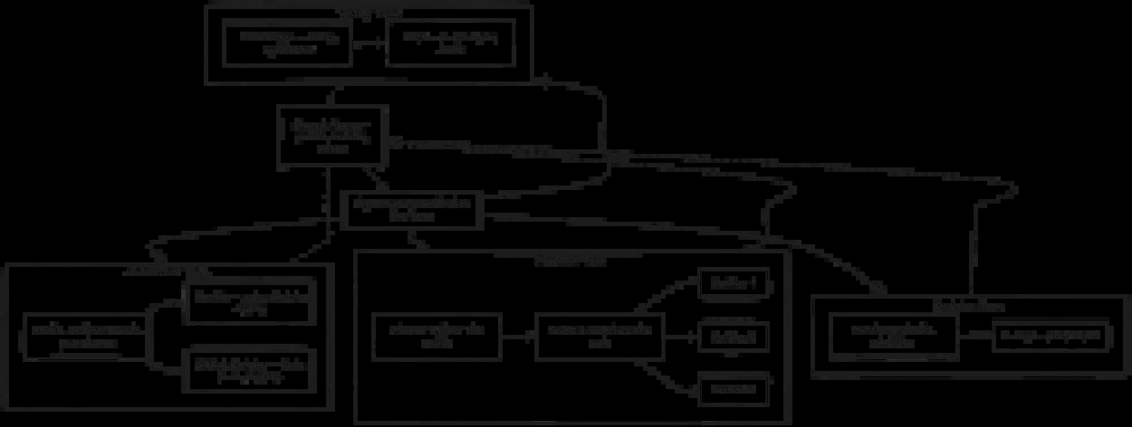
Diagram 1 — The agent teams and the shared memory
Team | What it does
Understand team | Profile Analyst reads the resume. Clarifier asks the student if something important is missing. GitHub Enricher finds projects from GitHub.
Research team | Planner plans the searches. Scout searches the web. Many Verifiers open the official pages at the same time and copy the exact rules.
Decision team | Matcher checks if the student is eligible. Ranker picks the top 5 and explains why.
Writing team | SOP Writer writes a draft. Critic checks every fact. They repeat until the draft is correct.
Supervisor | Coordinates the teams. If there are too few good results, it sends the Research team back to search again.

System architecture
The second diagram shows how the whole system fits together, from the student to the outside services.
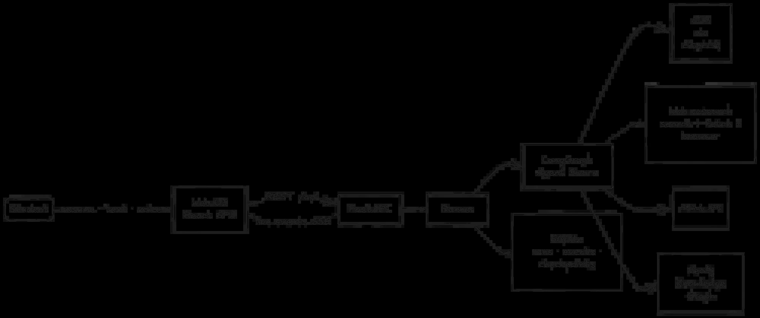
Diagram 2 — System architecture
- Web UI (React): the student gives a resume, text or voice. The page gets live updates from the agents.
- FastAPI and Runner: receive the request and start the agent swarm.
- LangGraph agent swarm: the agents. Their language model calls go through LiteLLM and are routed with Jev.
- Web research: search engines, page readers and a cloud browser (Kernel browser MCP) for hard pages.
- GitHub API and Neo4j: GitHub gives project details; Neo4j stores the knowledge graph.
- SQLite: stores every run, every event and checkpoints, so a run can be replayed or resumed.

4. Short note

Most interesting experiment
The most interesting experiment was making the agents prove what they say. When a Verifier finds a rule, like a deadline or an IELTS score, it must copy the exact sentence from the official page. Then the system checks that this sentence is really on the page. If the AI makes up a number, for example “IELTS 8.0” when the page says 6.5, the quote is removed and the result gets a lower confidence score.
After that, eligibility is checked by normal code, not by the AI. Because of this, we could build the “Unlock more” feature: the student moves a slider, for example IELTS from 6.0 to 7.0, and instantly sees which new scholarships open up. This needs no AI call, so it is fast and exact.

Biggest technical challenge
The biggest challenge was handling failures. Search engines time out, some websites block bots, the AI sometimes returns broken data, and the database can be down. We did not want the app to crash or fail silently.
So every outside call uses the same retry and fallback rules. For example, if one search engine fails, the next one takes over. If a page blocks a simple reader, the agent tries another reader and then a real cloud browser. Every recovery is shown live to the student. We also added a “Chaos Mode” that breaks things on purpose during a run, to show that the agents recover by themselves.
Another hard part was the live view: showing eleven agents, many parallel verifiers and their hand-offs clearly on one screen, on both computers and phones.
This project was built for the TetraNoodle AI Hackathon 2026.

