Chapter-1

**INTRODUCTION**

**1.1 Introduction:**

This project aims to develop a secure system for user authentication and data encryption, ensuring that only authenticated users can access and manipulate sensitive information securely. This system is particularly useful in environments where data integrity and security are paramount.

The Encryption and Decryption Project is a vital solution for securing sensitive information in the digital age. It addresses cyber threats by developing a comprehensive system that encrypts and decrypts data, ensuring confidentiality, integrity, and authenticity. Using sophisticated algorithms, the project transforms data for secure transmission and offers a user-friendly interface to empower seamless encryption and decryption. This effort stands as a pioneering solution to fortify digital communication against contemporary threats. add some points in this information

Chapter-2

**PROBLEM STATEMENT**

**2.2 Need of Work:**

1. Lack of Secure Authentication Mechanisms

Many systems rely on simple username-password combinations for authentication, which can be vulnerable to brute-force attacks, password guessing, or password sniffing.

There is a need for a more robust authentication mechanism that ensures only authorized users can access the system.

2. Vulnerability to Unauthorized Access

Without proper authentication and encryption, systems are susceptible to unauthorized access, potentially leading to data breaches, theft, or manipulation.

Strengthening access controls and implementing encryption techniques can mitigate these risks and enhance overall system security.

3. Data Security and Confidentiality Concerns

Sensitive information stored or transmitted by systems may be at risk of interception or unauthorized viewing.

Encrypting data ensures that even if intercepted, it remains secure and unintelligible to unauthorized parties, maintaining confidentiality and integrity.

**2.3 Problem Statement**

The Encryption and Decryption Project aims to address the escalating threats to digital data security. With the increasing risk of cyber-attacks and the heightened vulnerability of sensitive government information, there is a critical need for a user-friendly application that offers robust encryption and decryption capabilities. Existing methods often compromise either simplicity or comprehensive protection. This highlights the necessity for a streamlined system that ensures confidentiality, integrity, and authenticity of data during communication.

**2.4 Objectives:**

* Implement Seamless Decryption Processes:

Create efficient decryption processes that enable authorized users to swiftly and accurately restore encrypted data to its original form, maintaining data integrity and authenticity. Include measures for rapid recovery to minimize downtime in critical applications.

* User-Friendly Interface:

Develop an intuitive application interface that allows both technical and non-technical users to easily encrypt and decrypt data without the need for specialized skills. This should include step-by-step guides and one-click solutions to cater to users of all proficiency levels.

* End-to-End Data Protection:

Ensure comprehensive protection throughout the data transmission process by addressing vulnerabilities at each stage and guaranteeing end-to-end security. This involves implementing strong encryption protocols for data in transit as well as at rest, and using secure channels for data exchanges.

* Adherence to Security Standards:

Align the project with industry and government security standards, ensuring compliance with best practices for data protection and encryption.This will also involve regular updates to encryption algorithms and compliance protocols based on evolving regulations.

* Real-Time Encryption and Decryption:

Implement encryption and decryption processes that operate in real-time, allowing seamless and prompt secure communication between users. This objective should also focus on optimizing system performance to ensure minimal impact on user experience during the encryption and decryption processes.

* Regular Security Audits:

Conduct periodic security audits and updates to address emerging threats, vulnerabilities, and to enhance the overall resilience of the encryption and decryption system. This should also include stress testing and penetration testing to proactively identify and rectify potential security weaknesses.

Chapter-3

**DESIGN DETAILS**

**3.1 System Architecture:**

The system architecture comprises several interconnected modules that collectively enable secure user authentication, data encoding/decoding, and system operation. These modules work together seamlessly to provide a robust and efficient solution for handling sensitive information.

**Module 1: User Authentication**

This module is responsible for authenticating users before granting them access to the system. It verifies the credentials provided by the user against predefined valid username and password combinations.

**Module 2: Data Encoding and Decoding**

This module handles the encoding and decoding of messages or data files. It applies a simple encryption algorithm to encode messages and a corresponding decryption algorithm to decode them.

**Module 3: User Interface (Console)**

Although not explicitly defined as a separate module in the code, the console-based user interface serves as an essential component of the system architecture. It facilitates user interaction by providing prompts for username/password input and menu options for selecting encoding, decoding, or exiting the system.

**Module 4: File Handling**

This module manages file operations, including reading input files for encoding/decoding and writing output files with encoded/decoded data.

**Module 5:**  **Logging and Auditing**

This module facilitates logging and auditing of system activities to track user actions, monitor system performance, and maintain an audit trail for compliance and security purposes.

**3.3 System Design Diagrams(Any three Diagrams)**

**3.3.1** **Data Flow Diagram**

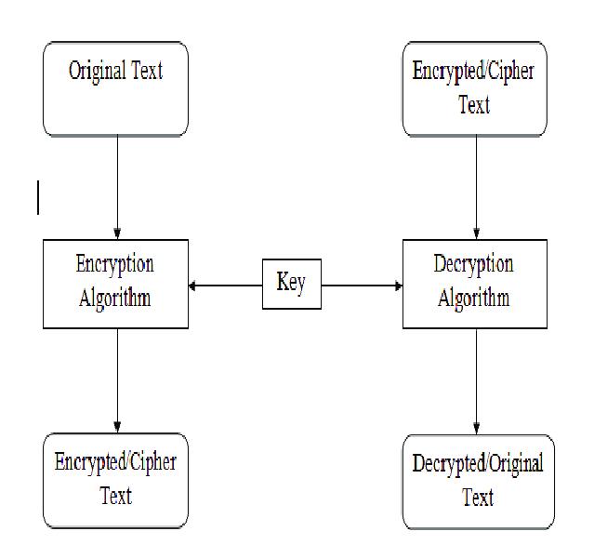

Fig.3.1 Data Flow diagram

* + 1. **Sequence Diagram**

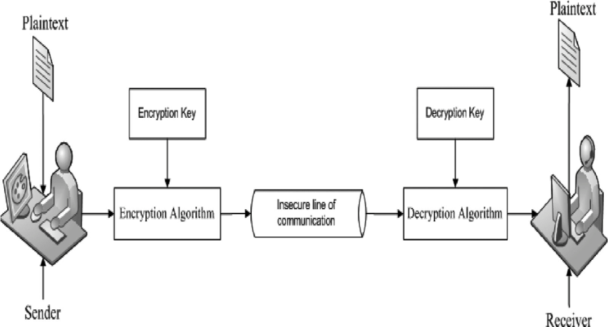

Fig.3.2 Sequence diagram

* + 1. **Use Case Diagram:**

**3.3.4 Class Diagram:**

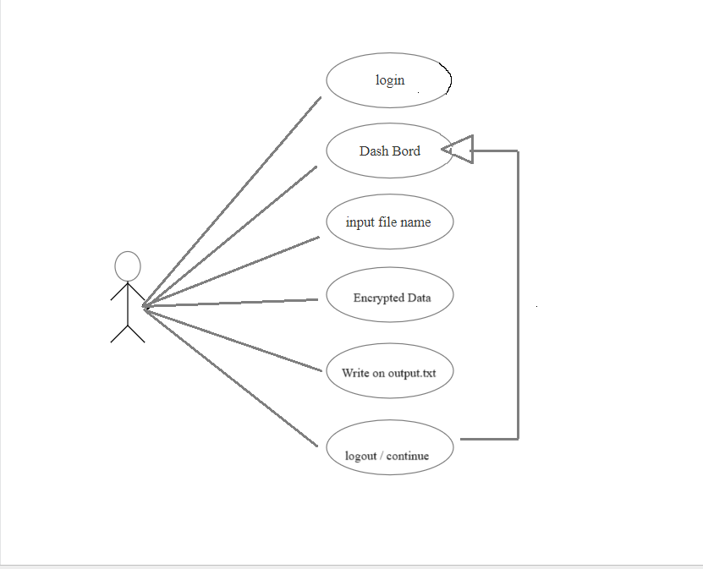

Fig.3.3Class diagram

Chapter – 4

**IMPLEMENTATION**

**1.Software Requirements**

* Turbo C & C++ and Dev-C
* Works on Windows 7, XP, Vista and 8
* Works on 64 bit Windows & 32 bit Windows
* Mac OS X 10.3 and above

**2.Hardware Requirements**

* Intel Pentium 4 or above
* CD-ROM drive
* 10 GB of free hard-disk
* RAM(minimum 512 MB)

Chapter -5

**EXPERIMENTAL RESULTS**

* 1. **Experimentation:(Output Screenshots with description)**

The validateLogin() function compares the username and password entered by the user with predefined valid credentials (validUsername and validPassword).

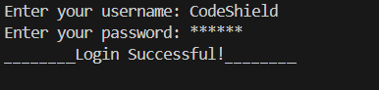

Img. 5.1 user Authentication

The system prompts the user to input a filename from which data will be encoded.

It reads the content of the specified file, applies an encryption algorithm (adding 3 to each character's ASCII value), and stores the encoded message.

The encoded message is displayed to the user and appended to an output file named "output.txt".

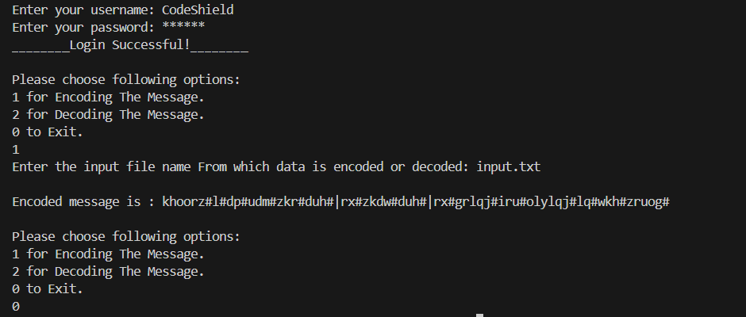

Img. 5.2 Encryption/Decryption

The system utilizes printf() and scanf() functions to display prompts and receive user input via the console.

Menu options are presented to the user to choose between encoding, decoding, or exiting the system.

Messages indicating the success or failure of authentication, file operations, and encoding/decoding processes are displayed to the user for feedback.

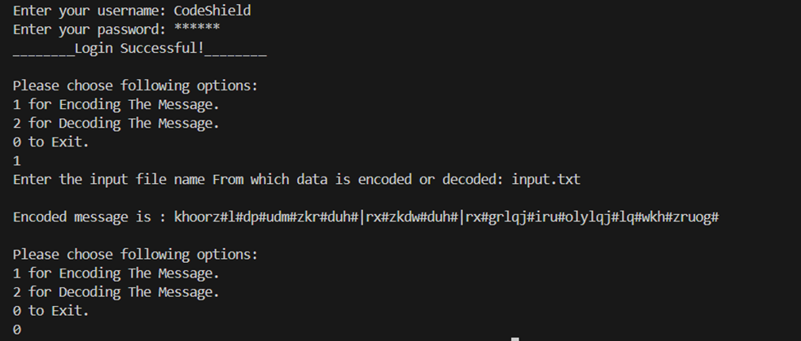

Img. 5.3 User interfac

The system utilizes standard file handling functions (fopen(), fclose(), fseek(), ftell(), rewind(), fgets(), fprintf()) to interact with input and output files.

Input filenames for encoding/decoding are obtained from user input via the console.

Encoded/decoded messages are stored in memory and written to an output file named "output.txt" for persistence.

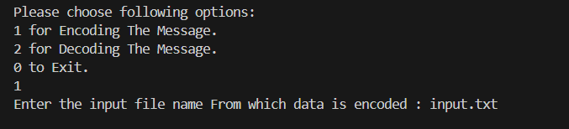

Img. 5.4 File Handling Module

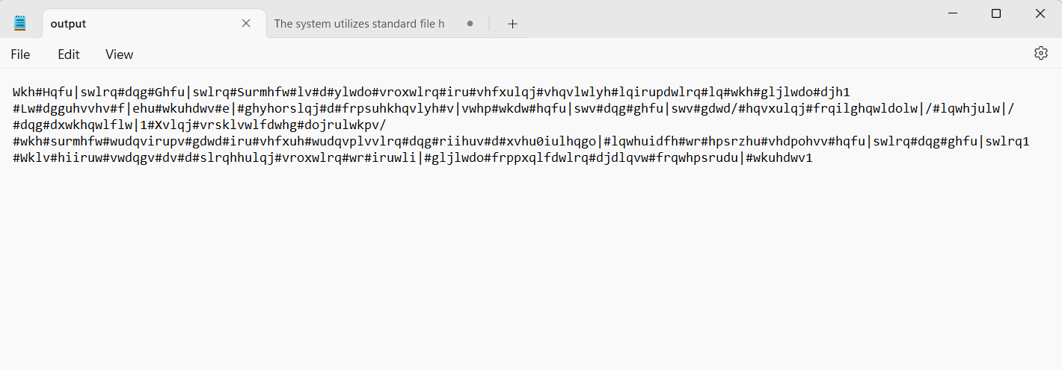

Img. 5.6 File Handling Module (output.txt)

Chapter – 6

**CONCLUSION**

* 1. **Conclusion:**

This project demonstrates its efficiency in providing offline encryption and decryption solutions that can be seamlessly utilized in various environments. By meeting the specified requirements for the operating environment, users can confidently deploy the system regardless of their location, ensuring data security even in offline scenarios.

Moreover, the user-friendly nature of the interface minimizes the burden on users, eliminating the need for in-depth understanding of the underlying encryption algorithms. This accessibility empowers individuals with varying technical expertise to utilize the system effectively, contributing to its widespread adoption and usability.

Furthermore, the project's success in delivering robust encryption and decryption processes underscores its ability to safeguard sensitive information against unauthorized access and cyber threats. By adhering to industry and government security standards, the system ensures compliance with best practices for data protection, enhancing trust and confidence among users.

* 1. **Future scope:**

1. Implementation of More Sophisticated Encryption Algorithms:

While the current system employs a basic encryption technique, future iterations could incorporate more advanced cryptographic algorithms such as AES (Advanced Encryption Standard), RSA (Rivest-Shamir-Adleman), or ECC (Elliptic Curve Cryptography).

These algorithms offer higher levels of security and may be better suited to protect sensitive information in scenarios where stronger encryption is required, such as in highly regulated industries or government sectors.

2. Introduction of a Graphical User Interface (GUI):

While the current implementation relies on command-line interactions, the addition of a graphical user interface (GUI) could greatly enhance user experience and accessibility.

A GUI can provide intuitive controls for users to navigate through the system, input their credentials, select files for encoding or decoding, and view the results in a visually appealing manner.

Features such as drag-and-drop functionality, progress indicators, and error notifications can further streamline the user interaction process and make the system more user-friendly.

3. Expansion to Handle Multiple User Roles and Permissions:

As systems grow in complexity and usage, there may be a need to implement role-based access control (RBAC) to manage user permissions more effectively.

By defining different user roles (e.g., admin, manager, regular user) and assigning specific permissions to each role, the system can enforce access restrictions based on the user's role and responsibilities.

This enhancement ensures that users only have access to the functionalities and data relevant to their role, reducing the risk of unauthorized access or accidental data manipulation.

Additionally, auditing and logging features can be incorporated to track user activities and maintain an audit trail for compliance and security purposes.

Chapter- 7

**REFERENCES**

**7.1 References:**

1.www.libsdl.org

2. <https://chat.openai.com>

3. <https://www.youtube.com/>

4. <https://en.wikipedia.org/>

5. <https://code.visualstudio.com/>

6. Programming In Ansi C|8th Edition