Get-Rescue — Case Study & Solution Architecture
Oct 22, 2026 · @Subash
Get-Rescue runs its whole roadside-assistance operation — intake, dispatch, field execution, customer payment, invoicing and vendor payout — on one Zoho Creator app with 13 purpose-built widgets and 24 server-side Custom APIs, built between 30 Jul and 22 Oct 2026.
How to read this document. Everything about the solution, architecture, flow, roles and integrations is taken from the delivered codebase and its field and access specs (FIELDS.md, ACCESS.md, per-widget READMEs, git history). Business facts the code cannot know — client size, the previous platform, costs, before/after metrics — are marked To be supplied and collected in the last section.
Marker | Meaning
Sourced | Taken from the code, specs or git history
To be supplied | Needs a figure or confirmation from the client or delivery team

1–2. Client profile
Get-Rescue is an Indian roadside-assistance provider that sends on-road repair (RSR) and towing (TOW) to stranded vehicles, for contracted B2B clients and walk-in "ON DEMAND" customers alike.
Item | Answer | Source
Client name | Get-Rescue (getrescued.in) | Sourced — Zoho org and portal getrescued
Industry | Roadside assistance: on-road repair (RSR) and towing (TOW) | Sourced — service types on every ticket
Country | India — Karnataka GST by default, ₹ billing, +91 numbers, Bengaluru operations | Sourced — GST and phone handling, rate cards
Customer types | Contracted B2B clients (picked per ticket) and ON DEMAND walk-ins | Sourced — Client field
Intake channels | Phone hotline (Ozonetel), WhatsApp, website form, agent-created tickets | Sourced — inbound creators
Size: tickets per month | To be supplied | —
Size: agents, vendors, technicians, drivers | To be supplied | —
Size: revenue or online sales | To be supplied | —

3–6. Platform and solution
The new solution is a single Zoho Creator application, extended with custom widgets and Deluge Custom APIs, and integrated with Zoho Books, Zoho Payments, Google Maps, WhatsApp and Ozonetel telephony.
3. Old platform — To be supplied. Nothing in the delivered code names the system it replaced. One pointer: the client's spec asks for full case detail to be pushed to Airtable at closure, so Airtable is in use today. Confirm whether it was the system of record before Zoho, or only a reporting copy.
4. Current platform. Zoho Creator (app get-rescue, India data centre), used through Creator portals for agents, vendors, technicians and drivers, plus public pages for customers.
5. Old solution and pain points — To be supplied. Which business functions the old setup covered, and what hurt, must come from the client. What the delivered system had to solve shows the likely gaps: one record per breakdown from first call to vendor payout, live dispatch to the nearest vendor, GPS-verified field steps, GST-correct invoicing, and a vendor payout trail.
6. New solution and tech stack.
Business function | What was built
Intake | Agent ticket wizard; tickets created automatically from WhatsApp, the website form and phone calls
Quote and booking fee | Rate-card pricing, GST breakdown, Zoho Payments links sent on WhatsApp
Dispatch | Nearest-vendor ranking from all vendor base locations, invite, accept or reject with timeout
Field execution | Vendor, technician and driver apps: accept, reach, work or tow, close — each step GPS-gated
Customer touchpoints | Public customer page: pay, share location, give feedback
Telephony | Ozonetel screen-pop, click-to-call, call log linked to the ticket
Closure and invoicing | Agent final closure, distance and ETA metrics, Zoho Books invoice, edit audit log
Vendor accounting | Operations approval, Accounts Payable with TDS and GST, Zoho Books bill and payment, vendor payment statement
Reporting | Agent and vendor performance dashboards, GST export, ops map

Layer | Technology
Application platform | Zoho Creator: forms, reports, pages, portals
User interfaces | 11 active custom widgets (HTML and JavaScript, Creator Widget SDK v2, packaged with the ZET CLI)
Server logic | Deluge: 24 Custom APIs and form workflows
Finance | Zoho Books (invoices, bills, vendor payments) and Zoho Payments (payment links, webhook)
Maps | Google Maps Platform — Routes API computeRoutes, with Distance Matrix and straight-line fallbacks
Messaging | WhatsApp Business API through WhatsPortal — templates out, webhook in
Telephony | Ozonetel CloudAgent — screen-pop, agent dial, end-of-call push

7–8. Architecture
The new architecture puts one Zoho Creator app at the centre: screens, server logic and data live together, and every outside service is reached through it.
7. Old architecture — To be supplied. The components and integrations of the previous setup, with a diagram if one exists, must come from the client.
8. New architecture.
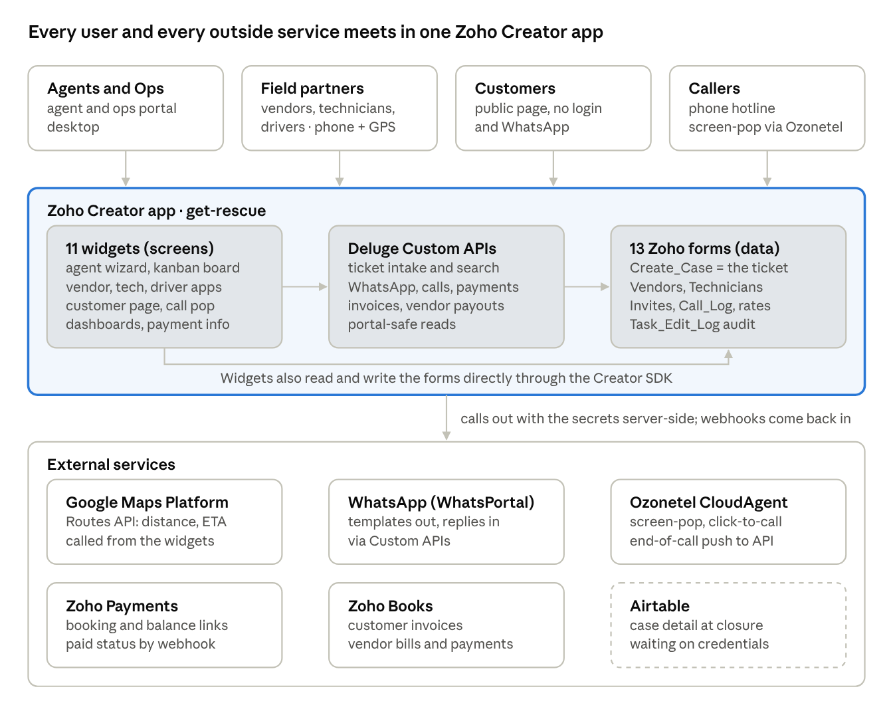
new architecture · 4 user groups, 3 Creator layers, 6 external services
Users reach the app through Creator portals or a public page. Any call that needs a secret — WhatsApp, Ozonetel, Zoho Payments, Zoho Books — goes through a Deluge Custom API on the server, and the replies (payment confirmations, inbound WhatsApp, end-of-call records) come back as webhooks into the same APIs. Google Maps is the one service the screens call directly. The dashed Airtable box is built but not yet connected.

Application components
The app is three layers: 13 Zoho forms hold the data, 11 active widgets are the screens, and Deluge Custom APIs do everything a screen must not do in the browser — calls to Zoho Books, Payments, WhatsApp and Ozonetel, and reads a portal user is not allowed to make.

Widgets (screens)
Widget | Used by | What it does
getRescueTicket | Agents, Operations Managers | Main agent app: dashboard, 9-stage ticket wizard, final closure, Vendor Accounting, Accounts Payable, GST export, ops map, call linking
Ticket Kanban | Operations | Status board over the same tickets, reusing the agent wizard
vendorTicket | Vendors | Vendor's jobs: accept or reject, reach, WIP, payment; fleet vendors hand jobs to their technicians
technicianTicket | Technicians | RSR field flow: accept, reach, work, payment, online toggle
driverTicket | Tow drivers | TOW field flow: accept, reach, loading, reached drop, unloading, payment
customerPage | Customers (no login) | Pay booking or remaining fee, share live location, give feedback
inboundCallPop | Agents | Ozonetel screen-pop listing the caller's tickets
callCenter | Agents | Ozonetel call panel on the dashboard; creates the call-log row
agentPerformance | Agents | Own stats: created, completed, cancelled, revenue, time to assign
vendorPerformance | Vendors | Own stats: rejections, completions, inside-ETA %, feedback ≥ 9 %
vendorPaymentInfo | Vendors | Own payment statement: Payment View and GST View by transaction
Retired and not deployed: serviceRequest (replaced by the website-form workflow) and toggleGetRescue (toggle now inside each field app).

Server logic (Deluge)
Area | Custom APIs and workflows
Ticket intake | createTicket (WhatsApp and API, also links the call), CreateServiceTicket workflow (website form), searchTickets
Telephony | recordRingingCall, getCallbackStatus, getVoiceCallbackDetails, getInboundCallerInfo, cleanCallLogUcids
Messaging | sendWhatsAppMessage, whatsappWebhook
Payments and invoicing | generateZohoPaymentLink, paymentWebhook, onDemandInvoicing, fetchInvoicePdf
Vendor accounting | recordVendorPayment (Zoho Books bill and payment), getVendorPayments
Portal-safe reads | getVendorTickets, getTaskRejections, getVehicleNames, checkOperationsManagerPermission
Customer page | getCustomerTicketInfo, submitCustomerLocation, submitCustomerFeedback

Data (Zoho forms)
Form | Holds
Create_Case | The ticket — one record per breakdown, carrying every stage from intake to vendor payout
Vendors | Vendor master: contact, type (Individual or Fleet), base locations, day and night rate card, GST number
Technicians | Technicians and drivers, their fleet vendor and live location
Invites | Each vendor or technician offered a ticket, and their answer
Task_Rejections | Every rejection with its reason
Client | Contracted clients and ON DEMAND
Rate_Master | Customer pricing rules
Vehicle_Master, Vehicle_Issue | Vehicle models and the issues per vehicle category
Call_Log | Every call, linked to its ticket
Task_Edit_Log | Field-level audit trail of agent edits
On_Demand_Invoicing | Invoice records for ON DEMAND customers
Agent | Agents and their user type (Operations Manager gate)

End-to-end flow
One Create_Case record carries a breakdown through 11 steps and four roles, from the first call to the vendor's payout, and its Status tells every app where to resume it.
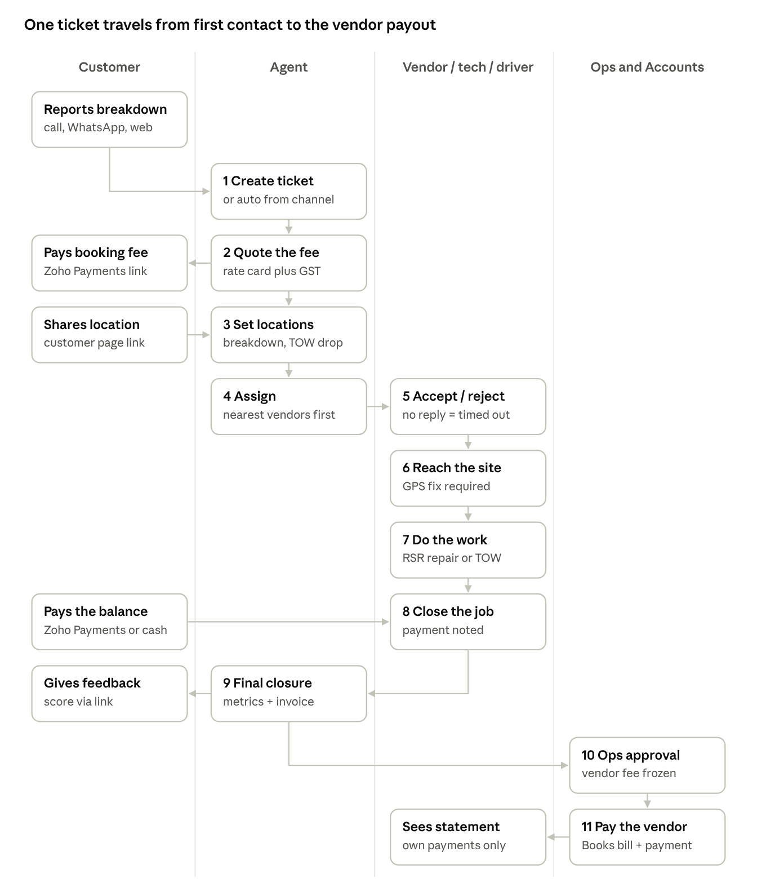
ticket lifecycle · 4 roles, 11 steps
The ticket moves down the page and changes hands at each crossing arrow; the customer's three touchpoints — paying, sharing location, giving feedback — all run through links on WhatsApp.
Before step 1 — the report. A call raises an Ozonetel screen-pop with the caller's past tickets; WhatsApp and the website form create the ticket automatically. A channel-created ticket stays NEW until an agent opens it.
- Create ticket. The agent records customer, vehicle, issue, client and time of service → SERVICE FEE QUOTE.
- Quote the fee. The rate card prices the job, GST is split out, and a booking-fee link goes out on WhatsApp → BOOKING FEE PENDING.
- Set locations. The customer shares their location from the customer page, or the agent sets it; TOW also needs a drop point → LOCATION PENDING, then READY FOR ASSIGNMENT (SCHEDULED for a later time).
- Assign. Vendors are ranked by road distance from their nearest base location and invited → RSP IRA (INVITE RESPONSE AWAITED).
- Accept or reject. The vendor, technician or driver accepts → RSP ON THE WAY, or rejects with a reason → RSP REJECT and the agent re-assigns. A fleet vendor can hand the job to one of its technicians.
- Reach the site. Recorded only with a GPS fix → WORK IN PROGRESS for RSR, LOADING for TOW.
- Do the work. RSR repairs on site; TOW loads, drives → TO DROP LOCATION, then UNLOADING. Either ends at REMAINING FEE DUE.
- Close the job. The balance is paid by link or cash → RSP CLOSED.
- Final closure. The agent closes the case: distances and ETA metrics are computed, an invoice is raised in Zoho Books for ON DEMAND customers, the feedback link is sent, and the outcome is set (Completed, Cancelled, Not Converted) → CLOSED.
- Ops approval. Operations checks and approves the vendor fee, which is then frozen on the case → settlement Payable.
- Pay the vendor. Accounts records the payment with TDS and GST, creating a bill and payment in Zoho Books → Paid; the vendor sees it in Vendor Payment Info.
Exits along the way: the field partner cancels → RSP CANCELLED; the customer refuses the work → CX REJECT.

User roles and permissions
Seven roles use the system; each logs into its own Zoho portal profile, sees only its own app, and is granted only the forms and reports that app touches. Customers never log in at all.
Role | App | What they do | Zoho access
Agent | getRescueTicket, callCenter, inboundCallPop, agentPerformance | Create and drive tickets, quote, dispatch, close, link calls | Add: Create_Case, Invites, Call_Log, Task_Edit_Log · View + Edit: Agent_Ticket_Report, Call_Log_Report · View: vehicle, issue, vendor, technician, client, rate and invite reports, Task_Edit_Log_Report
Operations Manager | getRescueTicket with extra screens | Everything an agent does, plus Ops Map, Vendor Accounting approval, Accounts Payable, GST export | Agent access plus View on Agent_Report, which marks who is an Operations Manager
Accounts | Accounts Payable inside getRescueTicket | Record vendor payments and GST remittances into Zoho Books | Same gate as Operations Manager today — To be supplied whether Accounts needs a separate role
Vendor | vendorTicket, vendorPerformance, vendorPaymentInfo | Accept or reject jobs, do the work or hand it to a fleet technician, see own stats and payments | Add: Task_Rejections, Invites · View + Edit: Agent_Ticket_Report, Vendors_Report, Invites_Report · own payments only through getVendorPayments
Technician | technicianTicket | RSR jobs: accept, reach, repair, collect payment | Add: Task_Rejections · View + Edit: Agent_Ticket_Report, Technicians_Report, Invites_Report
Driver | driverTicket | TOW jobs: accept, reach, load, drop, unload, collect payment | Same as Technician
Customer | customerPage (public link, no login) | Pay, share location, give feedback | No form or report access — only three Custom APIs, each limited to that one ticket
Controls beyond role access
- One editor at a time — a ticket open in the agent app is locked to that agent, with a heartbeat; others see who holds it.
- Location required — the vendor, technician and driver apps refuse every job step until the phone shares its GPS.
- Audit trail — every field an agent changes is written to Task_Edit_Log, which agents can view but not edit or delete.
- Closed means closed — a closed ticket reopens read-only.
- Server-side identity for money — a vendor's payment statement is filtered on the server from their login, so no vendor can request another's data.

Integrations
Five external systems are live and one is waiting on credentials; every call that carries a secret runs in Deluge on the server, never in the browser.
System | Used for | How it is called | Status
Google Maps Platform | Distance and ETA at acceptance and closure; nearest-vendor ranking; round-trip distance for vendor payout | Routes API computeRoutes from the widgets — traffic-aware only for the two ETAs, traffic-unaware for distances; falls back to Distance Matrix, then straight-line | Built; the Routes API must be enabled on the client's Google project
WhatsApp (WhatsPortal) | Payment links, location requests, status updates, feedback links to customers; inbound messages | sendWhatsAppMessage (approved templates with button parameters); whatsappWebhook receives replies | Live
Ozonetel CloudAgent | Inbound screen-pop, click-to-call, call history on the ticket | Screen-pop opens the agent dashboard with the call ids; getVoiceCallbackDetails dials; getCallbackStatus receives the end-of-call record; createTicket links a call from the Ozonetel pop | Live; call-to-ticket linking keyed on Monitor UCID from 22 Oct 2026
Zoho Payments | Booking-fee and remaining-fee payment links, with GST breakdown | generateZohoPaymentLink; paymentWebhook marks the ticket paid | Live
Zoho Books | Customer invoice for ON DEMAND tickets; vendor bill and payment with TDS and GST | onDemandInvoicing, fetchInvoicePdf, recordVendorPayment | Live
Airtable | Full case detail pushed at closure | Stub in place (sendToAirtable), plus two reference fields on the ticket | Waiting on the client's Airtable API key and base/table ID

9–11. Total cost of ownership
No cost figures exist in the delivered material, so this section is the template the team fills in: the same cost lines, the same 5-year period and the same currency (₹ INR) for old and new, so the reduction is comparable across case studies.
Cost line (₹, per year) | Old platform | New platform | What to include
Platform licences |  |  | Old system licences; Zoho Creator, Zoho Books and Zoho Payments plans and user seats
Add-ons and usage |  |  | Google Maps calls, WhatsPortal messages, Ozonetel telephony, payment-gateway fees
Internal team |  |  | Admin and support staff time spent running the system
Hosting and infrastructure |  |  | Servers, storage, backups — nil for Zoho-hosted
Partners |  |  | Implementation, support and change-request contracts
Other |  |  | Anything else, named
Annual running cost |  |  | Sum of the lines above
One-time build cost | — |  | Delivery effort for this build, licences bought up front, data migration
The reduced TCO is worked out over the same 5 years for both sides, with the new side carrying its one-time build cost:
\text{New TCO}_{5y} = \text{Build} + 5 \times \text{Annual}_{new} \qquad \text{Old TCO}_{5y} = 5 \times \text{Annual}_{old}

\text{Saving} = \text{Old TCO}_{5y} - \text{New TCO}_{5y} \qquad \text{Saving \%} = \frac{\text{Saving}}{\text{Old TCO}_{5y}} \times 100 \qquad \text{Payback (months)} = \frac{\text{Build}}{\text{Annual}_{old} - \text{Annual}_{new}} \times 12
What is known so far
- Build effort estimate: an August 2026 estimate for the accounting and integration workstream puts it at 456–655 hours across 88 tasks, excluding 4 optional add-ons (Accounting_Integration_Estimate_Detailed.csv). It is an estimate, not actual hours — the team should supply the hours actually spent and the rate.
- One cost lever designed in: Google's Routes API bills per request where the Distance Matrix billed per origin–destination pair, and traffic-aware pricing is used only for the two ETA figures. A 3-leg round trip moved from 9 billed elements to 3 requests.
- Source of the figures: to be named by the team (finance records, invoices or contracts) next to each line.

12–14. Delivery and results
The build ran from 30 Jul to 22 Oct 2026 — about 12 weeks so far — and went into daily use within the first weeks, with later features added in client feedback rounds rather than in one cut-over.
12. Timeline, team and approach
Item | Answer | Source
Start and latest release | 30 Jul 2026 → 22 Oct 2026, still in progress | Sourced — git history
Releases | 44 commits: 1 in July, 15 in August, 11 in September, 17 in October | Sourced — git history
Developers committing | 2 | Sourced — git history
Full team (PM, BA, QA, client SPOC) | To be supplied | —
Migration approach | Phased: live from August, extended in feedback rounds; data migration from the old system — To be supplied | Sourced in part — live bug reports from 4 Aug 2026
13. Main challenges and how we solved them
Challenge | Solution
Vendor, technician and driver portals are refused key reports by Zoho | Server-side Custom APIs read on their behalf and return only that user's rows
Ozonetel shows its screen-pop in a frame Zoho pages refuse to load in | A public screen-pop page read through key-protected APIs, and a pop that opens the agent dashboard directly
One phone call carries two ids, so the call log and the ticket did not meet | The call row is created at pop time keyed on Ozonetel's Monitor UCID, and linked when the agent creates or links the ticket
ETAs differed from what Google Maps showed | Moved to the Routes API with live traffic for the two ETA figures
Distances used one static vendor location | Every vendor base location is tried and the nearest to the breakdown is used
Field steps could be faked away from the site | Every job step requires a GPS fix first
Two agents could edit the same ticket | A ticket lock with a heartbeat and a visible holder
Vendor payouts had to match what Operations approved | Approved figures are frozen on the case; TDS, GST and a separate GST remittance are recorded, and a Zoho Books bill and payment are created
14. Other results — To be supplied. None of these are measured inside the app. Where each can come from:
Result | Where to get it
Conversion (calls or enquiries to paid jobs) | Agent Performance tracks created, completed, cancelled and not-converted tickets
Reached-inside-ETA rate, customer feedback | Vendor Performance computes both per vendor
Uptime during peaks | Zoho Creator status history for the period
WhatsApp deliverability | WhatsPortal delivery reports
Page speed, SEO | Not applicable to the internal apps; the website form lives outside this build

Still needed to finish the case study
Twelve facts are missing, all business data that only the client or the delivery team holds; the solution, architecture, flow and roles sections are complete.
From the client
- ☐ Size: tickets per month, number of agents, vendors, technicians and drivers, annual revenue
- ☐ The previous platform's name, and the business functions it covered
- ☐ Pain points with the previous setup, in their own words
- ☐ Whether Airtable was the system of record or only a reporting copy
- ☐ Old architecture: tools in use and how they connected, with any diagram
- ☐ Old annual cost per TCO line, and the source of each figure
- ☐ Before and after figures for conversion, reached-inside-ETA rate and customer feedback, over the same period length
From the delivery team
- ☐ Actual hours spent and the blended rate, for the one-time build cost
- ☐ New annual running cost per TCO line: Zoho plans and seats, Google Maps, WhatsPortal, Ozonetel, payment-gateway fees, support
- ☐ Full team composition and roles
- ☐ How existing data was migrated, if at all
- ☐ Whether Accounts should become its own role, separate from Operations Manager

