Project UML and Flow Diagrams
Healthcare Management System

01 High Level System Architecture
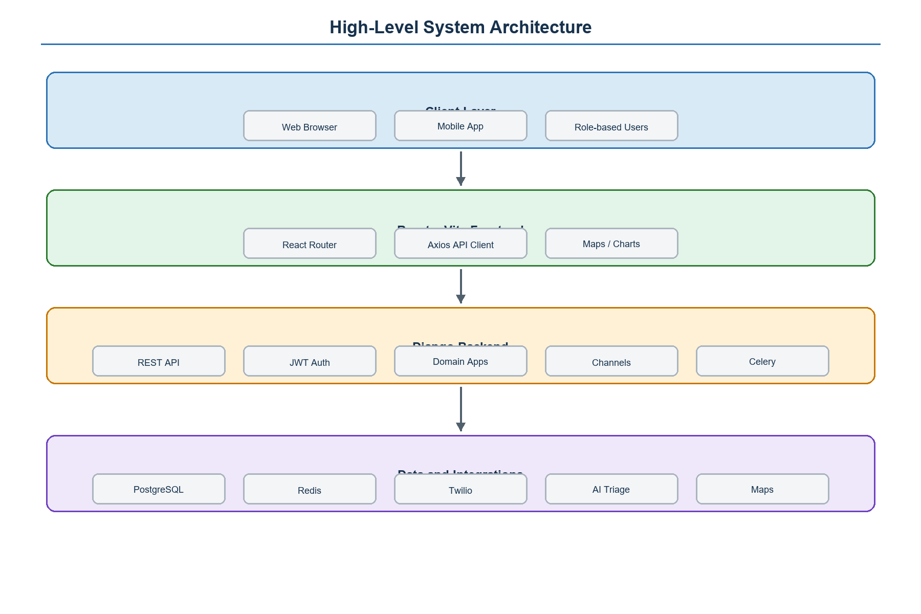

02 Use Case Diagram
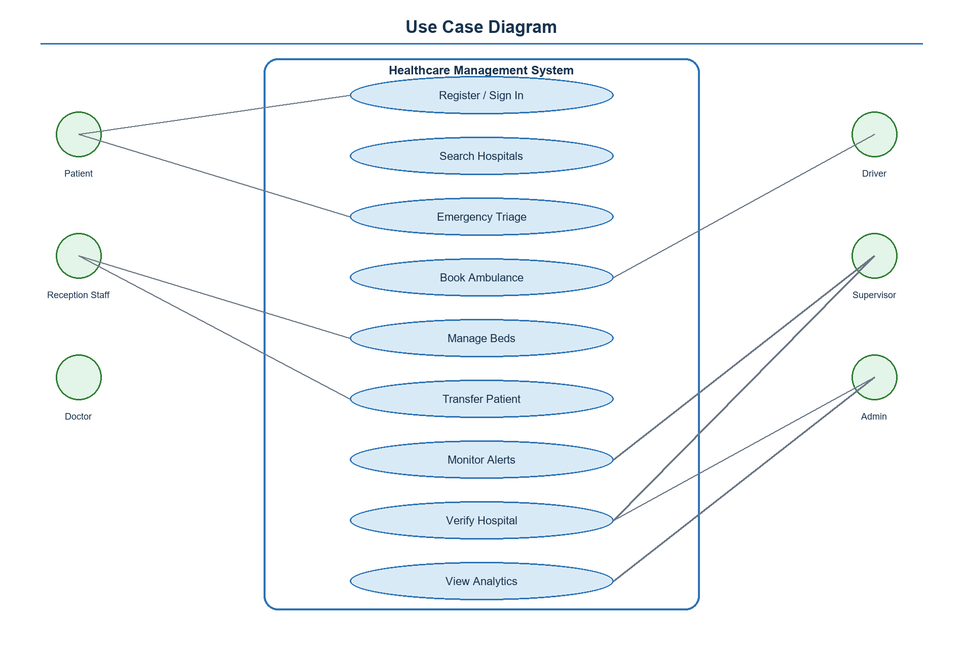

03 Main Database Er Diagram
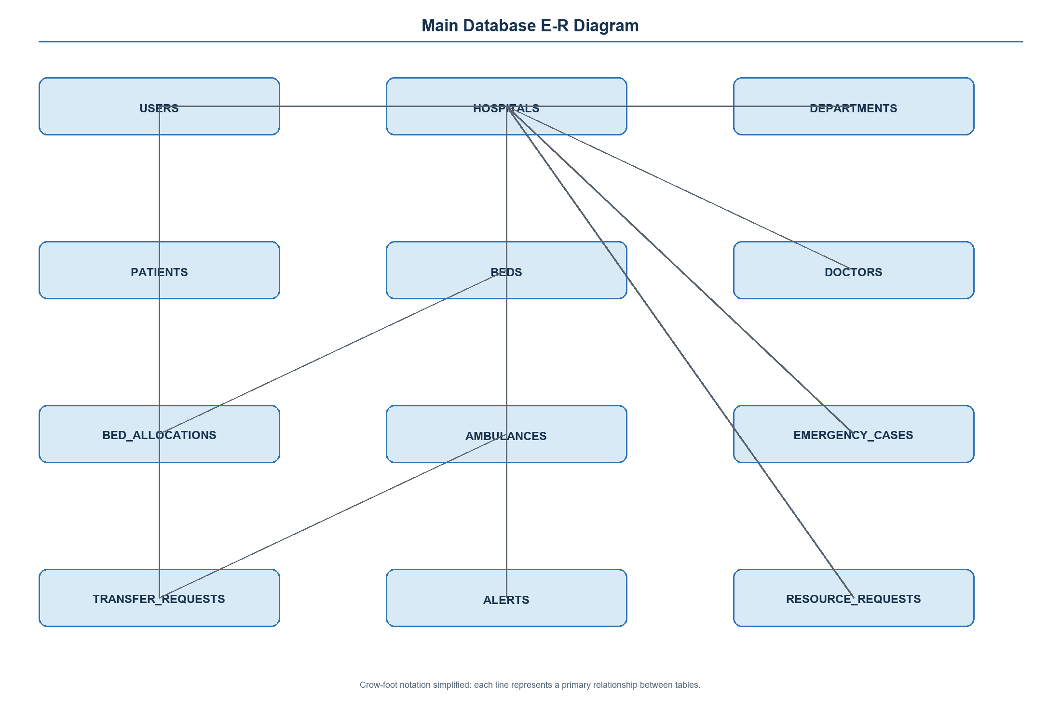

04 Uml Class Diagram Core Domain
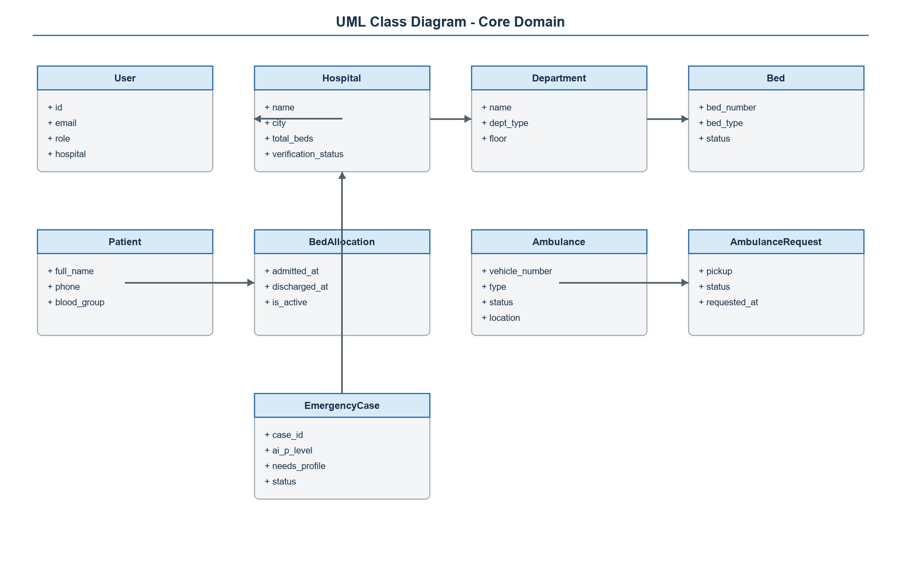

05 Authentication Role Flow
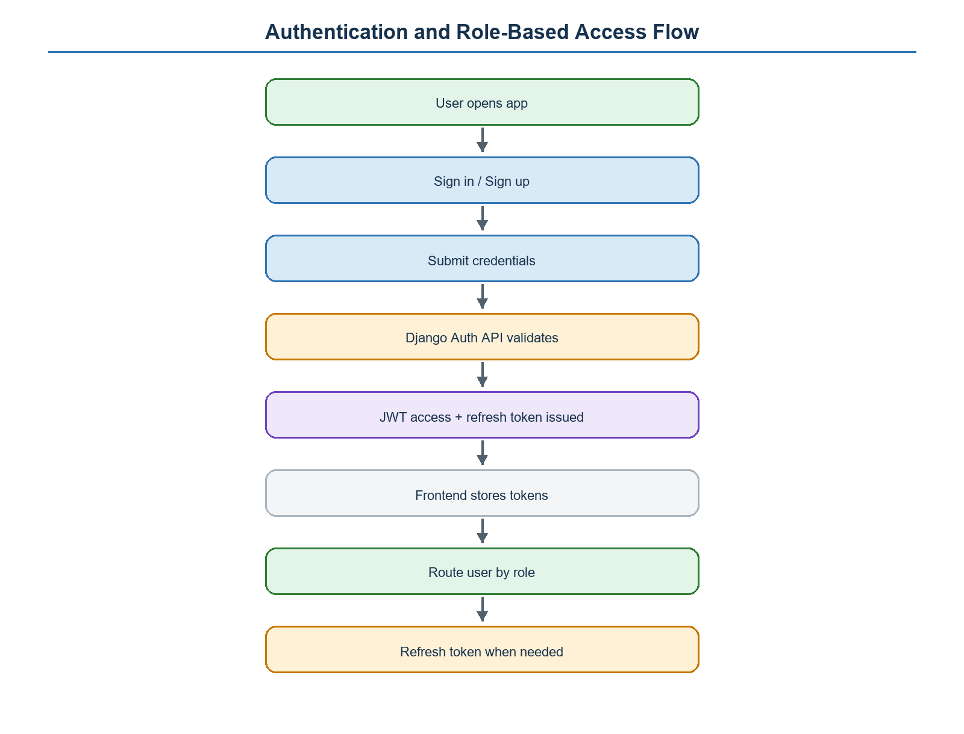

06 Emergency Ai Triage Flow
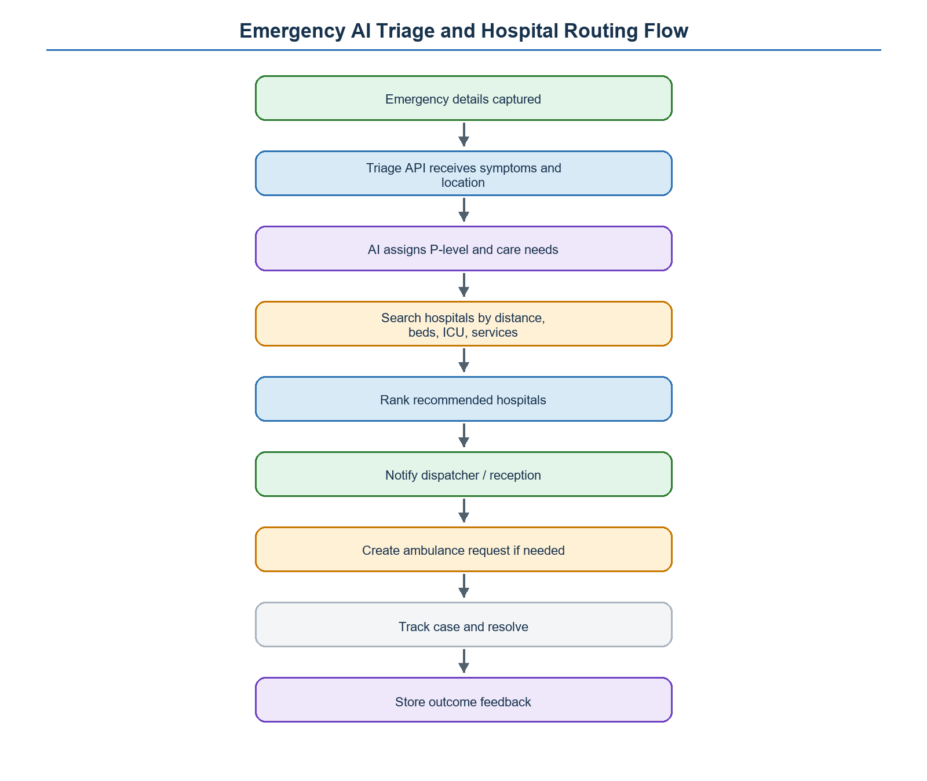

07 Ambulance Booking Sequence
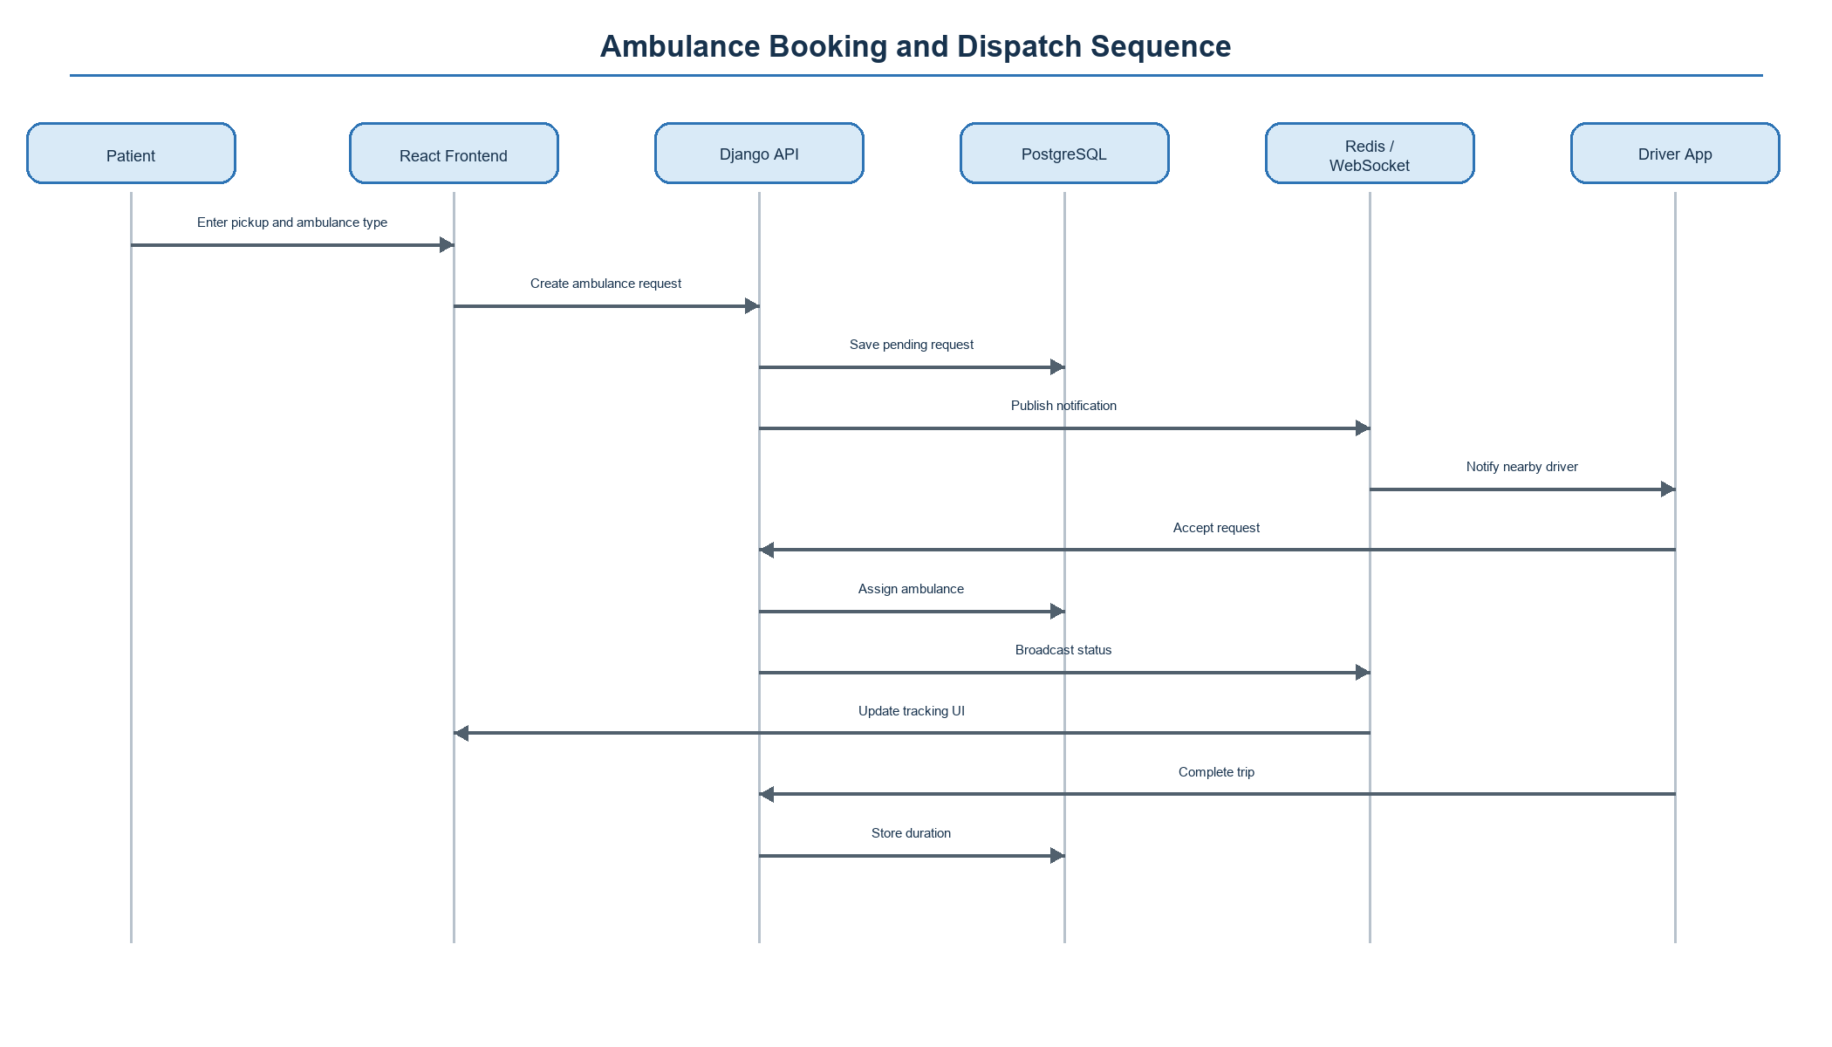

08 Bed Admission Discharge Flow
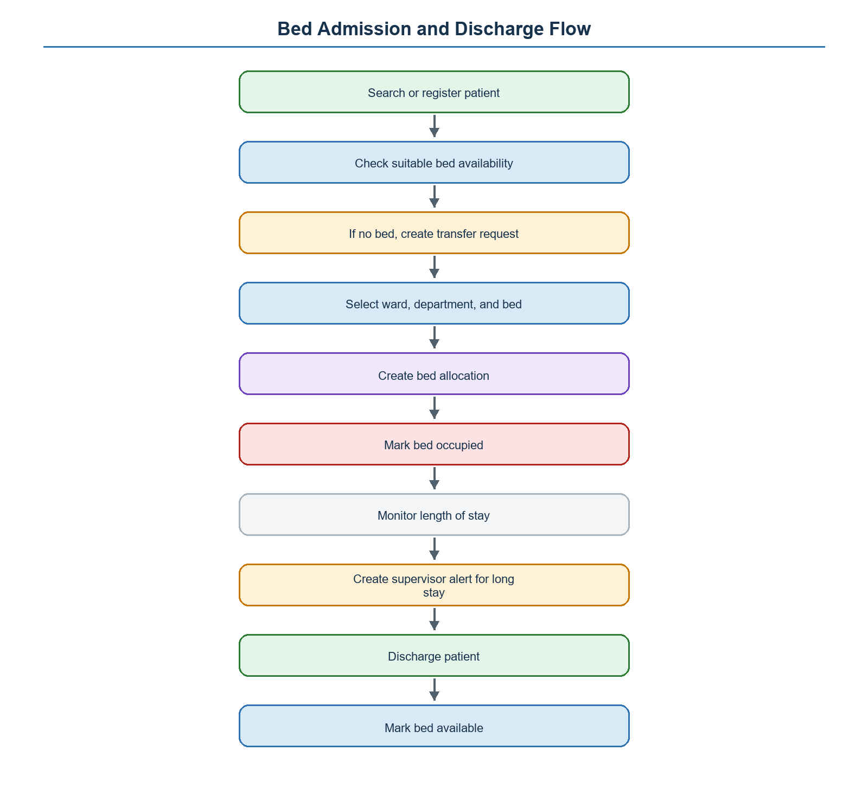

09 Patient Transfer Request Flow
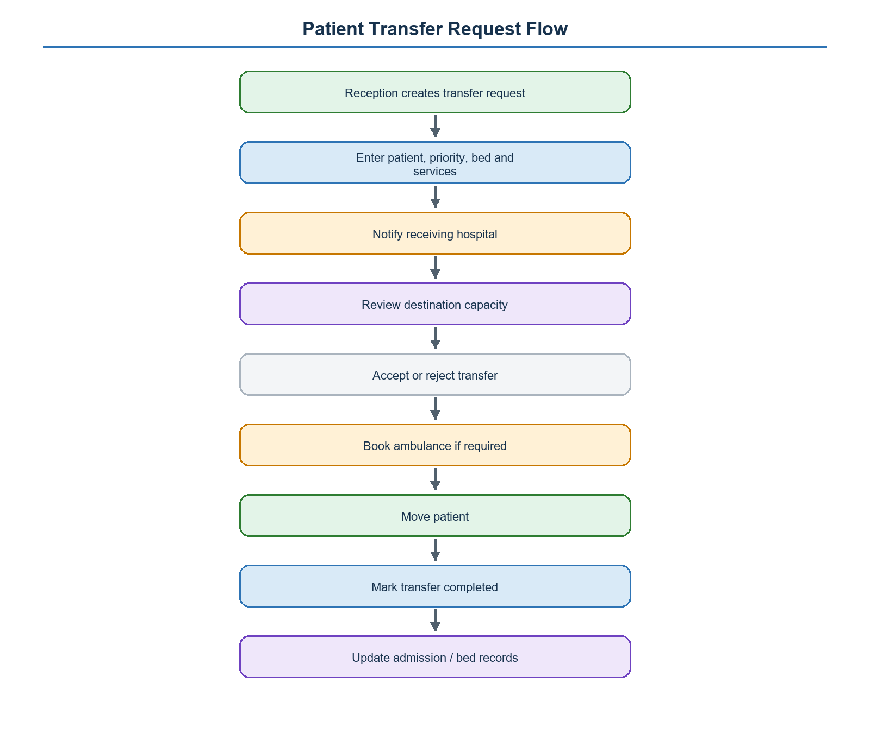

10 Supervisor Monitoring Flow
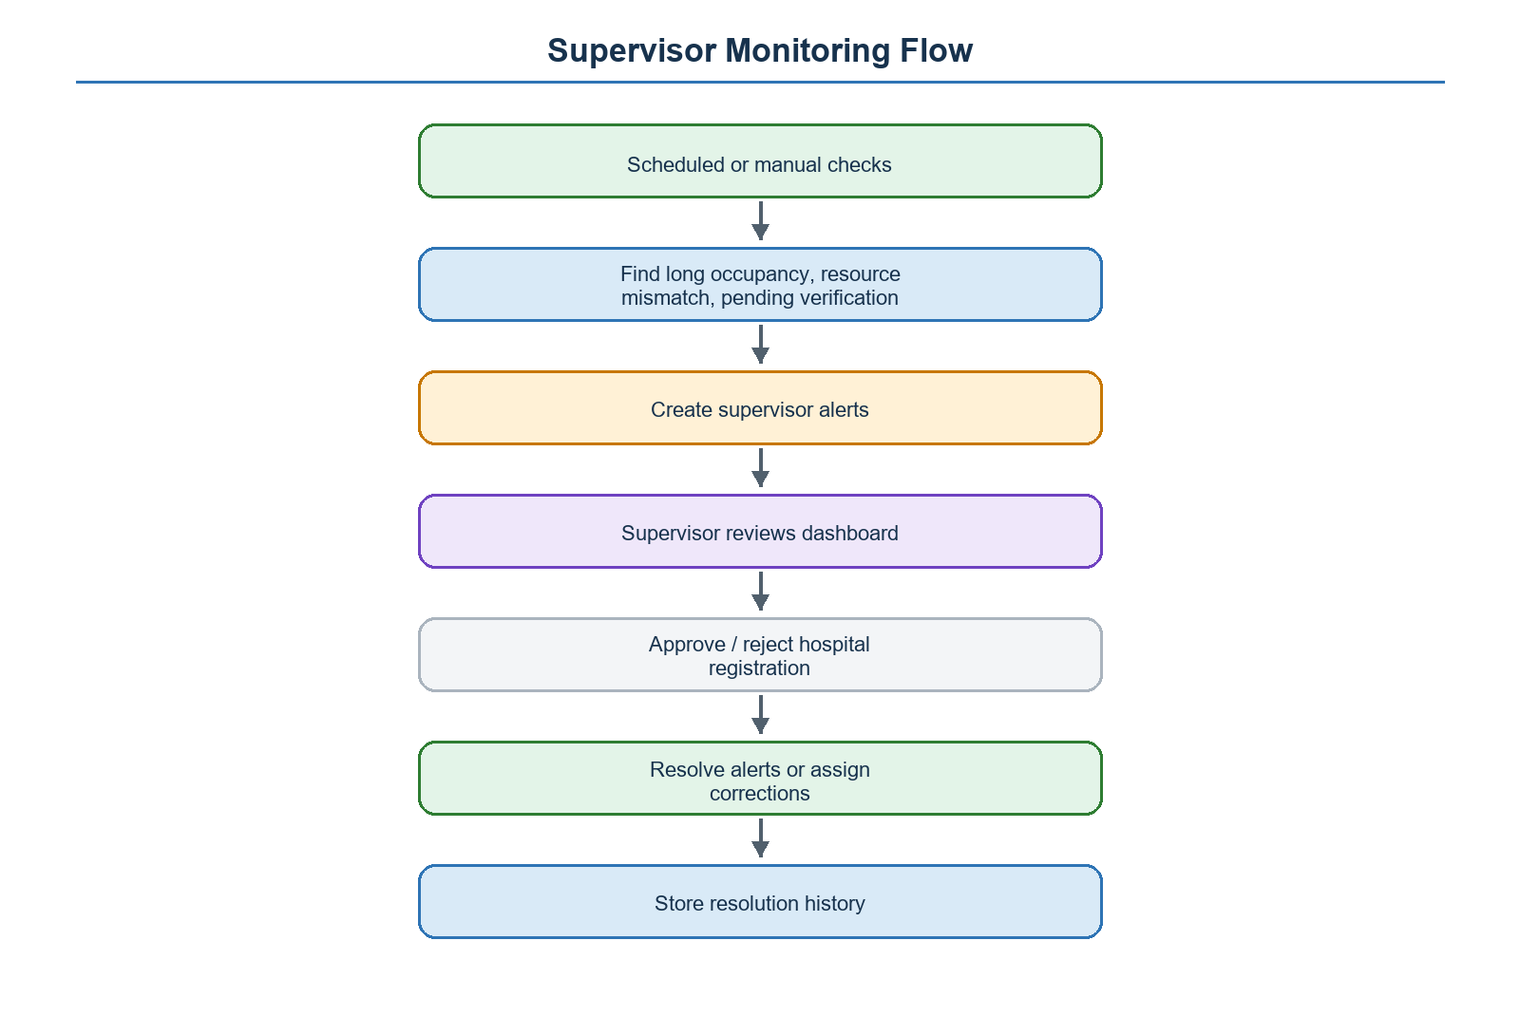

11 Realtime Notification Flow
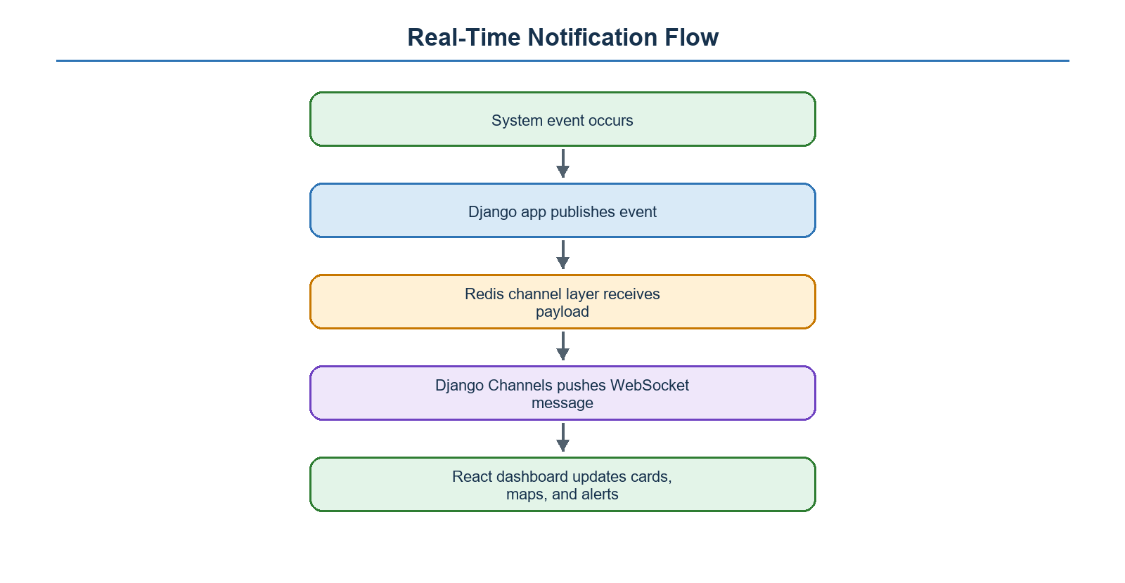

12 Deployment Diagram
