**FLAY:**

Flay analyzes code for structural similarities. Differences in literal values, variable, class, method names, whitespace, programming style, braces v/s do/end, etc., are all ignored.

It basically compares the files and looks for similar resources and checks if the code within is similar in the files being compared or not. If it finds any similar code, it would report the file names and the lines at which the code matches.

I installed the gem “flay” via the below command

sudo gem install -y flay

I have created two cookbooks and have created multiple recipes in each of them. I have placed the same code in a recipe each in both cookbooks.

To compare the recipes for similar code , use the command

flay -v --diff <source_recipes> <destination_recipes>

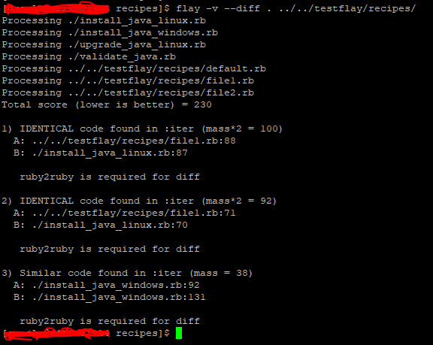

**Below is the content that is identical in both files:**

**####################################################################################**

**# Directory creation. #**

**# Add the required directories to the array. #**

**# Ownership and permissions of files and directories are changed as per reuirement.#**

**####################################################################################**

**directories "Create JDK directory" do**

**owner user**

**group user_group**

**mode mode**

**dir_paths [user_home, java_home, temp_location]**

**action :nothing**

**end.run_action(:create)**

**####################################################################################**

**# Download the required software. #**

**# ##################################################################################**

**remote_file "#{temp_location}/#{software}" do**

**source "#{software_location}"**

**owner user**

**group user_group**

**mode mode**

**show_progress true**

**action :create**

**end**

**logger 'Logging' do**

**message "REMOTE FILE: #{software} downloaded"**

**end**

**####################################################################################**

**# Extract the JDK software and Instal l #**

**####################################################################################**

**bash 'Extract software' do**

**user user**

**group user_group**

**code <<-EOH**

**cd "#{user_home}"**

**mkdir java_temp**

**cd java_temp**

**tar -xvf "#{temp_location}/#{software}"**

**cd jdk\***

**mv * "#{java_home}/"**

**rm -rf "#{user_home}"/java_temp**

**EOH**

**end**

**logger 'Logging' do**

**message 'BASH: extract software executed and Java Installed'**

**end**

**Note: The above gem works fine when the code within the resources under two recipes is identical. However, if the logic differs and the goal is to achieve the same installation or configuration etc., then this won ‘t be of any help.**

**When I tried the same by making a small change in one recipe, it did not work.**