1. Install Docker

2. Install Minikube

root@osboxes:~# mkdir -p /appdata/content

root@osboxes:~# sudo sh -c "echo 'Kubernetes Storage Volume' > /appdata/content/index.html"

**Create Persistent Volume:**

root@osboxes:~# cat pv-volume.yaml

apiVersion: v1

kind: PersistentVolume

metadata:

name: task-pv-volume

labels:

type: local

spec:

storageClassName: manual

capacity:

storage: 10Gi

accessModes:

- ReadWriteOnce

hostPath:

path: "/appdata/content"

root@osboxes:~#

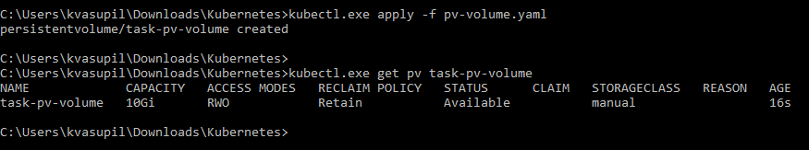

**4. Create a Persistent Volume Claim**

**vi pv-claim.yaml**

apiVersion: v1

kind: PersistentVolumeClaim

metadata:

name: task-pv-claim

spec:

storageClassName: manual

accessModes:

- ReadWriteOnce

resources:

requests:

storage: 3Gi

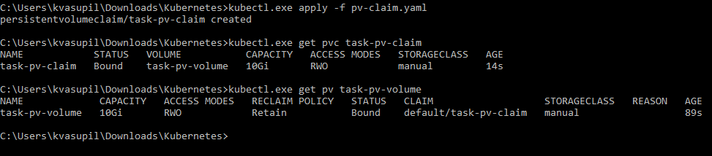

**5. Create a Pod**



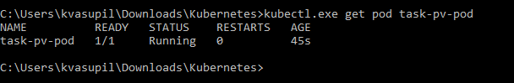 

apt-get update

apt-get install curl

curl localhost

**Ingress Installation**

