Author: Rajveer patel(251FA06023)
Affiliation: Vignan University
BATCH-04

Abstract
This document presents a novel approach to compute the day-to-day changes in water levels with a specific range. By subtracting the previous one, we apply a change in the water levels. The results reveal the pattern of changes. This project not only enhances understanding of number theory but also serves as a practical application of algorithm design.

1.Introduction
The study of an array provides a convenient structure for representing data. An array is a fixed-sized sequenced collection of elements of the same data type. It is simply a grouping of like-type data. It is classified as one of the data structures in c. Other data structures include structures, lists, queues and trees. The elements of the array are stored in consecutive memory locations and are referenced by an index (also known as the subscript). The subscript is an ordinal number which is used to indentify an element of the array. Some examples where the concepts of an array can be used.
The motivation for this study stems from the intersection of computational techniques and mathematical theory

By employing programming techniques to explore number properties, we can uncover hidden patterns.

2. Methodology
The algorithm comprises several key steps, ensuring clarity and efficiency in calculating changes.
2.1 read no of days
For each day the level of water will be changed. It may be one/two day same but not all days will same because it is a magical rain. This is achieved using a simple “scanf” function where specify the “int” data type.
2.2 calculate changes
To determine the change, the algorithm calculate changes by subtracting final data from initial data. The value of initial and final will be change with result.

2.3 flowchart
A flowchart outlining the steps of the algorithm enhances understanding:
Mathematica:
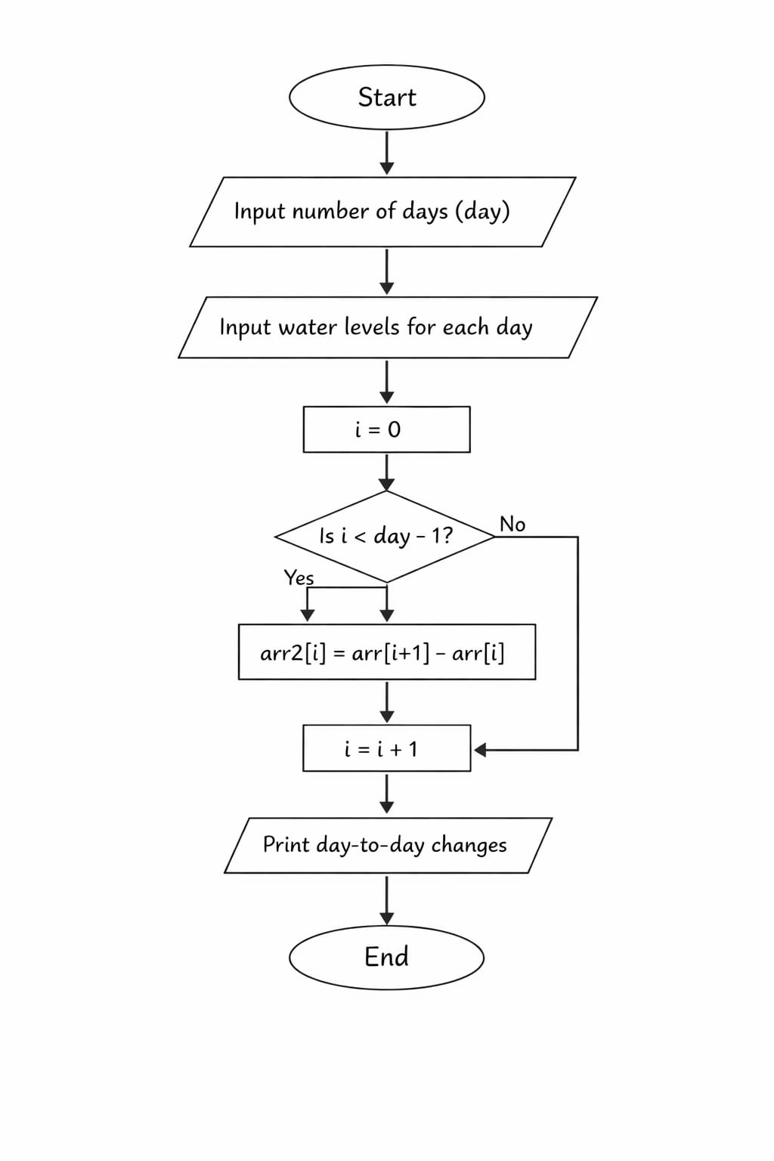

3. implementation
The implementation is executed in C. To access all the elements of the array, must use a loop. There is no single statement that can do the work. Below is the complete code:
C
Copy code
#include<stdio.h>
int main()
{
int day,i;
printf("Enter the number of days :");
scanf("%d", &day);
int arr[day];
printf("Enter the water level of each days :\n");
for(i=0;i<day;i++)
{
scanf("%d", &arr[i]);
}
day = day - 1;
int arr2[day];
for(i=0;i<day;i++)
{
//change = final - initial
arr2[i] = arr[i+1] - arr[i];
}
printf("The day-to-day changes in water level ");
for(i=0;i<day;i++)
{
printf("%d,", arr2[i]);
}
return 0;
}

4. conclusion
This project successfully computes the day-to-day changes in water levels through subtraction, demonstrating an effective algorithmic approach to a classic number theory problem.
Future work could enhance this analysis by use array to represent not only simple lists of values but also tables of data in two, three or more dimensions. The insights gained from this study may inspire further research.

5.result
After execution the program, we find the difference of element of an array.

Sample output:
C
Copy code
Enter the number of days :7
Enter the water level of each days :
21
20
19
18
22
25
23
The day-to-day changes in water level -1,-1,-1,4,3,-2,
In output there is a negative number which indicates that the rain is raining is less than previous day.

6. references
1. E. Balagurusamy programming in ansi c. Publication-mc graw hill. 6th addition,2013.
2. yashwant kanetkar. Let us C. Addition-11th ,2012.
3. reema thareja. Introduction to C programming. Addition-2nd ,2015

