INDEX

S/N | AIM
1 | To study and implement various DDL commands to create and modify a table in MySQL.
2 | To study and implement various DML commands to insert, retrieve, update, and delete data.
3 | To study and implement DCL commands to control access and permissions in MySQL.
4 | To implement aggregate functions MIN(), MAX(), SUM(), AVG(), and COUNT() on a table in MySQL.
5 | To perform data retrieval using conditions (greater than) and sorting techniques using ASC and DESC in MySQL.
6 | To implement NATURAL JOIN and EQUI JOIN on tables in MySQL.
7 | To implement LEFT OUTER JOIN and RIGHT OUTER JOIN on tables in MySQL.
8 | To implement SELF JOIN on a table in MySQL.

Q1 . To study and implement various DDL commands to create and modify a table in MySQL
Experiment 1
Aim
To study and implement various DDL (Data Definition Language) commands to create and modify a table in MySQL.
Theory
DDL (Data Definition Language) commands are used to define, manage, and modify the structure of database objects such as tables, databases, indexes, etc. These commands are essential for designing the database schema.
DDL commands do not deal with the data inside the table, but instead focus on the structure of the database.
Common DDL Commands
- CREATE → Used to create a new database or table
- ALTER → Used to modify the structure of an existing table
- DROP → Used to delete a table or database permanently
- TRUNCATE → Used to remove all records from a table quickly
Explanation of Queries
- Database college is created and selected.
- A table student is created with fields: id, name, age, and course.
- DESC command displays the table structure.
- ALTER TABLE ADD adds new column marks.
- ALTER TABLE MODIFY increases the size of the name column.
Result
The DDL commands were successfully executed. The table was created and modified using different DDL operations in MySQL.

SQL Queries (Implementation)
-- Create Database
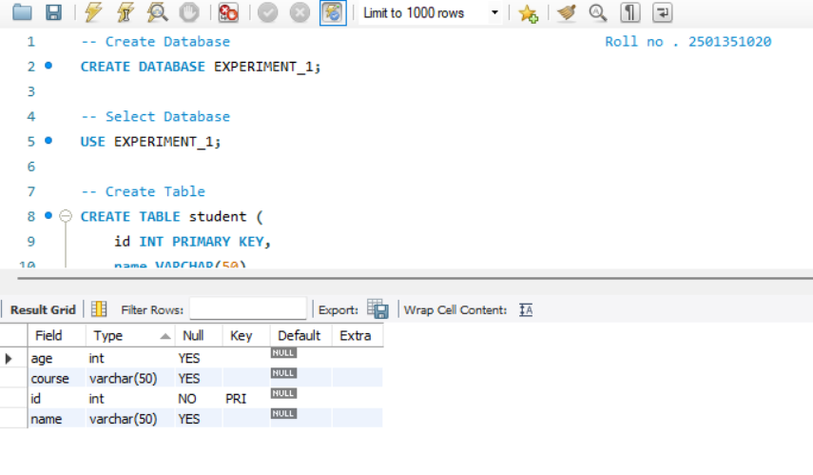
CREATE DATABASE EXPERIMENT_1;
-- Select Database
USE EXPERIMENT_1;
-- Create Table
CREATE TABLE student (
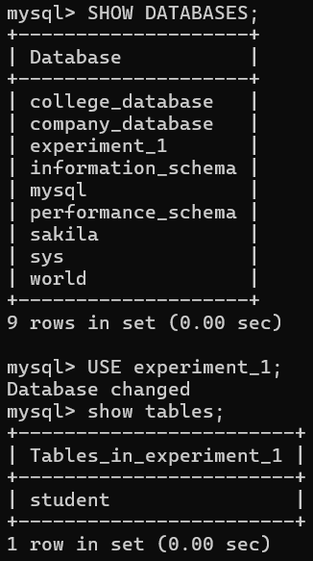
id INT PRIMARY KEY,
name VARCHAR(50),
age INT,
course VARCHAR(50)
);
-- Display Table Structure
DESC student;
-- Add New Column
ALTER TABLE student
ADD marks INT;
-- Modify Existing Column
ALTER TABLE student
MODIFY name VARCHAR(100);
Conclusion
DDL commands play a vital role in database design. They help in creating and modifying the structure of database objects efficiently.
Q2. To study and implement various DML commands to insert, . retrieve, update, and delete data.
Experiment 2
Aim
To study and implement various DML (Data Manipulation Language) commands to insert, retrieve, update, and delete data in MySQL.
Theory
DML (Data Manipulation Language) commands are used to manage and manipulate data stored in database tables. These commands help in inserting new records, retrieving existing data, updating records, and deleting unwanted data.
Common DML Commands
- INSERT → To add new data into a table
- SELECT → To retrieve data from a table
- UPDATE → To modify existing data
- DELETE → To remove data from a table
SQL Queries (Implementation)
-- Use Database || EXPERIMENT_2 ||
USE EXPERIMENT_1;
-- Insert Data
INSERT INTO student (id, name, age, course, marks) VALUES
(1, 'Rajveer', 20, 'BTech', 85),
(2, 'shruti', 21, 'BA', 90),
(3, 'veerraj', 19, 'B.Tech', 78), <-------------------------- DELETE THAT DATA
(4, 'Badal', 19, 'B.Tech', 78);

-- Retrieve Data
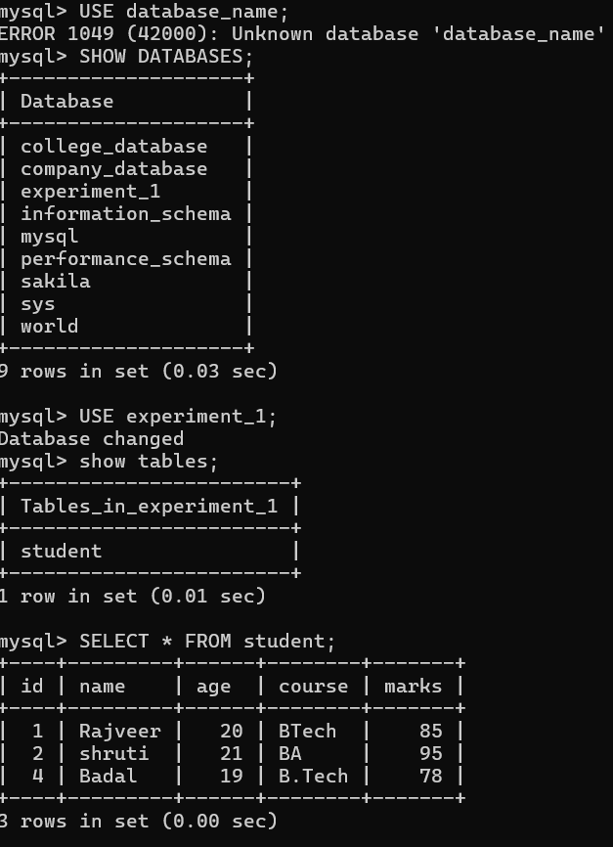
SELECT * FROM student;
-- Update Data
UPDATE student
SET marks = 95
WHERE id = 2;
-- Delete Data
DELETE FROM student
WHERE id = 3;
Explanation of Queries
- INSERT adds new records into the student table
- SELECT displays all records from the table
- UPDATE modifies marks of a specific student
- DELETE removes a record from the table
Result
The DML commands were successfully executed. Data was inserted, retrieved, updated, and deleted from the table.

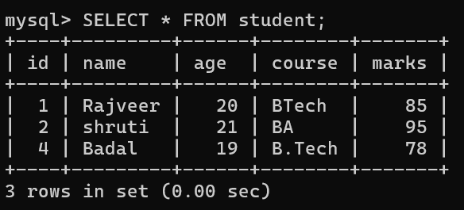

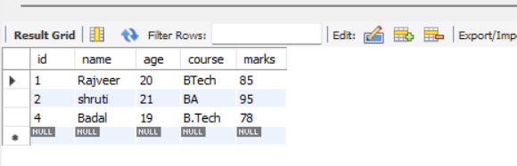
Conclusion
DML commands are used to handle data inside tables. They allow users to efficiently manage and manipulate records in a database

Q3. To study and implement DCL commands to control access and . . permissions in MySQL.
Experiment 3
Aim
To study and implement DCL (Data Control Language) commands to control access and permissions in MySQL.
Theory
DCL (Data Control Language) commands are used to control access to data stored in a database. These commands help in providing security by granting or removing user permissions on database objects like tables and databases.
DCL ensures that only authorized users can perform specific operations such as SELECT, INSERT, UPDATE, or DELETE.
Common DCL Commands
- GRANT → To give permissions to a user
- REVOKE → To remove permissions from a user
SQL Queries (Implementation)
-- || EXPERIMENT 3 |||
-- Step 1: Remove user if it already exists (to avoid error)
DROP USER IF EXISTS 'student_user'@'localhost';
-- Step 2: Create a new user with username and password
CREATE USER 'student_user'@'localhost' IDENTIFIED BY 'Rajveer123';
-- Step 3: Grant permissions (SELECT and INSERT) on EXPERIMENT_1 database
GRANT SELECT, INSERT ON EXPERIMENT_1.* TO 'student_user'@'localhost';
-- Step 4: Apply and refresh privileges
FLUSH PRIVILEGES;
-- Step 5: Revoke INSERT permission from the user
REVOKE INSERT ON EXPERIMENT_1.* FROM 'student_user'@'localhost';
-- Step 6: Check final permissions of the user (for verification)
SHOW GRANTS FOR 'student_user'@'localhost';
Explanation of Queries
- CREATE USER creates a new database user
- GRANT gives specific permissions (SELECT, INSERT)
- FLUSH PRIVILEGES updates the permission table
- REVOKE removes previously granted permissions
Result
The DCL commands were successfully executed. User access was controlled by granting and revoking permissions.
Conclusion
DCL commands are important for database security. They help in controlling user access and maintaining data safety.
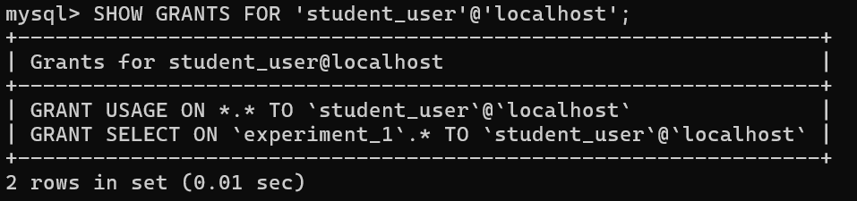


Q4. To implement aggregate functions MIN(), MAX(), SUM(), AVG(), and COUNT() on a table in MySQL.

Experiment 4
Aim
To implement aggregate functions MIN(), MAX(), SUM(), AVG(), and COUNT() on a table in MySQL.

Theory
Aggregate functions are used to perform calculations on a set of values in a table and return a single result. These functions are very useful for data analysis and summarization in databases.
They work on numeric data and help in finding minimum, maximum, total, average, and number of records.
Aggregate Functions
- MIN() → Returns the smallest value
- MAX() → Returns the largest value
- SUM() → Returns total sum of values
- AVG() → Returns average value
- COUNT() → Returns total number of records

SQL Queries (Implementation)
-- || EXPERIMENT 4 : AGGREGATE FUNCTIONS ||
-- Step 1: Use Database
USE EXPERIMENT_1;
-- Step 2: Display Table Data
SELECT * FROM student;
-- Step 3: Find Minimum Marks
SELECT MIN(marks) AS Minimum_Marks FROM student;
-- Step 4: Find Maximum Marks
SELECT MAX(marks) AS Maximum_Marks FROM student;
-- Step 5: Find Total Marks
SELECT SUM(marks) AS Total_Marks FROM student;
-- Step 6: Find Average Marks
SELECT AVG(marks) AS Average_Marks FROM student;
-- Step 7: Count Total Students
SELECT COUNT(*) AS Total_Students FROM student;
SELECT
MIN(marks) AS Minimum_Marks,
MAX(marks) AS Maximum_Marks,
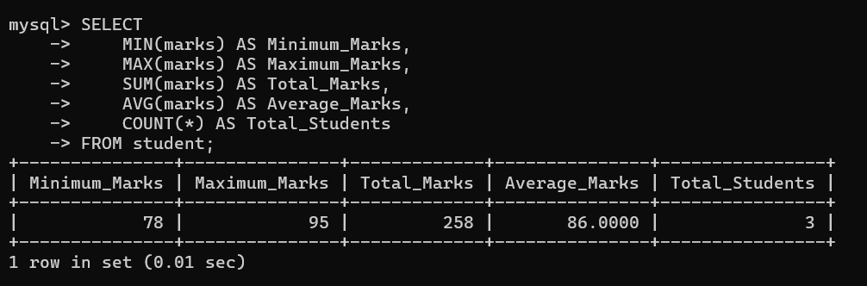
SUM(marks) AS Total_Marks,
AVG(marks) AS Average_Marks,
COUNT(*) AS Total_Students
FROM student;


Explanation
- MIN(marks) → gives lowest marks
- MAX(marks) → gives highest marks
- SUM(marks) → adds all marks
- AVG(marks) → calculates average
- COUNT(*) → counts total rows
Result
All aggregate functions were successfully executed on the student table, and the required results were obtained.
Conclusion
Aggregate functions simplify data analysis by providing summarized results from large datasets in a database.
Q5. To perform data retrieval using conditions (greater than) and . sorting techniques using ASC and DESC in MySQL.

Experiment 5
🔹 Aim
To perform data retrieval using conditions (greater than) and sorting techniques using ASC and DESC in MySQL.
Theory
Data retrieval in MySQL is done using the SELECT statement. Conditions can be applied using the WHERE clause to filter specific records. Sorting of data is done using the ORDER BY clause.
- WHERE → filters records based on conditions
- ORDER BY → sorts data
  - ASC → Ascending order (default)
  - DESC → Descending order

SQL Queries (Implementation)
-- || EXPERIMENT 5 : CONDITIONS & SORTING ||
-- Use Database
USE EXPERIMENT_1;
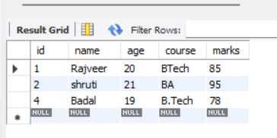
-- Display All Data
SELECT * FROM student; <-----------------------
-- Condition: Marks Greater Than 80
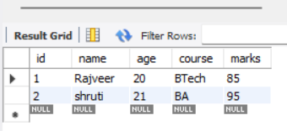
SELECT * FROM student <-----------------
WHERE marks > 80;
-- Sorting in Ascending Order
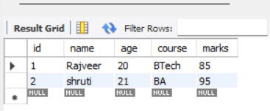
SELECT * FROM student <-----------------
ORDER BY marks ASC;
-- Sorting in Descending Order
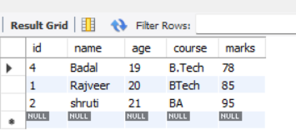
SELECT * FROM student <-----------------
ORDER BY marks DESC;
-- Condition with Descending Sorting
SELECT * FROM student
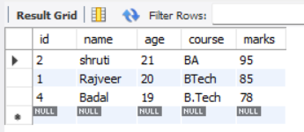
WHERE marks > 80 <-----------------
ORDER BY marks DESC;
Explanation
- WHERE marks > 80 → selects students with marks greater than 80
- ORDER BY marks ASC → sorts marks from low to high
- ORDER BY marks DESC → sorts marks from high to low
- Combined query filters + sorts results together
Result
The data was successfully retrieved using conditions and sorted using ascending and descending order.
Conclusion
The WHERE and ORDER BY clauses are essential for filtering and organizing data efficiently in MySQL.
Q6. To implement NATURAL JOIN and EQUI JOIN on tables in MySQL.

Experiment 6
Aim
To implement NATURAL JOIN and EQUI JOIN on tables in MySQL.
Theory
Joins in MySQL are used to combine data from two or more tables based on a related column.
- NATURAL JOIN → Automatically joins tables based on columns with the same name
- EQUI JOIN → Joins tables using equality condition (=) in ON clause
SQL Queries (Implementation)
-- || EXPERIMENT 6 : NATURAL JOIN & EQUI JOIN ||
USE EXPERIMENT_1;
-- Create Table 1: student_id
CREATE TABLE student_id (
id INT PRIMARY KEY,
name VARCHAR(50),
course VARCHAR(50)
);

-- Create Table 2: marks
CREATE TABLE marks (
id INT,
marks INT
);
-- Insert Data into student_id
INSERT INTO student_id VALUES
(1, 'Rajveer', 'BTech'),
(2, 'Badal', 'BTech'),
(3, 'Shruti', 'BA'),
(4, 'Aditya', 'BBA'),
(5, 'Shiv', 'BTech');
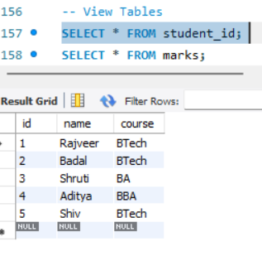
-- Insert Data into marks
INSERT INTO marks VALUES
(1, 85),
(2, 90),
(3, 78),
(4, 98),
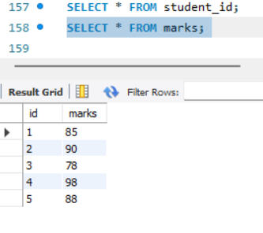
(5, 88);
-- View Tables
SELECT * FROM student_id;
SELECT * FROM marks;
-- NATURAL JOIN
SELECT * FROM student_id
NATURAL JOIN marks;
-- EQUI JOIN
SELECT student_id.id, student_id.name, student_id.course, marks.marks

FROM student_id
JOIN marks
ON student_id.id = marks.id;

Explanation
- NATURAL JOIN automatically joins using common column (id)
- EQUI JOIN uses ON student.id = marks.id condition
- Both produce similar results but work differently
Result
Data from both tables was successfully combined using NATURAL JOIN and EQUI JOIN.
Conclusion
Joins are important for combining related data from multiple tables. NATURAL JOIN is automatic, while EQUI JOIN provides more control.

Q7. To implement LEFT OUTER JOIN and RIGHT OUTER JOIN on . tables in MySQL.

Experiment 7
Aim
To implement LEFT OUTER JOIN and RIGHT OUTER JOIN on tables in MySQL.
Theory
Outer joins are used to retrieve data from multiple tables including unmatched records.
- LEFT OUTER JOIN → Returns all records from the left table and matching records from the right table. If no match, NULL values are shown.
- RIGHT OUTER JOIN → Returns all records from the right table and matching records from the left table. If no match, NULL values are shown.
SQL Queries (Implementation)
-- || EXPERIMENT 7 : LEFT & RIGHT OUTER JOIN ||
-- Use Database
USE EXPERIMENT_1;
-- Drop tables if already exist (to avoid errors)
DROP TABLE IF EXISTS student_left;
DROP TABLE IF EXISTS marks_right;
-- Create Table 1: student_left
CREATE TABLE student_left (
id INT PRIMARY KEY,
name VARCHAR(50)
);
-- Create Table 2: marks_right
CREATE TABLE marks_right (
id INT,
marks INT
);
-- Insert Data into student_left
INSERT INTO student_left VALUES
(1, 'Rajveer'),
(2, 'Badal'),
(3, 'Shruti'),
(4, 'Aditya'),
(6, 'Shiv');

-- Insert Data into marks_right
INSERT INTO marks_right VALUES
(1, 85),
(2, 90),
(3, 78),
(5, 88);
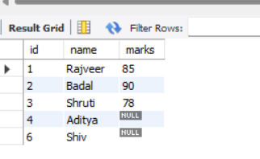
-- LEFT OUTER JOIN
SELECT s.id, s.name, m.marks
FROM student_left s
LEFT JOIN marks_right m
ON s.id = m.id;
-- RIGHT OUTER JOIN
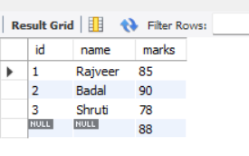
SELECT s.id, s.name, m.marks
FROM student_left s
RIGHT JOIN marks_right m
ON s.id = m.id;
Explanation
- In LEFT JOIN, all students are shown (even if marks not present → NULL)
- In RIGHT JOIN, all marks records are shown (even if student not present → NULL)
- Unmatched rows clearly demonstrate outer join behavior
Result
The LEFT and RIGHT OUTER JOIN operations were successfully performed, displaying both matched and unmatched records.
Conclusion
Outer joins help retrieve complete data from tables, including unmatched records, which is useful in real-world database applications.
Q8. To implement SELF JOIN on a table in MySQL.
Experiment 8
Aim
To implement SELF JOIN on a table in MySQL.
Theory
A SELF JOIN is a type of join where a table is joined with itself. It is used when we want to compare rows within the same table.
To perform a SELF JOIN, we use table aliases (different names for the same table).
Example: Finding employee and their manager from the same table.
SQL Queries (Implementation)
-- || EXPERIMENT 8 : SELF JOIN ||
-- Use Database
USE EXPERIMENT_1;
-- Drop table if exists (to avoid error)
DROP TABLE IF EXISTS employee;
-- Create Table
CREATE TABLE employee (
emp_id INT PRIMARY KEY,
emp_name VARCHAR(50),
manager_id INT
);
-- Insert Data
INSERT INTO employee VALUES
(1, 'Rajveer', NULL), -- Top manager
(2, 'Badal', 1),
(3, 'Shruti', 1),
(4, 'Aditya', 2),
(5, 'Shiv', 2);
select * from employee;
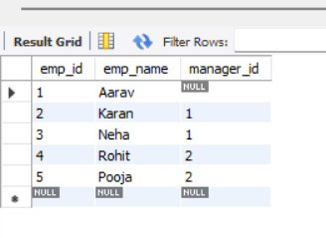
-- SELF JOIN (Employee with Manager)
SELECT
e.emp_id AS Employee_ID,
e.emp_name AS Employee_Name,
m.emp_name AS Manager_Name
FROM employee e
LEFT JOIN employee m
ON e.manager_id = m.emp_id;
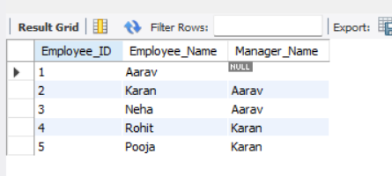
Explanation
- Table employee is joined with itself
- e → represents employee
- m → represents manager
- manager_id links employee to manager
Result
The SELF JOIN successfully displayed employees along with their respective managers.
Conclusion
SELF JOIN is useful when relationships exist within the same table, such as employee-manager hierarchy.
