A REPORT

ON

AUTOMATED TELEPHONE BILLING SYSTEM

BY

RAJVEER SINGH GANDHI 2012A7PS158U CSE

AT

HCL INFOSYSTEMS
F-23 SECTOR-11
NOIDA (U.P)

A Practice School – I Station of


BITS Pilani, Dubai Campus
Dubai International Academic City (DIAC)
Dubai, U.A.E

(JUNE 2014 - AUGUST 2014)

A REPORT

ON

AUTOMATED TELEPHONE BILLING SYSTEM

BY

RAJVEER SINGH GANDHI 2012A7PS158U CSE

Prepared in Partial Fulfillment of the
Practice School – I Course

AT

HCL INFOSYSTEMS
F-23 SECTOR-11
NOIDA (U.P)

A Practice School – I Station of

BITS Pilani, Dubai Campus
Dubai International Academic City (DIAC)
Dubai, U.A.E

(JUNE 2014 - AUGUST 2014)

BITS Pilani, Dubai Campus

Dubai International Academic City (DIAC)
Dubai, U.A.E

Station: HCL Infosystems Location: Noida
Duration: 8th June 2014 to 4th August 2014 Date of Start: 08/06/2014
Date of Submission: 04th August 2014
Title of the Project: Automated Telephone Billing System
Student Name: Rajveer Singh Gandhi Student ID: 2012A7PS158U
Discipline of Student: Computer Science Engineering
Name and Designation of Experts: Mr. Ashutosh Trivedi, Project Manager
Name of the Faculty: Dr. Nand Kumar


Signature of the Student Signature of PS Faculty

Date: 04.08.2014 Date: 04.08.2014

Abstract:

The automated telephone billing system that is programmed is meant to be for use of the employers of the company. This billing system will store the history of the employees call details made by the company phone.
This document presents an automated telephone billing system for employees in a company. It is also intended for the customer and the developer organizations to understand the system both functionally as well as technically. The software further estimates and differentiates calls on the nature of its purpose i.e. Official or Personal and is widely used by Companies like Etisalat and Du for monitoring phone calls made by its employees.
This Web based application allows employees to mark calls which were made for personal use from their official number .The user with no prior account is supposed to sign up entering his employee code and a randomly generated password. After the user is logged in using the password he can then enter his personal details like name, date of birth, social security number etc. that are grouped in a file which can be then uploaded as an excel file (in csv format) with monthly details and submitted to the database.

Acknowlegements

Firstly, I would like to express my heartfelt gratitude to Prof. R. N. Saha, Director BPDC who has given me an opportunity to apply and understand my engineering concepts in a practical atmosphere.

I am grateful to Mr. Bipin Upadhayay, HR for assisting me by providing the required information about the organization.

Also, I would like to thank Mr. Ashutosh Trivedi, Project Manager for helping and guiding me throughout my project.
I would also like to thank Prof. B. Muralidharan, Dean - Placement & Practice School, for giving me this opportunity to work and apply my knowledge in the technical field and gain firsthand experience.
My sincere gratitude to Dr. Nand Kumar our PS Faculty, for providing us with all the assistance required for successful completion of this report.

Signature of the Student
Date: 04.08.2014

Contents

Abstract
Acknowledgement
Table of contents
- Introduction……………………………………………….………………7.
  - Request for Proposal (RFP)…………………………………….……8
  - Automated Telephone Billing System………………………....…....9
- Functional features………………………………………………..........12
- Architectural Model……………………………………………..………13
- High Level Design Description……………………………….…….…14
  - My SQL Details…………………………………………………........14
  - Diag. to explain function of each incorporated table…………...…14
  - PHP Script Details……………………………………………………15
  - Screenshots of few PHP pages………………………….…………16
- Low Level Design Description……………………….……………….25
  - ATBS Database………………………………………………………25
  - Table Description…………………………………………………….25
  - Screenshots of Database Created…………………………..…….27
- Modus Operandi of PHP pages………………………………………30
  - Register………………………………………………………………30
  - Login………………………………………………………………….31
  - Screenshots of Different Test cases………………………………32
- Future Scope…………………………………………………….………40
- Conclusion………………………………………………………………41
- References………………………………………………………………42
- Turnitin Report…………………………………………………………44

Change Request Details
CR Number |  | Project Name | Automated Telephone Billing System
Requestor Name: | Jayadev
Dep. Name | Finance Manager | Contact info:
Date of initiation | 08/03/12 | Initiated By | Rajesh kumar
Required By |  | Priority (I/R/D) | Required

Request for Proposal
Description of Change
- The telephone billing file received from Etisalat and DU is uploaded in the system.
- The system should have the capability of capturing the staff id, staff mobile number, staff telephone number, email id.
- One staff can have multiple mobile numbers and land line numbers.
- At the time of upload, if the system does not find the telephone number for the user, it should reject uploading the entire file and provide the exceptions thru email.
- Email alerts are send to users informing the Telephone bill available for the period and needs to be submitted before the deadline.
- User needs to login to flydubai domain on the intranet portal.
- Application link is provided to the User (login credentials verified in the flydubai domain) to access the application on the ESS portal.
- The webpage displays the staff ID, phones listed against the staff, total amount against each phone no and ‘View Details’ option.
- In view details option, the list of telephone calls are listed (both landline and mobile).
- The system provides a check box against each number for marking the cost of the call for deduction.
- The user has to check the calls which are personal.
- The total amount on personal calls and official calls are shown in the end.
- The user needs to select ‘Submit’ to complete the billing information.
- An Email confirmation will be send to the user providing the details on amount for personal and official calls. The email confirmation would be notified to his immediate line manager (as mapped in ESS) regarding the amount to be deducted.
- After 30 days from the upload of the Etisalat AND du bills in the application, the system would close all open bills. A summary report is generated which would contain the following details: employee number, telephone number, total bill amount, deduction amount and official call amount for Etisalat and DU separately to the email id Accountspayable@flydubai.com. If the user does not submit the bills before the time period, the entire amount is charged against personal call.
- Billing information for the previous months will not be displayed to the users after 30 days of bill upload.
- The users can anytime query for their previous month telephone bill and it should be read only and can be printed.

Automated Telephone Billing System

- An automated telephone billing system is an enterprise application software designed to support the following
  - Telephone billing processes which are responsible to collect consumption data
  - Calculate charging and billing information, produce bills to employees, process their payments and manage debt collection.

- Operations area include
  - functions of capturing usage records (depending on the industry it can be call detail records
  - charging data records network traffic measurement data, (in some cases usage data could be prepared by telecommunications mediation system)
  - rating consumption (determining factors, significant for further calculation, for example, calculating total time of calls for each tariff zones, traffic summary in gigabytes)
  - applying prices, tariffs, discounts, taxes and compiling charges for each employee account, rendering bills,
  - Managing bill delivery
  - Applying adjustments
  - Maintenance of employee account.

- This application is designed to provide the employees of Etisalat a web based Billing facility collaborative tool using instant-detail submission. Any employee can stay and check his calls and bill status of the phones provided by the company. This application provides an amalgamation of Pay and Work Concept on web.

- Entire application is deployed on XAMPP server with Apache Web server as the web front end server. Both are open-source servers and the installation is done by the developer organization. MySQL database is generated by the scripts provided by the team. As the employee community increases, we can load the balance by the company balance the user requests using MySQL calls and uploading the files in “atbs” database.

Below are the features/functionality the application will support:-

- The telephone billing file is received from Etisalat and DU and is uploaded in the system.

- One staff can have multiple mobile numbers and land line numbers.

- The system would have the capability of storing the employee-id, employee mobile number and his email id.

- At the time of upload, if the system does not find the telephone number for the user, it would reject uploading the entire file and provide the exceptions through an email.

- Email alerts sent to users would then inform the Telephone bill available for the period which is required to be submitted before the deadline.

- User needs to login to Etisalat/Du domain on the intranet portal.

- Application link is provided to the User (login credentials verified in the Etisalat/Du domain) to access the application on the ESS portal.

- The webpage displays the staff ID, phones listed against the staff, total amount against each phone no and ‘View Details’ option.

- In view details option, the list of phone calls are mentioned

- The system provides a check box against each number for marking the cost of the call for deduction.

- The user has to check the calls which are personal.

- By default the system marks the call as official. The employee has to mark the personal calls.
- The total amount on personal calls and official calls are shown at the end.

- The user needs to select ‘Submit’ to complete the billing information.

- The billing information for the previous months would not be displayed to the employee post 30 days of bill upload.

- The employee can at any time ask for his previous month telephone bill .The document provided for which would be a read only format that can be printed.

Functional Features:

FEATURE ID | FEATURE | DESCRIPTION
F1 | Registration | As soon as the user types the URL of the website, the Registration is displayed
F2 | User Sign Up | All users will register themselves with the application using this feature
F3 | User Sign Out | User log out feature
F4 | User Login | User will have to login to use the functionality of the application
F5 | Generate Password | Allow user to retrieve password for first login
F6 | Forgot Password | Users will be reminded of their passwords if they use this feature
F7 | Dashboard | Show name ,employ code and other details of logged in user has sent
F8 | Personal Details | Displays user details stored in company's system
F9 | View Details | Displays the selected month's details of a individual phone
F10 | Upload File | Provides employee with an option to upload event file with a month's detail
F11 | Submit Feature | Allows user to view select and submit each individual call as official or personal

Architectural Model
This application is designed using a typical login-logout architectural pattern. Presentation layer comprises of JSP pages, MySql calls, HTML library etc. and makes calls to the Database. Business logic is also incorporated and all data access will be through Database via MySql calls.

Tools & Technologies
Development Infrastructure
S.No. | Tools & Technology | Description
1 | XAMPP Version 1.7.7 | Web server to develop and deploy application
2 | MySQL 5.5.16(Community Server) | Database
3 | CSS 3.0 | Style sheets technology
4 | phpMyAdmin 3.4.5 and related plugin | Database related framework
5 | PHP 5.3.8(VC9 X86 32 bit thread safe) + PEAR | Primary scripting language for webpage
6 | HTML & JavaScript | Secondary Languages
7 | Windows 8 | Development Environment

Browser Compatibility
The application supports the following browser versions:
- Internet Explorer 6.0+
- Mozilla Firefox 2.0+
- Safari
- Google Chrome

Deployment model
The entire application is deployed on XAMPP Version 1.7.7 server with Apache Web server as the web front end server. Both are open-source servers and the installation is done by the developer organization.
MySQL database is generated by the scripts provided by the team. As the employee community increases, we load the balance by the company balance the user requests using MySql Calls and uploading the files in “ATBS” database.

High Level Design Description

Automated Telephone Billing System is made by using the following programs:
1 PHP Scripting
2 JavaScript
3 HTML
4 MySQL Interface

MySQL Details
Database “ATBS” is created in the XAMPP server to store all operatic details of the project.
Tables incorporated in the “ATBS” Database are:
1 employinfo
2 employ_contact_details
3 contact_bill_details

Schematic diagram to explain the function of each incorporated table of the database
employ info
Stores employee’s login and personal details
employ_contact_details
stores company’s phone numbers and details

ATBS
DATABASE

contact_bill_details
stores individual call details of each phone of the employee

PHP Script Details

This project has been mostly coded in PHP scripting language with a minor usage of JavaScript
It includes the following list of Web pages:
- connect.inc.php
- index.php
- login.php
- core.inc.php
- register.php
- change_pass.php
- changed.php
- detour_details.php
- forgotpassword.php
- personaldetails.php
- profile.php
- register_success.php
- upload.php
- view_details.php
- logout.php
The PHP codes of which are mentioned in the appendix.

Screenshots of a few PHP pages from the project

login.php

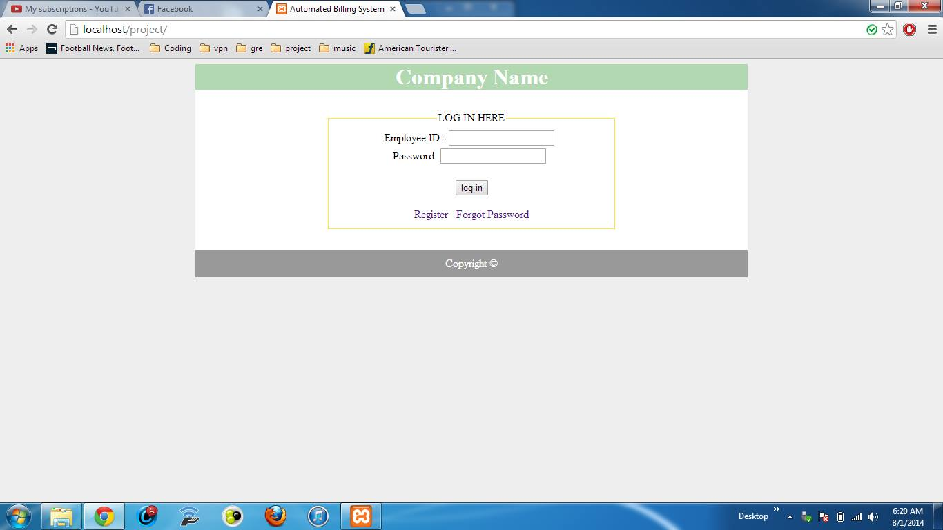

register.php

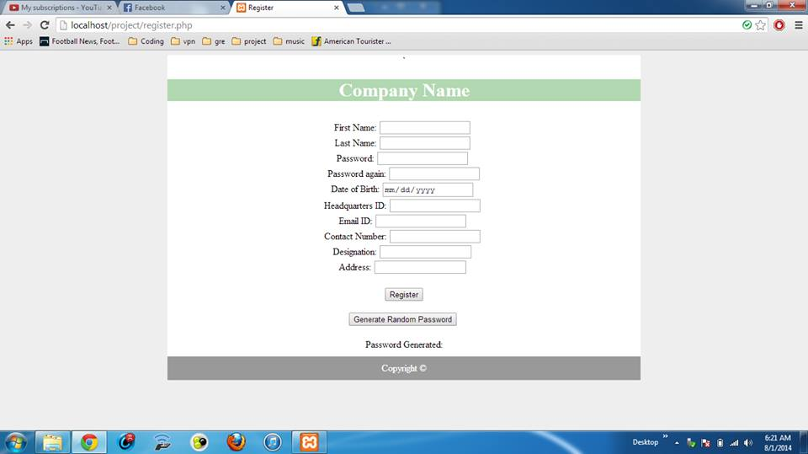
Register page without random password

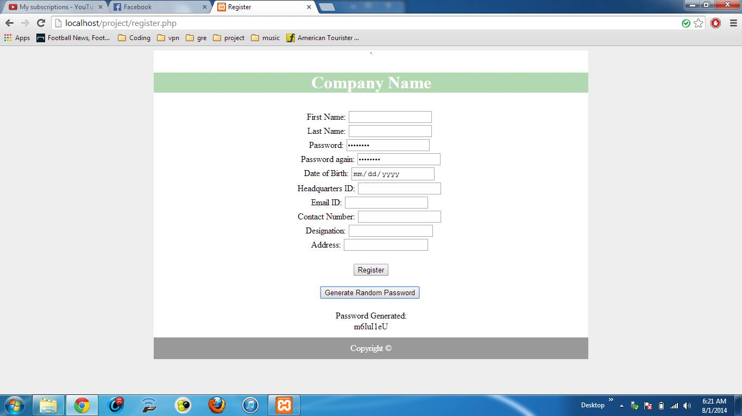
Register page after random password generated
change_pass.php

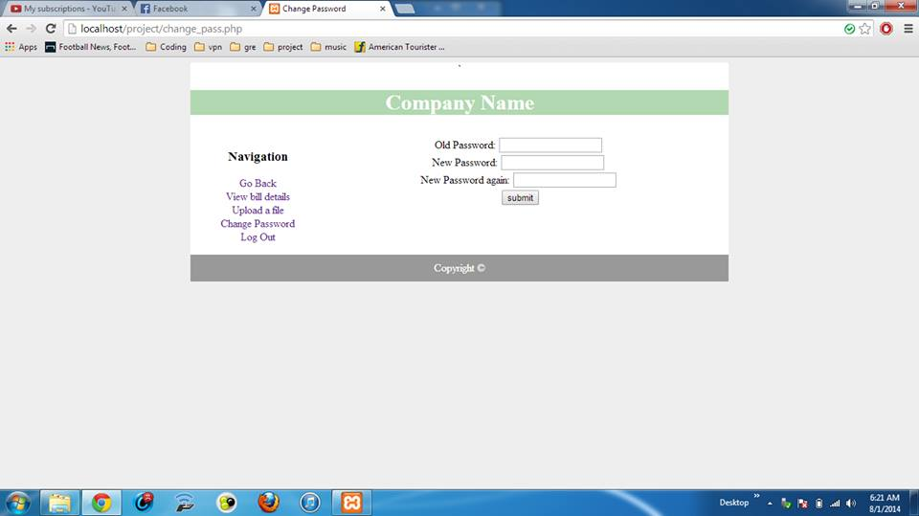
detour_details.php

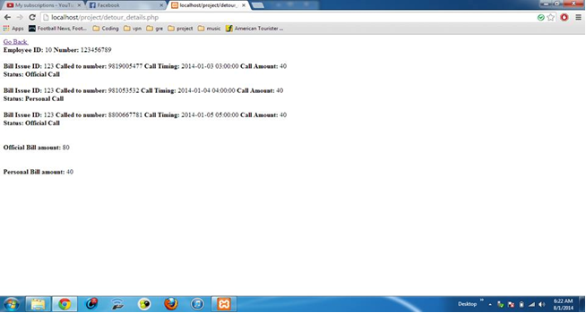
forgotpassword.php

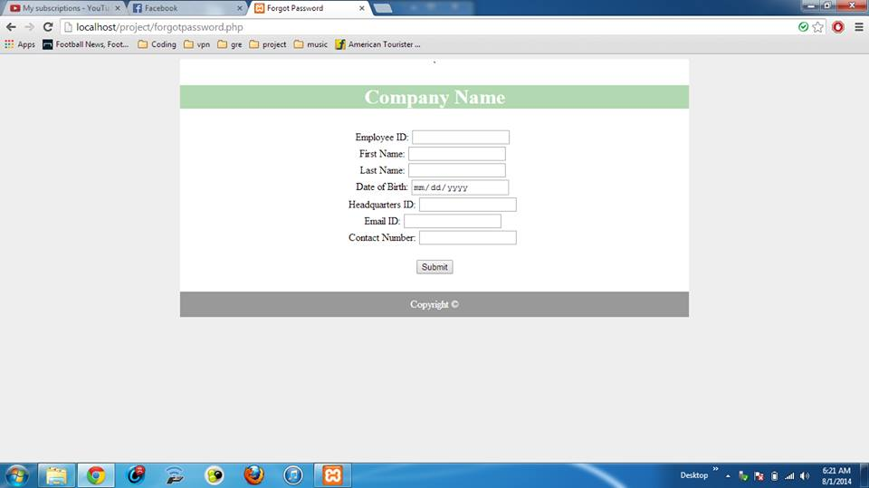
personaldetails.php

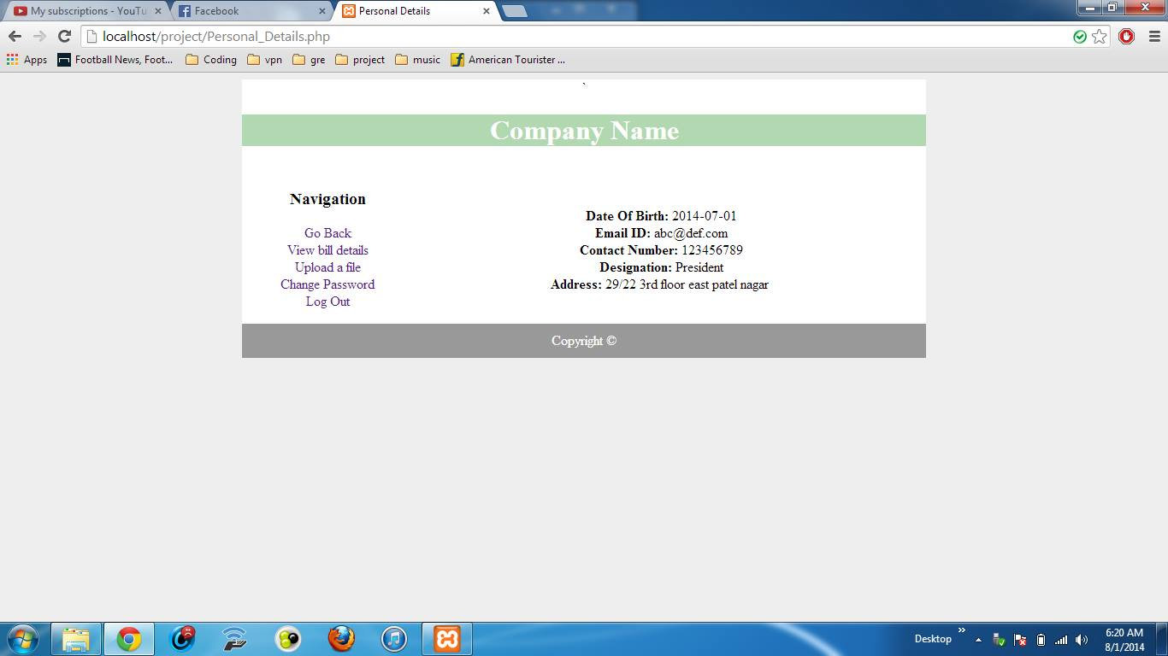

profile.php

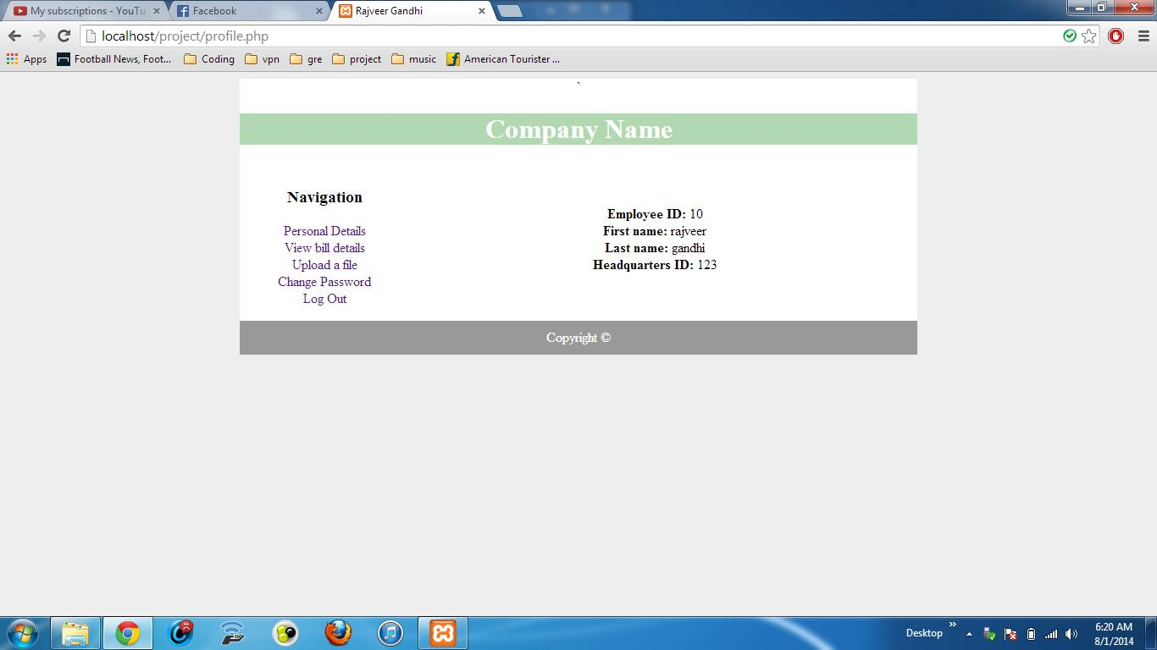

upload.php

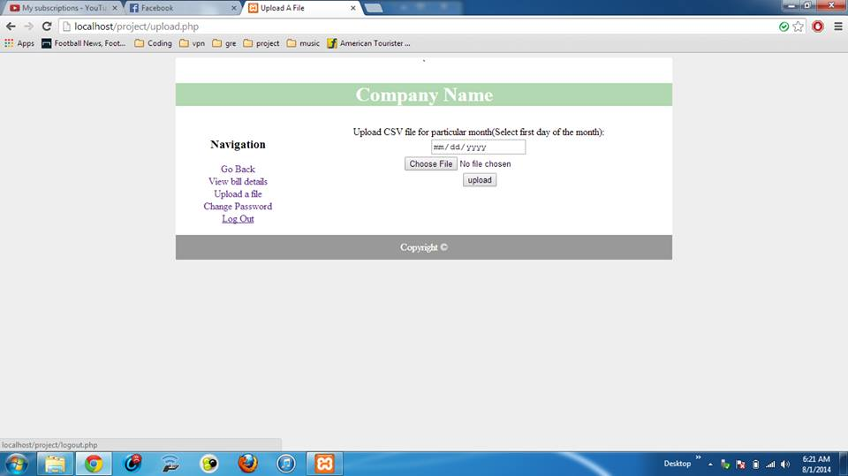

view_details.php

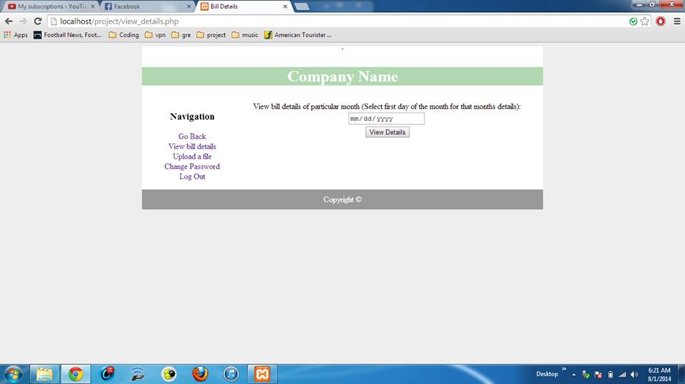

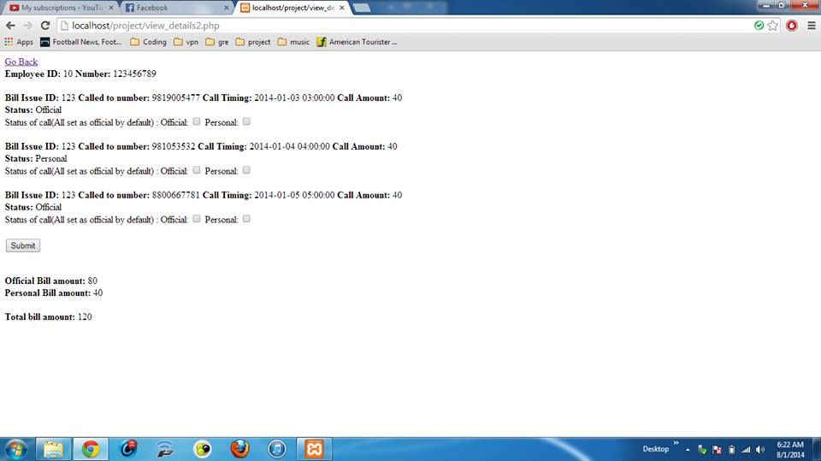
The total bill amount generated displayed

Low Level Design
The Automated Telephone Billing System Project incorporates the database “ATBS” which has 3 tables.

ATBS
DATABASE

employ_contact_details
stores company’s phone numbers and details
employ info
Stores employee’s login and personal details

contact_bill_details
stores individual call details of each phone of the employee

The description of these tables are mentioned below
- Table name: employinfo
This table stores the personal and the login details of the employee
The structure of the table is given below

Column | Datatype
id | int(11)
first_name | varchar(30)
lastname | varchar(30)
password | varchar(30)
dob | date
hq_id | int(11)
mail_id | varchar(50)
contact_no | varchar(100)
designation | varchar(30)
address | varchar(100)

- Table name: employ_contact_details
This table stores the details of each phone provided to the employee by the company
The structure of this table is given:

Column | Datatype
Id | int(11)
contact_number_1 | varchar(20)
service_provider_1 | varchar(20)
Contact_type | varchar(1)

- Table name: contact_bill_details

This table consists of details of each individual call of an employee and is indexed by an employee code,a phone number and a date of call
The structure of which is given as follows:

Column | Datatype
sno | int(11)
id | int(11)
number | varchar(20)
call_amount | double
call_timing | datetime
called_to_number | varchar(20)
bill_issue_id | varchar(10)
date_time | date
status | varchar(1)

Screenshots of the Database Created

1 employinfo

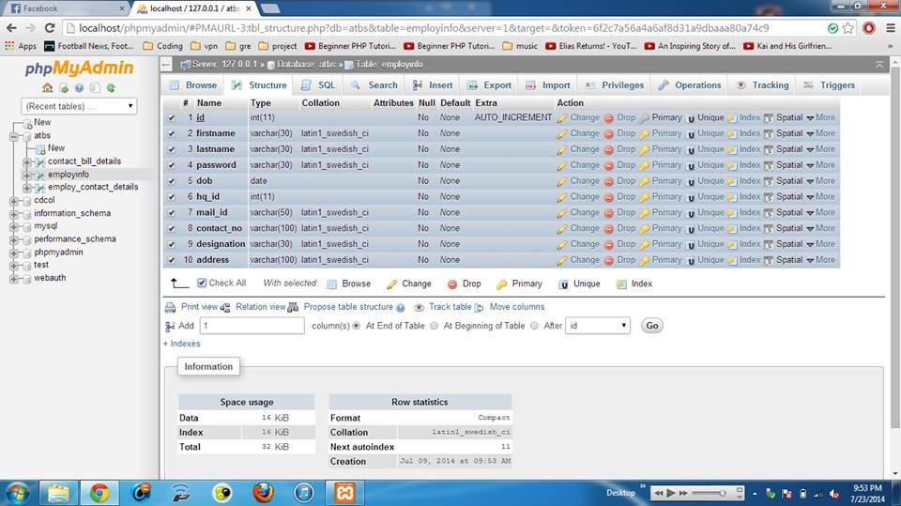
Table name: employinfo

2 employ_contact_details

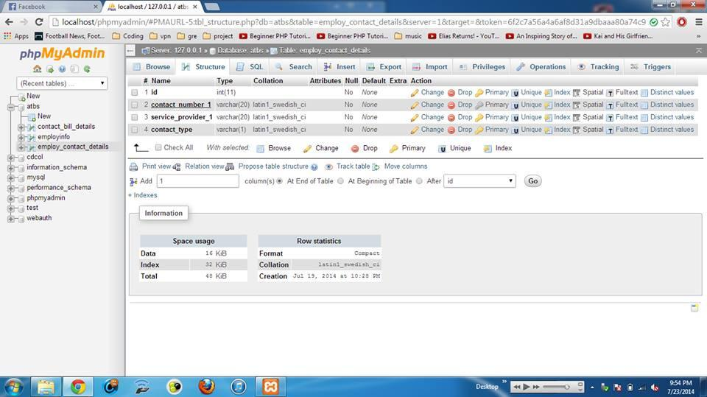
Table name: employ_contact_details

3 contact_bill_details

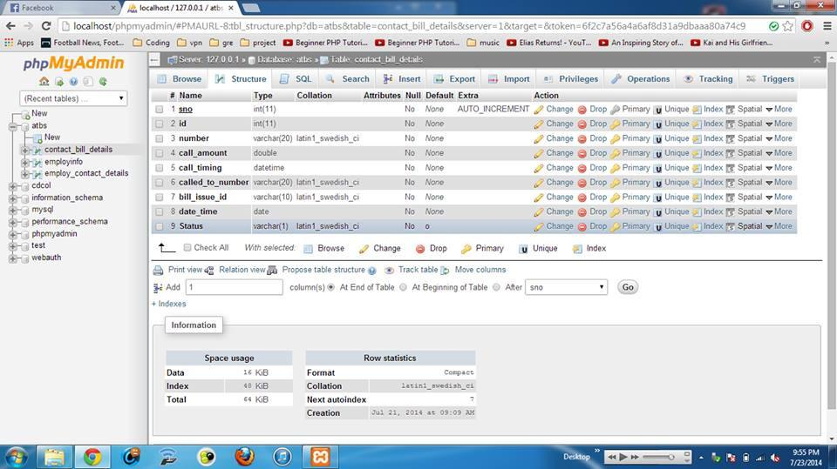
Table name: contact_bill_details

Modus Operandi of PHP pages
- Register: When a user clicks on the register button on the log in page, he is redirected to the register page to enter his details. After he registers in the portal window, a new entry is inserted in the table with the details being filled by user provided data. Since each employee has a unique Employee ID, so it acts as the primary key for the table. Else appropriate error message isdisplayed.
Test Cases for Register Page:
Suppose the Password corresponding to employee with name “Animesh” and Date of Birth “05/09/1994” is “Hcl123”
Note: Empty fields mean no form of input is provided by the user

NAME | PASSWORD | PASSWORD AGAIN | DATE OF BIRTH | EXPECTED RESULT | ACTUAL OUTPUT
Animesh | Hcl123 | Hcl345 | 05/09/1994 | Unable to Register | Password do not match
 |  |  |  | Unable to Register | Fill in all the fields
 | Hcl123 | Hcl123 | 05/09/1994 | Unable to Register | Fill in all the fields
Animesh | Hcl123 | Hcl123 |  | Unable to Register | Fill in all the fields
Animesh | Hcl123 | Hcl123 | 05/09/1994 | Registration Successful | Registration Successful

.

- Login: This page offers to input fields- EmployeeID and Password. User needs to provide input to both fields and if the combination of both Password and EmployeeID matches the specifications to the EmployeeInfo table , a new session is started and user logs in. Else appropriate error message is displayed.
Test cases for Login Page:
Suppose the Password corresponding to employee with ID 1111 is “Hcl123”.
Note: Empty fields mean no form of input is provided by the user.

EMPLOYEE ID | PASSWORD | EXPECTED RESULT | ACTUAL OUTPUT
 |  | Unable to Login | Please enter username and password
0000 | Hcl123 | Unable to Login | Invalid username /password combination.
1111 | Hcl345 | Unable to Login | Invalid username /password combination.
1111 | Hcl123 | Login Successful | Logged in.

Screenshots of the test cases
Case 1

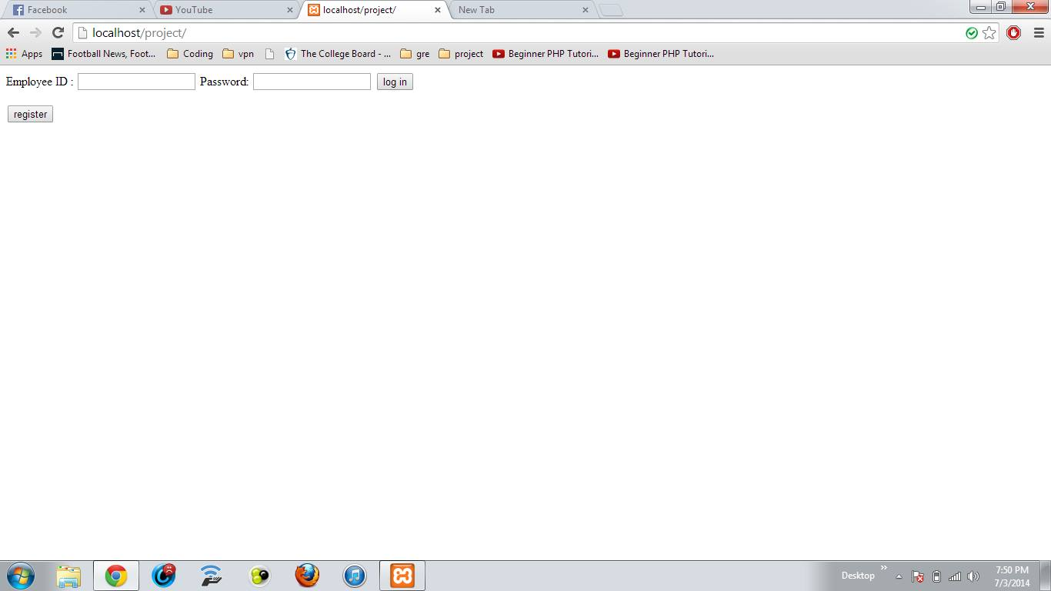

Login Page

**Please note that these screenshots are prior to styling which is the final step of the project

Case 2

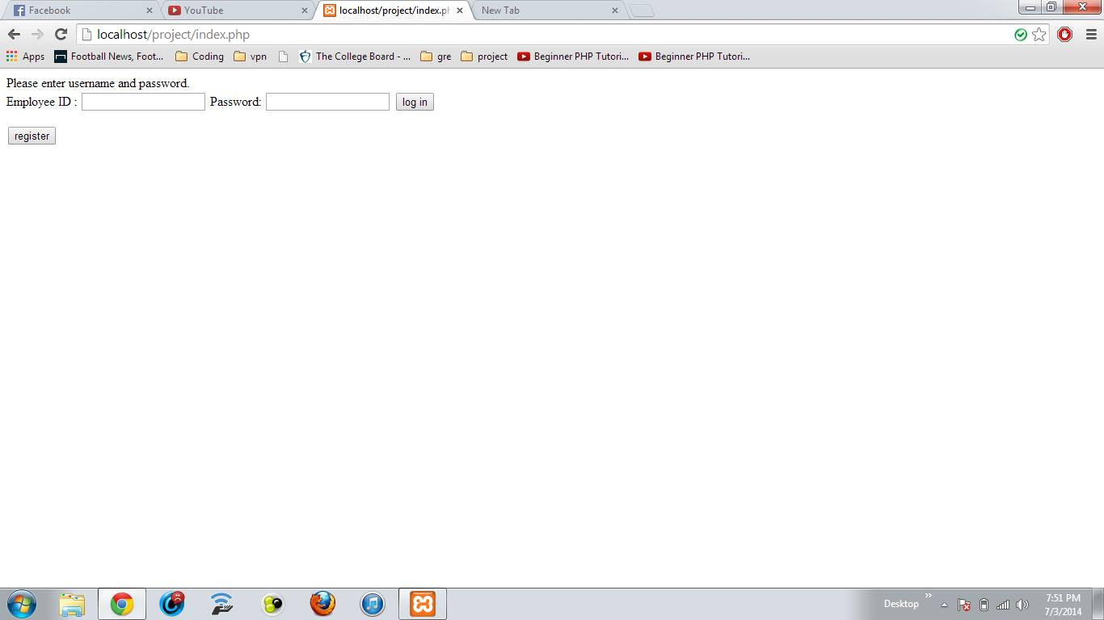

If you don’t enter anything and press login

Case 3

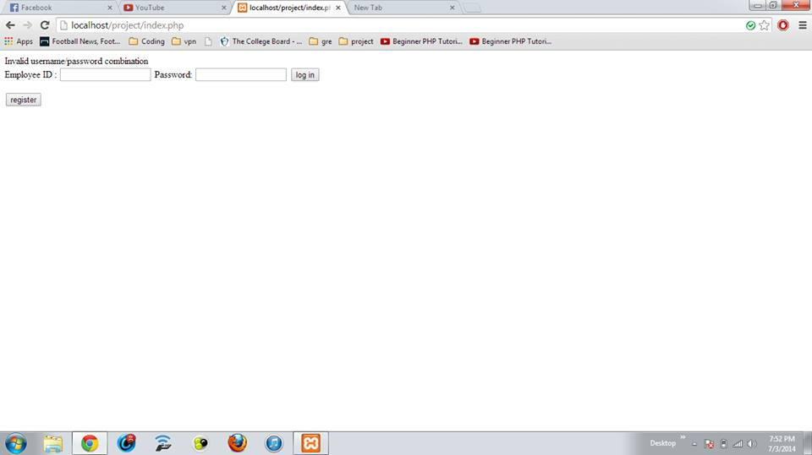

Wrong Combination

Case 4

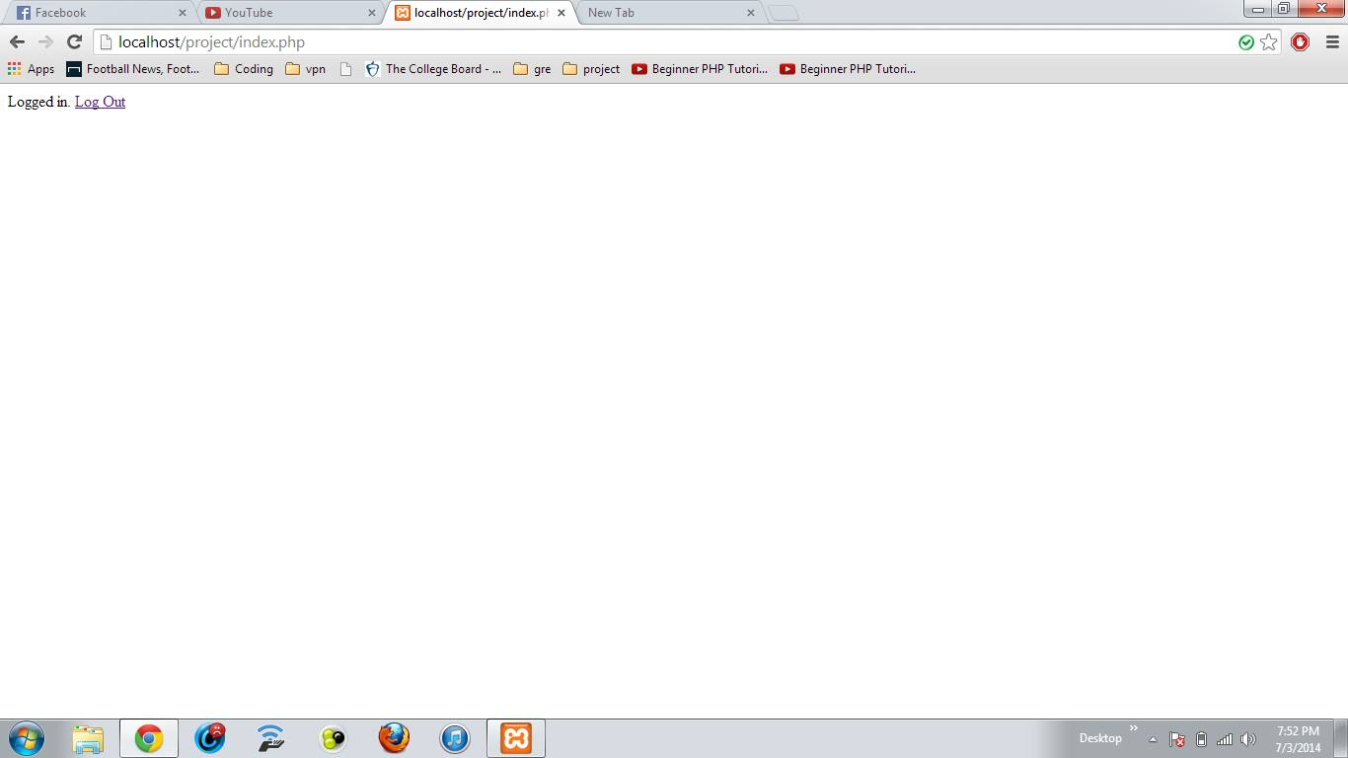

Enter Correct details

Case 5
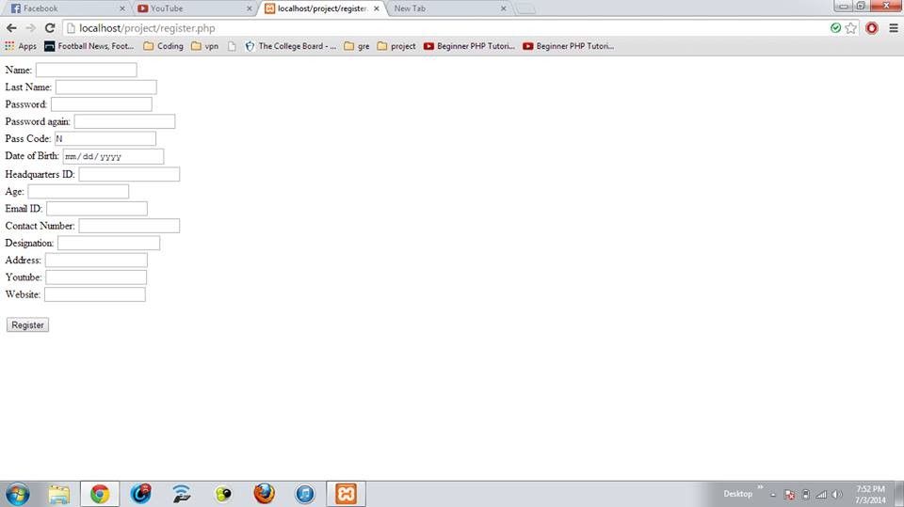

Register Page

Case 6

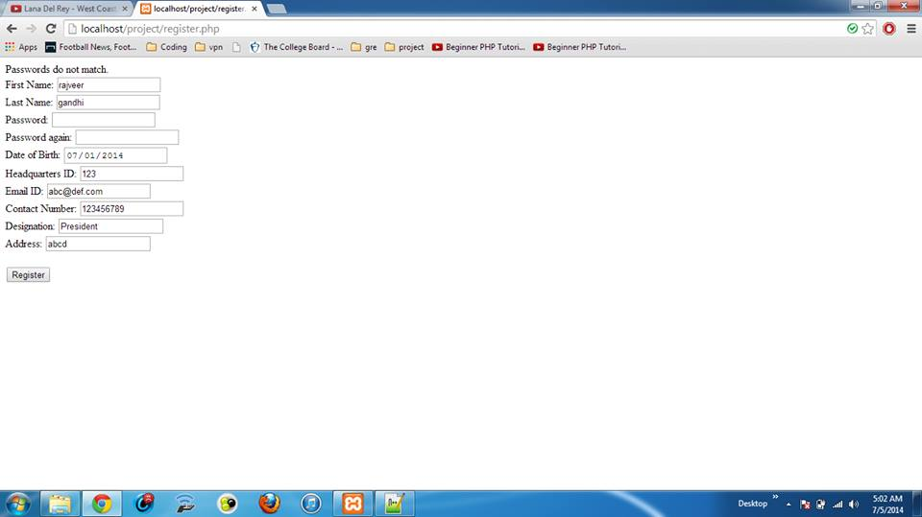

Registration passwords don’t match

Case 7

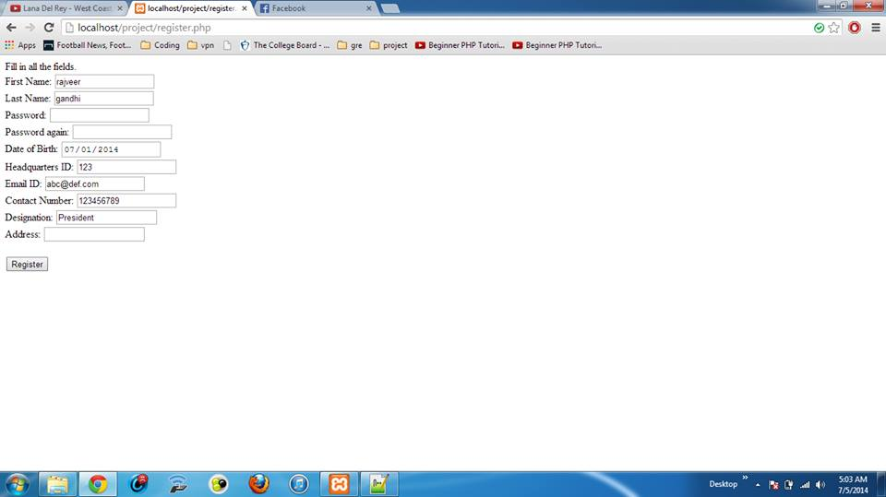

All fields not entered

Case8

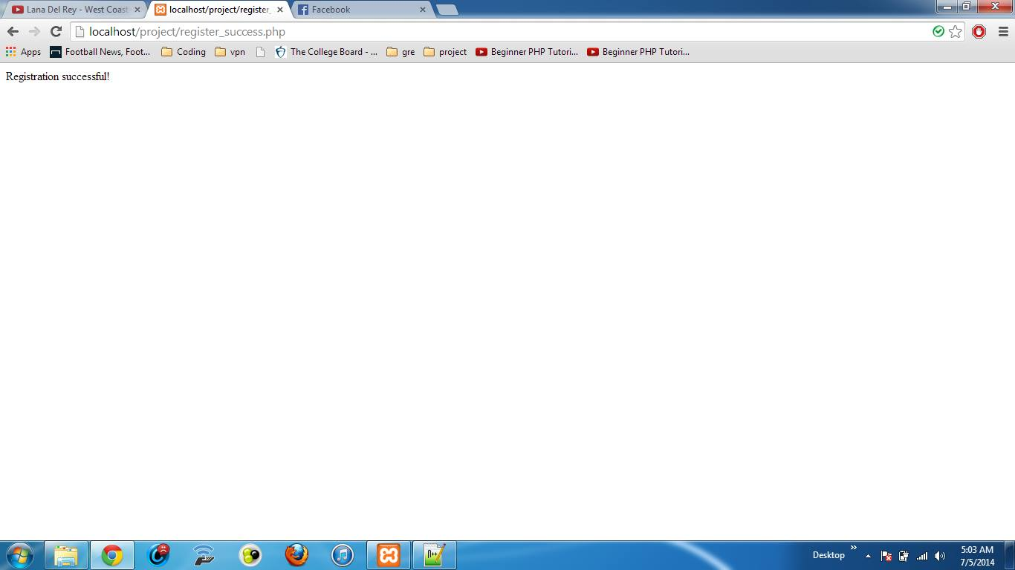

Successful registration

Future Scope

The entire process of creating the ATBS project had something to offer. The knowledge required of PHP, MySQL and JavaScript used for the same can be extended to create any interactive website and databases.
A few of the many scenarios in which it can be used would be when supposing you have to set up a company’s online product catalog or maybe you wish to set up your own Web based business the knowledge of PHP and JavaScript is a key component in the creation of these pages.

Other future prospects could include:
- Easy information retrieval
- Maintenance of Databases and overall project becomes easy
- Speed of data retrieval can be improved
- Maintenance of huge data becomes more efficient
- Redundancy in data can be reduced to a very large extent
- Analysis of international phone numbers
- A trigger can be added to the database which will send emails to employee when billing date is due.
- The existing system is totally manual thus there are chances of error in processing. Therefore, a more automated system can reduce such errors in future.

Conclusion

So using PHP (some JavaScript) and MySql Interface we have successfully created the “ATBS” project.
The entire application is deployed on XAMPP Version 1.7.7 server with Apache Web server as the web front end server. Both being open-source servers, the installation was done by the developer organization.

The final styling of these pages was done using CSS.

The login and register page has been created. We have also added some other functional features to our project. These features are:

- Generate password: Allows users to retrieve password for first login.
- Forgot password: Users will be reminded of their passwords.
- Dashboard: Show Name, employeeID and other details of logged in user.
- Personal Details: Displays users details stored in company’s system.
- View Details: Displays the selected month’s details of an individual phone.
- Upload File: Provide employee with an option to upload excel file with a month’s detail.
- Submit: Allows user to View select and submit each individual cell as official or personal.
etc.

References
The following resources proved extremely helpful for the successful completion of the ATBS project
- Wikipedia- http://en.wikipedia.org/wiki/Main_Page
- www.w3schools.com/php/
- www.php.net/manual/en/getting-started.php
- www.tutorialspoint.com/mysql/
- www.mysqltutorial.org/
- www.newboston.org
- PHP Tutorials-www.homeandlearn.co.uk/php/php.html
- PHP Codeacademy--http://www.codecademy.com/en/tracks/php
- PHP with MySQL Manual-http://php.net/manual/en/mysql.php
- MySQL Tutorial-www.mysqltutorial.org
- Document from HCL Infosystems Ltd. by Gaurav Sharma-Telephone Billing System SRS
- Document from HCL Infosystems: Request For Proposal of the company
- PHP for dummies By Janet Valade

