I. RECONNAISSANCE (INFORMATION GATHERING)

1. IDENTIFY TARGET IP
Used the netdiscover command to identify the target machine's IP address on the local network.
Result: Target IP was 192.168.88.129.
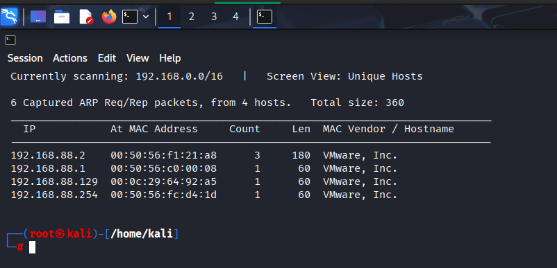

2. PORT AND SERVICE SCAN
Used nmap with aggressive script and version detection flags (-sC -sV -oA w34kn3ss) to identify open ports and services.
Command:
nmap -sC -sV -oA w34kn3ss 192.168.88.129
Result: Ports 22 (SSH), 80 (HTTP), and 443 (HTTPS) were open.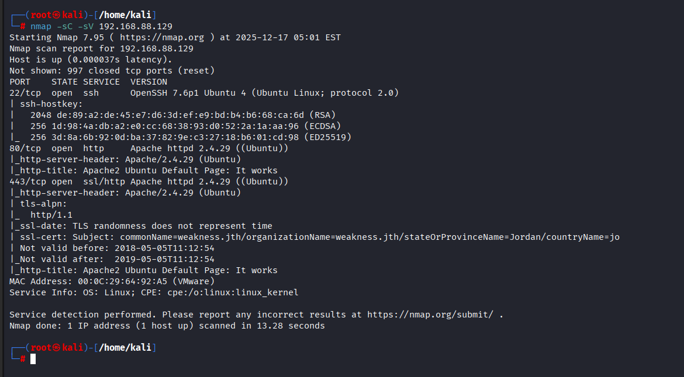

3. INITIAL WEB EXPLORATION
Browsed to:
- http://192.168.88.129
Result: Displayed the default Apache2 Ubuntu Default page.
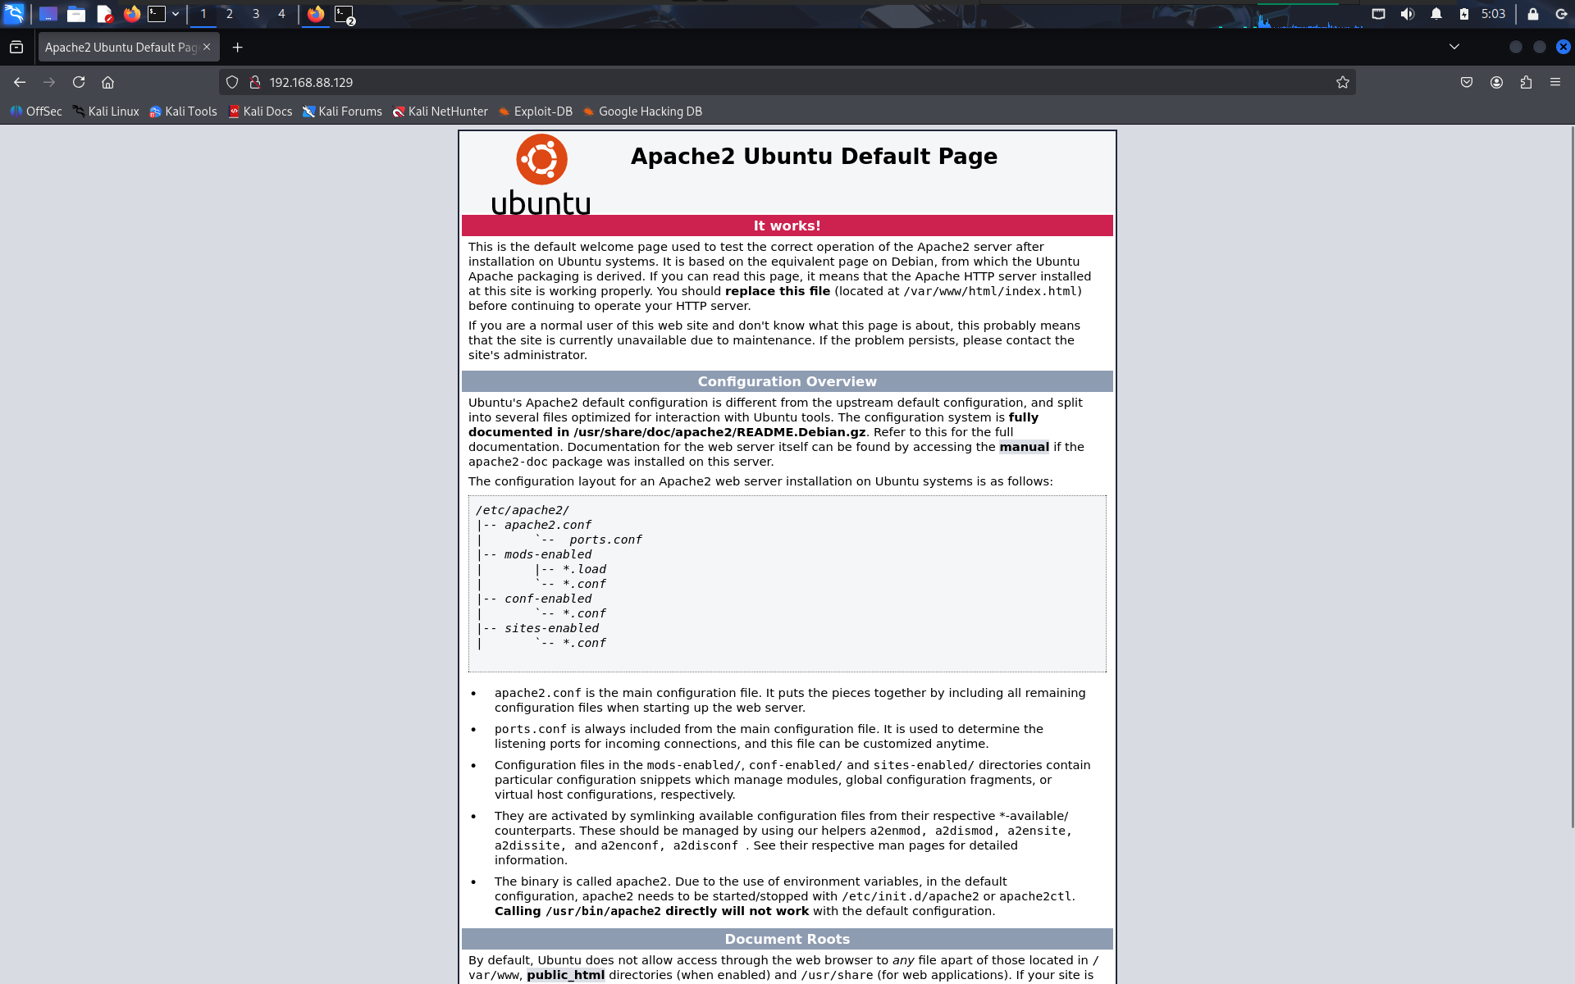

4. HOST FILE MODIFICATION
Identified the hostname weakness.jth from the Nmap results and added it to the /etc/hosts file mapping it to the target IP.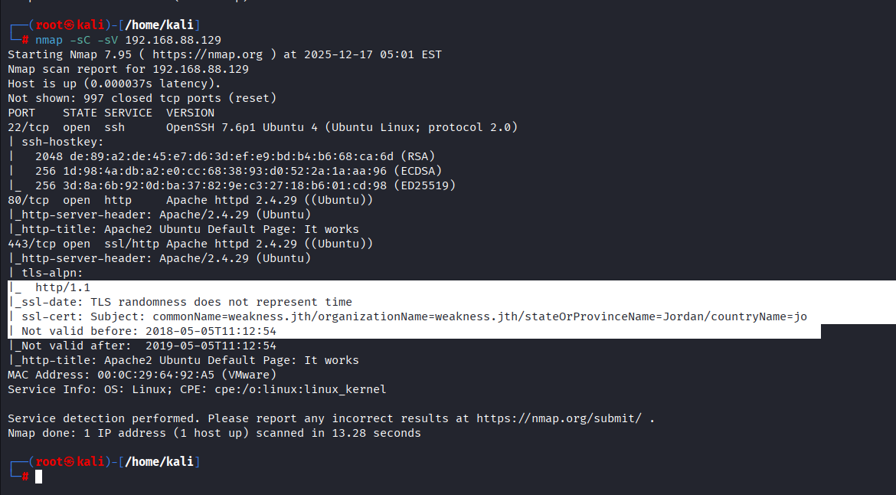

Command:
nano /etc/hosts
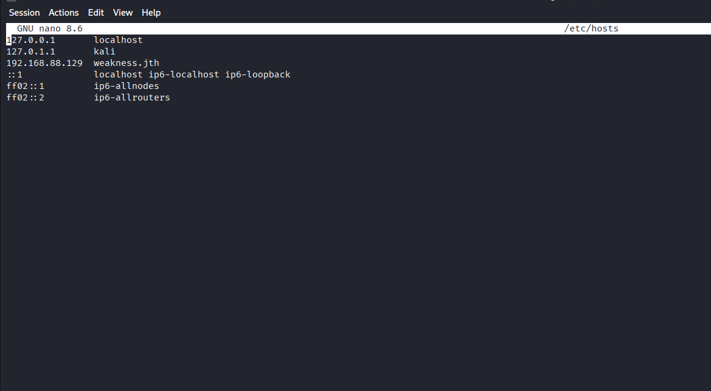
Added entry:
192.168.88.129 weakness.jth

5. HOSTNAME WEB EXPLORATION
Browsed to:
http://weakness.jth
Result: A different page was displayed with an ASCII art rabbit and the message "keep following the white rabbit 😀", written by user n30.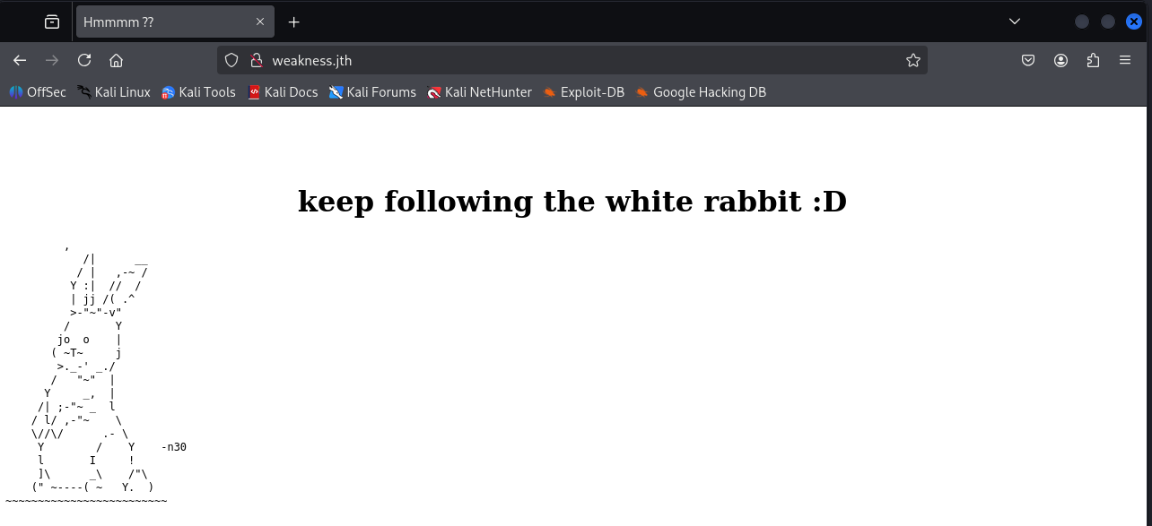

II. ENUMERATION (GAINING A FOOTHOLD)

6. DIRECTORY BRUTE-FORCING
Used gobuster to find hidden directories on the web server.
Command:
dirb http://weakness.jth
Result: Discovered the /private directory.
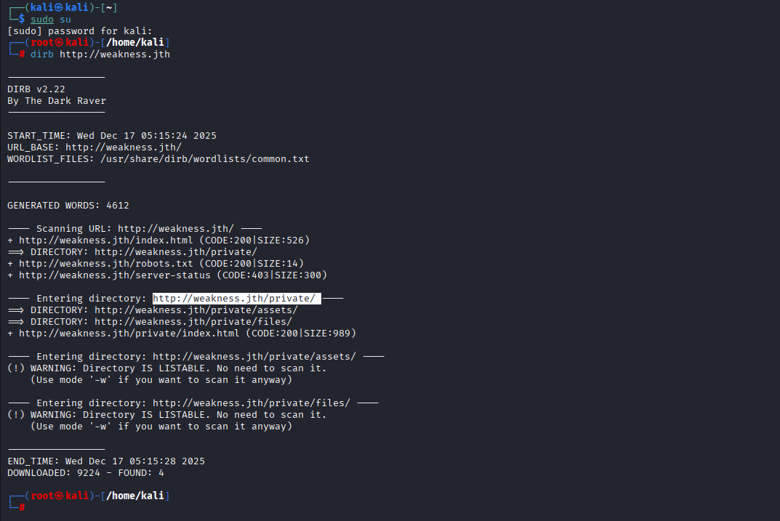

7. ANALYZING PRIVATE FILES
Browsed to /private and found two files.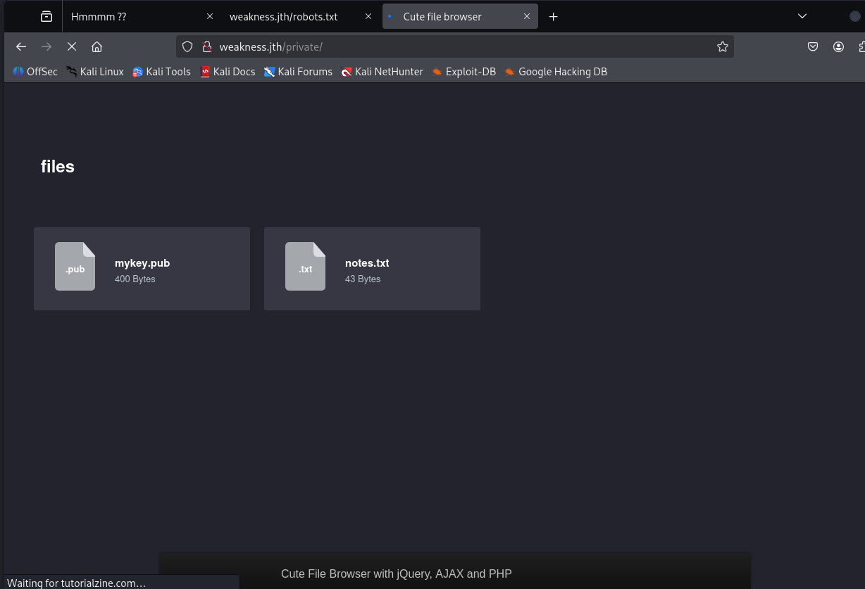
Downloaded the both file successfully .
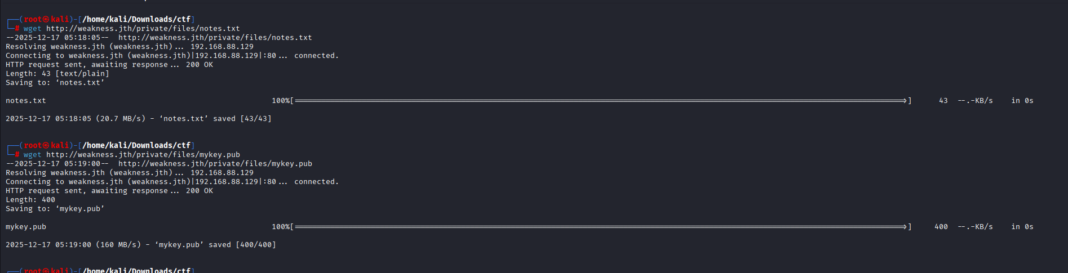Found:
- notes.txt – Contained a clue about OpenSSL 0.9.8c-1 and public key generation.
- mykey.pub – Contained an SSH RSA public key.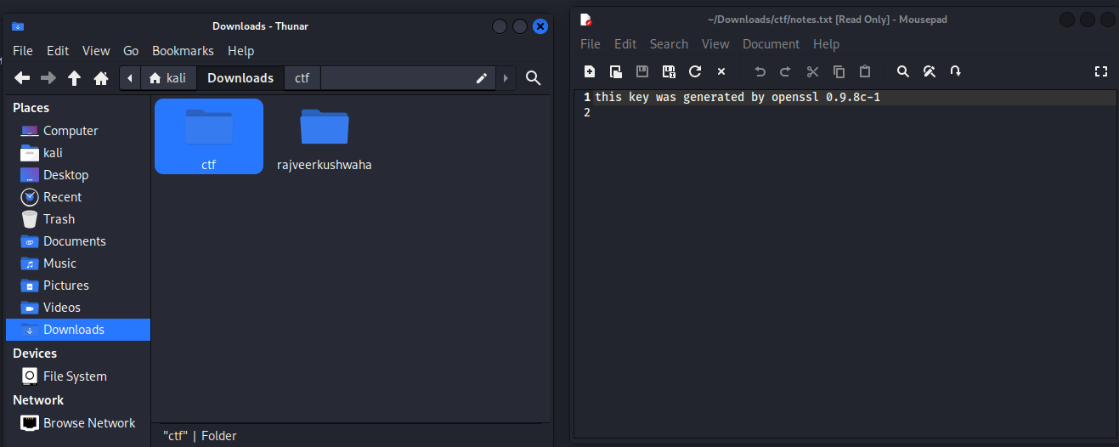

8. VULNERABILITY IDENTIFICATION
Searched for exploits related to OpenSSL 0.9.8c-1 and public key generation.
Vulnerability Identified: Debian OpenSSL Predictable PRNG attack (CVE-2008-0166), allowing private key deduction from a public key.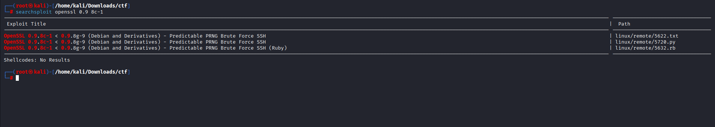

9. PRIVATE KEY RECOVERY
- Downloaded pre-generated vulnerable key pairs and matched the public key using grep.
- Downloaded that vulnerability by using the “wget” command and Later on Extracted the tar file by “tar -xsvf” .
- Then change the directory to “rsa” and locate the folder “2048” then view the public-key then copy it .
- Now by using the “grep -r -l <copied code >” then we will get the ssh code.
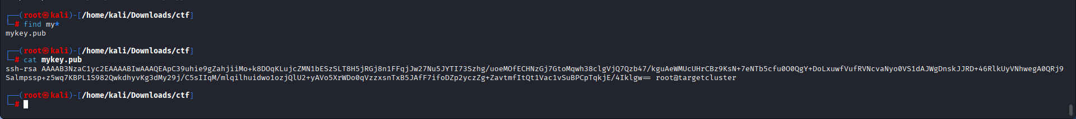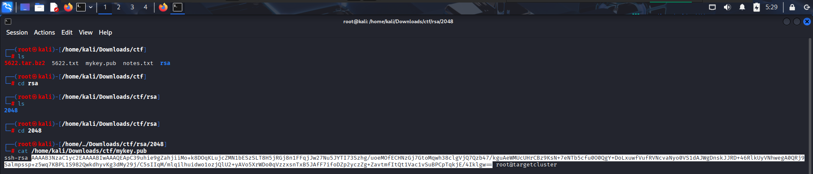
grep -r -l "ssh-rsa AAAAB3NzaC1yc2E..."

Result: Matching private key file identified as:
4161de56829de2fe64b9055711f531c1-2537

III. EXPLOITATION (USER ACCESS)

10. INITIAL ACCESS VIA SSH
Used the recovered private key with user n30 to log in via SSH.
Command:
ssh -i 4161de56829de2fe64b9055711f531c1-2537 n30@192.168.88.129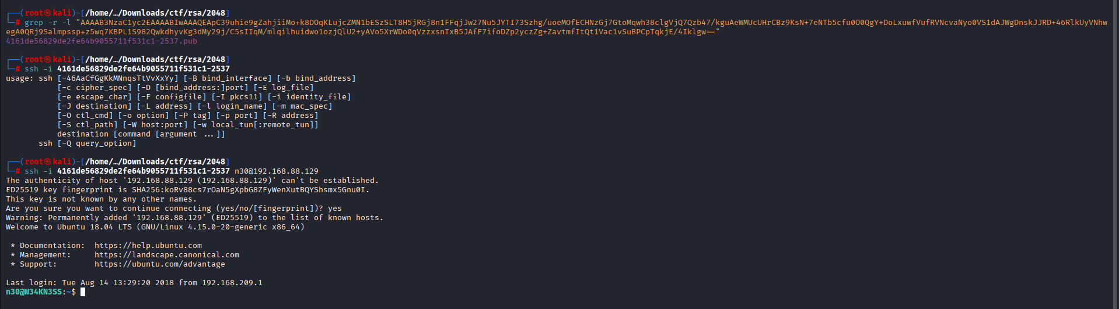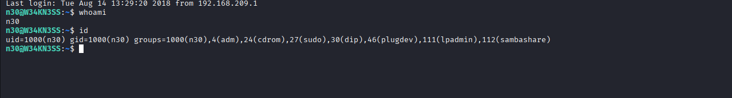

11. USER FLAG AND BINARY DISCOVERY
Enumerated the home directory.
Actions:
cat user.txt
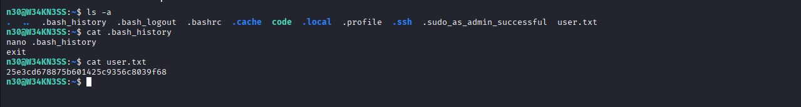
- Identified a compiled Python binary named code.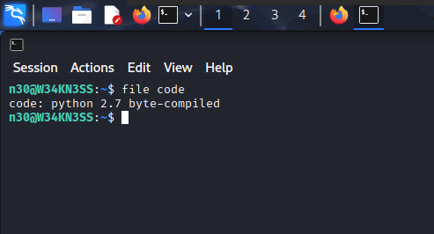

IV. PRIVILEGE ESCALATION (ROOT ACCESS)

12. TRANSFER AND DECOMPILATION
Transferred the binary to a web-accessible directory and decompiled it.
On target machine:
cp code /var/www/html
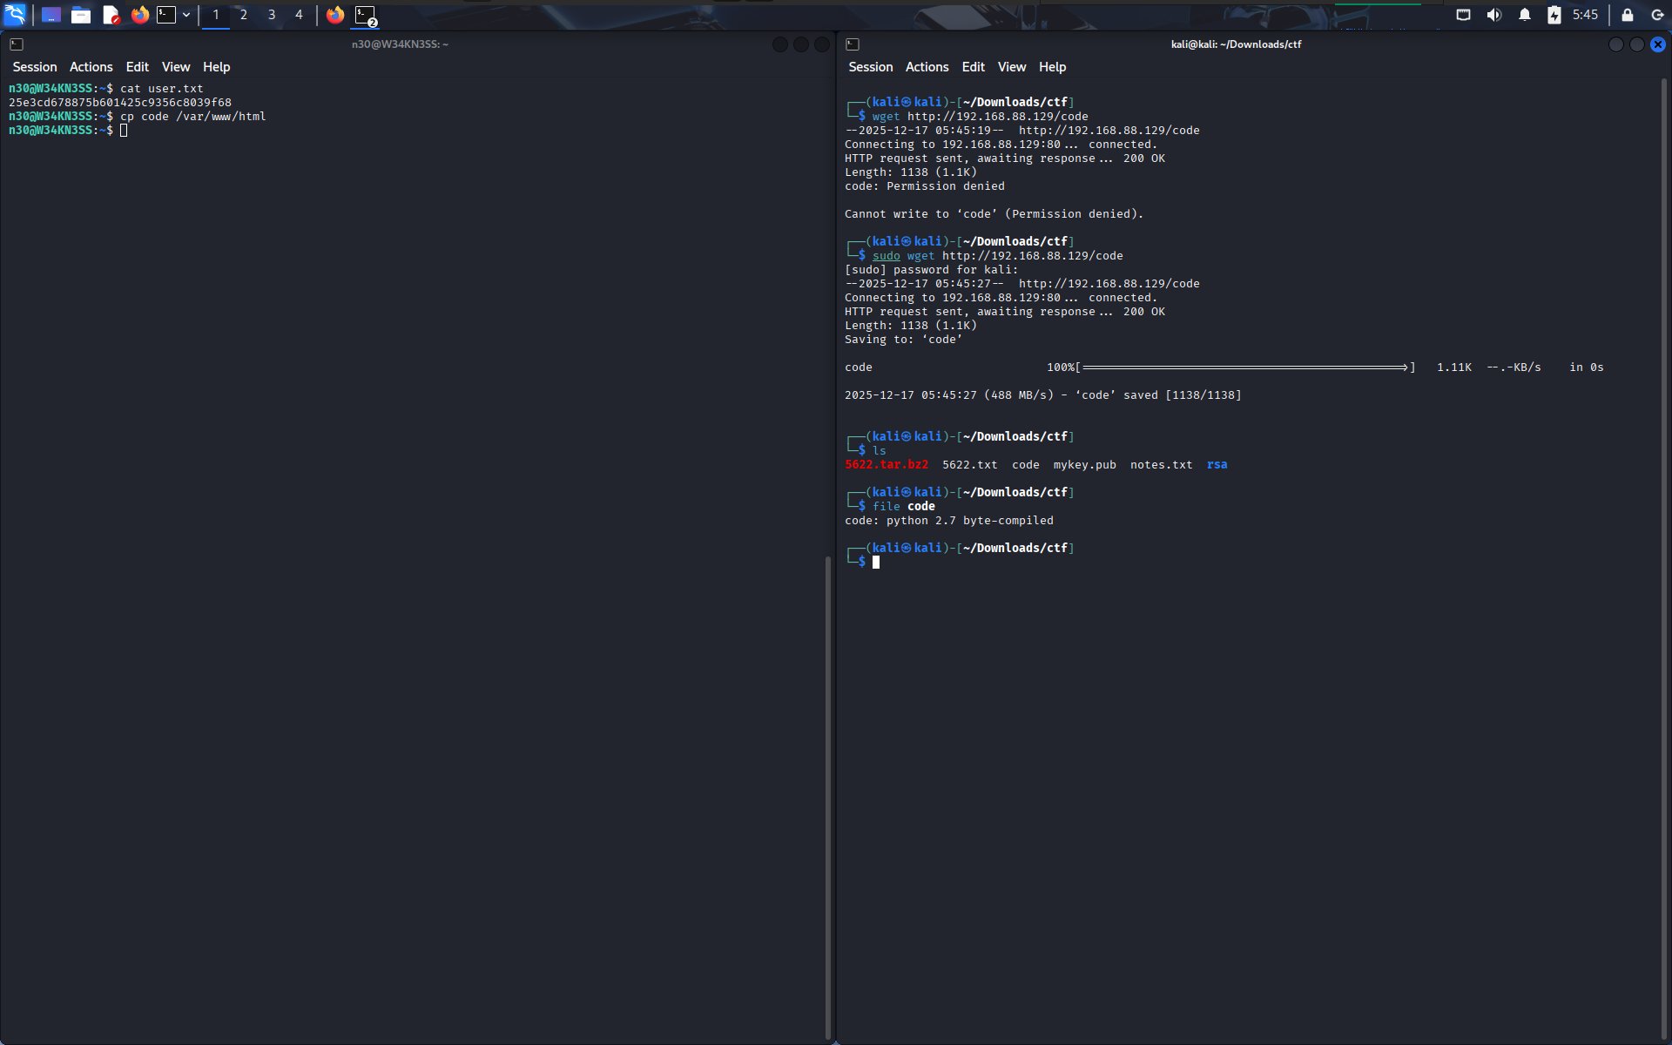
On attacker machine:
uncompyle6 code.pyc
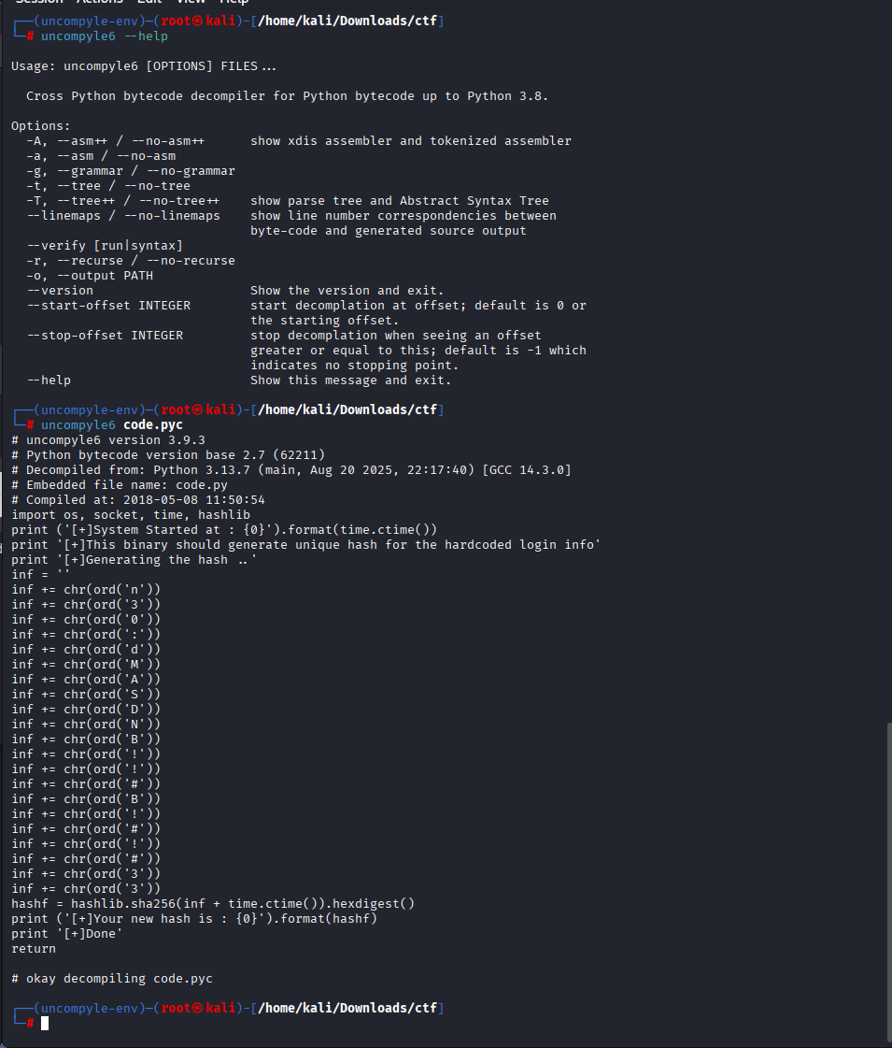
Result: Extracted credentials.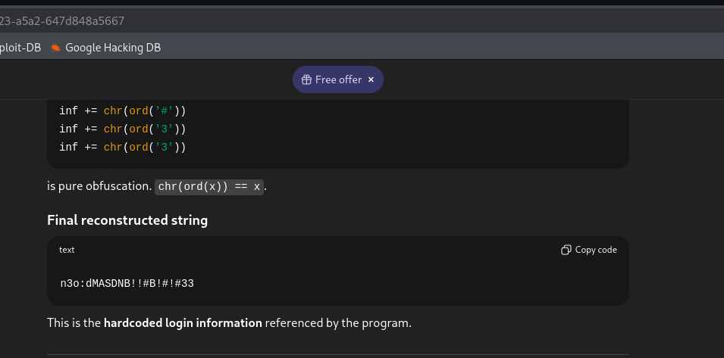
Username: n30
Password: dMASDNB!!#B!#!#33

13. SUDO PRIVILEGE CHECK
Checked sudo privileges for the current user.
Command:
sudo -l
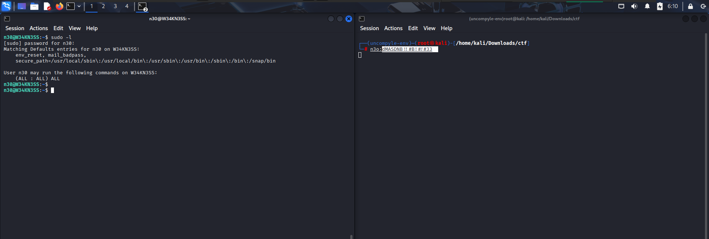
Result:
(ALL : ALL) ALL

14. GAINING ROOT ACCESS
Used sudo to switch to the root user.

Command:
sudo su -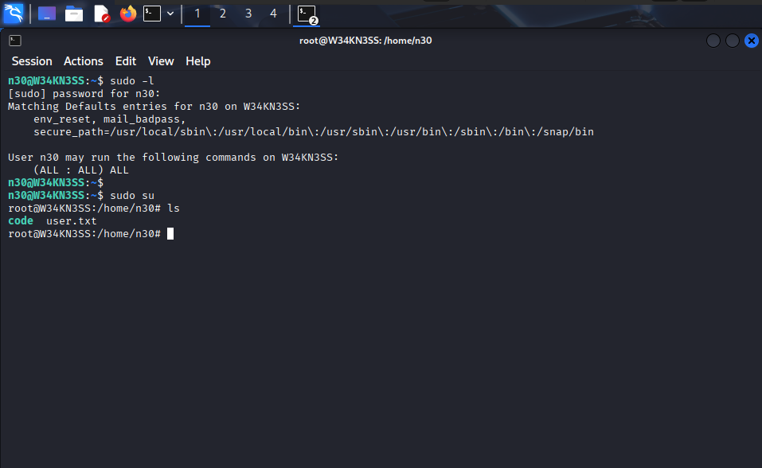

Congrats!! Root access successfully achieved.
By :-
RAJVEER KUSHWAHA

