

INFO1113 - S10

Final Project



November 28, 2018

Instructor: Dr.Abhijit Sen

**Authors: -**

Rajveer Sidhu (100367930), Rishi Parashar (100364055)

Ojesvee Chandel (100360066), Harmanpreet Kaur (100359525)

**GitHub URLs: -**

<https://github.com/rajveersidhu>

<https://github.com/ojesveechandel54>

<https://github.com/randp82>

<https://github.com/harmanpreetkaurr>

**WEB URLS: -**

<https://sites.google.com/view/phoneapp>

<https://sites.google.com/view/iproject10/>

<https://sites.google.com/view/mobileappliaction/>  
<https://sites.google.com/view/jeevanfoundationn/>

Contents

Executive Summary 2

Introduction 3

Project Requirements 4

Use – case Diagram 5

Use – case Description 6

Class Diagram 7

Class Diagram Description 8

Sequence Diagram 9

Interface Prototype 10

Project Experience 12

Conclusion 13

References 14

# Executive Summary

This project involves the design and construction of YouChat - an excessively easy application used for messaging. The primary aim of the task is to design and construct such an application which is functioned to successfully send messages, images, documents, animations, receive and make calls.

Initially, an individual feature of the application was designed separately. Team members brainstormed and integrated ideas for features. Sketches were created, and discussions were held regarding the proposed function of the features and the overall application.

Following the development of these designs, some features were made individually with other features. Early prototypes of these components included the use of the mobile application.

After making of the prototype, the application was modified to improve efficiency and overall functionality. Some features were updated by more efficient processes. In order to be quicker and more reliable, new updates were made to the application.

In the construction of the final application, some changes were made to improve stability, reliability, and effectiveness. 128-bit encryption feature was added to the final application to provide a shield to the messages and attachments from being read or opened by anyone except the intended recipients.

As such, the performance of the application during formal assessment is expected to be successful, providing no damage or unknown crashing occur prior to the final competition.

# Introduction

This application allows users to send texts, documents, photos, videos, contact information, and group messages using different forms of Internet access for android users, thus providing an alternative to standard SMS/MMS messaging for most users with devices running the latest Android versions. An individual feature of the application was designed separately. Team members brainstormed and integrated ideas for features. Sketches were created, and discussions were held regarding the proposed function of the features and the overall application.

# Project Requirements

* Android Operating System
* Storage Permission
* Contacts Permission
* Call logs
* Camera permission
* Location
* Microphone
* SMS Permission
* Notification
* Overlay Permission

# Use – case Diagram

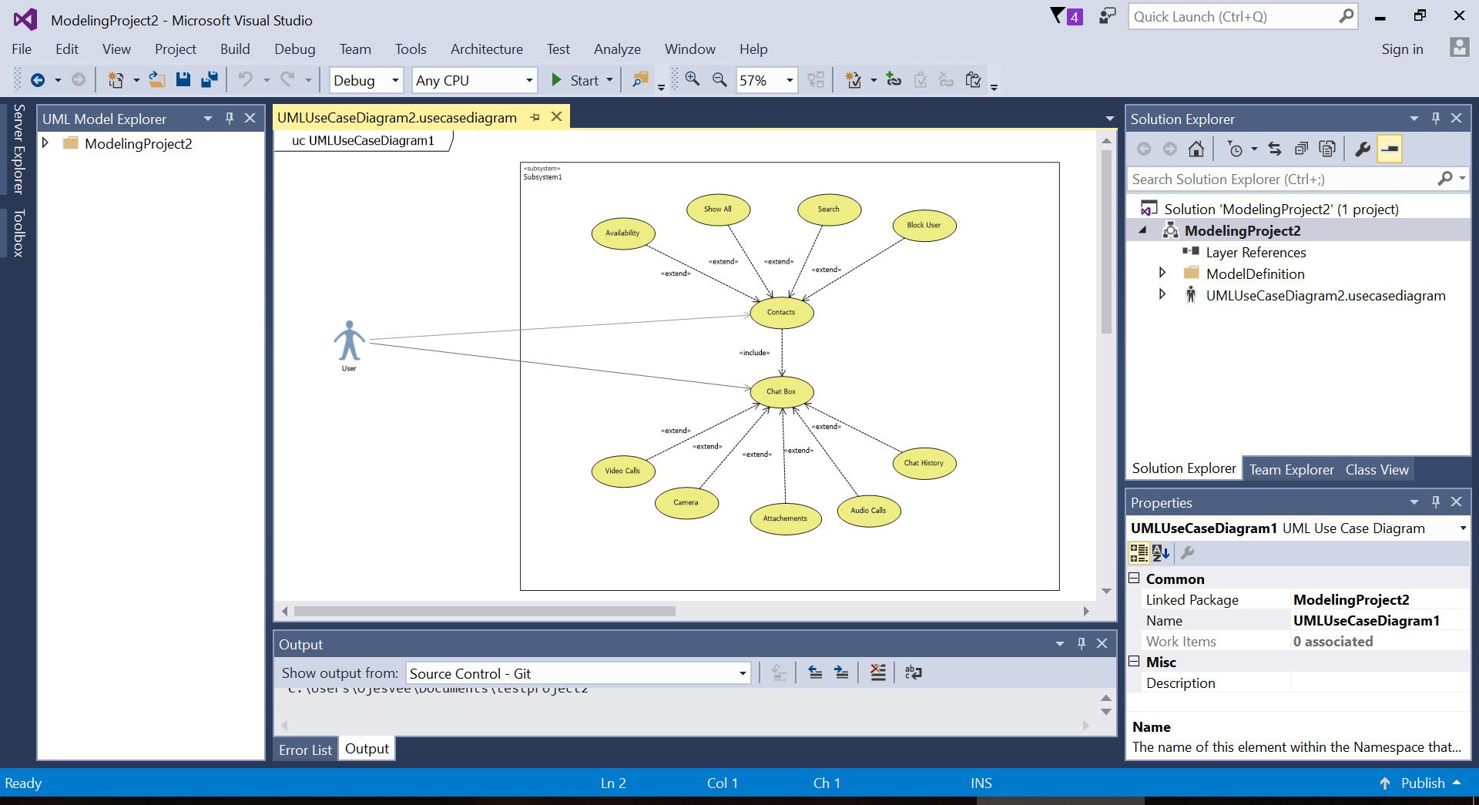

# Use – case Description

|  |
| --- |
| Use Case Title : Messaging app |
| Primary Actor : User |
| Level : Kite |
| Stakeholders : User, Developer |
| Precondition : User has to signup |
| Minimal guarantee : User can deactivate the account |
| Success guarantee : |
| Trigger : Login Screen |
| Main success scenario :   1. User can share media files. 2. User can exchange messages. 3. User can make call or videotelephony over the internet through app. |
| Extensions:  1a. Sending messages getting interrupted.  1a1. User can resend the message.  2a. App fails to show notification.  2a1. User can rerun the app.  2a2. User give permission for background process. |

# Class Diagram

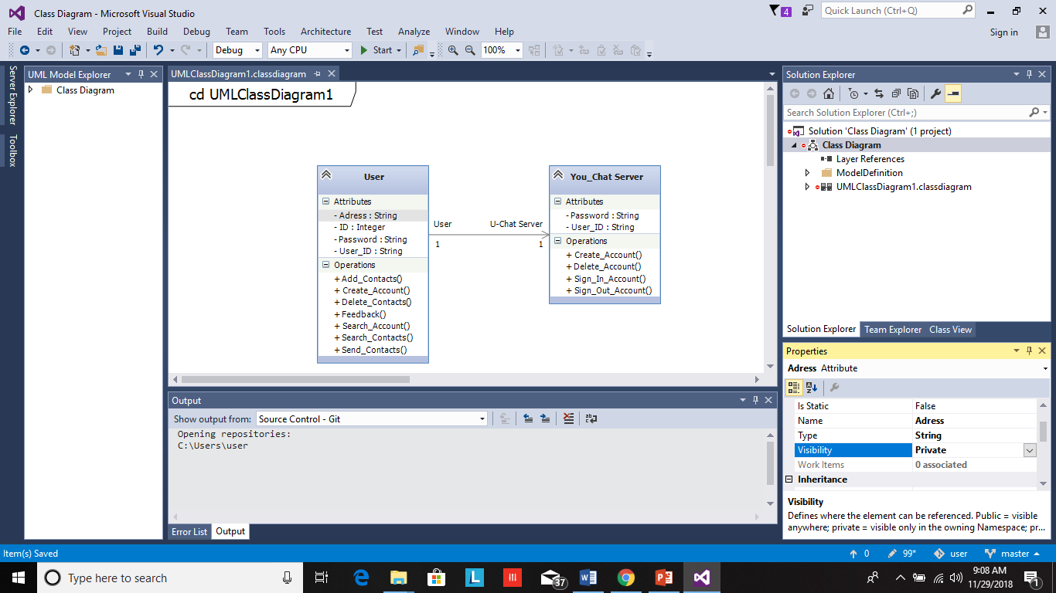

# Class Diagram Description

There are few types of attributes we need to be familiar with. Some of these are simple, composite and multivalued attributes. As per the definition of simple attributes drawn from the atomic value domains- User_ID and Password are single-valued attributes. Address consist of a hierarchy of attributes as address may consist street and suburb.

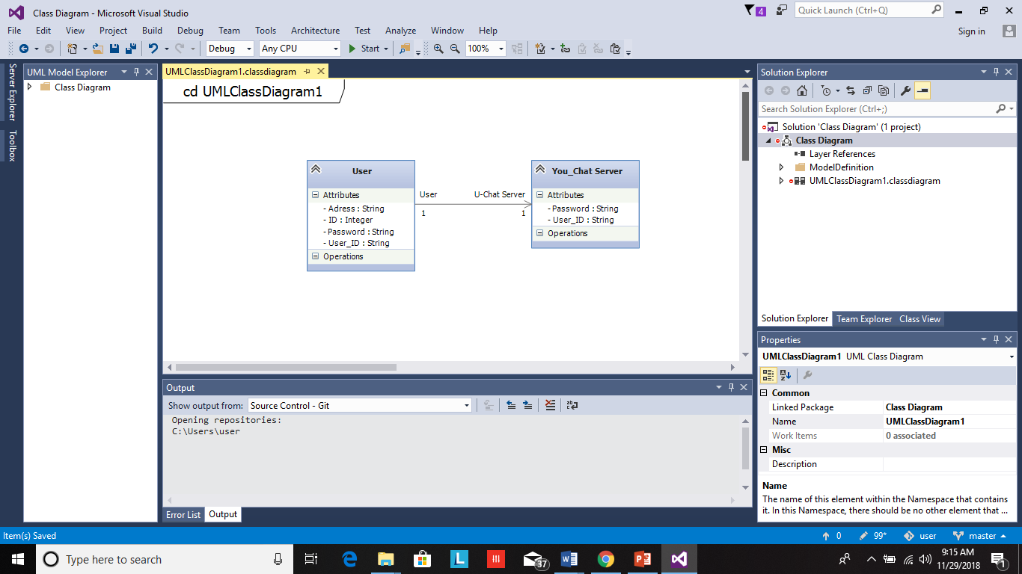

# Sequence Diagram

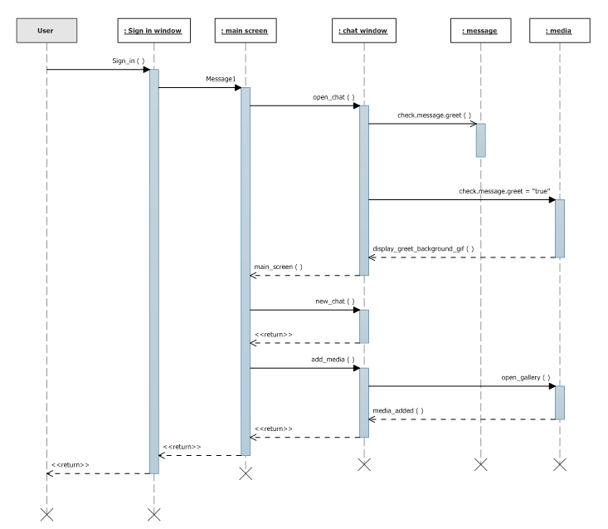

# Interface Prototype

Main Screen

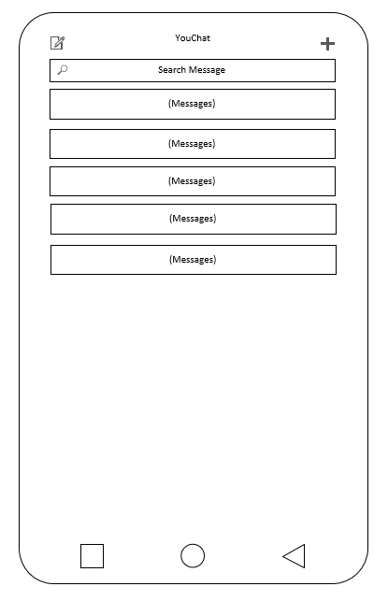

Chat Screen

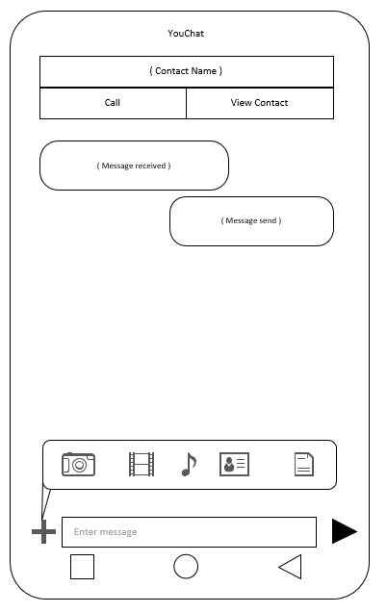

# Project Experience

At the beginning of the project, we experienced some trouble in pushing the files on GitHub, but we figured it out later by searching it on Google and YouTube. Later during the third assignment, we had some problem in making the description of the Use Case Diagram. We overcame that huddle by some group discussions and by downloading 2015 edition of Visual Studios.

# Conclusion

We conclude by saying that this document describes the use case of a Mobile Messaging Application. The documents include the features/ functions of the application. Use case diagram, sequence diagrams, interface prototype have also been attached, and files are pushed on Gitbash program for further reference.

# References

1. <https://www.google.ca/search?q=how+to+add+file+in+git+bash&rlz=1C1OCLT_enCA765CA765&oq=how+to+add+file+in+git+bash&aqs=chrome..69i57j0l3.8903j0j4&sourceid=chrome&ie=UTF-8#kpvalbx=1>
2. <https://visualstudio.microsoft.com/downloads/>