DEVOPS MICRO INTERNSHIP · DMI

Week 0

Internet, Networking & Tools Basics



Learn the foundations. Put them into practice. Share your progress.
By Pravin Mishra · The CloudAdvisory

Welcome to Your First Assignment
Explore networking basics, draw application architectures, set up VS Code, and share what you learn.
This document guides you through six tasks, with space for your answers, diagrams, and screenshots.

Student Details
Complete this section in your own copy.
Detail | Your Information
Full Name | Rajeswari Vemuri
Registration Email | rajvemuri1@gmail.com
Country / Timezone | India / GMT+5:30
LinkedIn Profile | https://www.linkedin.com/in/rajeswari-vemuri-9339a68a/
Start Here
Read How to Complete and Submit This Assignment on the next page before starting.

Need help?
Join the DMI Cohort 4 WhatsApp group to get help with assignments and receive the latest updates.
- Join the WhatsApp Group — Click here to join

How to Complete and Submit This Assignment

Step 1 - Make Your Own Copy
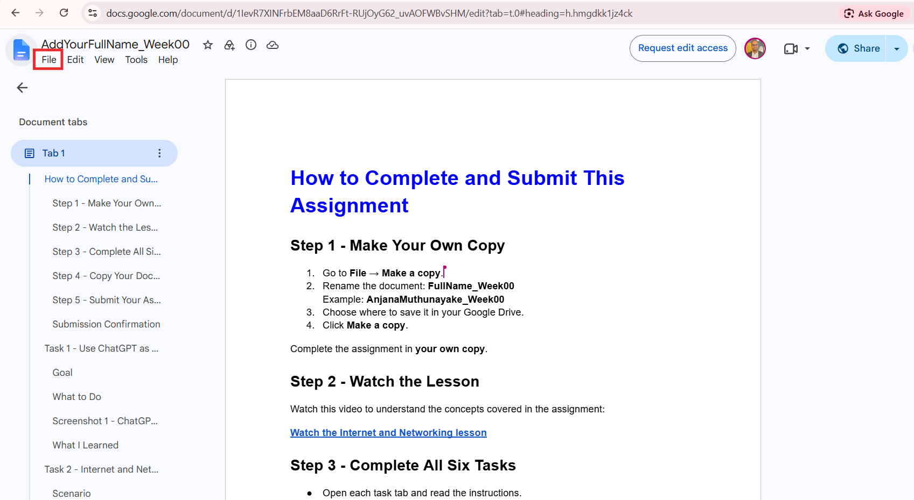
- Click File at the top-left of the document.

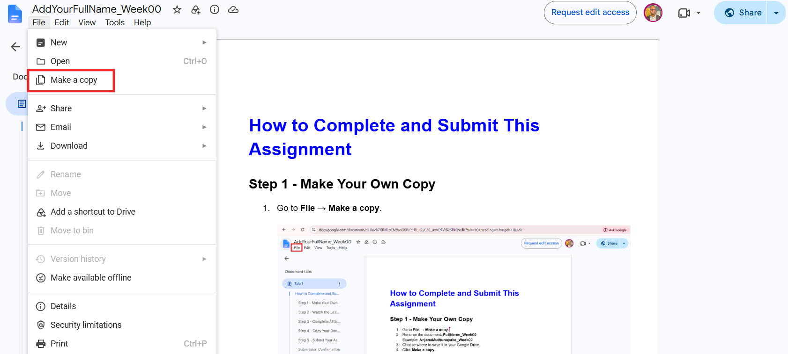
- Select Make a copy.

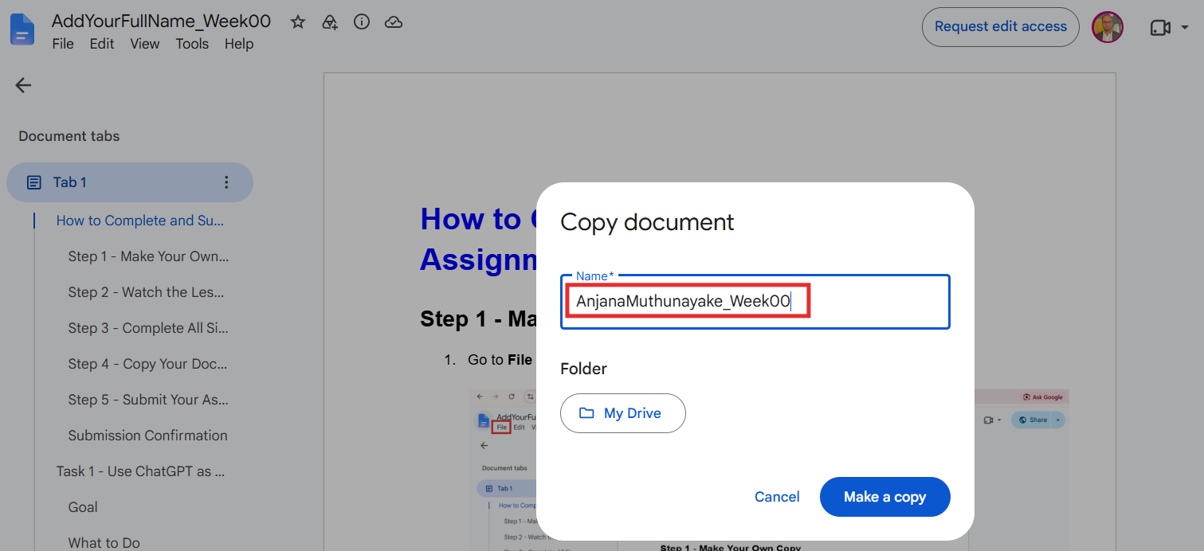
- Rename the document using this format: FullName_Week00
Example: AnjanaMuthunayake_Week00

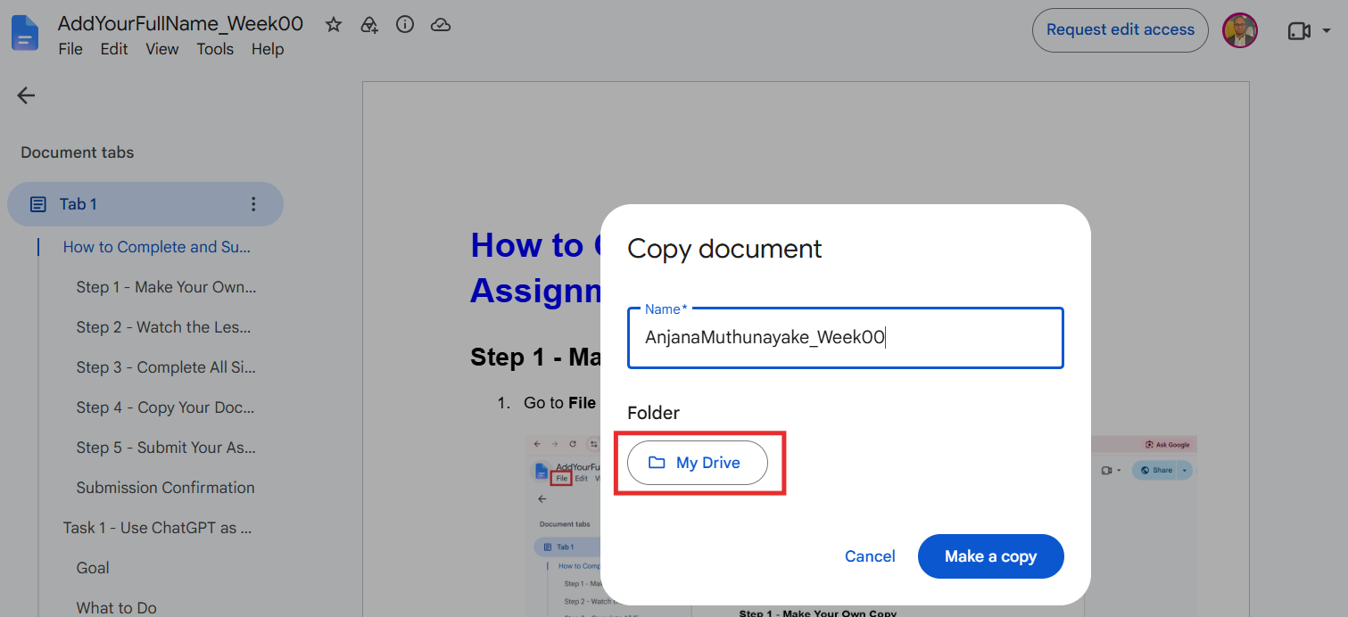
- Choose where to save your copy in Google Drive. You can select an existing folder or create a new one.

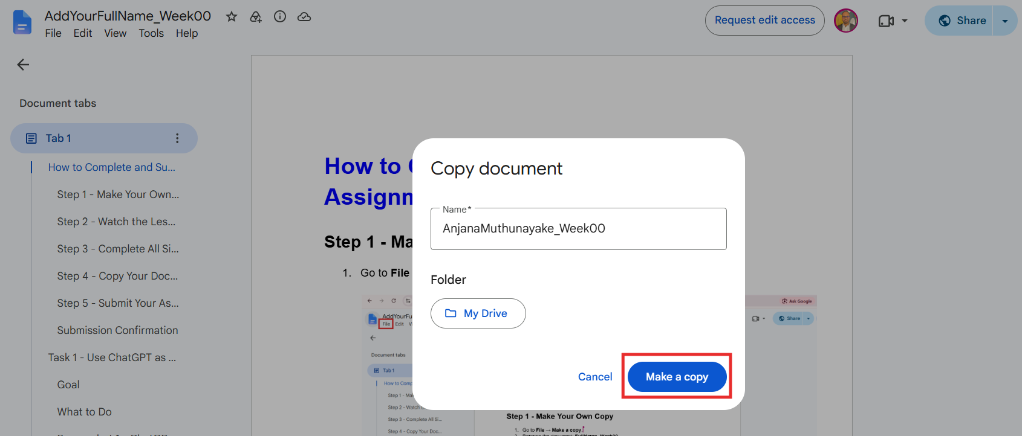
- After choosing the folder, return to the Copy document window and click Make a copy.

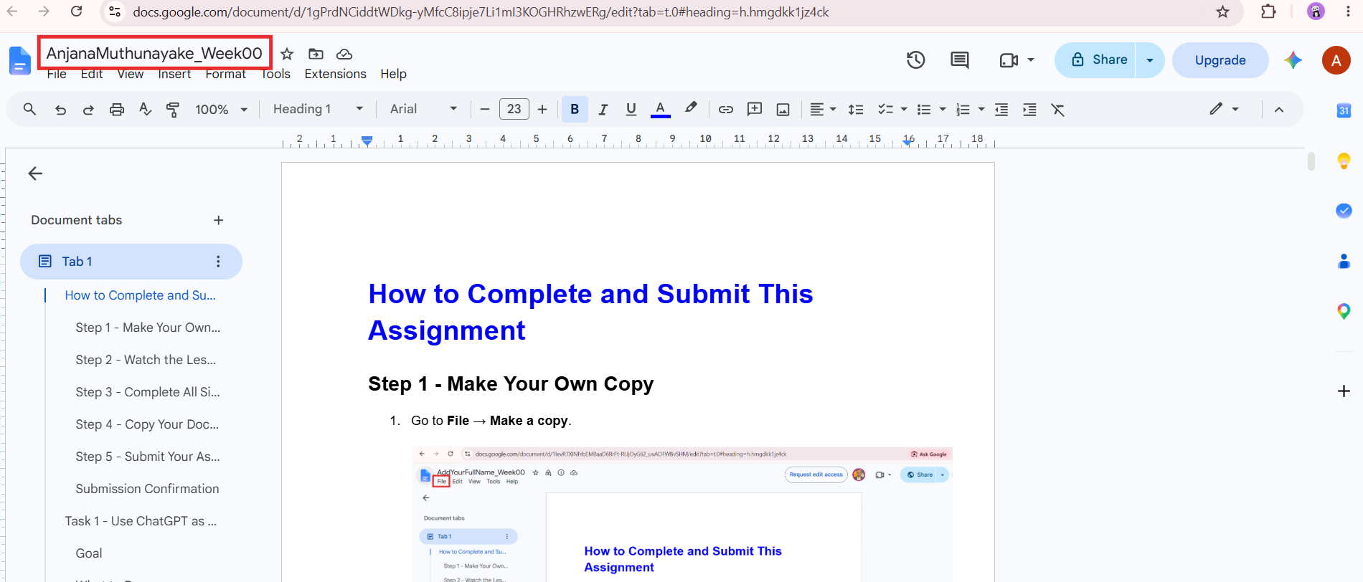
- Your copy will open in a new browser tab. Complete all six tasks in this copy.

Step 2 - Watch the Lesson
Watch this video to understand the concepts covered in the assignment:
Watch the Internet and Networking lesson

Step 3 — Complete All Six Tasks
Click a task below to jump to its instructions and answer section:
- Task 1 — ChatGPT as Your Learning Assistant
- Task 2 — Internet and Networking
- Task 3 — Application Architecture and Stack
- Task 4 — Domain Name and DNS
- Task 5 — Visual Studio Code Setup
- Task 6 — Share Your Learning on LinkedIn
Read the instructions, replace the placeholders with your own answers, and insert screenshots where requested. Keep the task instructions and complete all six tasks before submitting.

Step 4 — Share Your Document and Copy the Link
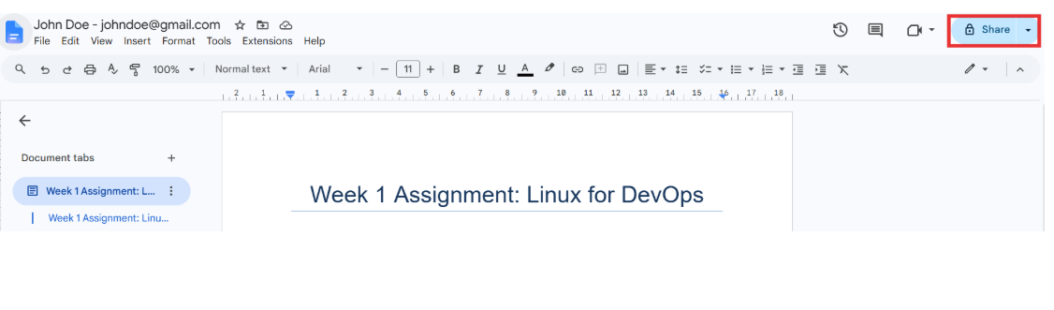
- Click the Share button in the top-right corner of your Google Doc.

- Under General Access, click the dropdown next to “Restricted”.
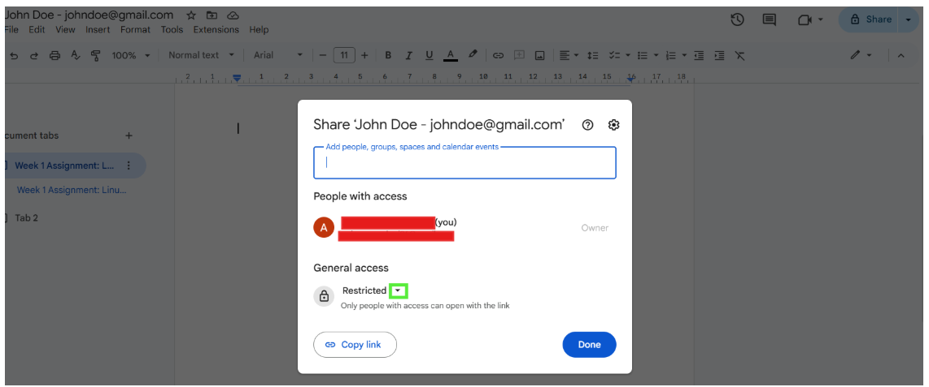

- Select: Anyone with the link
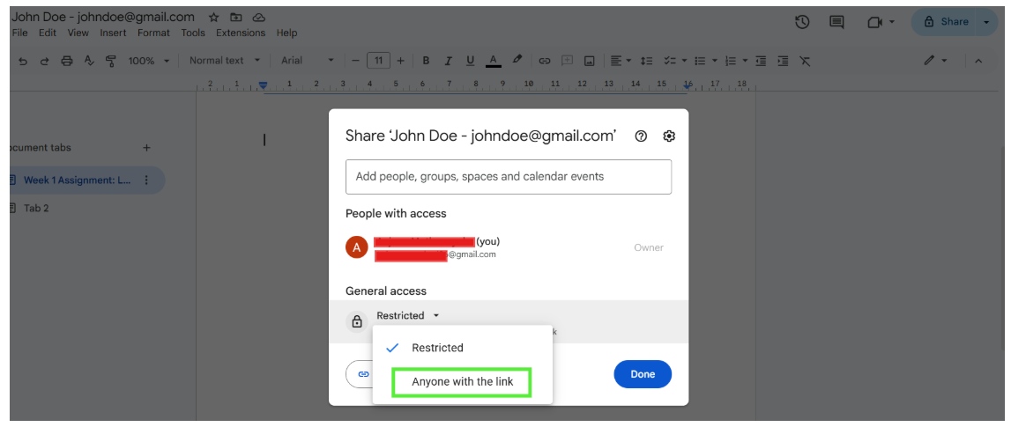

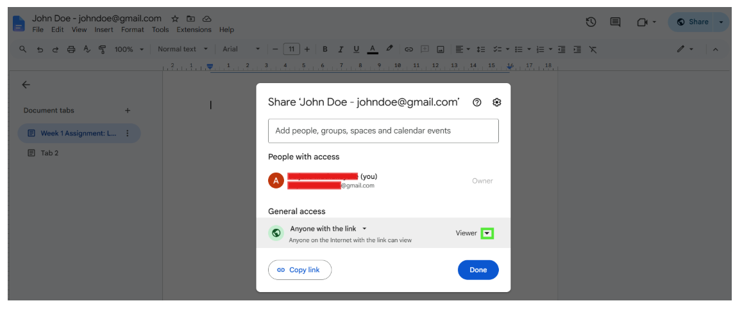
- Click the permission dropdown next to “Viewer”.

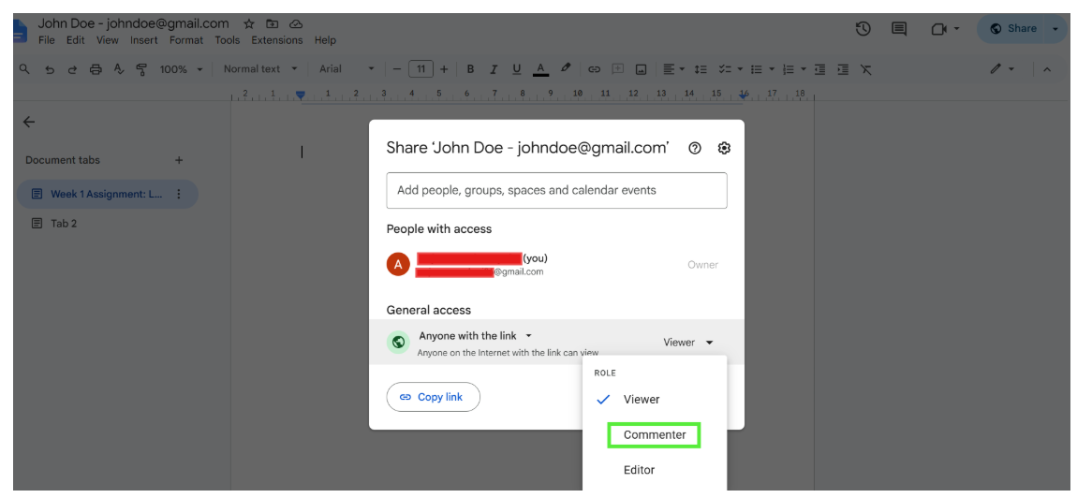
- Select: Commenter

- Click Copy link, then click Done.
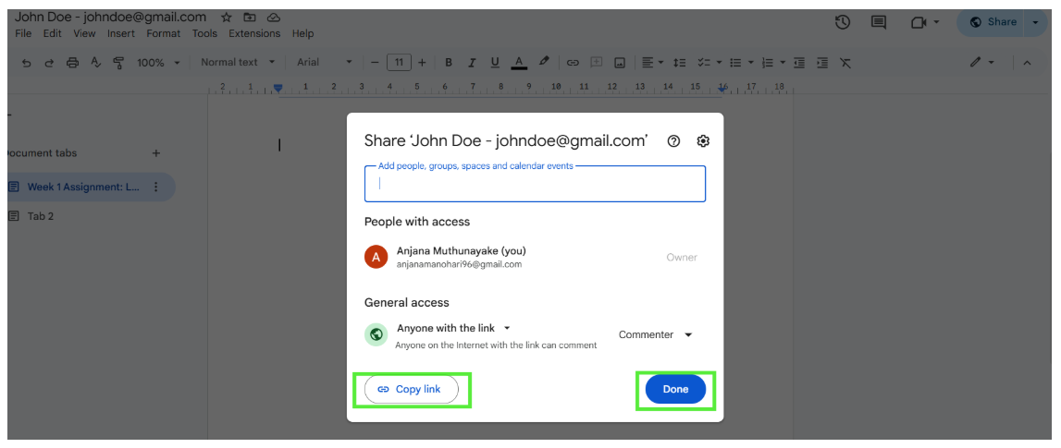

Result
Your document is now ready to share. Paste the copied link into the Google Doc URL field in the assignment submission form.
Before submitting: Open the copied link in a private/incognito browser window. Make sure your document opens without requesting access.

Step 5 - Submit Your Assignment
Open the submission form below and paste your completed Google Doc link into the assignment-link field.
- Submission form: Click here
Enter your details carefully, including your email address, then submit the form.
Submit the link to your completed copy, not the original template.

Submission Confirmation
After submitting the form, you will receive an email confirming that your assignment has been submitted. Check your spam or junk folder if you do not see it in your inbox.
This email confirms submission; it does not mean your assignment has been reviewed or approved.

Task 1 - Use ChatGPT as Your Learning Assistant

Goal
Learn how to ask ChatGPT a clear question and use it to understand a basic networking concept.

What to Do
- Open ChatGPT.
- Write your own prompt asking: “What is a protocol in networking?” Ask for beginner-friendly language and a simple real-life example.
- Read the response. If something is unclear, ask a follow-up question.
- Take a clear screenshot showing your prompt and ChatGPT’s explanation with the example.
- Insert your screenshot below and write 2–3 lines about what you learned.
Tip: A prompt is simply the question or instruction you give ChatGPT. Explain that you are a beginner and describe the kind of answer you need.
Remember: Use ChatGPT to help you understand. Write your learning summary and answers to later tasks in your own words.

Screenshot 1 - ChatGPT Interaction
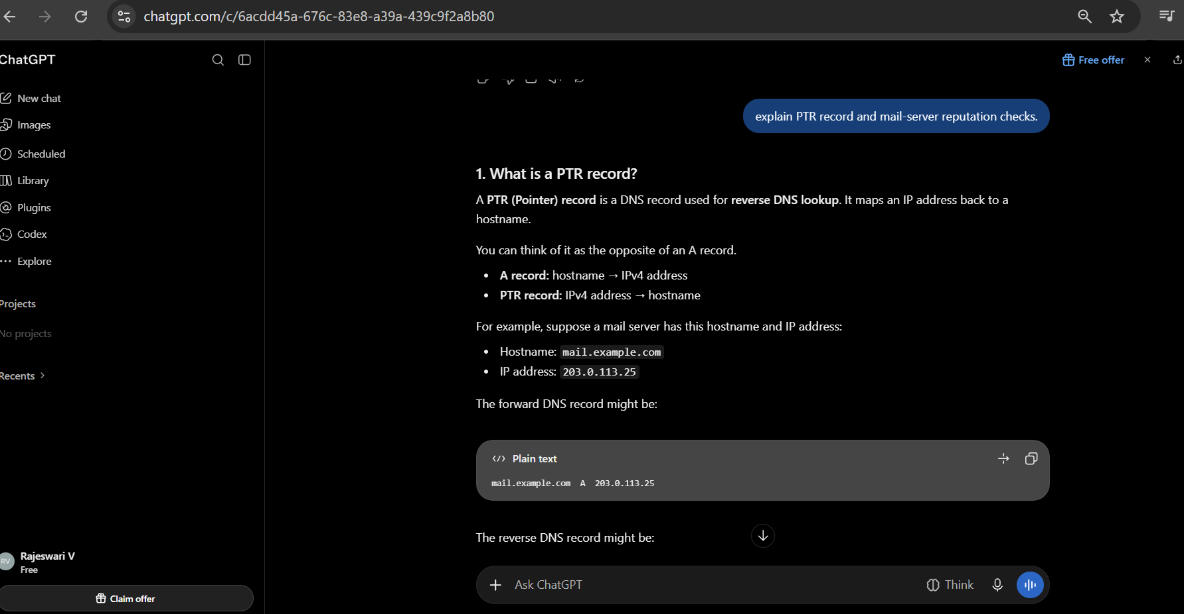

What I Learned
A PTR (Pointer) record is a DNS record used for reverse DNS lookup. It maps an IP address back to a hostname. When one mail server sends an email to another, the receiving server wants to assess whether the sending server looks legitimate. For example, imagine you send an email from user@example.com to person@gmail.com.
- The sending mail server connects to the receiving mail server.
- The receiving server identifies the sender's public IP address.
- It may perform a reverse DNS lookup to find the hostname associated with that IP.
- It may check whether the hostname resolves back to the same IP address.
- It combines these results with other signals to decide whether to accept the email, flag it as suspicious, or reject it.

Task 2 - Internet and Networking

Scenario
Your friend is launching an online bookstore named EpicReads. The website is hosted in Finland, and he wants to understand how someone in the USA can access it.

What to Do
- Write a 100 - 150-word explanation describing how a user in the USA accesses the EpicReads website hosted in Finland.
- Your explanation must clearly cover these concepts and briefly explain their roles:
  - Packet switching
  - IP address
  - TCP/IP
  - HTTP/HTTPS
- Read your explanation again to check that it is clear and written in your own words.
Tip: You can use ChatGPT to help you understand these concepts, as you did in Task 1. Then explain what you understood in your own words.
No screenshot is required for this task.

Your Answer
Step 1: The user enters the website address
The user types https://www.epicreads.example into a browser.
The browser needs to find the server hosting the website. Since it has a domain name rather than the server's IP address, it typically uses DNS to look up the IP address.
Step 2: The browser establishes a connection
The browser uses TCP/IP to communicate with the server.
- IP (Internet Protocol) provides addressing and routing so packets can travel from the user's device to the server.
- TCP (Transmission Control Protocol) establishes a connection and helps deliver data reliably and in the correct order.
For HTTPS, the browser also establishes TLS security, which encrypts the communication.
Step 3: The browser sends an HTTPS request
The browser sends an HTTP request, such as:
GET / HTTP/1.1
Host: www.epicreads.example
This is a simplified HTTP request example. In a real HTTPS connection, the HTTP data is encrypted while travelling between the browser and the server.
HTTP/HTTPS roles:
- HTTP defines how browsers request resources and how web servers respond.
- HTTPS is HTTP protected by TLS, providing encryption, integrity and server authentication.
Step 4: Packet switching moves the data across the internet
The request is carried across the user's local network, internet service provider and multiple interconnected networks toward Finland.
The data is divided into packets. Routers examine packet headers and forward packets toward their destinations using routing information.
This is called packet switching.
- Different packets may travel through different routes.
- Packets may arrive at different times or out of order.
- TCP reorders received data and retransmits missing data when necessary.
The internet does not need one dedicated communication path reserved for the entire conversation.
Step 5: The server in Finland responds
The EpicReads server receives the request, processes it and returns the requested HTML page and other resources, such as CSS, JavaScript and images.
The response travels back through networks to the user's device. The browser assembles the received data and displays the website.

Task 3 - Application Architecture and Stack

Scenario
The EpicReads bookstore has two application versions:
- Two-tier application: Frontend and Database
- Three-tier application: Frontend, Backend, and Database

What to Do
- Draw two separate architecture diagrams:
  - A two-tier diagram showing Frontend ↔ Database.
  - A three-tier diagram showing Frontend ↔ Backend ↔ Database.
- Label each layer clearly and use arrows to show the direction of communication between the layers.
- List at least two common technologies or tools for each layer: Frontend, Backend, and Database. Add these to the table below.
- Take a clear screenshot or photo of your diagrams and insert it below. You may include both diagrams in one image or insert them separately.
Note: You can draw by hand or use a tool such as draw.io. Create your own diagrams and make sure all labels and arrows are readable.

Screenshot 2 - Application Architecture Diagrams
Two-Tier Application
1. Two-tier architecture
Two-tier architecture is also called client-server architecture. The client communicates directly with the database server.

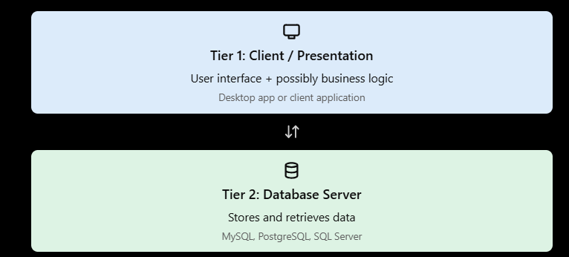
How it works
Imagine a desktop banking application.
- The user enters an account number in the client application.
- The client sends a database query directly to the database server.
- The database retrieves the account details.
- The database returns the result to the client.
- The client displays the account details.
Where does business logic run?
Business logic can run inside the client application, while the database handles data storage and queries. Some logic may also reside in database procedures.
Advantages
- Simple to develop and deploy.
- Suitable for small applications and local networks.
- Fewer components to manage.
Disadvantages
- Direct database access can create security risks.
- Difficult to manage many clients as the application grows.
- Updating business logic may require updating every client application.
Example: A desktop inventory application that connects directly to a SQL Server database.
Three-Tier Application
Three-tier architecture separates the application into three distinct tiers:
- Presentation tier
- Application or business logic tier
- Data tier
The client does not communicate directly with the database. It communicates through the application server.

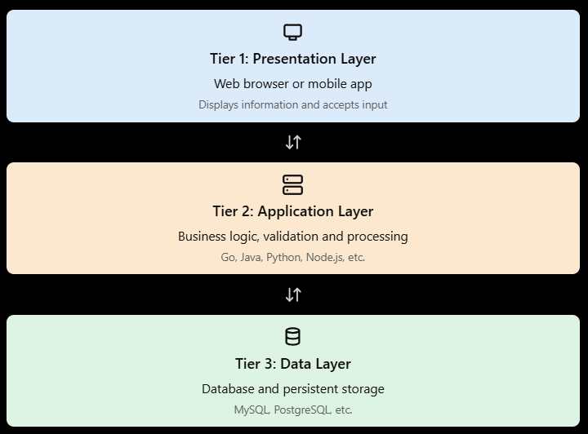
How it works
Consider an online shopping application.
- The user clicks Place Order in a web browser.
- The browser sends a request to the application server.
- The application server validates the order, checks the price and calculates the total.
- The application server sends the necessary query to the database.
- The database saves the order and returns the result.
- The application server sends a response to the browser.
- The browser displays the order confirmation.
Where does business logic run?
The main business logic runs in the application tier, not directly in the browser or database.
Advantages
- Better security because clients do not need direct database access.
- Easier to maintain and update business logic centrally.
- Can scale the application tier independently.
- Supports many clients and complex applications.
Disadvantages
- More components to develop and maintain.
- More infrastructure and deployment complexity.
- Communication between tiers adds some overhead.
Example: An e-commerce website built with a web frontend, a Go or Java backend, and a PostgreSQL database.

Technologies / Tools for Each Layer
Layer | Technology / Tool 1 | Technology / Tool 2
Frontend | React + JavaScript | Swift (iOS), Kotlin (Android)
Backend | Go (Golang) | Python
Database | MongoDB | MySQL

Task 4 - Domain Name and DNS

Scenario
Your friend’s bookstore, EpicReads, is accessible at 52.172.142.222:3000. He has purchased the domain epicreads.com and wants to connect it to his server.

What to Do
Write a 50–100-word explanation in your own words covering:
- What is DNS (Domain Name System)?
- Which DNS record type should be used to connect epicreads.com to 52.172.142.222, and why?
Keep your explanation conceptual. Detailed DNS configuration steps are not required.
Important: DNS maps the domain to the server’s IP address. It does not configure port 3000, which is handled separately.
No screenshot is required for this task.

Your Answer
DNS (Domain Name System) is a system that translates human-readable domain names, such as epicreads.com, into IP addresses that computers use to locate servers on the internet.
The correct DNS record type is an A record.
An A record maps a domain name to an IPv4 address.
The DNS record would be configured as follows:
Field | Value
Record type | A
Host / Name | @
Value / IPv4 address | 52.172.142.222
TTL | Default value from the DNS provider
Here, @ represents the root domain, epicreads.com.
The IP address 52.172.142.222 is an IPv4 address. An A record connects the domain epicreads.com to that IP address, allowing DNS resolvers to find the server.

Task 5 - Visual Studio Code Setup

Goal
Set up Visual Studio Code (VS Code) and run basic commands in its built-in terminal.

What to Do
- Install Visual Studio Code if it is not already installed, then open it.
- Select and apply a theme of your choice.
- Open the terminal using Terminal → New Terminal.
- Run the commands for your operating system, one at a time.
Windows (PowerShell or Command Prompt):
dir
Linux / macOS:
pwd
ls
- Take a clear screenshot showing:
  - Your VS Code window and selected theme.
  - The terminal with the command and its output.

Screenshot 3 - VS Code Setup
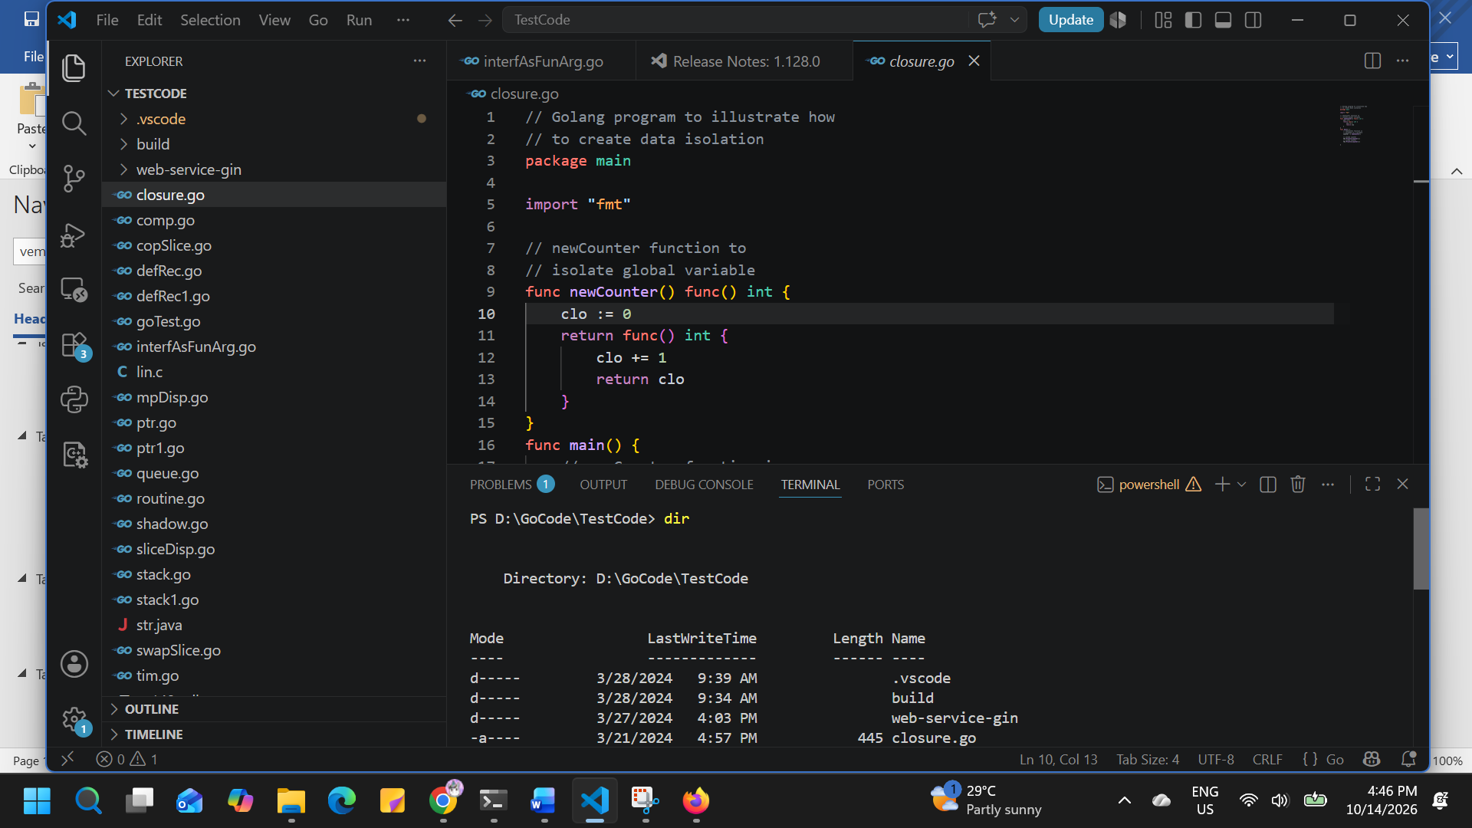

Task 6 - Share Your Learning on LinkedIn

Goal
Share what you learned in Tasks 1–5 and document your Week 0 DevOps learning journey.

What to Do
- Create a LinkedIn post summarizing your learning in your own words. Include a short section for each topic:
  - ChatGPT: How you used it to understand a networking protocol.
  - Internet & Networking: How users access a website hosted in another country.
  - Application Architecture: What you learned about two-tier and three-tier applications.
  - DNS: How a domain name connects to an IP address.
  - VS Code Setup: Your experience setting up VS Code and using its terminal.
- Add screenshots or diagrams from your completed assignment.
- Include this credit note at the end of your post:
P.S. This post is part of the DevOps Micro Internship (DMI) with Agentic AI — Cohort 4 by Pravin Mishra. Want to build practical DevOps skills through hands-on assignments and projects? Join the DMI Cohort 4 waiting list: https://docs.google.com/forms/d/e/1FAIpQLSdJTrzJi33PvpccoAiPOaN2RuYpPEk_ltzRQsEqM6YbkYEBCg/viewform
- Tag Pravin Mishra: Linkedin Profile - www.linkedin.com/in/pravin-mishra-aws-trainer
- Add these hashtags:
#DMIByPravinMishra #AgenticAI #DevOps
- Publish the post with visibility set to Anyone so reviewers can access it.
- Paste the published post link below.
- Take a screenshot showing your published post and profile name, and insert it below.

LinkedIn Post URL
https://lnkd.in/p/d-cnuyES

Screenshot 4 - Published LinkedIn Post
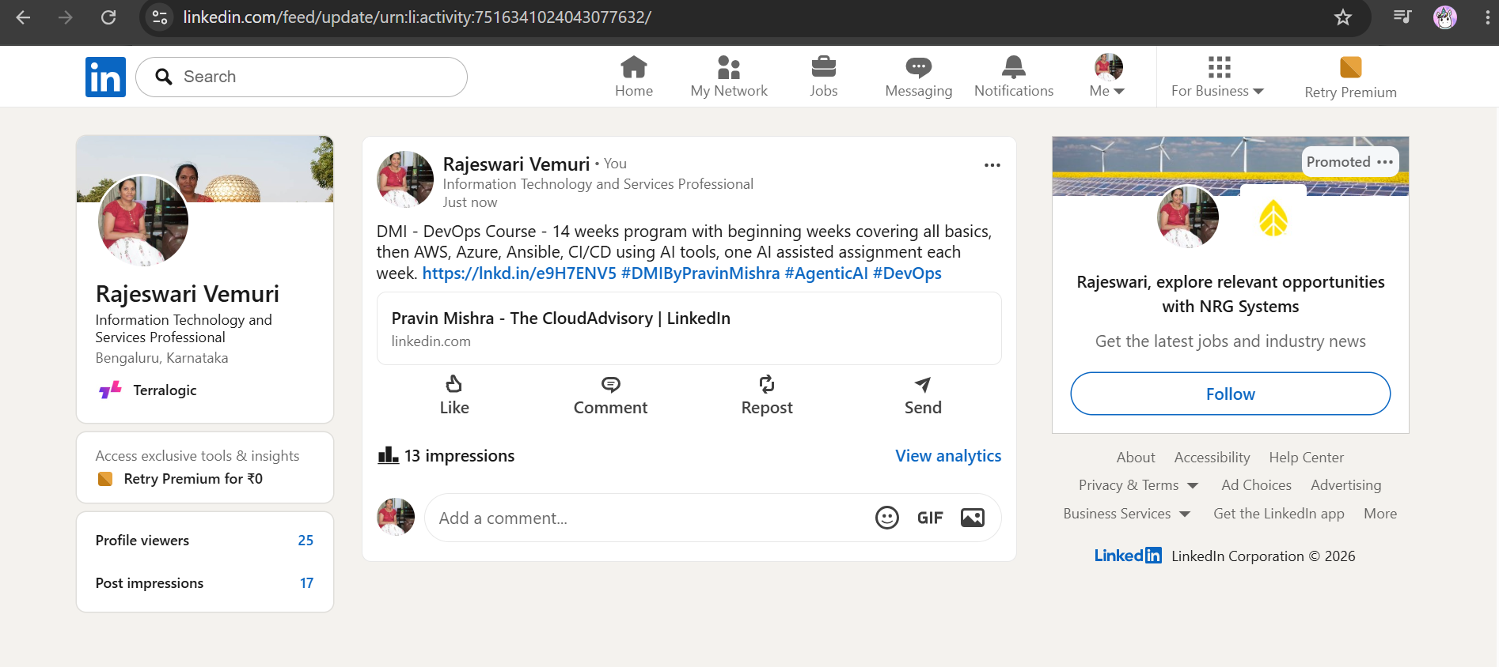

LinkedIn Post Backup Copy
DMI - DevOps Course - 14 weeks program with beginning weeks covering all basics, then AWS, Azure, Ansible, CI/CD using AI tools, one AI assisted assignment each week.
How to Add a Clickable Link:

- Copy the link you need to add
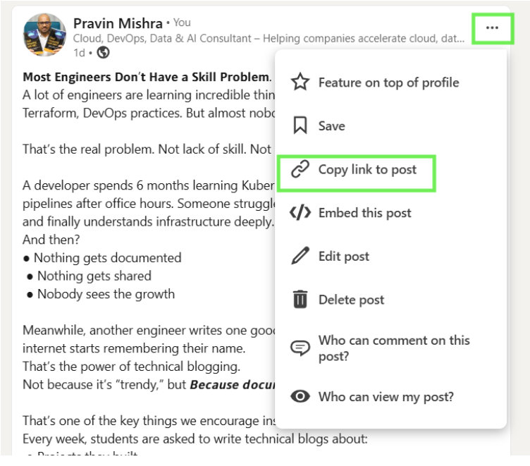

- Paste it into the document

- Select the pasted link
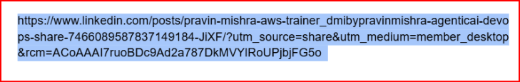

- Right click & select ‘Insert link’
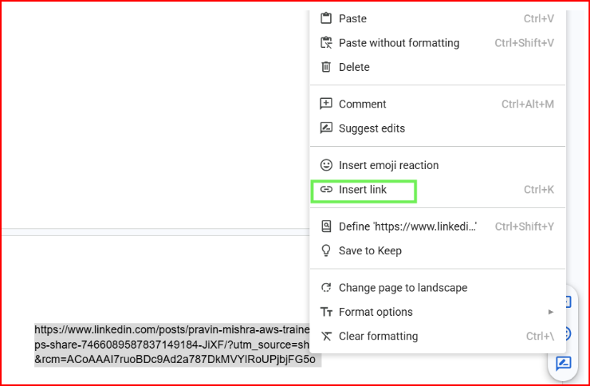

- The text will now become a clickable link.

https://www.linkedin.com/posts/pravin-mishra-aws-trainer_dmibypravinmishra-agenticai-devops-share-7466089587837149184-JiXF/?utm_source=share&utm_medium=member_desktop&rcm=ACoAAAI7ruoBDc9Ad2a787DkMVYlRoUPjbjFG5o

LinkedIn posting tips:

- Do not add IP addresses in your LinkedIn post.

Examples:
127.0.0.1
54.20.30.2

- Do not add fake website-style text.

Example:
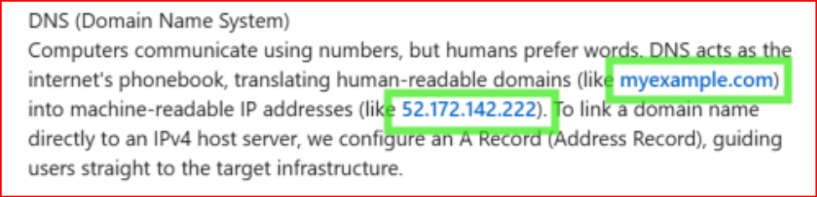
myexample.com

Reason for this:
- LinkedIn may detect these as website links.
- If that happens, your post may not display properly or the link may not work.
- In some cases, LinkedIn may show an error like: “This post cannot be displayed.”

This is what can happen if you include them:

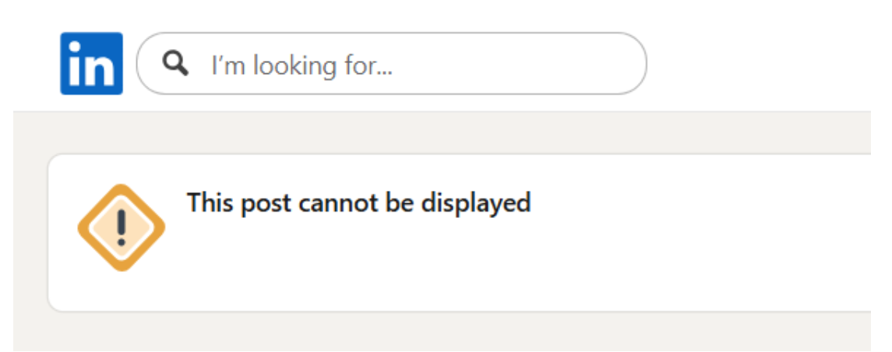

If you still need to show them:
- Use commas instead of dots
Examples:
127,0,0,1
myexample,com
