The Stack Beneath the Signal: Enterprise IT Explained
LegacyForward.ai
Table of Contents

Why You Need to Understand IT Before You Touch AI
Every enterprise AI initiative starts the same way. Someone in leadership sees a demo, reads an article, or attends a conference. They come back energized: “We need to do this. What’s stopping us?”
The answer is almost never the AI itself.
The answer is almost always the infrastructure underneath it. The systems that have been running for twenty, thirty, sometimes forty years. The data that lives in seven different places in seven different formats. The integration layer that was stitched together over a decade of mergers and quick fixes. The vendor contract that makes switching painful. The process that nobody documented because the person who understood it retired in 2018.
This is what enterprise IT actually looks like. Not the clean architecture diagrams on vendor whiteboards. The real thing.

Why This Book Exists
Most books about AI in the enterprise assume you already understand the technology stack. They jump straight to machine learning models, vector databases, and agent frameworks. They treat the underlying infrastructure as a given.
But for many people, business leaders, product managers, career pivoters, consultants, and even technical people new to enterprise environments, the stack is not a given. It is a mystery. A slow-moving, highly political, surprisingly expensive mystery.
This book explains the mystery.
It is not a technical manual. There is no code. There are no architecture diagrams requiring a computer science degree to read. This book explains enterprise technology the way you would explain it to a smart colleague who just joined the company and needs to understand why nothing works the way they expected.

What You Will Learn
The book is organized in four parts.
Part One: The Foundation covers the basics: what makes enterprise IT different from consumer technology, how systems are layered, what legacy actually means, why mainframes still exist, and how enterprise resource planning systems became the spine of global business.
Part Two: The Modern Layer explains what got built on top of the foundation over the last twenty years: cloud computing, software-as-a-service, commercial off-the-shelf software, APIs, and the data infrastructure that sits beneath analytics and AI.
Part Three: The IT Sprawl Problem gets into how things get complicated. Every organization accumulates technology. Through acquisitions, through shadow IT, through good intentions and deferred decisions, the landscape grows in ways no one fully planned. This section explains how sprawl happens and what it costs.
Part Four: Where AI Lands connects everything to the AI conversation. Why AI does not replace the stack: it runs on top of it. What data readiness actually means. Which systems are AI-ready and which are not. Why ripping and replacing is rarely the right answer. And where to start finding genuine AI value inside a complex, layered enterprise environment.
The book closes with three appendix chapters: a glossary of fifty terms every non-technical leader should know, a plain-language map of how the layers connect, and a checklist of questions to ask before committing to any AI initiative.

A Word on Jargon
Enterprise IT has more acronyms than any field has a right to. ERP. CRM. ETL. API. SaaS. IaaS. PaaS. COTS. SOA. ESB. MDM. The list goes on.
This book defines every term when it first appears. The glossary at the end collects them all in one place. If you hit a term you do not recognize, check the glossary before assuming the book skipped an explanation.

Who This Is For
This book is for anyone who needs to understand the enterprise technology landscape but does not have a traditional IT background. That includes:
- Business leaders who are sponsoring AI initiatives and need to understand why progress is slower than expected
- Product managers working on enterprise software who need to understand what they are building on top of
- Career pivoters moving into technology roles who need to quickly build a mental model of how enterprise systems work
- Consultants and analysts who interact with IT organizations and want to understand the terminology and constraints
- Technical practitioners from consumer or startup backgrounds who are now working in large enterprise environments for the first time
If you have spent your career in enterprise IT and already know this material, this book is not for you. But it might be useful for someone you are trying to bring up to speed.

One Thing to Keep in Mind
Enterprise technology is not broken. It is the product of thousands of reasonable decisions made over decades by people who were solving real problems with the tools available at the time. The systems that seem ancient were state-of-the-art when they were built. The processes that seem inefficient exist because they prevent very specific, very expensive failures.
Understanding enterprise IT means understanding why things are the way they are, not just that they are that way. That context is what separates people who can navigate the landscape from people who keep running into the same walls.
Let us start at the foundation.

Why Enterprise IT Is Different
If you have ever used a consumer app: a streaming service, a food delivery platform, a messaging app, you have experienced technology that was designed to be easy. The interfaces are clean. The onboarding is fast. Things work, and when they break, they get fixed quickly. The goal is to make you happy so you keep using the product.
Enterprise technology was designed for something else entirely. Not to make you happy. To make sure the payroll runs, the inventory does not go negative, the regulatory report gets filed, and the transaction does not get lost. It was designed for reliability, auditability, and scale, under conditions where failure is not just an inconvenience but a legal, financial, or operational disaster.
That difference in purpose shapes everything else.

Scale Changes Everything
The first thing that separates enterprise IT is scale: not just of users, but of data, transactions, and organizational complexity.
A large bank might process tens of millions of transactions per day. A global retailer might have product records for hundreds of millions of SKUs across dozens of countries. A healthcare network might manage patient records for millions of people, each with years of history, across dozens of hospitals and thousands of physicians.
At this scale, decisions that are trivial in consumer technology become genuinely hard. How do you store that much data? How do you search it quickly? How do you make sure every transaction is recorded exactly once, even if a server fails halfway through? How do you replicate data across geographies so that a network outage in one region does not take down the entire organization?
Consumer technology companies deal with scale too, but the nature of the failure is different. If Netflix is slow for five minutes, people are annoyed. If a bank’s payment system is down for five minutes, regulatory clocks are ticking, fraud windows are open, and real money is not moving.

Risk Is Not Optional
In consumer technology, a certain amount of failure is acceptable. A startup might ship a feature that breaks for ten percent of users, learn from the data, and fix it the next day. The cost of that failure is some lost engagement and maybe some social media complaints.
In enterprise technology, the cost of failure can be catastrophic. A manufacturing plant that runs on a broken inventory system might stop the production line. A hospital with a failed electronic health record system might delay patient care. A financial institution with a broken settlement system might fail to meet regulatory obligations and face fines, or worse.
This is why enterprise IT has processes that seem slow and bureaucratic from the outside: change management, testing environments, rollback plans, approval gates, maintenance windows. Every one of those processes exists because something went wrong without it. The bureaucracy is the scar tissue of previous disasters.
It is also why enterprise organizations are risk-averse about new technology. “Move fast and break things” is a reasonable philosophy when what you are breaking is a feature in a consumer app. It is a poor philosophy when what you might break is a system that processes a billion dollars in transactions per day.

Regulation Shapes Architecture
Many enterprise systems exist inside heavily regulated industries: financial services, healthcare, pharmaceuticals, utilities, defense. Regulation imposes requirements that do not exist in consumer technology.
Data must be retained for a specific number of years. Transactions must be auditable, with every change tracked, a timestamp recorded, and an identifier for who made the change. Certain data cannot leave certain jurisdictions. Access to sensitive information must be logged and controlled. In some industries, the software itself must be validated and approved by a regulatory body before it can be used.
These requirements are not obstacles that can be designed around. They are hard constraints. They shape which technologies can be used, how data must be stored, and what processes must exist around every system.
A technology that is perfectly good in an unregulated context might be completely unusable in a regulated one. Not because it is technically inferior, but because it cannot satisfy the compliance requirements. This is one of the reasons enterprise organizations cannot simply adopt whatever the latest technology is. The compliance surface has to be evaluated first.

Institutional History Is a Feature, Not a Bug
Consumer technology companies are often young. The engineers who built the system are often still working there. The decisions made two years ago are well-understood and can be changed relatively easily.
Enterprise organizations are often old. They may have been using the same core systems for twenty or thirty years. The people who built those systems have long since retired. The decisions encoded in the software, including the business rules, the data structures, and the workflows, reflect how the organization worked decades ago, sometimes under regulatory or market conditions that no longer exist.
This institutional history is locked into the technology. When someone says “the system works this way,” they often mean: “this is how it has always worked, the reason why has been lost, and changing it would require understanding every downstream system that depends on it.”
That is not dysfunction. It is the natural result of decades of accumulated decisions in a risk-averse environment where changing things can break other things in ways that are expensive to fix. Understanding this is the beginning of understanding enterprise IT.

The People Dimension
Finally, enterprise IT is different because of the people and organizational structures around it. Consumer technology companies tend to be relatively flat. Enterprise IT organizations are often large, hierarchical, and distributed across multiple functions, including infrastructure, applications, security, data, architecture, operations, and procurement.
These teams have different priorities, different budgets, different governance processes, and different definitions of success. Getting a new system deployed might require sign-off from IT security, legal, compliance, architecture review boards, and the business unit, all of whom have legitimate but different concerns.
This is not bureaucracy for its own sake. It is coordination overhead that exists because enterprise technology touches many parts of the organization and failure in one area can cascade to others.
For anyone coming from a startup or consumer technology background, this coordination overhead can feel baffling. The goal of this book is to help you understand why it exists, so that you can work within it effectively rather than being surprised by it at every turn.

The Three Layers: Record, Engagement, Intelligence
One of the most useful mental models for understanding enterprise technology is the idea of three distinct layers: systems of record, systems of engagement, and systems of intelligence. Each layer has a different job. Each layer has different technical characteristics. And each layer has a different relationship to the other two.
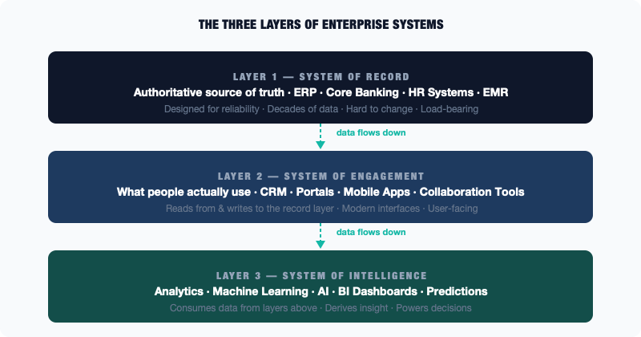
Diagram
Most enterprise complexity comes from the interactions between these layers: data flowing (or failing to flow) from one to another, systems designed in one layer being asked to do the job of another, or projects that underestimate how hard it is to move information across the boundaries.

Systems of Record
A system of record is the authoritative source of truth for a particular type of data in an organization.
When a customer places an order, somewhere in the enterprise there is a system that records that order: the canonical, official, definitive record. When an employee is hired, somewhere there is a system that holds the authoritative record of their employment. When a product is manufactured, somewhere there is a system that tracks the inventory. These are systems of record.
Systems of record tend to share certain characteristics: they are old, they are stable, and they are designed for reliability above all else. The most important thing they do is not lose data. They often have rigid data structures, because the structure of the data is part of the business contract: an order has these fields, a product has those fields, and changing the fields requires a careful process because everything downstream depends on them.
The most common systems of record in large enterprises are enterprise resource planning systems (ERP), which we will cover in detail in Chapter 5. Other examples include core banking systems in financial services, electronic medical record systems in healthcare, and claims management systems in insurance.
The critical thing to understand about systems of record is that they are authoritative. If the system of record says a customer has five hundred units of inventory, that is the official answer, regardless of what any other system might say. This authority comes with significant responsibility: these systems must be correct, they must be consistent, and they must be available.

Systems of Engagement
A system of engagement is what people actually interact with to do their work or to interact with the organization.
The gap between systems of record and systems of engagement is often enormous. The system of record might be a mainframe application from 1985 that can only be accessed through a terminal emulator, essentially a text-based interface that looks like a black screen with green or amber text. Almost no one in the organization can actually use this system directly. Instead, they use a system of engagement: a modern web application, a mobile app, a customer portal, a call center tool.
The system of engagement presents information in a way that humans can work with. It pulls data from the system of record, displays it in a readable format, and writes changes back. It is the face of the technology stack: the part that users see.
Customer relationship management (CRM) systems like Salesforce are a good example of a system of engagement. The customer’s actual account record might live in an old banking or billing system, but the sales team interacts with the customer data through Salesforce, a modern, usable interface that reads from and writes to the underlying systems.
The challenge with systems of engagement is that they add a layer of complexity. Now you have two systems that need to stay in sync. Changes made in the system of engagement need to make it back to the system of record. Data in the system of record needs to be accessible to the system of engagement. And if there are multiple systems of engagement, such as a web portal, a mobile app, or a call center tool, they all need to present consistent information.

Systems of Intelligence
A system of intelligence is a system that takes data from systems of record and systems of engagement, analyzes it, and produces insights, predictions, or decisions.
This layer has grown dramatically with the rise of data analytics, machine learning, and AI. Historically, “intelligence” in enterprise technology meant reporting: dashboards, data warehouses, business intelligence tools that helped executives understand what was happening in the business. Today it means much more: machine learning models that predict customer churn, algorithms that detect fraud, AI systems that automate decisions.
Systems of intelligence are consumers of data. They do not typically create or manage the authoritative record. They read from it. Their value comes from what they can derive from the data: patterns, predictions, anomalies, recommendations.
The challenge for systems of intelligence is getting clean, consistent, complete data from the layers below. This is the source of almost every “AI project runs into data problems” story you will ever hear. The data in the system of record might be accurate for operational purposes but structured in ways that are difficult to analyze. There might be gaps, periods where data was not collected or was collected differently. There might be inconsistencies between systems of record for different parts of the business.

How Data Flows Between the Layers
Understanding the three layers is valuable. Understanding how data flows between them is essential.
In a well-designed enterprise, data flows in a relatively coherent path. Transactions happen and are recorded in systems of record. Systems of engagement read from those records and enable people to do their work. Data from both layers is extracted, transformed, and loaded into the intelligence layer, where it can be analyzed.
In reality, the flow is rarely this clean. Data gets duplicated across systems. Systems of engagement maintain their own local copies of data that drift out of sync with the system of record. Intelligence systems work from stale data because the pipeline to refresh it runs overnight, not in real time. Multiple systems of record exist for the same type of data because of acquisitions or departmental decisions made without central coordination.
This is why, when someone says “we want to build an AI system on top of our enterprise data,” the first and most important question is not “which AI model should we use?” It is: “what does the data landscape actually look like across these three layers, and what would it take to get clean, consistent data into the intelligence layer?”
The answer to that question determines almost everything about how hard the AI project will be.

What Is a Legacy System, Really?
Ask ten people to define “legacy system” and you will get ten different answers. Most of them will involve the word “old.” Some will involve the word “outdated.” A few will involve frustration.
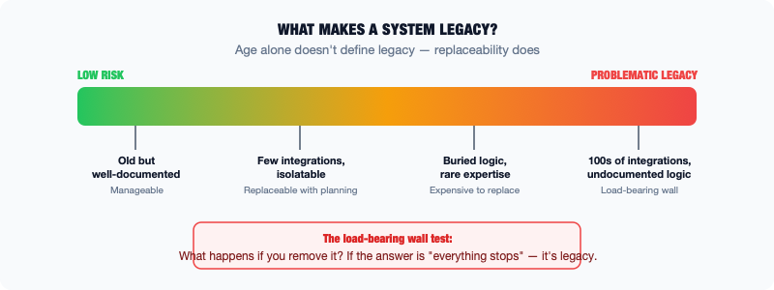
Diagram
The problem with defining legacy as “old” is that age alone does not make something legacy. Some systems running on forty-year-old technology are perfectly fit for purpose and will continue running for another forty years. Some systems built last year are already legacy in the sense that matters: they are hard to change, hard to replace, and deeply embedded in how the organization functions.
The better definition has nothing to do with age. A legacy system is a system that the organization cannot easily replace or significantly modify without unacceptable risk or cost.
That is what matters. Not when it was built. The question is whether you are trapped.

Why Organizations Get Trapped
Being trapped by a system happens for several reasons, and they usually stack on top of each other.
The system is deeply integrated. Legacy systems often sit at the center of a web of connections. Other systems read from them. Other systems write to them. Reports are generated from them. Processes depend on the data they hold. When a system is this connected, changing it means changing everything connected to it. Understanding all those connections is a project in itself.
The business logic is buried in the code. Over decades, the rules that govern how the business operates get encoded in the system. Pricing rules. Eligibility rules. Calculation methods. Approval workflows. Some of these rules are documented. Many are not. They exist only inside the software, and the people who put them there are long gone. The system is not just storing data. It is running the business. Replacing it means understanding every rule it enforces, which often requires months of reverse-engineering.
The data is irreplaceable. Systems accumulate years or decades of transaction history, customer records, compliance data, and operational information. This data has to go somewhere when the system is replaced. Migrating it is always harder than expected. Not because migration tools are bad, but because data quality issues that have accumulated over years become visible all at once when you try to move the data somewhere new.
The skills to run it are rare. Some legacy systems require specialized knowledge to operate. The people who have that knowledge may be approaching retirement. Replacing the system requires training new people, but training them requires documentation that often does not exist, which requires working with the people who are about to retire, which creates a race against time.

The Load-Bearing Wall Metaphor
The most useful metaphor for a legacy system is a load-bearing wall.
In an old building, not every wall is structural. Some walls are just partitions. You can remove them relatively easily to open up a space. But some walls are holding the building up. Remove them without understanding what they are doing and the ceiling comes down.
Legacy systems are load-bearing walls. The fact that they are old, ugly, or inconvenient is beside the point. The question is: what happens if you remove them?
In most cases, the answer is that everything depending on them stops working. And because legacy systems tend to be at the center of things, everything means a lot.
This is why enterprises do not simply replace legacy systems when something new comes along. Not because the people making the decisions are incapable of seeing that the old system is imperfect. Replacing it requires a level of planning, risk management, and organizational alignment that is genuinely difficult. The cost of getting it wrong is high.

What Makes a System Legacy vs. Old
It is worth being precise about the distinction, because it matters for how you think about AI and modernization.
An old system that is stable, well-understood, well-documented, and not deeply integrated with other things is not really legacy in the problematic sense. It is just old. You can plan to replace it in an orderly way, or you can continue running it indefinitely if it serves its purpose.
A system becomes problematic legacy when:
- It is hard to change because the underlying technology or code is poorly understood
- It is hard to integrate with modern systems because it uses protocols, data formats, or interfaces that modern tools do not speak natively
- The organization depends on it for something critical but the expertise to manage it is disappearing
- Regulatory or security requirements cannot be met without changing it, but changing it is risky
When AI projects run into legacy systems, the issue is almost always one of these four things. The data is in the legacy system but getting it out cleanly is hard. The legacy system needs to be part of the AI workflow but it does not have a modern API. The business logic in the legacy system needs to be replicated in the AI model but nobody can fully document what that logic is.

The Right Posture
The right posture toward legacy systems is not dismissal and not reverence. It is realism.
These systems are there for a reason. They have survived not because no one noticed they were old, but because they are doing something valuable and the cost of replacing them has consistently exceeded the benefit. That is important information.
At the same time, legacy systems create real constraints for modernization and AI. Those constraints need to be understood and planned around, not wished away.
The practitioner who understands legacy, what it actually means, why it persists, and how to work with it rather than against it, has a significant advantage over the one who simply says “we need to rip and replace” and is then surprised when it takes five years and three times the budget.

The Mainframe Is Still Running Your Money
The mainframe computer was declared dead approximately fifty times between 1980 and today. It is still running.
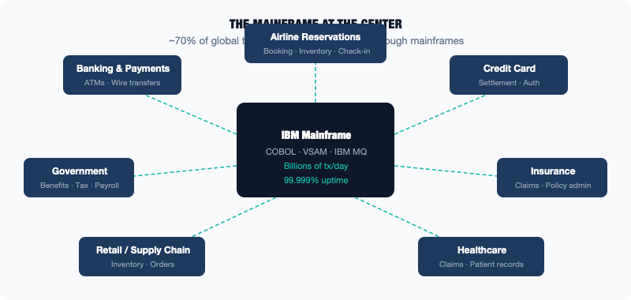
Diagram
The IBM mainframe and its ecosystem of related technology processes an estimated seventy percent of all global transaction processing. That includes most major bank transactions, the majority of airline reservation systems, a large portion of government benefit payments, and the systems that settle credit card transactions worldwide.
If you have used an ATM, booked a flight, received a social security payment, or paid with a credit card today, there is a very good chance a mainframe processed part of that transaction.

What a Mainframe Actually Is
A mainframe is a type of computer designed for high-volume, high-reliability transaction processing. The name comes from the large metal frames that housed the early machines, but modern mainframes bear little physical resemblance to those original machines. What has stayed consistent is the purpose: processing enormous volumes of transactions with exceptional reliability and speed.
Modern mainframes can process billions of transactions per day. They are designed to be available essentially all the time. The target uptime for mainframe systems is often measured in minutes of downtime per year, not hours. They support hot-swappable components, meaning parts can be replaced while the system is running, without taking it offline.
The primary language still widely used to write mainframe applications is COBOL, Common Business-Oriented Language, which was created in 1959. This often surprises people. But consider: the business rules encoded in a payroll system, a banking core, or an insurance claims system have not changed that much in fifty years. The calculations for compound interest, the rules for benefit eligibility, the logic for settling a securities trade: these are stable. The code that implements them, once it works, tends to stay working.

Why Mainframes Persist
The obvious question is: why not replace them with modern technology?
The answer involves reliability, performance, cost of replacement, and risk.
Reliability. Modern cloud infrastructure is capable, but it is designed with the assumption that individual components will fail and the system will route around them. Mainframes are designed so that individual components almost never fail. For certain transaction types, including financial settlement, benefits processing, and airline reservations, the tolerance for failure is effectively zero. The mainframe was engineered for that tolerance. Replicating it with distributed cloud architecture is possible but requires significant engineering investment.
Performance. At very high transaction volumes, mainframes remain extremely efficient. The hardware is optimized for exactly the kind of structured, high-volume transaction processing that financial and government systems require. Modern distributed systems can match this performance, but often require significantly more infrastructure.
Cost of replacement. The mainframe might look expensive as a line item, but it is processing millions of transactions per hour. When you calculate cost per transaction, it is often cheaper than the alternatives. More importantly, the cost of replacing the mainframe is enormous. Not primarily because of the hardware, but because of the software. Decades of COBOL code would need to be rewritten, tested, validated, and migrated. The business rules embedded in that code would need to be fully understood and reproduced. For major financial institutions, this is a multi-year, multi-billion-dollar project with significant risk of failure.
Risk. Every major attempt to replace a core banking system or large government mainframe has stories of projects that ran over budget, ran over schedule, or failed outright. The systems are so central to operations that errors during migration can have immediate, visible consequences: payments not processed, benefits not paid, accounts showing wrong balances. The risk of getting it wrong is so high that many organizations have decided that running the mainframe indefinitely is the more rational choice.

The COBOL Problem
One of the most discussed aspects of mainframe persistence is the COBOL skills gap. The language is old. Computer science programs stopped teaching it decades ago. The people who have deep COBOL expertise are approaching or past retirement age.
This creates a risk: organizations that depend on COBOL systems may find themselves with aging code that fewer and fewer people can read, debug, or extend. When something breaks, or when a regulatory change requires the code to be modified, finding the right expertise becomes increasingly difficult and expensive.
This is a real concern, but it is often overstated. There is still a significant COBOL developer community, and organizations that depend on COBOL systems invest in training and in automated tools that help modernize or extend COBOL code without fully replacing it. The crisis has been predicted for decades and has not fully materialized because the economic incentives to maintain COBOL expertise remain strong as long as the systems that require it are running.

What This Means for AI
The practical implication for AI practitioners is this: if you are working at a large financial institution, a government agency, an insurance company, or any other organization that relies on mainframe transaction processing, the data that AI needs is probably in or flowing through that mainframe.
Getting that data into a modern AI system is not impossible, but it requires understanding how the mainframe exposes data, what format that data is in, and what the latency and volume constraints are. The mainframe does not have a REST API the way a modern cloud service does. It has its own interfaces, including batch file exports, VSAM data sets, and IBM MQ message queues, that require specific knowledge to work with.
This is not an insurmountable problem. But it is a real one, and recognizing it early saves significant time and frustration. The AI model is the easy part. Getting clean data out of the mainframe in the right format at the right frequency is where the work actually lives.

ERP: The Spine of the Enterprise
If you work at or with a large organization and wonder why things take so long, why processes require so many approvals, or why connecting a new system to the existing infrastructure seems so difficult, there is a good chance ERP is involved.
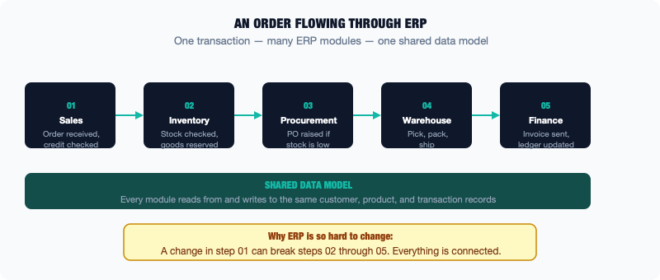
Diagram
Enterprise Resource Planning, or ERP, is the category of software that manages the core business processes of an organization. Finance. Procurement. Human resources. Supply chain. Manufacturing. Project management. An ERP system is designed to hold all of these functions together in a single, integrated system, or at least a closely connected family of systems, so that the data flows coherently between them.
The dominant ERP vendors are SAP and Oracle. Between them, they power the back-office operations of a very large share of the global economy. When a large manufacturer wants to know its total inventory position across forty factories in twenty countries, it asks SAP. When a global retailer wants to see which purchase orders are outstanding, it asks Oracle. When a government agency needs to run payroll for fifty thousand employees, it is probably running a version of one of these systems, or a specialized equivalent built for the public sector.

What ERP Actually Does
The best way to understand ERP is to follow a business transaction through an organization and see all the places it touches.
Imagine a manufacturing company receives a customer order. Here is what needs to happen:
The order needs to be recorded in the sales system. Credit needs to be checked: does this customer have an outstanding balance that should hold the order? If the goods are in inventory, they need to be reserved. If they need to be manufactured, a production order needs to be created. Raw materials need to be checked: is everything needed in stock, or do purchase orders need to be placed with suppliers? When the goods ship, a delivery record needs to be created, the inventory needs to be reduced, and an invoice needs to be generated. When the invoice is paid, the payment needs to be applied to the customer’s account and recorded in the general ledger.
Each one of these steps involves data. And all of that data needs to be consistent. The inventory level used when the production order is created needs to be the same inventory level the warehouse team sees when they go to pick the goods.
An ERP system is designed to manage all of these steps in an integrated way, with a single shared data model. The customer order in sales, the production order in manufacturing, the purchase order in procurement, and the invoice in finance all refer to the same transaction, tracked through its lifecycle.

Why ERP Is So Hard to Change
ERP systems are notoriously difficult and expensive to implement and to change. Large ERP implementations are the subject of case studies in project management failure: projects that ran years over schedule, hundreds of millions of dollars over budget, and in some cases had to be abandoned.
Understanding why helps explain a lot about enterprise IT dynamics.
They touch everything. Because ERP integrates so many business functions, a change in one area can have ripple effects across others. Change how the system records a purchase order, and you may affect the way accounts payable processes invoices, the way the general ledger closes the month, and the way the audit trail is maintained. Testing every change requires understanding all of these interdependencies.
They encode business processes. An ERP system is not just a database. It is an implementation of how the organization runs its business. When you configure an ERP system, you are making decisions about how procurement works, how approvals flow, how inventory is valued. Those decisions become embedded in the software. Changing them later requires not just a technical change but an organizational one: getting people to work differently.
Customizations accumulate. ERP vendors ship a standard product, but most large organizations modify it extensively to match their specific processes. Over years, these customizations pile up. When a vendor releases a new version of the software, the organization has to decide whether to apply the customizations to the new version, which is expensive, or stay on the old version. Many organizations end up years behind on ERP versions because the cost of upgrading is too high, which eventually means they are running software the vendor no longer supports.
Data quality issues surface during implementation. When an organization implements or upgrades an ERP system, it has to migrate data from existing systems. This process almost always reveals data quality problems that were invisible before: customer records with missing fields, inventory counts that do not match physical counts, supplier records that are duplicated. Cleaning up this data is time-consuming, and the problems discovered are often politically sensitive, because they reveal that business processes have not been followed consistently.

ERP and AI
ERP systems hold some of the richest operational data in an enterprise. Financial data, supply chain data, procurement data, and workforce data are all potentially valuable for AI applications: demand forecasting, spend analysis, workforce planning, and anomaly detection in financial transactions.
The challenge is getting that data out. Modern ERP systems from SAP and Oracle have APIs and data export capabilities, but they are complex. The data model inside an ERP is sophisticated. A single business object like a sales order might be spread across dozens of database tables, each of which needs to be understood to reconstruct the complete picture.
There is also the question of what the data means. ERP data is rich with configuration-dependent values: codes, flags, and statuses that mean different things depending on how the system is configured. Understanding what those values mean requires knowing how the specific organization has configured its ERP instance, which is often documented poorly.
Despite these challenges, ERP data is worth the effort. Organizations that succeed in getting clean, well-understood ERP data into their AI pipelines unlock significant analytical and predictive capability. The work is front-loaded. Understanding the data model takes time. The payoff is access to the most accurate operational data the organization has.

Cloud Is Infrastructure, Not Magic
Cloud computing is the most over-hyped and under-explained technology of the last twenty years. The term is used to describe everything from storing photos on your phone to running complex machine learning workloads across thousands of servers. It has been sold as a solution to problems it does not solve, and blamed for problems it did not cause.
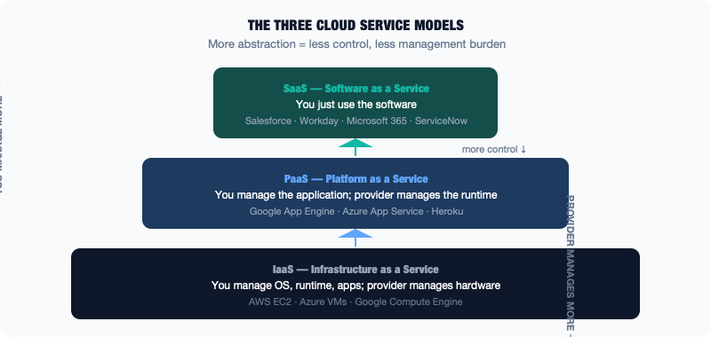
Diagram
The reality is simpler and more useful than the hype: cloud computing is a model for consuming computing infrastructure, including storage, processing power, and networking, as a service rather than owning and operating that infrastructure yourself.
That is it. It is important, but it is not magic.

What Cloud Actually Provides
Before cloud computing became widely available, organizations that needed computing infrastructure had to buy it. They purchased servers, stored them in data centers, hired people to manage them, bought software licenses, and maintained all of it themselves. If their needs grew, they bought more hardware. If their needs shrank, they were stuck with hardware they were not using.
Cloud computing changed this by allowing organizations to rent computing infrastructure from large providers, primarily Amazon Web Services (AWS), Microsoft Azure, and Google Cloud Platform (GCP). Instead of buying a server, an organization can provision one in minutes, use it for as long as needed, and then shut it down and stop paying for it.
The economic model is fundamentally different. Instead of large upfront capital expenditures on hardware, organizations pay for what they use on an ongoing basis. Instead of a months-long procurement process to buy servers, computing capacity can be added in minutes. Instead of maintaining data centers, the cloud provider handles the physical infrastructure.

The Three Service Models
Cloud services are typically described in three tiers, each representing a different level of abstraction from the underlying infrastructure.
Infrastructure as a Service (IaaS) is the most basic level. The cloud provider supplies virtual machines, essentially computers you can access over the internet. You control what software runs on them, how they are configured, and how they connect to each other. AWS EC2, Azure Virtual Machines, and Google Compute Engine are IaaS offerings. This is closest to running your own servers, just without owning the physical hardware.
Platform as a Service (PaaS) goes a step further. The cloud provider manages the underlying infrastructure, including the operating system, the runtime environment, and the scaling, and you focus on deploying your application. Google App Engine is an example. PaaS reduces operational overhead but also reduces control. You cannot configure the underlying environment in the same way you can with IaaS.
Software as a Service (SaaS) is what most people interact with every day without thinking of it as cloud computing. Salesforce, Microsoft 365, Workday, and ServiceNow are applications delivered over the internet that you use without managing any infrastructure. The cloud provider (or software vendor) handles everything. You just use the software.

What Cloud Does Not Solve
Cloud computing solves certain problems very well. It eliminates the need to own and manage physical hardware. It makes it easy to scale computing resources up and down. It provides access to sophisticated managed services, including databases, machine learning tools, and messaging systems, that would be expensive and time-consuming to build and maintain independently.
What cloud does not solve is organizational or process complexity.
Moving an application to the cloud does not automatically make it more reliable, faster, or easier to maintain. An application with poor architecture will have poor architecture in the cloud. A database with data quality problems will have data quality problems in the cloud. A process that requires seven approvals will still require seven approvals even if it is running in the cloud.
This is one of the most common misunderstandings in enterprise technology. Organizations sometimes expect that migrating to cloud will modernize their systems. In many cases, what happens is a “lift and shift”: the existing system, with all its complexity and limitations, is simply moved from a physical server to a virtual one. The costs are often lower, and the operational burden may be reduced, but the application itself is unchanged.
True modernization, changing the architecture, improving the code, and fixing the data, requires separate effort on top of the cloud migration. Cloud provides the platform. The work of improving what runs on that platform is a different project.

Hybrid Cloud and Multi-Cloud
Most large enterprises do not run entirely in the cloud or entirely on-premises. They run in a hybrid: some systems in the cloud, some in their own data centers, some from cloud providers, some from on-premises infrastructure.
This is not an intermediate state on the way to “full cloud.” For many organizations, hybrid is the permanent destination. Regulatory requirements may mandate that certain data stays on-premises. Some legacy systems cannot be migrated to the cloud without a rewrite. Some workloads are genuinely cheaper and more manageable on owned hardware. The economics of cloud versus on-premises depend on the specific workload, and the calculation is different for every organization.
Many organizations also use multiple cloud providers: AWS for some workloads, Azure for others, Google Cloud for machine learning. This is called multi-cloud. It introduces its own complexity, as different providers have different services, different APIs, different pricing models, and different operational tooling. It also reduces dependence on any single vendor and allows organizations to use each provider where it has particular strengths.

Cloud and AI
The rise of cloud computing is directly connected to the rise of enterprise AI, for a simple reason: training and running AI models requires enormous amounts of computing power. Before cloud, only the largest organizations could afford the hardware infrastructure for significant AI workloads. Cloud made that infrastructure available to any organization willing to pay for it.
The major cloud providers have also built AI services on top of their infrastructure: managed machine learning platforms, pre-trained models accessible via API, and data processing pipelines. This has lowered the barrier to experimenting with and deploying AI considerably.
But the same caveat applies: cloud provides the platform. If the data needed for AI is in a legacy system that cannot easily connect to the cloud, or if the data quality is poor, or if the business process around the AI system is not designed well, cloud does not fix those problems. The infrastructure is the easy part. The hard part is everything else.

SaaS Sprawl: When Every Team Bought Their Own Tool
There was a time when buying enterprise software was hard. You needed to get IT involved. You needed to go through procurement. You needed budget approval. The process took months and involved vendors, contracts, and significant internal political capital. This friction was annoying, but it had a side effect. It kept the technology landscape somewhat coherent. When buying software was hard, organizations bought less of it.
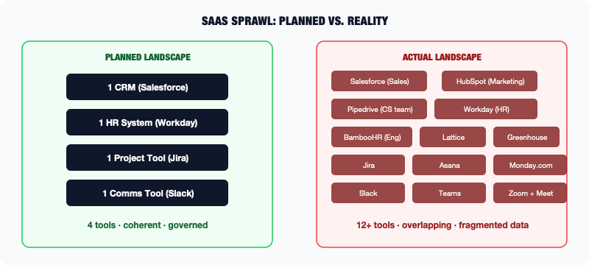
Diagram
Then software-as-a-service changed the economics. A team could sign up for a new tool with a credit card. The software ran in the browser. IT did not need to install anything. The monthly subscription cost was low enough to be approved at a department level without going through the capital expenditure process. Suddenly, buying software was easy.
And organizations bought a lot of it.

What SaaS Sprawl Looks Like
A mid-size company today might have hundreds of active SaaS subscriptions. Marketing uses a content management system, an email marketing platform, a social media scheduling tool, a webinar platform, an A/B testing tool, and an analytics platform. Those are just the ones the marketing team knows about. Sales uses a CRM, a sales engagement platform, a conversation intelligence tool, a proposal software, and a data enrichment service. Engineering uses a project management tool, a code repository, a CI/CD platform, a logging service, and an error tracking tool.
Each of these tools was acquired by a team that had a legitimate need and found a tool that solved it. The problem is that they did not coordinate with each other. Now the company has three different tools for project management, four different tools for video conferencing, two different CRMs that the sales and customer success teams are using in parallel, and a customer data platform that does not talk to the CRM that does not talk to the marketing automation tool.
The customer who called in last week shows up in the CRM with one record, in the helpdesk tool with another record, and in the marketing platform with a third record. These records have conflicting information because they were created independently and have never been synchronized.
This is SaaS sprawl. It is the natural outcome of distributing purchasing power to individual teams without enforcing architectural coherence.

The Data Problem
The deeper issue with SaaS sprawl is data. Every SaaS tool holds some data about the business. Salesforce holds customer and deal data. Workday holds employee data. ServiceNow holds IT service request data. HubSpot holds marketing engagement data.
In a coherent architecture, these systems would share a common view of key entities, particularly the customer and the employee. A customer would have one record across all systems, and changes made in one system would propagate to others. In practice, data in SaaS tools frequently diverges. The same customer has different contact information in the CRM and the support tool. The same employee has different job titles in HR and in the directory.
This data fragmentation is one of the most underappreciated challenges for enterprise AI. AI systems that need to understand “the customer” or “the employee” as a unified entity have to reconcile data from multiple systems. That data was created independently, is stored in different formats, and has been updated on different schedules. This reconciliation process is called master data management, and it is hard, time-consuming, and never quite finished.

Shadow IT: The Unofficial Technology Layer
Related to SaaS sprawl is shadow IT: technology that is in use within the organization but is not sanctioned, supported, or even known about by IT.
Shadow IT exists because people have needs that official systems do not meet. A finance team that cannot get a report out of the ERP system fast enough builds one in Excel. A marketing team that finds the official project management tool too rigid uses a personal Trello board. A sales team that wants to share competitive intelligence uses a shared Google Doc that nobody told IT about.
Some shadow IT is benign. A shared spreadsheet for tracking meeting schedules does not create significant organizational risk. Other shadow IT is not benign. When sensitive customer data ends up in a personal Dropbox account because the official file sharing system was too slow, that is a data security and compliance problem. When critical business calculations are happening in an Excel spreadsheet that one person maintains and nobody else understands, that is an operational risk.
The challenge is that shadow IT exists for real reasons. The official systems often genuinely do not meet the needs of the teams using them. Eliminating shadow IT without addressing those needs just drives it further underground.

Managing Sprawl
Large organizations increasingly have a function, sometimes called IT asset management, sometimes called SaaS management, sometimes sitting within IT governance, focused on tracking and managing the portfolio of tools in use.
The practical activities include maintaining an inventory of all active tools, understanding which tools overlap in functionality, consolidating where possible, establishing standards for data security review before a new tool is acquired, and creating processes for decommissioning tools that are no longer needed.
None of this is glamorous work, but it has significant implications for data quality, security, and the organization’s ability to build coherent analytics and AI systems on top of its data.
For AI practitioners, the lesson is straightforward: before assuming you know where the relevant data is, invest time in mapping the actual tool landscape. The data you need for an AI application may be spread across three different SaaS tools, two Excel spreadsheets in someone’s personal folder, and a legacy system that predates the internet. Understanding that landscape upfront is always better than discovering it halfway through a project.

COTS vs. Custom: The Build vs. Buy Decision
One of the most consequential decisions in enterprise technology happens constantly, at every level of the organization: should we buy a commercial product, or should we build something ourselves?
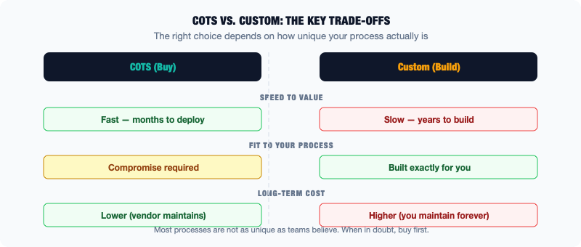
Diagram
The commercial product option is called COTS: Commercial Off-The-Shelf software. The acronym emphasizes that it comes pre-built, ready to use, purchased from a vendor. SAP, Salesforce, Workday, ServiceNow — these are all COTS products. You buy them, configure them, and use them.
The alternative is custom development: building software specifically for your organization, designed to your exact specifications, maintained by your own (or contracted) engineering team.
Both options have genuine strengths and real weaknesses. The right choice depends on the specific situation. And yet organizations consistently get this decision wrong in predictable ways.

The Case for COTS
Commercial software exists because many organizations have the same problems. Every company that sells things needs to manage customer relationships. Every company with employees needs to run payroll. Every company with physical goods needs to manage inventory. Because these needs are common, vendors have built products that address them — products that have been refined over years through use by thousands of customers.
The advantages of buying commercial software are significant.
Faster time to value. A COTS product can often be deployed and operational in months. Custom development takes years. When the business has an urgent need, COTS frequently wins on speed.
Proven functionality. A mature commercial product has been used extensively by many organizations. Its core functionality has been tested in production, bugs have been found and fixed, edge cases have been discovered. A custom-built system starts from zero — you discover the edge cases yourself, after you have deployed.
Vendor support and ongoing development. When you buy a commercial product, you are also buying the vendor’s commitment to maintain and improve it. Regulatory changes get incorporated into new software versions. Security patches get released. The vendor has a financial incentive to keep the product current.
Lower total cost of ownership (in theory). Building and maintaining custom software requires ongoing engineering investment. The total cost of custom development — including the initial build, ongoing maintenance, bug fixes, enhancements, and eventually replacement — is often significantly higher than people expect when they decide to build rather than buy.

The Case for Custom
Commercial software has real limitations, and there are situations where building custom is genuinely the right answer.
Your process is genuinely unique. Most business processes are not unique. Most companies manage customers and inventory and employees in roughly similar ways. But some organizations have processes that are genuinely differentiated — processes that create competitive advantage or meet specific regulatory requirements that no commercial product addresses. In these cases, custom development may be the only viable option.
Commercial products require too much compromise. Every COTS product is designed to work for many organizations, which means it is designed to work perfectly for none of them. To use a commercial product, you have to adapt your processes to fit the software’s assumptions — or configure the software heavily to match your processes. Sometimes this compromise is acceptable. Sometimes it is not, particularly when the processes in question are central to how the business operates.
Integration requirements are unusual. If your environment requires integration with legacy systems or proprietary protocols that commercial vendors do not support, custom development may be necessary to bridge the gap.

Where Organizations Go Wrong
The most common mistake is underestimating the cost and complexity of custom development and overestimating the uniqueness of the organization’s needs.
Teams that decide to build custom frequently do so because they believe their requirements are unique, the commercial products are not quite right, and building something custom will give them exactly what they need. What often happens is different. The requirements turn out to be less unique than expected. The commercial products would have been adequate with some configuration. The custom system takes three times as long and costs twice as much to build. Then, once it is built, it requires ongoing maintenance that consumes engineering capacity indefinitely.
The second common mistake is “COTS plus heavy customization”: buying a commercial product and then modifying it so extensively that it no longer functions as a standard product. The organization gets some of the initial speed advantages of COTS but none of the long-term advantages, because the heavily customized product cannot be upgraded without re-doing all the customizations. This is how many organizations end up stuck on old versions of ERP and CRM systems.

What This Means for AI
The build-versus-buy question applies directly to AI. Organizations face it constantly: should we buy an AI tool from a vendor, or should we build our own AI capability?
The same principles apply. If your need is common — AI-powered customer service, document summarization, demand forecasting — there are commercial products available that can be deployed relatively quickly. If your need is genuinely unique, or if the commercial products do not work with your specific data and systems, custom development may be necessary.
What is different about AI is the rate of change. The commercial AI landscape is evolving rapidly. A commercial product that does not exist today may be available next year. Capabilities that required custom development in 2023 can be bought off the shelf in 2025. This argues for caution about large custom AI development investments. Before committing to building something, ask whether a commercial product will solve the problem within the timeframe of the project.

APIs: The Connective Tissue
If you have heard the term API (Application Programming Interface) and nodded along without being entirely sure what it means, you are not alone. API is one of those terms that gets used constantly in technology conversations and rarely explained well.
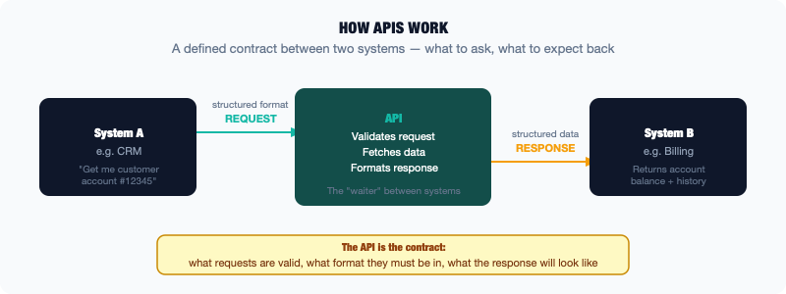
Diagram
Here is the plain-language version: an API is a defined way for one piece of software to talk to another.
That is it. An API is an agreement between two systems about how they will communicate. System A sends a request in a specific format. System B receives the request, does something, and sends back a response in a specific format. Both sides know what to expect because the API defines the protocol.

A Simple Analogy
Think of a restaurant: the kitchen is one system, you are another, and the waiter is the API.
You do not walk into the kitchen and start cooking. You interact with the waiter. You say what you want, in the format the restaurant expects: you look at a menu and give your order verbally or in writing. The waiter carries that request to the kitchen. The kitchen does its work and sends back a response, the food, through the same channel.
The API is the waiter. It defines what requests are valid (you can order anything on the menu, not anything in the world), what format the request should be in (you say “I’ll have the salmon” not “give me the pink fish”), and what the response will look like (food on a plate, not raw ingredients).
Different systems have different APIs — different menus, different ordering conventions. An organization with many systems has to manage many different APIs, each with its own protocol.

Types of APIs
The most common type of API you will encounter in modern enterprise environments is a REST API (Representational State Transfer). REST APIs use the same communication protocol as web browsers (HTTP), are relatively simple to use, and have become the standard for most modern software. When one cloud service wants to talk to another, it almost always uses a REST API.
Older enterprise systems often use different types of APIs. Web services built in the early 2000s frequently use SOAP (Simple Object Access Protocol), which is more verbose and complex than REST but was the standard of its era. Many ERP and mainframe systems expose their data through even older mechanisms: batch file exports, message queues, or proprietary protocols that require specialized connectors.
This diversity of API types is one of the practical challenges in enterprise integration. A modern AI application built using REST APIs needs to integrate with an ERP system that speaks SOAP and a mainframe that exports flat files. Each integration requires different technical approaches and different expertise.

Why Enterprise APIs Break
In consumer technology, APIs are often treated as products. Google’s Maps API, Stripe’s payment API, Twilio’s messaging API — these are carefully documented, stable, versioned, and treated as revenue-generating products in their own right. When they change, there is a formal deprecation process with advance notice.
In enterprise technology, APIs are often an afterthought. A system exposes an API because it needs to connect to something else, not because the API is designed for broad reuse. Documentation is incomplete, the API is not versioned so changes can break integrations without warning, and performance and availability are not guaranteed in the way they would be for a commercial API product.
The result is that enterprise integrations are fragile. They work when conditions are exactly right, and they break when something changes: the underlying system is updated, the data format shifts, the authentication mechanism changes, or the system is simply unavailable when the integration tries to connect.
This fragility is a significant operational burden. Someone has to monitor integrations, identify when they break, diagnose the problem, and fix it. In organizations with many integrations, this becomes a continuous maintenance effort.

The Integration Layer
Large enterprises often have an integration platform, sometimes called an enterprise service bus (ESB), an integration platform as a service (iPaaS), or simply middleware, that sits between systems and manages the connections between them.
Instead of System A connecting directly to System B, both systems connect to the integration platform. The platform handles routing, translation, error handling, and monitoring. Translation means converting data from one system’s format to another. When an integration breaks, the problem is visible in the integration platform, not buried somewhere in the connection between two systems.
The integration platform is an important component of enterprise architecture, but it adds its own complexity. It needs to be managed, monitored, and maintained. The mappings between systems accumulate over time and can become difficult to understand. These mappings are the rules that translate data from one format to another.

What This Means for AI
Every AI system that needs to read from or write to enterprise systems will interface with APIs. Understanding the API landscape of the organization is essential to understanding what is feasible for an AI project.
The key questions are practical: Does the system you need data from have an API? Is that API documented? Is it performant enough to support real-time AI use cases, or is it only suitable for batch queries? Is the API stable, or does it change frequently in ways that would break integrations?
For many AI use cases, the right answer is not to call enterprise APIs directly in real time, but to create a data pipeline that extracts data from source systems at a cadence (hourly, daily), transforms and cleans it, and stores it in a format optimized for AI queries. This adds a layer of complexity, but it also insulates the AI system from the fragility of direct API connections to enterprise systems.
Understanding APIs is not about writing code. It is about understanding how data moves between systems, where the connective tissue is strong and where it is about to tear.

The Data Warehouse, the Lake, and the Swamp
The systems in the previous chapters are where enterprise data is created and managed. This chapter covers where it goes to be analyzed. The data warehouse, the data lake, and the related concepts around them form the infrastructure that sits between operational systems and the analytics and AI systems that need to learn from the data.
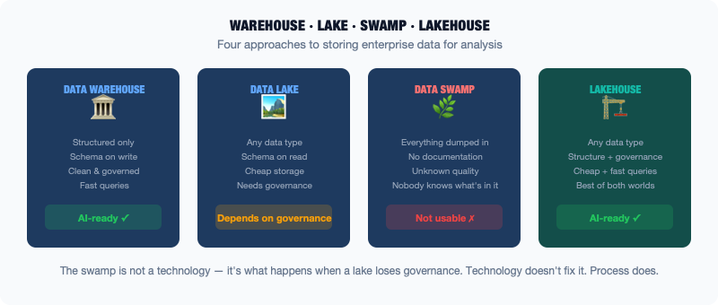
Diagram
Understanding this infrastructure — and the ways it tends to go wrong — is essential for anyone involved in enterprise AI.

The Data Warehouse
The data warehouse has been around since the 1980s. The core idea is straightforward: take data from operational systems, transform it into a consistent, analysis-ready format, and load it into a central repository optimized for queries.
Operational systems, including the ERP, the CRM, and the core banking system, are optimized for transactions. They are very good at recording individual events quickly and reliably. They are not particularly good at answering analytical questions: “What were our total sales by product category by region last quarter?” Answering that question requires aggregating data from many records, joining information from multiple tables, and performing calculations — operations that are slow and resource-intensive on systems designed for transactional throughput.
The data warehouse solves this by maintaining a separate copy of the data, organized specifically for analytical queries. The data is transformed before it arrives — cleaned, standardized, and restructured — so that analysts and reporting tools can query it efficiently without affecting the performance of operational systems.
The transformation process is called ETL: Extract, Transform, Load. Data is extracted from source systems, transformed into the target format, and loaded into the warehouse. ETL pipelines run on a schedule, often overnight, so the data in the warehouse may be a day old, or several days old, depending on the pipeline.
Major data warehouse products include Snowflake, Google BigQuery, Amazon Redshift, and Microsoft Azure Synapse. These are the modern versions of technology that ran, in earlier generations, on dedicated hardware from vendors like Teradata and IBM.

The Data Lake
The data warehouse model works well for structured, well-understood data — the kind that comes from transactional systems with defined schemas. But enterprises increasingly generate other kinds of data: emails, documents, audio recordings, images, sensor readings, log files, social media. None of this fits neatly into the structured format of a traditional data warehouse.
The data lake emerged as a concept around 2010 as a response to this challenge. The basic idea: instead of transforming data before storing it, store everything in its raw form. The lake accepts any kind of data, structured, semi-structured, or unstructured, and holds it in a central repository. Transformation and structure are applied when the data is read, not when it is written. This is sometimes described as “schema on read” rather than “schema on write.”
Data lakes are typically built on cheap, scalable storage — originally Hadoop distributed file systems, today usually cloud object storage like Amazon S3 or Google Cloud Storage. The cost of storing data in a lake is much lower than in a structured data warehouse, which makes it practical to store everything rather than selecting what is worth storing.
The appeal is clear: centralize all the organization’s data in one place, raw and unprocessed, and then use it for whatever analysis or AI application turns out to be valuable.

The Data Swamp
The data lake concept, in practice, frequently produces what has come to be called a data swamp.
A swamp happens when data accumulates in the lake without adequate governance — without clear ownership, without documentation, without quality controls, without a catalog that tells people what is in there and whether it can be trusted.
Organizations set up a data lake with good intentions. Teams start loading data into it. Over time, the lake fills up with datasets of uncertain provenance, unknown quality, and undocumented format. When an analyst tries to use the data, they find that they cannot determine whether a particular dataset is current, whether it has been cleaned, what business rules were applied to it, or who to ask if they have questions.
The data is there, technically. But it is not usable. And the time it takes to make it usable — understanding the provenance, assessing the quality, documenting the transformations — often exceeds the time it would have taken to never put it in the lake in the first place.
The swamp problem is fundamentally a governance problem. Technology does not create data swamps. The absence of clear ownership, accountability, and process creates them.

The Modern Data Lakehouse
The current direction in enterprise data infrastructure is toward a hybrid model called the data lakehouse. It combines the scalable, low-cost storage of a data lake with the structure, governance, and query performance of a data warehouse.
Products like Databricks and modern versions of Snowflake and BigQuery support this approach. Data is stored in open formats on cheap storage, but with schemas, governance, and access controls applied. Analytical queries run efficiently against structured tables. Raw data is also accessible for exploratory work and machine learning.
The lakehouse is not magic. It still requires governance discipline to avoid swamp conditions. It does, however, represent a more mature approach to managing the full spectrum of enterprise data.

What This Means for AI
The data infrastructure layer — warehouse, lake, lakehouse — is where most enterprise AI gets its training and inference data. Understanding what is in this infrastructure, and how trustworthy it is, is one of the first questions to ask before committing to an AI initiative.
Specifically: Is the data that the AI needs in the warehouse or lake? When was it last updated? Has it been cleaned and validated? Is there a data catalog that explains what each dataset contains and what transformations have been applied? Who owns the data and can answer questions about it?
Organizations with mature, well-governed data infrastructure have a significant advantage in AI initiatives. Organizations whose data infrastructure has drifted into swamp territory will spend most of their AI project time cleaning and understanding data rather than building and deploying models.
This is not a comfortable truth, but it is an important one. The quality of your data infrastructure predicts the success of your AI projects better than the sophistication of your AI models.

How Sprawl Happens: M&A, Shadow IT, and Organic Growth
No CIO ever sat down and decided to build a technology landscape with forty-seven overlapping systems, three conflicting sources of truth for customer data, and integration spaghetti that nobody fully understands. Sprawl is not a decision. It is the accumulated outcome of thousands of reasonable decisions made over time by people who were solving immediate problems without full visibility into the larger picture.
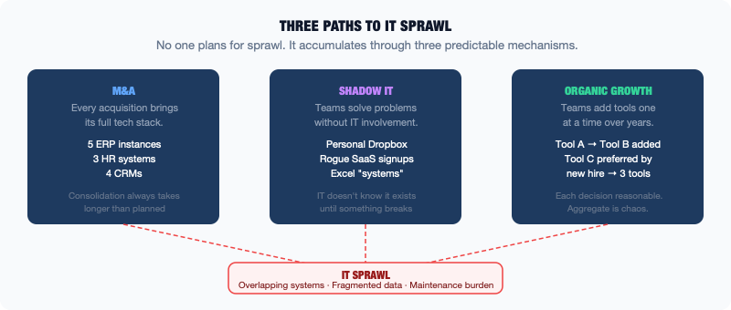
Diagram
Understanding how sprawl happens is the first step to understanding why it is so hard to fix — and what it costs.

Mergers and Acquisitions
The most dramatic source of IT sprawl is mergers and acquisitions. When one company acquires another, it inherits that company’s technology landscape in its entirety. Not just the systems the acquired company was planning to keep — everything. The ERP system they were in the middle of replacing. The custom application that one department built fifteen years ago. The data warehouse that was never quite finished. The SaaS tools that fourteen different teams signed up for independently.
In theory, post-merger integration involves consolidating the two technology landscapes into one. In practice, this consolidation is expensive, time-consuming, and highly disruptive. The systems being consolidated are often deeply integrated with business processes that cannot be interrupted. The people who understand the acquired company’s systems may leave after the acquisition. The timeline for integration is usually longer than expected and the budget is usually tighter than needed.
The result is that most organizations that have gone through multiple acquisitions are running systems from multiple eras and multiple companies, at various stages of integration. Some are fully consolidated. Some are running in parallel. Some are connected by integrations built quickly during the merger period that nobody has had time to stabilize. Others are running independently, with data synchronized manually or not at all.
A global organization that has done twenty acquisitions over twenty years may be running five different ERP instances, three different HR systems, and customer data spread across four different CRMs. Each was inherited from a different acquisition, at different stages of a consolidation plan that has been deprioritized every year in favor of more urgent work.

Shadow IT
As discussed in the chapter on SaaS sprawl, shadow IT is technology that is in use within the organization but is not managed by IT. It grows whenever official systems fail to meet the needs of the people doing the work.
The mechanisms are predictable. A team needs a capability that IT says it will deliver in eighteen months. The team finds a SaaS tool that does most of what they need and signs up. A manager needs to produce a report that the official reporting system cannot generate, so they build it in Excel. A department needs to share files with an external partner, but the official file sharing system has access control limitations that would take weeks to sort out through IT, so they use a personal file sharing service.
Each individual decision is reasonable. The cumulative effect is a shadow technology landscape that IT does not fully know about, does not manage, and cannot control. When the organization needs to understand its data landscape for an AI initiative, shadow IT is often the biggest source of surprises. Valuable data exists in unofficial systems that nobody cataloged.

Organic Team-Level Growth
The third mechanism is quieter than M&A and harder to see than shadow IT. It is the simple organic growth of technology at the team or department level over time.
A team starts with a need. They find a tool. The tool works, so they use more of it. They add a second tool that integrates with the first. A new team member joins and brings a tool from their previous job. Over five years, a team of ten people has built a micro-ecosystem of eight tools. Four are redundant with tools elsewhere in the organization. Two are critical to daily operations. None was ever reviewed by IT security.
Multiply this across every team in a large organization and you have organic sprawl at scale. No single decision was wrong. The aggregate outcome is a landscape that is difficult to manage, expensive to maintain, and nearly impossible to fully document.

Why Sprawl Persists
The reason sprawl is so hard to address is that the cost of cleaning it up is always immediate and concrete. The benefit of having a cleaner landscape is diffuse and hard to quantify.
Consolidating two CRM systems requires a migration project: time, money, disruption, risk of data loss, and organizational change management to get people using the new system. The benefit is real, less duplication, cleaner data, reduced maintenance cost, but it is spread across many future projects and hard to attribute directly to the consolidation effort.
Leadership consistently prioritizes new capabilities over landscape rationalization. Every year, there is something more urgent than cleaning up the technology portfolio. The rationalization project gets deferred, the sprawl continues, and the cost of addressing it grows.

What Sprawl Costs
The cost of IT sprawl is distributed and largely invisible. It shows up in a few ways.
License costs. Organizations frequently pay for software they are not using, or pay multiple times for software that does the same thing. IT asset management audits regularly find significant savings from decommissioning redundant tools.
Integration maintenance. Every connection between two systems requires maintenance. More systems mean more connections. More connections mean more maintenance burden.
Data quality degradation. Data that is spread across many systems and synchronized through fragile integrations drifts out of consistency over time. The more systems hold the same data, the harder it is to know which one is authoritative.
Project velocity. Every new initiative has to navigate the existing landscape. Understanding the dependencies, getting access to the right systems, and building integrations all take longer when the landscape is more complex. Sprawl is a tax on every project the organization tries to run.
For AI initiatives, this tax is particularly heavy. AI needs clean, consistent, well-understood data. Sprawl is the primary reason that data is often not clean, not consistent, and not well understood.

Technical Debt Is a Balance Sheet Item
The term “technical debt” was coined by software developer Ward Cunningham in 1992 to describe a specific phenomenon. When you take a shortcut in software development, writing code that solves the immediate problem but is not quite right, you create a debt. Like financial debt, it accrues interest. The longer you carry it, the more it costs you.
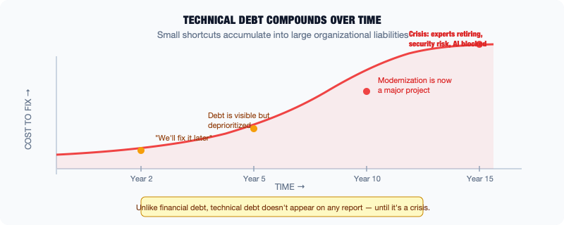
Diagram
The concept has expanded beyond its original meaning. Today, technical debt refers broadly to any deferred decision or deferred investment in technology that creates ongoing cost or risk. It is not just about code quality. It is about infrastructure that is past its end of life, systems that have not been upgraded, integrations that were built quickly and never stabilized, documentation that was never written, security patches that were deferred, and architecture decisions that made sense at the time but now constrain what the organization can do.

The Interest Metaphor
The interest metaphor is worth dwelling on because it explains why technical debt is so insidious.
When an organization takes on financial debt, the interest is visible. It shows up on financial statements. It is tracked and reported. There is institutional accountability for managing it.
When an organization takes on technical debt, the interest is largely invisible. It does not appear on any report. It is not tracked. It accumulates as slower development velocity, more time spent on maintenance rather than new capabilities, more incidents and outages, and more expensive projects when modernization eventually becomes necessary.
The interest compounds. A system that is five years out of date is manageable. A system that is fifteen years out of date, having accumulated fifteen years of customizations, integrations, and undocumented business logic, is significantly harder to modernize. The longer the debt goes unaddressed, the more expensive it becomes to pay it off.

Forms of Technical Debt
Technical debt manifests in several distinct ways in enterprise environments.
Code debt is the original meaning: software that works but is written in ways that make it hard to understand, modify, or maintain. The code accomplishes its purpose, but the way it accomplishes it is convoluted, undocumented, or built on outdated patterns. Every time someone needs to change it, they spend extra time understanding it first. The risk of introducing a bug is higher than it would be with cleaner code.
Infrastructure debt refers to hardware and software infrastructure that is past its recommended life or end of vendor support. Servers running operating systems that no longer receive security updates. Databases running versions that the vendor no longer patches. Network equipment that is past its replacement cycle. Infrastructure debt creates security risk, because known vulnerabilities cannot be patched, and operational risk, because aging hardware fails more frequently.
Architecture debt accumulates from decisions that were appropriate at the time but now constrain what is possible. A system designed for a few hundred concurrent users that now serves tens of thousands. An integration approach that worked for ten systems but becomes unmanageable at fifty. An authentication model built before current security requirements existed. Architecture debt is often the most expensive to address because fixing it requires redesigning, not just maintaining.
Documentation debt is the most underappreciated form. When a system is built, the people who build it understand how it works. When those people leave, that understanding goes with them unless it was documented. In enterprises, systems often outlast the people who built them by decades. Documentation debt means that when something breaks, when someone needs to modify the system, or when an AI initiative needs to understand what business rules the system enforces, nobody knows. Finding out is slow and expensive.

Who Pays for Technical Debt
One of the structural challenges of technical debt is that the people who accrue it are often not the people who pay for it.
A development team under pressure to ship a feature quickly writes code that works but creates debt. The team moves on. The debt is inherited by whoever maintains the system in the future, which may be a different team, or the same team under different management, several years later. The pressure that created the debt is not felt by the people who eventually pay it off.
This is not a moral failing. It is a structural consequence of how technology work is organized and evaluated. When teams are measured on short-term delivery and not on the long-term health of the systems they build, optimizing for short-term delivery is the rational response.
Changing this requires treating technical debt as a real organizational liability, something that is tracked, reported to leadership, and factored into planning. Some organizations do this formally. Engineering teams maintain a register of known technical debt, estimate the cost of addressing each item, and dedicate a portion of each development cycle to debt reduction.

Technical Debt and AI
Technical debt creates specific challenges for AI initiatives.
First, it constrains data access. AI needs data. Data lives in systems. If those systems carry heavy technical debt, with undocumented interfaces, fragile integrations, and inconsistent data formats, getting data out of them for AI purposes is significantly harder.
Second, it creates risk for AI-adjacent modernization. Many AI initiatives require some modernization of the underlying systems — better APIs, more real-time data, cleaner data models. If those systems are carrying significant technical debt, the modernization work is more complex and more risky, because the debt needs to be understood and addressed as part of the work.
Third, AI systems themselves can accumulate technical debt rapidly. A machine learning model that is trained and deployed but never maintained is technical debt. Not monitored for performance degradation. Not retrained as the underlying data changes. Not documented so that someone else can understand how it works. The responsible approach when deploying AI is to include a plan for its ongoing maintenance, which many organizations do not do.
Technical debt is not glamorous. It does not make headlines. It is, however, one of the most significant factors in determining how fast and how successfully an organization can move on AI and modernization. Taking it seriously is a mark of organizational maturity.

Integration Spaghetti: Point-to-Point vs. Platform
At some point in its growth, almost every enterprise technology organization creates an architecture diagram of its systems and the connections between them. The first time this diagram is drawn honestly, it frequently looks like a plate of spaghetti. Lines cross in every direction. Systems connect to other systems without apparent logic. Integrations overlap and branch in ways that nobody planned and nobody can fully explain.
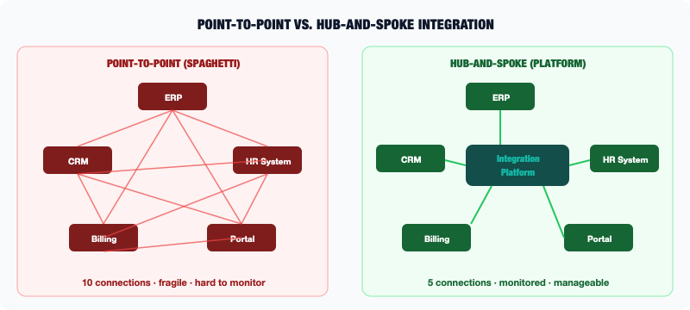
Diagram
This is integration spaghetti. It is one of the most common and most costly problems in enterprise IT. It is almost always the result of the same pattern: integration decisions made one at a time, to solve immediate needs, without a coherent architecture to govern how systems should connect.

How Point-to-Point Integration Happens
Imagine an organization with five core systems: an ERP, a CRM, an HR system, a billing platform, and a customer portal.
The CRM needs customer financial data from the ERP. An integration is built: a nightly batch job extracts financial data from the ERP and loads it into the CRM. Done.
A year later, the billing platform needs the same customer data from the ERP, but also needs deal information from the CRM. Two more integrations are built.
Another year passes. The customer portal needs to display account information from the billing platform and support history from the CRM. Two more integrations.
The HR system needs to sync employee data to the ERP for payroll purposes. Another integration.
Each of these integrations solved a real problem. But look at what has been built: a web of direct connections between systems, each built independently, each with its own logic, its own error handling, its own schedule. If the ERP’s data format changes, multiple integrations may break simultaneously. If the CRM’s API is unavailable, everything that reads from it fails. There is no central place to monitor what is running and what is failing. Tracing whether the customer portal shows current data requires following a chain through multiple integrations, each with different latency and error characteristics.
This is point-to-point integration. When it exists between five systems, it is manageable. When it exists between fifty systems — as in many large enterprises — it is the spaghetti problem.

The Geometric Problem
The reason spaghetti gets so bad so quickly is mathematical. With n systems that all need to talk to each other directly, the maximum number of connections is n times (n minus 1) divided by two. With five systems, that is ten potential connections. With ten systems, it is forty-five. With fifty systems, it is 1,225.
Not every system needs to talk to every other system. But in a large enterprise, the number of actual integrations can easily reach into the hundreds or thousands. Each integration is a potential point of failure. Each requires monitoring, documentation, and maintenance. The aggregate cost is enormous.

Platform-Based Integration
The alternative to point-to-point is hub-and-spoke. Instead of systems connecting directly to each other, they all connect through a central integration platform.
The integration platform sits in the middle. It receives data from source systems, applies transformation rules to convert data from one system’s format to another, and routes the data to the destination system. Instead of n-squared connections, you have n connections, one from each system to the platform.
The advantages are significant. Monitoring is centralized: all integrations are visible in one place, and failures are immediately apparent. Changes to one system’s data format only need to be addressed in the platform, not in every downstream integration. New integrations can often be built faster because the connections to existing systems are already established.
The integration platform comes in several flavors. An Enterprise Service Bus (ESB) is the traditional enterprise approach: a heavyweight, on-premises integration layer that handles message routing, transformation, and orchestration. More modern approaches include Integration Platform as a Service (iPaaS), cloud-based platforms like MuleSoft, Dell Boomi, or Azure Logic Apps that provide similar capabilities with less infrastructure overhead. Event streaming platforms like Apache Kafka handle high-volume, real-time data flows.

The Trade-Offs
Platform-based integration is better than spaghetti. It introduces its own challenges, however.
The integration platform becomes a single point of failure. If the platform is unavailable, all integrations stop. This requires the platform itself to be highly available and carefully managed.
The platform adds latency. Data routed through a platform takes longer to arrive than data transferred directly. For real-time use cases that need data in milliseconds, a platform may introduce unacceptable delay.
The platform requires investment. Building and maintaining an integration platform is not cheap. The initial setup, the training for the team that manages it, and the ongoing management are significant costs. For small organizations with few integrations, the cost may exceed the benefit.
A platform does not eliminate the need for good integration design. A poorly designed integration running through a well-managed platform is still a poorly designed integration. The platform improves manageability. It does not substitute for thoughtful architecture.

What This Means for AI
Integration architecture matters for AI in a direct way: AI systems need data, and data gets to AI systems through integrations.
An AI system that needs real-time data from multiple operational systems is at the mercy of the integration architecture. If the architecture is spaghetti, the data will be inconsistent, late, or missing, and the AI system will reflect that in its outputs.
When planning an AI initiative, one of the first architectural questions should be: how will data flow from the source systems to the AI system? Through what integrations? What is the latency? What happens when one of those integrations fails? The answer to these questions shapes the design of the AI system as much as any model or algorithm decision.

The Governance Gap: Who Actually Owns This System?
Ask the IT organization who owns a critical enterprise system, and you will get a name on an organizational chart, probably a role like “System Owner” or “Application Manager.” Ask that person how the system actually works, who the key users are, what the system’s dependencies are, and what would happen if it went down, and you may get a much less clear answer.
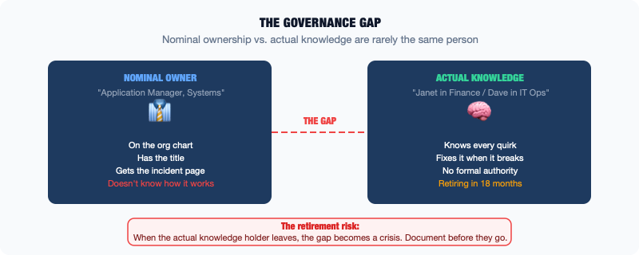
Diagram
This is the governance gap: the distance between nominal ownership and actual understanding and control. It exists in virtually every large organization. It is one of the most underappreciated sources of risk, friction, and project failure in enterprise IT.

What Governance Is Supposed to Mean
In enterprise IT, governance refers to the policies, processes, and accountabilities that define how technology is managed — who makes decisions about it, who is responsible for its operation, and how its use is controlled.
Good governance means that for every significant system, there is clear accountability. Someone understands what the system does and why it exists. Someone is responsible for its availability and data quality, approves changes, manages the vendor relationship if it is a commercial product, and decides when it should be retired.
Good governance also means documented standards for how systems are built and integrated. Changes go through a controlled process that includes testing and approval. The organization maintains a current inventory of what systems exist, what they do, and how they connect to each other.

Why Governance Gaps Form
Governance gaps form through a predictable set of mechanisms.
System owners change. The person who originally owned a system leaves the organization, is promoted, or moves to a different role. Their replacement inherits nominal ownership without inheriting the knowledge. The documentation, if it existed, is out of date. The real understanding of how the system works lives with people who are no longer the nominal owners.
Systems outlive their sponsors. Many enterprise systems were implemented to solve a specific business problem under the sponsorship of a specific executive. That executive moves on. The business problem is considered solved. The system stays, because other things have come to depend on it, but the organizational energy around it dissipates. Nobody is actively managing it. It just keeps running.
Shadow ownership emerges. In the absence of effective formal governance, informal governance takes over. The person in the business unit who uses the system every day, the analyst who built the reports on top of it, the junior IT person quietly maintaining the integrations: these people become the de facto owners. They have the knowledge. They do not have the authority or the accountability. When something goes wrong, there is a mismatch between who gets called and who actually knows what to do.
Documentation is never written, or goes stale. Organizations consistently underinvest in documentation. Building a system is visible and rewarded. Documenting it is invisible and time-consuming. Over time, the gap between what exists and what is documented grows. When the people who carry that knowledge leave, the documentation gap becomes a crisis.

The Retirement Risk
One of the most acute manifestations of the governance gap is the knowledge concentrated in employees approaching retirement.
Many critical enterprise systems were implemented decades ago. The people who implemented them, who understand the business logic embedded in them, and who have years of experience with their idiosyncrasies are often in their late fifties or sixties. When they retire, irreplaceable knowledge leaves with them.
Organizations that have not captured this knowledge, through documentation, structured knowledge transfer programs, or apprenticeship arrangements, face a genuine operational risk. When a critical system behaves unexpectedly and the person who could diagnose the problem has retired, resolution time can be measured in days or weeks rather than hours.
This risk is not hypothetical. It is playing out in real time in many organizations, particularly those that rely on mainframe systems and COBOL code.

The RACI Problem
A common approach to governance is the RACI matrix, a tool that assigns Responsible, Accountable, Consulted, and Informed roles for decisions and activities. RACI matrices are used to clarify who does what and who is ultimately accountable.
The problem with RACI in practice is that it is a document, not a reality. A RACI that assigns accountability to a role that does not have the budget, the authority, or the knowledge to exercise that accountability is not governance. It is documentation of a fiction. Real governance requires that the people in the accountable roles actually have the information, authority, and resources to do the job.

What This Means for AI
The governance gap creates specific problems for AI initiatives.
When an AI project needs data from a system, it needs someone who can provide authoritative information about what the data means, how it was collected, what business rules were applied to it, and how reliable it is. If the governance gap means that nobody knows the answers to these questions, the data cannot be trusted for AI purposes without significant investigation.
When an AI system needs to write back to enterprise systems — updating records, triggering processes — it needs clear governance over who authorizes those writes and what controls exist. Without it, the AI system is operating without the guardrails that prevent errors from propagating through the organization.
The AI system itself also needs governance. Who owns it? Who monitors it? Who is accountable when it produces a wrong answer? Who decides when it needs to be retrained? The same governance principles that apply to traditional enterprise systems apply to AI systems. Organizations that do not establish clear AI governance before deployment are creating future governance gaps of their own.

Vendor Lock-In: When Switching Costs Become Strategic Risk
Every technology decision is also a relationship decision. When an organization chooses an ERP vendor, a cloud provider, a CRM platform, or a database technology, it is not just choosing software. It is choosing a relationship that will be difficult to end.
Vendor lock-in is the condition where the cost of switching from a vendor’s technology to an alternative is so high that it constrains the organization’s choices. At its worst, it means that even if a vendor raises prices dramatically, delivers poor service, or falls behind competitors, the organization continues to use their product because the cost of switching exceeds the pain of staying.
Understanding lock-in — how it forms, what it costs, and how to manage it — is important for anyone involved in enterprise technology decisions.

How Lock-In Forms
Lock-in is not always a trap vendors set intentionally. It is usually the natural result of deep integration between an organization’s operations and a vendor’s technology.
Data lock-in is the most fundamental form. When years of business data are stored in a vendor’s proprietary format or database, extracting it requires a significant migration effort. The data needs to be exported, transformed into a different format, validated, and loaded into the new system. This is technically complex, time-consuming, and carries real risk of data loss or corruption. The longer data has been in the system, the harder the migration.
Process lock-in occurs when an organization’s business processes have been adapted to fit a vendor’s product. When teams have learned to work in a particular way because that is how the software works, changing the software means changing the process. Changing how people work is often harder than changing the technology.
Integration lock-in happens when a vendor’s product is deeply woven into the integration fabric of the organization. Every system that connects to it, reads from it, or writes to it would need to be modified or replaced in a migration. When a vendor’s product is at the center of dozens of integrations, the switching cost is not just replacing that product. It is reworking everything connected to it.
Skills lock-in occurs when the organization’s team has built expertise in a specific technology that does not transfer to alternatives. SAP-certified consultants, Oracle database administrators, and Salesforce developers are people whose skills are valuable specifically in the context of a particular vendor’s ecosystem. Switching vendors means either retraining these people or finding new people with different skills, which is expensive and time-consuming.
Contract lock-in can also constrain choices. Multi-year contracts, significant upfront license fees, or contractual commitments to minimum usage levels can make switching economically prohibitive even if the organization wants to.

The Spectrum of Lock-In
Not all vendor dependencies are equally problematic. It is useful to think about lock-in on a spectrum.
At one end are commodity technologies: products that implement open standards, where the organization’s data is in portable formats, and where switching to a comparable product is a manageable project. Switching from one email server to another is a significant project but not an existential one.
At the other end are deeply embedded platform technologies: ERP systems, core banking platforms, insurance policy administration systems. In these cases, the organization’s entire operational logic is encoded in the vendor’s software, years of data live in proprietary formats, and hundreds of integrations connect everything else to this central system. Replacing one of these is a multi-year, potentially nine-figure project that most organizations undertake only when they have no other choice.

When Lock-In Becomes a Problem
Lock-in is a condition, not necessarily a crisis. Many organizations are heavily locked into specific vendors for decades without significant harm. The relationship is stable, the vendor continues to invest in the product, and the switching costs remain a background constraint rather than an active problem.
Lock-in becomes a problem when something changes:
- The vendor raises prices significantly, knowing the organization cannot easily leave
- The vendor falls behind competitors and stops innovating, but the organization cannot switch to better technology
- The vendor is acquired by a company with different strategic priorities
- The vendor’s product cannot meet a new regulatory requirement or security standard
- A new capability — like AI — requires integration with the vendor’s platform, and the vendor either does not support it or charges prohibitive prices for it
At that point, the organization discovers the true cost of lock-in. It does not just constrain technology choices. It constrains strategic choices.

Managing Lock-In
The goal is not to eliminate vendor lock-in, which is not realistic for most enterprise technology. The goal is to understand it, manage it, and make conscious decisions about where to accept it and where to resist it.
Prefer open standards where possible. Technologies that use open data formats, open APIs, and open protocols are easier to migrate from because other products can read and write the same formats. Proprietary formats are a red flag.
Maintain data portability. Regardless of what system holds the data, the organization should periodically test its ability to extract and migrate that data. Running a data extraction exercise is far better than discovering, during a crisis, that the data cannot be exported in a usable format.
Negotiate exit rights. Contracts with significant vendors should include provisions for data export in portable formats and a transition period to support migration. This is sometimes negotiable.
Avoid building on proprietary APIs when open alternatives exist. If a cloud provider’s proprietary service can be replaced with an open-source equivalent running on the same infrastructure, the proprietary service creates lock-in that the open-source equivalent does not create.

What This Means for AI
AI introduces new forms of vendor lock-in that are worth understanding explicitly.
The major cloud providers, AWS, Azure, and Google Cloud, offer managed AI services, pre-trained models, and AI development platforms. Using these services is often the fastest way to build AI capabilities. It also creates a new layer of lock-in. Workflows, models, and pipelines built using one cloud’s AI services may be difficult to move to another.
AI model providers, including OpenAI, Anthropic, and Google, represent another form. If an organization builds AI applications that depend on a specific model’s API, switching to a different model requires testing and potentially significant rework to adapt to the different model’s behavior and response patterns.
This does not mean organizations should avoid these services. It means they should make the decision consciously, understand the dependency they are creating, and architect their systems to minimize unnecessary coupling. For instance, putting an abstraction layer between the AI application and the specific model API means that switching models requires changing one layer rather than the whole system.
Lock-in is not inherently bad. Sometimes the benefits of a deeply integrated vendor relationship far outweigh the costs of dependency. The problem is not lock-in itself. It is lock-in that was not thought through.

AI Does Not Replace the Stack: It Runs on Top of It
There is a version of the enterprise AI story that goes like this: AI arrives, legacy systems are replaced, and the organization emerges transformed, running on modern, intelligent infrastructure that is nothing like what came before. This story is told at conferences, in vendor presentations, and in business publications. It is not how enterprise AI actually works.
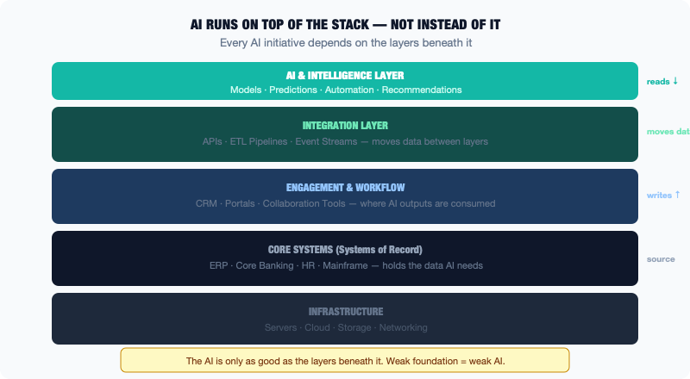
Diagram
The reality is almost exactly the opposite. AI is additive, not replacement. It runs on top of the existing technology stack, reads from existing systems, writes back into existing processes, and depends on data that has been sitting in databases and data warehouses for years or decades. The stack does not disappear when AI arrives. The stack becomes the foundation on which AI either succeeds or fails.
Understanding this is the single most important conceptual shift for anyone working on enterprise AI.

Why AI Runs on Top, Not Instead Of
The reasons AI does not replace the stack are the same reasons legacy systems persist at all.
Existing systems store the data that AI needs. Years of transaction history, customer behavior, operational records, and financial data are all in existing systems. AI models are trained on historical data. The quality and depth of the historical data determines what the AI can and cannot learn. You cannot replace the system that holds that data without first migrating the data. Migration is complicated, expensive, and risky.
Existing systems enforce the business rules that the organization depends on. The pricing logic, the eligibility rules, and the compliance requirements are encoded in existing systems and have been refined over years. An AI system can learn from these rules, automate some of the decisions they produce, and augment the process of applying them. But it cannot simply replace the system that enforces them without first understanding every rule and replicating it. That is a massive undertaking for any significant system.
Existing processes are built around existing systems. People know how to use them. The workflows, the approvals, the reports, and the audits all assume the existing system is there. Changing the system means changing the process means organizational change management. This is slow, expensive, and risky regardless of how good the new technology is.

The Three Walls
When an AI project runs into trouble in an enterprise, it almost always runs into one of three walls.
The data wall. The data the AI needs is in an existing system but is not accessible in a form the AI can use. It is in the wrong format, it is incomplete, it has quality problems, or there is no practical way to extract it at the volume and frequency required. The AI cannot improve until the data problem is solved, and solving the data problem requires work in the existing system.
The integration wall. The AI system needs to read from or write to existing systems, but the integration is difficult. The existing system does not have a modern API. The API that exists is slow, unreliable, or poorly documented. The data formats are incompatible. Building and maintaining the integration takes longer and costs more than anticipated.
The process wall. The AI system produces a recommendation, a prediction, or an automated action. The existing process does not have a clean way to incorporate it. The recommendation has to be manually reviewed and entered into a different system. The automation triggers a workflow that the existing process was not designed to handle. The AI output is technically correct but organizationally unactionable.
These three walls are not bugs in the AI initiative. They are the normal friction of inserting new technology into an existing, deeply layered environment. The organizations that navigate them successfully are the ones that understood they were coming and planned accordingly.

What “Running on Top” Looks Like in Practice
Here is a concrete example of what it means for AI to run on top of the existing stack rather than replace it.
A large insurance company wants to use AI to speed up claims processing. Today, a claim is filed, an adjuster reviews it, and the decision takes several days.
The AI initiative does not replace the claims system. The claims system is a thirty-year-old platform with millions of historical claims, business rules encoded in COBOL, and a dozen downstream systems connected to it. Replacing it would take five years and hundreds of millions of dollars.
Instead, the AI initiative runs alongside it. The AI model is trained on historical claims data extracted from the existing system. It is deployed as a separate service that, when a new claim comes in, reads the claim details through an integration, generates a recommendation — low risk, approve; medium risk, fast-track to adjuster; high risk, detailed review — and posts that recommendation back to the adjuster’s interface. The adjuster sees the recommendation, uses it to prioritize their work, and makes the final decision, which is recorded in the existing system as always.
The existing system is untouched. The AI does not replace it. The AI adds intelligence to the process that runs through it. The value is real: faster processing, better prioritization, and more consistent outcomes, without requiring a replacement of the underlying system.
This is what enterprise AI actually looks like in practice, and it is a useful mental model for almost every AI initiative at scale.

The Implication for AI Strategy
The most important implication of this reality is that AI strategy in the enterprise cannot be separated from data strategy, integration strategy, and process strategy.
An AI initiative that does not account for the data it needs, how it will access that data, and how its outputs will be incorporated into existing processes is not a complete strategy. It is a technology experiment that will hit walls.
The organizations that succeed at enterprise AI treat it as a layer on top of an existing landscape, designed to work with that landscape rather than despite it. They invest in the data infrastructure. They build and maintain the integrations. They redesign the processes. And they choose AI use cases that are achievable given the actual state of the systems underneath.

What “Data Readiness” Actually Means
“We have the data” is one of the most optimistic, and frequently incorrect, statements made at the beginning of an enterprise AI initiative.
Every enterprise has data. Large enterprises have enormous amounts of it. Transaction records going back decades. Customer records in the millions. Operational data from every system that has ever run in the organization. The data exists.
What most enterprises do not have is data that is ready to use for AI. The gap between “we have the data” and “the data is ready” is where most AI projects run into their first serious problems. Projects often fail or take significantly longer than expected at this stage.
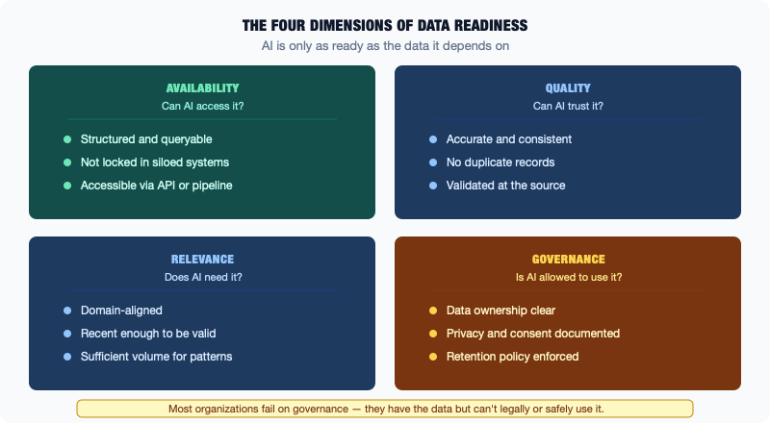
Diagram

The Four Dimensions of Data Readiness
Data readiness is not a single thing. It is a combination of four distinct qualities, each of which needs to be present for data to be genuinely useful for AI.
Availability is the most basic question: can we actually get to the data? It sounds obvious, but data that exists is not always accessible. It may be in a system with no API or export capability. It may be in a legacy system that requires specialized knowledge to access. It may be protected by access controls that make it difficult to get to without going through a formal request process. Or it may technically be accessible but only through a mechanism that is too slow or too low-volume to support AI workloads.
Quality is the question of whether the data is accurate, complete, and consistent. Quality problems in enterprise data are extremely common and often invisible until you try to use the data for something other than its original purpose. Records with missing fields. Duplicate customer records created by different systems over time. Addresses in inconsistent formats. Dates stored in incompatible formats across different systems. Codes that mean different things in different parts of the system because their meaning was changed at some point without updating historical records.
Relevance is the question of whether the data actually captures what you need to capture for the AI use case. It is possible to have high-quality, easily accessible data that is simply not the right data. If you want to predict customer churn, you need data about customer behavior: what customers do, how they interact with the product, and what their support history looks like. If your systems only capture transactional outcomes and not the behaviors that lead to them, the data is not relevant to the use case.
Governance is the question of whether the data can be used for this purpose. This includes both legal and regulatory questions: is there consent to use customer data for AI modeling, and are there regulatory restrictions on how this data can be processed? It also includes organizational questions: does the data have a documented owner who has approved its use for this purpose, and is there a record of what transformations have been applied to it?

Why Data Quality Problems Are Invisible Until AI
One of the counterintuitive aspects of data quality is that poor quality is often invisible in the context of the operational system that created the data, and becomes highly visible when the data is used for analytics or AI.
Consider a CRM system with duplicate customer records. The sales team using the CRM every day may barely notice. They interact with their own accounts. The duplicates are in other parts of the system, created by other teams, and nobody is looking at the aggregate picture.
When an AI model is trained on that CRM data, the duplicates become a significant problem. The model may learn from conflicting records about the same customer. It may count one customer as two, inflating certain metrics. It may fail to connect behaviors across the two records, missing patterns that would be visible if the data were clean.
This is not a problem the operational team knows about, because the operational team never looks at the data the way the AI does: across the whole dataset, looking for patterns and relationships.
This is why AI projects so consistently surface data quality problems that were not previously known. AI looks at data differently from the way operational users look at it. And the scrutiny that AI-scale analysis applies to data reveals problems that have existed for years but went unnoticed.

The Data Readiness Assessment
Before committing significant resources to an AI initiative, any organization should conduct a data readiness assessment. This is a structured evaluation of the four dimensions described above, for the specific data that the AI initiative requires.
The assessment should answer: - Where does the required data live? In what systems? In what formats? - How would it be accessed for AI purposes? What are the technical mechanisms? - What is the known data quality? Have quality assessments been done recently? - Are there governance requirements that affect how the data can be used? - What transformations would be required to make the data suitable for AI modeling?
The output of a data readiness assessment is not a yes or no answer. It is a realistic picture of what work needs to happen before the data is actually ready, and therefore how long the AI project will really take and what it will really cost.
Organizations that skip this step frequently discover mid-project that the data they assumed was available is not, or that the data quality problems are more severe than expected. At that point, timelines slip, budgets expand, and confidence in the initiative erodes.

What Good Data Readiness Looks Like
For comparison: a mature organization with strong data readiness for a given AI initiative would have:
- Clear documentation of where the relevant data lives and how to access it
- Recent data quality assessments with known, quantified issues and remediation plans
- An established data pipeline that extracts, transforms, and loads the data into an analytics-ready environment on a known schedule
- A data governance structure that defines ownership, approved uses, and privacy controls
- A data catalog that explains what each dataset contains, what its provenance is, and who to contact with questions
Most enterprises are not here, and that is fine — these capabilities take time and investment to build. But the gap between where an organization is and where it needs to be for AI is the most honest measure of how ready it actually is for enterprise AI initiatives.
Data readiness is not glamorous. It does not make for exciting board presentations. But it is the foundation on which every AI initiative either stands or collapses.

Which Systems Are AI-Ready (and Which Are Not)
One of the most practical questions in enterprise AI is not “what can AI do?” but “what can AI do given the systems we actually have?” The answer is different for every organization, and it is determined largely by the characteristics of the existing technology landscape.
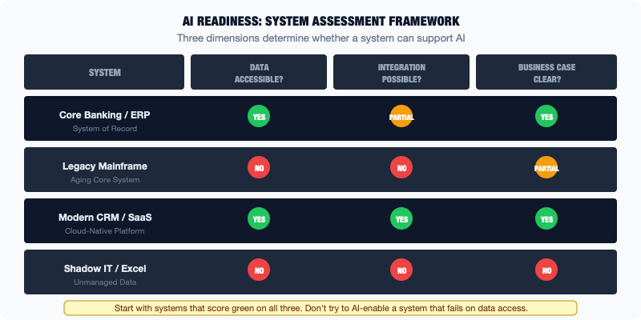
Diagram
Some systems are well-suited to AI integration — they have modern APIs, clean data, documented business rules, and stable interfaces. Others are not, relying instead on proprietary protocols, poor data quality, and interfaces that are difficult to change or integrate with. Understanding the difference upfront saves enormous time and prevents the common pattern of starting an AI project with enthusiasm and then discovering mid-stream that the foundational systems are not ready.

Characteristics of AI-Ready Systems
A system is AI-ready when it can provide data to an AI system efficiently, receive AI outputs in a way the process can use, and be integrated with without creating unacceptable risk.
Modern, documented API. The system exposes a well-documented API, ideally a REST API, or at minimum a SOAP or messaging interface that is stable and supported. The API has predictable behavior, returns data in a consistent format, and has enough throughput to support the query volume AI systems require.
Clean, consistent data. The data in the system is accurate, reasonably complete, and consistent over time. There are no major known data quality problems that would distort AI training or inference. Key entities such as customers, products, and transactions have unique, stable identifiers that can be used to join data across systems.
Stable interfaces. The system’s APIs and data exports do not change frequently in ways that would break integrations. There is a versioning approach, or at least a change management process that gives advance notice of interface changes.
Clear data semantics. The meaning of the data fields is documented or well-understood. Codes and flags are documented. The business rules that govern how data is created and modified are either documented or can be explained by people who have that knowledge.
Access controls that allow appropriate use. The system has access controls that can be configured to allow AI systems to read (and write, if needed) data without requiring special workarounds or bypassing security controls.

Systems That Are Not AI-Ready
By contrast, certain characteristics make a system difficult or impossible to integrate with for AI purposes without significant prior investment.
No API or only batch file exports. Systems that can only export data as periodic batch files, for example a flat file generated every night, are not well-suited to real-time AI applications. They can still be used for AI applications that work on daily or historical data, but they cannot support real-time inference or continuous learning.
Proprietary protocols. Some older systems communicate using protocols that are specific to their vendor or era and require specialized connectors to work with. If the organization does not have the expertise or tooling for those connectors, integration is a significant project before AI work can begin.
Poor data quality. Systems with significant known data quality problems, such as high rates of missing fields, many duplicates, and inconsistent values, require data cleaning work before the data can be trusted for AI. This is not impossible, but it is additional work and it needs to be planned.
Undocumented business logic. If the system contains business logic, such as pricing rules, eligibility rules, and calculation methods, that is not documented and not understood by anyone currently working with it, any AI system that tries to learn from or replicate that logic is operating without a map. This is particularly common with older systems where the original developers are no longer available.
High change risk. Some systems are so fragile or so tightly coupled to other things that integrating with them carries significant risk of causing problems elsewhere. These systems should be approached with care: not necessarily avoided, but assessed thoroughly for impact before any integration work begins.

A Simple Assessment Framework
For each system in the landscape that an AI initiative might need to interact with, a practical assessment can be done in three dimensions.
Data access: Can we get the data we need from this system? How? At what frequency? With what quality? Rate this from straightforward (modern API, clean data) to blocked (no access path without significant investment).
Integration stability: How stable is the interface? How much will changes to this system affect our AI integration? Rate this from stable (versioned API, predictable behavior) to fragile (no versioning, frequent undocumented changes).
Data quality: How reliable is the data for AI purposes? Rate this from production-ready (known quality, minimal issues) to requires remediation (significant quality work needed before use).
Systems that score well on all three dimensions are good candidates for AI integration now. Systems that score poorly on one dimension need targeted investment in that dimension before AI work begins. Systems that score poorly on all three are best approached later, either after preparatory work or by designing AI applications that do not depend on them.

Where AI-Ready Systems Usually Are
In most enterprises, the systems that are most AI-ready tend to be the modern ones: cloud-based SaaS tools with APIs designed for integration, modern data platforms built with analytics in mind, and systems implemented or significantly upgraded in the last five years.
The systems that are least AI-ready tend to be the most important. The core legacy systems hold the deepest, most valuable data. This is the paradox of enterprise AI: the data you most want for AI is often in the systems that are hardest to integrate with.
The resolution to this paradox is not to ignore legacy systems or to wait until they are replaced. It is to invest in extraction layers, such as middleware, integration platforms, and data pipelines, that make the data from legacy systems available to modern AI applications without requiring changes to the legacy systems themselves. This is the practical manifestation of the coexistence principle that runs through this entire book.

The Coexistence Imperative: Why Rip-and-Replace Does Not Work
“Why don’t they just replace it?”
It is a question that gets asked, in some form, at almost every enterprise AI project kickoff. The legacy system that holds the data is old, hard to integrate with, and runs on technology that most modern developers have never worked with. Why not replace it with something modern, clean the data, and start fresh?
The answer, in practice, is that rip-and-replace rarely works. The exceptions are so expensive, so risky, and so time-consuming that they prove rather than challenge the rule.
This chapter explains why coexistence is not a failure mode. It is the correct strategy for most enterprise AI and modernization work.
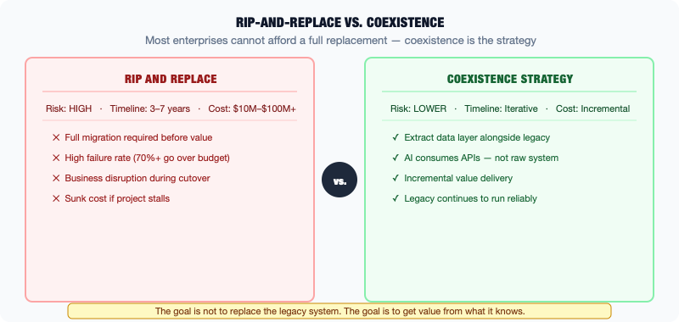
Diagram

Four Reasons Legacy Stays
There are four fundamental reasons why legacy systems persist even when organizations know they need to modernize, and all four apply simultaneously to most large enterprises.
Risk. Core legacy systems run critical business operations. A core banking system processes millions of transactions per day. A manufacturing ERP controls production across dozens of facilities. A government benefits system issues payments to millions of people. When you replace one of these systems, you are conducting a high-wire act: you have to move everything from the old system to the new system while keeping the business running. The window during which both systems are running in parallel is inherently risky. Data may be inconsistent, processes may behave differently, and errors that appear in one system may not be visible in the other. If the cutover fails, the consequences are immediate and severe.
Cost. The visible cost of a legacy system, meaning the licenses, the maintenance fees, and the aging hardware, is often much lower than the cost of replacing it. A full ERP replacement for a large organization can cost hundreds of millions of dollars and take five to ten years. A core banking migration may be even more expensive. When leadership compares the cost of running the legacy system for another decade against the cost and risk of replacing it, continuing to run it often wins.
Regulation. In regulated industries, changing systems requires regulatory oversight. New systems must demonstrate that they meet the same regulatory requirements as the systems they replace. In some cases, the software itself must be formally validated before it can be used in production. This process takes time, costs money, and adds to the risk of replacement. For organizations in multiple regulated jurisdictions, compliance across all jurisdictions adds further complexity.
Institutional knowledge. Legacy systems encode decades of business logic that is often not fully documented anywhere outside the system. Replacing the system requires fully understanding that logic and replicating it in the new system. But the people who understand it may no longer be at the organization. Reconstructing undocumented business logic from a running system is an enormous, painstaking task. Getting it wrong means the new system does not actually do what the old system did, a gap that may only be discovered after the cutover.

The Real Cost of Failed Replacements
The history of enterprise IT is full of cautionary tales about large-scale system replacement projects that went badly wrong.
A major airline attempted to replace its reservation system. The project ran years over schedule, failed to fully migrate customer data, and caused significant disruption to operations when the new system went live. The organization spent years dealing with the fallout.
A global bank attempted to replace its core banking platform across multiple countries simultaneously. The project was eventually abandoned after years of work and hundreds of millions of dollars spent, with the original legacy system still running.
A state government attempted to replace its benefits administration system. The new system, when it launched, failed to process claims correctly, leaving vulnerable citizens without payments for months.
These are not stories about bad technology or incompetent teams. They are stories about the genuine difficulty of replacing systems that are deeply embedded in operations, at scale, with continuity requirements that leave no room for error.

Coexistence as Strategy
Coexistence means designing AI and modernization initiatives to work with existing systems rather than requiring their replacement.
This is not settling for second best. It is the mature, realistic, frequently optimal approach.
Coexistence looks like building an extraction layer between the legacy system and the AI system: a data pipeline that pulls data from the legacy system, transforms it, and makes it available to modern tools without requiring the legacy system to be changed. The legacy system continues to do what it does. The AI system gets the data it needs.
Coexistence looks like building a modern experience layer on top of a legacy backend: a new interface, a new API, or a new workflow that makes the legacy system more accessible and useful without touching its core. The COBOL is still running underneath. The modern application is what users see.
Coexistence looks like identifying specific, bounded AI use cases that can be implemented without requiring deep changes to legacy systems. This means AI that augments a process, provides a recommendation, or automates a narrow task, rather than AI that requires replacing the system the process runs on.

What Coexistence Requires
Making coexistence work requires a few specific capabilities.
Integration discipline. Coexistence depends on reliable integrations between legacy systems and modern components. This means investing in integration platforms, monitoring, and the engineering discipline to build integrations that are stable and maintainable over time.
Data architecture. Coexistence requires a clear strategy for how data flows between legacy and modern systems: what is the single source of truth, how frequently is data synchronized, and how are conflicts resolved when the two systems have inconsistent data.
Clear boundaries. Every coexistence architecture needs clear decisions about which system does what. If the legacy system and the modern system both manage parts of the same process, there need to be clear rules about which takes precedence and how they hand off to each other.
Patience. Coexistence is a medium-term strategy. The legacy system may eventually be replaced, but on a realistic timeline, after thorough preparation, with the modern layer already running. That transition takes years, not months. Organizations that understand this commit to coexistence as a real strategy rather than as an admission of failure.
The practitioners who understand coexistence, who know how to extract value from the stack that exists rather than the stack they wish they had, are the ones who actually deliver AI results in enterprise environments.

Where to Start: Finding the Signal in the Sprawl
After twenty chapters of honest accounting, covering legacy systems, technical debt, integration spaghetti, vendor lock-in, data swamps, and governance gaps, it would be easy to conclude that enterprise AI is too hard and the landscape too broken for anything to work.
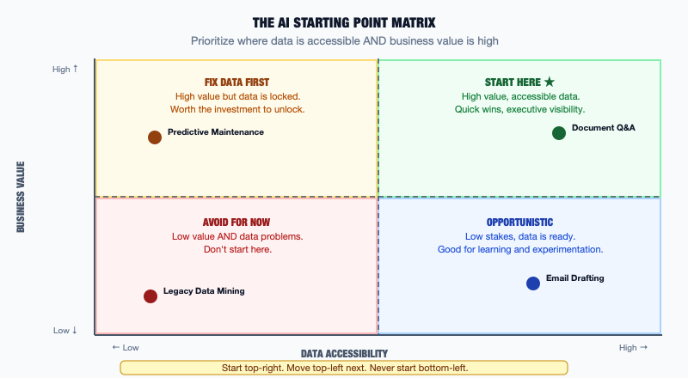
Diagram
That conclusion would be wrong.
Enterprise AI is working. It is working at scale, in large organizations, delivering real and measurable value. Not everywhere, not easily, and not in the way the vendor presentations suggest. But it is working. The organizations doing it successfully share a common approach: they start where the conditions are right, not where the ambition is highest.
This chapter is a practical guide to finding those places.

The Signal Capture Mindset
The first mental shift required is from “what is the most exciting AI application we could build?” to “where is AI value genuinely achievable given what we have?”
This distinction matters enormously. The most exciting AI application might require integrating five legacy systems, cleaning three years of data, and redesigning a process that involves four departments. That project will take years, cost more than expected, and has a meaningful chance of failure.
A less exciting AI application, one that works with data that is already clean and accessible, fits into an existing process without requiring redesign, and solves a problem the business actually feels acutely, might take months, cost a fraction of the ambitious project, and has a high chance of delivering real value.
The less exciting project is almost always the better starting point. Success builds credibility, and credibility builds organizational capacity for more ambitious work. An enterprise AI practice built on a series of successful smaller applications is far more durable than one that staked everything on a transformational flagship project.

Four Criteria for a Good Starting Point
A good starting AI use case in an enterprise context meets four practical criteria.
The data is accessible. The data required for the AI application already exists in a system that can be accessed without a major integration project. It is reasonably clean, reasonably complete, and can be extracted on a schedule that supports the use case. You may need to do some data preparation, but you are not starting with a data migration.
The outcome is measurable. There is a clear, quantifiable metric that the AI application is expected to improve. Processing time. Error rate. Cost per transaction. Customer satisfaction score. If you cannot measure the outcome before and after, you cannot demonstrate that the AI worked. Demonstrating that it worked is how you build support for the next initiative.
The process has a natural AI integration point. The AI output, whether a prediction, a recommendation, a classification, or an automated action, can be incorporated into the existing process without requiring the process to be redesigned from scratch. There is a natural place for the AI to add value: before a human makes a decision, after a document arrives, when a threshold is triggered. The simpler the integration into the existing process, the better.
The scope is bounded. The use case is specific enough that it can be delivered by a small team in a reasonable timeframe. Not “improve customer service,” but “reduce the time to classify incoming support tickets by department.” Not “optimize the supply chain,” but “flag purchase orders that exceed historical price benchmarks for this supplier.” Specific, bounded scope makes delivery achievable and learning possible.

Where to Look
With those criteria in mind, there are categories of enterprise problems where these conditions frequently align.
Document processing and classification. Enterprises process enormous volumes of documents: invoices, contracts, claims, applications, reports. Many of these require human review to classify, extract information from, or route to the right person. AI is well-suited to this work. Documents are already in digital form, the classification categories are usually well-defined, and the value of automation in speed, consistency, and cost is measurable. The data is the documents themselves, which are usually accessible.
Anomaly detection in transaction data. Transactional systems generate enormous volumes of structured data. Identifying anomalies, such as unusual transactions, outlier patterns, and deviations from historical norms, is a task that AI handles well and that humans handle poorly at scale. Fraud detection in financial systems, unusual expense reports, and procurement orders that deviate from historical patterns are all areas where AI can add significant value with data that is usually already available.
Predictive maintenance. For organizations with physical assets such as manufacturing equipment, fleet vehicles, and infrastructure, predicting when maintenance is needed before failure occurs is valuable and often achievable with sensor data that is already being collected. The business case is clear: reduced downtime and lower maintenance costs. The data exists, and the integration point is well-defined in the maintenance scheduling system.
Internal search and knowledge retrieval. Many enterprises have enormous volumes of internal documentation, policies, procedures, and institutional knowledge that is difficult to find when it is needed. AI-powered search and retrieval, helping employees find the right document, the right policy, or the right answer, is an application that works with data already in the organization, requires no integration with operational systems, and delivers clear value that users experience directly.
Report generation and summarization. The time people spend reading, synthesizing, and writing reports is significant in most enterprises. AI that can summarize lengthy documents, generate first drafts of standard reports, or extract key information from structured data sources can save real time on work that is well-understood and measurable.

What to Avoid
The flip side of the criteria above is a list of conditions that suggest a use case is not the right starting point.
Avoid use cases where the data required is in systems with poor data quality, no API, or no clear access path. Avoid use cases where the outcome is hard to measure or where success criteria are vague (“improve strategic decision-making”). Avoid use cases that require redesigning a major process before AI can be deployed. Avoid use cases that depend on integrating many systems simultaneously.
These are not permanently off the table. They are for later, after the organization has built experience, demonstrated value, and developed the organizational capacity to handle more complex work.

Starting Is Not Waiting
One final point. The analysis and criteria above are meant to help identify the right starting point, not to create an endless planning cycle that delays any action.
The organization that never starts because the data is not quite ready, the process is not quite right, or the use case is not quite ambitious enough will never build the capability to tackle harder problems. At some point, you have to start with what you have, learn from it, and improve.
The goal is to start in a place where success is genuinely achievable, not to wait for perfect conditions that will never arrive. Enterprise AI landscapes are never clean. They are always complicated. The organizations that lead in AI are not the ones with the cleanest data or the most modern stack. They are the ones that learned to move forward within the constraints of the stack they have, while steadily improving it over time.
That is the stack beneath the signal. Learn it. Work with it. And find the value inside it.

Glossary: 50 Terms Every Non-Technical Leader Should Know
API (Application Programming Interface) — A defined way for one piece of software to talk to another. APIs let systems exchange data and trigger actions without human involvement. When your CRM automatically pulls data from your billing system, it is using an API.
Batch processing — Running a large set of transactions or data operations all at once, on a schedule, rather than one at a time as events occur. Payroll is a classic batch process. It does not calculate your pay every second. It runs once per pay period.
Business intelligence (BI) — Tools and processes that help organizations analyze data and make decisions. Dashboards, reports, and data visualizations are BI outputs. Tableau, Power BI, and Looker are common BI tools.
Change management — The process of planning, testing, approving, and deploying changes to IT systems in a controlled way. In enterprise IT, change management exists to reduce the risk of changes causing problems in production systems.
Cloud computing — A model for consuming computing infrastructure (servers, storage, networking) as a service over the internet rather than owning and operating physical hardware.
COBOL (Common Business-Oriented Language) — A programming language created in 1959 that is still widely used in mainframe systems at banks, government agencies, and insurance companies. It is old, but it is processing trillions of dollars in transactions every day.
COTS (Commercial Off-The-Shelf) — Software that is built by a vendor for general sale, rather than custom-built for a specific organization. SAP, Salesforce, and Workday are COTS products.
CRM (Customer Relationship Management) — Software that manages an organization’s interactions with customers. Salesforce is the most widely used CRM. It typically stores contact records, sales pipeline, and customer communication history.
Data catalog — A centralized inventory of an organization’s data assets: what data exists, where it lives, what it means, and who owns it. A good data catalog makes it possible to find and trust data quickly.
Data governance — The policies, processes, and accountabilities that define how data is managed: who can access it, how it can be used, who is responsible for its quality, and how long it is retained.
Data lake — A storage system that holds large volumes of data in its raw, unprocessed form. Unlike a data warehouse, a data lake accepts any type of data, including structured, semi-structured, and unstructured. Governance challenges frequently lead data lakes to become data swamps.
Data lakehouse — A hybrid approach combining the low-cost storage of a data lake with the structure, governance, and query performance of a data warehouse. Databricks pioneered the concept.
Data pipeline — An automated process that moves data from one system to another, typically performing transformations along the way. Data pipelines are how data gets from operational systems into data warehouses and AI systems.
Data swamp — A data lake that has accumulated data without adequate governance: no documentation, no quality controls, no catalog. Data is technically present but practically unusable.
Data warehouse — A database optimized for analytical queries rather than transactional processing. Data from operational systems is extracted, transformed, and loaded into the warehouse on a schedule, making it available for reporting and analysis.
ERP (Enterprise Resource Planning) — A category of software that manages core business processes, including finance, procurement, HR, supply chain, and manufacturing, in an integrated system. SAP and Oracle are the dominant vendors.
ESB (Enterprise Service Bus) — An integration platform that routes data between enterprise systems, handling format translation, message queuing, and routing logic. The traditional approach to enterprise integration middleware.
ETL (Extract, Transform, Load) — The process of extracting data from source systems, transforming it into the target format, and loading it into a destination system (typically a data warehouse). ETL is the backbone of most enterprise data infrastructure.
Failover — The automatic switching to a backup system or component when the primary one fails. Enterprise systems with high availability requirements are designed with failover capabilities so that a single component failure does not take down the whole system.
Firewall — A security control that monitors and restricts network traffic. Firewalls are a fundamental component of enterprise security architecture. They define what traffic is allowed into and out of the network.
General ledger — The master financial record of an organization, recording all financial transactions. The general ledger is maintained in the ERP or accounting system and is the authoritative source for financial reporting.
Hybrid cloud — An architecture where an organization uses both on-premises infrastructure and cloud services. Most large enterprises are hybrid, running some workloads in the cloud and some on their own hardware.
IaaS (Infrastructure as a Service) — The most basic cloud service model: the cloud provider supplies virtual computing infrastructure (servers, storage, networking) that the customer configures and manages.
Integration — A connection between two systems that allows them to exchange data. Integrations can be real-time (one system calling another’s API as events occur) or batch (data transferred on a schedule).
iPaaS (Integration Platform as a Service) — A cloud-based integration platform that connects enterprise systems without requiring on-premises middleware. MuleSoft, Dell Boomi, and Azure Logic Apps are examples.
Legacy system — A system that the organization cannot easily replace or significantly modify without unacceptable risk or cost. Legacy is defined by replaceability, not age.
Mainframe — A type of computer designed for high-volume, high-reliability transaction processing. IBM mainframes still process the majority of the world’s financial transactions.
Master data management (MDM) — The discipline of creating and maintaining a single, authoritative record for key business entities, typically customers, products, and employees, across multiple systems.
Middleware — Software that sits between two other systems and facilitates their communication. Integration platforms and enterprise service buses are forms of middleware.
Multi-cloud — Using services from multiple cloud providers. An organization might use AWS for one workload, Azure for another, and Google Cloud for machine learning. Multi-cloud reduces dependency on a single vendor but adds operational complexity.
On-premises (on-prem) — Technology infrastructure that the organization owns and operates in its own facilities, as opposed to cloud infrastructure rented from a provider.
PaaS (Platform as a Service) — A cloud service model where the provider manages the underlying infrastructure and runtime environment, and the customer deploys applications on top. Google App Engine is an example.
Point-to-point integration — Direct connections between individual systems, built independently for each pair of systems that need to communicate. Point-to-point integration works for small numbers of systems but creates spaghetti at scale.
Procurement — The business process of purchasing goods and services. Enterprise procurement is typically managed through the ERP system and involves vendor selection, purchase orders, goods receipt, and invoice processing.
REST API — The most common type of API in modern software. REST APIs use the same communication protocol as web browsers (HTTP) and are the standard for integrating modern cloud services.
SaaS (Software as a Service) — Software delivered over the internet as a service, typically on a subscription basis. The provider manages everything: infrastructure, application, and updates. Salesforce, Workday, and Microsoft 365 are SaaS products.
Shadow IT — Technology that is in use within an organization but is not managed or sanctioned by the IT organization. Shadow IT emerges when official systems do not meet the needs of the people who need to work.
Single source of truth — The system or dataset that is designated as the authoritative record for a specific type of data. When there is only one source of truth, decisions can be made with confidence about which data to trust.
SOAP (Simple Object Access Protocol) — An older API standard that uses XML-formatted messages. SOAP was the dominant standard for enterprise web services in the 2000s and is still used by many older enterprise systems.
SOA (Service-Oriented Architecture) — An architectural pattern in which software components provide services to other components through a network, using standard protocols. SOA was the precursor to modern microservices architecture.
System of engagement — A system that humans interact with to do their work or interact with the organization. CRMs, customer portals, and mobile apps are systems of engagement. They typically read from and write to systems of record.
System of intelligence — A system that analyzes data to produce insights, predictions, or automated decisions. Data warehouses, machine learning platforms, and AI systems are systems of intelligence.
System of record — The authoritative source of truth for a particular type of data. The ERP is typically the system of record for financial and inventory data. The HR system is the system of record for employee data.
Technical debt — Deferred investment in technology quality, architecture, or infrastructure that creates ongoing cost and risk. Like financial debt, technical debt accrues interest over time.
Uptime — The percentage of time a system is operational and available. Enterprise systems that process critical operations are typically required to achieve very high uptime, 99.9% or higher, measured in minutes of downtime per year.
Vendor lock-in — The condition where the cost of switching from a vendor’s technology is so high that it constrains the organization’s choices. Lock-in forms through data portability limitations, process dependencies, integration complexity, and skills concentration.
Virtualization — The creation of virtual versions of hardware resources, such as servers, storage, and networks, that can be managed independently of the underlying physical hardware. Virtualization is the technology foundation of cloud computing.
VSAM (Virtual Storage Access Method) — A file storage method used on IBM mainframes. VSAM datasets are a common way that mainframe systems store and access data. Integrating with VSAM data requires mainframe-specific knowledge and tooling.

The IT Landscape Map
The chapters of this book covered the enterprise technology landscape in sequence: foundation first, then modern layers, then sprawl, then AI. This appendix brings those pieces together into a single coherent map. Use it as a reference when you need to orient yourself quickly to how the layers connect.
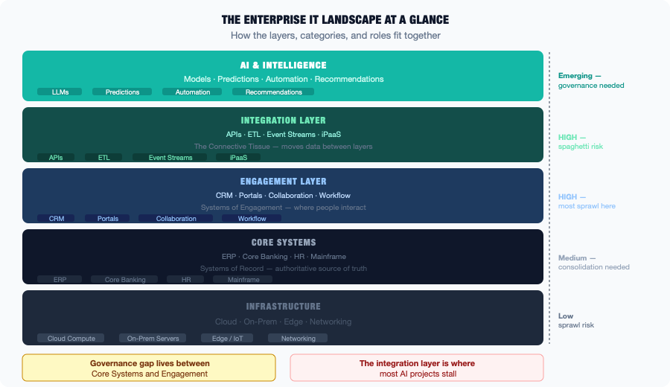
Diagram

The Five-Layer Model
Enterprise technology can be organized into five layers, each building on the one below it.

Layer 1: Infrastructure
What it is: The physical and virtual computing resources, including servers, storage, networking, and data centers, that everything else runs on.
On-premises: Servers and network equipment owned and operated by the organization in its own data centers. Managed by infrastructure teams. High upfront cost, full control.
Cloud: Computing resources rented from providers (AWS, Azure, Google Cloud). Variable cost, consumed on demand. Managed by the provider for physical infrastructure. The organization manages what runs on top.
Hybrid: Most large enterprises run a combination. Some workloads stay on-premises (regulatory requirements, cost, legacy constraints). Others move to cloud (scalability, modern services, managed operations).
Key insight: Infrastructure is a foundation, not a differentiator. What matters is what runs on top of it, and whether the infrastructure meets the reliability, security, and performance requirements of the workloads it supports.

Layer 2: Core Systems (Systems of Record)
What it is: The authoritative sources of business truth: the systems that hold the data the organization depends on.
ERP: Finance, procurement, inventory, manufacturing, HR. The operational spine. SAP and Oracle dominate. Deeply integrated, expensive to change, holds decades of data.
Core banking / industry-specific platforms: For regulated industries, including banking cores, insurance policy administration, healthcare EMRs, and government benefits systems. Often mainframe-based or built on legacy platforms. Process the highest-stakes transactions.
HR systems: Employee records, payroll, benefits, performance. Workday and SAP SuccessFactors are common in large enterprises.
Key insight: Core systems are the hardest to change and hold the most valuable data. They are the primary source of data for analytics and AI, and also the primary source of data access challenges.

Layer 3: Engagement and Workflow (Systems of Engagement)
What it is: The systems people actually interact with: the faces of the enterprise technology stack.
CRM: Customer records, sales pipeline, support history. Salesforce dominates. The engagement layer for customer-facing processes.
Collaboration tools: Email, calendar, messaging, document management. Microsoft 365 and Google Workspace are dominant. These are systems of engagement for internal work.
Portals and applications: Customer-facing websites, employee self-service portals, mobile apps. These sit on top of core systems and present their data in usable form.
Workflow platforms: Tools that manage processes such as routing approvals, tracking tasks, and managing service requests. ServiceNow is the enterprise standard for IT service management.
Key insight: Systems of engagement are the most visible and the most changeable. They are where user experience improvements happen. They read from and write to core systems through integrations.

Layer 4: Integration (The Connective Tissue)
What it is: The mechanisms that move data between layers: the plumbing.
Point-to-point integrations: Direct connections between two specific systems. Fast to build, fragile at scale. The source of most integration spaghetti.
Integration platforms (ESB, iPaaS): Centralized middleware that routes data between systems, handles format translation, and provides monitoring. More complex to set up, much more manageable at scale.
Event streaming: High-volume, real-time data movement. Apache Kafka is the most widely used platform. Used when data needs to move in milliseconds and at very high volume.
Batch ETL: Scheduled data extraction and loading. The backbone of most data warehouse pipelines. Runs on a schedule (nightly, hourly) rather than in real time.
Key insight: Integration is where most enterprise projects underestimate complexity and cost. The integration layer is the reason that “just connect these two systems” is never as simple as it sounds.

Layer 5: Data and Intelligence (Systems of Intelligence)
What it is: The infrastructure that holds data for analysis and the systems that derive intelligence from it.
Data warehouse: Structured, schema-on-write storage optimized for analytical queries. Holds historical, cleaned, analysis-ready data. Snowflake, BigQuery, and Redshift are the modern platforms.
Data lake / lakehouse: Storage for raw and semi-processed data, including unstructured types. The lakehouse model adds structure and governance on top of lake storage.
Business intelligence: Dashboards, reports, and visualization tools that help humans understand what the data says. Tableau, Power BI, Looker.
AI and machine learning: Systems that learn from historical data to make predictions, classifications, recommendations, or automated decisions. These run on top of the data infrastructure, reading training data from the warehouse or lake and writing outputs back into engagement systems or directly into processes.
Key insight: AI lives here, at the top of the stack. Its quality depends entirely on the quality of the layers below: the data in the core systems, the reliability of the integrations, and the governance of the data infrastructure. No amount of model sophistication compensates for weak foundations.

How a Single Business Event Flows Through the Stack
To see how these layers connect in practice, follow a customer order through the map.
A customer places an order through the engagement layer (an e-commerce portal). The order is recorded in the core system (ERP). The recording triggers an integration that notifies the warehouse management system to pick and ship the goods. A separate ETL batch job runs overnight, extracting the order record into the data warehouse. A week later, an AI model trained on historical orders uses this data, along with thousands of similar orders, to update its demand forecasting, which feeds into an integration that adjusts future purchase orders in the ERP.
One customer order. Five layers. Multiple integrations. Days from event to AI insight.
This is the enterprise technology landscape. Not clean, not fast, but functional. It is full of data that AI can learn from, once you understand the map.

Questions to Ask Before Any AI Initiative
The most expensive AI mistakes in enterprise environments happen because the wrong questions were asked, or the right questions were asked too late. This checklist is designed to surface the key risks, assumptions, and dependencies before significant resources are committed.
Use it at the beginning of an AI initiative, when evaluating a vendor proposal, when reviewing a project plan, or any time an AI project seems like it is moving faster than the groundwork beneath it.

Section 1: The Problem
1. What specific problem is this AI initiative solving? Can you describe it in one sentence, with a measurable outcome? “Improve customer experience” is not specific enough. “Reduce the time to resolve tier-1 support tickets from 48 hours to 24 hours” is.
2. How is this problem currently being solved? Understanding the current process is essential before redesigning it. Who does the work today? What tools do they use? What are the known pain points?
3. Has this problem been validated with the people who actually do the work? Executive sponsors often define problems differently from the people experiencing them. Have frontline users been consulted? Do they agree this is the right problem to solve?
4. What would success look like in 90 days? In one year? If you cannot define success criteria before you start, you will not be able to demonstrate success after you finish.

Section 2: The Data
5. What data does this AI initiative require? Be specific. What entities? What time range? What level of granularity?
6. Where does that data currently live? Name the specific systems. If you cannot name them, you do not yet know enough to plan the initiative.
7. Has anyone actually looked at the data? Not “we have the data.” Has someone opened it, queried it, and assessed its quality? Are there missing values? Duplicates? Inconsistent formats?
8. How old is the data? Is it current enough for the use case? An AI model trained on data from five years ago may not reflect current patterns. How frequently does the data need to be refreshed?
9. Are there regulatory or privacy constraints on using this data? Is there consent to use customer data for AI modeling? Are there data residency requirements that limit where the data can be processed? Has legal or compliance reviewed the data use?
10. Who is accountable for the data quality? If the data has quality problems, who can authorize and resource the work to fix them?

Section 3: The Systems
11. Which systems will the AI initiative need to read from? List them. For each one: does it have an API? Is the API documented? Is it stable?
12. Which systems will the AI initiative need to write to? Writing AI outputs back into operational systems is harder than reading from them. What are the write interfaces? What are the data validation rules? What happens if the AI writes something incorrect?
13. What integrations need to be built or modified? New integrations take time to build, test, and stabilize. Are they accounted for in the project plan and budget?
14. Are any of the required systems approaching end of life or planned for replacement? Building AI integrations on top of a system that is about to be replaced means doing the work twice.
15. What is the expected latency? Does the AI need real-time data, or is batch sufficient? Real-time requirements are significantly more complex and expensive than batch. Is real-time actually necessary for the use case?

Section 4: The Process
16. Where in the existing process will AI output be consumed? If the AI produces a recommendation, where does it go? Who sees it? How do they act on it? Is there a natural integration point, or does the process need to be redesigned?
17. What happens when the AI is wrong? AI makes mistakes. What is the process for handling incorrect AI outputs? Is there a human review step? Is there a feedback mechanism to capture errors and improve the model?
18. Who is responsible for the human-in-the-loop decisions? For high-stakes decisions, AI should augment human judgment, not replace it. Who makes the final call? Are they aware of and comfortable with this role?
19. Have the people whose work will change been involved in the design? Change management failures are among the most common reasons AI initiatives do not deliver value. Have the affected teams been consulted? Do they see this as helping them or threatening them?

Section 5: The Model and Technology
20. Build, buy, or partner? Is there a commercial AI product that solves this problem? Has it been evaluated? If building custom, why is custom better than buying?
21. What AI model or approach is proposed, and why? “We’ll use AI” is not a technical plan. What type of model? What training data? What evaluation approach? Has this been validated as the right approach for the specific problem?
22. How will the model be evaluated before deployment? What metrics? What test datasets? What accuracy threshold is required before the model goes into production?
23. How will the model be monitored in production? AI models degrade over time as the data they were trained on becomes less representative of current reality. Is there a monitoring plan? A retraining schedule?

Section 6: Governance and Risk
24. Who owns this AI system after it is deployed? Who is responsible for monitoring it, maintaining it, retraining it, and deciding when to retire it? If the answer is unclear, the system will become unmanaged technical debt.
25. What are the failure modes, and how will they be caught? If the AI system produces systematically wrong outputs, such as biased recommendations, incorrect classifications, or flawed predictions, how will that be detected? How quickly?
26. Are there bias or fairness concerns? If the AI is making decisions that affect people, such as employees, customers, or applicants, has the potential for biased outputs been considered and tested?
27. What is the exit plan if this does not work? Not every AI initiative succeeds. If this one does not, what is the plan? Can the organization return to the previous process? Has the investment been sized appropriately for a risk that may not pay off?

How to Use This Checklist
Not every question needs a complete answer before an initiative begins. Some answers will emerge during the project. The goal is not to require perfect answers upfront. It is to identify which questions do not have answers yet, and to treat the most critical unanswered questions as explicit risks that need to be managed.
A project team that can honestly answer these questions is a team that understands what it is building and what it is building on top of. That understanding is the difference between AI initiatives that deliver on their promise and AI initiatives that deliver expensive lessons.

