A Practitioner's Guide to Enterprise AI Transformation
Samira & Rajesh Verma — LegacyForward.ai
Table of Contents

From Chaos to Clarity
The majority of enterprise AI initiatives fail to deliver meaningful returns — not because the technology does not work, but because the organizations deploying it are making predictable, avoidable mistakes and repeating them at scale. The capabilities are genuine and the value is achievable, yet five recurring failure patterns continue to define the current state of enterprise AI.
LegacyForward.ai is a practitioner framework built to break that pattern — three pillars that address each failure mode directly, in the environment enterprises actually operate in rather than the one they wish they had.
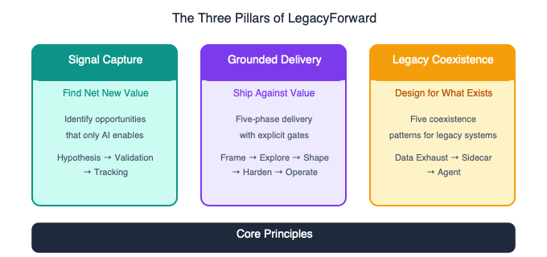
The Three Pillars: Signal Capture, Grounded Delivery, Legacy Coexistence

The Problem Is Not AI. It Is How Enterprises Are Approaching It.
The capabilities are genuine and the value is achievable. And yet, the majority of enterprise AI initiatives fail to deliver meaningful returns — not because the technology does not work, but because the organizations deploying it are making predictable, avoidable mistakes and repeating them at scale.
Here are the five failure patterns that define the current state of enterprise AI:
1. Hype exceeds value. Organizations measure AI success by deployment volume — users on platform, queries per day, departments with copilots — not by business outcomes. An internal chatbot that fields ten thousand queries a month is meaningless if those queries would have been answered faster by a well-organized wiki. Vanity metrics crowd out honest value assessment, and leadership mistakes activity for progress.
2. Wrong delivery method. Traditional Agile was designed for deterministic systems: the same input produces the same output, every time. AI systems are non-deterministic. A prompt that produces a correct answer ninety-four times can produce a wrong answer on the ninety-fifth with no warning, no error code, and no traceable root cause. Sprint velocity, binary acceptance criteria, and regression testing — the foundations of Agile — all break against this reality. Teams apply the wrong tools and wonder why their AI projects behave differently from their software projects.
3. Legacy reality is ignored. Every vendor pitch, every conference demo, every agent framework tutorial makes the same assumption: you are building on a clean slate — fresh APIs, cloud-native infrastructure, and modern data stores. This world does not exist inside any enterprise that has been operating for more than a decade. The mainframe is still running. The integration layer is held together with FTP drops and batch jobs. The data lives in six systems that do not agree with each other. AI strategies that do not account for this reality fail when they collide with it — which is always in production, and always late.
4. Agent fantasy. A senior leader watches two demos, reads three articles, and concludes that autonomous AI agents will replace half the workforce by next quarter. They sponsor initiatives with no value hypothesis, no integration plan, and no understanding of what it actually takes to deploy, govern, monitor, and trust an autonomous system in a production environment. The result is a series of expensive, high-visibility failures that damage organizational trust in AI broadly.
5. Vibe coding creates false momentum. AI-assisted development has compressed idea-to-demo from weeks to hours. This feels like progress. It is a trap. Faster demos mean faster arrival at the wrong destination. The demo becomes the organizational commitment before anyone validates whether the initiative captures real value. Speed without a value hypothesis is just a faster route to waste.
These are not random failures. They form a pattern. And LegacyForward.ai exists to break it.

What LegacyForward.ai Is
LegacyForward.ai is a practitioner framework for enterprise AI transformation. It does not exist to generate excitement about AI. It exists to help enterprises capture real, measurable value from AI — in the environment they actually operate in, not the one they wish they had.
The framework rests on three pillars that address each failure mode directly:
Signal Capture addresses the value problem. Before a dollar of development budget is committed, Signal Capture requires every AI initiative to answer one question: Where does this create net new value that we cannot achieve any other way? It distinguishes between genuine transformation and mere automation, provides a structured Value Assessment Framework, and establishes the portfolio discipline that prevents organizations from accumulating portfolios of technically interesting but operationally meaningless projects.
Grounded Delivery addresses the delivery problem. It replaces Agile’s deterministic assumptions with a five-phase methodology built for non-deterministic systems: Frame, Explore, Shape, Harden, Operate. Each phase has explicit activities, gate criteria, and decision rules — including the hardest decision in delivery: when to kill an initiative before it consumes more than it will ever return.
Legacy Coexistence addresses the reality problem. It provides five architectural patterns — Data Exhaust, Sidecar, Gateway, Shadow Pipeline, Legacy-Aware Agent — for deploying AI alongside the systems an enterprise already has, without ripping them out, without pretending they are temporary, and without designing integrations that collapse the first time the mainframe has a bad night.
These three pillars are not independent modules. They form a closed feedback loop. Signal Capture identifies what to build and why. Grounded Delivery defines how to build and validate it. Legacy Coexistence defines how to deploy it in the real enterprise environment. And the evidence produced in delivery feeds back into Signal Capture, sharpening the next hypothesis.

Who This Is For
The LegacyForward.ai framework is for every role that participates in enterprise AI transformation — not just technologists, but every role that influences, funds, builds, or operates AI initiatives.
Technology leaders and architects use Signal Capture to challenge AI proposals before they reach development, Grounded Delivery to design delivery processes that account for non-determinism, and Legacy Coexistence to build integration architectures that actually survive production.
Product managers and business analysts use Signal Capture to write defensible value hypotheses, Grounded Delivery to structure initiatives with honest gate criteria, and Legacy Coexistence to scope integration requirements early enough to affect feasibility decisions.
AI engineers and data scientists use Grounded Delivery to structure their experimental work as legitimate delivery phases rather than open-ended research, and Legacy Coexistence to understand the data access constraints that determine what they can actually build.
Executive sponsors and program leaders use Signal Capture to govern AI portfolios by value rather than by activity, Grounded Delivery to understand what constitutes real progress in AI initiatives, and Legacy Coexistence to set realistic expectations about timelines and constraints.
Business leaders who are not technologists use the framework to ask better questions of their AI teams — to distinguish genuine transformation proposals from automation dressed up in transformation language, and to understand why their enterprise AI initiatives take longer and cost more than the demos suggested.
This framework is the foundation of the LegacyForward.ai Series — seven practitioner books that apply these three pillars to specific enterprise roles and contexts. Each book assumes the framework. This guide is where to start.

Signal Capture: Finding Net New Value
Signal Capture is the first pillar of the LegacyForward.ai framework — the discipline for identifying where AI creates outcomes that are genuinely impossible by any other means, and for killing initiatives that cannot make that case before they consume development budget.
Most enterprise AI portfolios fail not because the technology is wrong, but because no one asked a hard enough question at the start. Signal Capture exists to ask it: not “how can we use AI here?” but “where does AI create net new value that nothing else can?”
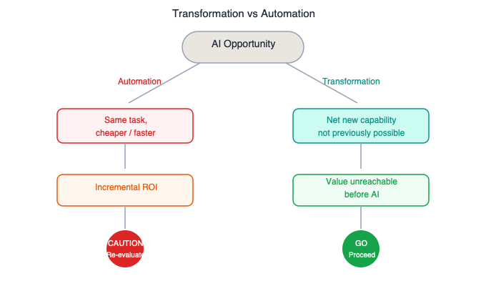
Transformation vs Automation: Two paths from an AI opportunity

The Core Question
Signal Capture is a discipline for identifying where AI creates outcomes that are impossible by any other means — and for killing initiatives that cannot make that case.
The discipline begins with one question, applied to every AI initiative before it receives funding:
Where does this create net new value that we cannot achieve any other way?
Not: how does this make an existing process faster? Not: how does this reduce headcount? Not: how does this automate a manual task? Those are automation questions. They have their place, but they do not justify AI-scale investment or AI-scale governance.
The Signal Capture discipline is not a one-time assessment. It is a continuous practice applied across the full lifecycle of every initiative. Most organizations discover they have been measuring the wrong things. Signal Capture replaces those vanity metrics with a rigorous, honest answer to the only question that matters.

Transformation vs. Automation
The most important distinction in Signal Capture is between transformation and automation. Getting this wrong is the foundation of almost every enterprise AI portfolio failure.
Dimension | Automation | Transformation
Definition | AI performs a task previously done by humans, faster or cheaper | AI produces an outcome that was previously impossible at any cost
Test | Remove the AI. Could enough humans achieve the same result? | Remove the AI. The outcome ceases to exist entirely.
Example | AI reads invoices and extracts fields into a spreadsheet | AI analyzes 15 years of invoice data, contracts, vendor communications, and payment patterns to identify systematic 4% overcharging — a pattern spanning too much data across too many systems for any human to detect
Value ceiling | Bounded by the cost of the human labor it replaces | Unbounded — net new value that did not exist before
Funding model | ROI based on labor cost reduction | ROI based on new value created or risk eliminated
Portfolio role | Efficiency gains, proportionate governance | High-risk, high-reward bets, investment-grade governance
Automation is not bad. It has a legitimate place in enterprise portfolios. But it must be funded, measured, and governed as automation — not dressed up as transformation to justify AI-scale investment. The sin is not doing automation. The sin is calling automation transformation.
Think of it like this: Hiring more clerks to process invoices faster is automation. Building a system that reads every invoice your company has ever paid alongside every contract, every vendor email, and every payment, then surfaces a systematic overbilling pattern that no individual clerk — or any team of clerks — could ever find in a lifetime, is transformation. The first improves throughput. The second creates something that did not exist before.

Where AI Creates Net New Value
Non-deterministic AI capabilities create genuine transformation opportunities in four categories. These are the territories where Signal Capture looks first.
Pattern recognition across unstructured data. Identifying signals in volumes of text, images, audio, or mixed media that no human could process at scale. Detecting fraud patterns across millions of transactions and communications. Identifying regulatory compliance gaps across thousands of documents. Surfacing emerging risks from unstructured market intelligence.
Natural language reasoning over complex documents. Synthesizing meaning across large, heterogeneous document sets that would take teams of humans months to review. Analyzing an entire regulatory framework against an organization’s policies and controls. Extracting actionable intelligence from years of customer feedback across channels.
Cross-system synthesis. Connecting patterns across data that lives in different systems, formats, and time horizons — data that was never designed to be analyzed together. Correlating vendor performance, contract terms, payment history, and market benchmarks to identify renegotiation opportunities across an entire procurement portfolio.
Probabilistic decision support. Providing decision recommendations for scenarios with high uncertainty, many variables, and insufficient precedent for rule-based systems. Evaluating acquisition targets by synthesizing financial data, market signals, cultural indicators, and risk factors that a purely quantitative model would miss.
When an initiative falls clearly into one of these four categories, there is a genuine transformation hypothesis worth testing. When it does not — when the honest description of the initiative is “it does what humans do, faster” — that is automation. Name it correctly.

Signal Capture: The Value Assessment Framework
Identifying where AI creates net new value is the first discipline. The second is ensuring that identification holds up under scrutiny — that a plausible story does not get funded as though it were a proven one. The Value Assessment Framework provides the structure for that scrutiny through three sequential stages: Hypothesis, Validation, and Tracking.
Each stage has a gate. Skipping a stage does not save time — it converts a correctable mistake into an expensive one discovered in production.
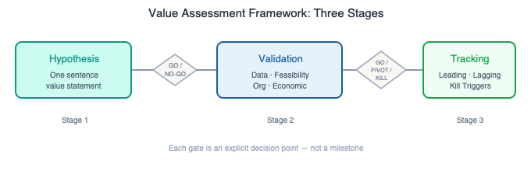
Value Assessment Framework: Hypothesis → Validation → Tracking

The Three Stages
Signal Capture is implemented through a three-stage Value Assessment Framework. The stages are sequential. Skipping a stage is not an efficiency gain — it is how organizations waste money on initiatives that should never have been funded.

Stage 1: Value Hypothesis
Before any technical work begins, every initiative must produce a Value Hypothesis. This is a document, not a slide. It must answer five questions:
1. Value statement. One sentence: “This initiative creates [specific value] that is impossible without AI because [reason].” Vague statements fail. “Improve customer experience” is not a value statement. “Identify at-risk customers 60 days before churn by synthesizing behavioral signals across support, usage, and billing data that no analyst could correlate manually” is a value statement.
2. Transformation test. Answer the question directly: if we removed the AI and used unlimited human effort, could we achieve the same outcome? Document the reasoning. If the answer is yes, the initiative is automation. Fund it accordingly.
3. Measurable outcome. Define what success looks like in operational terms — revenue captured, cost avoided, risk reduced, time-to-insight compressed — with specific targets. “Reduce regulatory review time by 40%” is measurable. “Improve efficiency” is not.
4. Uniqueness claim. Which AI capability — pattern recognition, natural language reasoning, cross-system synthesis, probabilistic inference — makes this outcome possible? If the answer is “it just does it faster,” this is automation.
5. Value ceiling estimate. What is the maximum value this initiative could deliver if everything goes right? If the ceiling is low, the initiative may not justify AI-scale investment even if it succeeds.
Gate: GO / NO-GO. An initiative without a complete, credible Value Hypothesis does not proceed. Not into discovery, not into prototyping, not into a hackathon. The gate is a policy, not a review meeting.

Stage 2: Value Validation
Value validation occurs before significant investment. It answers one question: is the value hypothesis real, or is it a plausible story?
Data validation. Does the data required to deliver the value actually exist, and is it accessible? Many value hypotheses assume data availability that does not hold. The most common failure mode: an initiative requires data from a legacy system that cannot export it in a usable format. This is why Legacy Coexistence is a prerequisite input to Signal Capture, not an afterthought. Data validation must account for legacy system constraints — formats, access patterns, extraction limitations.
Feasibility validation. Can current AI capabilities actually deliver the claimed value in production, against real data, with real edge cases? Not in a demo. A demo that uses curated data and ignores edge cases validates nothing. This is where the Grounded Delivery Explore phase does its work — structured experiments against real production data.
Organizational validation. Will the organization actually use the output? A perfectly valid value hypothesis fails if the humans who need to act on the AI’s output do not trust it, cannot interpret it, or have no process for incorporating it into their decisions. The AI does not create value. The decisions made with its output create value. If the output will not be acted on, the value hypothesis is invalid.
Economic validation. Does the value justify the full investment? Include the cost of development, data preparation, legacy integration, governance infrastructure, monitoring, retraining, and the organizational change required to realize the value. Initiatives that look attractive on development cost alone often fail economic validation when full lifecycle costs are included.
Gate: GO / PIVOT / KILL. If validation passes on all four dimensions, the initiative proceeds to funded development. If one or more dimensions reveal a flaw, the initiative either pivots its hypothesis to address the flaw, or is killed. There is no “continue with known problems” option.

Stage 3: Value Tracking
Funding an initiative based on a validated hypothesis is not the end of Signal Capture. It is the beginning of accountability.
Leading indicators are early signals that value is being captured: accuracy of outputs, time-to-insight improvements, user trust metrics, decision quality measures. They must be defined before deployment, not after.
Lagging indicators are actual business outcomes — revenue, cost, risk, compliance posture — attributed to the AI initiative with honest methodology. Attribution requires rigor. “The business improved after we deployed AI” is not attribution.
Kill triggers are predefined thresholds that trigger initiative review or termination. If leading indicators fail to materialize within defined timeframes, the initiative is paused for reassessment — not allowed to limp along consuming resources while the team hunts for a success story to justify the spend.

Key Questions: Signal Capture
Practitioners across all roles should be able to answer these questions for any AI initiative they are involved with. If the answers are not documented or not available, the initiative has not completed Signal Capture.
- What specific outcome becomes possible with AI that was impossible without it?
- If we removed the AI and used unlimited human effort, what happens to the outcome?
- What is the value ceiling — the maximum this initiative could deliver if everything goes right?
- What data is required, and have we confirmed it exists and is accessible in the required format and latency?
- Who will act on the AI’s output, and how does that action create business value?
- What are the kill triggers, and who has the authority to pull them?
- How is this initiative classified in the portfolio — transformation, automation, or experimental?

Anti-Patterns: Signal Capture
The Adoption Trap. Organizations measure AI success by deployment volume — users on platform, queries per day, departments with copilots. These are vanity metrics. Adoption measures activity, not value. An internal chatbot that gets ten thousand queries a month is meaningless if those queries would have been answered faster by a well-organized wiki. High adoption of a low-value tool is worse than low adoption of a high-value tool — it consumes more organizational attention and creates dependency on something that does not justify its existence.
Solutions Looking for Problems. AI initiatives begin with the technology — “we need an AI strategy” — rather than with the value — “we have a business problem that only AI can solve.” The result is a portfolio of technically interesting projects with no value thesis. The fix is to start every initiative from a business problem, not a technology category.
Automation as Transformation. Making a broken process faster is not transformation. If the initiative’s value statement can be achieved by throwing enough people at the problem, it is automation. Fund it as automation. Govern it as automation. Do not dress it up as transformation to justify AI-scale investment.
The Vibe-Coded Commitment. A team uses AI-assisted development to build a compelling demo in days. The demo is shown to leadership. Leadership commits organizational resources. Nobody validated the value hypothesis — the speed of the demo created momentum that bypassed value discipline. Speed without a value hypothesis is just arriving at the wrong destination faster. The demo is not validation. The demo is a prototype.
The Perpetual Pilot. Initiatives stay in “pilot” status indefinitely, avoiding the accountability of production deployment while continuing to consume resources. Every pilot must have a predefined end date with three possible outcomes: promote to production, pivot the value hypothesis, or kill. Permanent pilots are permanent avoidance.
The Sunk Cost Spiral. An initiative has consumed significant resources but has not demonstrated value. Leadership keeps funding it because killing it means admitting the investment was wasted. The correct response: the investment is already wasted. Additional funding does not recover it. Kill the initiative and reallocate. The only thing that changes when you continue funding a failing initiative is the size of the loss.

Grounded Delivery: The Five Phases
Grounded Delivery is the second pillar of the LegacyForward.ai framework — a five-phase delivery methodology designed specifically for non-deterministic AI systems. It does not replace engineering discipline; it replaces the Agile assumptions that break when applied to systems whose outputs cannot be predicted with certainty.
The five phases — Frame, Explore, Shape, Harden, Operate — address the full lifecycle of an AI initiative, from defining what “good” looks like before a line of code is written to monitoring quality in production as a permanent operational discipline.
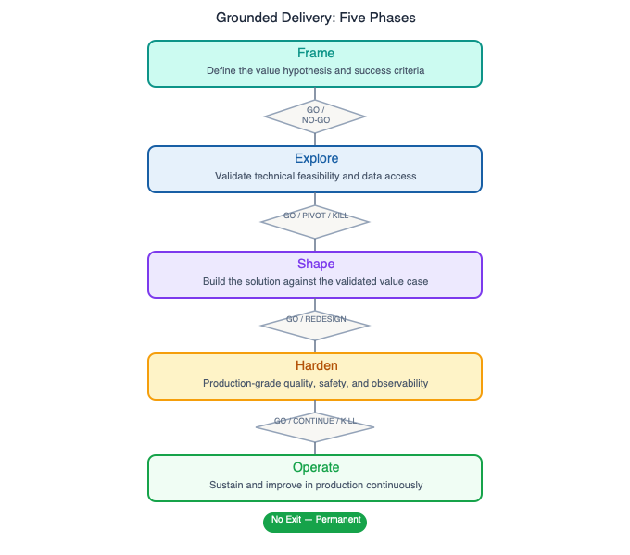
Grounded Delivery: Frame → Explore → Shape → Harden → Operate

Why Agile Breaks for AI
Agile works for deterministic systems, where software follows rules and the same function called with the same input produces the same output every time. Agile’s foundational constructs — user stories with binary acceptance criteria, sprint velocity estimates, regression test suites — all depend on that property.
AI systems are non-deterministic. The same prompt, applied to the same document, at different times, can produce different outputs. Not because of a bug. Because of how large language models and probabilistic systems work. An answer that is correct ninety-four times can be wrong on the ninety-fifth with no error code, no warning, and no traceable root cause.
Here is what breaks when you apply Agile to AI:
Agile Assumption | AI Reality
User stories have binary acceptance criteria (pass/fail) | AI output quality is a distribution, not a point — you need confidence intervals, not checkboxes
Sprint velocity is measurable and predictable | AI exploration does not have predictable output — a two-week spike might produce a breakthrough or a dead end
Regression tests prevent quality degradation | Model drift, prompt drift, and data shift degrade AI quality between releases without any code change
“Done” means releasable | AI systems require ongoing monitoring, retraining, and quality management — they are never done
The build phase follows the design phase | AI development is iterative discovery — you cannot design what you have not yet explored
Definition of Done is fixed at sprint start | AI quality thresholds evolve as the team learns what “good” means for this specific use case
Think of it like this: Agile is a production line. You design the car, break the design into parts, build the parts, assemble the car, test it, and ship it. Grounded Delivery is more like running a clinical trial. You form a hypothesis, design structured experiments, analyze the results, and define what “works” based on evidence rather than requirements. You establish ongoing monitoring because the treatment that works today may not work the same way next year.
Grounded Delivery replaces Agile’s deterministic machinery with five phases designed for the reality of AI systems: Frame, Explore, Shape, Harden, Operate.

Grounded Delivery vs. Traditional Agile
Dimension | Traditional Agile | Grounded Delivery
Quality model | Binary pass/fail tests | Quality distributions with confidence intervals
Planning unit | Sprint velocity | Experiment results and learning milestones
Acceptance criteria | Deterministic (output equals expected) | Probabilistic (output meets threshold at defined confidence level)
Exploration | Time-boxed spikes within sprints | Full dedicated phase (Explore) with explicit gate criteria
Test assets | Regression test suite | Evaluation dataset — a first-class asset rivaling production code
Done criteria | Feature complete, tests pass | Quality thresholds met, monitoring in place, drift detection active
Post-deployment | Maintenance mode | Operate — permanent monitoring, retraining, ongoing evaluation
Failure handling | Bug report, fix, regression test | Drift detection, quality gate breach, probabilistic review
Governance | Velocity and burn-down | Phase gate decisions: GO / PIVOT / KILL

Phase 1: Frame
Objective: Establish the value target, define what “good” means probabilistically, and create the conditions for honest exploration before development begins.
The Frame phase does not define what to build. It defines what value to pursue and how to know whether the initiative is achieving it. It takes the Value Hypothesis from Signal Capture and translates it into operational terms that can drive delivery decisions.
Activities: - Translate the Value Hypothesis into measurable success criteria expressed as probability distributions, not binary targets. “Summarize regulatory documents with 85% analyst-agreement score at the 90th percentile” is a Frame output. “AI summarizes documents” is not. - Define the evaluation dataset requirements: what data is needed to know whether the AI is working? The evaluation dataset is designed here, not in Harden. - Map the legacy integration landscape for this initiative. Which legacy systems participate? What data is needed, at what latency, in what format? - Identify failure modes: what happens when the AI is wrong? What is the business impact? What is the fallback? Non-deterministic systems must have fallbacks designed from the start, not added as an afterthought. - Define the go/no-go criteria for the Explore phase. What would cause this initiative to be killed or pivoted before significant development investment?
Gate: GO / NO-GO. Frame exits with documented success criteria, evaluation dataset design, integration map, and failure mode analysis. If these cannot be produced — if the team cannot articulate what “good” looks like before they start building — the initiative should not proceed to Explore.

Phase 2: Explore
Objective: Validate whether current AI capabilities can actually deliver the claimed value, against real data, with real edge cases — before committing to production development.
Explore is not a spike. It is not a two-week experiment wedged into a sprint. It is a full delivery phase with its own objectives, activities, and gate criteria. The purpose is to discover what is possible, what is not possible, and what is possible under which conditions — before anyone writes production code.
Activities: - Run structured experiments against production-representative data — not curated subsets or synthetic data, but real data that includes the edge cases and outliers that curated data hides. - Build and iterate the evaluation dataset. The evaluation dataset is the most important asset produced in Explore — it defines what “good” means for this specific use case and becomes the quality benchmark for everything that follows. - Explore multiple technical approaches. Do not commit to the first approach that produces a promising demo. Explore competing architectures, model configurations, and prompt strategies. Document what each approach can and cannot do. - Validate legacy data access. Can the initiative actually access the data it needs from the legacy systems that hold it? In what format? At what latency? Does the actual data quality match the assumed data quality? - Produce a capability map: a documented assessment of what the AI can reliably do, what it cannot do, and where its performance degrades. This is not a demo reel. It is an honest assessment.
Gate: GO / PIVOT / KILL. Explore ends with a Go/Pivot/Kill decision based on evidence. GO means the capability map demonstrates that the value hypothesis is achievable with current technology. PIVOT means the hypothesis needs to be revised. KILL means the hypothesis is not achievable with current technology, the data does not support it, or the integration constraints make it infeasible. Killing an initiative at Explore is success — it means the organization did not spend production development resources on something that would fail.

Phase 3: Shape
Objective: Design the production architecture, separating deterministic and non-deterministic components, defining fallback paths, and creating the technical foundation for a system that can be operated and monitored in production.
Shape is where Grounded Delivery’s most important architectural principle is implemented: deterministic and non-deterministic components must be separated and governed independently.
Activities: - Design the system architecture with explicit separation between deterministic components (business logic, data validation, integration code, routing) and non-deterministic components (model inference, prompt execution, AI-generated content). - Design fallback paths for every non-deterministic component. What happens when the AI component is unavailable? When quality drops below acceptable thresholds? When the model produces output that fails validation? Fallbacks must be designed before Harden, not after. - Define monitoring requirements. What metrics will be tracked? What constitutes a quality gate breach in production? What triggers human review? What triggers automatic rollback? - Select Legacy Coexistence patterns for each integration point. - Design the evaluation pipeline. How will the system be evaluated continuously in production? What is the evaluation cadence? Who reviews the results?
Gate: GO / REDESIGN. Shape exits with a production architecture that has explicit fallback paths, monitoring design, and legacy integration patterns. An architecture without fallbacks does not exit Shape.

Phase 4: Harden
Objective: Build the production system against the architecture defined in Shape, continuously evaluating quality against the thresholds established in Frame, and making explicit decisions when quality gates are not met.
Activities: - Implement deterministic components with conventional engineering rigor: unit tests, integration tests, code review, regression testing. - Implement non-deterministic components against the evaluation dataset. Every iteration is evaluated against the quality thresholds defined in Frame. Output quality is tracked as a distribution over time, not a point-in-time pass/fail. - Implement legacy integrations and test against production-representative legacy behavior. Mocked legacy systems in test environments do not replicate the timing, data quality, format variations, and error conditions of production legacy systems. - Implement monitoring infrastructure before going to production, not after. Drift detection, quality gate thresholds, alerting, and the operational dashboard are built in Harden. - Conduct red-team evaluation: deliberately attempt to produce failure modes identified in Explore. Document the failure rate. Determine whether it is within the acceptable threshold defined in Frame.
Gate: GO / CONTINUE / KILL. Harden exits when quality thresholds from Frame are consistently met in evaluation, legacy integrations are validated against production-representative data, and monitoring is operational.

Phase 5: Operate
Objective: Run the AI system in production as a permanent operational discipline — monitoring quality, detecting drift, managing ongoing performance, and feeding evidence back into Signal Capture.
Operate is not maintenance mode. An AI system that is not actively monitored and managed will degrade. Model drift, prompt drift, data distribution shift, and changing business context all erode AI performance between releases — often without any code change, without any error log, and without any user complaint until the damage is significant.
Activities: - Run continuous evaluation against the evaluation dataset. Quality is not a deployment-time property — it is an ongoing property that must be measured. - Monitor for drift: model drift, prompt drift, and data drift. - Operate governance checkpoints: regular reviews of quality metrics by the team responsible for the system. These are not optional. An AI system without a defined governance cadence is not in production — it is abandoned. - Feed operational evidence back into Signal Capture. Is the initiative capturing the value that was hypothesized? - Manage the human-AI trust boundary. As confidence in the system builds, the trust boundary can be adjusted — from 100% human verification to sampling-based verification to exception-only review. Trust graduation criteria must be explicit.
There is no exit gate for Operate. Operate is forever. If the organization is not willing to maintain an AI system in production as a permanent operational discipline, the system should not be deployed.

Grounded Delivery: Anti-Patterns
The five phases of Grounded Delivery only function if practitioners are honest at each gate. Anti-patterns are the ways that honesty breaks down — through skipped phases, misread metrics, and sunk-cost reasoning that turns a gate review into a formality. Recognizing these patterns before they take hold is the difference between a portfolio that learns and one that accumulates expensive failures.
Before committing to any phase gate, the questions below provide a minimum bar for honest evaluation.

Key Questions
Before committing to a phase gate, practitioners should be able to answer these questions:
- What are the success criteria, expressed in probabilistic terms with specific thresholds?
- What is the evaluation dataset, and does it represent real production behavior including edge cases?
- Where is the deterministic/non-deterministic boundary in the architecture, and is it explicit?
- What are the fallback paths for AI component failure or quality degradation?
- What legacy integration constraints affect the delivery timeline and technical approach?
- What are the kill criteria, and who has authority to make the kill decision?
- How will quality be monitored in production, and by whom, on what cadence?

Anti-Patterns: Grounded Delivery
Frame Skipped. The team jumps directly to building because the problem seems clear and the technology seems obvious. The Frame phase is skipped to “save time.” The result is a system built against undefined success criteria, evaluated against undefined quality thresholds, deployed with no monitoring design, and eventually abandoned because nobody can agree on whether it is working. Frame is not overhead. It is the foundation without which everything else is guesswork.
Velocity as Progress. The team tracks sprint velocity and burn-down as evidence of progress. Features ship, story points accumulate, and the demo looks polished — but the evaluation dataset shows quality distributions that do not meet the success criteria defined in Frame. Sprint completion is not value delivery. In AI systems, activity and progress are easily decoupled.
Test Generation Illusion. AI-assisted test generation produces thousands of test cases quickly. The team reports high test coverage and the tests pass — but the tests were generated by the same AI system being tested, which means they validate what the AI thinks is correct rather than what is actually correct. Test coverage generated by the system under test is not validation. Evaluation datasets must be built from ground-truth human judgment, not AI-generated assertions.
Sunk Cost at Gates. Explore or Harden produce evidence that the value hypothesis is not achievable, or that quality thresholds cannot be met. The team pivots the framing of the results to justify continuing — the demo is polished, the leadership has seen it, the team has worked hard. The gate becomes a formality. Sunk cost reasoning at gates is the most expensive anti-pattern in AI delivery. Gates exist to make the kill decision before more is wasted, not after.
Ship and Forget. The system is deployed, the team moves on, and nobody monitors quality in production. Six months later, users notice degraded output quality. The evaluation dataset has not been updated. Drift has not been detected. The system is producing subtly wrong outputs that nobody formally noticed. AI systems are not static software. Shipping without operating is not shipping — it is abandonment on a delayed schedule.

Legacy Coexistence: The Five Patterns
Legacy Coexistence is the third pillar of the LegacyForward.ai framework — five architectural patterns for deploying AI alongside the enterprise systems that will not be replaced. It starts from a premise that most AI strategies ignore: the enterprise environment that will host your AI is not the one in the vendor demo, and pretending otherwise is how integration failures happen in production.
The five patterns — Data Exhaust, Sidecar, Gateway, Shadow Pipeline, and Legacy-Aware Agent — span a range of complexity and latency requirements. They are not mutually exclusive, and most real initiatives combine more than one.
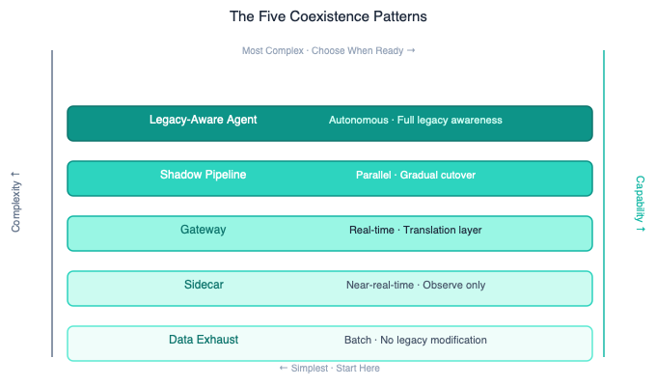
The Five Coexistence Patterns: complexity ladder from Data Exhaust to Legacy-Aware Agent

The Legacy Reality
Every enterprise AI strategy that ignores existing systems is a fantasy.
Legacy systems are not technical debt waiting to be retired. They are load-bearing walls that process trillions in transactions, encode decades of business logic, and will outlive most of the AI initiatives being built alongside them. Here is what the real enterprise environment looks like:
The mainframe is still running. It processes every transaction. It has been running for thirty years. It will be running in ten more. The business logic encoded in its COBOL programs is the actual source of truth for how the organization operates — not the documentation, not the wiki, not the architecture diagrams. The mainframe.
The integration layer is held together with duct tape: SOAP endpoints, flat file transfers, batch jobs that run at 2 AM, FTP drops, MQ queues, and point-to-point integrations that nobody fully maps because the person who built them retired in 2014.
The data is everywhere and nowhere. Customer data lives in six systems that do not agree with each other. The “golden record” project from three years ago covers sixty percent of the data and has not been updated since the team was reassigned. The data warehouse is eighteen months behind the operational systems.
The “modern” systems are already legacy. That microservices platform deployed four years ago has its own technical debt, its own integration patterns, and its own undocumented behaviors. Legacy is not an age — it is a state. Any system that is in production, has accumulated institutional knowledge, and cannot be easily replaced is legacy.
This is the real enterprise environment — not the demo environment — into which enterprises are actually deploying AI.

Why Rip-and-Replace Fails
The instinct when confronting legacy is to replace it. Modernize. Migrate. Re-platform. This instinct has a poor track record.
The scope expands until it collapses. A mainframe modernization project starts with one application, but discovery reveals dependencies that connect it to forty others. The project scope triples, the timeline stretches, and eventually the initiative is killed, descoped to meaninglessness, or declared a success while the mainframe continues running in parallel — which is the definition of the outcome modernization was supposed to prevent.
The business logic is the system. Legacy systems do not just store data and execute transactions. They encode decades of business rules, regulatory requirements, exception handling, and edge case logic that was never formally documented. Replacing the system means reverse-engineering all of that logic — and the organization discovers that nobody fully understands what the system does until they try to replicate it and fail.
The risk is existential. When a legacy system processes every transaction or serves as the system of record for regulatory reporting, failure is not an inconvenience. It is an existential event. No CIO should bet the enterprise on a big-bang migration.
The economics do not work. Full modernization of a complex legacy landscape costs hundreds of millions and takes years. The ROI calculation assumes the new system will be complete before the old one is decommissioned — but that assumption rarely holds, and the result is running two systems in parallel indefinitely.
Dimension | Rip-and-Replace | Legacy Coexistence
Starting assumption | Legacy is a problem to solve | Legacy is a permanent fixture to design for
Timeline | Years before value is realized | Value achievable in months by working alongside legacy
Risk profile | Existential risk if migration fails | Bounded risk — legacy system remains authoritative
Business logic | Must be reverse-engineered and replicated | Remains encoded in the legacy system
ROI timing | Deferred until modernization completes | Achievable during coexistence
Outcome if modernization never happens | Sunk cost with no value | Coexistence patterns remain operational indefinitely
AI value capture | Blocked until modernization | Enabled immediately through coexistence patterns
The organizations that succeed with AI are not the ones that modernize first. They are the ones that learn to create value alongside the systems they already have.

The Five Coexistence Patterns
Legacy Coexistence is not a single pattern. It is a catalog of patterns selected based on the specific characteristics of the legacy system, the AI capability being deployed, and the value hypothesis being pursued. Patterns are not mutually exclusive — complex initiatives may combine multiple patterns.

Pattern 1: Data Exhaust
What it is. The legacy system produces data — batch extracts, log files, report outputs, database snapshots — as a byproduct of its normal operation. This data exhaust becomes the input for AI analysis without requiring any modification to the legacy system.
When to use it. The legacy system produces data regularly. The AI use case does not require real-time access. The value hypothesis involves analyzing historical patterns that are captured in the data exhaust.
Example. A mainframe processes millions of insurance claims daily. Nightly batch extracts feed an AI system that identifies fraud patterns, anomalous processing times, and systemic errors across the full claims history. The mainframe is untouched. The AI operates on data that was already being produced.
Constraints. Latency is bounded by the extraction schedule — daily extracts mean daily insights, at best. Not suitable for real-time use cases. Data format translation is required: flat files, fixed-width records, EBCDIC encoding.
Why it matters. The highest-value AI opportunities are often Data Exhaust patterns. Decades of transactional data have never been analyzed holistically because no human team could process them at scale. This is where transformation lives — in data that has been sitting in legacy systems for thirty years, waiting for something that could actually read it.

Pattern 2: Sidecar
What it is. An AI system operates alongside the legacy system, receiving the same inputs or observing the same events, and providing supplementary outputs — recommendations, risk scores, quality checks — to human operators or downstream systems. The legacy system remains the system of record and the primary execution path.
When to use it. AI needs to augment a legacy process in near-real-time without modifying the legacy system. The value hypothesis involves providing AI-generated insight alongside — not instead of — legacy-generated outputs.
Example. A loan processing system runs on a legacy platform. A sidecar AI receives the same application data and produces a risk assessment that includes factors the legacy rules engine cannot evaluate — unstructured data from applicant communications, market signals, and cross-portfolio patterns. The loan officer sees both outputs.
Constraints. Requires a mechanism to observe or receive events from the legacy system — message queues, database change capture, API events. The sidecar must never block or interfere with the legacy system’s operation. If the sidecar is unavailable, the primary process continues uninterrupted.

Pattern 3: Gateway
What it is. An integration gateway sits between the AI system and the legacy environment, translating requests and responses between modern and legacy protocols. The gateway encapsulates legacy complexity, presenting a clean interface to the AI system.
When to use it. AI needs to interact with legacy systems through a controlled interface. The legacy system does not expose a modern API. The translation logic is complex enough to warrant a dedicated integration component.
Example. An AI agent needs to query customer account status from a CICS mainframe application. The gateway accepts a REST call from the agent, translates it into a 3270 terminal interaction with the mainframe, captures the screen response, extracts the relevant data, and returns structured JSON. The AI never knows it is talking to a forty-year-old system.
Constraints. Gateway development requires deep knowledge of the legacy system’s interface. Performance depends on the legacy system’s response characteristics. Error handling must account for legacy failure modes that modern systems do not expect — batch windows, session timeouts, abend codes.
Think of it like this: The Gateway pattern is a skilled interpreter who speaks both modern English and ancient Latin. The AI speaks modern English. The legacy system speaks Latin. The gateway translates, in real time, in both directions. Without the interpreter, neither side can communicate. But the interpreter is not a permanent replacement for the Latin speaker — the mainframe keeps running, the interpreter keeps working.

Pattern 4: Shadow Pipeline
What it is. The AI system runs in parallel with the legacy system, processing the same inputs and producing its own outputs. Both outputs are compared, and over time, as confidence builds, production traffic is gradually shifted to the AI system.
When to use it. AI will eventually replace a legacy process, but the transition must be gradual and evidence-based. The value hypothesis involves demonstrating that AI output is equivalent to or better than legacy output, validated against the legacy system’s known-correct results.
Example. A legacy system calculates insurance premiums using a complex rules engine built over twenty years. An AI system is trained to produce premium calculations from the same inputs. Both systems run in parallel for six months. Every discrepancy is investigated. When the AI system reaches 99.7% agreement with the legacy system — and the 0.3% disagreements are understood and acceptable — production traffic begins shifting.
Constraints. Running two systems simultaneously has cost and operational implications. The comparison logic must distinguish meaningful disagreements from acceptable variance. Timeline to cutover is typically longer than leadership expects.

Pattern 5: Legacy-Aware Agent
What it is. AI agents are designed with explicit knowledge of the legacy landscape — protocols, batch schedules, data formats, reversibility constraints, failure modes — and their reasoning and action planning account for legacy constraints as first-class considerations.
When to use it. AI agents need to operate autonomously across both modern and legacy systems within a business process. The business process requires interaction with legacy systems that have non-standard interfaces, asynchronous processing, or significant operational constraints.
Example. An AI agent handles supplier onboarding across seven systems — three modern and four legacy (mainframe ERP, AS/400 procurement system, legacy document management, homegrown contracting system accessible only through terminal emulation). The agent knows that the ERP requires batch submission with 24-hour processing, the AS/400 has a four-field limitation on vendor names, and the document management system accepts only TIFF format. Its action plan sequences steps accordingly.
Constraints. Requires comprehensive mapping of legacy system behaviors, constraints, and failure modes. Agent design must include fallback paths for legacy system unavailability. Testing must cover the full matrix of legacy system states, including partial failures. This is the most complex coexistence pattern — do not default to it when a simpler pattern will suffice.

Legacy Coexistence: Data Challenges and Anti-Patterns
Selecting the right coexistence pattern is necessary but not sufficient. The data flowing across the legacy boundary carries its own set of challenges — format mismatches, consistency gaps, access constraints, and governance questions that cannot be resolved by the integration pattern alone. These must be addressed architecturally before the integration design is locked.
This chapter covers the data challenges endemic to legacy environments and the anti-patterns that cause AI integration to fail in production even when the coexistence pattern was chosen correctly.
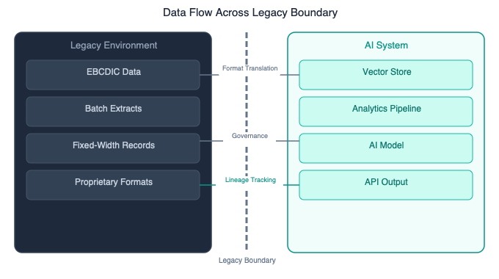
Data flow across the legacy boundary: format translation, governance, and lineage

Data Challenges in Legacy Environments
AI value depends on data. Legacy environments present data challenges that must be addressed architecturally, not ad hoc.
Data format translation. Legacy systems store and export data in formats that modern AI pipelines do not natively consume: EBCDIC encoding, fixed-width records, packed decimal fields, proprietary binary formats, hierarchical databases, flat file structures with implicit schemas. Translation must preserve semantic meaning — including business rules embedded in field lengths, value ranges, and record relationships.
Data consistency across eras. When AI synthesizes data from legacy and modern systems, inconsistencies emerge: different field definitions for the same concept, different granularity levels, different temporal resolutions, different quality standards. The architecture must define a reconciliation strategy — not necessarily a single golden record, but explicit rules for how conflicts are resolved based on the use case.
Data access constraints. Legacy systems were not designed for the access patterns that AI requires. A mainframe optimized for transaction processing may not tolerate full-table scans, extraction windows are limited, and API exposure is often unavailable. Integration must respect these operational constraints while still providing AI with the data it needs.
Data governance across boundaries. When data flows between legacy and AI systems, governance becomes complex. Which system is the system of record? Who owns data quality? How is lineage tracked across the boundary? What regulatory requirements apply to data collected under legacy-era policies but now analyzed by AI? These questions must be answered architecturally.

Key Questions: Legacy Coexistence
- Which legacy systems participate in the targeted business process?
- What are the interface types — API, batch, terminal, file — for each legacy system?
- What data format translation is required, and where does that translation happen?
- Which coexistence pattern is appropriate for each AI-to-legacy interaction, and why?
- What is the data access latency for each legacy system, and does it satisfy the value hypothesis’s requirements?
- What happens when a legacy system is unavailable — what is the fallback?
- How long will the coexistence architecture be in production? Is it designed for permanence, or is it a bridge to modernization that may never happen?

Anti-Patterns: Legacy Coexistence
The Greenfield Fantasy. “Once we modernize, we can deploy AI properly.” This is a strategy for never deploying AI. Modernization takes years while AI value is needed now — organizations that wait for a greenfield environment will be outcompeted by those that learn to coexist with what they have. Modernization is a separate initiative, and AI deployment should not be held hostage to it.
The Wrapper Illusion. “We will put an API wrapper around the legacy system.” Wrappers hide complexity — they do not eliminate it. The wrapped system still has batch processing schedules, concurrency limitations, data format constraints, and failure modes that the wrapper does not surface. AI systems that interact through wrappers without understanding the underlying legacy behavior will fail in production in ways the wrapper cannot diagnose.
The Integration Afterthought. “We will figure out legacy integration later.” No. Legacy integration determines whether the value hypothesis is feasible. An initiative that requires real-time access to data locked in a batch-processing mainframe has a fundamentally different feasibility profile than one that works with nightly extracts. Integration must be assessed during Signal Capture — not after development begins.
The Screen Scraping Default. When all else fails, teams resort to screen scraping — automating terminal interactions to extract data from legacy systems. This works in demos but breaks in production: screen layouts change without notice, response timing varies under load, and error screens go unhandled. Screen scraping is a last resort, not a pattern. If it is the only option, it must be engineered with full rigor: error handling, retry logic, layout change detection, and continuous monitoring.
The Strangler Fig Misconception. The Strangler Fig pattern — gradually replacing legacy system functionality — is valid for deterministic modernization. It is dangerous for AI integration because AI does not replace legacy function-for-function. AI creates net new capabilities around legacy systems. Applying Strangler Fig to AI integration conflates modernization with transformation. They are different problems with different solutions.

How the Pillars Connect: Feedback Loop and Core Principles
The three pillars of LegacyForward.ai are not independent modules to be applied selectively. Signal Capture, Grounded Delivery, and Legacy Coexistence form a closed feedback loop — each pillar informs the others, and the evidence produced in one continuously sharpens the inputs to the next.
Understanding how the pillars connect is what separates organizations that apply the framework as a checklist from those that use it to build genuine learning systems around AI delivery.
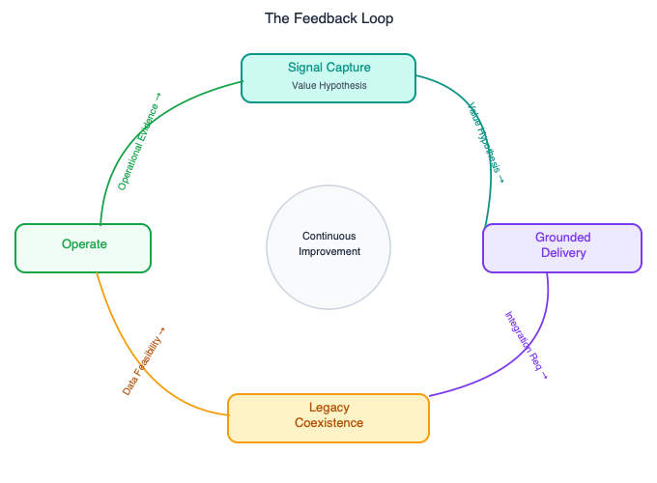
The LegacyForward.ai Feedback Loop: Signal Capture → Grounded Delivery → Legacy Coexistence → Operate

The Feedback Loop
The three pillars are not a linear process. They form a closed feedback loop that continuously improves the organization’s ability to identify, deliver, and operate AI value.
Signal Capture → Grounded Delivery. The Value Hypothesis produced in Signal Capture becomes the primary input to the Frame phase of Grounded Delivery. Frame does not define what to build — it defines what value to pursue and how to validate it. Value Tracking feeds the probabilistic quality gates in Grounded Delivery: quality is not measured by feature completion, it is measured by progress toward value capture.
Grounded Delivery → Legacy Coexistence. The Explore phase must include legacy integration discovery. Teams that defer integration testing to Harden discover too late that the legacy system cannot support the required access patterns. The Shadow Pipeline coexistence pattern maps directly to the Harden phase: probabilistic quality gates evaluate AI output against legacy system baselines. The dual-track governance in Grounded Delivery extends to hybrid architectures — deterministic components including legacy integrations use conventional engineering rigor; non-deterministic components use probabilistic evaluation.
Legacy Coexistence → Signal Capture. The highest-value AI opportunities often exist precisely because legacy systems contain decades of data that has never been analyzed holistically. Legacy Coexistence patterns determine what data is accessible, at what latency, in what format — directly informing whether a value hypothesis is feasible. Data validation in the Value Assessment Framework must account for legacy constraints. A value hypothesis that assumes real-time access to mainframe data is a fundamentally different proposition than one that works with nightly batch extracts.
Operate → Signal Capture. Operational evidence from deployed AI systems feeds back into Signal Capture at the portfolio level. What did the system actually deliver, versus what was hypothesized? What signals did operational monitoring surface that suggest new value opportunities? What did the organization learn about legacy data quality that opens new hypotheses? The feedback loop makes each iteration smarter than the last.

Red Flags by Pillar
When practitioners observe these signals, the corresponding pillar requires immediate attention.
Signal Capture — Five Red Flags: 1. The AI portfolio is organized by technology category (chatbots, agents, ML models) rather than by value outcome. 2. AI success is reported in adoption metrics — users, queries, departments — without reference to business outcomes. 3. No AI initiative has documented kill criteria. Every initiative has been active for more than twelve months. 4. The value hypothesis for an initiative cannot be stated in one sentence by the team building it. 5. A demo has been shown to leadership before data validation has been completed.
Grounded Delivery — Five Red Flags: 1. The team cannot state success criteria in probabilistic terms with specific thresholds. 2. The evaluation dataset was generated by the AI system being evaluated, not by ground-truth human judgment. 3. Sprint velocity is the primary progress metric reported to leadership. 4. The system has been deployed to production but has no defined governance cadence for quality review. 5. A phase gate occurred without a genuine PIVOT or KILL option — the outcome was GO before the review began.
Legacy Coexistence — Five Red Flags: 1. The integration design was produced after development began. 2. Legacy system testing uses mocked environments that do not replicate production behavior. 3. The coexistence pattern was selected as “temporary until modernization” without a defined modernization timeline. 4. Screen scraping is the primary integration mechanism with no engineering rigor or monitoring. 5. The architecture does not define a fallback for legacy system unavailability.

Core Principles
These six principles are the philosophical foundation of the LegacyForward.ai framework. Every pillar, every phase, every pattern is an expression of one or more of these principles.

1. Kill Early
The most expensive AI initiatives are the ones that should have been killed in month two but were allowed to run for two years. Killing early is not failure — it is discipline. An initiative that cannot demonstrate progress toward its value hypothesis within a defined timeframe is consuming resources that could fund an initiative that can. Kill criteria must be established before funding, documented in writing, and enforced without sentiment.
The hardest kill decision is the one where an executive sponsor is invested in the initiative. Create organizational structures — value review boards, explicit criteria, portfolio-level accountability — that provide cover for the kill decision. The alternative is a portfolio of zombie initiatives that consume resources, occupy talented people, and damage organizational trust in AI.

2. Non-Deterministic by Default
AI systems are not software — they do not fail the same way, and they do not succeed the same way. Every process, tool, and governance model that touches an AI system must be designed with non-determinism as the baseline assumption, not as an exception to handle.
Quality is a distribution, not a binary. Testing is evaluation, not assertion. Done is an ongoing state, not a completion event. Progress is measured in evidence, not story points. These are not philosophical preferences. They are engineering requirements for systems whose outputs cannot be predicted with certainty.

3. Legacy Is a Feature
Stop treating legacy systems as obstacles to AI deployment. They are repositories of thirty years of business logic, transactional data, and operational truth that no greenfield system can replicate. The highest-value AI opportunities are often Data Exhaust opportunities — AI that can finally read and synthesize the data that legacy systems have been accumulating for decades.
Design for permanence. The mainframe will be running when the current AI initiative reaches end-of-life. Build coexistence architectures that do not depend on modernization. The organizations that thrive in AI are not the ones that modernize fastest — they are the ones that extract the most value from the systems they already have.

4. Value Before Technology
Every AI initiative begins with a business problem, not a technology capability. The question is never “what can we do with AI?” The question is always “what value do we need to create, and can AI create it in a way nothing else can?”
Technology-first portfolios produce impressive demos and disappointing returns. Value-first portfolios produce boring demos and compelling ROI. Choose boring demos.

5. Operate Forever
Deploying an AI system without operating it is not deployment — it is abandonment with a delayed start date. AI systems degrade over time: models drift, data distributions shift, and prompt performance erodes. An AI system in production without ongoing monitoring, evaluation, and governance will produce subtly wrong outputs that nobody formally notices until the damage is significant.
The operational commitment must be made before deployment, not after. If the organization is not willing to maintain an AI system in production as a permanent operational discipline, the system should not be deployed.

6. Coexist Deliberately
Legacy integration is not a secondary concern to be addressed after the interesting AI work is done. It is a primary design input that determines whether the value hypothesis is feasible. Integration patterns must be selected deliberately, based on the specific characteristics of each legacy system and each AI interaction.
Accidental integration — wrappers, screen scraping, undocumented batch jobs, API calls that silently time out — is technical debt that compounds in production. Deliberate integration — documented patterns, explicit fallbacks, defined governance, production-representative testing — is infrastructure that pays returns for the life of the initiative.

Quick Reference
This chapter consolidates the LegacyForward.ai framework into summary tables — one reference point for the core questions, phases, gates, patterns, and principles across all three pillars. Use it alongside the detailed chapters, not instead of them.
The diagram below illustrates the cost-of-delay principle that underpins the Kill Early discipline: the later an initiative is terminated, the more it costs to stop it, and the less value the organization recovers.
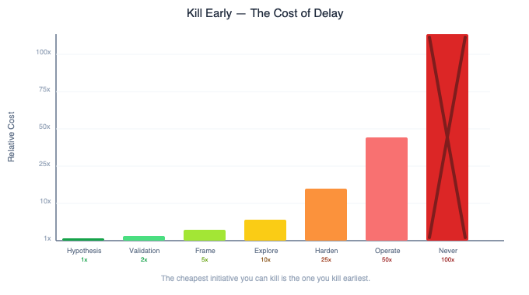
Kill Early: The Cost of Delay — relative cost by stage

The LegacyForward.ai Framework at a Glance
Pillar | Core Question | Stages / Phases | Gate Types | Key Anti-Patterns
Signal Capture | Where does this create net new value that we cannot achieve any other way? | Hypothesis → Validation → Tracking | GO/NO-GO; GO/PIVOT/KILL; Kill Triggers | Adoption Trap; Sunk Cost Spiral; Vibe-Coded Commitment; Perpetual Pilot; Automation as Transformation
Grounded Delivery | Are we delivering toward the value hypothesis, or toward a definition of done that does not measure value? | Frame → Explore → Shape → Harden → Operate | GO/NO-GO; GO/PIVOT/KILL; GO/REDESIGN; GO/CONTINUE/KILL; Operate Forever | Frame Skipped; Velocity as Progress; Test Generation Illusion; Sunk Cost at Gates; Ship and Forget
Legacy Coexistence | How do we create AI value in the enterprise environment we actually have? | Data Exhaust → Sidecar → Gateway → Shadow Pipeline → Legacy-Aware Agent (pattern complexity increases) | Pattern selection gate; Integration validation gate; Trust graduation criteria | Greenfield Fantasy; Wrapper Illusion; Integration Afterthought; Screen Scraping Default; Strangler Fig Misconception

Signal Capture: Value Assessment at a Glance
Stage | Primary Question | Key Activities | Gate
Hypothesis | Can we state the value in one sentence? | Value statement; Transformation test; Value ceiling estimate | GO / NO-GO — no hypothesis, no funding
Validation | Is the hypothesis real, or plausible? | Data validation; Feasibility validation; Organizational validation; Economic validation | GO / PIVOT / KILL
Tracking | Is value being captured? | Leading indicators; Lagging indicators; Kill trigger monitoring | Kill if thresholds breached

Grounded Delivery: Phase Summary
Phase | Objective | Primary Deliverable | Gate
Frame | Define what “good” looks like before building | Probabilistic success criteria; Evaluation dataset design; Integration map; Failure mode analysis | GO / NO-GO
Explore | Validate what is technically possible against real data | Evaluation dataset; Capability map; Legacy data access validation | GO / PIVOT / KILL
Shape | Design production architecture | Deterministic/non-deterministic separation; Fallback paths; Monitoring design; Coexistence pattern selection | GO / REDESIGN
Harden | Build and evaluate against quality thresholds | Production system; Monitoring infrastructure; Legacy integration validation; Red-team results | GO / CONTINUE / KILL
Operate | Monitor, maintain, and feed evidence back | Quality metrics; Drift detection; Value tracking; Trust graduation decisions | No exit — permanent

Legacy Coexistence: Pattern Selection Guide
Pattern | Latency Requirement | Legacy System Modification | Complexity | Best For
Data Exhaust | Batch (hours to days) | None | Low | Historical analysis; pattern recognition over accumulated data
Sidecar | Near-real-time | None | Medium | Augmenting legacy processes with AI insight without replacing them
Gateway | Real-time | None (gateway handles translation) | Medium-High | Agent or API access to legacy systems without modern interfaces
Shadow Pipeline | Batch (validation) | None | High | Gradual transition from legacy process to AI process with evidence
Legacy-Aware Agent | Mixed (agent handles asynchrony) | None | Highest | Autonomous AI operations spanning modern and legacy systems

Core Principles Summary
Principle | In One Line
Kill Early | The most expensive initiative is the one that should have been killed in month two and ran for two years.
Non-Deterministic by Default | Every process that touches an AI system must be designed for systems whose outputs cannot be predicted with certainty.
Legacy Is a Feature | Thirty years of transactional data is the highest-value input your AI can have — design to access it, not replace it.
Value Before Technology | Start with a business problem. The question is never “what can we do with AI?”
Operate Forever | Deploying without operating is abandonment on a delayed schedule.
Coexist Deliberately | Integration patterns must be selected before development begins, not figured out after.

The LegacyForward.ai Framework is the foundation of the LegacyForward.ai Series. For more, visit legacyforward.ai.

