* Semantic Elements mean “an element with a meaning.”
* Semantic Elements clearly describe its meaning to both the browser & the developer. That means it makes the browser understand what the developer wants to show as a result.
* Semantic Elements clearly define the purpose of the element. Such elements can quickly let you know what type of content takes place in it.
* Examples of such elements are <form>, <article>, <table>, <header> and <figure> etc.

* Using Semantic Element “<article>” in code gives you a clear idea that the content is an article.

* Semantic Elements are used because it helps data to be shared and reused across applications, enterprises, and communities.
* It helps to add meaning to the web page rather than just a presentation. It makes your website more accessible and improves the user interface.
* The figure below displays the HTML5 Semantic Element Structure.

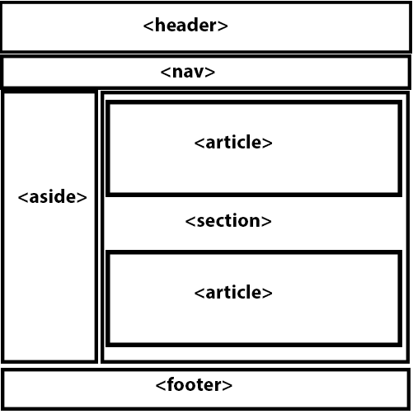

Fig.: HTML5 Semantic Element Structure