**Java Web Pages and Database Management**

FSD: Lab Guide - Phase 2



This section will guide you to:

* Use labs to execute all demos included in this course

This lab has two subsections, namely:

1. Starting practice labs on LMS
2. Using different IDEs and software required for Phase 2

**Step 1:** Starting practice labs on LMS

* Login to Simplilearn LMS
* Go to the respective course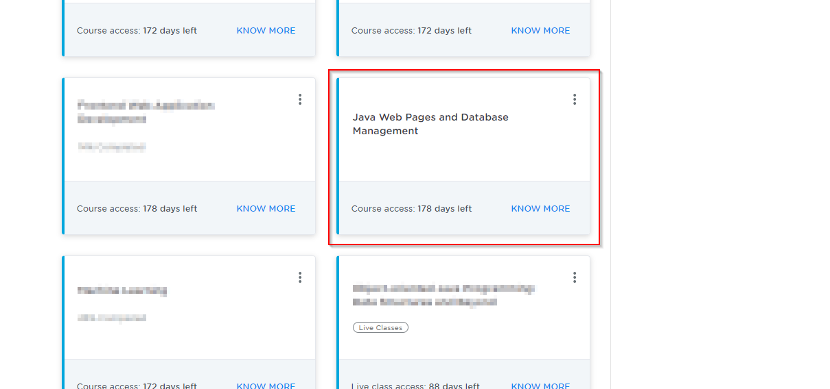
* On the left, you will find the course ToC page
* To its left, you will find the **PRACTICE LABS** tab
* Click on it

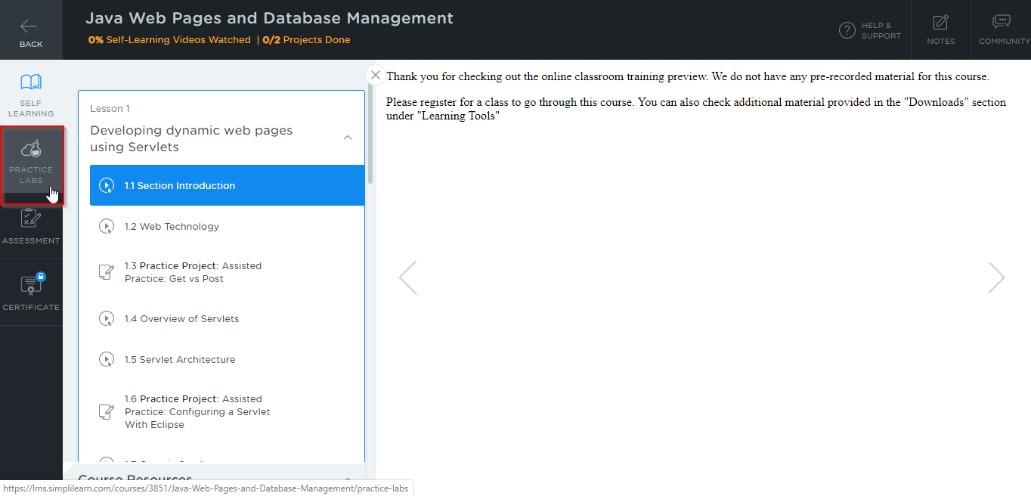

* As a new window opens, read the instructions and click on **LAUNCH LAB**
* This will launch practice labs for this course

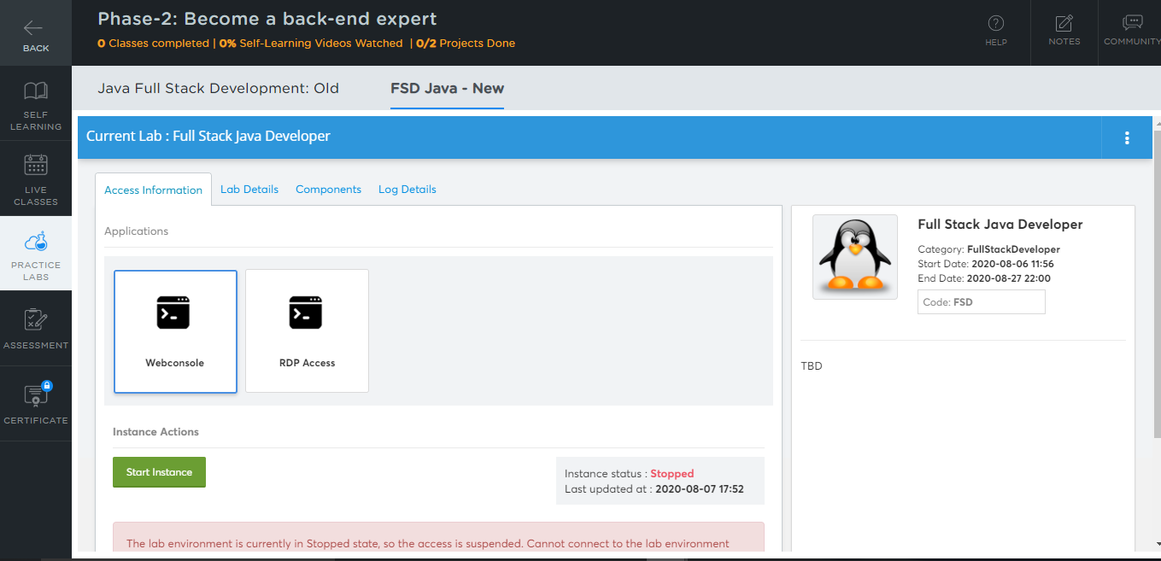

* After that, you will get two things: Web Console and RDP Access
* Click on RDP Access and start the instance as shown below:

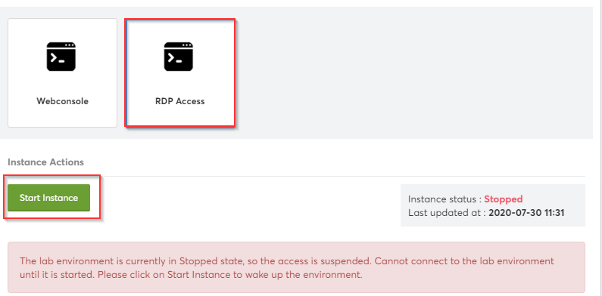

* Next, use the Auth URL and launch the lab as shown below:

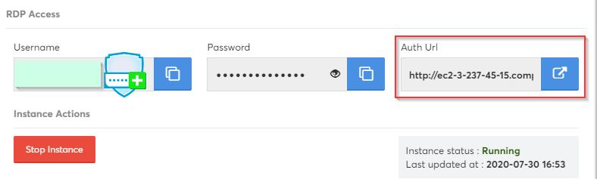

* You will be able to access IDEs and software which are present in labs

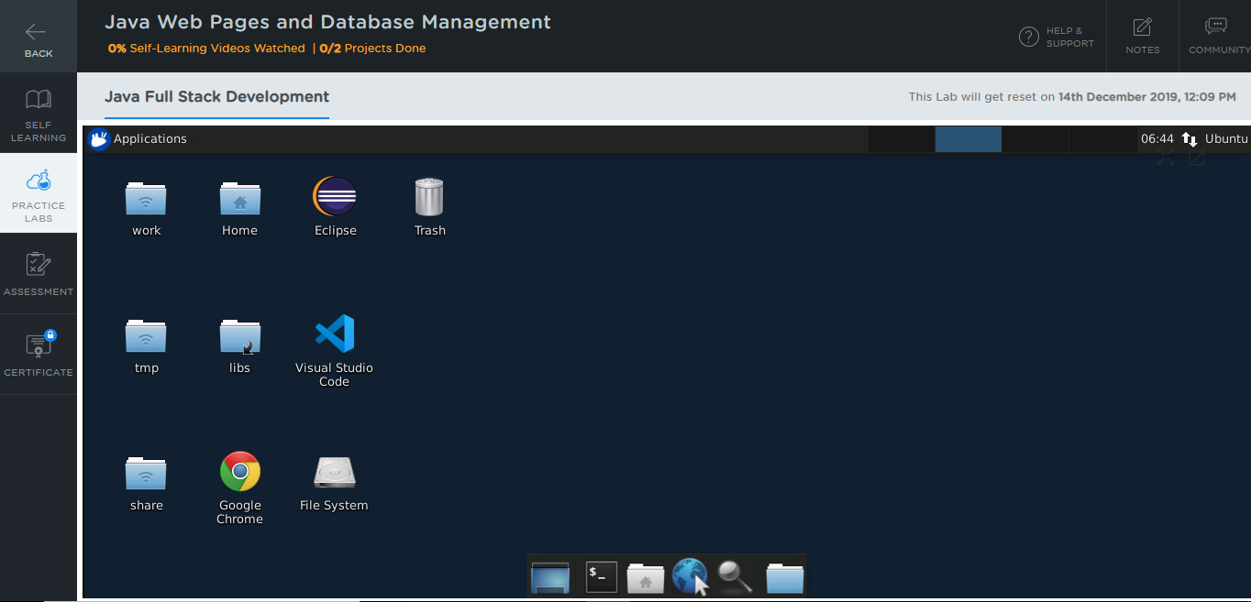

**Step 2:** Using different IDEs and software required for Phase 2

**Apache:**

* Apache is already installed in your practice labs
* To verify the installation:

1. Open the command-line interface
2. Type the following command:

*sudo apache2 -version*

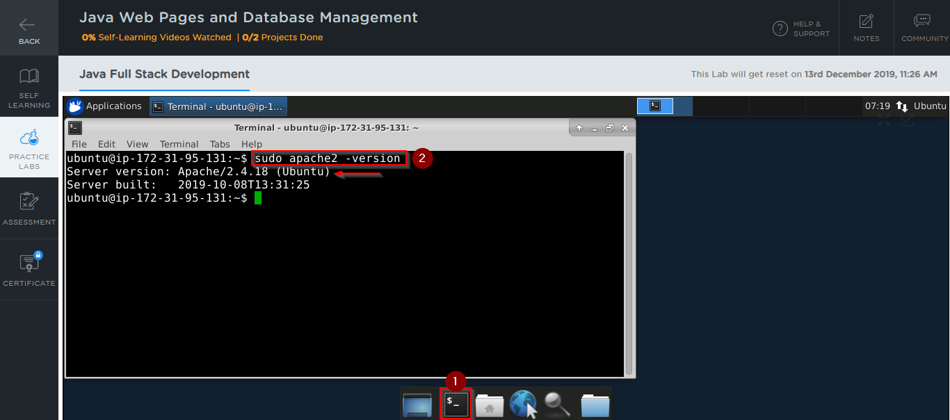

The command mentioned above displays the apache version installed in your practice labs

* In case you find that **apache2** is not installed in your practice labs, you can install it using the following commands:

*sudo apt update*

*sudo apt install apache2*

**MySQL:**

* MySQL is already installed in your practice labs
* To verify the installation:

1. Open the command-line interface
2. Type the following command:

*Mysql -V*

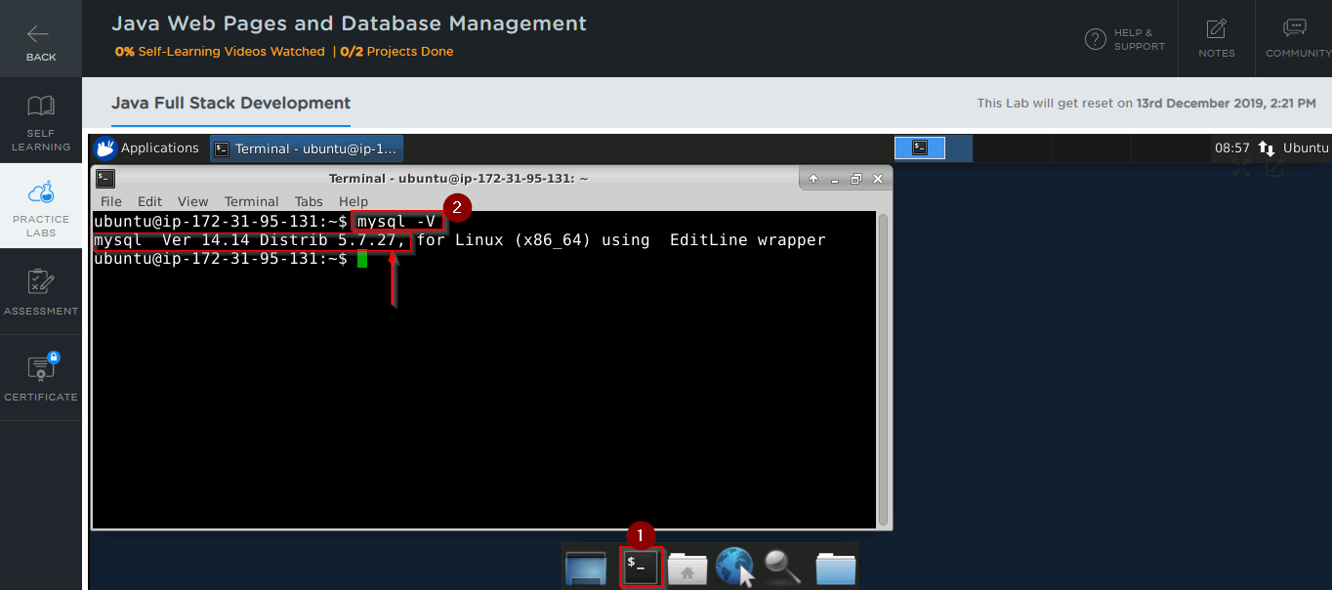

The command mentioned above displays the MySQL version installed in your practice labs

* In case you find that MySQL is not installed in your practice labs, you can install it using the following commands:

*sudo apt-get update*

*sudo apt-get install mysql-server*

**Tomcat:**

* Tomcat 8 is already installed in your practice labs
* For Eclipse integration, you need to download Tomcat from within Eclipse
* To do that, follow these steps:

1. Open the Eclipse environment from your desktop
2. Select the directory where you would like to save your programs
3. Select the **Use this as default and do not ask again** checkbox and click on **launch**

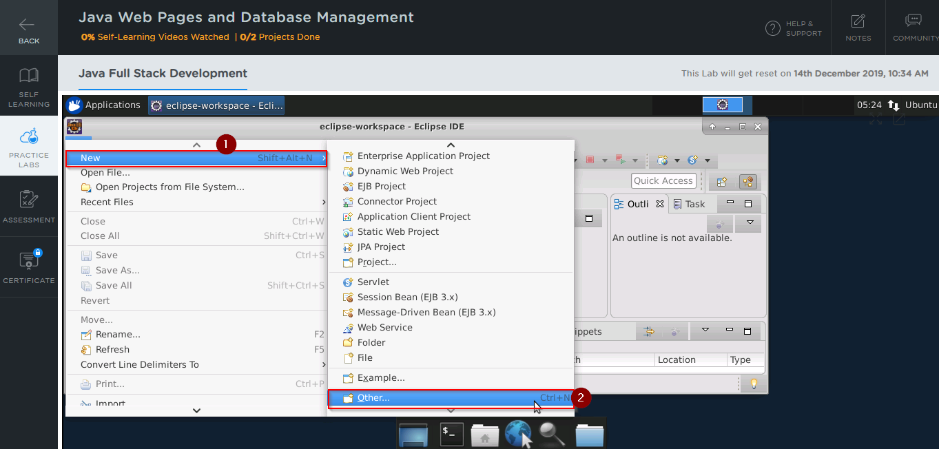

1. Now, on the next page, select **Server > Server** and click on **Next**

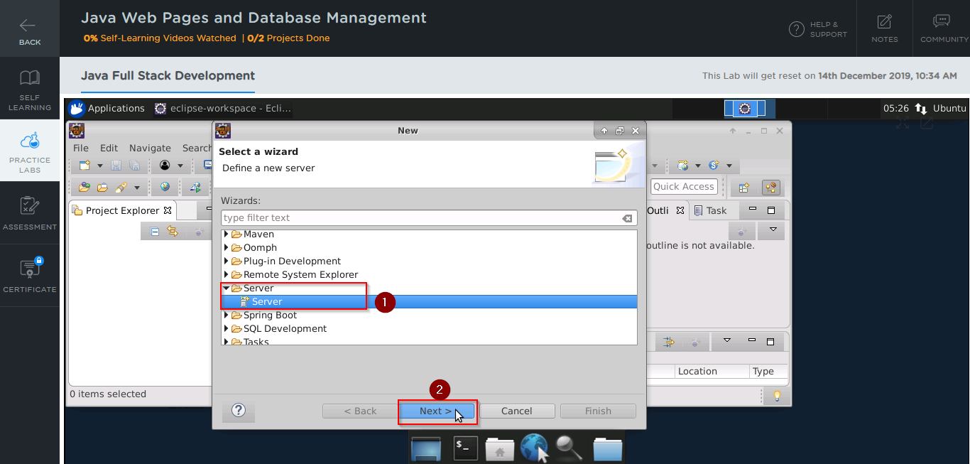

1. Type Tomcat in the **filter text** field, select the Tomcat version that you would like to install, and click on **Next**

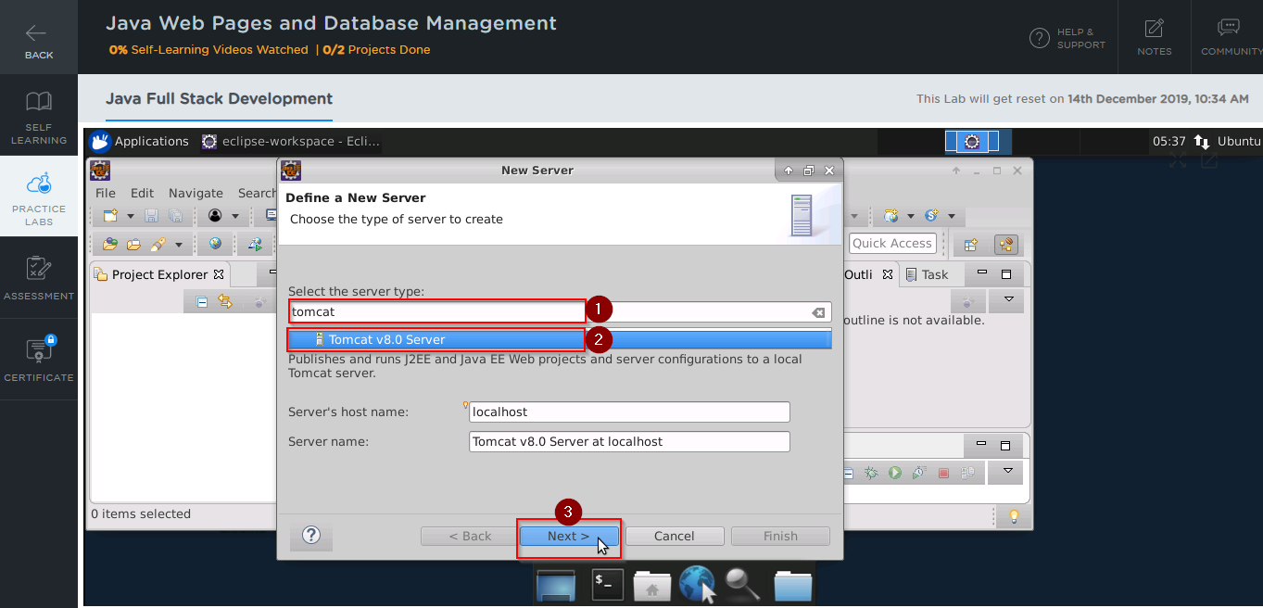

1. Click on **Download and Install** and select the directory where you want to download Tomcat
2. Select the installed JRE and click on **Finish**

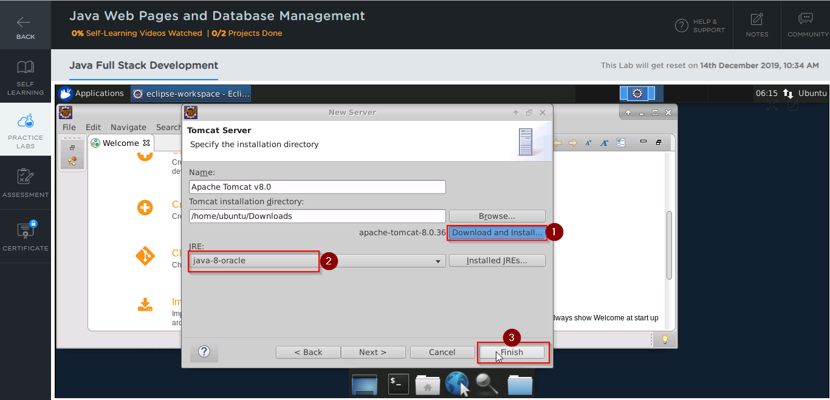

**Servlet and JSP:**

* Servlet and JSP are already installed in your practice labs
* You will find their jar files at *usr/share/java*



