Home Assignment

Submitted By Vishwakarma Raj S.
Rollno. 262
Subject. ASP.Net
Stream-TYBCA Sem-5 Div-3
Year 2026-27 of
Naran Lala College
Eru, Char Rasta, Navsari

Q.1 Create a Webpage using ASP.Net to insert records inside database table having following fields:
Table&Fields:--stud (Rollno,Name ,Course,Percentage)
Operations Provide Insert,Update,Delete Student Records.

Designing Page:
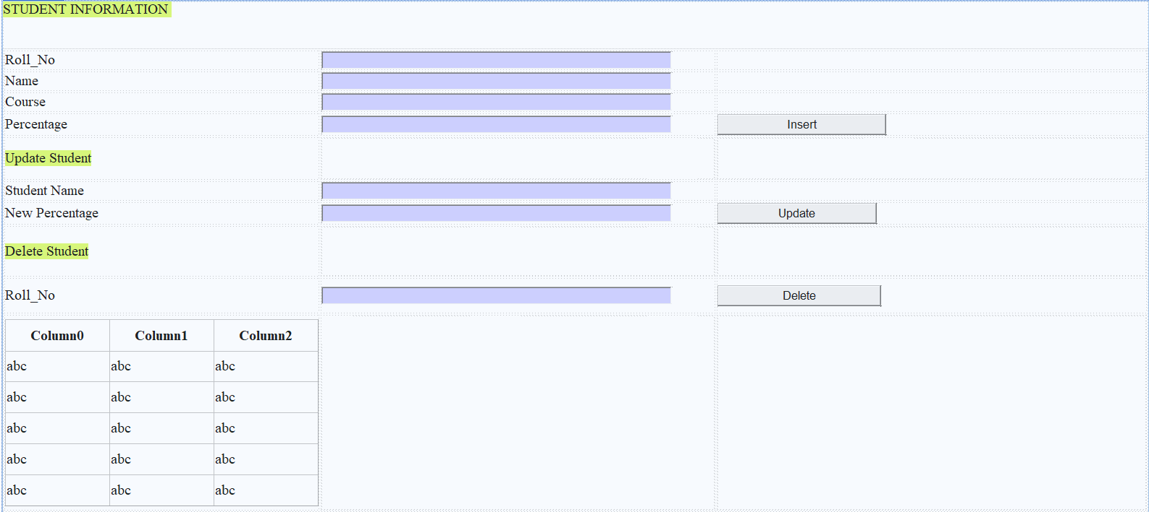

Code:
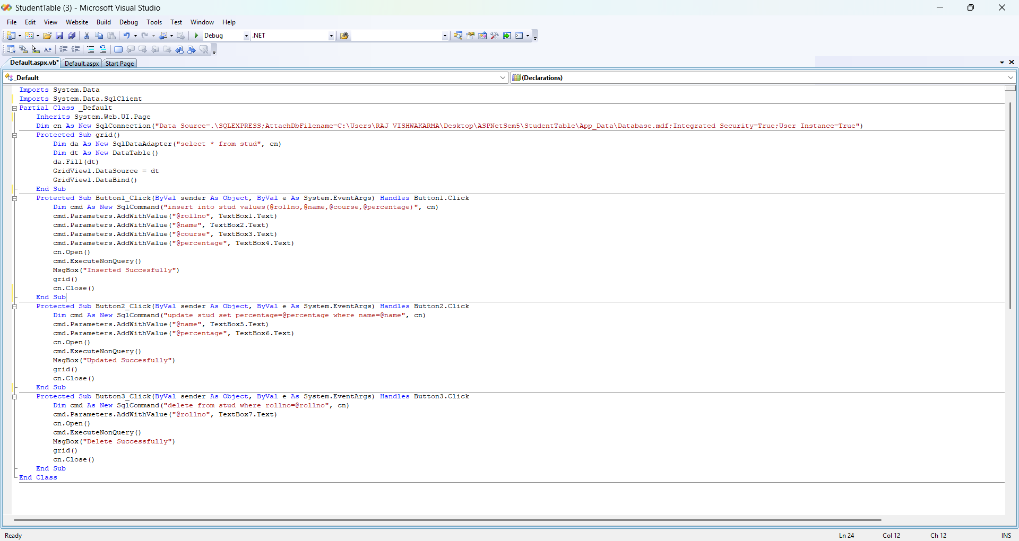
Output :
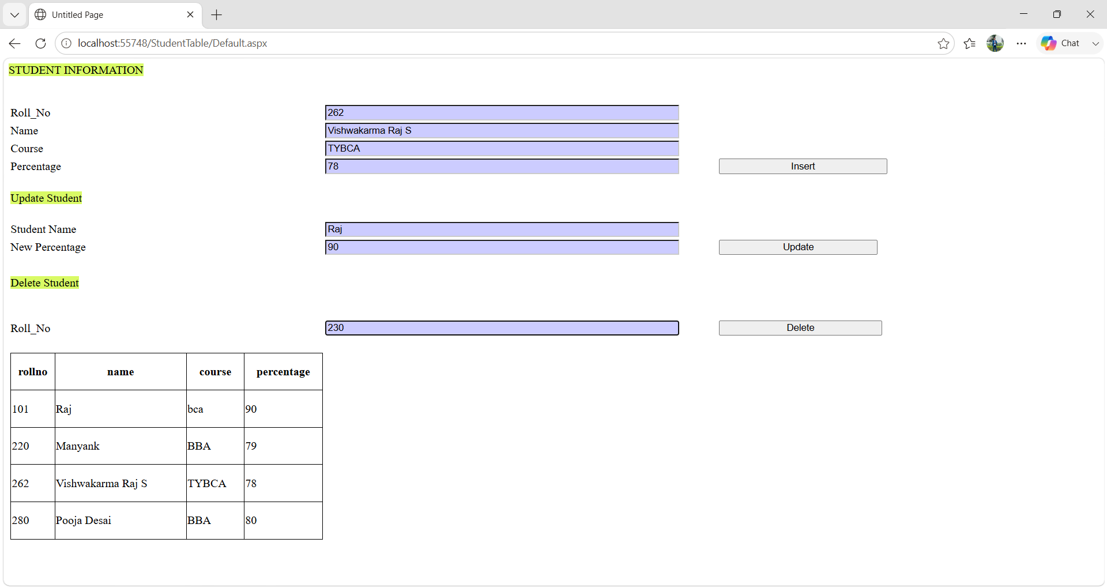

Q.2 Create a Webpage using ASP.Net to Employee Details with following fields give provision for login & signup.
Once the Login is successful and on webpage with functionality to add, shows,update and delete employees.
Maintain Session for login users an also use concept of MasterPage.
Table1&Fields:---emp_data(Emp_Id,Emp_Name,Mobile,
DateOfBirth,DateOfJoining,City,Salary)
Table2&Fields:--- user_login(UserName,Mobile,Email,Password)

Login Page:
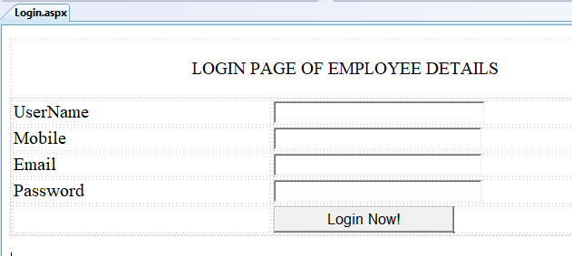
Code :
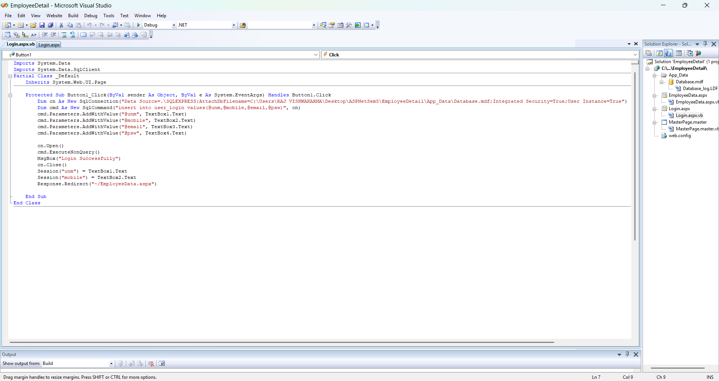
Output :
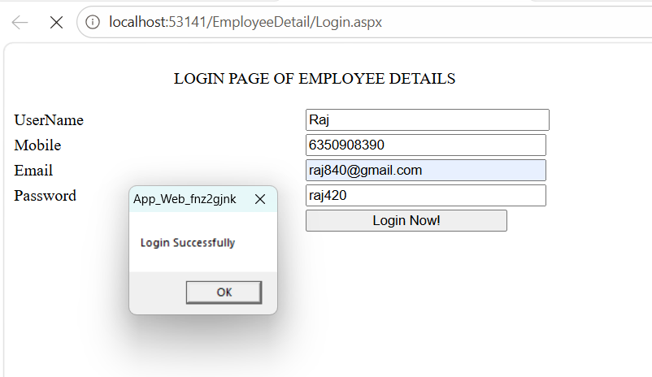
MasterEmp Page:
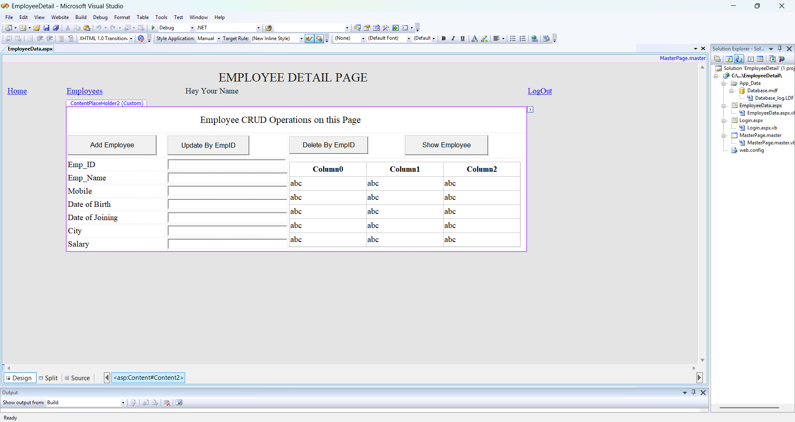
Code :
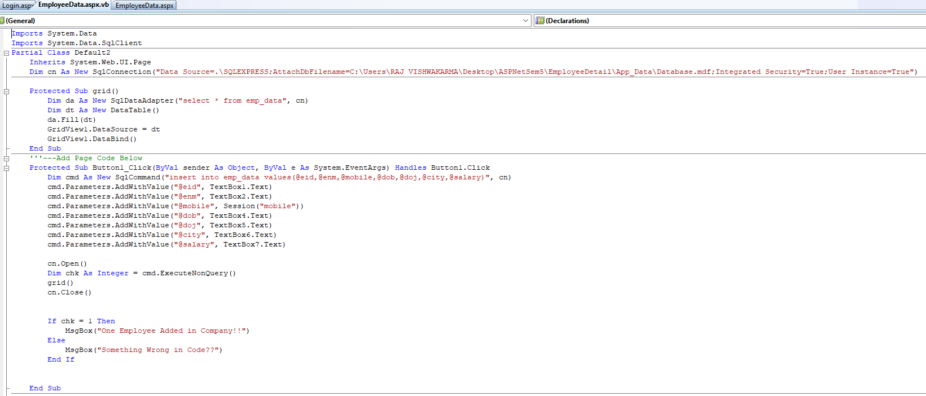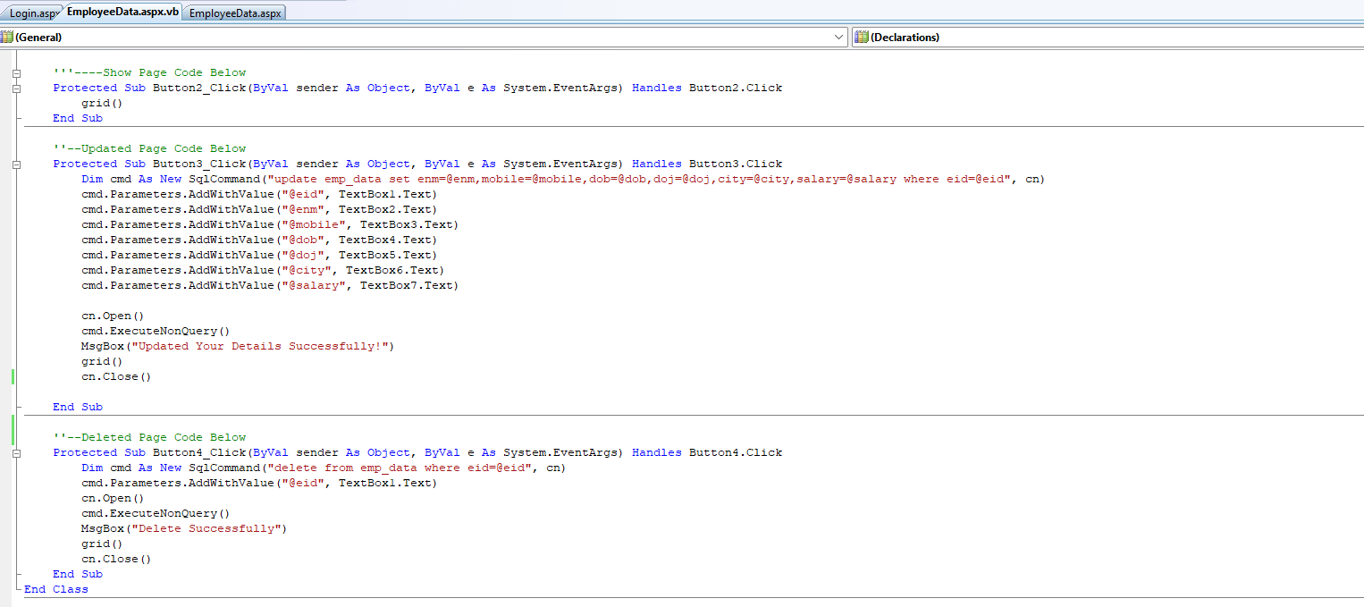
Output :
