**Library Management System – V2**

Rajya Lakshmi Jampani | [22f3002986@ds.study.iitm.ac.in](mailto:22f3002986@ds.study.iitm.ac.in)

**Overview**

**ClickReads** is a dynamic multi-user web application for managing the activities of an e-library. It has two roles - a librarian/admin to maintain sections/e-Books, and general user to access the e-books. RBAC (Role Based Access Control) is implemented using Flask-Security. Profile management, searching e-books/sections by title, author etc. are common to both the roles.

The application also has backend jobs for sending daily reminders to users and monthly activity report to admin. Admin can also trigger asynchronous jobs to download book report and issues report from UI. Frequently accessed pages like Book Management, Section Management are cached to increase the performance.

**Technologies** **Used**

* HTML, CSS, Bootstrap and VueJS for UI and styling
* Flask framework of Python for backend
* SQLite database – integrated using Flask-SQLAlchemy and Flask-RESTful
* Jinja2 for email templates
* Redis for caching
* Redis and Celery for batch jobs

**System design**

The application is built using Model-View-ViewModel architecture as below.

Notifications

Notifications

Updates

Data binding and commands

**Model**

(Application Data)

**View Model**

(State & Operations)

**View**

(User Interface)

**DB Model design**

The application uses 10 database tables (Models) defined as Python classes. The ER diagram corresponding to the design is as below.

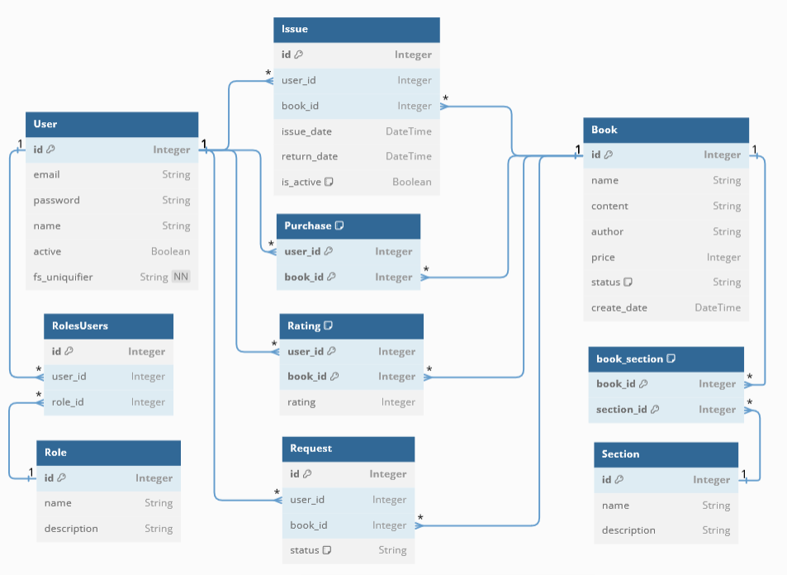

**Folder structure of submission**

* Entry point of the application is app.py in root
* application folder contains .py files for configuration, model definition, view definition, scripts for mail service, celery task and worker.
* static folder has .js files for component definition to be used as UI.
* templates folder has index.html for application entry point and the HTML templates required for emails.

**Demo link**

<https://drive.google.com/file/d/1lYjiX5KB5pSy_Zrvyoawh18eL4S5eqJ_/view?usp=sharing>