Login Screen
Integrated API : https://uat.iotsa.tech:7177/Api/v4/User/CustomerPortalLogin
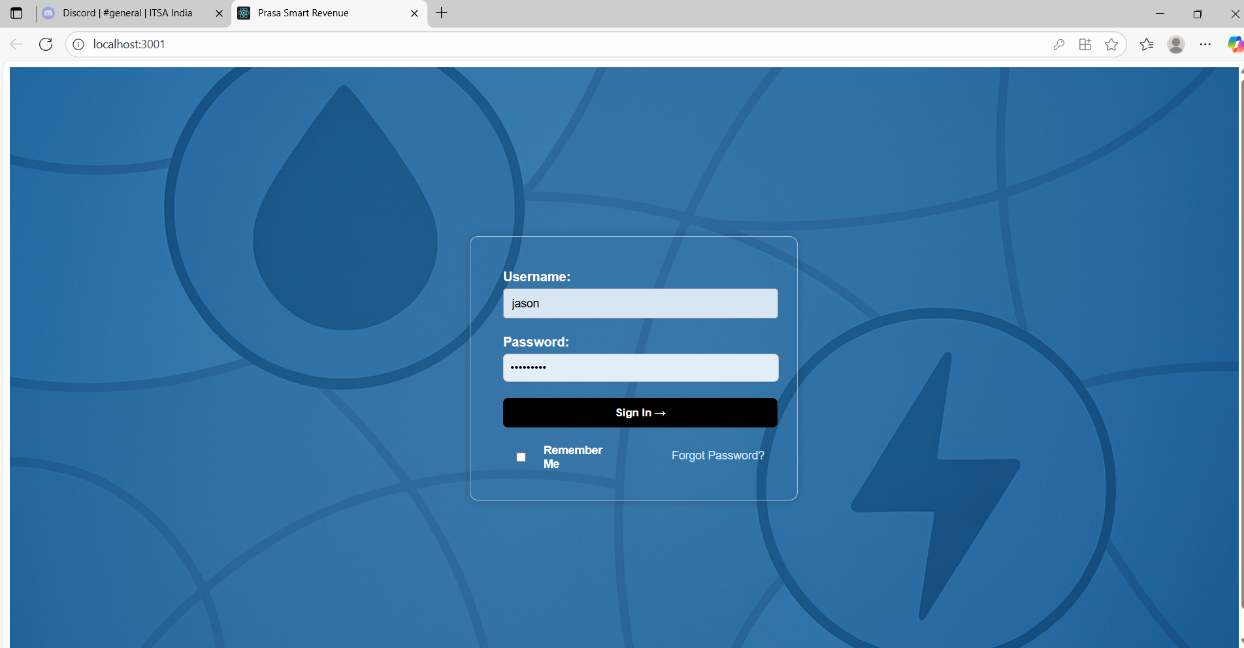
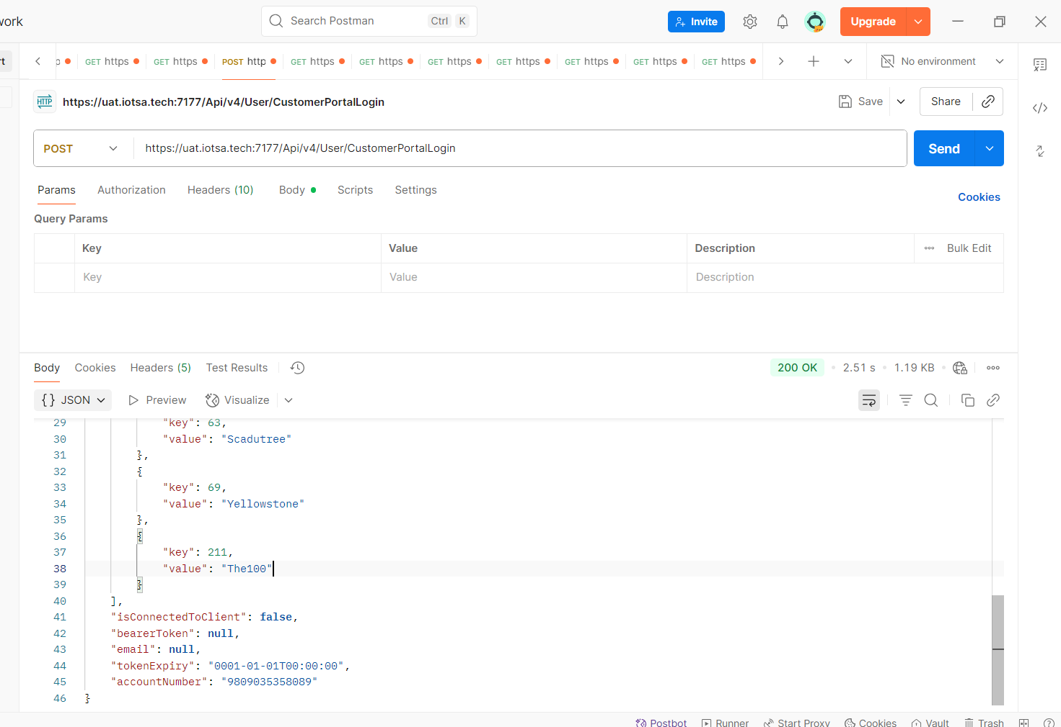
We are getting for Jason Login these details, for now Account number we are using 45077793219 this, because Jason not yet registered, Bearer token and token expiry date is getting null

Total Accounts Screen
After Login In phase 1 left menu ,Total Accounts screen
Integrated API : https://djibouti.imssahes.com:445/getMeterAccount.jsp?LOGIN=aus.abdul&PWD=aus4africa&account_number=45077793219
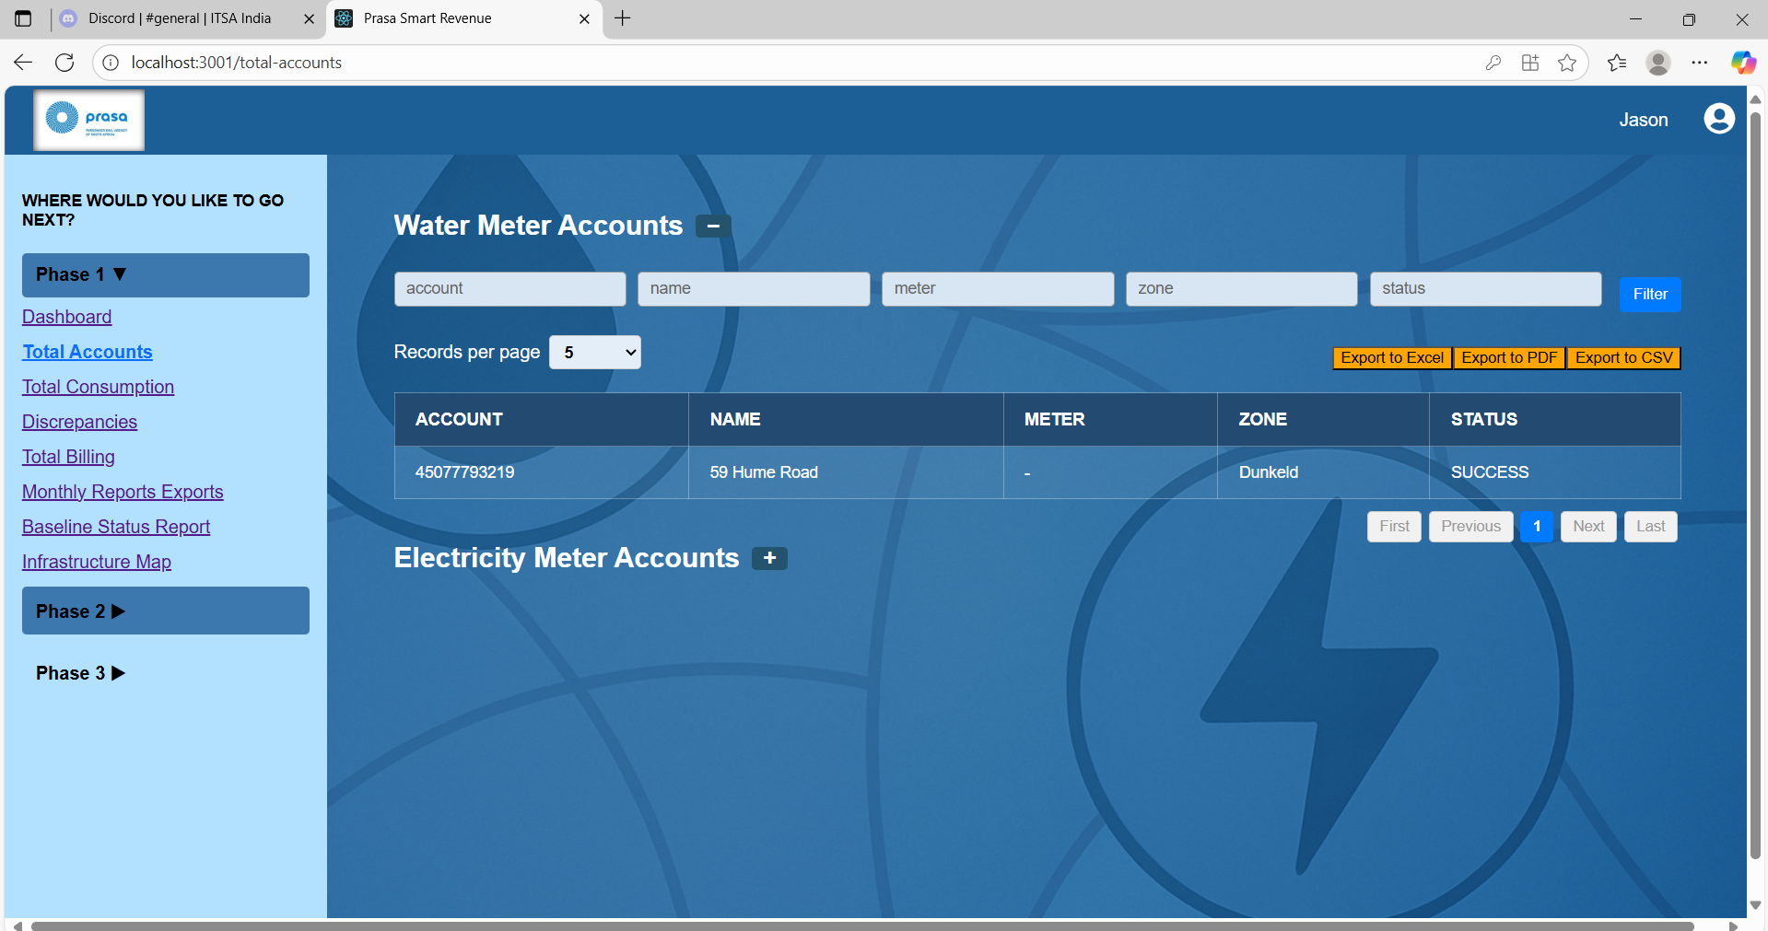
Output response and Table fields are not matching, for which we need map these details we are finding weather response is water or electricity in this api
Output Response
{
"result": "SUCCESS",
"account": {
"id": 4884,
"cid": 109,
"key1": "6",
"key2": "45077793219-Account ; 45077793219",
"accountNumber": "45077793219",
"tariff": {
"id": 4882,
"cid": 111,
"key1": "3003000002",
"key2": "PostPaid"
},
"meter": {
"id": 4352,
"cid": 283,
"key1": "45077793219",
"key2": "45077793219 ; 59 Hume Road ; Dunkeld",
"commsDevice": {
"id": 4351,
"cid": 283,
"key1": "45077793219",
"key2": "45077793219 ; 59 Hume Road ; Dunkeld"
},
"breaker": {
"id": 4353,
"cid": 283,
"key1": "45077793219",
"key2": "45077793219 ; 59 Hume Road ; Dunkeld"
}
}
}
}
Total Consumption screen
In left menu phase 1 we have total consumption screen we have Integrated below api
https://aus-djibouti-l.imssahes.com/getTotals.jsp?LOGIN=aus.abdul&PWD=aus4africa&startdate=2025-01-01&enddate=2025-07-30&key1=45077793219
To call above api we need to pass start date and end date so we have given input fields to capture and account number is passing key parameter which we are auto populating as Login details and binding output response as added image.
In this API Output response we didn’t find the meter name weather its is water or Electricity and output response and table fields are not matching to map.
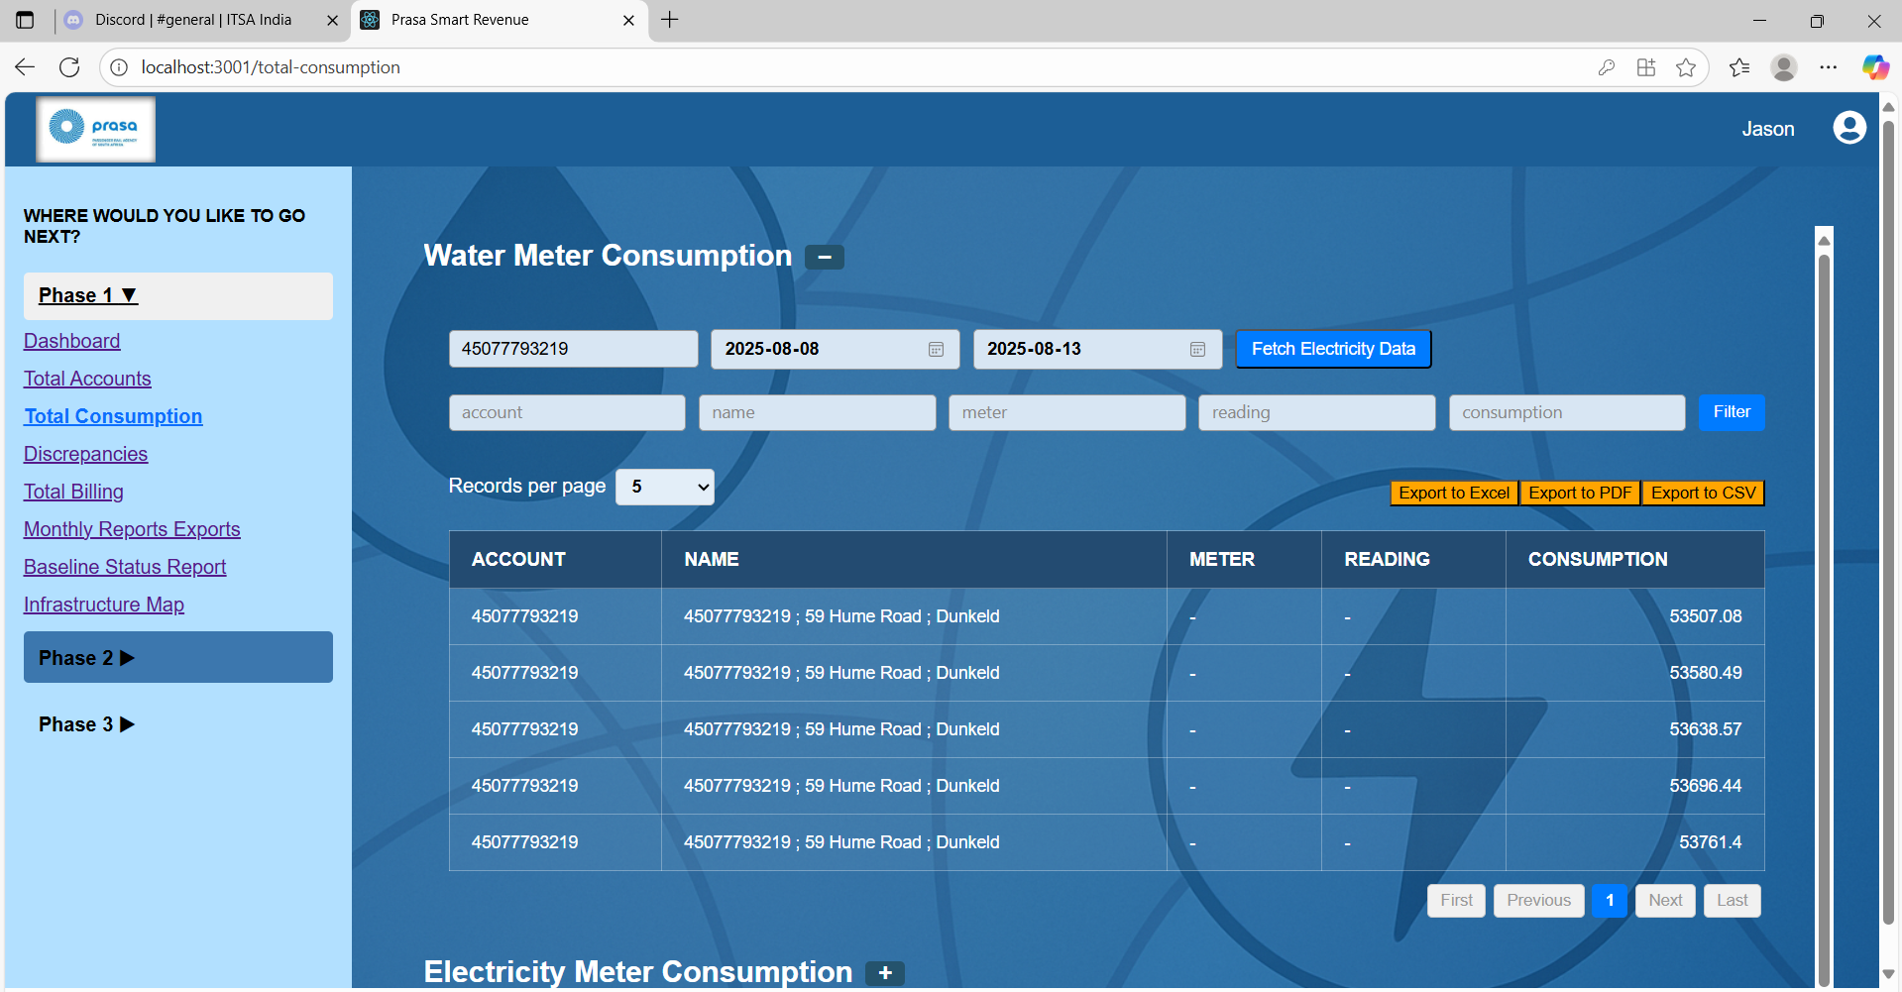
Output Response :
{
"result": "SUCCESS",
"meter": {
"serial": "45077793219",
"name": "45077793219 ; 59 Hume Road ; Dunkeld",
"totals": [
{
"dateRaw": "2025-08-08 00:00:00.000",
"date": "2025-08-08T00:00:00",
"e1": 53507.08,
"e2": 6.8,
"f1": 42.82,
"f2": 13.22,
"f3": 0.74,
"f4": 12103.87,
"status": 333333
},
{
"dateRaw": "2025-08-09 00:00:00.000",
"date": "2025-08-09T00:00:00",
"e1": 53580.49,
"e2": 6.8,
"f1": 42.82,
"f2": 13.22,
"f3": 0.74,
"f4": 12121.4,
"status": 333333
},
{
"dateRaw": "2025-08-10 00:00:00.000",
"date": "2025-08-10T00:00:00",
"e1": 53638.57,
"e2": 6.8,
"f1": 42.82,
"f2": 13.22,
"f3": 0.74,
"f4": 12136.27,
"status": 333333
},
{
"dateRaw": "2025-08-11 00:00:00.000",
"date": "2025-08-11T00:00:00",
"e1": 53696.44,
"e2": 6.8,
"f1": 42.82,
"f2": 13.22,
"f3": 0.74,
"f4": 12151.59,
"status": 333333
},
{
"dateRaw": "2025-08-12 00:00:00.000",
"date": "2025-08-12T00:00:00",
"e1": 53761.4,
"e2": 6.94,
"f1": 42.83,
"f2": 13.22,
"f3": 0.75,
"f4": 12164.33,
"status": 333333
}
]
}
}

Total Billing Screen:
In left menu phase 1 we have total billing screen integrated api
https://djibouti.imssahes.com:445/getMonthlyBills.jsp?LOGIN=aus.abdul&PWD=aus4africa&key1s=6&startdate=2025-07-01&enddate=2025-08-01

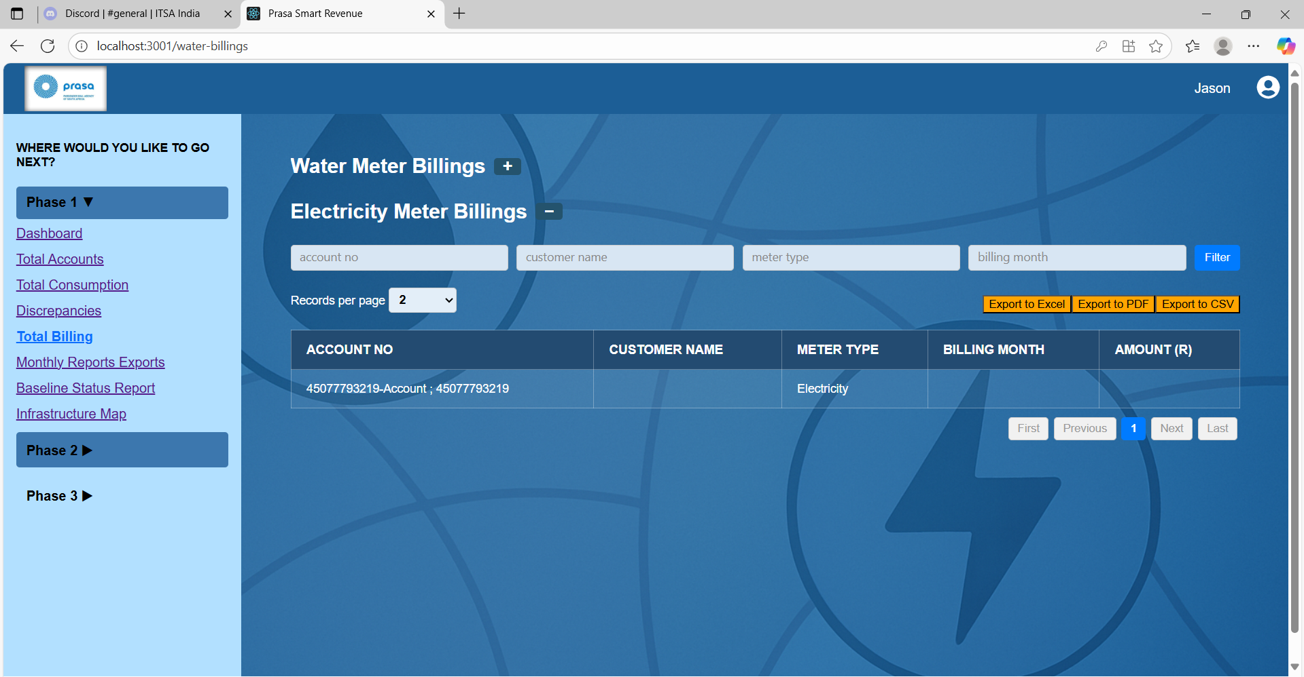
In output response only getting electricity data and no matching fields in screen, In which url we can find water data for this API
Output Response :
{
"result": "SUCCESS",
"startDate": "2025-07-01 00:00:00.000",
"endDate": "2025-08-01 00:00:00.000",
"meterAccount": {
"key1": 6,
"key2": "45077793219-Account ; 45077793219",
"util": "Electricity",
"brid": "4901",
"documentDate": "2025-08-05 11:55:01.288",
"currency": "R",
"align": "PRE",
"tariff": "PostPaid",
"taxType": "VAT",
"taxPerc": 15,
"currencyDecimals": 2,
"items": 1,
"bill": [
{
"tName": null,
"desc1": null,
"desc2": null,
"units": 0,
"rate": 0,
"amount": 0,
"unitsUnit": null,
"type": null,
"compareId": null,
"tariffLineId": null,
"taxed": null,
"touId": null
}
],
"totalNonTax": 0,
"totalTaxed": 4080.860000000015,
"tax": 612.1290000000023,
"total": 4692.989000000017,
"readings": {
"mr": [
{
"sNumber": "45077793219",
"mType": "SANXING",
"start": {
"date": "2025-07-01 00:00:00.000",
"e1": "50995.759kWh",
"billingMultiplier": 1
},
"end": {
"date": "2025-08-01 00:00:00.000",
"e1": "53036.190kWh"
},
"portion": 1,
"multiplier": 1
}
]
}
}
}

