SMART ROAD MANAGEMENT SYSTEM
Software Engineering — System Design Diagrams

Prepared as a reference document for drawing in Sparx Systems Enterprise Architect

Project overview
The Smart Road Management System is designed to help road users understand traffic conditions, check road damage and other road issues, report problems, and identify suitable routes using origin, destination and district information. The system can use road status, congestion, accidents, construction and closures when presenting route alternatives. Administrators can review issue reports and maintain road and traffic information.

Assumptions used in these diagrams
- The database is MySQL (smart_road_db) and the backend is Node.js with Express.
- Core modules represented: Traffic Management, Road Condition / Issue Reporting, and Route Management.
- The existing schema context includes Locations and Roads. Traffic records, issue reports and route/usage history are represented as logical data stores/classes to complete the design; confirm they match your actual implementation.
- Dijkstra's algorithm is shown as a possible shortest-path method for route calculation, but the diagram does not claim it is already implemented.
- The map/routing service is optional. If the project does not use an external map API, remove that external entity from the Level 0 diagram.
- These are clean reference diagrams for recreating in Sparx Enterprise Architect; they are not native .qea/.eap project files.

1. DFD — Level 0 (Context Diagram)
The entire system is shown as one process. External entities exchange requests and information with the Smart Road Management System.
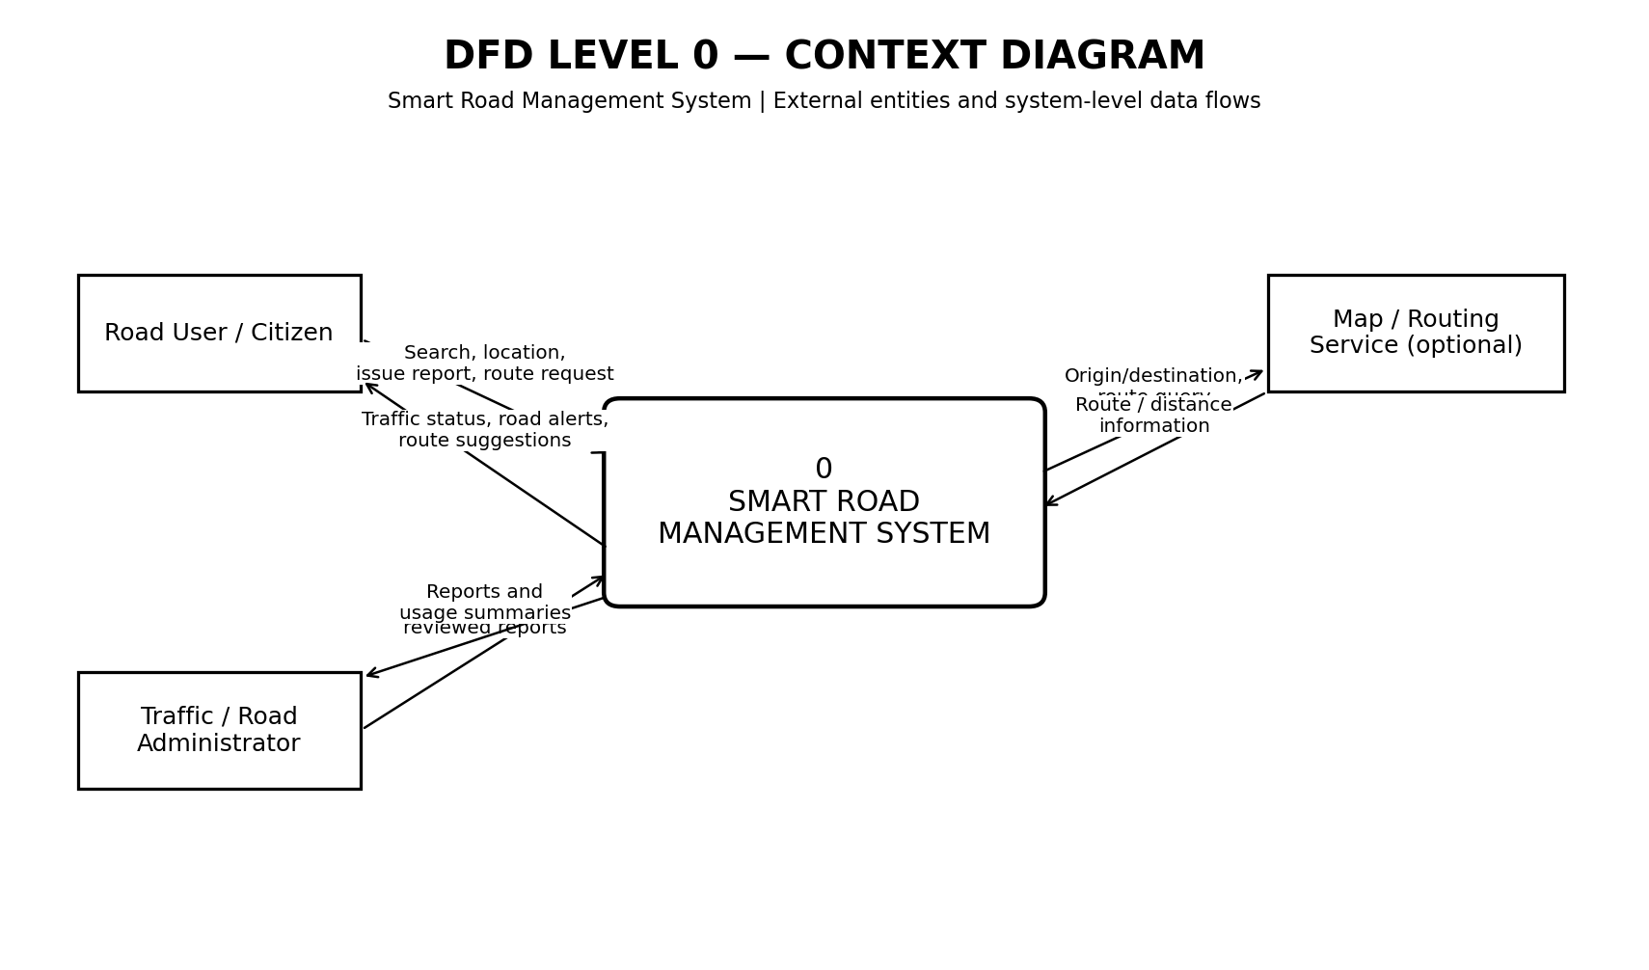

2. DFD — Level 1 (Major Processes)
The system is decomposed into traffic management, road-condition reporting, route management, and usage/damage analysis. Data stores are shown separately.
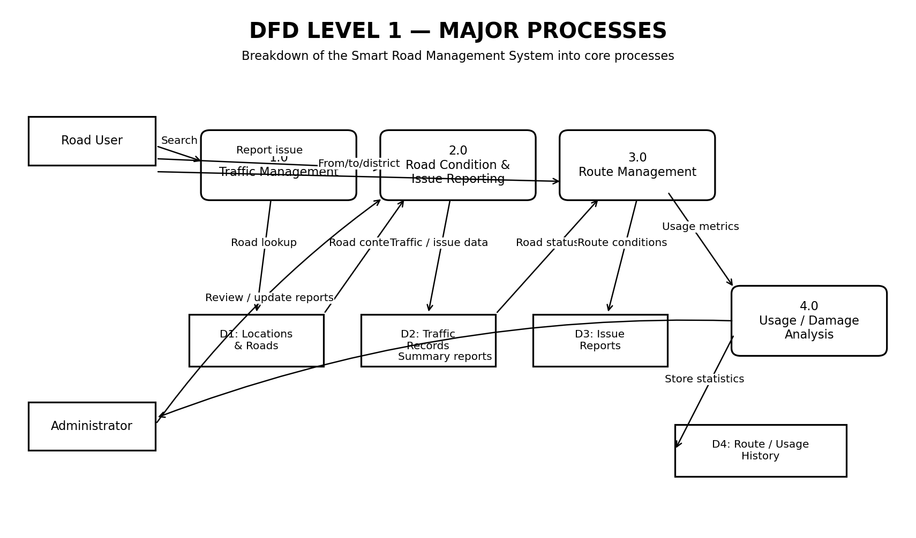

3. DFD — Level 2 (Route Management)
This expands process 3.0 to show request capture, location validation, road-data retrieval, road-condition checks, route calculation, ranking, and output. Use Dijkstra only if implemented or planned.
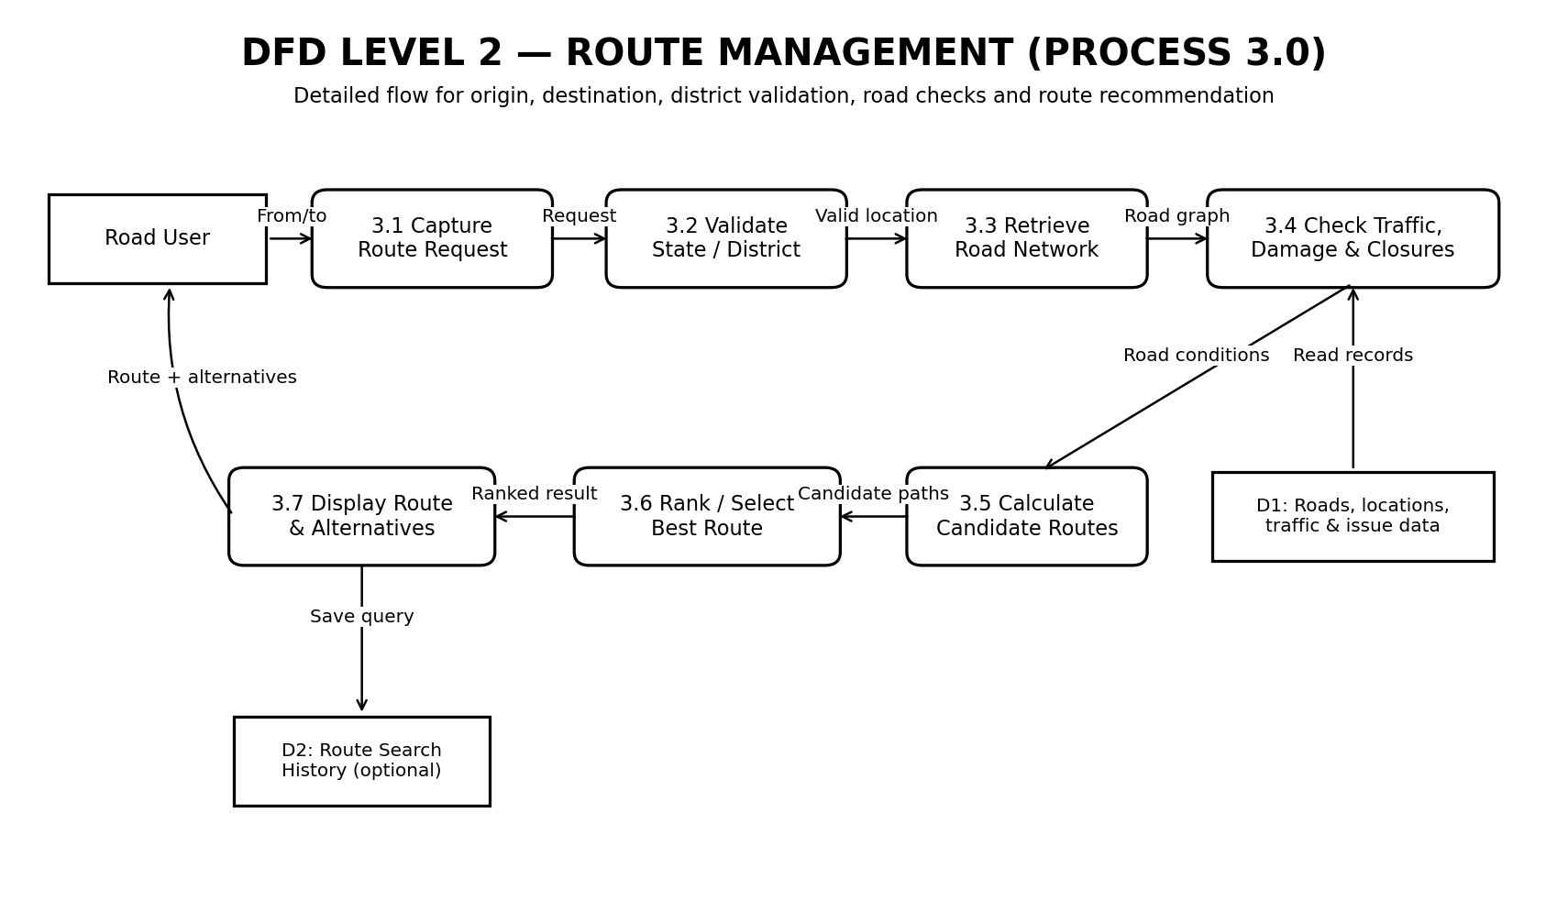

4. UML Use Case Diagram
The Road User searches traffic and road conditions, submits an issue, and requests routes. The Administrator manages information, reviews issues, and checks summary statistics.
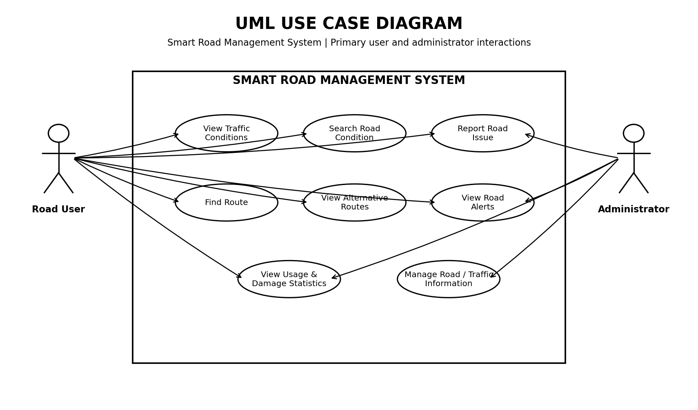

5. UML Class Diagram
A proposed domain model. Location and Road represent core entities; TrafficRecord and RoadIssue capture changing road information; RouteRequest and RouteOption support route searches; RoadUsage supports usage analysis.
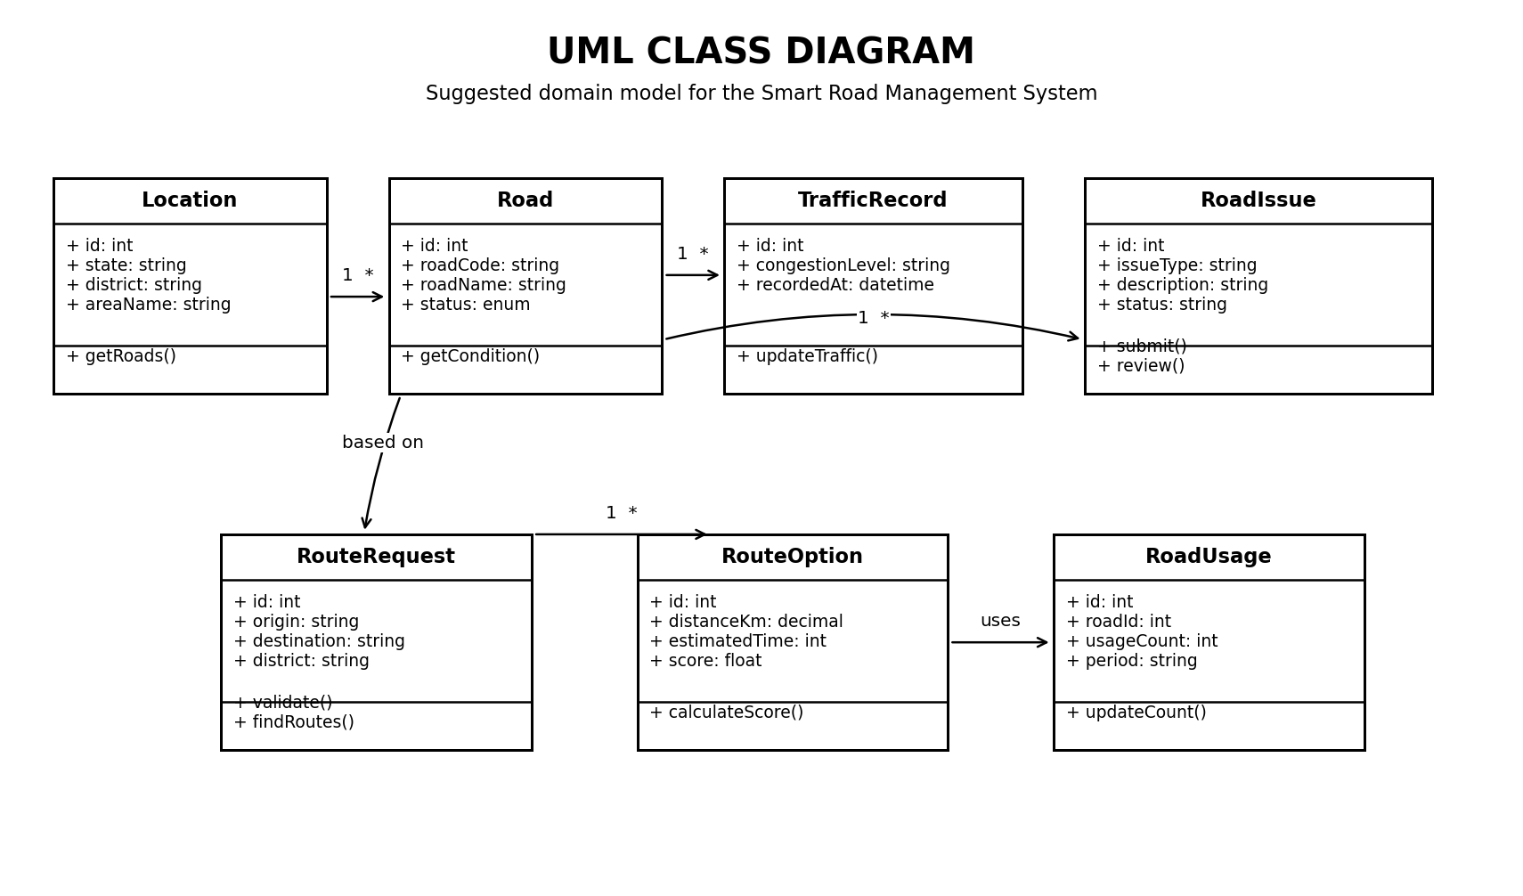

6. Swimlane Activity Diagram
The route-search workflow is divided into Road User, System/Backend, and MySQL Database lanes to show responsibility and hand-offs.
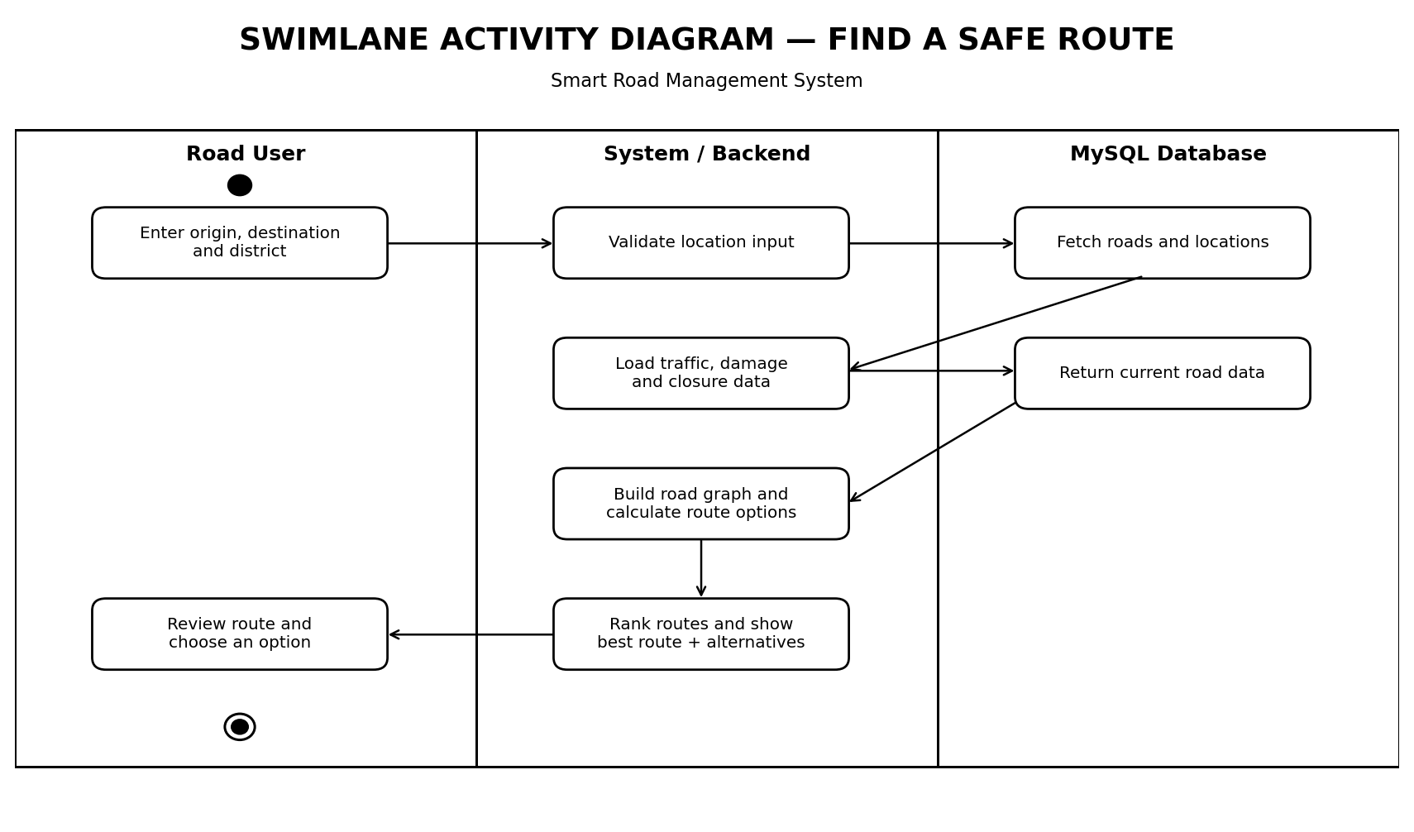

How to recreate these in Sparx Systems Enterprise Architect
- Create a project and a package named Smart Road Management System.
- For DFDs, use a Data Flow Diagram template (or a suitable diagram type with external entities, processes and data stores). Create separate diagrams for Level 0, Level 1 and Level 2.
- For the use case diagram, add actors, use-case ellipses, a system boundary, and association connectors. Use <<include>> or <<extend>> only where the behavior genuinely requires it.
- For the class diagram, add classes with attributes and operations, then connect them with associations and multiplicities.
- For the swimlane diagram, use an Activity diagram with Activity Partitions for Road User, System/Backend and MySQL Database. Add actions and control-flow arrows.
- Keep labels and names consistent with the actual database tables and implemented backend endpoints.

Important validation before submission
Please compare the logical entities and processes with your current code. If your project currently contains only the Locations and Roads tables, do not claim that separate TrafficRecord, RoadIssue, RouteOption or RoadUsage tables already exist. They are design-level concepts unless you have created them. Likewise, mark Dijkstra's algorithm as proposed/planned unless your route module actually uses it.
This document uses the project details previously discussed. If your final implementation has changed, update the diagram names, data stores, and process flows before submitting it.

