**Description:**

Library:

A library is a collection of organized information and resources which is made accessible to a well-defined community for borrowing or reference sake. The collection of the resources and information are provided in digital or physical format in either a building/room or in a virtual space or even both. Library’s resources and collections may include newspapers, books, films, prints, maps, CDs, tapes, videotapes, microform, database etc.

This Database is Library management system of such a library that has several branches in different cities with employees, where customers can borrow (issue) books that are available in the library. The database provides some information about a book’s author and its publisher. It keeps track of a book’s issue date, return date, and salary of the library’s employees.

**Schemas/Tables in the Library Database:**

* Author (ID, Name, Gender, Qualification)

* Publisher (ID, Name, City, Zip)

* Books (ID, Name, Name, ISBN, Author_ID, Publisher_ID, No_of_Books)

* Branch (ID, City, Street)

* Employee (ID, Branch_ID, Name, Salary, Gender, Phone, City, Street)

* Customer (ID, Name, Email, Phone, City, Zip)

* Issue (Customer_ID, Book_ID, Branch_ID, Employee_ID, Issue_Date, Return_Date)

**Schema Diagram for Library Database:**

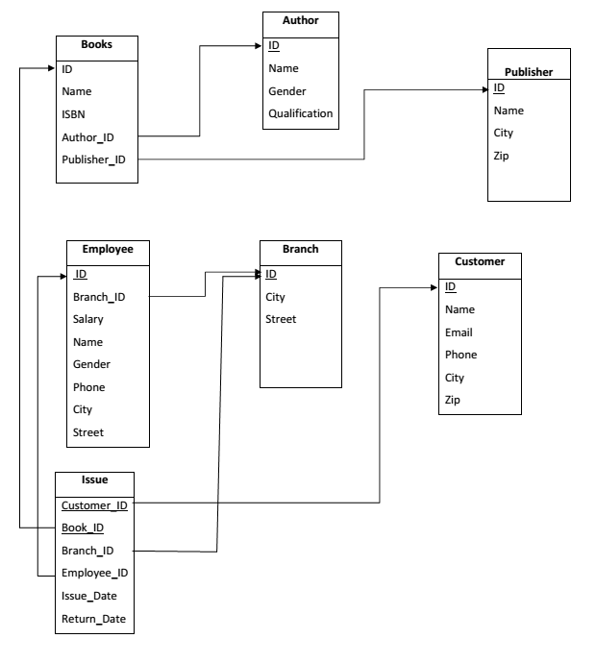

**Creating the Tables and Inserting the Data:**

1. **Author:**

create table Author

(

ID integer,

Name varchar(100) constraint "Author_Name_CHK_NL" not null,

Gender char(1) constraint "Author_Gender_CHK_NL" not null,

Qualification varchar(50),

constraint "Author_Gender_CHK" check (Gender in ('M', 'F')),

constraint "Author_ID_PK" primary key (ID)

);

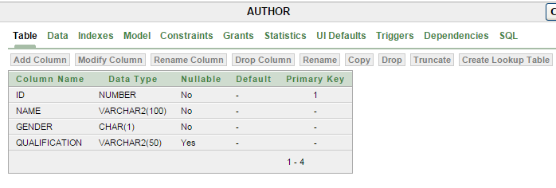

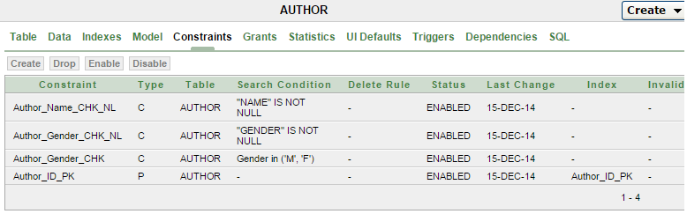

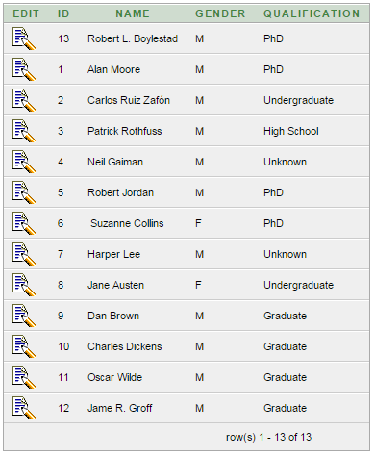

1. **Publisher:**

CREATE TABLE "PUBLISHER"

( "ID" integer,

"NAME" VARCHAR2(100) CONSTRAINT "Publisher_Name_CHK_NL" NOT NULL ENABLE,

"CITY" VARCHAR2(50),

"ZIP" VARCHAR2(5),

CONSTRAINT "Publisher_ID_PK" PRIMARY KEY ("ID") ENABLE,

CONSTRAINT "Publisher_Zip_CHK" CHECK ( "ZIP" like '_____') ENABLE

);

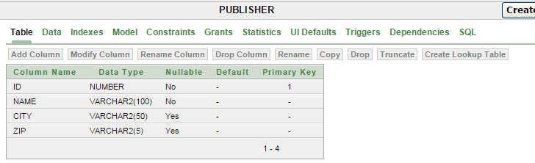

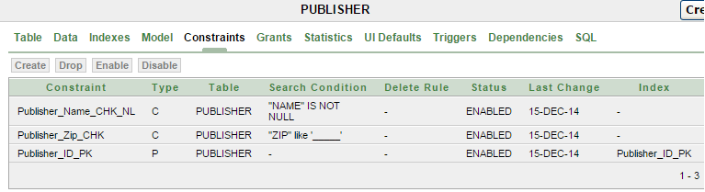

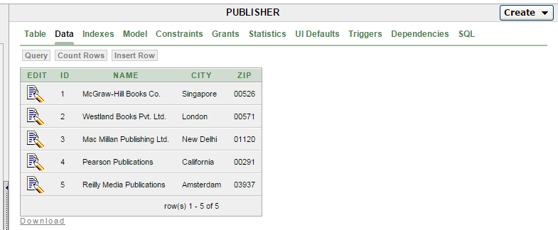

1. **Books:**

create table Books

(

ID integer,

Name varchar(100),

ISBN varchar(30) constraint "Books_ISBN_CHK1" not null,

Author_ID numeric(10),

Publisher_ID numeric(10),

No_of_Books numeric(10, 0),

constraint "Books_No_Of_Bks_CHK2" check (No_of_Books >= 0),

constraint "Books_ISBN_CHK" check (ISBN like '%-%-%-%'),

constraint "Books_ISBN_UK" unique (ISBN),

constraint "Books_Author_ID_FK" foreign key (Author_ID)

references Author(ID) on delete set null,

constraint "Books_Publish_ID_FK" foreign key (Publisher_ID)

references Publisher(ID) on delete set null,

constraint "Books_ID_PK" primary key (ID)

);

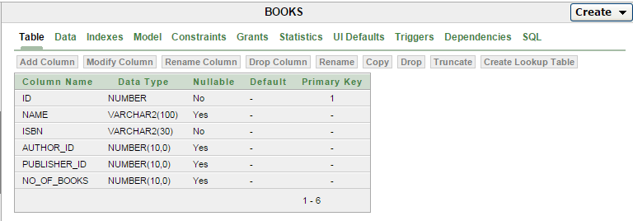

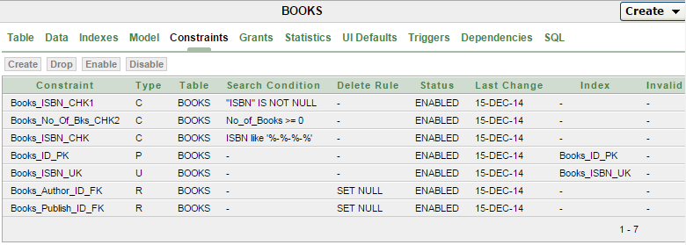

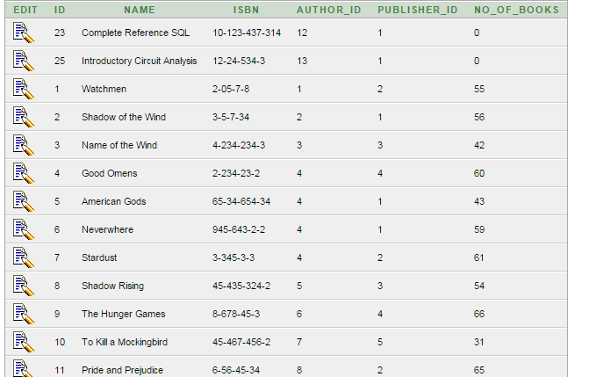

25 rows.

1. **Branch:**

create table Branch

(

ID varchar(3),

Street varchar(50),

City varchar(50) constraint "Branch_City_CHK_NL" not null,

constraint "Branch_ID_PK" primary key (ID),

constraint "Branch_ID_CHK" check (ID like '___')

);

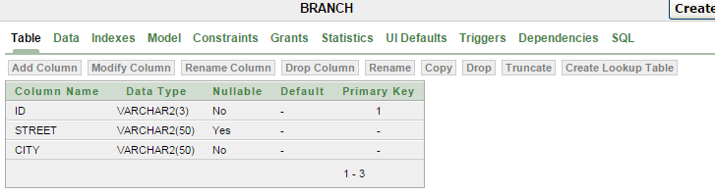

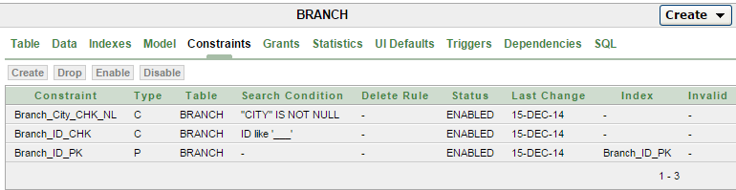

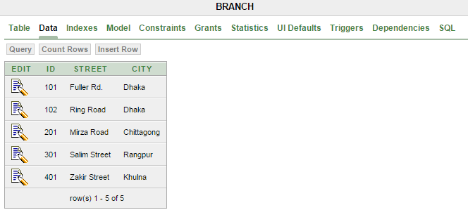

1. **Employee:**

create table Employee

(

ID integer,

Branch_ID varchar(3) constraint "Employee_Br_ID_CHK" not null,

Salary numeric(10, 2),

Name varchar(100) constraint "Employee_Dt_Name_CHK_NL" not null,

Gender char(1) constraint "Employee_Dt_Gender_CHK_NL" not null,

Phone varchar(11) constraint "Employee_Dt_Phone_CHK_NL" not null,

City varchar(50) constraint "Employee_Dt_City_CHK_NL" not null,

Street varchar(50),

constraint "Employee_Salary_CHK" check (Salary >= 2000),

constraint "Employee_Branch_ID_FK" foreign key (Branch_ID)

references Branch(ID) on delete cascade,

constraint "Employee_Phone_CHK" check (Phone like '0%'),

constraint "Employee_Phone_UK" unique (Phone),

constraint "Employee_ID_PK" primary key (ID)

);

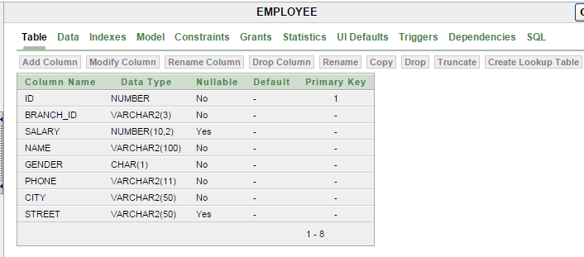

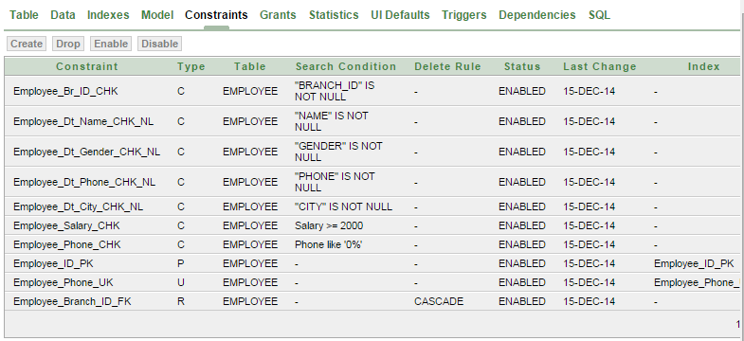

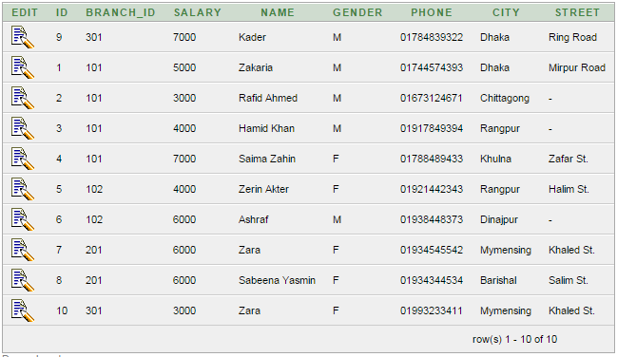

1. **Customer:**

create table Customer

(

ID integer,

Name varchar(100) constraint "Customer_Name_CHK_NL" not null,

Email varchar(100),

Phone varchar(11),

City varchar(50),

Zip varchar(4),

constraint "Customer_Zip_CHK" check (Zip like '_____'),

constraint "Customer_Phone_CHK" check (Phone like '0%'),

constraint "Customer_Phone_UK" unique (Phone),

constraint "Customer_Email_CHK" check (Email like '%@%.%'),

constraint "Customer_ID_PK" primary key (ID)

);

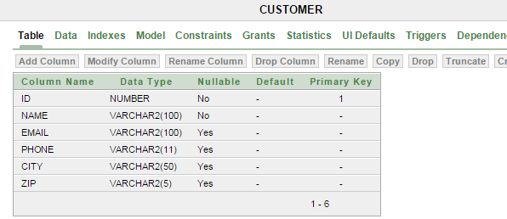

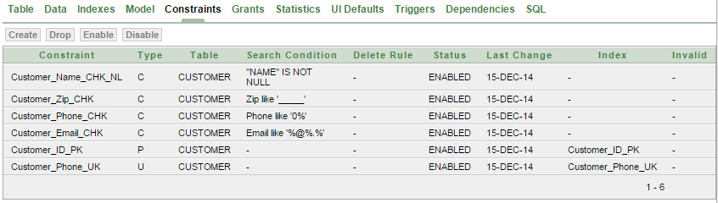

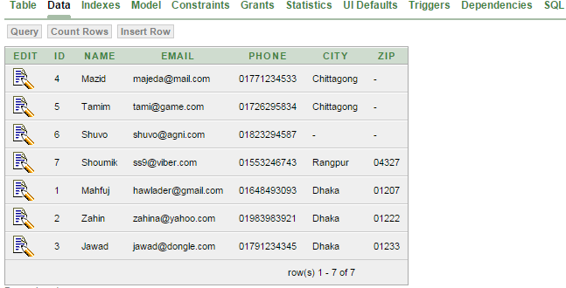

1. **ISSUE:**

create table Issue

(

Customer_ID integer constraint "Issue_Cust_ID_CHK" not null,

Book_ID integer constraint "Issue_BK_ID_CHK" not null,

Branch_ID varchar(3) constraint "Issue_Br_ID_CHK" not null,

Employee_ID integer constraint "Emp_ID_CHK" not null,

Issue_Date date,

Return_Date date,

constraint "Issue_Cust_ID_FK" foreign key (Customer_ID)

references Customer(ID),

constraint "Issue_Book_ID_FK" foreign key (Book_ID)

references Books(ID),

constraint "Issue_Branch_ID_FK" foreign key (Branch_ID)

references Branch(ID),

constraint "Issue_Emp_ID_FK" foreign key (Employee_ID)

references Employee(ID),

constraint "Issue_PK" primary key (Customer_ID, Book_ID)

);

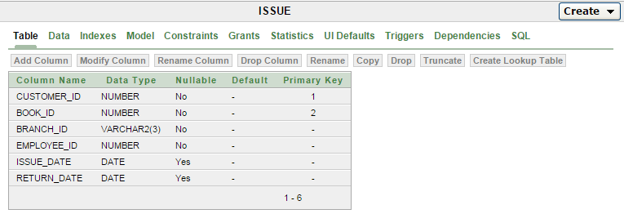

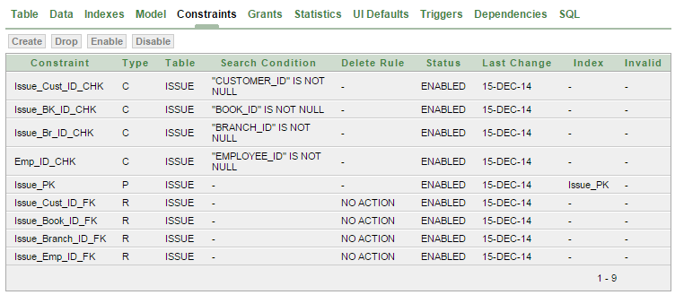

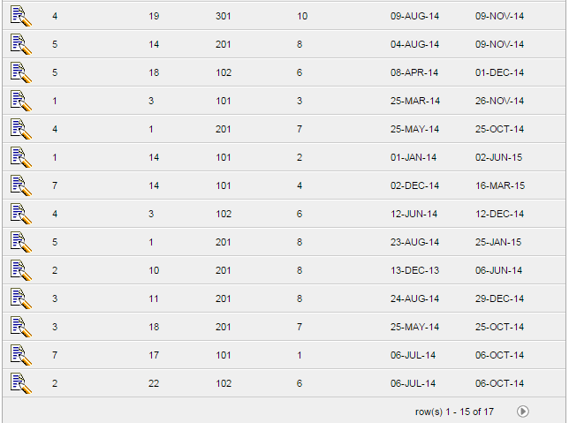

**Queries:**

1. ID, name, and phone of employees who work Dhaka shown in descending order of their names:

select A.ID, A.Branch_ID, A.NAME, A.PHONE

from EMPLOYEE A, BRANCH B

where A.BRANCH_ID = B.ID and LOWER(B.CITY) = 'dhaka'

order by A.NAME desc

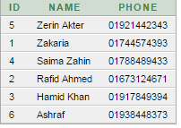

1. Details of those customers who use grameen phone and live in Dhaka:

select *

from customer

where phone like '017%' and lower(city) = 'chittagong'

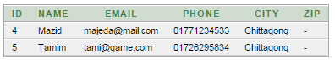

1. Number of books issued by those employees who have a salary greater than 5000:

select A.Employee_ID, count((A.BOOK_ID))

from ISSUE A

group by A.Employee_ID

having A.Employee_ID in (

select B.ID

from Employee B

where B.salary > 5000

)

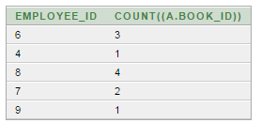

1. Customer ID, Customer Name and Book ID, Book Name, Author Name, Issue date and Return date of those customers and the books they have issued.

select customer_ID, customer.name "Customer Name", book_ID, books.name "book name",

author.name "Author Name", Issue.issue_date, Issue.Return_date

from ((issue inner join customer

on customer_ID = customer.id) inner join books on book_ID = Books.id)

inner join author on books.author_id = author.ID

order by customer.ID

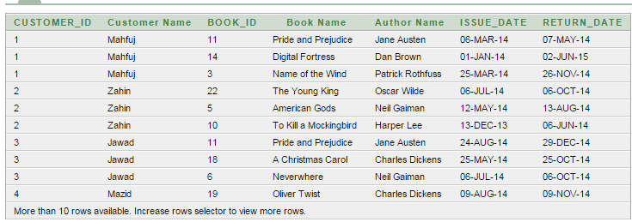

1. Book_ID issued between between '1-jan-2014' to '31-dec-2014' :

select distinct(book_ID)

from ISSUE

where issue_date between '1-jan-2014' and '31-dec-2014'

order by book_id

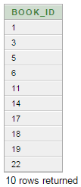

1. ID, name and salary of those employees whose salary is greater than average salary of all employees.

select ID, name, salary

from employee

where salary > (

select avg(salary)

from employee

)

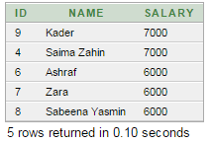

1. Book_ID and Name of those books that were issued whose publisher name starts with the characters ‘mc’

select Book_ID, books.name

from issue inner join books on issue.Book_id = Books.id

where Book_ID in (

select B.ID

from Books B, Publisher

where B.Publisher_ID = Publisher.ID and upper(Publisher.name) like (upper('Mc%'))

)

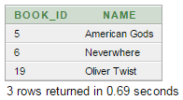

1. Number of different books that have been issued:

select count(distinct(Book_ID))

from issue

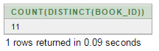

1. Branch_ID and City name of those Braches whose avg(salary) > the salary of atleast one female employee:

select B.ID, B.city

from branch B inner join Employee E on B.ID = E.Branch_ID

group by B.ID, B.city

having avg(salary) > some(

select salary

from Employee Y

where Y.Gender = 'F'

)

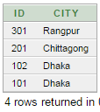

1. Branch_ID and City name of those Braches whose avg(salary) > the salary of all employee:

select B.ID, B.city

from branch B inner join Employee E on B.ID = E.Branch_ID

group by B.ID, B.city

having avg(salary) > all(

select salary

from Employee Y

where Y.Gender = 'F'

)



1. Check if no book with book_ID = 25 has been issued and then show details of all issues involved with customer_ID = 1

select *

from issue

where not exists

(

select *

from issue

where book_id = 25

) and customer_ID = 1

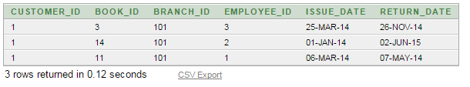

1. Information about those boooks that have "l" in its name and whose no of books is not 0

select *

from books A

where lower(A.name) like '%l%' and exists

(

select *

from books B

where A.name = B.name and no_of_books <> 0

)

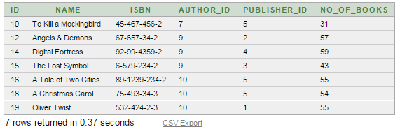

1. Cities in branch or employee table:

select city from branch

union

select city from employee

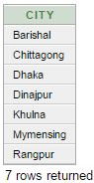

1. Increase salary by 1000 for those employees whose salary is < average salary of all employees:

update employee

set salary = salary+1000

where salary < (

select avg(salary)

from employee

)



1. Delete those books that have an ID > 15 and has never been issued.

delete from books

where ID > 15 and ID not in (

select BOOK_ID

from issue

)



1. Employee ID, name, and number of books sold by each employee whose salary > 5000:

with tmp as(

select A.Employee_ID EMP, count((A.BOOK_ID)) sold

from ISSUE A

group by A.Employee_ID

having A.Employee_ID in (

select B.ID

from Employee B

where B.salary > 5000

)

)

select EMP, name, sold

from employee, tmp

where employee.ID = tmp.EMP

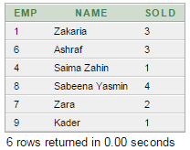

1. Those employees whose cities don’t match with Branch cities:

select distinct(employee.name), branch.city

from employee left join BRANCH

on employee.city = branch.city

where branch.city is null

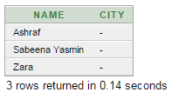

**Discussions:**

This is a sample database. There are some limitations. It requires many improvements. I will add more facilities to this database in the near future, to make the database more user-friendly and efficient.