* RMSE Vs RMSLE
  + Root Mean Square Log Error
    - RMSLE measures the ratio between actual and predicted.
    - log(pi+1)−log(ai+1) = log((pi+1)/(ai+1))
    - Used when you don’t want to penalize huge differences when both the values are huge numbers. It is evident from the natural log plot, as you move along x-axis the increment is very gradual and as get close to origin, its steeper.
      * 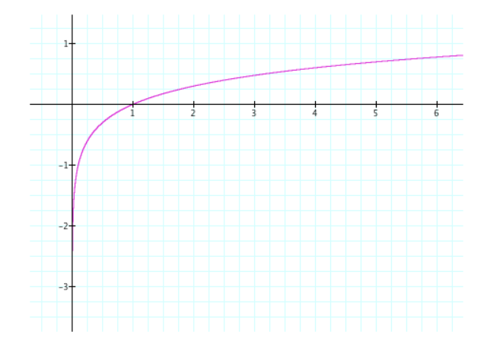
    - Under estimates are penalized more than over estimates
      * Ex: <https://www.quora.com/What-is-the-difference-between-an-RMSE-and-RMSLE-logarithmic-error-and-does-a-high-RMSE-imply-low-RMSLE>
      * RMSE gives the same value either under or over-estimate
    - The mean squared error is variance plus bias squared. Assuming you have zero bias (sure why not) root mean squared error is just the standard deviation.  taking the log of the predictions and the measurements beforehand just changes what variance you are measuring. You are now measuring the variance (or rather standard deviation) of the log of the measurements vs the log of the predictions or essentially the standard deviation in the magnitude of your prediction vs the magnitude of the measurements.