Github : <https://github.com/rakabagusadityo/ujianmatrikulasicomputerprogramming>

Simulasi :

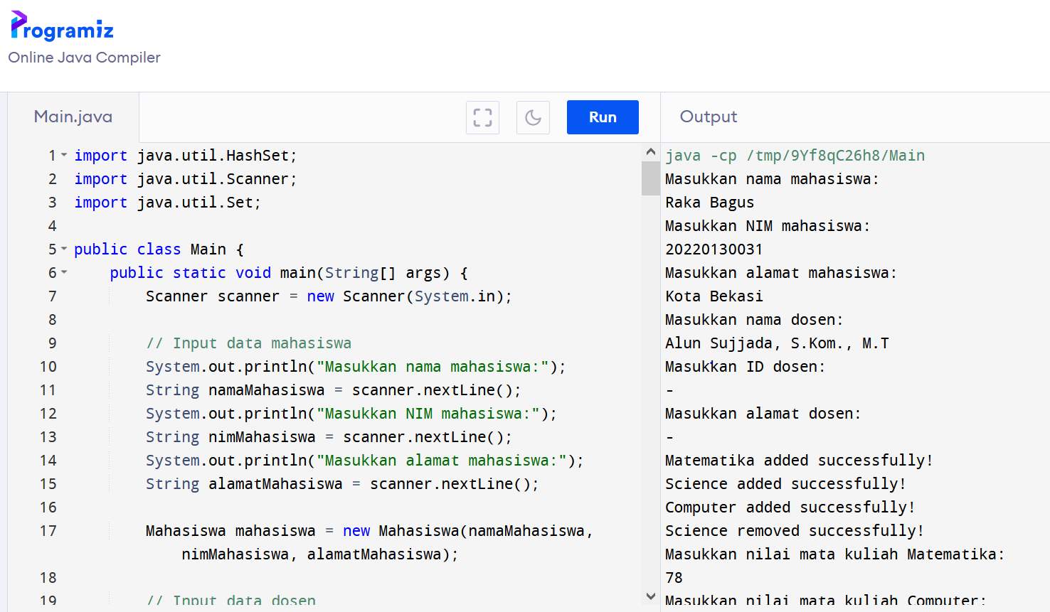

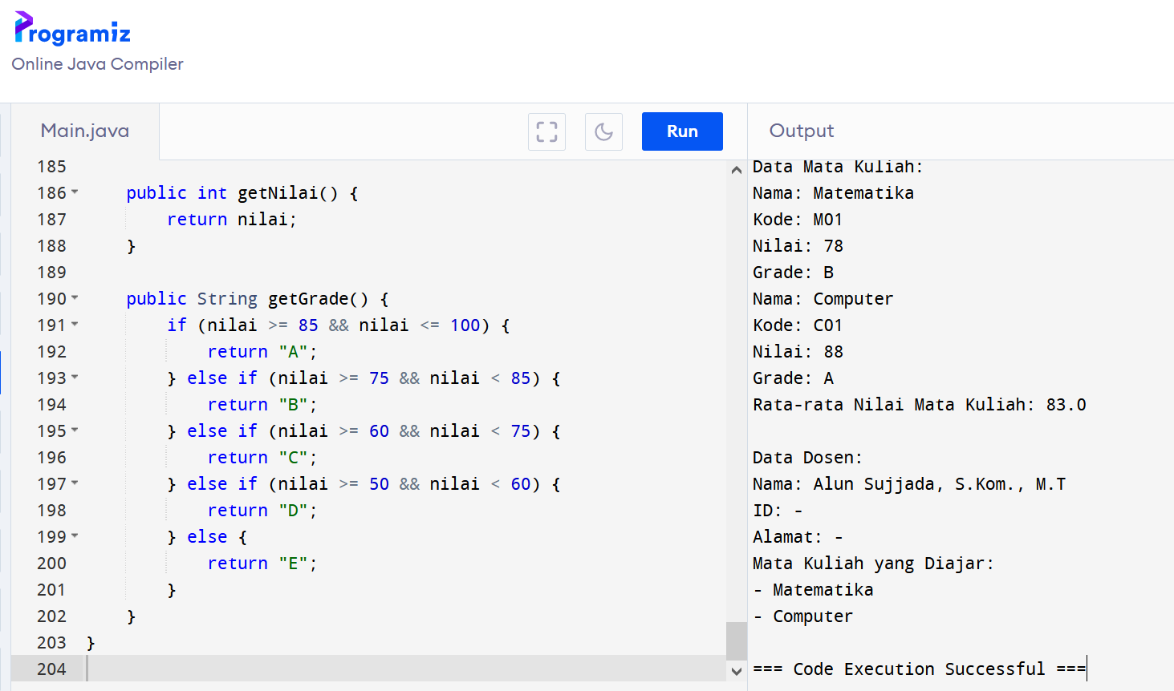

Code :

import java.util.HashSet;

import java.util.Scanner;

import java.util.Set;

public class Main {

public static void main(String[] args) {

Scanner scanner = new Scanner(System.in);

// Input data mahasiswa

System.out.println("Masukkan nama mahasiswa:");

String namaMahasiswa = scanner.nextLine();

System.out.println("Masukkan NIM mahasiswa:");

String nimMahasiswa = scanner.nextLine();

System.out.println("Masukkan alamat mahasiswa:");

String alamatMahasiswa = scanner.nextLine();

Mahasiswa mahasiswa = new Mahasiswa(namaMahasiswa, nimMahasiswa, alamatMahasiswa);

// Input data dosen

System.out.println("Masukkan nama dosen:");

String namaDosen = scanner.nextLine();

System.out.println("Masukkan ID dosen:");

String idDosen = scanner.nextLine();

System.out.println("Masukkan alamat dosen:");

String alamatDosen = scanner.nextLine();

Dosen dosen = new Dosen(namaDosen, idDosen, alamatDosen);

// Menambahkan mata kuliah yang diajar oleh dosen

dosen.addCourse("Matematika");

dosen.addCourse("Science");

dosen.addCourse("Computer");

// Menghapus mata kuliah dari dosen

dosen.removeCourse("Science");

// Input data nilai mata kuliah Matematika

System.out.println("Masukkan nilai mata kuliah Matematika:");

int nilaiMatkul1 = scanner.nextInt();

// Input data nilai mata kuliah Computer

System.out.println("Masukkan nilai mata kuliah Computer:");

int nilaiMatkul2 = scanner.nextInt();

MataKuliah matkul1 = new MataKuliah("Matematika", "M01", nilaiMatkul1);

MataKuliah matkul2 = new MataKuliah("Computer", "C01", nilaiMatkul2);

// Menambahkan mata kuliah ke dalam data mahasiswa

mahasiswa.addMataKuliah(matkul1);

mahasiswa.addMataKuliah(matkul2);

// Perhitungan rata-rata nilai

double rataRataNilai = (nilaiMatkul1 + nilaiMatkul2) / 2.0;

// Menampilkan informasi yang telah dimasukkan

System.out.println("Data Mahasiswa:");

System.out.println("Nama: " + mahasiswa.getNama());

System.out.println("NIM: " + mahasiswa.getNim());

System.out.println("Alamat: " + mahasiswa.getAlamat());

System.out.println("Data Mata Kuliah:");

for (MataKuliah matkul : mahasiswa.getMataKuliahSet()) {

System.out.println("Nama: " + matkul.getNama());

System.out.println("Kode: " + matkul.getKode());

System.out.println("Nilai: " + matkul.getNilai());

System.out.println("Grade: " + matkul.getGrade());

}

System.out.println("Rata-rata Nilai Mata Kuliah: " + rataRataNilai);

// Menampilkan informasi dosen

System.out.println("\nData Dosen:");

System.out.println("Nama: " + dosen.getNama());

System.out.println("ID: " + dosen.getId());

System.out.println("Alamat: " + dosen.getAlamat());

System.out.println("Mata Kuliah yang Diajar:");

dosen.displayCourses();

}

}

class Mahasiswa {

private String nama;

private String nim;

private String alamat;

private Set<MataKuliah> mataKuliahSet;

public Mahasiswa(String nama, String nim, String alamat) {

this.nama = nama;

this.nim = nim;

this.alamat = alamat;

this.mataKuliahSet = new HashSet<>();

}

public String getNama() {

return nama;

}

public String getNim() {

return nim;

}

public String getAlamat() {

return alamat;

}

public void addMataKuliah(MataKuliah mataKuliah) {

mataKuliahSet.add(mataKuliah);

}

public Set<MataKuliah> getMataKuliahSet() {

return mataKuliahSet;

}

}

class Dosen {

private String nama;

private String id;

private String alamat;

private Set<String> courses;

public Dosen(String nama, String id, String alamat) {

this.nama = nama;

this.id = id;

this.alamat = alamat;

this.courses = new HashSet<>();

}

public String getNama() {

return nama;

}

public String getId() {

return id;

}

public String getAlamat() {

return alamat;

}

public boolean addCourse(String course) {

if (courses.contains(course)) {

System.out.println("Course already exists!");

return false;

} else {

courses.add(course);

System.out.println(course + " added successfully!");

return true;

}

}

public boolean removeCourse(String course) {

if (!courses.contains(course)) {

System.out.println("Course does not exist!");

return false;

} else {

courses.remove(course);

System.out.println(course + " removed successfully!");

return true;

}

}

public void displayCourses() {

for (String course : courses) {

System.out.println("- " + course);

}

}

}

class MataKuliah {

private String nama;

private String kode;

private int nilai;

public MataKuliah(String nama, String kode, int nilai) {

this.nama = nama;

this.kode = kode;

this.nilai = nilai;

}

public String getNama() {

return nama;

}

public String getKode() {

return kode;

}

public int getNilai() {

return nilai;

}

public String getGrade() {

if (nilai >= 85 && nilai <= 100) {

return "A";

} else if (nilai >= 75 && nilai < 85) {

return "B";

} else if (nilai >= 60 && nilai < 75) {

return "C";

} else if (nilai >= 50 && nilai < 60) {

return "D";

} else {

return "E";

}

}

}