proje_rak

Rafet Ali Kaba

2023-02-24

## PROJECT

In this project, we will analysis whether the game makers earned more than the games they released for ps4 or ps3.

## MY CODES

I insatalled my libraries first

library(tidyverse)

## -- Attaching packages --------------------------------------- tidyverse 1.3.2 --  
## v ggplot2 3.4.0 v purrr 0.3.4   
## v tibble 3.1.7 v dplyr 1.0.10  
## v tidyr 1.2.0 v stringr 1.4.0   
## v readr 2.1.3 v forcats 0.5.1   
## -- Conflicts ------------------------------------------ tidyverse_conflicts() --  
## x dplyr::filter() masks stats::filter()  
## x dplyr::lag() masks stats::lag()

library(ggplot2)  
library(dplyr)  
library(tidyr)  
library(readr)  
library(stringr)

I import my dataset and examine it and make it more organized and editable

oyunlar<-read.csv("game.csv")  
oyunlar$total_sales<-gsub("N/A","",oyunlar$total_sales)  
oyunlar$total_sales<-str_replace(oyunlar$total_sales,"m","")  
oyunlar$total_sales<-str_replace(oyunlar$total_sales,".","")  
oyunlar$total_sales<-as.numeric(oyunlar$total_sales,na.rm=TRUE)  
toplam_total_sales<-sum(oyunlar$total_sales,na.rm=TRUE)

Then i separate the platform

ps4<- oyunlar%>%  
 filter(platform=="PS4")  
  
ps3<- oyunlar%>%  
 filter(platform=="PS3")

Then I find the total earnings of the publishers from the platform and turn them into a data frame.

eagames<-oyunlar%>%  
 filter(publisher=="Electronic Arts")%>%  
 filter(platform=="PS4")%>%  
 summarise(toplamsatis=sum(total_sales,na.rm=TRUE))  
  
rockstar<- oyunlar%>%  
 filter(publisher=="Rockstar Games")%>%  
 filter(platform=="PS4")%>%  
 summarise(toplamsatis=sum(total_sales,na.rm=TRUE))  
  
activision<- oyunlar%>%  
 filter(publisher=="Activision")%>%  
 filter(platform=="PS4")%>%  
 summarise(toplamsatis=sum(total_sales,na.rm=TRUE))  
  
sony<- oyunlar%>%  
 filter(publisher=="Sony Interactive Entertainment")%>%  
 filter(platform=="PS4")%>%  
 summarise(toplamsatis=sum(total_sales,na.rm=TRUE))  
  
ubisoft<- oyunlar%>%  
 filter(publisher=="Ubisoft")%>%  
 filter(platform=="PS4")%>%  
 summarise(toplamsatis=sum(total_sales,na.rm=TRUE))  
  
  
eagames2<-oyunlar%>%  
 filter(publisher=="Electronic Arts")%>%  
 filter(platform=="PS3")%>%  
 summarise(toplamsatis=sum(total_sales,na.rm=TRUE))  
  
rockstar2<- oyunlar%>%  
 filter(publisher=="Rockstar Games")%>%  
 filter(platform=="PS3")%>%  
 summarise(toplamsatis=sum(total_sales,na.rm=TRUE))  
  
activision2<- oyunlar%>%  
 filter(publisher=="Activision")%>%  
 filter(platform=="PS3")%>%  
 summarise(toplamsatis=sum(total_sales,na.rm=TRUE))  
  
sony2<- oyunlar%>%  
 filter(publisher=="Sony Interactive Entertainment")%>%  
 filter(platform=="PS3")%>%  
 summarise(toplamsatis=sum(total_sales,na.rm=TRUE))  
  
ubisoft2<- oyunlar%>%  
 filter(publisher=="Ubisoft")%>%  
 filter(platform=="PS3")%>%  
 summarise(toplamsatis=sum(total_sales,na.rm=TRUE))  
  
toplam2<-data.frame(eagames2,rockstar2,activision2,sony2,ubisoft2)  
rownames(toplam2)<-"PS3"  
colnames(toplam2)<-c("EA","Rock Star","Activision","Sony","Ubisoft")

toplamsatislar<-data.frame(eagames,rockstar,activision,sony,ubisoft)  
rownames(toplamsatislar)<-"PS4"  
colnames(toplamsatislar)<-c("EA","Rock Star","Activision","Sony","Ubisoft")  
  
toplam2<-data.frame(eagames2,rockstar2,activision2,sony2,ubisoft2)  
rownames(toplam2)<-"PS3"  
colnames(toplam2)<-c("EA","Rock Star","Activision","Sony","Ubisoft")  
  
toplamsatislar<-rbind(toplamsatislar,toplam2)  
  
toplam1<-t(toplamsatislar)  
toplam1<-data.frame(toplam1)

and finally I visualize this total sales data.

graph1<-ggplot(toplam1, aes(x=toplam1[,1],y=row.names(toplam1)))  
   
graph1<-graph1+labs(x="Total Sales",y="Game Companies",title="PS 4")+geom_point(color="blue",size=7,shape=16)  
  
graph2<-ggplot(toplam1, aes(x=toplam1[,2],y=row.names(toplam1)))  
   
graph2<-graph2+labs(x="Total Sales",y="Game Companies",title="PS 3")+geom_point(color="green",size=7,shape=16)

graph1

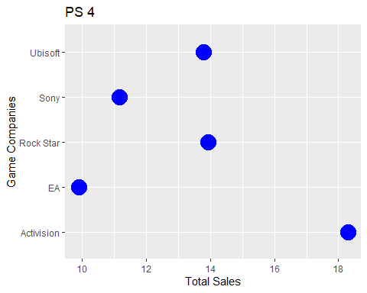

graph2

