

Al Imam Mohammad Ibn Saud Islamic University College of Computer and Information Sciences

Information Systems Department

Course Title: | App Development
Course Code: | IS337
Course Instructor: | Dr. Prabu Pachiyannan, Dr. Fareeha Anwar
Exam: | Project
Semester: | 2nd 2026-27
Due Date:
Marks: | 20
Privileges: | - Open Book  - Calculator Permitted | - Open Notes  - Laptop Permitted

Instructions:
- The assignment is to be carried out in groups of 3 students.
- Submit a soft copy (.PDF file) via Blackboard.
- Any attempt to cheat from any of your classmates or form the Internet the whole assignment will be marked as Zero. Be aware that Blackboard uses plagiarism check tool! (Read and sign Plagiarism Declaration)
- There will be no extension in the submission deadline.
- No hand writing is accepted.
- Use this cover page.

Group No | Student Name | Student ID | Section No. | Read and accept (Plagiarism  Declaration)
G-04 | Rayan Saad Alshamrani | 444012651 | 172 | I Accept
G-04 | Rakan Khalid Alfadhel | 444003360 | 172 | I Accept
G-04 | Omar Khalid Almazrou | 444004804 | 172 | I Accept
Plagiarism Declaration: I declare that the proposed document is my own work and I own the copy right of it with no copy rights violation or plagiarism from other resources
Official Use Only
Question | Student Marks | Question Marks
1 |  | 15
2 |  | 5
Total |  | 20



PLO S2, S4: Apply HTML5, CSS3 and related technologies to create simple web sites
PLO V1, V2: Function effectively on teams to accomplish a common goal.
Vision 2030 (Website)

Project Description:

Students should participate in developing Vision 2030–themed using PHP, JavaScript, HTML, CSS, and MySQL. Your website should be attractive and display the information in a professional way.
Your website should be attractive and display the information in a professional and modern way reflecting Saudi Vision 2030 goals, such as Tourism Growth, Culture & Heritage Promotion, Quality of Life Enhancement, Smart Destinations, and Digital Transformation.
The main aim of this coursework is to develop a complete Vision 2030 aligned Web App.
Your website should include the following:

    - Improve your own steady environment design created from assignment.
    - About us page: Add this Menu
- Give a short CV of the developer’s details (name, interests, degrees,) presented in a slide show as the following link shows:
https://www.w3schools.com/howto/howto_js_slideshow.asp

    - Improve “SignUp/Register new User” option for to be able to register new user to your database.
      - When click ok submit before submitting to DB, your code should check that all mandatory fields must be filled.
      - Save all data in database

  - When “Log in/sign in” match user name and password from the database that the user is registered user or not. If anyone is not registered ask to register first and sign in again.

    - There should be feedback option. Save feedback in database. Provide an interface where Other users can see all feedbacks

    - Integrate AI feature in your website (e.g chatbot or AI based recommendation system etc.,)

Notes:

- Make sure that all your work looks as professional as possible and enough to stand alone as a website. Which means with a common and steady environment for all web pages (menus, logo (at the header) and copywrite sign (at the bottom) of every page), a good design for each subpage action frame area etc. To develop a user-friendly site. It will be pretty much appreciated all extra design elements and properties used.
- Each page on your website must have an appropriate title.
- Implement any required validation.



Deliverables:

- Zip the files and upload the zipped file to the Blackboard. If guidelines are needed to run the website, you MUST give them in the zipped file. Do not forget to upload the Database file.
- Create a report that must include the following:
  - Cover page (use the project cover page).
  - Index page.
  - Introduction page explaining in your own words and shortly the requirements that you are going to cover in your project.
  - 5-6 pages with a report of the implementation of your web site with the important screenshots stages of your efforts that prove the outcomes required as listed above (use as many screenshots as you find necessary but MUST write a short paragraph for each).
  - The database tables and brief description of each.
  - 1 page, report explaining the programming/scripting languages you used to develop the web site, the programming tools. (Don’t include your code in this section).
  - 1 page report of the group members and their duties as to the actual project work. The students’ id numbers and names should be included, and every member of the group should sign the report.

Policies:

      - This is a team work
      - Student should respect due date. Any submission after due date will not be considered.
      - You are required to give a presentation and demonstration of for your code to confirm it is indeed your work.
      - The demo will be on our lectures time.
      - It is a group discussion, but students will be evaluated and graded individually based on their participation during the discussion.
      - Students are expected to work on their own.
      - Plagiarism will not be tolerated. If 2 or more groups work together, all of them will get a Zero. (No matter who initiated plagiarism).

Good Luck!

    - In the last conclusions section of the report describe all the technologies used and how they were combined to succeed on your output web page. (2 mark)

Q2. Project Demo

Table of Contents

Introduction 5
1.2 Implemented project requirements 5
2.1 Homepage 6
2.2 Register Page 7
2.3 User Login 8
2.4 Events Page 9
2.5 Booking System 9
2.6 AI Recommendations 12
2.7 AI Chatbot Assistant 12
2.8 Feedback System 13
2.9 Favorites Feature 13
2.10 About Us Page 14
2.11 Gallery Page 15
3. Database Tables & Description 16
3.1 users 16
3.2 events 16
3.3 feedback 17
3.4 favorites 17
3.5 bookings 17
4. Programming & Scripting Languages 18
5. Group Members & Duties 19

Introduction

Riyadh Events Platform is a website that supports Vision 2030. People can find and book events in Riyadh like concerts, sports, gaming, cultural shows, and food festivals. The idea is simple: one place for everything so users don’t have to switch between apps or social media.
The project includes a consistent design with the same header and footer on all pages, an About Us page with a team slideshow, user registration that saves accounts to a database, and a login system that checks credentials. It also has a feedback section that stores and shows public reviews, plus an AI recommendation engine and a chatbot.
The site is built with PHP, JavaScript, HTML5, CSS3, and MySQL. inspired by Riyadh Season.

1.2 Implemented project requirements
Consistent environment: Every page uses the same header with the logo and navigation, and the same footer with copyright and quick links.
About Us page: Features a JavaScript-powered slideshow presenting each team member's CV, including name, interests, and academic degree.
Sign up / Registration: A full form validates inputs on the client and server, then saves users to MySQL with secure password hashing.
Login / Sign in: Users are checked against the database; unregistered users are prompted to register.
Feedback system: Logged-in users can submit feedback with a star rating; all feedback is stored and shown on the Feedbacks page.
AI features: An AI recommendation engine suggests events based on user interests, and an AI chatbot is available on every page via the footer.
Additional Features: Event browsing with filtering and search, a 3-step ticket booking system with payment simulation, a favorites system, a countdown timer per event, and a gallery page.

The website is designed to look professional and modern, reflecting Saudi Vision 2030's digital transformation goals with a dark-gold theme inspired by Riyadh Season branding.

2.1 Homepage

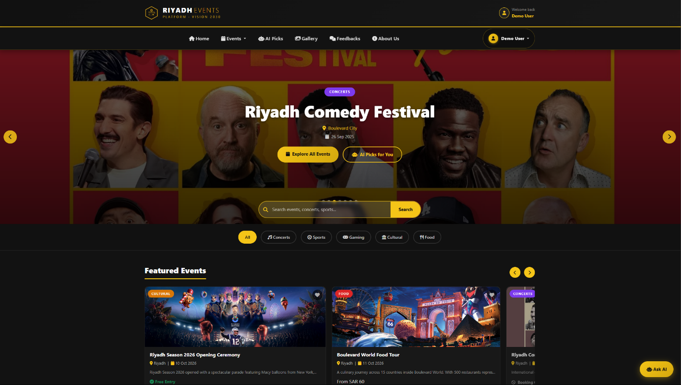
(Figure 1 – Homepage)

As shown in (Figure 1 – Index.php) The homepage is the first page users see. It has a full-screen slideshow that automatically cycles through seven events. Each slide shows the event name, location, date, and category.

Below the hero section, a category filter bar allows quick access to event types (Concerts, Sports, Gaming, Cultural, Food, Art). A Featured Events horizontal slider showcases events that users can scroll through. The page also contains a Vision 2030 section highlighting four pillars: Quality of Life, Tourism Growth, Digital Transformation, and Entertainment Economy.

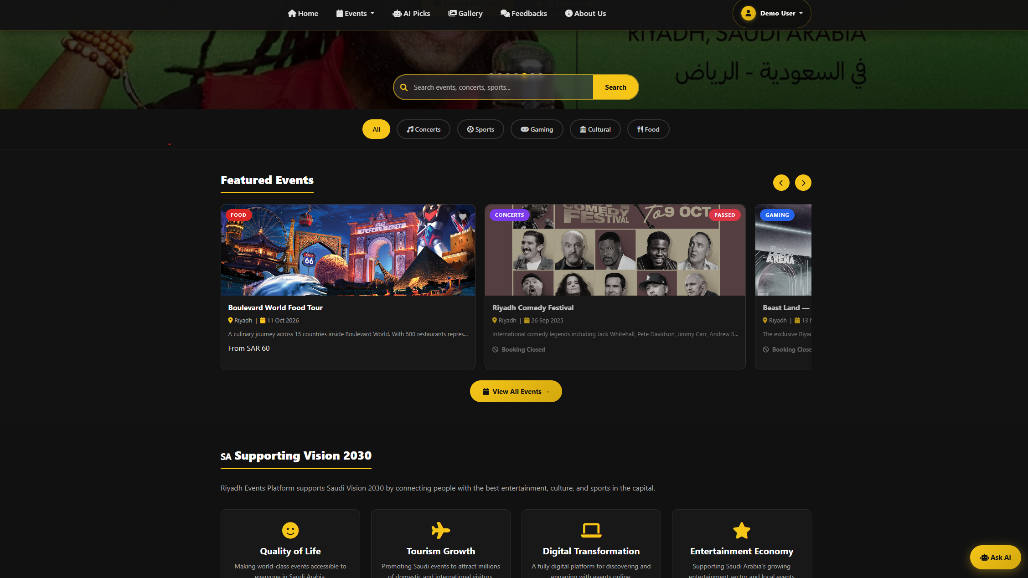
(Figure 2 – Featured Events Slider)

2.2 Register Page

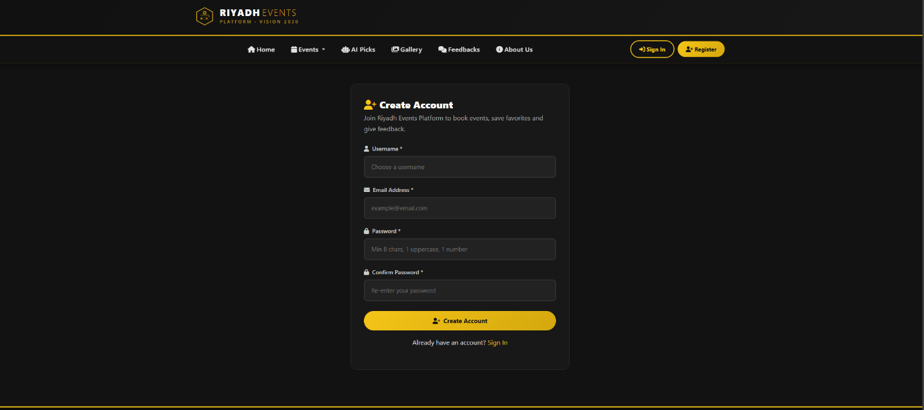
(Figure 3 – The Registration Page)

The Registration Page (Figure 3 - Register.php) lets new users create an account. The form has four fields: username, email, password, and confirm password.
Before anything gets saved to the database, the system checks everything. If a field is empty, it shows an error. If the password is less than 8 characters or doesn't have an uppercase letter and a number, it tells the user exactly what's wrong. If the email is already registered, it tells them to sign in instead.

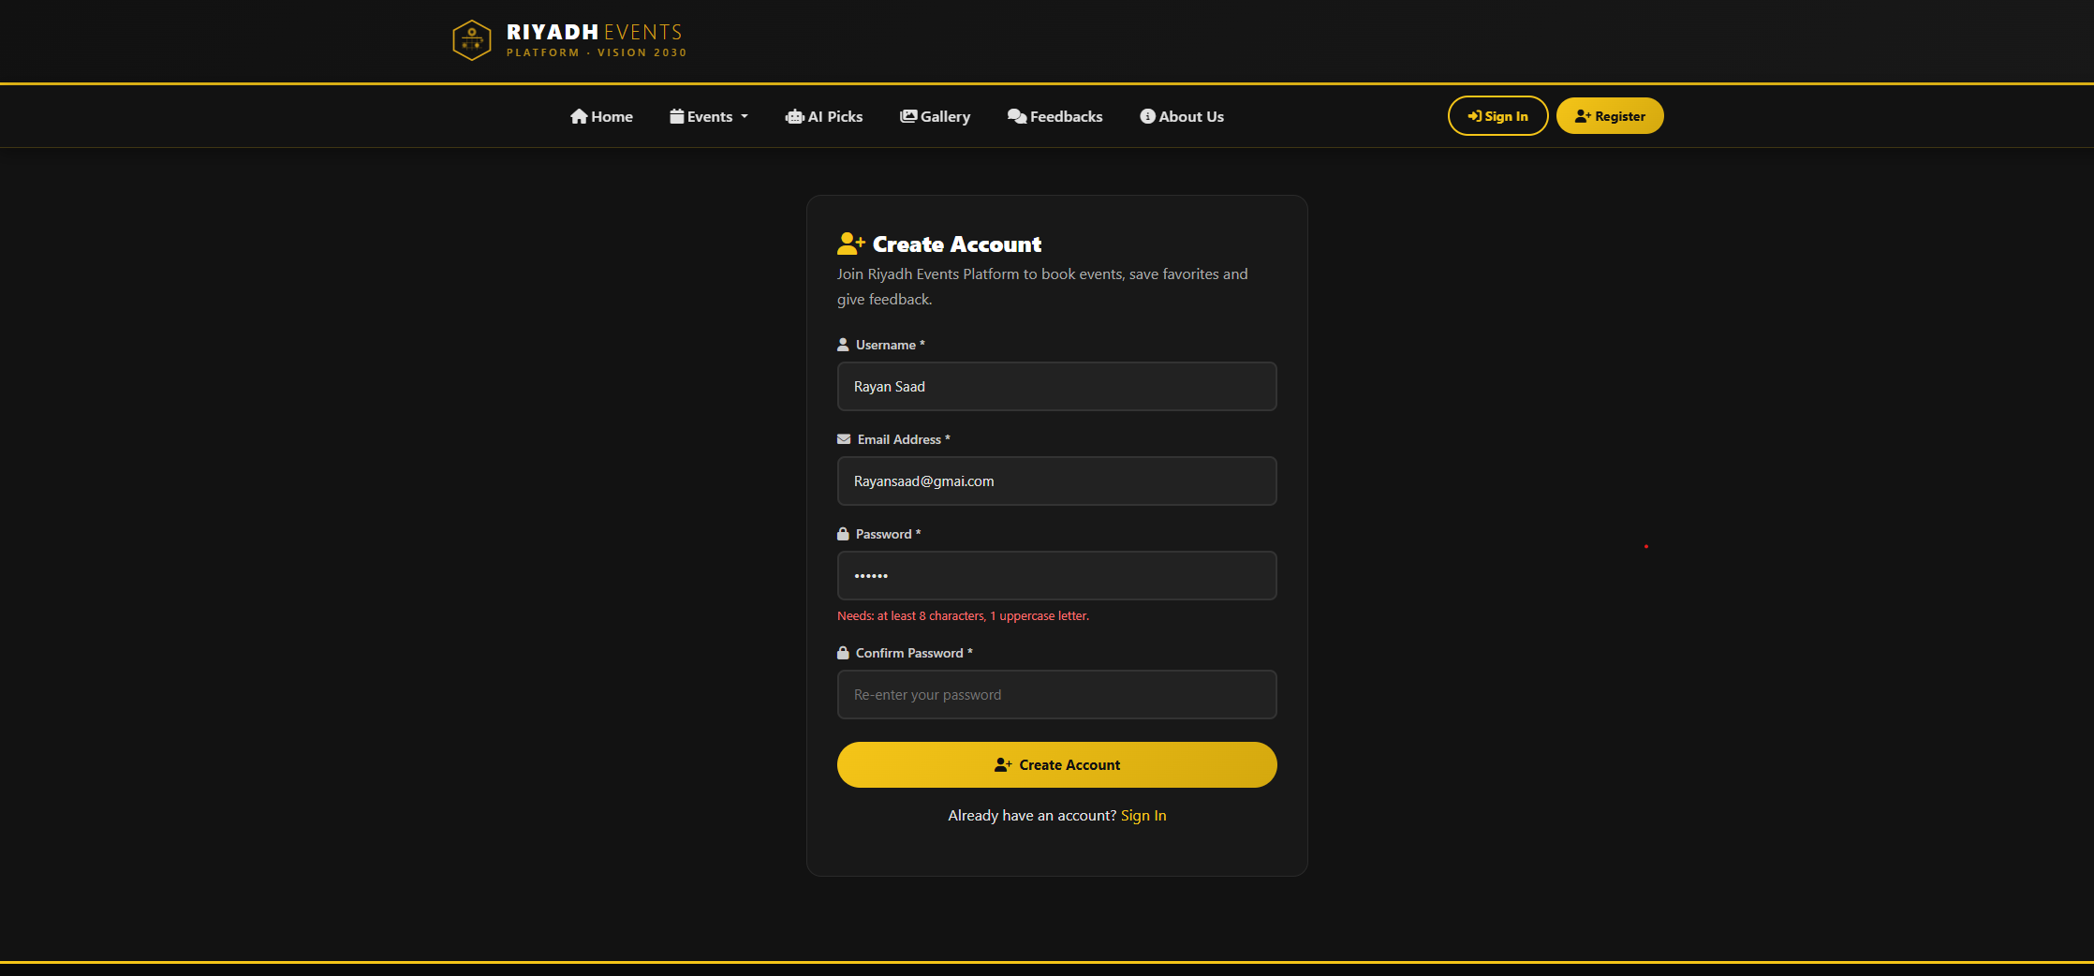
(Figure 4 – Validation error messages)

When everything is correct, the password gets encrypted before it's stored, so even if someone accessed the database they wouldn't see the actual passwords. After registering, the user is automatically logged in and taken to the homepage.

2.3 User Login

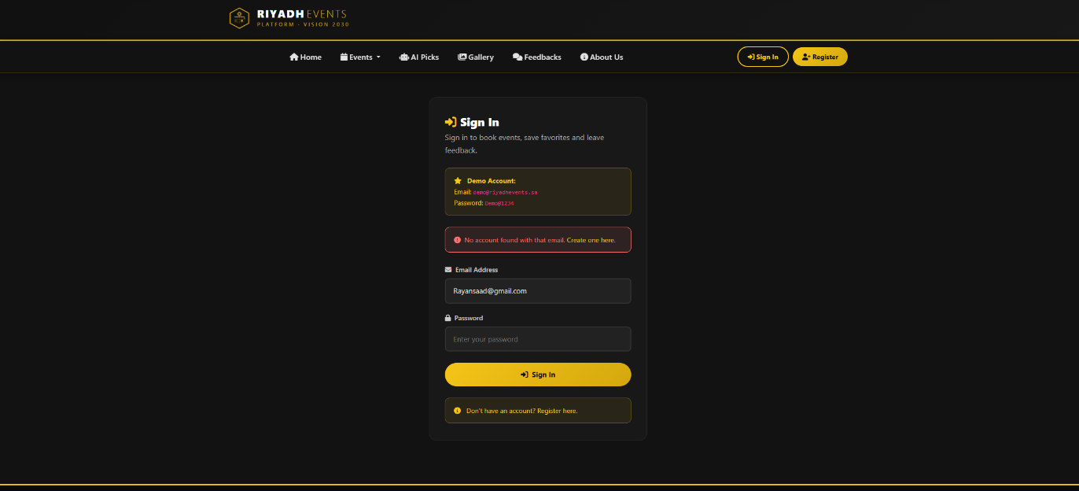
(Figure 5 – Login Page)

The Login Page (Figure 5 - Login.php) is straightforward. The user enters their email and password. The system checks the database, if the email doesn't exist, it shows a message saying "No account found" with a link to register. If the email exists but the password is wrong, it says "Incorrect password." If both are correct, the user gets logged in and taken to the homepage where their name appears at the top.

We also added a demo account on the login page so anyone can test the website without needing to register.

2.4 Events Page

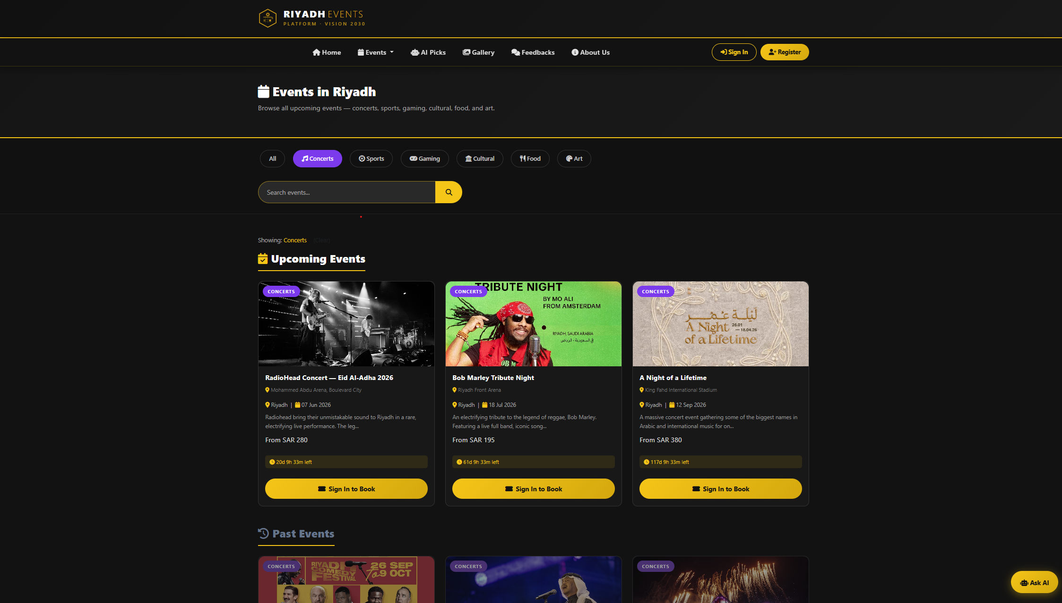 (Figure 6 – The Events Page)

The Events Page (Figure 6 - Events.php) shows all events in the database. At the top there are category filter buttons and a search bar. When you click a category, the page shows only events from that type. You can also type in the search bar to find events by name or city.

The page is split into two parts, upcoming events shown in full color with a countdown timer under each one showing how many days, hours, and minutes are left, and past events shown in gray with the booking button disabled. This makes it clear to users which events they can still book.

2.5 Booking System

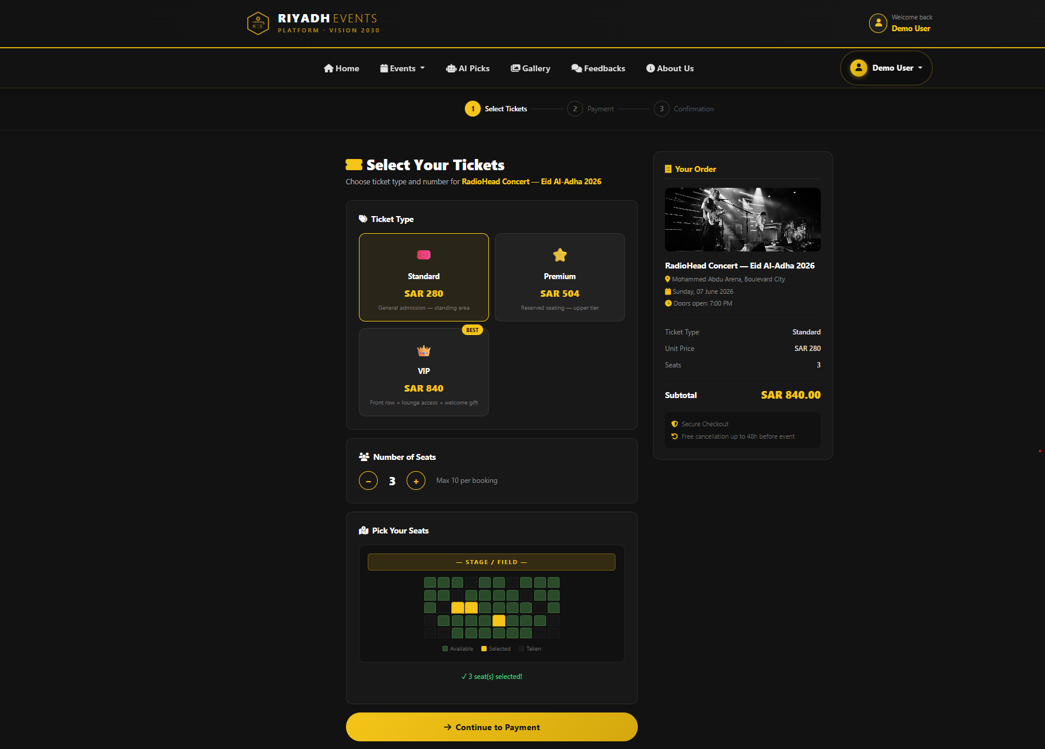
(Figure 7 – The Booking Page - Ticket Selection)

The booking system (Booking.php) is a three step wizard. Step 1 (Figure 7) is ticket selection. The user chooses a ticket type: Standard, Premium, or VIP, and picks how many tickets they want. For venue events like concerts and sports, an interactive seat map appears so users can click to choose seats. The order summary updates live using JavaScript.

Step 2 (Figure 8) is payment. The user enters card number, cardholder name, expiry date, and CVV. The card number formats as they type and JavaScript helpers improve input. The server validates the payment data before accepting it.

Step 3 (Figure 9) is confirmation. After a successful submission the system generates a unique booking reference such as REP-A3F9C21B and shows it on the confirmation page. The booking is saved in the bookings table. If a user already booked the same event the site prevents another booking and the button changes to Already Booked.

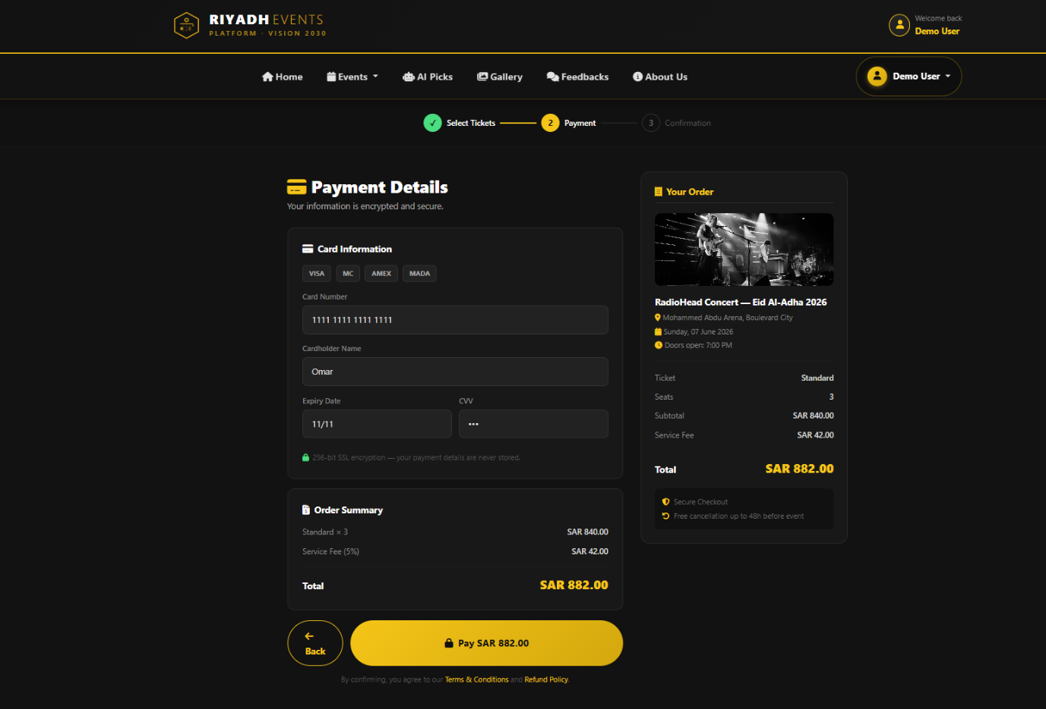
(Figure 8 – The Booking Payment)

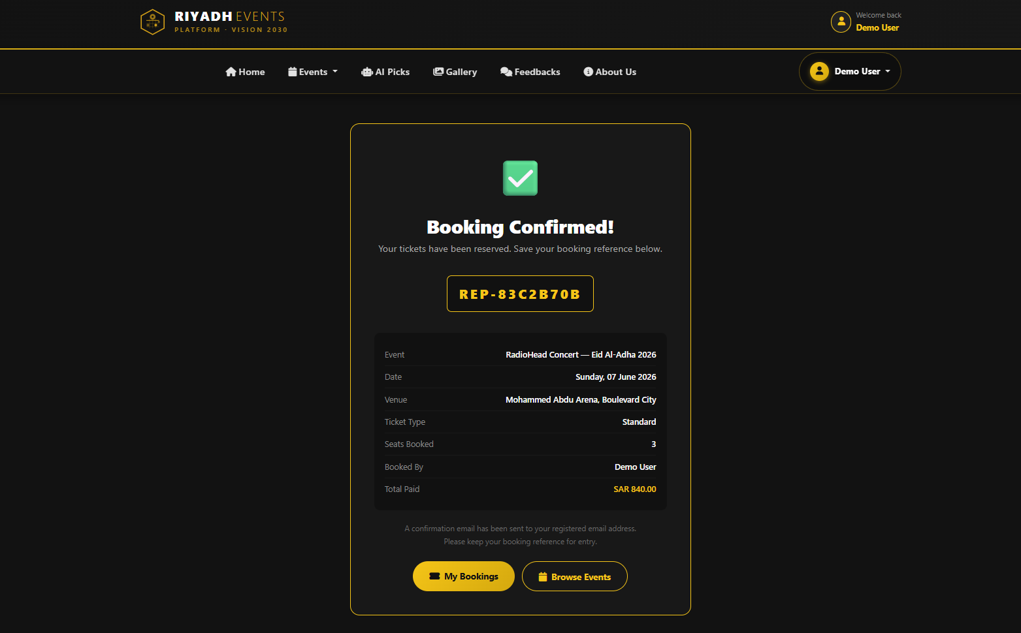
(Figure 9 – Full Order Details.)

2.6 AI Recommendations
The AI Recommendations page (Figure 10 - Ai-recommend.php) shows event suggestions based on what users like. Users pick one or more interest categories from a visual grid of eight options: Music, Sports, Gaming, Culture, Food, Family, Art, and Outdoor.
When the user clicks Get My Event Recommendations, a JavaScript function filters the full events list to find upcoming events that match the chosen interests. The events are loaded from the database by PHP and passed to JavaScript as JSON, so filtering and ranking happen on the client side and results appear instantly as event cards with details and a Book Now button.
This feature gives a fast, personalized way to find events and supports the platform’s goal of digital transformation.
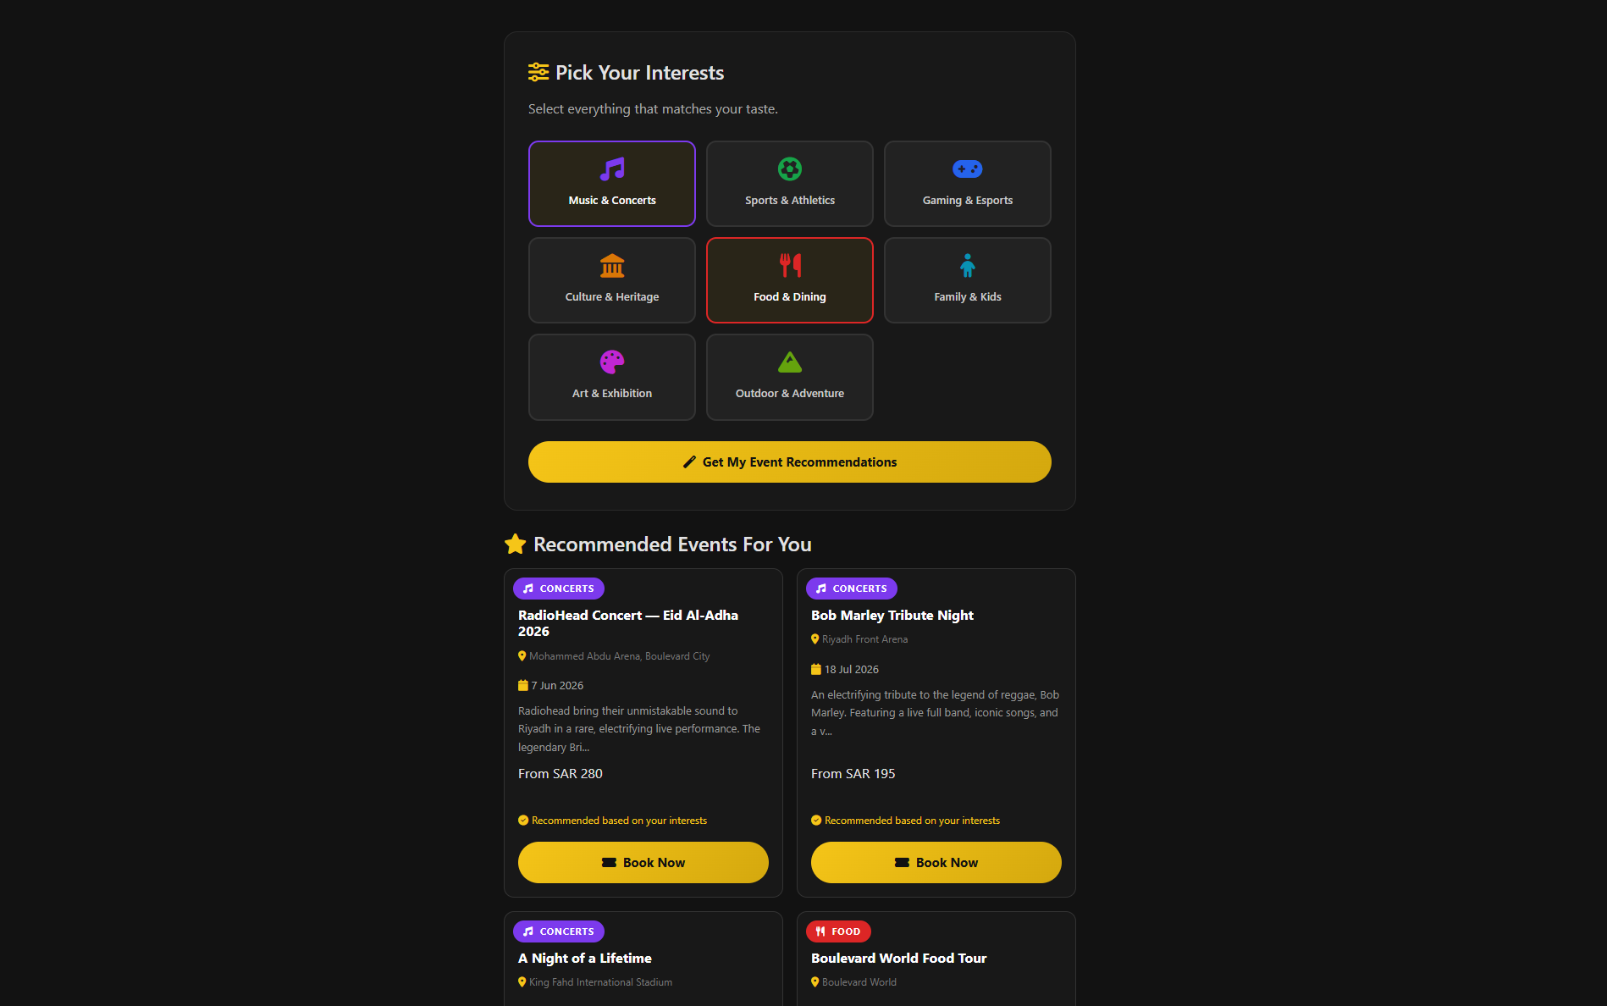
(Figure 10 – AI Recommendation Page)

2.7 AI Chatbot Assistant
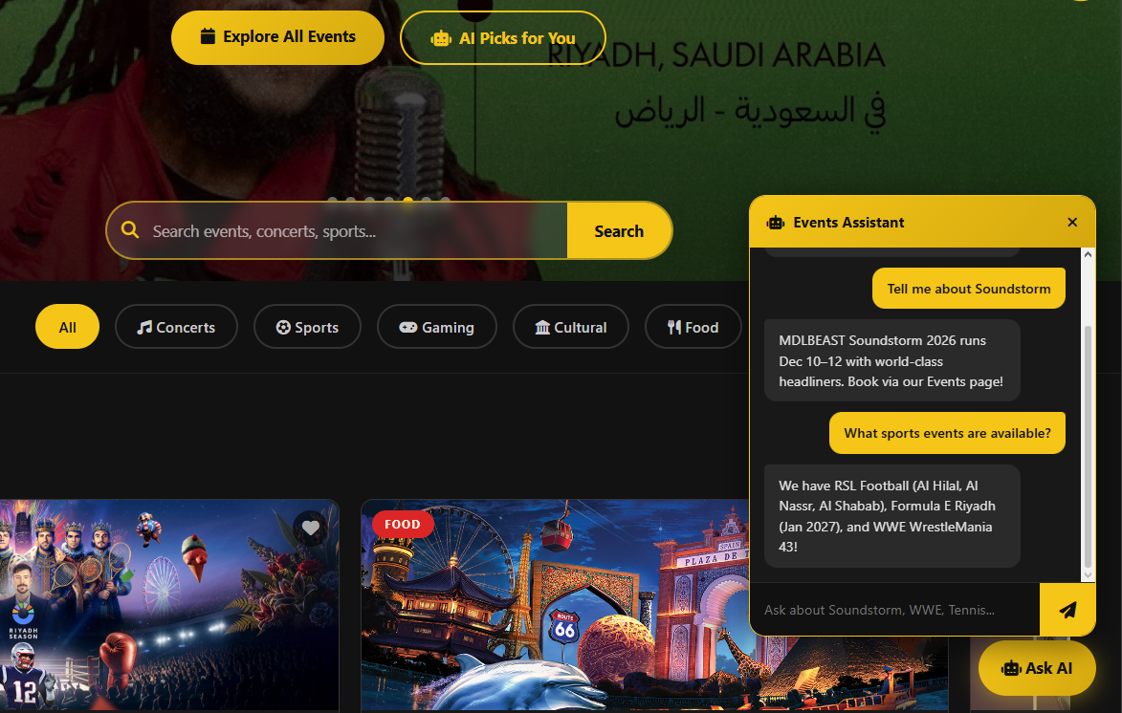
A floating chatbot button labeled "Ask AI" is embedded in the footer and appears on every page of the website. When clicked, a chat window opens where users can type questions about events.
(e.g., "Tell me about Soundstorm," "What sports events are available?").
The chatbot is implemented in JavaScript and uses keyword matching against event data to generate context-aware responses about the platform's events. This provides users with a 24/7 interactive assistant experience.

(Figure 11 – AI Chatbot)

2.8 Feedback System
Logged-in users submit feedback (Figure 12 – Feedback.php) through a form that requires a star rating (1–5) and a text message; both fields are validated before submission. Each entry is stored in the feedback database table with the username and timestamp.
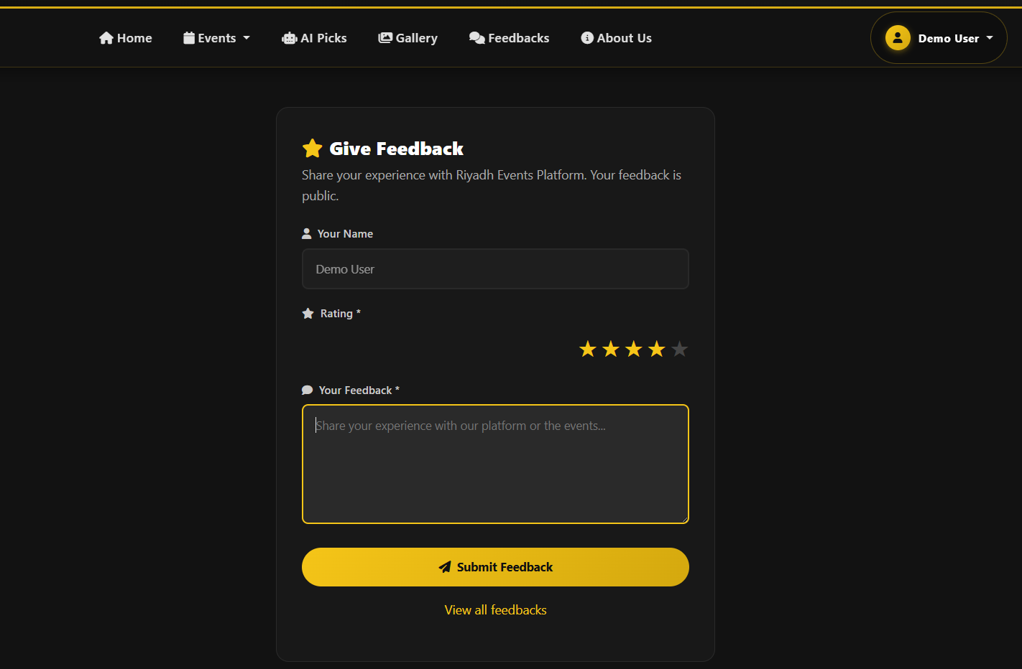
On the Feedbacks page (Figure 13– Feedbacks.php) all submitted feedback is displayed publicly in a card grid showing username, date, star rating, and message. Guests can view feedback but must sign in before submitting their own.

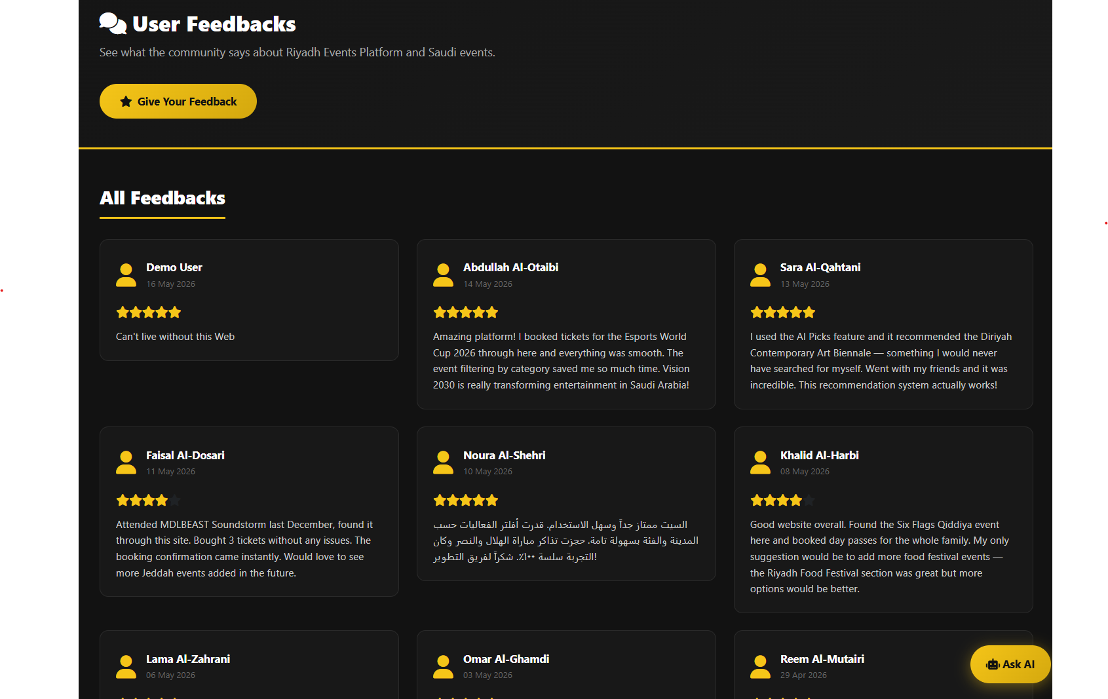
(Figure 12 – Feedback Submission Form)
(Figure 13 – Public Feedbacks Page)

2.9 Favorites Feature
Authenticated users can save events to a personal favorites list by clicking the heart icon on any event card. The toggle is handled via AJAX (JavaScript fetch() to favorites.php), so the page does not reload. Favorites are stored in the favorites database table with a unique constraint per user/event pair to prevent duplicates. The "My Favorites" page lists all saved events, with the option to remove them or proceed to booking. Past events are shown as disabled (grayed out) in the favorites list.
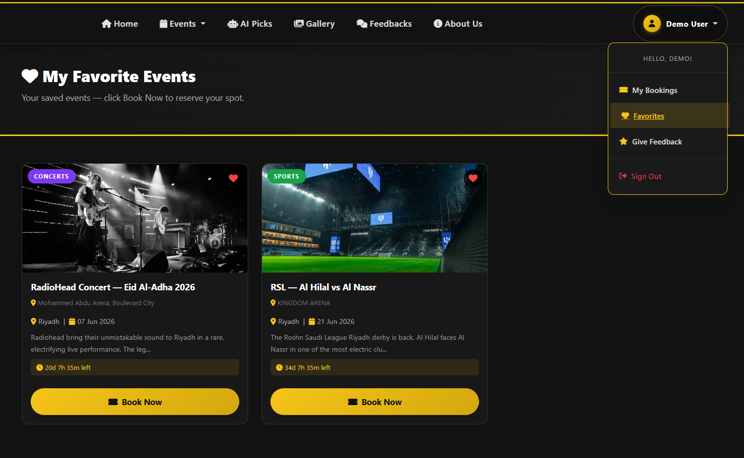
(Figure 14 – My Favorites Page)

2.10 About Us Page

The About Us page (Figure 15 - About.php) features a JavaScript slideshow presenting the three team members. Each slide shows the member’s name, role in the project, a description of their contributions, their degree, and their areas of interest. Navigation is provided with left and right arrow buttons and dot indicators at the bottom following the W3Schools slideshow pattern. The page also includes a project summary section listing the technologies used and the Vision 2030 alignment points.

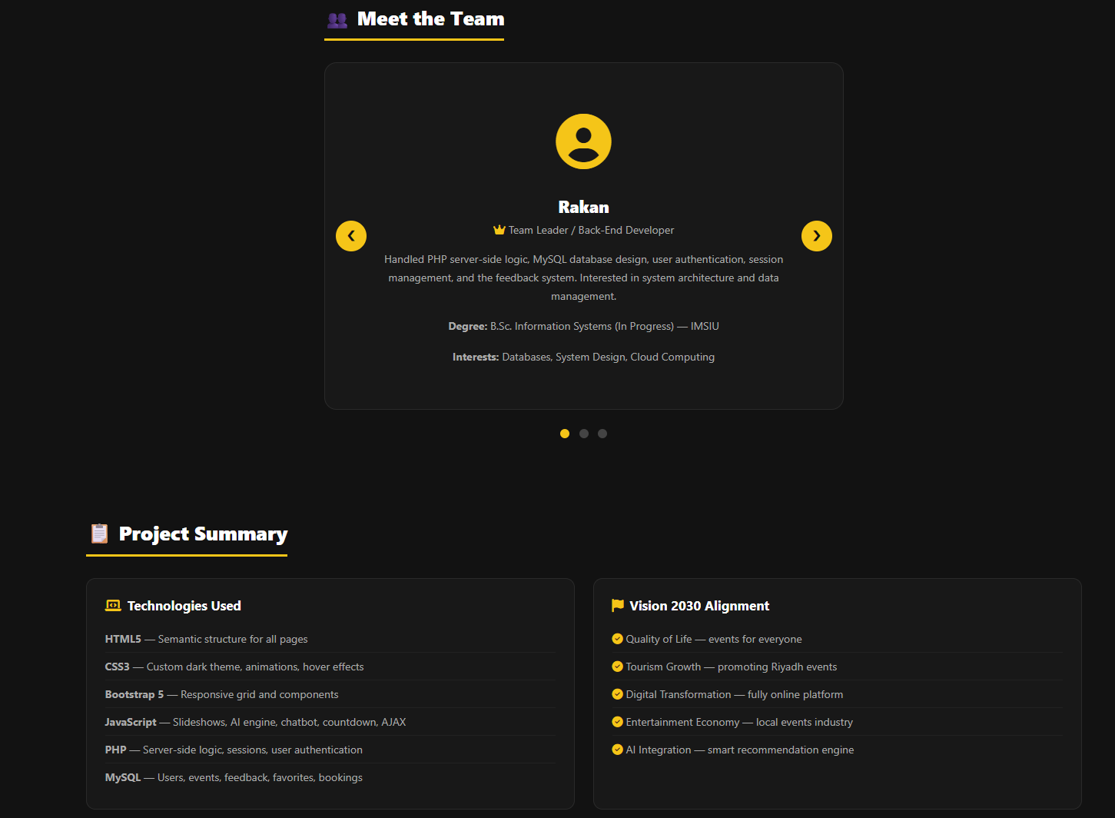
(Figure 15 – About Us Slideshow)

2.11 Gallery Page
The gallery page (Figure 16 - gallery.php) displays all events in a responsive image grid. Upcoming events are fully colored and clickable, linking directly to their booking page. Past events are displayed in grayscale with a "Event Passed" overlay and no booking link. An overlay effect on hover shows the event title and a "Book Now" call to action for upcoming events.

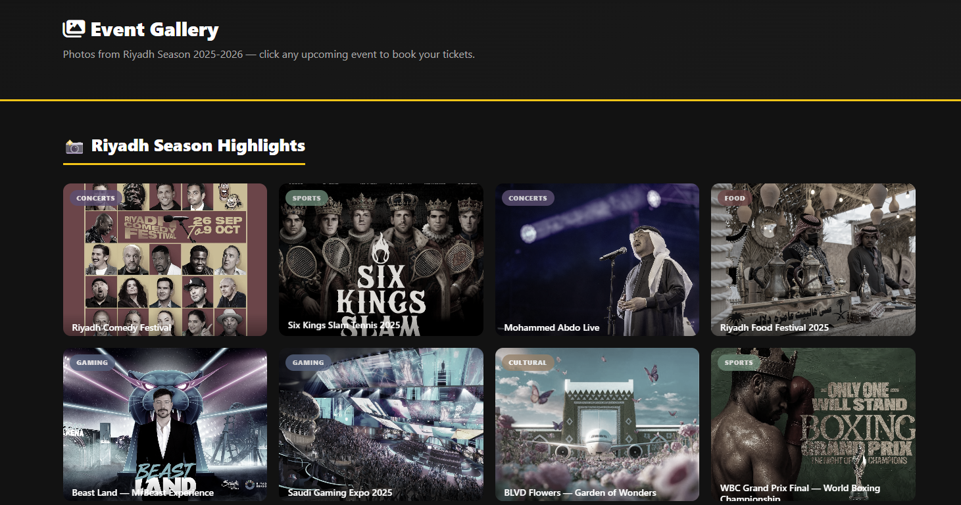
(Figure 16 – About Us Slideshow)

3. Database Tables & Description
The website uses a MySQL database named riyadh_events with 5 tables:

3.1 users
Stores all registered user accounts. Passwords are stored as bcrypt hashes for security.
Column | Type | Description
id | INT (PK, Auto) | Unique user identifier
username | VARCHAR(80) | Display name chosen by the user
email | VARCHAR(120) UNIQUE | User email — used for login, must be unique
password | VARCHAR(255) | bcrypt-hashed password (never stored in plain text)
created_at | TIMESTAMP | Date and time the account was created

3.2 events
Stores all events available on the platform, including past and upcoming events.

Column | Type | Description
id | INT (PK, Auto) | Unique event identifier
title | VARCHAR(150) | Event name (e.g., "MDLBEAST Soundstorm 2025")
category | VARCHAR(50) | Event type: Concerts, Sports, Gaming, Cultural, Food, Art
city | VARCHAR(80) | City where the event takes place
venue | VARCHAR(150) | Specific venue name (e.g., "Kingdom Arena, Riyadh")
event_date | DATE | Date of the event — used to distinguish upcoming vs. past
price | DECIMAL(8,2) | Base ticket price in SAR (0.00 = free entry)
image | VARCHAR(200) | Filename of the event image stored in the images/ folder
description | TEXT | Full event description shown on cards and booking page
created_at | TIMESTAMP | Date the event record was inserted into the database

3.3 feedback
Stores all user-submitted feedback and star ratings, displayed publicly on the Feedbacks page.

Column | Type | Description
id | INT (PK, Auto) | Unique feedback record identifier
username | VARCHAR(80) | Name of the user who submitted the feedback
message | TEXT | The feedback text written by the user
rating | TINYINT (1–5) | Star rating selected by the user (default 5)
created_at | TIMESTAMP | Submission date and time

3.4 favorites
Records which events each user has saved as favorites. A unique constraint prevents duplicate saves.

Column | Type | Description
id | INT (PK, Auto) | Unique record identifier
user_id | INT (FK → users.id) | References the user who saved the event
event_id | INT (FK → events.id) | References the saved event

3.5 bookings
Records all ticket bookings. Each user can only book a given event once (enforced by a UNIQUE constraint).

Column | Type | Description
id | INT (PK, Auto) | Unique booking identifier
user_id | INT (FK → users.id) | The user who made the booking
event_id | INT (FK → events.id) | The event that was booked
seats | INT | Number of seats/tickets purchased (max 10)
ticket_type | VARCHAR | Ticket category chosen: standard, premium, or vip
total_price | DECIMAL | Total amount paid including service fee
booking_ref | VARCHAR | Unique booking reference code shown to the user
booked_at | TIMESTAMP | Date and time the booking was confirmed

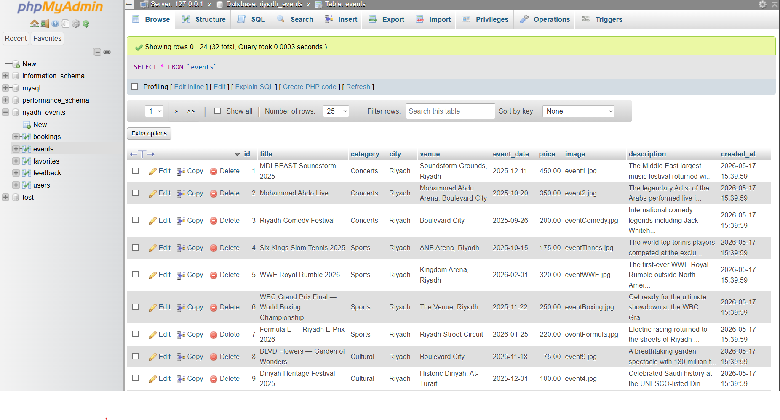
(Figure 17 – Database Tables in phpMyAdmin)

4. Programming & Scripting Languages

This section describes the languages and development tools used to build the Riyadh Events Platform.
PHP handled all backend logic, database queries, sessions, authentication, form processing.
JavaScript handled everything interactive, slideshows, countdown timers, the AI engine, chatbot, AJAX favorites, seat map, and payment formatting.
HTML5 gave the semantic structure for every page. Every page has its own title tag.
CSS3 handled the visual design, dark-gold theme, event cards, gallery grid, responsive breakpoints, animations.
MySQL stored everything, users, events, bookings, feedback, favorites, with foreign keys keeping the data consistent.
Bootstrap 5 for the responsive grid and components. Font Awesome 6 for icons.
Tools: XAMPP for local development, phpMyAdmin for the database, VS Code for writing code, Chrome DevTools for debugging.

5. Group Members & Duties

# | Student Name | Student ID | Role & Duties
1 | Rakan Khalid Alfadhel  ________________ | 444003360 | Back-End Developer — PHP server-side logic, MySQL database design, user authentication, session management, and feedback system.
2 | Rayan Saad Alshamrani  ________________ | 444012651 | Front-End Developer — Overall site design, HTML/CSS structure, Bootstrap integration, About page, UI/UX, and gallery page.
3 | Omar Khalid Almazrou  ________________ | 444004804 | JavaScript Developer & Content — AI recommendation engine, chatbot assistant, countdown timers, slideshow, favorites system, and event content.

6. Conclusions

This project taught us how different technologies work together to build a real web application. HTML and CSS gave the site its look, Bootstrap made it responsive, and JavaScript added the interactive features like the slideshow, countdown timers, seat map, and the AI recommendation engine. PHP handled everything on the server side, login, registration, bookings, and feedback, while MySQL stored all the data.

Combining all of these wasn’t always easy, but it helped us understand how a full web app actually works from the front end all the way to the database. Overall, we’re happy with what we built and feel it genuinely reflects the Vision 2030 theme the project was asking for.

