VEGA
Verify · Execute · Guide · Audit

PS-03 | Runbook-Following Agent
Use Case & System Diagrams Report
Plan-and-Execute Agent + Custom MCP Shell Tool (Allowlisted)
Stack: React (JS) · Python · SQLite · Ollama (Local LLM)

1. System Actors & Use Cases

1.1 Actors
Actor | Description
On-Call Engineer | Engineer paged at 2 AM; monitors VEGA, approves HIGH-risk steps, can abort.
Incident Source | Alertmanager / PagerDuty / monitoring webhook posting the JSON alert.
Runbook Repository | Git-backed folder of Markdown runbooks indexed by alert type.
Planner Agent (Ollama) | Local LLM that parses the runbook and tags each step with a risk level.
Executor Agent | Python dispatcher that routes each step to the correct adapter.
MCP Shell Tool | Allowlist-enforced subprocess executor with timeout and capture.
Target Systems | Hosts (Shell), REST APIs and Databases (SQL) that VEGA operates on.
Audit Log Store | Append-only SQLite table holding a hash-chained record of every action.

1.2 Use Case Summary
UC# | Use Case | Primary Actor | Brief Description
UC1 | Ingest Alert & Load Runbook | Incident Source | Match alert to runbook, create session in SQLite.
UC2 | Parse Numbered Steps | Planner Agent | Tokenise Markdown into ordered, structured steps.
UC3 | Verify Step & Classify Risk | Planner Agent | LLM + rules tag each step LOW / MEDIUM / HIGH.
UC4 | Execute Safe Step via MCP Shell | Executor Agent | Run via allowlisted subprocess with timeout.
UC5 | Guide — Request Human Confirmation | On-Call Engineer | Pause on HIGH-risk; engineer approves or rejects.
UC6 | Handle Multi-Input Step | Executor Agent | Shell / REST / SQL / File (HTML/CSV/JSON) adapters.
UC7 | Enforce Allowlist | MCP Shell Tool | Hard-deny any command outside YAML allowlist.
UC8 | Stream Live Log to UI | On-Call Engineer | SSE stream of stdout/stderr to React console.
UC9 | Append Audit Record | Audit Log Store | Hash-chained, immutable row per action.

2. Use Case Diagram
This diagram captures all external actors and the nine use cases within the VEGA system boundary, including the «includes» and «extends» relationships between them.
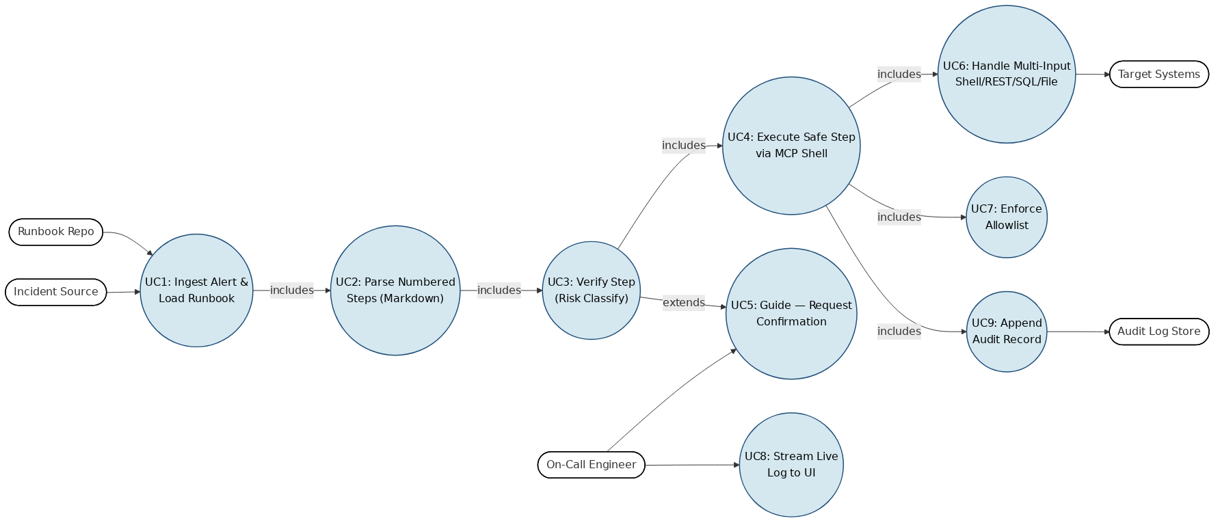
Figure 1 — Use Case Diagram. All nine use cases mapped to their primary actors with includes / extends relationships.

3. Sequence Diagram
The sequence diagram captures the full message lifecycle for a single alert — from JSON ingestion through risk classification, MCP shell execution, human-in-the-loop approval on HIGH-risk steps, audit persistence and live log streaming back to the operator.
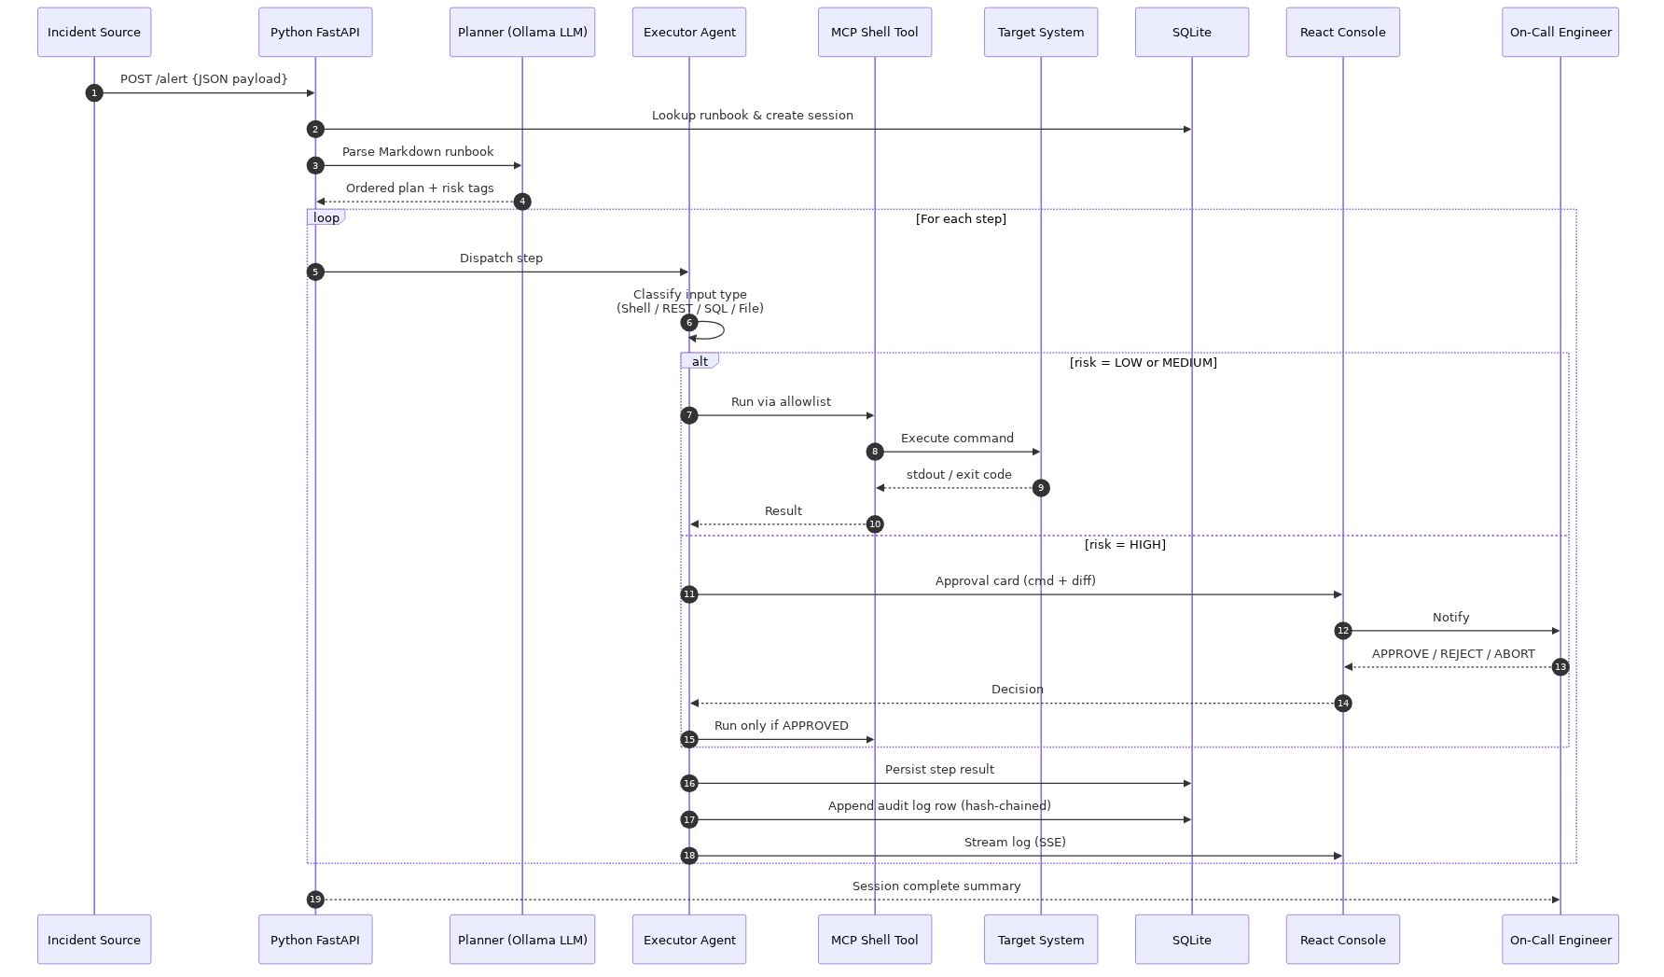
Figure 2 — Sequence Diagram. Full lifecycle of one runbook execution session.

4. Activity / Flowchart Diagram
The activity diagram models VEGA's decision logic — input-type classification, allowlist enforcement, risk-tier branching, retry/escalate on failure, and audit logging on every path.
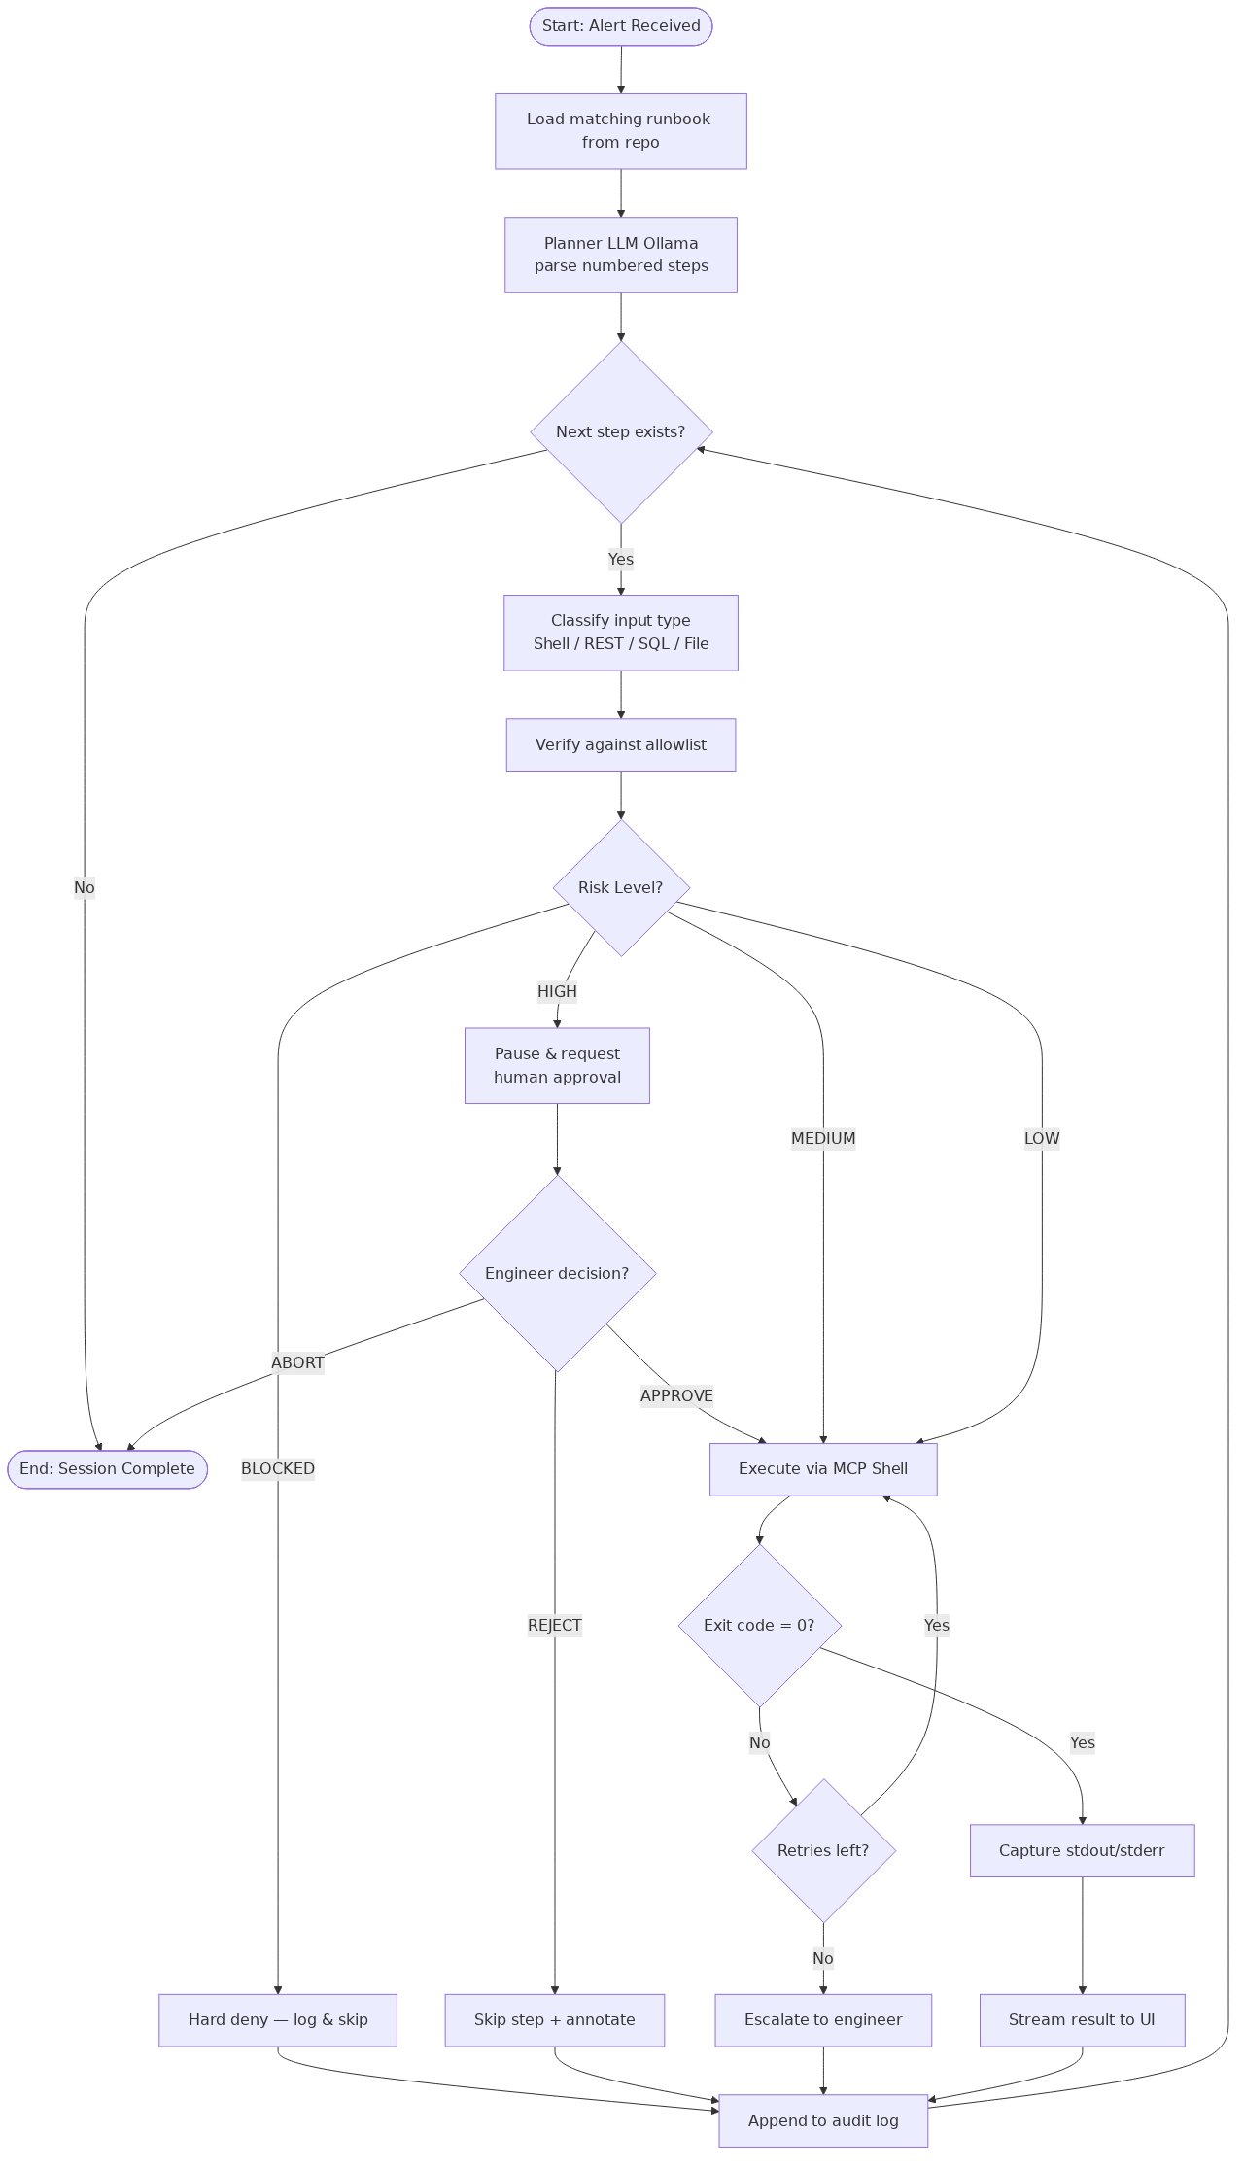
Figure 3 — Activity Diagram. Decision logic for a single runbook step.

5. System Architecture Diagram
VEGA is organised in seven layers from React UI down to target systems. The MCP Shell allowlist sits between the executor and any subprocess so no command can reach the OS unchecked.
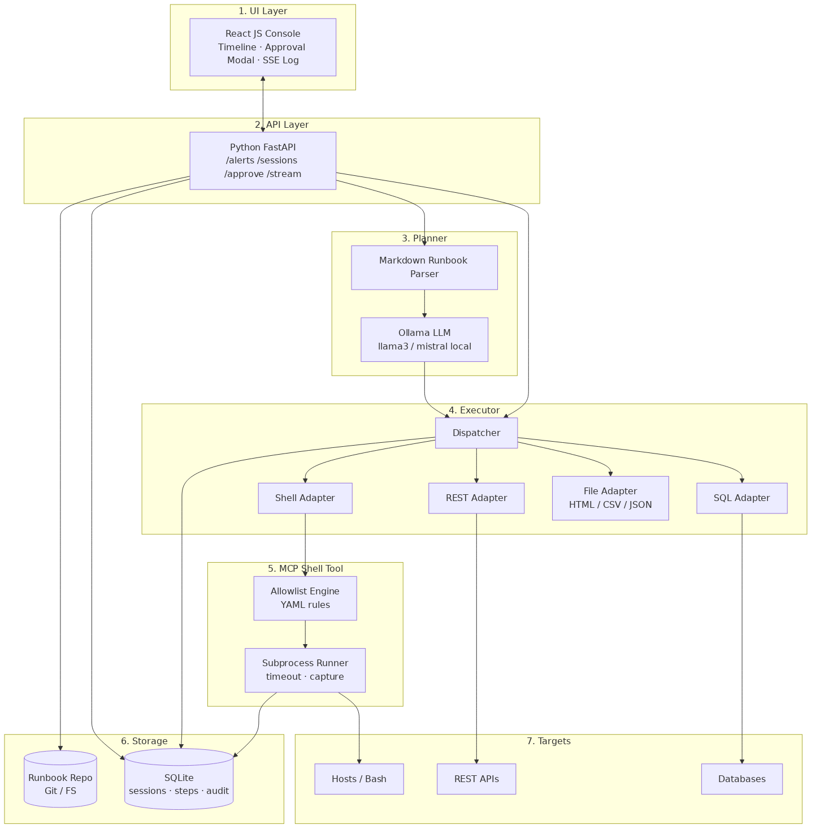
Figure 4 — System Architecture. React (JS) UI · Python FastAPI · Ollama planner · MCP Shell with allowlist · SQLite audit store.

5.1 Layer Summary
# | Layer | Key Components / Technology
1 | UI Layer | React (JavaScript) console — runbook timeline, approval modal, SSE log stream.
2 | API Layer | Python FastAPI — /alerts, /sessions, /approve, /stream endpoints.
3 | Planner | Ollama local LLM (llama3 / mistral) + Markdown runbook parser.
4 | Executor | Python dispatcher with Shell / REST / SQL / File adapters.
5 | MCP Shell Tool | YAML allowlist engine + subprocess runner with timeout & capture.
6 | Storage | Git-backed runbook repo + SQLite (sessions, steps, audit log).
7 | Targets | Bash hosts, REST APIs, SQL databases — the systems VEGA operates on.

6. System Inputs
VEGA accepts heterogeneous inputs through dedicated executor adapters:
- Shell / Bash — executed via the MCP shell wrapper against the YAML allowlist.
- REST API — HTTP GET/POST with JSON, used for health probes and restart endpoints.
- SQL — read-only diagnostic queries against SQLite or target databases.
- Files — Markdown runbooks (.md), HTML pages, CSV metric exports, JSON configs and alert payloads.

7. MCP Shell Tool — Allowlist Tiers
Risk | Behaviour | Examples
LOW | Auto-execute, log only | ls, cat, grep, ps, df -h, systemctl status, curl -I
MEDIUM | Auto-execute with strict limits | systemctl restart <svc>, kubectl rollout status, tail -n 200
HIGH | Block until human approval | systemctl stop, kubectl delete, DROP / TRUNCATE / DELETE, rm -rf
BLOCKED | Never executed (hard deny) | mkfs, dd of=/dev/*, shutdown, fork bombs

8. Use Case Specifications

8.1 UC1 — Ingest Alert & Load Runbook
Field | Detail
Primary Actor | Incident Source (Alertmanager / PagerDuty)
Precondition | FastAPI alert webhook is reachable; runbook repo is mounted.
Main Flow | POST /api/alerts → validate JSON → match alert.name to runbook → create session row → return session_id.
Exception | No matching runbook → 404; on-call engineer paged directly.
Postcondition | Session created in SQLite; planner enqueued.

8.2 UC3 — Verify Step & Classify Risk
Field | Detail
Primary Actor | Planner Agent (Ollama)
Input | Numbered step text from the Markdown runbook.
Output | { command, input_type ∈ {shell,rest,sql,file}, risk ∈ {LOW,MED,HIGH}, rationale }.
Rule | Any destructive verb (delete, drop, stop, restart prod) → HIGH regardless of LLM output.
Postcondition | Step row updated with risk tag and rationale.

8.3 UC4 — Execute Safe Step via MCP Shell
Field | Detail
Primary Actor | Executor Agent
Precondition | risk ∈ {LOW, MEDIUM} AND command passes allowlist.
Main Flow | Dispatch to adapter → run with timeout (default 30s) → capture stdout/stderr/exit code → persist.
Alt Flow | Exit ≠ 0 → retry up to N times → escalate to engineer.
Postcondition | Result streamed via SSE; audit row appended.

8.4 UC5 — Guide: Request Human Confirmation
Field | Detail
Primary Actor | On-Call Engineer
Trigger | risk = HIGH OR allowlist miss.
Main Flow | Pause session → push approval card (command, diff, blast radius) to React UI.
Decisions | APPROVE → execute; REJECT → skip + annotate; ABORT → terminate session.
Postcondition | Decision recorded with approver identity and timestamp.

8.5 UC7 — Enforce Allowlist
Field | Detail
Primary Actor | MCP Shell Tool
Allowlist | YAML file: { binary, allowed_flags[], forbidden_args[] }.
Behaviour | Hard deny — request never reaches subprocess; event logged as BLOCKED.
Postcondition | Engineer notified on any deny event in real time.

9. Risks & Mitigations
Risk | Mitigation
LLM hallucinates a destructive command | Hard allowlist + destructive-verb rule overrides LLM risk tag.
Runbook drifts from production reality | Dry-run mode; engineer can edit step before approval.
Approval fatigue at 2 AM | Risk tiers — LOW/MED auto-execute, engineer sees only HIGH steps.
Audit log tampering | Append-only SQLite with per-row SHA-256 chained to previous row.
Ollama unavailable | Fallback to rule-based parser (regex on numbered steps + keyword tags).

10. Success Metrics
- MTTR for runbook-driven incidents reduced by ≥ 40%.
- 0 unauthorised destructive commands executed (allowlist bypass = 0).
- ≥ 95% of LOW / MEDIUM steps auto-executed without human input.
- 100% of HIGH steps gated by a recorded human approval.
- 100% of executed steps present in the immutable audit log.

