NASA Earth-Observation Data for Seven Bangladesh Regions
What the archive contains, how reliable it is, and what it already shows — 2022 to 2026
Companion to NASA_Data_Sources_and_Django_API_Plan.docx. Prepared 11 November 2026. All statistics computed from the CSVs in this folder.

1. Summary
Six NASA datasets were collected for the same seven representative points used for the existing POWER weather files, over 1 January 2022 to the latest available day. Together they cover rainfall, surface soil moisture, vegetation greenness, land-surface temperature, terrain and regional water storage. Weather (POWER) and, where relevant, the plan's HLS adapter sit alongside them.
The headline finding is that Bangladesh cannot be treated as one agronomic zone. Annual rainfall ranges from 1,295 mm in the northwest to 3,638 mm in the northeast — a factor of 2.8 — and heavy-rain days range from 2 to 14 per year. The same regional split appears in soil moisture, vegetation and water storage.

2. What the archive contains
Each folder holds per-region CSV time series, a combined CSV, and a provenance file recording product, version, variables, resolution and limits.
Folder | Source and product | Native support | Rows | Values
GPM_IMERG_Rainfall | GPM IMERG Final + Late Run v07 | 0.1° (~11 km), daily | 12,418 | 12,418
SMAP_SoilMoisture | SMAP SPL3SMP_E v006 (Harmony subset) | 9 km, AM and PM | 24,206 | 9,618
ECOSTRESS_LST_ET | ECOSTRESS ECO_L2T_LSTE v002 | 70 m, irregular overpasses | 2,819 | 933
HLS_Vegetation_Indices | HLS HLSL30 / HLSS30 v2.0 | 30 m, sampled monthly | 413 | 220
GRACE_WaterStorage | JPL Mascon CRI RL06.3 v04 | 0.5° mascon, monthly | 399 | 399
SRTM_Elevation | SRTMGL1 v003 | 1 arc second (~30 m), static | 7 | 7
Table 1. Inventory. 'Values' counts rows with a real measurement; the remainder are the product's own gaps (cloud, no retrieval, radio-frequency interference), not download failures.
Storage was kept proportionate to the question. Coarse products (rainfall, soil moisture, water storage) are stored whole for the seven points. Fine products are sampled at the pixels over each point and the imagery is discarded: full HLS and ECOSTRESS scenes for this footprint would run to hundreds of gigabytes for no extra information at a point.

3. What the data shows

3.1 Rainfall: a 2.8-fold gradient across the country
Mean annual rainfall over 2022–2025 runs from 1,295 mm (Rajshahi) through 2,117 mm (Dhaka) to 3,638 mm (Sylhet). The number of days with 50 mm or more follows the same gradient — 2.2 per year in Rajshahi against 14.2 in Sylhet.
The monsoon dominates everywhere: 64–76% of the annual total falls in June–September. That leaves a genuinely dry half-year, which is where irrigation and planting decisions actually sit.
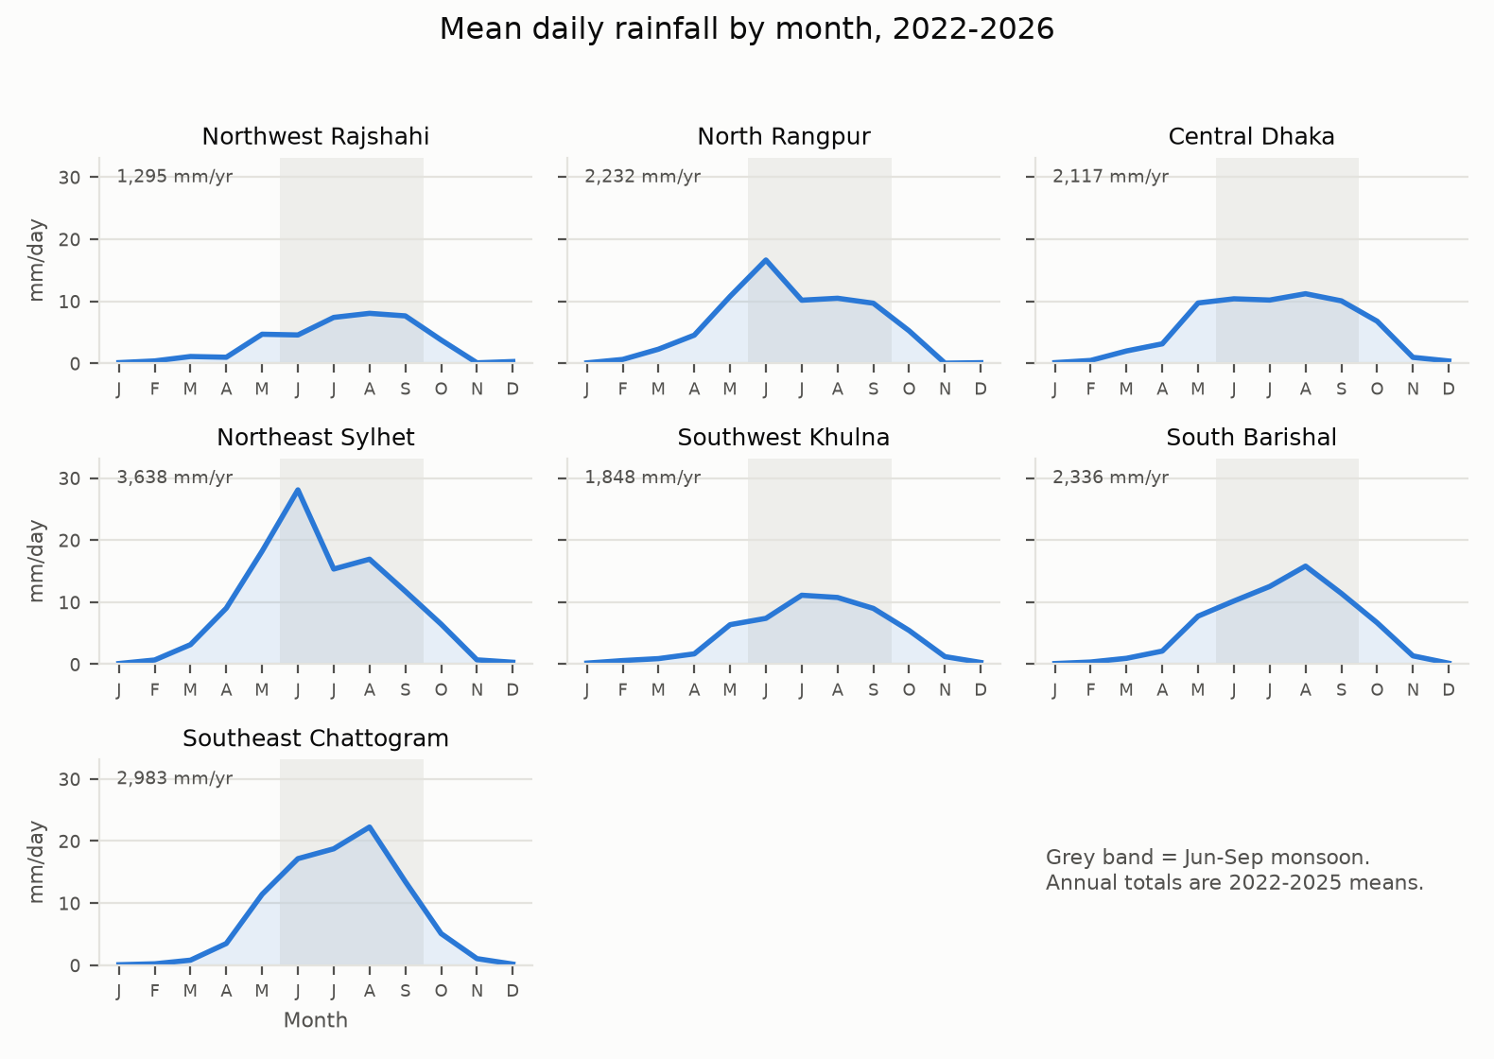
Figure 1. Mean daily rainfall by month. Shared scale; the shaded band is the June–September monsoon. Annual totals are 2022–2025 averages.
Region | Annual mm | Monsoon | Wet days | Days ≥50 mm | Wettest / driest | Max day | Variability
Northwest Rajshahi | 1,295 | 71% | 105 | 2.2 | Aug / Nov | 85 (2024-07-11) | 16%
North Rangpur | 2,232 | 66% | 123 | 9.0 | Jun / Nov | 172 (2023-06-15) | 4%
Central Dhaka | 2,117 | 64% | 135 | 6.8 | Aug / Jan | 175 (2023-10-05) | 10%
Northeast Sylhet | 3,638 | 65% | 168 | 14.2 | Jun / Jan | 195 (2022-06-18) | 10%
Southwest Khulna | 1,848 | 70% | 143 | 4.8 | Jul / Jan | 112 (2022-10-24) | 18%
South Barishal | 2,336 | 72% | 139 | 8.2 | Aug / Jan | 134 (2022-10-24) | 16%
Southeast Chattogram | 2,984 | 76% | 153 | 12.6 | Aug / Jan | 174 (2023-08-06) | 19%
Table 2. Rainfall per region, 2022–2025 (wet day = ≥1 mm/day). Variability is the coefficient of variation across years; with four years it shows volatility, not a trend.

3.2 Soil moisture: rainfall with memory
Surface soil moisture averages 0.30 m³/m³ in Chattogram to 0.44 m³/m³ in Khulna, and tracks the rainfall cycle with a flattened amplitude — the wet season roughly doubles the dry-season floor rather than scaling with rainfall. The tenth-to-ninetieth percentile band is widest where the dry season bites hardest (Chattogram 0.15–0.44 m³/m³).
Availability is the practical constraint: 59–73% of pass-days carry a retrieval at these points. The gaps are systematic (quality masking, radio-frequency interference), so a daily soil-moisture series should be smoothed or gap-filled before use, not treated as continuous.

3.3 Vegetation: greenness follows the monsoon by a month
NDVI runs from 0.26 in Rajshahi to 0.56 in Barishal — the same northwest–south gradient as rainfall and soil moisture, but expressed through land cover as well as water. Greenness peaks in September, one month after peak rainfall, and bottoms out between January and April.
Thirty-metre vegetation data over Bangladesh is cloud-limited: only 220 of 413 sampled region-months produced an NDVI value at 50% or better clear coverage. That is a property of the climate, not of the download, and it means NDVI should be read as a monthly series with stated coverage rather than as a weekly signal.
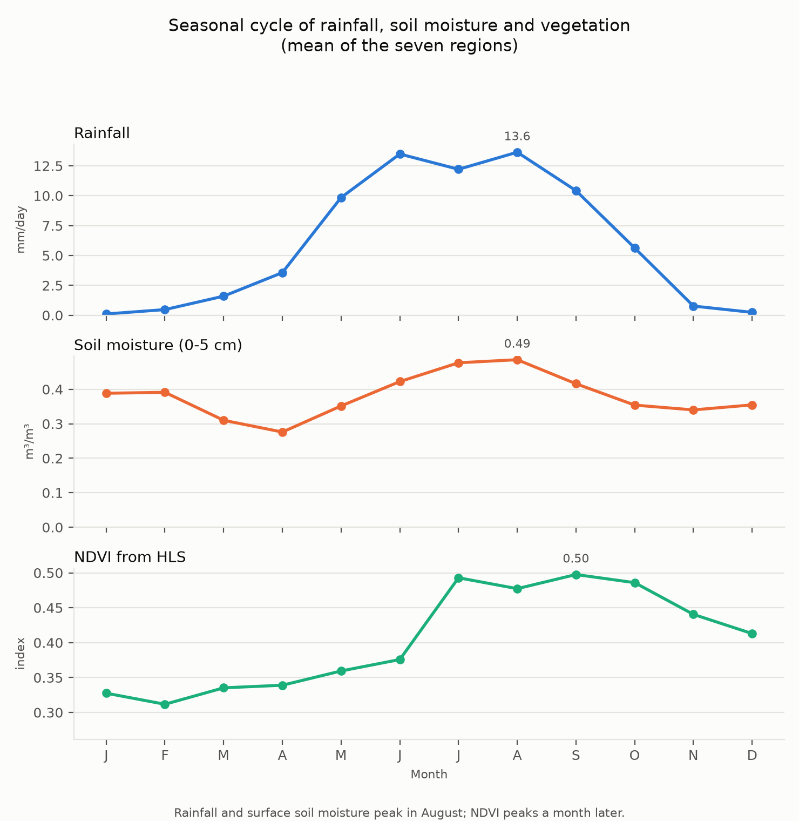
Figure 2. Mean seasonal cycle across the seven regions. Rainfall and surface soil moisture peak in August; NDVI peaks in September. Separate axes by design — the three quantities are not on one scale.

3.4 Surface temperature
ECOSTRESS land-surface temperature averages 24.3–26.5 °C by region and spans 10–55 °C overall. Only 933 of 2,819 overpasses returned a value at the point — thermal imagery is unusable through cloud. The series is an opportunistic sample of clear-sky overpasses at all hours - only about a quarter of the usable values are daytime - so it mixes day and night and must not be read as a daily maximum.
This is surface skin temperature, not the 2 m air temperature farmers recognise. It is useful for heat-stress and irrigation-timing signals, and misleading if presented as air temperature.

3.5 Terrain
Mean elevation ranges from 5.4 m (Khulna) to 34.4 m (Rangpur). The steepest average slopes are around Sylhet (3.89°), with Dhaka (2.76°) and Chattogram (2.62°) next, while Rajshahi and Khulna are flattest. The practical reading is that Khulna and Barishal sit low enough for tidal and drainage effects to dominate field water status, whereas around Sylhet slope-driven runoff is worth modelling.

3.6 Water storage: large-area context only
The seven points fall into four GRACE mascons (1214, 1320, 1321, 1431), so Dhaka, Sylhet, Barishal and Khulna share one value — that is the product's design, not a duplicate row. Over 2022–2026 the delta mascon trends upward while Rangpur and Chattogram trend down slightly.
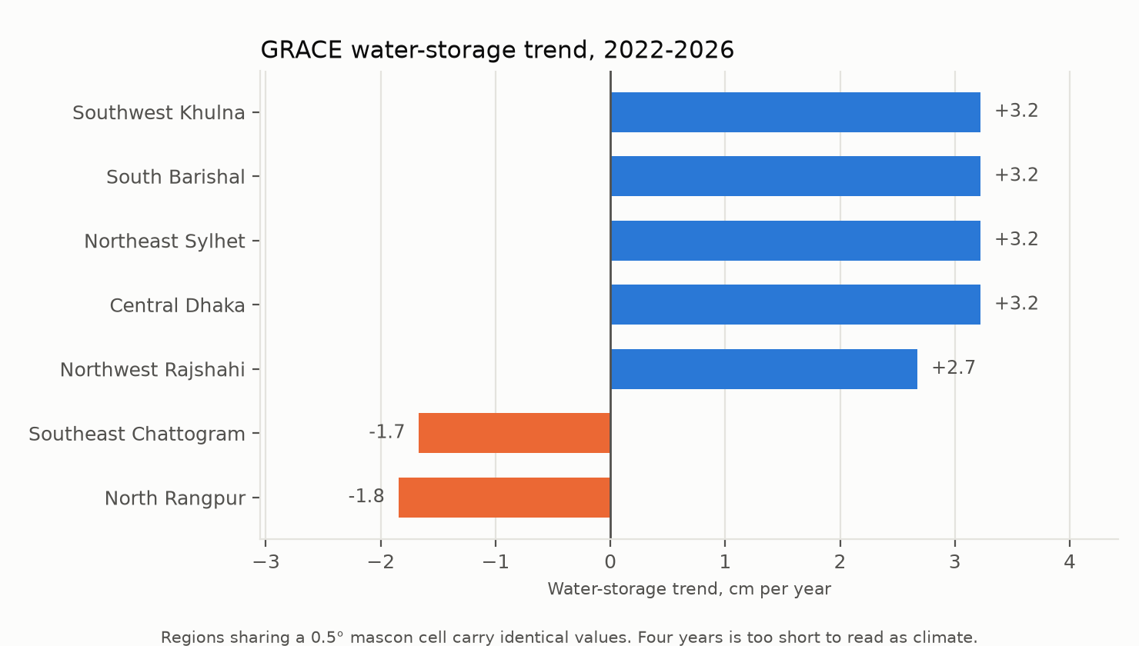
Figure 3. Fitted linear trend in water-storage anomaly. Four years is far too short to call this a climate trend; it is descriptive of this window only. The mascon grid is ~55 km and is not a groundwater measurement.

3.7 How the variables move together
Pooling monthly means across the seven regions (413 rain–moisture pairs, 220 rain–NDVI pairs), rainfall correlates most strongly with soil moisture in the same month (r = 0.41), and weakly at a one-month lag (r = 0.20). Vegetation tracks rainfall more weakly (r = 0.33) even though its seasonal peak trails the rains by a month. Surface temperature falls as rainfall rises (r = 0.55).
Relationship | r | Pairs | Reading
Rainfall vs soil moisture, same month | 0.41 | 413 | Moisture responds within the month
Rainfall vs soil moisture, +1 month | 0.20 | 413 | Little carry-over at the surface
Rainfall vs NDVI, same month | 0.33 | 220 | Weak immediate link
Soil moisture vs NDVI | 0.40 | 220 | Moisture and greenness agree moderately
Surface temperature vs NDVI | 0.12 | 220 | Weak; cloud sampling confounds it
Table 3. Pearson correlations on monthly regional means. These are descriptive associations over a short record, not causal models, and they pool regions with different climates.

4. Regional profile
One row per region, drawing on all six datasets.
Region | Rain mm/yr | Soil m³/m³ | NDVI | LST °C | Elev m | Slope ° | Storage cm/yr
Northwest Rajshahi | 1,295 | 0.32 | 0.26 | 25.4 | 18 | 1.7 | +2.7
North Rangpur | 2,232 | 0.36 | 0.47 | 24.3 | 34 | 1.9 | -1.9
Central Dhaka | 2,117 | 0.42 | 0.41 | 25.6 | 10 | 2.8 | +3.2
Northeast Sylhet | 3,638 | 0.39 | 0.40 | 25.4 | 22 | 3.9 | +3.2
Southwest Khulna | 1,848 | 0.44 | 0.44 | 25.6 | 5 | 2.0 | +3.2
South Barishal | 2,336 | 0.41 | 0.56 | 25.2 | 7 | 2.5 | +3.2
Southeast Chattogram | 2,984 | 0.30 | 0.34 | 26.5 | 13 | 2.6 | -1.7
Table 4. Regional summary. LST is a clear-sky surface temperature, not air temperature; storage is a mascon trend over four years.

5. Limits you should carry forward
- A coordinate selects a grid cell or pixel. None of these series is a measurement at the exact point, and none is a regional average.
- Empty values are the product's own quality masking. They must be preserved as nulls; substituting zero would invent dry days and cold afternoons that never happened.
- ECOSTRESS samples only clear-sky overpasses at varying times of day. Any climatology built from it inherits that sampling bias.
- HLS gives about one usable observation per region-month. Sub-monthly change detection is not supportable from this footprint.
- GRACE is a ~55 km mascon product with four distinct cells across the country; it cannot speak to field-level groundwater.
- The record is under five years. Seasonal statements are solid; trend statements are not.
- SMAP reports volumetric fraction: 0.30 is 30%. It is not a rover-depth or laboratory measurement.

6. Where this fits in FieldShift
The datasets map cleanly onto the endpoints the plan proposes:
- Environmental context per field — rainfall, soil moisture, NDVI, temperature and terrain keyed by point or polygon.
- Dry-spell and heavy-rain flags — the monsoon share and the ≥50 mm day counts give region-specific thresholds instead of one national number.
- Irrigation prompts — soil moisture percentile bands per region are a defensible baseline when no rover is present, provided they are labelled as modelled, not measured.
- Vegetation trends — monthly NDVI with coverage reported, so a low value can be distinguished from a cloudy month.
- Research workspace — water-storage and terrain context for regional studies, kept out of farmer-facing advice.
The natural next step is to load these CSVs into the `environmental_data` tables and serve them through `GET /api/v1/fields/{id}/environment/`, with each row carrying its source, resolution and quality flags as the plan requires.

7. File map
Path | Contents
GPM_IMERG_Rainfall/ | Daily rainfall per region; Final and Late Runs labelled in a column
SMAP_SoilMoisture/ | Daily AM/PM surface soil moisture, error, quality flags; raw daily subsets in raw/
ECOSTRESS_LST_ET/ | Per-overpass land-surface temperature with QC value
HLS_Vegetation_Indices/ | Monthly NDVI, NDMI and valid-pixel coverage
SRTM_Elevation/ | Terrain summary per region; 30 one-degree .hgt tiles
GRACE_WaterStorage/ | Monthly water-storage anomaly and uncertainty; source NetCDF in raw/
README.md | Folder-by-folder documentation and scripts
*.py | Idempotent download scripts; re-running fills gaps
Table 5. What is where.
Data: NASA GES DISC, NSIDC DAAC, LP DAAC and PO.DAAC, accessed through Earthdata Login. Products and versions are recorded in each folder's provenance file.

